# Report for Stereo Vision task in OpenCL

Nikunj Arora – 2646352

Dennis Goyal – 2627601

With the same constants as Stereo Vision Task in plain C:

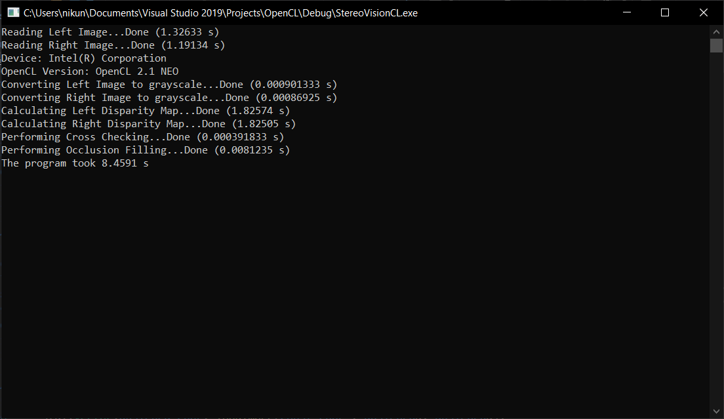

We observed that unlike running the program of CPU which took several minutes, running on GPU took just over 1 second. Therefore, we can run this program for different window sizes.

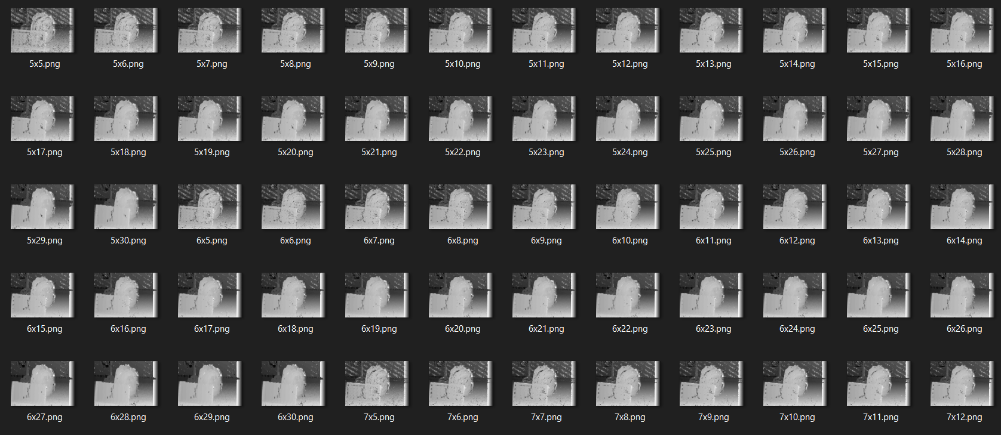

After trying out window sizes from 5x5 all the way to 30x30, we settled with a window size of 15x15. Therefore, the new constants:

maxDisp = 64

windowWidth = 15

windowHeight = 15

crossCheckingThreshold = 2

occlusionNeighbours = 256

## OpenCL on Intel UHD Graphics 620

**Resource Usage:**

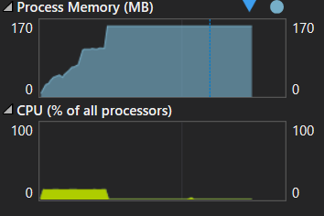

RAM: 154.7 MB

CPU: 13%

**Output:**

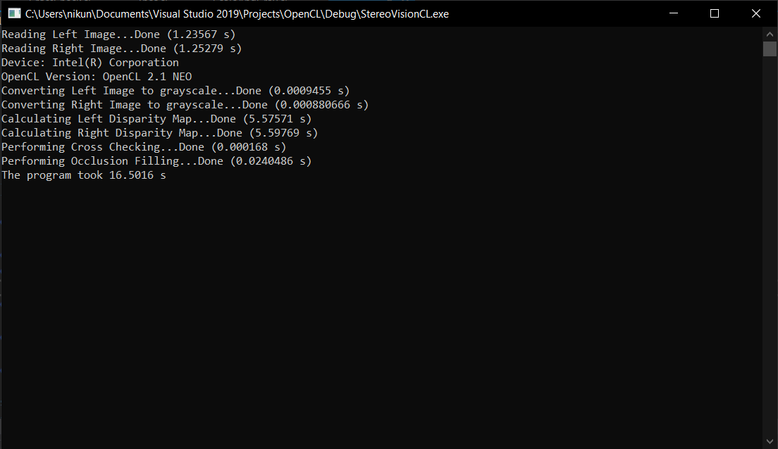

## OpenCL on Nvidia GTX 1070ti

**Resource Usage:**

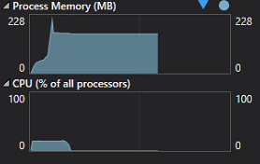

Ram: 153.4 MB

CPU: 17%

**Output:**

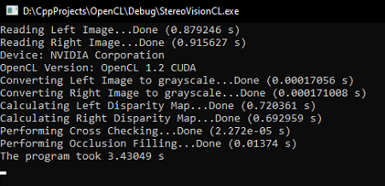

As we can see the Nvidia GPU is approximately 5x faster than the integrated Intel GPU.

## CUDA implementation on Nvidia GTX 1070ti

**Resource Usage:**

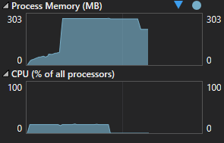

RAM: 274.1 MB

CPU: 17%

**Output:**

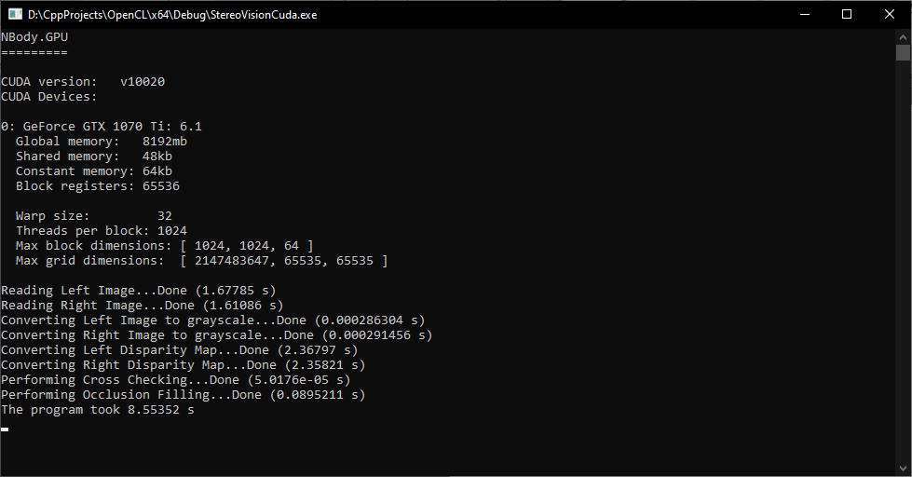

From what we observe, CUDA implementation performs worse than OpenCL implementation. This is probably due to inefficient CUDA code.