# Report for Optimized Stereo Vision task in OpenCL

Nikunj Arora – 2646352

Dennis Goyal – 2627601

Previous unoptimized output:

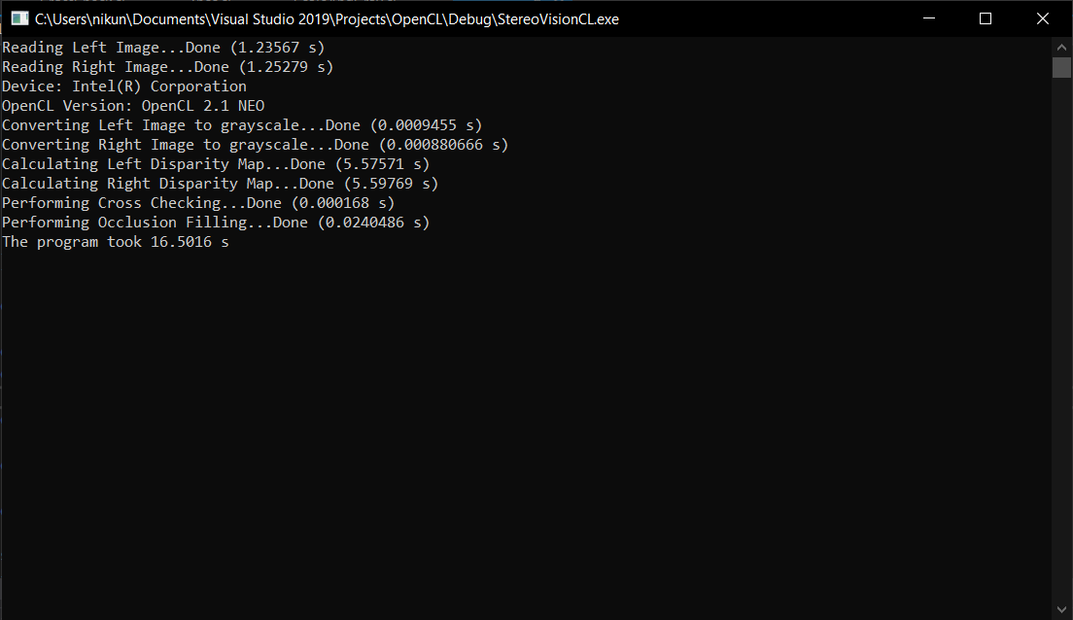

## Changes performed

1. Getting rid of separate calls for left and right image in ScaleAndGray.cl as well as Zncc.cl. Now both images get processed in a single kernel call.  
   This made the program run 0.5 – 1.0 seconds faster.
2. Assigning appropriate work group size to the Zncc program. After trial and error, the value most suited for this image and hardware turned out to be of size 2 x 15.  
     
     
     
   This also does not give significant boost in performance either.
3. Finally, we perform the final step which gives the program a major boost. In the Zncc program, we apply the “memory coalescing” technique. The hardware combines reads from contiguous memory blocks on a low level. By taking advantage of this feature and combining with appropriate work group size, we can give our program a significant boost.  
   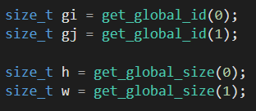  
   

## Result

**Output**

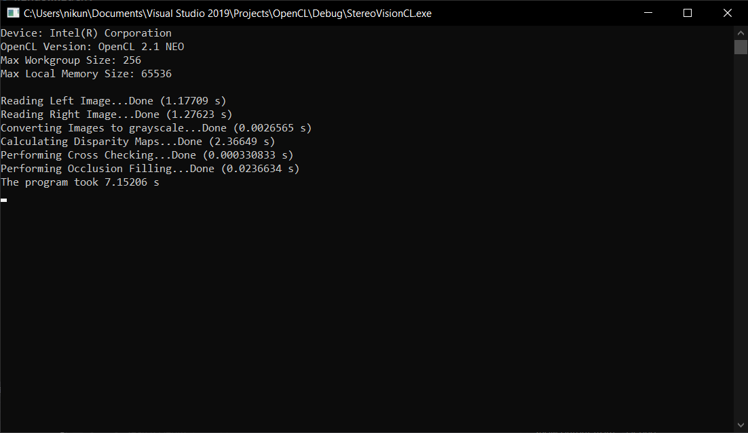

We can observe that the execution time increased by a factor of about **2.3**

**Resources Used**

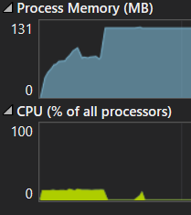

RAM: 117.8 MB

CPU: 13%