# Report for Stereo Vision task in plain C

Nikunj Arora – 2646352

Dennis Goyal – 2627601

**Constants**:

maxDisp = 64

windowWidth = 9

windowHeight = 9

crossCheckingThreshold = 2

occlusionNeighbours = 256

**Resource Usage:**

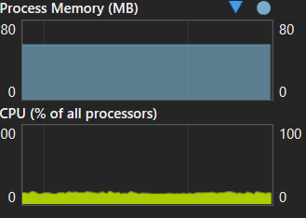

RAM: 54.7 MB

CPU: 13%

**Output:**

