# Report for Stereo Vision task in Nvidia CUDA

Nikunj Arora – 2646352

Dennis Goyal – 2627601

**Constants:**

maxDisp = 64

windowWidth = 15

windowHeight = 15

crossCheckingThreshold = 2

occlusionNeighbours = 256

**Resource Usage:**

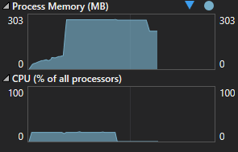

RAM: 274.1 MB

CPU: 17%

**Output:**

