# Report for Stereo Vision Multithreaded implementation using OpenMP

Nikunj Arora – 2646352

Dennis Goyal – 2627601

Processor used for recording performance: Intel i5 8th gen (4 cores, 8 threads)

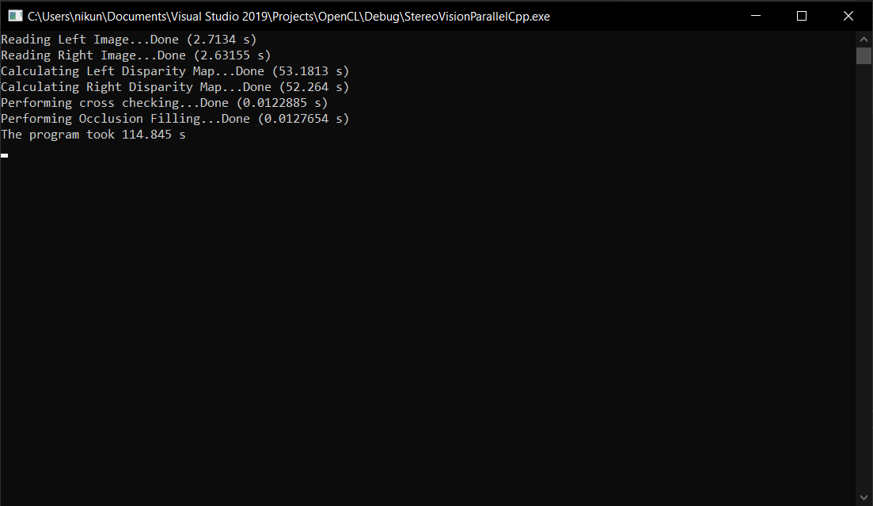

1024 threads

|  |  |
| --- | --- |
| Number of Threads | Time Taken (seconds) |
| 1024 | 114.8 |
| 512 | 114.4 |
| 256 | 116.6 |
| 128 | 118.8 |
| 64 | 118.6 |
| 32 | 120.2 |
| 16 | 122.8 |
| 8 | 125.0 |
| 4 | 178.4 |
| 2 | 275.4 |
| 1 | 464.1 |

We observe that, increasing the number of threads halves the time taken by the program, until we reach the physical limitation of the CPU (8 threads in this case). After this, the difference is only a few seconds.