chapter2_2

Nikunj Goel

9/21/2020

library(astsa)

## 2.6

Judging with our eyes, the time series for gtemp appears non-stationary. The mean is non-constant and there is clearly an upward trend. The variance appears to be pretty consistent however.

We can further check this through the acf2() function. If stationary, the ACF/PACF plots will show a quick drop-off in correlation after a small amount of lag between points.

acf2(gtemp)

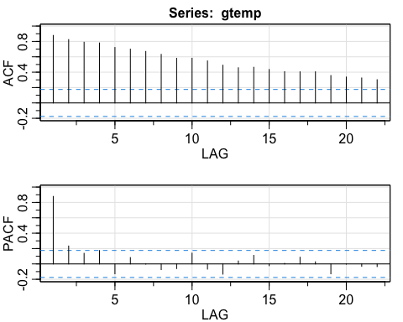

## [,1] [,2] [,3] [,4] [,5] [,6] [,7] [,8] [,9] [,10] [,11] [,12] [,13]  
## ACF 0.88 0.82 0.79 0.78 0.72 0.70 0.67 0.63 0.58 0.58 0.55 0.49 0.46  
## PACF 0.88 0.23 0.14 0.17 -0.13 0.08 0.00 -0.07 -0.06 0.14 -0.07 -0.13 0.04  
## [,14] [,15] [,16] [,17] [,18] [,19] [,20] [,21] [,22]  
## ACF 0.46 0.44 0.41 0.40 0.40 0.36 0.34 0.32 0.30  
## PACF 0.11 -0.02 0.01 0.09 0.03 -0.13 0.00 -0.03 -0.03

The dotted blue line details significance threshold for each lag. Clearly this data is non-stationary as a high number of previous observations are correlated with future values.

## 2.7

The time series Xt is weakly stationary because the mean is zero and the Co-variance of the equation is just dependent on time difference **h** and not on time **t**.A close up of text on a white background

## 

## 2.8

Part a)

part b)

Part c)

Also,  
Time series Xt and Yt are individually time series stationary because their Mean is Constant and not dependent on time.   
Their Variance is also independent of time.

## 2.11

### part a)

set.seed(123)  
t = 1:500  
x = rnorm(t)  
acf1(x,20)

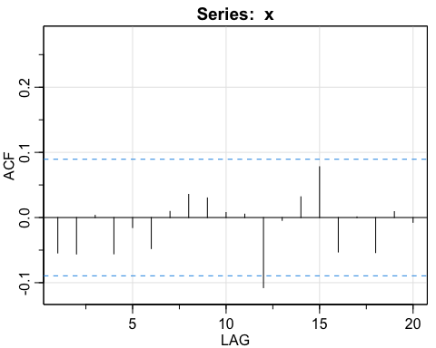

## [1] -0.05 -0.06 0.00 -0.06 -0.02 -0.05 0.01 0.04 0.03 0.01 0.01 -0.11  
## [13] 0.00 0.03 0.08 -0.05 0.00 -0.05 0.01 -0.01

In the Actual ACF, the ACF is 1 when lag = 0 and 0 otherwise but in sample ACF it gives us 5% values out of the bound. Due to which other values are small but not zero.

### part b)

set.seed(123)  
t=1:50  
x = rnorm(t)  
acf1(x,20)

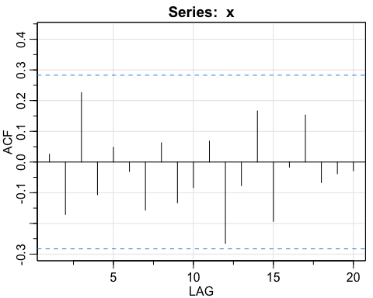

## [1] 0.03 -0.17 0.23 -0.11 0.05 -0.03 -0.16 0.06 -0.13 -0.08 0.07 -0.26  
## [13] -0.08 0.17 -0.19 -0.02 0.15 -0.07 -0.04 -0.03

Changing the value of n decreases the number of samples. In the part a) with 500 values, we have all the values in the range between -0.09 and 0.09 which shows that 95% values are within . Whereas in part b) as the number of samples are less, the error is high and we have ACF values bound at (-.29 to 0.29).

As the number of samples decrease the standard error increases.

## 2.12

### part a)

w = rnorm(500)  
x = filter(w,sides=2,filter=rep(1/3,3))  
acf1(x,20)

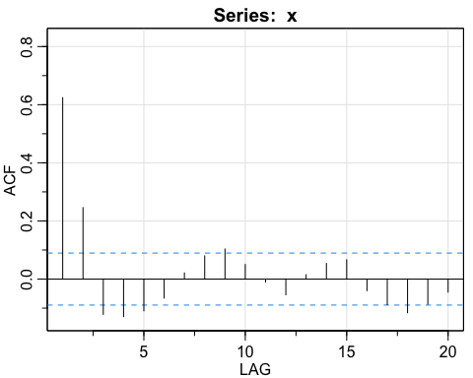

## [1] 0.62 0.25 -0.12 -0.13 -0.11 -0.07 0.02 0.08 0.10 0.05 -0.01 -0.05  
## [13] 0.01 0.05 0.07 -0.04 -0.09 -0.12 -0.09 -0.04

In the Actual ACF, the ACF is not 0 when lag=0 and 1. For all other values ACF=0 but in sample ACF it gives us 5% values out of the bound. Due to which other values are small but not zero.

### part b)

w = rnorm(50)  
x = filter(w,sides=2,filter=rep(1/3,3))  
acf1(x,20)

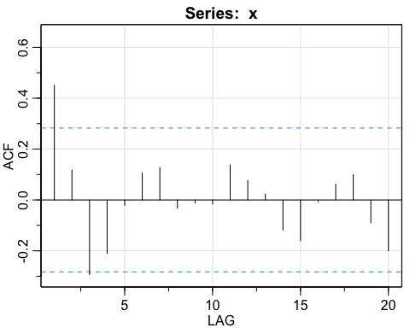

## [1] 0.45 0.12 -0.29 -0.21 -0.02 0.11 0.13 -0.03 -0.01 -0.02 0.14 0.08  
## [13] 0.02 -0.12 -0.16 -0.01 0.06 0.10 -0.09 -0.20

Changing the value of n decreases the number of samples. In the part a) with 500 values, we have all the values in the range between -0.09 and 0.09 which shows that 95% values are within . Whereas in part b) as the number of samples are less, the error is high and we have ACF values bound at (-.29 to 0.29).

As the number of samples decrease the standard error increases.

## 2.13

set.seed(123)  
w = rnorm(500+50)  
x = filter(w,filter=c(1.5,-0.75),method="recursive")[-(1:50)]  
acf1(x,50)

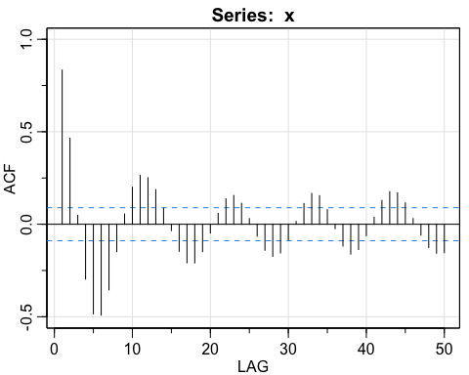

## [1] 0.83 0.47 0.05 -0.30 -0.48 -0.49 -0.35 -0.15 0.06 0.20 0.26 0.25  
## [13] 0.19 0.09 -0.03 -0.15 -0.21 -0.21 -0.15 -0.05 0.06 0.14 0.16 0.11  
## [25] 0.03 -0.06 -0.14 -0.17 -0.16 -0.09 0.02 0.11 0.17 0.15 0.08 -0.02  
## [37] -0.12 -0.16 -0.14 -0.06 0.04 0.13 0.18 0.17 0.12 0.03 -0.06 -0.13  
## [49] -0.16 -0.15

The approximate cyclic behavior is sinusoidal in nature with a periodicity of 12. Also after certain Lag, ACF decreases in amplitude and values becomes less significant.

## 2.15

set.seed(123)  
x = sample(c(-2,2), 11,replace=TRUE)  
y = 5 + filter(x,sides = 1,filter = c(1,-0.5))[-1]  
acf1(y,4)

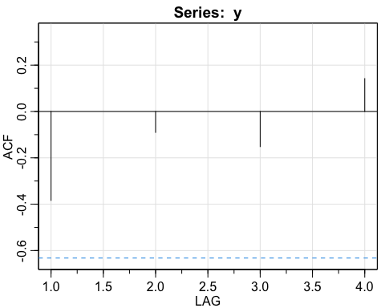

## [1] -0.38 -0.09 -0.15 0.14A close up of text on a white background

Description automatically generated

ACF at 1.0 is -0.4 and all other values are supposed to 0, but they are small enough to ignore.