Final Project

Emma Pazoff

ME359 Section B1

April 27th, 2017

Table of Contents

Introduction…………………………………………………………………………………………………………………………………………….3

Gearbox Analysis……………………………………………………………………………………………………………………………………..4

Graphical Representation of Product Structure……………………………………………………………………………………….6

Discussion………………………………………………………………………………………………………………………………………………..7

Feedback…………………………………………………………………………………………………………………………………………………8

Conclusion……………………………………………………………………………………………………………………………………………….9

Table of Figures

Graphical Representation of Product Structure……………………………………………………………………………………….6

Assembly of Gearbox……………………………………………………………………………………………………………………………..10

Planetary Carrier……………………………………………………………………………………………………………………………………11

Ring……………………………………………………………………………………………………………………………………………………….12

Planet…………………………………………………………………………………………………………………………………………………….13

Sun………………………………………………………………………………………………………………………………………………………..14

Introduction

The purpose of this project was to learn more about machine components and how they are produced and put together. By taking apart a relatively cheap, mass produced screwdriver and then analyzing it, it makes it possible to learn more about the engineering design process by looking at it in reverse. By being able to spot instances where DFMA tactics are implemented, observing how each component of the screwdriver fits into subassemblies and then into the final assembly, and observing the overall shape and size, it’s made clear that the seemingly simple design of the screwdriver had a lot of thought put into it. The portion of the project dedicated to analyzing the gearbox allows for a greater understanding on how gear ratios work, and some real-world applications of gear trains. It is another way to see all of the thought that must go into a design.

Gearbox Analysis

After taking apart the screwdriver, the individual parts of the gear train were analyzed, starting with the number of teeth (N). For the ring, planets, and the sun, N is found by simply counting the number of teeth. For the planetary carrier, however, N is found by using Equation 1.

$$N_{R}+N_{S}=N_{PC}$$

*Equation 1: Calculation of Planetary Carrier Teeth*

|  |  |  |  |
| --- | --- | --- | --- |
| **N Ring** | **N Planet** | **N Planetary Carrier** | **N Sun** |
| 48 | 19 | 54 | 6 |

*Table 1: Number of Teeth Epicycle Gear Components*

Once the number of teeth for each component is calculated, the gear ratio for each stage can be determined by Equation 2 and then the total gear ratio for an epicyclic gear train can be found by using Equation 3.

$${GR}_{1}={GR}_{2}=\frac{N_{PC}}{N_{S}}$$

*Equation 2: Gear Ratio for one stage of train*

$${GR}_{total}={GR}_{1}*{GR}_{2}$$

*Equation 3: Total Gear Ratio*

|  |  |  |
| --- | --- | --- |
| **Gear Ratio #1** | **Gear Ratio #2** | **Total Gear Ratio** |
| 9 | 9 | 81 |

*Table 2: Gear Ratios for the different stages and the total*

The gear ratio is proportional to the ratio between the input and output torque, as well as the input and output angular velocity (RPM), as can be seen in Equation 4. The values in table 3 reflect the calculations done using Equation 4.

$$GR=\frac{N_{output}}{N_{input}}=\frac{ω_{input}}{ω_{output}}=\frac{τ_{output}}{τ_{input}}$$

*Equation 4: Calculate angular velocity and torque by using GR*

|  |  |
| --- | --- |
| **Output Torque** | **Output RPM** |
| $$9τ_{motor}$$ | $$\frac{1}{9}ω_{motor}$$ |

*Table 3: Output Torque and Angular Velocity screwdriver*

One of the most important values needed when working with gears is the pitch diameter. This diameter is somewhere in between the outside diameter and the center and is crucial to making sure that the gears fit together without friction. In order to calculate the pitch diameter for an epicyclic gear train, the value of the center to center distances between the two gears is needed. Equation 6 can be used if the two components have the same number of teeth and Equation 7 can be used if they do not. The calculated values for the pitch diameters are listed below in Table 4.

$$C=\frac{({PD}_{1}+{PD}_{2})}{2}$$

*Equation 5: Center to Center Distance*

$${PD}_{1}={PD}_{2} ∴ PD=C$$

*Equation 6: Pitch Diameter if number of teeth is equal*

$${PD}_{2}=\frac{N_{2}}{N_{1}}{PD}_{1}$$

*Equation 7: Pitch Diameter if number of teeth is unequal*

|  |  |  |
| --- | --- | --- |
| **PD Planet** | **PD Sun** | **PD Ring** |
| .52in | .164in | 1.204in |

*Table 4: Pitch Diameter of components in Epicycle Gear Train*

Graphical Representation of Product Structure

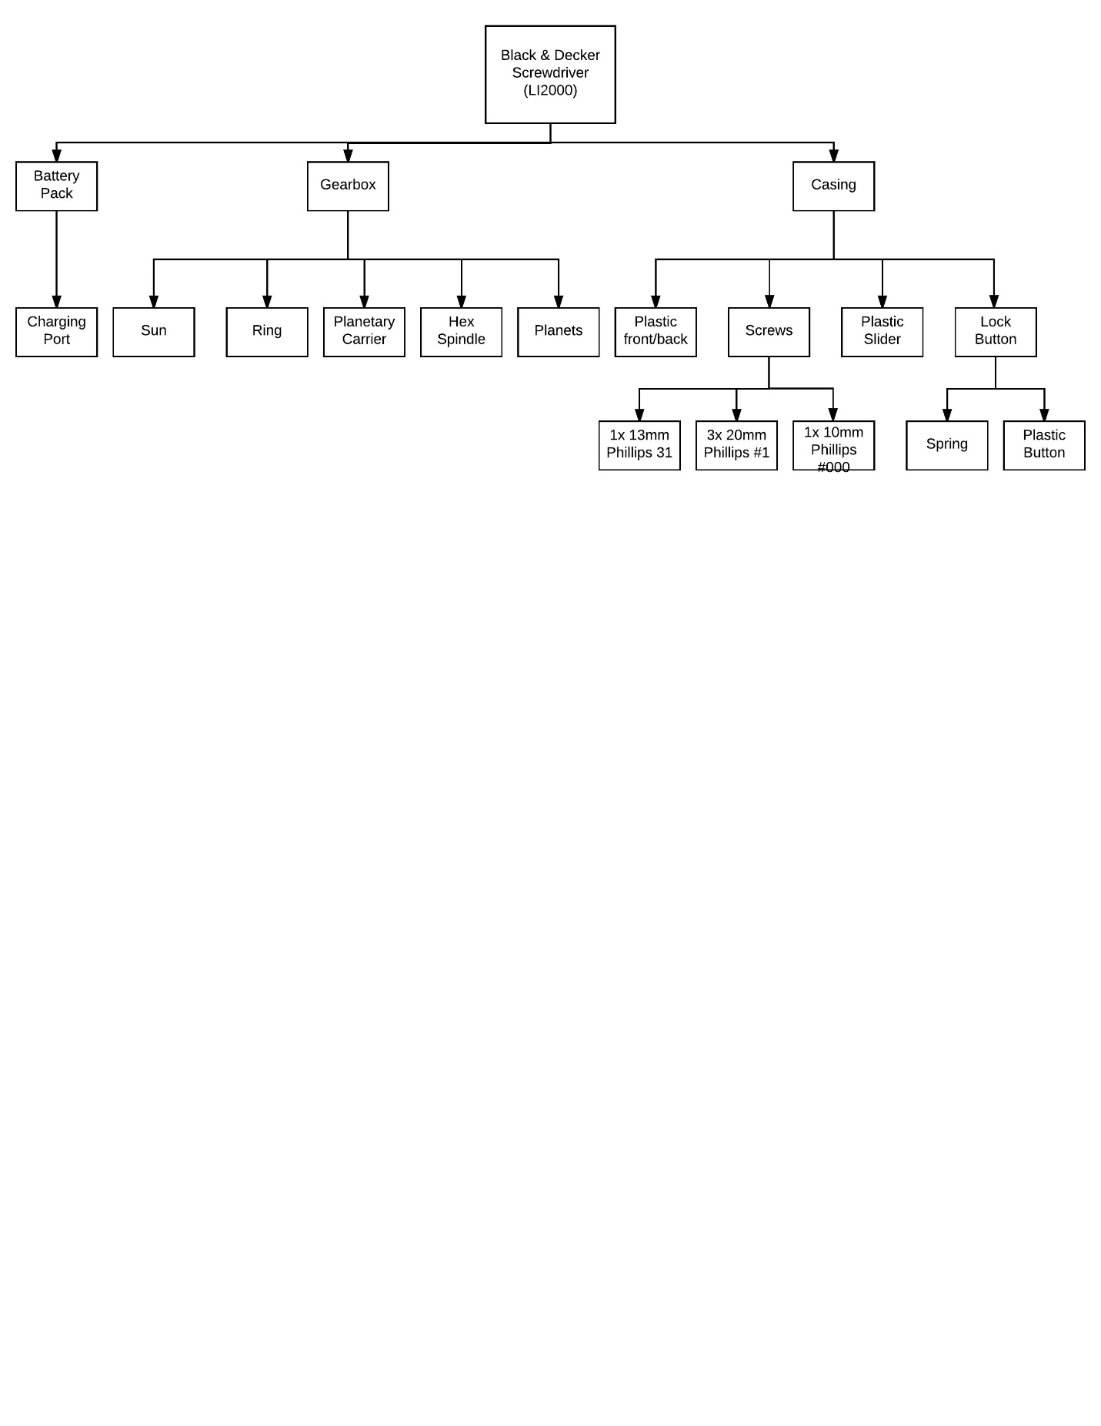

*Figure 1: Graphical Representation of Product Structure*

This image displays all of the different components and subassemblies that go into the creation of the LI2000 Black & Decker screwdriver.

Discussion

1. Three instances where Black & Decker incorporated Design for Manufacturing and Assembly (DFMA):

* Injection molding: When looking at the product closely, it is easy to tell that parts of the structure of the screwdriver were created through injection molding. The orange plastic covers, in particular, have small round circles that are a result of the molds pushing together and not lining up exactly.
* Uniform fasteners: Three out of the five screws used to assemble the screwdriver are identical—a tactic used by manufacturers to make it simpler to put the product together. The other two screws are most likely different because they need to serve a specific function that couldn’t be obtained using the other screw.
* Premade gears: premade gears make the most sense to use since it is extremely difficult to make from scratch. Using standardized gears is also more reliable and cost effective.

1. How the Power/Manual option works:

The drill can switch from power to manual mode and vice versa by rotating the tip of the drill until it clicks into place. Perhaps the rotation of the tip causes the gear train to lock so that it can no longer rotate, so then the bit will be able to act like a normal screwdriver.

1. Why did B&D choose an epicyclic gear train?

Black & Decker most likely used an epicyclic gear train because it is more compact than other types of gear trains and it is an efficient way to increase the maximum amount of torque that the output is able to produce. This helps to keep the design compact, yet still powerful.

Feedback

I thought that the project wasn’t all that helpful. I think I spend more time trying to get all the measurements correct using the caliper than working on the actual report, which was frustrating to keep getting the numbers incorrect. Also, it was not really enjoyable to have to take apart the gears when they had tons of lubricant on them. In order to make the project better, have a set of gears to measure that are already dry and out of the screwdriver and provide more instructions about how to calculate pitch diameter in class.

One aspect of the project I did enjoy was being able to see all of the different intricate design pieces that go into the making of the screwdriver and learning more about DFMA.

Conclusion

One of the most valuable parts of the assignment was being able to get more practice making assemblies in Creo. I still wasn’t feeling completely confident creating assemblies but feel more so after doing this. Another valuable component of the project was looking for the DFMA methods used by Black & Decker, which allowed a closer look at the product and how the design may have been created. After doing this project it will be easier to take apart more products and be able to fully analyze them.