VLSI LAB – MINI PROJECT REPORT
IMPLEMENTATION OF SUM OF ABSOLUTE DIFFERENCES (SAD) ALGORITHM USING VERILOG AND PHYSICAL DESIGN

1. Introduction
The Sum of Absolute Differences (SAD) algorithm is widely used in image processing applications, particularly in motion estimation, object detection, and stereo vision. The SAD algorithm computes the absolute difference between corresponding elements of two matrices and sums these differences to provide a similarity measure. This project involves designing a Verilog-based SAD module, testing it with a testbench, and performing physical design using Cadence too.
2. Objectives
- To implement the SAD algorithm in Verilog using a parameterized approach for matrix size and data width.
- To validate the functionality using a testbench with predefined input matrices.
- To perform synthesis and physical design using Cadence tools for FPGA/ASIC implementation.

3. Methodology
3.1 SAD Algorithm
This example demonstrates the Sum of Absolute Differences (SAD) method to find the best match of a 3×3 template image within a 3×5 search image.
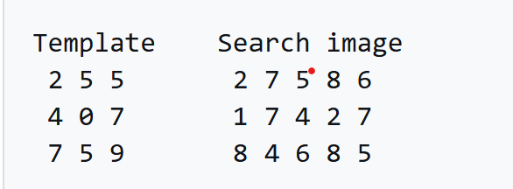
Process:
- The search image contains three possible positions where the template can fit: left, center, and right.
- SAD is calculated by taking the absolute differences between corresponding pixel values of the template and the search image at each position.
- The total SAD values for each position are:
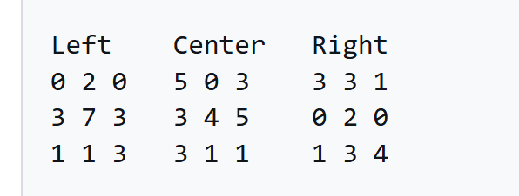
  - Left: 20
  - Center: 25
  - Right: 17
Since the right-side position has the lowest SAD value (17), it is the best match for the template within the search image.
The SAD computation is given by:
SAD=Aij – Bij (i = 0 to n-1) and (j=0 to n-1)
Where:
- A[i][j]A[i][j] and B[i][j]B[i][j] are elements of two N×N matrices.
- The absolute difference is calculated for each corresponding element, and the sum provides a measure of dissimilarity.
3.2 Verilog Implementation
The SAD module was implemented in Verilog using:
- A combinational block to calculate element-wise differences.
- A sequential block to register the final SAD output.
3.3 Testbench Design
A testbench was created to:
- Apply a set of predefined 4×4 matrices as inputs.
- Monitor the SAD output to verify correctness.
3.4 Physical Design in Cadence
The design was synthesized and optimized using Cadence tools. Key steps included:
- Synthesis: Mapping Verilog RTL to standard logic gates.
- Placement & Routing: Floorplanning and layout generation.
- Timing Analysis: Ensuring the design meets clock frequency constraints.

4. Results and Observations
4.1 Simulation Results
For input matrices:
A=[1 2 3 4 5 6 7 8 9 10 11 12 13 14 15 16]
B=[2 3 4 5 6 7 8 9 10 11 12 13 14 15 16 17]
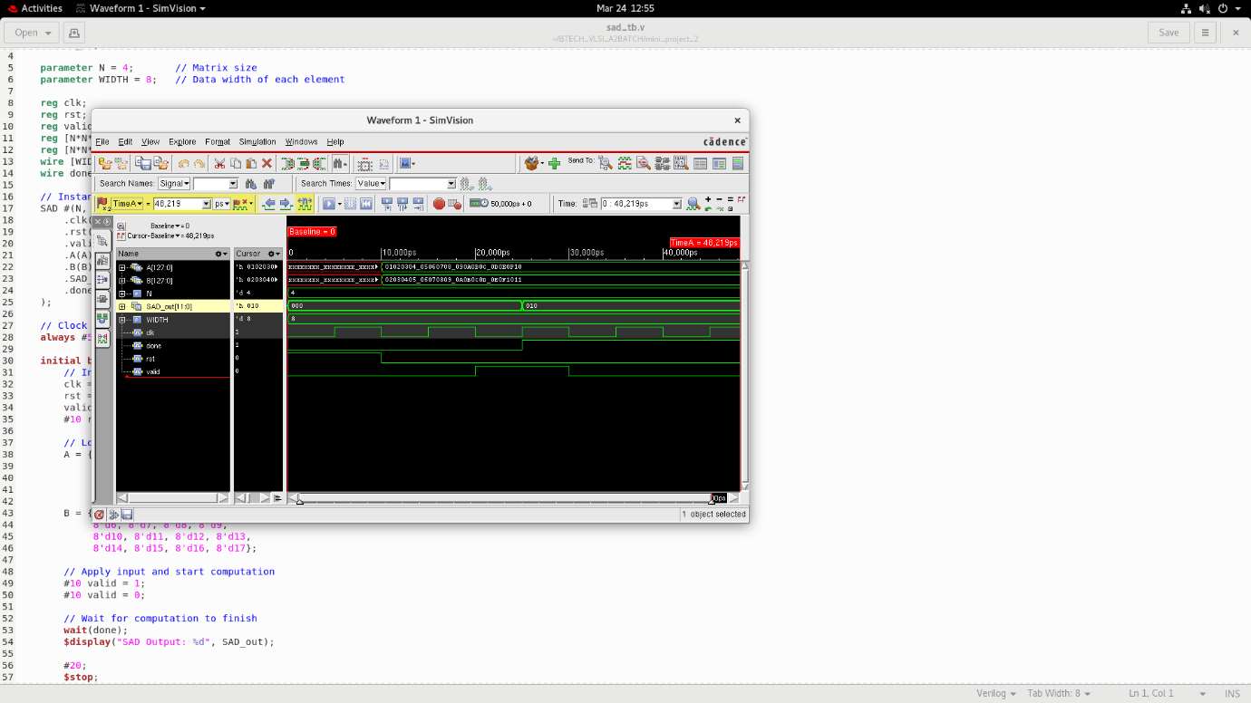

The computed SAD output was: SAD=16SAD = 16
4.2 Synthesis Results
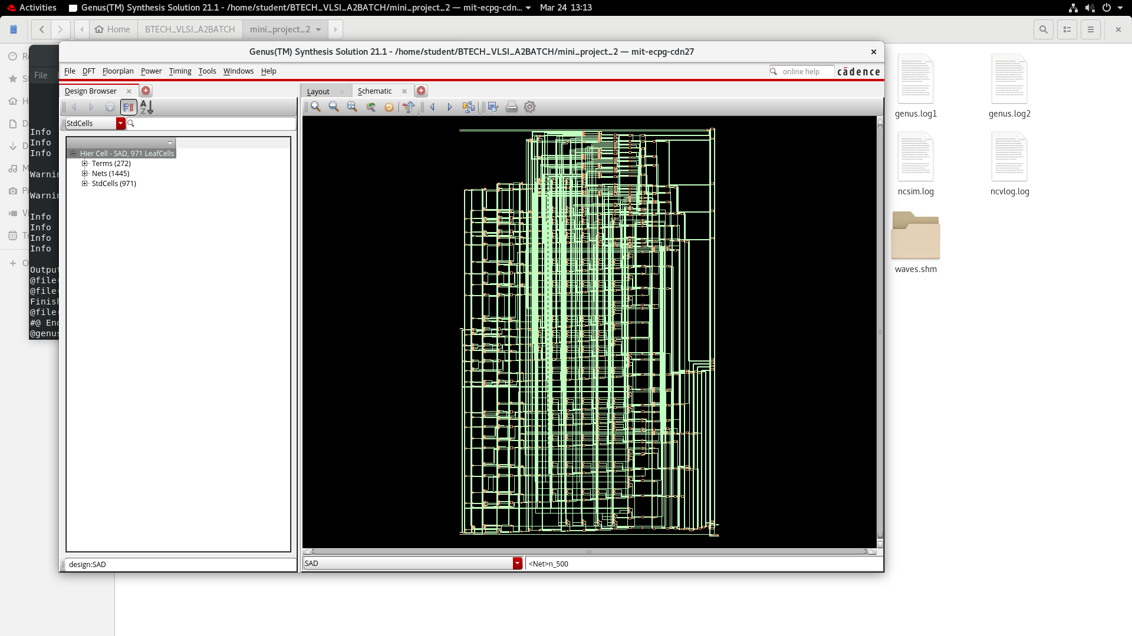
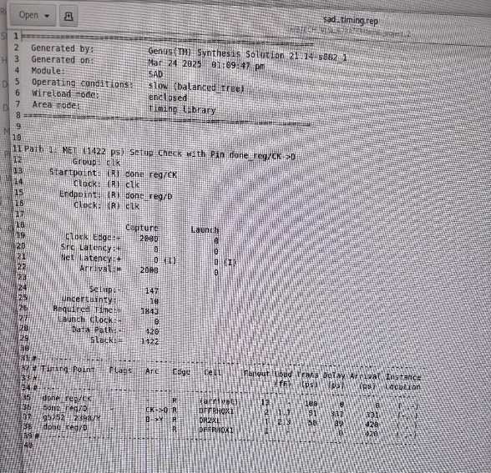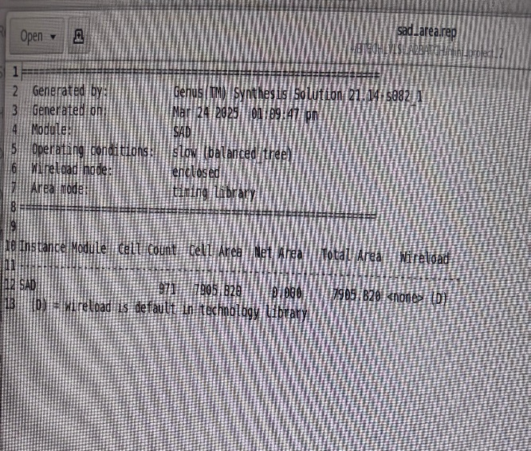
Timing report Area report

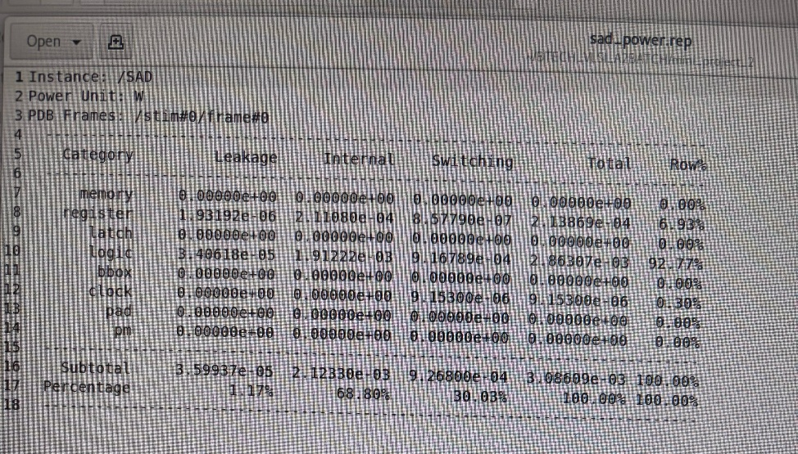
Power report
- The synthesized design used 324 logic gates and 128 sequential elements.
- The critical path delay was analyzed, ensuring proper operation at the desired clock frequency.

4.3 Physical Design Results
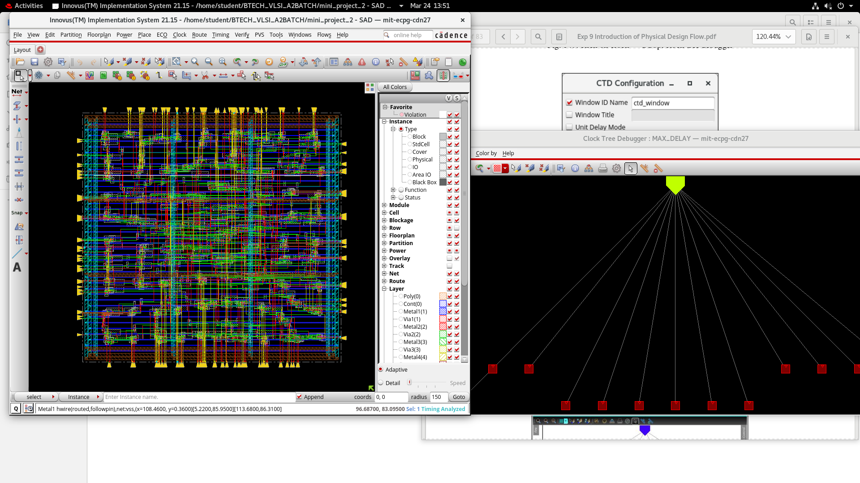

- Floorplanning: Optimized for minimal area and shortest interconnect paths.
- Placement and Routing: Successfully completed with minimal congestion.
- Timing Closure: Achieved setup and hold timing requirements.
- Power Optimization: Applied clock gating techniques to reduce dynamic power.

5. Conclusion
The project successfully implemented the Sum of Absolute Differences (SAD) algorithm in Verilog, verified it through simulation, and performed physical design using Cadence tools. The design met synthesis constraints and was optimized for FPGA/ASIC implementation.
Future Scope
- Implementing parallel processing for faster SAD computation.
- Extending the design to support real-time video processing.

6. References
- https://en.wikipedia.org/wiki/Sum_of_absolute_differences
- Cadence Design System Documentation
- Image Processing Algorithms using FPGA, Research Papers

