Deblur Editor

Nikunj Shah
15D100004
nikunj10jun98@gmail.com

Abstract—This paper is a detailed report about making a image editor from almost scratch with GUI and required functionality in Python IDE. Transformations used for modifying images are applied on color images separately on channels R, G and B. Basic deblurring techniques such as Inverse filtering, truncated Inverse filtering, Weiner filter, and Constrained Least Squares filtering are implemented. All filters are manipulations in frequency domain. Assignment was mainly aimed to get to learn handlining and manipulating image data in efficient manner.
Keywords—GUI, numpy, image, matrix, FFT, deblur, filter

Introduction
Deblurring is the process of removing blurring artifacts from images, such as blur caused by defocus aberration or motion blur. It is important problem to solve as it has vast range of applications for example in taking exact image of moving object. In most cases we don’t know the reason of the blur or specifically the kernel which can exactly reproduce the blur and hence it becomes difficult problem to solve. Also, knowing the kernel only may not be enough in most cases to get exact original unblurred image. As mentioned in following subsections I tried four deblurring techniques assuming blur filter is known and is spatially invariant.

Background and Approach
Assignment was mainly aimed to get to learn handlining and manipulating image data in efficient manner. Given problem statement was approached in modular fashion. First, I used the GUI made in first assignment and modified it appropriately to create required inputs and buttons. After GUI, I tried to implement DFT and IDFT algorithms from scratch. Completing that I implemented all the techniques on single channel grayscale image to reduce complexity of the problem. After obtaining successful results on those I implemented procedure for color image inputs and applied similar transformations in each of the 3 channels. Once code was complete with required functionalities I tried to make GUI interface better and simpler to use. At the end I optimized my code to make efficient use of vector and matrix and 2d array operations with the help of numpy [2] library.
As mentioned above modular type approach was followed by me. First GUI was modified then discrete Fourier transform and Inverse discrete Fourier transform functions were made using appropriate algorithms. Each button in GUI internally called the transformation function corresponding to one mentioned on it.
Following important deblurring transformations and functions were implemented:

- Fully Inverse Filtering:
This filter assumes there is no noise added after blurring. Hence it just divides the Fourier transform of given image by Fourier transform of kernel and obtains the output image. As expected due to little noise or quantization the high frequency components blow up in input image and hence very noisy output is obtained.
- Truncated Inverse filter:
This is almost like fully invers filter except inversion is applied within given radius from center in centered DFT, hence the name ‘truncated’. It performs little better than Inverse as high frequency noise is not amplified.
- Weiner filtering:
It is a bit complex filter which assumes that noise indeed plays substantial part during blurring of an image. It tries to minimize the mean squared error in predicted and original image.
- Constrained Least Squares filtering:
This filter fits the least squared deblurred image to corresponding blurred image. It is assumed that norm of difference in given blurred image and blurred version of output clean image is equal to noise.
- Blurring: As name suggests it blurs the input image. It is done by using given input kernel and its discrete Fourier transform. Frequency transforms of kernel and input image are simply multiplied to get frequency transform of blurred image. Inverse transform of this gives blurred image in spatial domain. This function was specifically made for testing purpose.
- Undo and Undo all: These functions restore the edited image to previous state by one step and by all steps respectively. It was accomplished by maintaining global variables for current state, previous state and original state of image being edited. They were modified in appropriate manner in each function.
- Save: This saves the image present in current edited state at the same location from where the original image was loaded. It was done using opencv function to save image.
- Some helper functions: dft_2d, dft_1d, idft_2d, padding functions, etc.

Experiments and Results

Following are the outputs on some chosen testcases:

Guitar testcase
This image was chosen as base case and most of the transformation were applied on this image to maintain the uniformity of the output. Functions verified were blurring, sharpening, gamma correction, log transformation, color output.

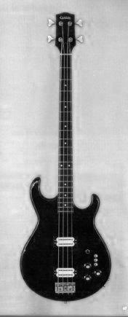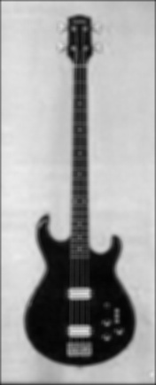
(i)Guitar grayscale (ii)Blurred

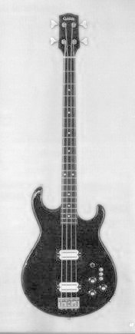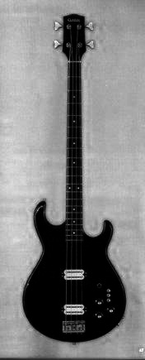
(iii)Gamma (=0.5) (iv)Gamma (=2.0)

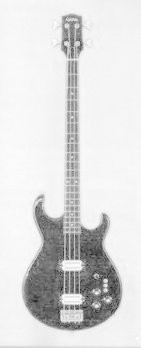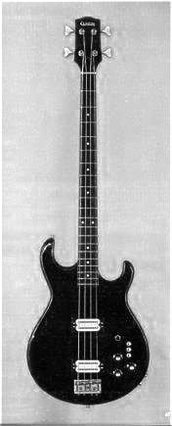
(v)Log transformation (vi) Sharpened
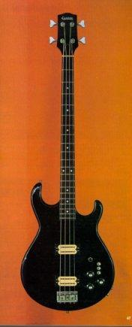
(vii) Colored

Histogram testcase
I wanted to choose testcase for histogram equalization such that the result of histogram equalization was desired image or in other words was better to visualize as compared to original. In most good images histogram equalization used to worsen the image quality.

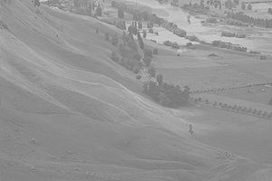 (i) Input image [7]
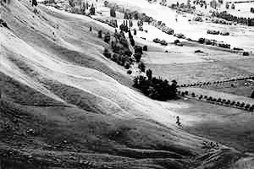
(ii) Histogram equalized image

Motorcycle testcase
This test case was solely chosen to depict the effect of watermark addition on image as clearly as possible.
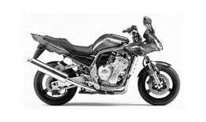 (i) Input image
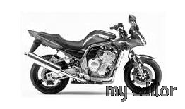

Discussions
As the problem statement was pretty clear and transformations were already taught in the class [4] there weren’t any major problems faced. But it was challenging to create FFT and DFT function accurately and fast enough by applying vector operations. We can easily conclude from this report that if blur kernels are known then it is possible to recover original deblurred image to very good extent even in the presence of noise, but exact recovery is still an unsolved problem. Also, from above applied filters it seems that Weiner filter and Constrained LS filter seem to give better results than straightforward inverse filters after optimizing the respective parameters. Also, it is possible to improve accuracy if there is any information on noise made available.
Currently I think machine learning and deep learning methods are best available techniques to perform such image restoration transformations of deblurring in presence of noise. Advantage here is we need not investigate specific features of noise as algorithms are capable of doing it on their own and then can eliminate them effectively. Only hurdle in using such techniques is requirement of appropriate quality and quantity of dataset which may be difficult to obtain/create in certain cases.

References
- http://www.numpy.org/
- https://docs.scipy.org/doc/numpy/reference/
- https://docs.opencv.org/3.4/
- EE 610 Lecture slides.
- https://wiki.python.org/moin/TkInter
- https://docs.python.org/2/library/tkinter.html
- https://en.wikipedia.org/wiki/Histogram_equalization
- http://northstar-www.dartmouth.edu/doc/idl/html_6.2/Sharpening_an_Image.html
- https://www.google.co.in/ (for testcase images)

(ii) Watermarked image

