  PROPOSAL & QUOTATION  Website Design  & Development  A luxury jewellery website with a complete admin panel, a 3D jewellery viewer and an SEO-friendly build — explained module by module.  ——— ◆ ———  PREPARED FOR  Mangalam Jewellers, Surat, Gujarat  PREPARED BY  Nikunj · Website Design & Development  DATE  11 October 2026  QUOTATION NO.  MJ/WEB/2026/01 | 
  TOTAL PROJECT COST
  ₹48,000 One-time cost

01 OVERVIEW

Your website, at a glance
——— ◆ ———
Mangalam Jewellers needs a website that feels as premium as its jewellery — and that the team can update every day without calling a developer. This proposal covers the complete project: luxury design, every page your customers visit, a 3D jewellery viewer, a full admin panel for products, offers and enquiries, and an SEO-friendly build so customers find you on Google.
13  Page designs  Home, catalogue, product, offers, journal, contact and more |  | 18  Admin screens  Manage products, offers, pages and enquiries yourself |  | 3D  Jewellery viewer  Rings, bangles, earrings and pendants — customisable
SEO  Ready on every page  Google title, description and clean address for each page |  | All  Devices  Designed for phones first, then tablets and desktops |  | ₹0  Monthly platform fee  Runs on normal hosting — you own the code

How the website works for your business
STEP 1  Customer finds you  on Google, Instagram or WhatsApp | → | STEP 2  Browses jewellery  catalogue, offers and the 3D view | → | STEP 3  Sends an enquiry  or books a store visit online | → | STEP 4  Your team replies  from the admin by email or WhatsApp | → | STEP 5  Visits the store  and buys — a new loyal customer

Cost summary
PART | WHAT IT COVERS | AMOUNT
A | Website design & development  What your customers see · 8 modules | ₹26,000
B | Admin panel (content management)  What your team uses — no coding needed · 6 modules | ₹15,000
C | SEO-friendly development & speed  So Google can find you and pages open fast · 2 modules | ₹4,500
D | Security, testing & launch  Safe, tested and live on your domain · 3 modules | ₹2,500
 | Total project cost | ₹48,000
02 WEBSITE PREVIEW

A look at the website
——— ◆ ———
These are real screens from the website built for Mangalam Jewellers, running on the development computer. Final photos, prices and contact details are managed by your team from the admin panel.
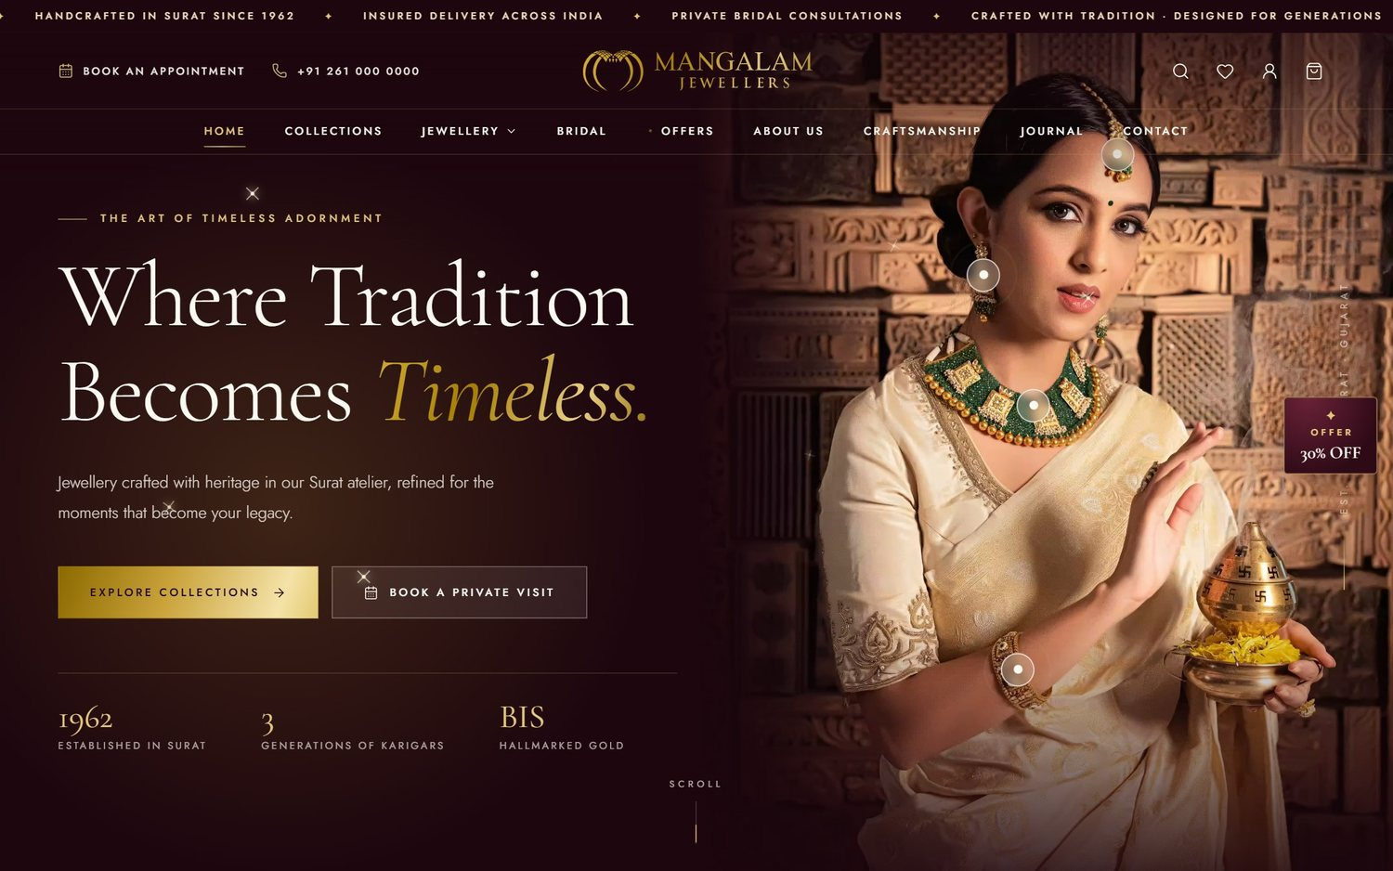
The home page: hero photo with “shop the look” pins, announcement bar, menu and the offer tab.

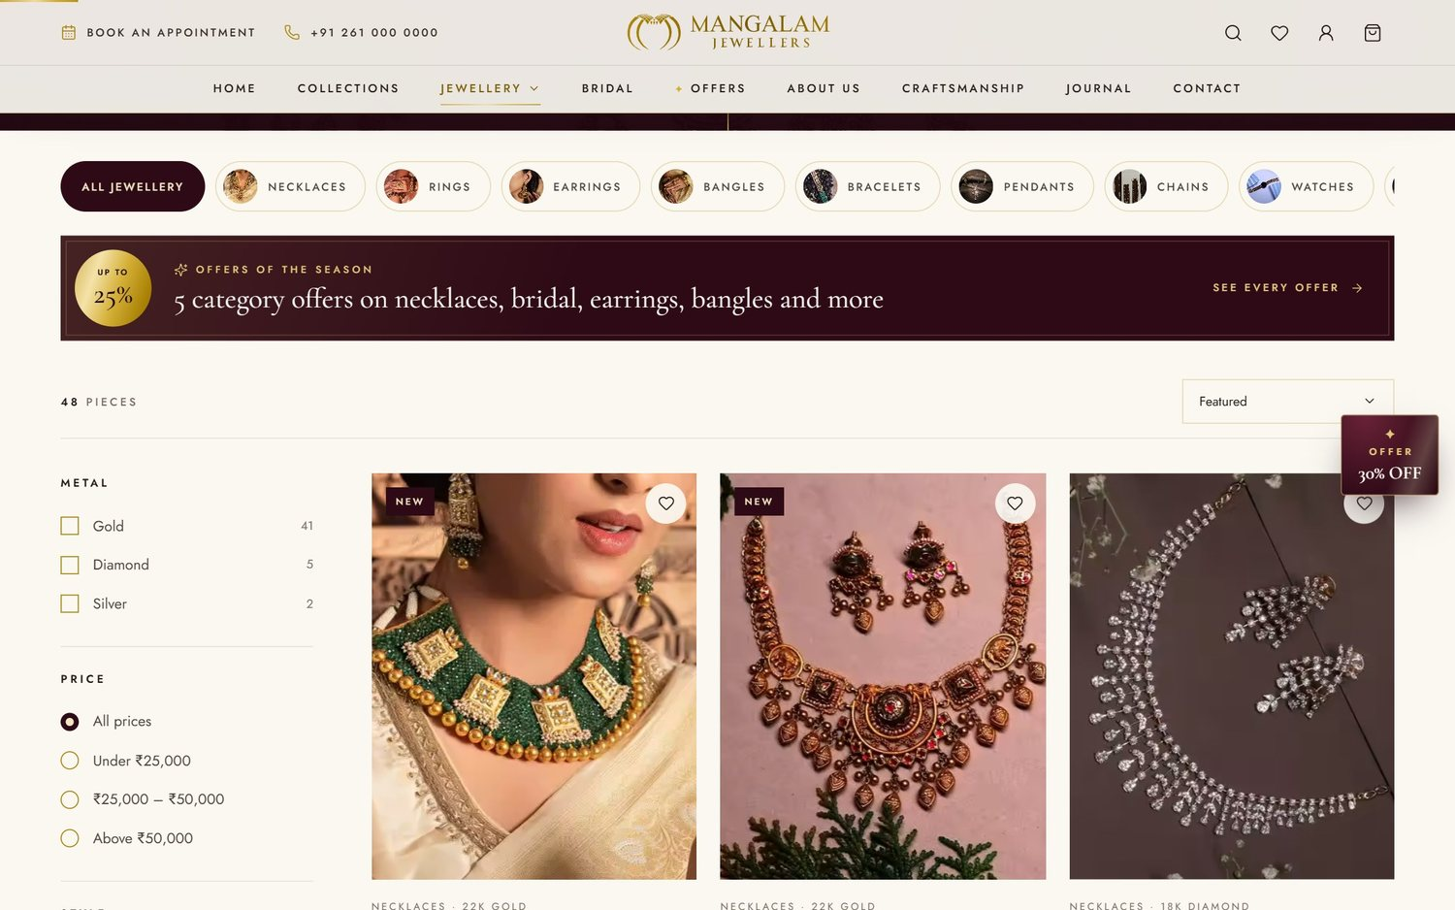 |  | 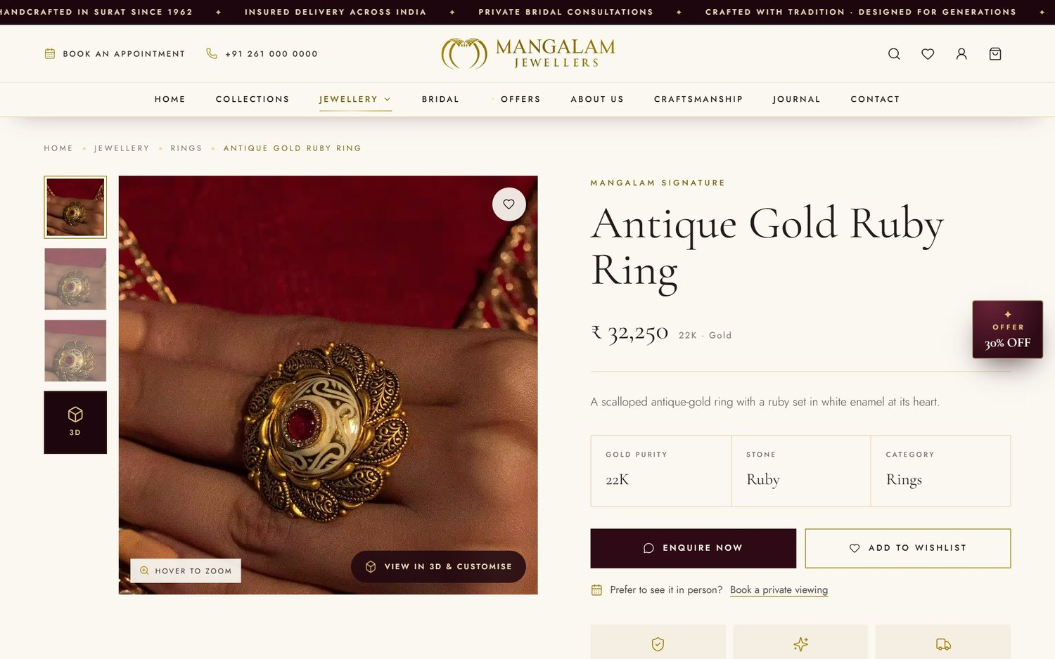
Category page with filters, sorting and an offer ribbon. |  | Product page with gallery, zoom, details, enquiry and 3D view.

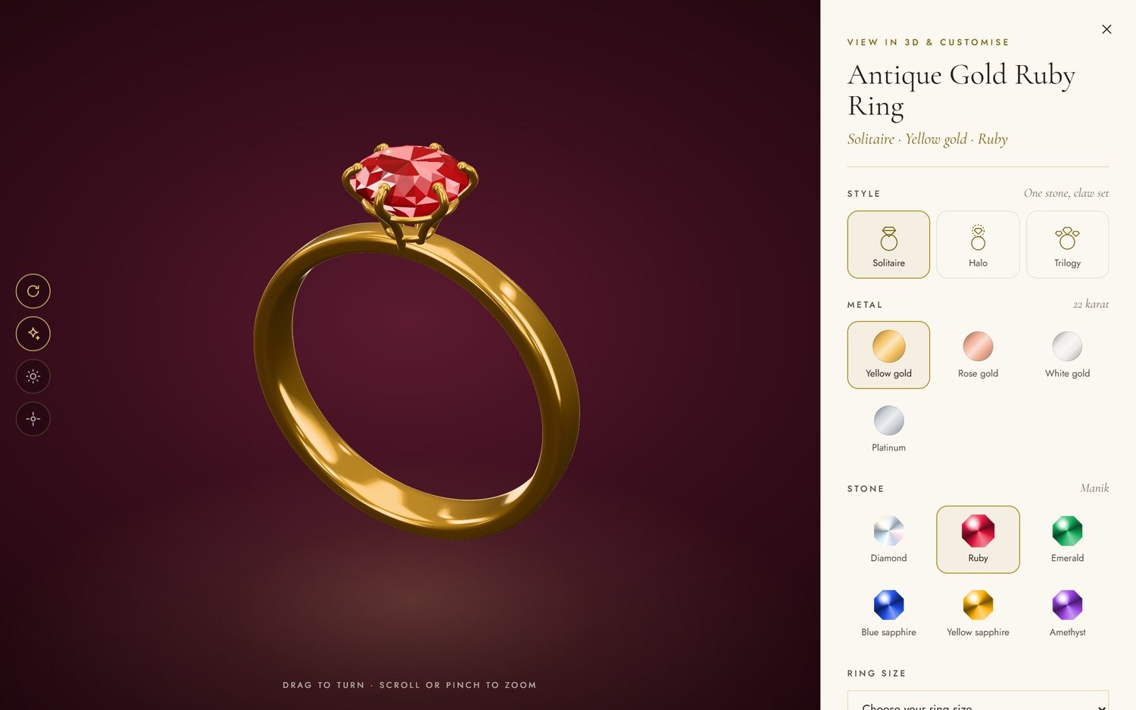
The 3D view: customers turn the ring, change style, metal and stone, choose their size and send an enquiry for their own design.

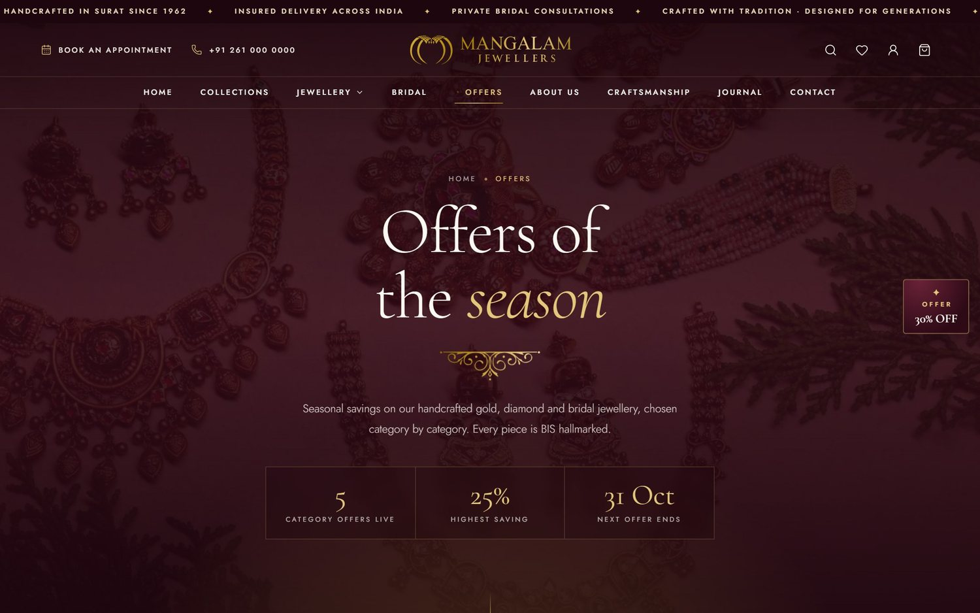 |  | 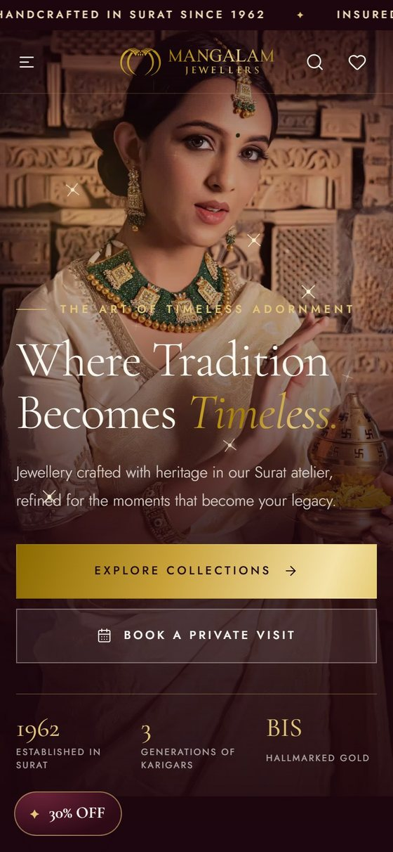 |  | 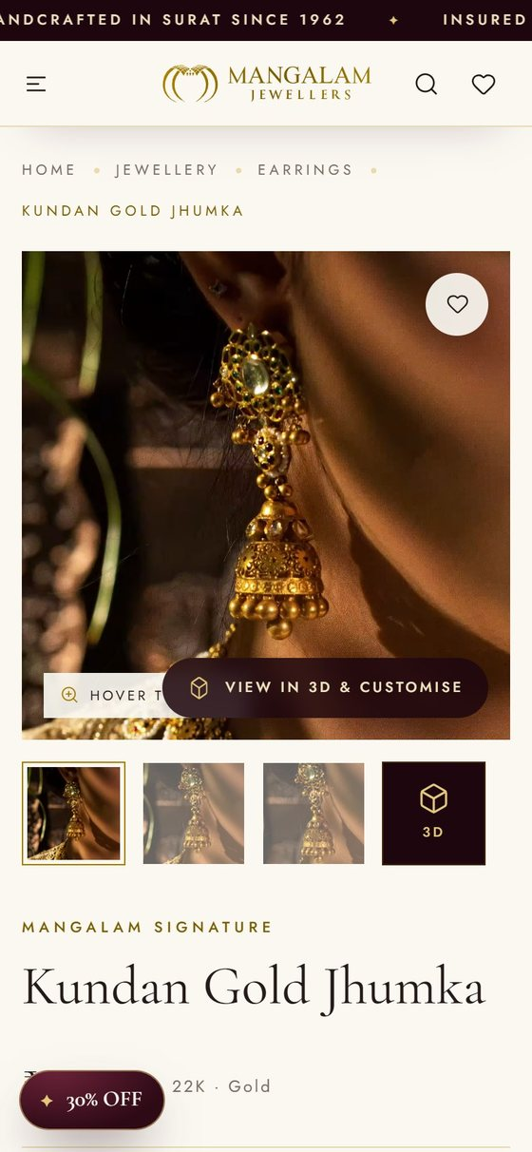
Offers page with live category offers and countdowns. |  | On a phone: home and product page.

You stay in control
Every photo, price, offer, banner and line of text you see on these screens can be changed by your team from the admin panel — the changes show on the website immediately.
03 MODULE-WISE QUOTATION

Module-wise quotation
——— ◆ ———
Every module below is part of the ₹48,000 project cost (all amounts in Indian Rupees). Each line explains, in simple words, what you get.
# | MODULE & WHAT IS INCLUDED | COST
Part A · Website design & development |  | ₹26,000
A1 | Luxury UI/UX design & brand styling  Custom design built around your logo — midnight-wine, ivory and antique-gold colours, elegant fonts, animated gold logo, page loader and smooth scroll animations. Designed for mobile, tablet and desktop. | ₹4,500
A2 | Home page  Large hero photo with “shop the look” pins on the jewellery, shop by category, collections, signature pieces with a tab for each category and New In, bridal panels, craftsmanship and heritage story, testimonials slider, journal stories, Instagram gallery and store-visit section. | ₹3,500
A3 | Jewellery catalogue & 9 category pages  All Jewellery page plus Rings, Necklaces, Earrings, Bangles, Bracelets, Pendants, Chains, Watches and Bridal — each with banner and heading; filters by metal, price and style; sorting; New / Featured labels; second photo on hover; mega menu, live search and wishlist. | ₹4,000
A4 | Product detail page  Photo gallery with thumbnails and hover-to-zoom, price and offer price, gold purity, stone, specifications and HUID, breadcrumb, Enquire Now, Add to Wishlist, Book a Private Viewing and related pieces. | ₹3,000
A5 | 3D jewellery view & customiser  Interactive 3D view for rings, kangans & bangles, earrings and pendants. Customers turn and zoom the piece, try other metals (yellow, rose, white gold, platinum), stones and styles, choose their size, save a picture and send an enquiry for the design they made. Exact 3D models (.glb) from your CAD designer are also supported. | ₹4,500
A6 | Brand & information pages  About Us, Craftsmanship, Collections, Journal (blog) list and story pages, Contact page with map, address and opening hours, plus a custom 404 page and a maintenance page. | ₹2,500
A7 | Offers page, offer popup & announcement bar  Offers page with each category offer, discount seal, live countdown to the last day, photo gallery and category filter; automatic offer popup with side tab; scrolling announcement bar; offer ribbons on category pages. | ₹2,000
A8 | Enquiry, appointment & newsletter forms  Product enquiry and contact forms, Book an Appointment form, newsletter sign-up, automatic thank-you emails in your brand style, and a private conversation page where each customer reads your replies and writes back. | ₹2,000
Part B · Admin panel (content management) |  | ₹15,000
B1 | Secure login, dashboard, users & roles  Secure sign-in with encrypted passwords and password-reset links; dashboard with enquiries per week, upcoming appointments, products online, subscribers and to-do items; invite staff as Owner, Manager, Editor or Sales with tick-box permissions. | ₹3,000
B2 | Product, category & collection management  Add, edit, duplicate, hide, publish or delete products (one by one or many together); upload photos straight from the phone (auto-resized) and drag to reorder; price, offer price, purity, stone, HUID, labels and publish date; manage categories and collections with drag-and-drop order; export to Excel (CSV). | ₹3,500
B3 | 3D jewellery manager  One screen for every product with a 3D view: add 3D to any product, match it to the product photo with a live preview, choose which metals, stones, styles and sizes customers may try, switch it on or off, or upload a .glb model. | ₹1,500
B4 | Website content management  Edit the homepage (hero photo, headline, figures, shop-the-look pins, signature pieces, bridal panels, section order); banner, heading and Google listing of every page; journal stories (write, schedule, publish); testimonials; and the media library with alt text. | ₹3,000
B5 | Offers management  Create category offers with discount, dates, message, photos and small print; switch on/off and reorder; edit the Offers page content, the popup offer's wording and timing, and the announcement bar. | ₹1,000
B6 | Customer enquiries (mini CRM), appointments & subscribers  All enquiries in one inbox as conversations: reply by email (ready templates with preview) or WhatsApp, add team notes, change status, book appointments; customers' email replies come back into the admin; edit email templates; appointment calendar; newsletter subscribers; CSV export. | ₹3,000
Part C · SEO-friendly development & speed |  | ₹4,500
C1 | SEO-friendly development & Google setup  Clean page addresses; editable Google title and description for every page, product, category and story; correct heading structure; image alt text; social-share previews; XML sitemap and robots.txt; schema markup for the store and products; Google Search Console and Google Analytics setup. | ₹3,000
C2 | Speed & image optimisation  Photos auto-resized and converted to light AVIF / WebP formats (homepage photos went from 13.8 MB to 2.9 MB), small thumbnail copies, lazy loading, browser caching and GZIP compression — fast even on mobile data. | ₹1,500
Part D · Security, testing & launch |  | ₹2,500
D1 | Security & testing  Protected forms and sign-in sessions, private system folders, HTTPS / SSL; testing on Android, iPhone, tablet and desktop in Chrome, Safari, Edge and Firefox. | ₹1,000
D2 | Hosting setup, data upload & go-live  Installation on your hosting (e.g. Hostinger), database setup, domain and SSL connection, website email setup, and upload of the first catalogue — 49 products, 120 photos, 9 categories and 6 collections. | ₹1,000
D3 | Admin training & 30 days free support  Training for your team on the admin panel, and 30 days of free support for bug fixes after launch. | ₹500

Total project cost  Parts A + B + C + D · one-time development cost | ₹48,000

Payment schedule
INSTALMENT | SHARE | WHEN | AMOUNT
1st | 50% | Advance, on order confirmation | ₹24,000
2nd | 30% | After the website & admin panel demo | ₹14,400
3rd | 20% | On launch, before the website goes live | ₹9,600
Total |  |  | ₹48,000
Work starts on receipt of the advance payment.

04 TIMELINE

Project timeline
——— ◆ ———
The full project is delivered in about 5 weeks, counted from the advance payment and receiving your content (product photos, prices, text and contact details).
STEP | WORK DONE | TIME
1 | Planning & design  Requirements, page list, design style and home page design for your approval | Week 1
2 | Website development  All pages, catalogue, product page, 3D viewer, offers and forms | Weeks 2 – 3
3 | Admin panel  All 18 admin screens, enquiries, emails, appointments, roles | Weeks 3 – 4
4 | SEO, testing & launch  SEO setup, speed optimisation, testing, catalogue upload, training and go-live | Week 5

What we need from you
- Final product photos, names, prices, weights and HUID details (the first 49 pieces are already prepared)
- Store address, phone, WhatsApp number, email, opening hours and social media links
- Domain name and hosting account (or we can guide you to buy them in your name)
- Any changes to the text for About Us, Craftsmanship and the offers
- One person from your team for the design approval and the admin training

After launch
- First 30 days: free support — any bug found after launch is fixed at no cost
- Your team updates the website — products, prices, offers, banners and stories from the admin panel
- Optional AMC: yearly maintenance for updates, backups, security checks and small changes (quoted separately)
05 WEBSITE PAGES

Pages your customers will visit
——— ◆ ———
PAGE | WHAT VISITORS SEE AND DO
Home | Hero photo with shop-the-look pins, categories, collections, signature pieces with category tabs and New In, bridal panels, craftsmanship and heritage, testimonials, journal, Instagram gallery, store visit.
All Jewellery & 9 category pages | Rings, Necklaces, Earrings, Bangles, Bracelets, Pendants, Chains, Watches and Bridal. Banner, category chips, filters (metal, price, style), sorting, offer ribbon, product cards.
Product page | Gallery with zoom, price and offer price, purity, stone, HUID and specifications, Enquire Now, Wishlist, Book a Private Viewing, related pieces, and View in 3D & Customise.
3D view & customise | Turn and zoom the piece; try metals, stones and styles; choose ring / bangle size or chain length; save a picture; send an enquiry for the chosen design.
Collections | Six curated collections (Bridal, Diamond, Everyday, Gold, Heritage, Statement) that fill themselves by category, metal or style.
Offers | Each live category offer with discount seal, countdown, photo gallery and its pieces; category filter; How the offers work; Book a viewing.
About Us & Craftsmanship | Your story since 1962, three generations of karigars, BIS hallmarking and the making of each piece.
Journal & story pages | Blog articles — bridal guides, gold care, trends — with cover photos and filters. Fresh articles help Google rankings.
Contact | Address, map, opening hours, phone, email and contact form.
Customer conversation page | A private page for each customer to read your replies and write back.
404 & maintenance pages | A friendly page for wrong links, and a “we'll be back soon” page while you update the site.

On every page  - Mega menu with category photos  - Live search across all jewellery  - Wishlist saved on the customer's phone  - Book an Appointment from every page |  | Also on every page  - Offer popup that folds into a side tab  - Scrolling announcement bar  - Newsletter sign-up in the footer  - Social links, phone and opening hours in the footer
06 ADMIN PANEL

Admin panel, screen by screen
——— ◆ ———
Your team signs in at yourwebsite.com/admin. Every screen saves straight to the website — no coding and no developer needed for daily updates.
ADMIN SCREEN | WHAT YOUR TEAM CAN DO
CATALOGUE
Dashboard | Enquiries per week, upcoming appointments, products online, subscribers and what needs attention — for the last 7 days, 30 days, 90 days or 12 months.
Products | Add, edit, duplicate, hide, publish and delete products; upload photos from the phone and drag to reorder; price, offer price, purity, stone, weight, HUID; New / Featured labels; Google title and description; publish date; bulk actions; export to Excel (CSV).
Categories | Add, edit and drag to reorder; show or hide in the menu; menu photo, page banner, heading and introduction.
Collections | Create collections that fill themselves by category, metal or style; show them on the homepage.
3D jewellery | Add a 3D view to any product; choose the metals, stones, styles and sizes customers may try; live preview beside the photo; upload an exact .glb model.
WEBSITE CONTENT
Homepage | Change the hero photo, headline and figures; drag shop-the-look pins onto the photo; choose signature pieces and bridal panels; show, hide and reorder sections; publish when ready.
Pages & banners | Banner photo, heading, introduction and Google listing (SEO title & description) for every page.
Journal (blog) | Write, schedule, publish and unpublish stories with a cover photo and photos in the text.
Testimonials | Add, edit, reorder and choose which customer reviews show on the homepage.
Media library | Upload photos into folders, add alt text for Google, see where each photo is used, optimise older photos in one click.
CUSTOMERS
Enquiries | Every customer enquiry as a conversation; reply by email (templates, preview) or WhatsApp; team notes; status; edit contact details; book an appointment; customers' email replies arrive here; export to CSV.
Email templates | Edit the automatic emails (enquiry received, appointment requested, appointment confirmed) and the reply templates, with a live preview and “send me a test”.
Appointments | Month calendar and the next two weeks; website requests arrive as Pending; book, confirm, complete or cancel.
Subscribers | Newsletter sign-ups from the website: add, unsubscribe, remove, export to CSV.
OFFERS & SETTINGS
Offers page | Category offers with discount, dates, message, photo gallery and small print; switch on / off; drag to reorder; edit every section of the Offers page.
Offers & announcements | The popup offer's wording, discount, link, dates and timing, and the announcement bar messages.
Settings | Store details, phone, email, address, opening hours, social links, email notifications, maintenance mode and the “show on Google” switch.
Users & roles | Invite staff, give roles (Owner, Manager, Editor, Sales), tick what each role may do, and create password-reset links.

Staff roles & permissions
Owner can do everything. Manager, Editor and Sales see only the screens their role allows — for example, Sales staff can answer enquiries and book appointments without changing prices.

Security built in  - Encrypted passwords and secure sign-in sessions  - Every form protected against misuse (CSRF tokens)  - Each person sees only what their role allows  - System folders and data files blocked from visitors  - Installer switches itself off after setup  - HTTPS / SSL on the live website |  | Automatic emails  - “Enquiry received” email to the customer  - “Appointment requested” and “confirmed” emails  - Your team is emailed for every new enquiry  - Customers' email replies join their conversation  - All emails in your brand colours, with your logo  - Each automatic email can be switched off
07 SEO-FRIENDLY DEVELOPMENT

Built for Google
——— ◆ ———
SEO (Search Engine Optimisation) means building the website so that Google can read it, understand it and show it to people searching for jewellery in Surat and across India. These points are built into the website as part of this project:
On-page SEO  - Clean, readable page addresses — e.g. /rings.html, /bridal.html  - Google title & description for every page, product, category and story — editable from the admin  - Correct heading structure (H1, H2) and clean, semantic code  - Image alt text for every photo (Media library)  - Breadcrumbs on category and product pages  - Social-share previews for WhatsApp, Facebook and Instagram links  - Journal (blog) for fresh content that helps rankings  - Private pages kept out of Google; a switch to hide the site while it is being prepared |  | Speed & technical SEO  - Mobile-friendly design — Google ranks the mobile version first  - Photos converted to light AVIF / WebP — homepage photos from 13.8 MB down to 2.9 MB  - Small thumbnail copies, lazy loading of photos  - Browser caching and GZIP compression for fast repeat visits  - XML sitemap and robots.txt  - Schema markup (JSON-LD) for the jewellery store, products and breadcrumbs  - Canonical tags, custom 404 page and HTTPS / SSL

Google setup at launch
- Google Search Console — verify the website, submit the sitemap and request indexing
- Google Analytics 4 — see visitors, popular pages and where enquiries come from
- Google Business Profile — link your store listing and map to the website (if you have a profile)

Good to know
This project makes the website SEO-ready: Google can find, read and list every page. Reaching the first page of Google for competitive searches also needs regular work over months — new articles, Google reviews, backlinks and local listings. That ongoing SEO can be taken up as a separate monthly plan if you wish.
08 SCOPE & TERMS

Scope & terms
——— ◆ ———
Included  - Everything listed in the module-wise quotation (section 03)  - Two rounds of design changes  - Upload of the first catalogue: 49 products, 120 photos, 9 categories, 6 collections  - Admin panel training for your team  - 30 days of free support for bug fixes after launch  - Full source code, database and admin access — the website is yours |  | Not included — can be quoted separately  - Online payment, shopping-cart checkout and customer login accounts (the website works on enquiries, WhatsApp and store appointments)  - Domain, hosting and paid business-email charges  - Product photography, video shoots and 3D CAD models  - Monthly SEO, Google Ads and social media marketing  - Mobile app (Android / iPhone)  - Paid third-party tools or services

Terms & conditions
- The total cost of ₹48,000 covers everything in this quotation. GST, if applicable, is charged extra.
- Domain, hosting and business email are bought in the client's own name; we will help set them up.
- Two rounds of design changes are included. New features outside this quotation are quoted separately before work starts.
- The 5-week timeline starts after the advance payment and once the content is received. Delays in content or approvals move the launch date.
- Full source code, database and admin access are handed over after the final payment.
- Free support covers bug fixes for 30 days after launch. After that, an optional Annual Maintenance Contract (AMC) can be taken.
- This quotation is valid for 15 days from the date above.

Acceptance
Please sign below to confirm the scope, cost and terms of this quotation.
FOR MANGALAM JEWELLERS  Name  Signature  Date |  | FOR NIKUNJ · WEBSITE DESIGN & DEVELOPMENT  Name  Signature  Date

——— ◆ ———
Thank you for the opportunity to build the Mangalam Jewellers website.

