### [National Institute of Technology Karnataka, Surathkal](http://nitk.ac.in/)

#### Mangalore - 575 025, Karnataka, India

#### Home

HOUSEKEEPING

Submitted by- Submitted to-

Shreya Pradhan (15ca77) Ms.Usha Kiarana

Sushil Ranjan(15ca86)

Vinay Jain(15ca90)

Abstract

Today in the world of technology we get everything just by sitting at our places. But sometimes we don't get everything we want on just a click. We don't get maids, servants, gardeners, drivers on just a click, for that we have to roam around the area or have to ask to our neighbors for them, and today no one has time to search for maids and all in their area or to ask someone. Suppose a person shifts to a new place, so he wants maids or servants to work at their home, and it is not guaranteed that the maid is good at her work. So to overcome this problem we got a solution of making a website online,tat will help the people to get servants on just a click. maids,cooks,drivers,gardners.Here,people will find all the details about the servant they want and a plus point is that there will be ratings alloted to each servant.So,a customer can select the servant on the basis of ratings.Here,the servant can also fill his details so,that when someone will search for servants on the basis of category,his details will also be visible to the customer.By,this employement will increase if someone wants to be a servant.A person can choose which type of servant he want without any problem on just a click.After login only,the customer can select the servant and will get all the information containing his contact number and address.

Index

1. Abstract

2. Introduction

3. Literature Survey

4. Diagrams

4.1 Data Flow Diagram

4.2 State Diagram

4.3 Interaction Diagram

4.4 Use Case Diagram

4.5 Collaborative Diagram

4.6 Activity Diagram

5. Implementation

Introduction

Whenever people shifts from one area to another area, they don’t know much about that area, they are new to the area and no one has time to search for a servant by asking to everyone. So, for that, this is the solution where we can find lots of servants of that particular area. In this project, we will have a database containing four tables for cooks, maids, gardener and drivers. Here, the interested people can also fill their details if they really want to do the housekeeping jobs. The data will then be entered into the database. A customer can choose any one from them, on the basis of ratings. The ratings are given by those people who were the owners of their previous servants. The customer can choose the servants of a particular area by giving the location. The names will then be sort out on the basis of location. The customer will then have all the details of the servant, on the basis of this contact information, he can easily contact to the servant and can ask about his fees and timings. So, this is a very simple way of getting everything on just a click. The advantage of this project is that we can get the type of servant we want on just a click and we can have their reviews given by their previous customers and it is very convenient method. But the main disadvantage is that we can’t know whether he is the only one who has registered the name in the website or the other one and he should have a little bit knowledge about this type of website, where he can fill his details to find a housekeeping job.

Literature Survey

Domestic work has a long history in India with both men and women working in other’s homes as ‘servants’. These people come with other people from the village, through private recruiting agents, or other organizations to be employed as ‘servants’ in urban households.

In the Indian context, domestic work is generally defined in terms of types of work performed and the time spent at work, i.e. in the employer’s home. Live out and live-in are two distinct categories of domestic work. Live-out work is primarily of two types: first, those who work in one house for the whole day and go back to their homes in the evening and; secondly, those who work in different houses, moving from one to the other, performing one or more tasks in each household. They may clean in one house, chop vegetables in another and wash clothes in the third, while some others may only perform a task, such as cooking. They often visit these households twice a day though the requirements in some families may be limited to only once a day. Another form of part-time live-out work is in terms of piece-rate. It is often applied to washing clothes and wages are calculated on the basis of buckets of clothes.

The purpose of this literature review was to explore the online searching experience and evaluate why consumers should search servants online as opposed to physically searching. Research and findings- There are no Previous researches conducted on the online searching of servants, that indicates that convenience and time are the major factors affecting the decision to search a servant online. It may also found that young consumers will more likely to prefer online searching of servants.

Diagrams

1.Data Flow Diagram

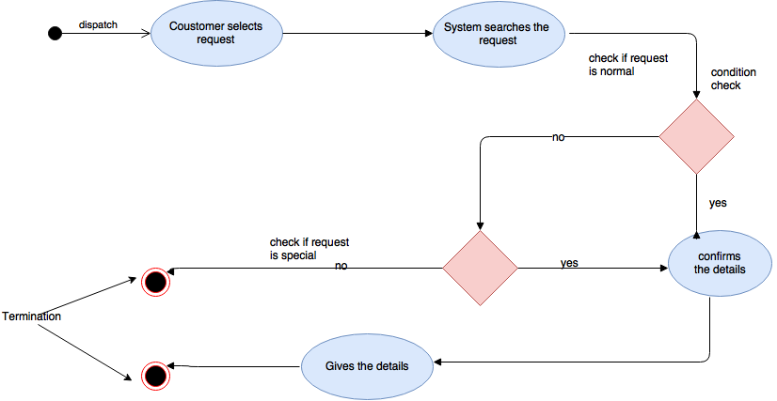

2.State Diagram

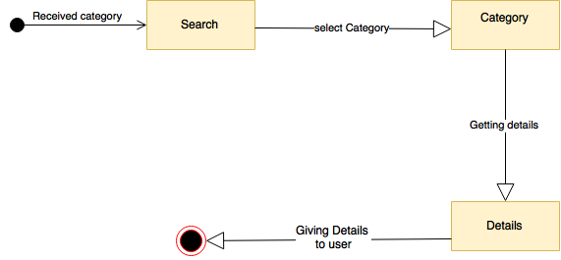

3.Interaction Diagram

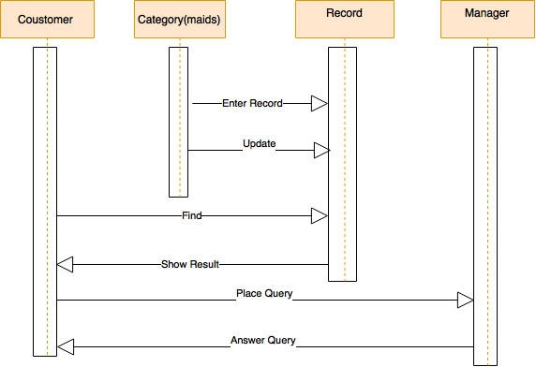

4.Collaborative Diagram

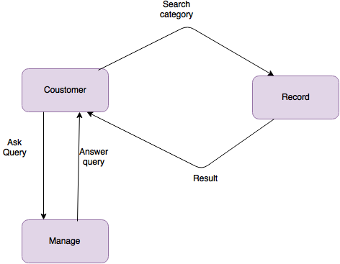

5.Use Case Diagram

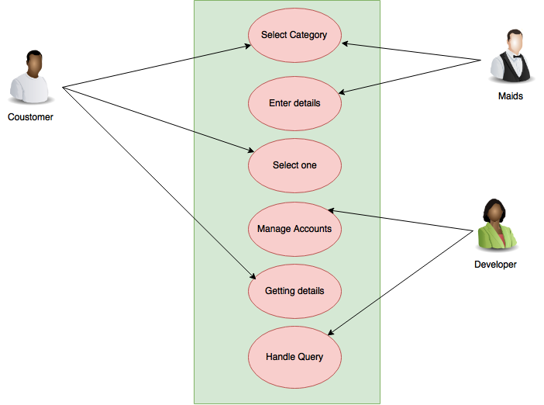

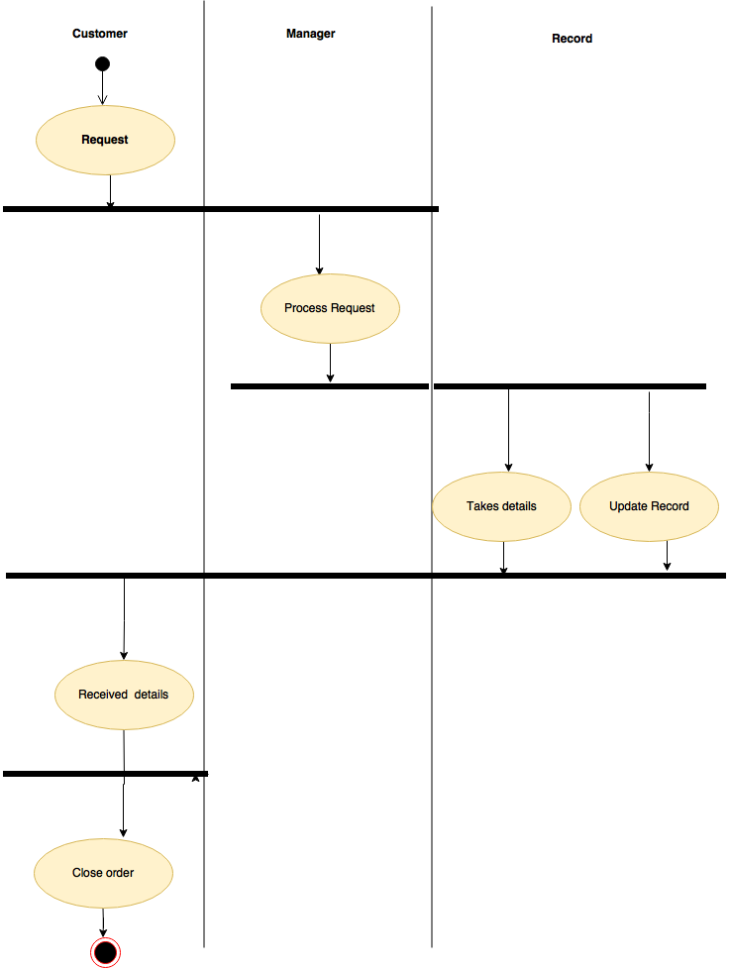

Implementation