**WANT TO BE A PART OF A MONTEL WILLIAMS “LIVING WELL” TELEVISION PROGRAM?**

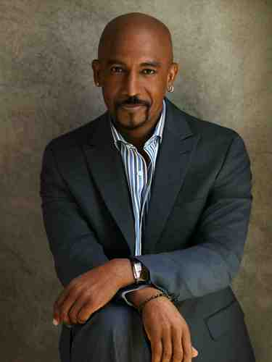

**MONTEL WILLIAMS IS HOSTING A CANDID CHAT (ALONG WITH A NUTRITIONIST AND DOCTOR) WITH A GROUP OF WOMEN OF ALL AGES ABOUT TOPICS INCLUDING:**

* ***STRESS***
* ***DIET***
* ***FITNESS***
* ***SELF-IMAGE***
* ***MANAGING WORK AND FAMILY***

**WHEN: WEDNESDAY, SEPTEMBER 4th**

**WHERE: MIDTOWN MANHATTAN – exact location TBA**

**TIME: TBD *will most likely be about a 2 hour commitment\***

**\*\*\*LOTS OF GREAT INFORMATION WILL SURELY BE SHARED!!!\*\*\***

**FOR MORE INFORMATION PLEASE CONTACT KIM ASAP AT** [**kawright0606@gmail.com**](mailto:kawright0606@gmail.com)