**WANT TO BE A PART OF A MONTEL WILLIAMS “LIVING WELL” WEB PROGRAM?**

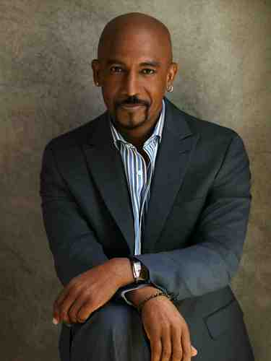

***MONTEL WILLIAMS IS LOOKING FOR MEN OF ALL AGES TO PARTICIPATE IN AN OPEN FORUM (ALONG WITH A NUTRITIONIST AND DOCTOR) TO DISCUSS THE FOLLOWING:***

* ***STRESS***
* ***DIET***
* ***FITNESS***
* ***MEDICAL CONCERNS***
* ***SEX***
* ***SLEEP ISSUES***

**WHEN: THURSDAY, OCTOBER 17th**

**WHERE: MIDTOWN MANHATTAN – exact location TBA**

**TIME: TBD *will be about a 2-3 hour commitment\***

**\*\*\*LOTS OF GREAT INFORMATION WILL SURELY BE SHARED!!!\*\*\***

**FOR MORE INFORMATION PLEASE CONTACT KIM ASAP AT** [**kawright0606@gmail.com**](mailto:kawright0606@gmail.com)