A Database with Graphical User Interface
for Inter-Course Grade Comparison

James E. Corrigan

CIS4914, Senior Project
Department of CISE
University of Florida

Advisor: Dr. J.H. Doe, email: jhdoe@cise.ufl.edu
Department of CISE
University of Florida, Gainesville, FL 32611

Date of Talk: 7 Dec 1999

Abstract
Current trends in secondary education emphasize student performance assessment with a variety of metrics such as achievement test results, SAT scores, course grades, and instructor evaluation. Software support for measurement of such performance data exists under a variety of operating systems, most notably MS-DOS and Windows-95/98/NT. Course-support software typically includes accounting functions such as grade entry/revision, computation of grade statistics per class and per individual, as well as graphical display of grading information (e.g., using histograms or pie charts). More recently, Bergerbilder has suggested that comparison of student grade results should be accomplished on a cross-category basis. That is, one should be able to compare a student’s grades with those of his peer achievement group. Comparison of grades between individuals in a given course is rarely provided for in course-support software. Additionally, grading programs reported in the literature and in manufacturer’s brochures (e.g., GradeMaster, SuperSnooper, and TeacherTerror) available to us during the performance period of this project do not support comparison of student performance between courses offered in a given department, school, or district.
In response to this situation, we have developed a comprehensive grading and performance analysis database using the In-house DistressTM database system from First Software Corporation. A more elaborate graphical user interface (GUI) than one can build with the aforementioned system was constructed with the Application FrustrationTM GUI builder from Pretty Good Programs, Inc. The database and GUI were linked, then tested on a large corpus of grades synthesized with input from faculty of the Fawlty Memorial High School in Mudville, Florida. Software was freely distributed to the sponsor, with assistance and training provided during the beta phase of installation.

Introduction.
The increasing use of performance analysis techniques in industry, business, government, and academia results in the requirement of progressively more capable, comprehensive, and robust analysis tools. Primarily based in computer software, such tools support data acquisition, classification, analysis, and reporting. This report summarizes the development of a software system that supports course grading and performance analysis for secondary students on a between- as well as within-course basis. The software developed under the scope of this project is portable to a wide variety of platforms, and has been thoroughly tested for robustness under a variety of realistic operating conditions. Technology transfer to a wide variety of educational applications is foreseen as a result of this project.
  - Problem Domain.
As teachers, schools, and school districts are held more accountable for student performance, the analysis of such performance becomes more important to the successful teacher. For example, the integration of diverse sources of information such as SAT scores, achievement test results, test grades, homework, etc., can provide a comprehensive and detailed picture of student performance. Currently, PC-based software does not exist for integrating these different types of information. In response to this situation, we have proposed and successfully completed the first phase of a multi-part software development effort that is expected to result in a comprehensive grading and performance analysis package for secondary educators and administrators. When completed, this package would be useful for classroom administration (e.g., identifying and remediating underperforming students), as well as school administration (e.g., highlighting teachers who students habitually outperform or underperform the norm). An additional application si school district adminstration, by comparing performance in different classes, weighted by teacher type and achievement score, as well as a history of student involvement, diligence, and work in a given subject area.
  - Previous Work (Literature Search).
Throughout the evolution of academic course support software, which began in the late 1960s with the IBM 400x series of business machines running COBOL-2 [3,4], the vast majority of associated research and development reported in the literature has been focused on within-course data entry, revision, analysis, visualization, and archival. Although existing programs such as GradeMasterTM support detailed analysis of student performance within a given class, there is little support for comparison of achievement measures (e.g., course grades, achievement test scores, SAT scores) between students of comparable achievement within a given class, or between classes or courses. This lack of support becomes more apparent when one considers the need for comparing previous student achievement results with current performance metrics. For example, an instructor might want to compare performance of the top 10 percentile in Chemistry 1 in Fall Semester 1998 with the top 10 percentile of the same course in Spring Semester 1998. Similarly, a school administrator could find useful the comparison of student performance among all classes taught by a given instructor, or could establish comparisons across different instructors teaching the same class at different times.
Unfortunately, the preceding goals are not supported by current courseware. For example, Grade Master [-], which is typical of the genre, is basically an automated gradebook program that allows teachers to enter grades and compute statistics within a class or subgroup of that class. No cross-course comparisons are available, unless one enters all student grades in the same course page, which defeats the purpose of grade isolation within course boundaries. SuperSnooper [-], a modest package with a very ambitious graphical user interface (GUI), emphasizes sophisticated analysis and presentation of grades entered in a spreadsheet. However, unless one puts all grades for all courses in the same spreadsheet, then sorts or filters grades based on a tag such as course number (a laborious process), the GUI cannot display cross-course analysis. Additionally, between-student or between-subgroup comparisons are difficult – one must use the Comparison filter, which caused SuperSnooper to crash over 50 percent of the time in our preliminary tests.
A third grading package, TeacherTerror [-], certainly lived up to its name – grade entry was slow, difficult, and fraught with error. The GUI features did not work as advertised: when a test set of five grades was entered, TeacherTerror failed to compute the mean and median grades correctly. Also, the GUI operations fragmented the screen and caused the software to crash frequently. It is difficult to see how such a package could provide an increase in teacher productivity or facilitate accurate analysis of student performance.
- Technical Approach (Solution).
In response to the lack of reliable or robust cross-course and cross-class performance analysis software, we have developed Astute, an object-oriented, GUI-driven software platform for student grade entry, analysis, and presentation. Astute is written in ANSI C++ and has been successfully ported to IBM-PC, Apple Macintosh, and Sun Solaris environments, with comparable performance and identical features cross-platform. Astute allows data entry using a spreadsheet-like interface to a relational database constructed using InHouse Distress (IHD), as well as the Application Frustration (AF) GUI builder.
IHD allowed us to structure the class and course data in a hierarchical fashion, which mirrors the natural hierarchy of Department > Course > (Teacher, Class) > Student found in secondary education situations. The high-level design of each level of the hierarchy is shown in Figure 1. In follow-on elaborations of this design, the hierarchy can be extended upward to include School and District levels, which were omitted in this project for purposes for simplicity.
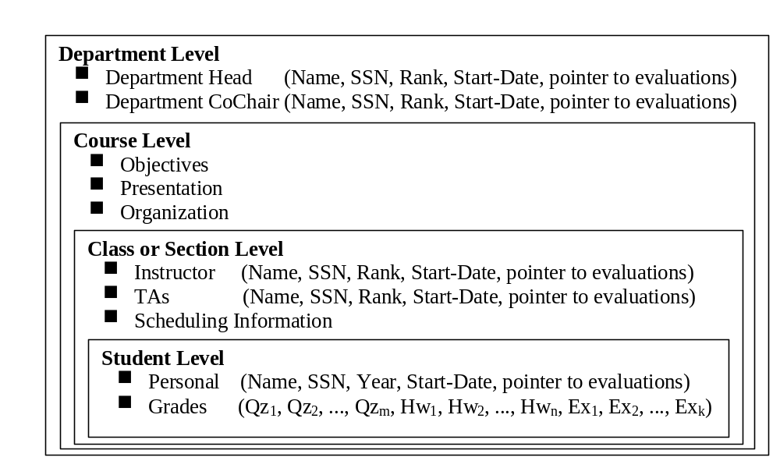 Figure 1. Structural diagram of database hierarchy for Astute grade analysis program.
In order to access data efficiently, we implemented cross-category comparisons, as shown in the notional diagram of Figure 2, which illustrates an example performance analysis. In Figure 2a, the performance of students with two years of prior classroom experience in mathematics is compared with the performance of students having no mathematics classes. In order to perform such an analysis, it is necessary to compare students cross-class, cross-course, and cross-department. The Astute system does this by user-specified creation of relations between students, classes, courses, and departments, as shown in Figure 2b.
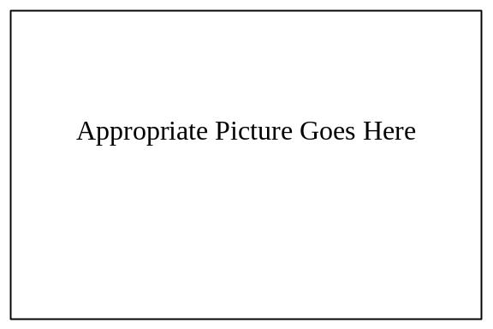
Figure 2. Example of student performance comparison with Astute: (a) comparing students with two years of mathematics versus students with no mathematics experience, and (b) relations between students, classes, courses, and departments.

Software development at the database level incurred few challenges or problems, due to the routine nature of the database development process using InHouse Distress. No major problems were encountered linking the database to the GUI. Note to students: In an actual project, you would want to describe database structure, relations, query protocol, and interface to a GUI in some detail.
Analytical engines were developed to process data obtained from the Astute database by the GUI-driven query engine. The analytical functions implemented in the prototype version of Astute developed for this project include:
- Basic Statistics: Mean, Standard deviation, Median, Mode, and Quintiles
- Advanced Statistics: Student t-test, Pearson rho, Ranking test
- Graphical Analysis: Histogram, Scatter plot, X-Y plot
The basic statistics were readily coded and tested, and were derived from textbook examples. Advanced statistics and graphical analysis were obtained from the HiStat library, which can be downloaded from the Internet [-]. I used the student version (v. 2.8.6) purchased at University Books, Inc. [-], because it supported more graphing features than the downloadable version. Since I plan to enhance the prototype in the future, it was reasonable to procure the more capable version.
Testing and debugging of the Astute prototype proceeded without incident, partly due to InHouse Distress’ comprehensive code generator, which produces code that was completely compatible with the GUI interface code. Additionally, the library code obtainable for the statistics modules was written in ANSI standard C, which further aided compatibility. I plan to recode certain sections of the statistics routines, in order to be upward compatible with an object-oriented implementation planned for the next round of enhancements to the Astute prototype.
- Results
The Astute prototype tested successfully, performing all statistical analyses listed in Section 2 within-class, within-course, within-department, cross-class, and cross-course. It was thus decided to compare the performance of the Astute prototype with established grading packages such as GradeMaster and SuperSnooper. Since neither of these packages can perform within-course analysis, given multiple classes or sections in a given course, and neither can perform cross-category analysis, performance testing was restricted to within-class analysis.
All tests were conducted using the InHouse Distress runtime module, running on an IBM-PC under Snively Software’s Swindle-OK operating system (Version 6.9.82). The PC hardware platform was comprised of a UFO Industries Printem IV processor running at 550 MHz, with a 512KB cache and 64MB of RAM, and a 14.6 GB Beebonnet hard drive (7.8 ms average access time). Test data sets were comprised of a flat file database containing 100 bytes per record. The number of records N was varied from ten to 100,000, with error measured through tenfold replicate measurements at N = 10, 100, ..., 100,000. This was designed to simulate retrieval and computation times for a group of students ranging from a small class to a large metropolitan school system.
Five measures were computed from timing calls inserted into the database source code. First, total execution and I/O time was measured for a given command (e.g., retrieve-database, store-database, and analysis commands). This represents the clock time required for a request issued from the GUI to be executed, with termination of the timed procedure being return of a completion acknowledgement to the GUI. Note that GUI response times, which are idiosyncratic to a given user, were not recorded in this study. The second performance metric was retrieval time, expressed in clock seconds and in CPU seconds. Third, CPU time required for the analytical procedures outlined in Section 2 was measured for each procedure. Fourth, the time to retrieve a given record from a randomly-sorted database was measured in terms of CPU time. Fifth, the time to partition a given set of records into a subset of user-specified size or attribute (a searching and sorting problem), was measured in terms of clock time and CPU time. The results of these tests are graphed in Figures 3 through xxxx.
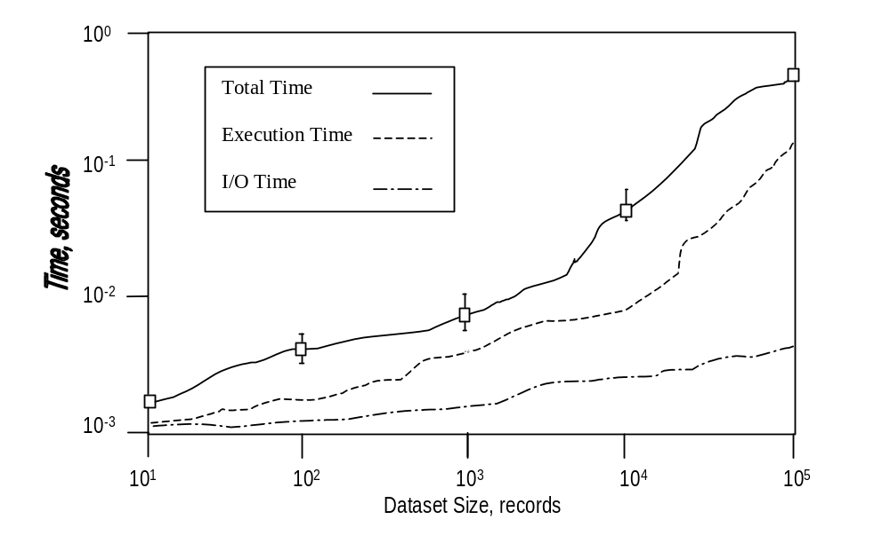
Figure 3. Total execution and I/O times for Astute to retrieve a record
from a database of size 10, 50, 100, 500, ... , 100,000 records.
Note to students: The remaining graphs would be similar. My apologies for using Microsoft WordArt to get the vertical text on the ordinate – my version of Word would not rotate the text, which should appear in the same font as the horizontal caption on the abscissa.
When analyzing data such as that presented in Figure 3, it is important to observe the nonmonotonic behavior at fine scale, which could result from measurements being made at different system load. Additionally, if a number of measurements are made at one data point, then one can compute mean μ and standard deviation σ, which are assigned to error bars (the I-shaped graphic objects in the topmost graph of Figure 3). One typically draws the top and bottom limits of the error bars at 1σ, but if error is actually measured, then the error bar could be asymmetric about the mean. Error bars are useful for determining usefulness of a given measurement for purposes of comparison and subsequent analysis, and should be used only if there are sufficient replicates at a given data point to reliably compute standard deviation (say, > 10 replicates).

- Acknowledgements
The author would like to thank his advisor, Dr. Jane Doe, for her guidance, advice, and encouragement toward successful completion of this project. Additional thanks go to K.B. Ernest of the Department of Bee Biology, for his help with sorting records randomly to prepare test data, and for my good friend Ted Edison for proofreading this report.
- References
[1] Agawam, R.S.K., C.B. Beebonnit, and J.K. Mugwump. “The courageous professor’s assistant”, Proceedings of the Fourth International Conference on Educational Performance Measurement, Maggdwyn, Wales, 2:163-170 (1995).
[2] Gump, F. “All you ever needed to know about a box of chocolates”, Proceedings of the Third International Conference on Educational Cybernetics, pp. 223-225 (1994).
[3] Bugbottom, T.C. Course Web pages for CGS314, Department of Computer Science, Swamp State University, World-Wide Web site as-of 7 December 1999 at URL: http://www.cs.swstu.edu/~tcbugb/CGS314/IHD-preview-21b.htm .
[4] Roger, T., and K.B. Overholster. “TeacherTerror – A new approach to student performance analysis”, Journal of Educational Software 5(3):92-104 (1996).
[5] Swindle, K. Tea for Two, if You Please: The Compleat Guide to Programming the Swindle-OK Operating System (Version 6), BugTussel, WV: Snively Press (1999).
[6] Tudbrannius, C.B. Introduction to Academic Performance Analysis, New York: Pessimistic Press (1973).
- Appendix A – Test Data
Note to Students: This section is optional, but if included in the report, the data should be entabulated using the Microsoft Word Table construct. A page of representative test data (single spaced) usally helps bolster any claims you make about the resutls of your project, and can be useful as a starting point for in-depth discussion.

- Appendix B – Technology Transfer Plan
Note to students: A technology transfer plan is an optional one or two paragraph summary of how you plan to introduce the results of your project to business or industry. For example, in the case of the mythical Astute grading system, one might list (a) corporate contacts that are interested in receiving more information about the software (list only companies and individuals that you have actually spoken to or contacted); (b) possible future applications that your project results could address, and how you plan to develop such applications; and (c) market potential for your project results, if you have such information. Don’t include a lot of wordy nonsense, just a tight summary.
- Biography
James E. Corrigan was born in Frostproof, Florida on February 12, 1977, the only day that schools in Florida have ever been closed because of snow. He completed his secondary education at Frostproof High School, and is completing his baccalaureate degree in Computer and Information Science at University of Florida (Gainesville, FL), where he expects to graduate on December 18, 1999. Mr. Corrigan is an avid computer programmer, with industrial experience in the software engineering field, and is proficient in C, C++, Java, and Cobol. He recently completed an internship with the Oops! software company, a key provider of remedial business services for the Y2K problem, and plans to accept employment with the HeadsUp Software Company (Matanzas, FL), a nationally-known developer of educational software. Mr. Corrigan enjoys surfing, hiking, working on his car, and (of course) Gator football. He also hopes to pursue an advanced degree in Computer Science while employed in the software design and development industry.

