MASTER THESIS

Open-Set Reliability and Confidence Calibration in AI-Generated Image Detection for Cybersecurity Applications

submitted by:
Nikhitha Somwarpet Prashanth
(student number: 200457)

submitted on: 07.08.2026
Examiner: Prof. Dr. Jianmin Chen
Supervisor: Prof. Dr. Jianmin Chen
Declaration on Thesis
I hereby certify that this work was completed without the help of third parties and only with the sources and resources indicated. All ideas that originate directly or indirectly from external sources are properly denoted as such.
I acknowledge the use of artificial intelligence tools for document structuring, code troubleshooting and visualisation design.
All outputs were reviewed, and responsibility for the experiments, numerical verification, interpretation, and final thesis remains with the author.
I am aware that this work will be screened for the use of unauthorised means and subsequently checked for partial or complete plagiarism. In order to compare my work with existing sources, I consent to its inclusion in a database and its retention for checking future submissions. Any other rights of reproduction or exploitation are not granted.
This work has not previously been submitted to an examination authority or published in the same or a similar form.
(Signature)
First name Surname
Munich, xx.xx.xxxx

Abstract
AI-generated image detectors increasingly support cybersecurity workflows, yet benchmark accuracy does not establish whether their confidence is trustworthy when the image generator changes. In this thesis, open-set generator shift simply means that the detector is tested on a generator that was excluded from training and validation.
A ResNet-50 detector is evaluated under three conditions: a closed-set reference on Unbiased Tiny GenImage, a true seven-fold leave-one-generator-out (LOGO) protocol, and a 3,000-image recent cross-dataset stress test containing MS COCO real images and five newer generator sources. Post-hoc scalar temperature scaling is fitted only on validation logits. Fine-tuning raises closed-set accuracy to 0.9571 and AUROC to 0.9921. Under true LOGO, mean accuracy is 0.9075 and mean AUROC is 0.9741, with generator-dependent error patterns. On the recent external sample, accuracy is 0.8117, balanced accuracy is 0.6734, and 267 of 500 real images are incorrectly classified as AI-generated. Temperature scaling preserves accuracy and AUROC while reducing Expected Calibration Error and high-confidence errors in the closed-set result, every LOGO fold, and the external recalculation. Mean LOGO ECE decreases by 32.09% and mean high-confidence-error count by 20.58%; external ECE decreases by 11.46% and high-confidence errors from 330 to 283.
The findings answer the registered research questions: unseen generators reduce reliability, while temperature scaling improves confidence quality without repairing classification errors. For cybersecurity use, the detector should therefore support triage and human review alongside provenance, logging, and drift monitoring rather than make an autonomous authenticity decision.
Table of contents
1 Introduction 1
1.1 Background and Motivation 1
1.2 Cybersecurity Context 2
1.3 Problem Statement 3
1.4 Research Questions 3
1.5 Research Objectives 3
1.6 Scope and Delimitations 4
1.7 Contributions 5
1.8 Thesis Structure 5
2 Theoretical Basics 5
2.1 AI-Generated Images and Detection Signals 6
2.2 Residual Networks and ResNet-50 7
2.3 Discrimination, Probability, and Calibration 7
2.4 Temperature Scaling 9
2.5 Dataset Shift and Generator-Level Open Set 9
2.6 Reliability as Cybersecurity Risk Evidence 10
2.7 Summary 11
2.8 Literature Survey and State of the Art 11
2.8.1 Review Scope and Organising Questions 11
2.8.2 Convolutional Detection and Generator Fingerprints 12
2.8.3 Large Benchmarks and General-Purpose Detectors 13
2.8.4 Cross-Generator and Cross-Dataset Evaluation 14
2.8.5 Calibration Research 15
2.8.6 Open-Set Recognition and Rejection 15
2.8.7 Cybersecurity, Provenance, and Governance 16
2.8.8 State of the Art Synthesis 17
2.8.9 Research Gap 18
2.8.10 Literature Survey Summary 18
3 Method and Approach 20
3.1 Research Design 20
3.2 Data Sources 20
3.2.1 Unbiased Tiny GenImage 20
3.2.2 Closed-Set Split 21
3.2.3 LOGO Splits 22
3.2.4 Recent External Stress-Test Sample 23
3.3 Preprocessing and Data Pipeline 23
3.4 Model Architecture and Training 24
3.5 Temperature-Fitting Procedure 25
3.6 Evaluation Metrics 25
3.7 Metric Harmonisation 26
3.8 Reproducibility and Integrity Controls 27
3.9 Ethical and Legal Considerations 28
3.10 Chapter Summary 28
4 Main Part 29
4.1 Result-Selection Rule 29
4.2 Closed-Set Reference 29
4.2.1 Phase 1: ImageNet-Initialised Baseline 29
4.2.2 Phase 2: Fine-Tuned Detector 29
4.2.3 Phase 3: Temperature-Scaled Detector 29
4.3 True Seven-Fold LOGO Results 30
4.3.1 Discrimination Under Held-Out Generators 30
4.3.2 Calibration Across Folds 32
4.3.3 Generator-Specific Reliability Profile 33
4.4 Recent Cross-Dataset Stress Test 34
4.4.1 Overall Discrimination 34
4.4.2 External Calibration Transfer 36
4.4.3 Source-Level External Results 36
4.5 Cross-Experiment Synthesis 37
4.5.1 Cybersecurity Interpretation of Existing Results 38
4.5.2 Calibration Benefit and Boundary 39
4.6 Chapter Summary 39
5 Conclusion and Results 40
5.1 Interpreting the Closed-Set Improvement 40
5.2 Effect of Generator-Level Open-Set Shift 40
5.3 Effect of Broader Cross-Dataset Shift 41
5.4 Does Temperature Scaling Solve Overconfidence? 41
5.5 Answer to the Main Research Question 42
5.6 Answer to the Calibration Sub-Question 42
5.7 Cybersecurity Meaning of High-Confidence Errors 43
5.8 Threats to Validity 44
5.8.1 Internal Validity 44
5.8.2 Construct Validity 44
5.8.3 External Validity 44
5.8.4 Conclusion Validity 44
5.9 Comparison with Prior Work 45
5.10 Chapter Summary 45
6 Discussion and Forecast 46
6.1 Deployment Principle 46
6.2 Cybersecurity Application Profiles 46
6.3 Intake and Evidence Preservation 47
6.4 Detector and Calibration Services 47
6.5 Policy and Human Review 48
6.6 Monitoring and Drift Detection 48
6.7 Defence in Depth 49
6.8 Governance and Documentation 49
6.9 Deployment Readiness Checklist 50
6.10 Paper-Oriented Reporting Recommendations 50
6.11 Discussion Summary 51
6.12 Conclusion and Future Work 51
6.12.1 Conclusion 51
6.12.2 Contributions Revisited 52
6.12.3 Future Work 52
6.12.4 Final Statement 52
References 53
Appendix A: Important Code Excerpts 55
A.1 Generator inventory and binary labels 55
A.2 True held-out-generator fold construction 55
A.3 ResNet-50 with an explicit binary logit 56
A.4 Validation-only temperature fitting 57
A.5 Correct top-label ECE implementation 57
A.6 Correct external batch prediction and record alignment 58
A.7 External recalibration with the final saved temperature 58
A.8 Deterministic input pipeline and seed control 59
A.9 Two-stage optimisation and checkpoint selection 60
A.10 Structured JSON result record 60
A.11 Reloaded-artifact integrity checks 61
A.12 Complete per-fold LOGO orchestration 61
A.13 Metric bundle and source-level result writing 62
Appendix B Detailed Result Records 64
B.1 Result Integrity Checks 64
Appendix C Reproducibility Record 65

List of figures
Figure 1: End to end Workflow. 2
Figure 2: Cybersecurity threat model. 11
Figure 3: Dataset composition. 22
Figure 4: Metric harmonisation. 28
Figure 5: Closed-set performance. 32
Figure 6: LOGO discrimination. 33
Figure 7: LOGO calibration error. 34
Figure 8: High-confidence errors. 35
Figure 9: LOGO reliability risk profile. 36
Figure 10: External confusion matrix. 37
Figure 11: External reliability. 38
Figure 12: External source performance. 39
Figure 13: Reliability evidence board. 41
Figure 14: Calibration effects. 42
Figure 15: Research evidence chain. 47
Figure 16: Cybersecurity deployment. 51
List of Tables
Table 1: Threats and controls. 11
Table 2: Comparative literature survey and relationship to the present study. 13
Table 3: State of the art. 19
Table 4: Experimental conditions and their role in the research design. 21
Table 5: Open-set evaluation boundaries. 21
Table 6: Primary Unbiased Tiny GenImage inventory. 23
Table 7: Closed-set train, validation, and test split. 23
Table 8: True LOGO fold construction and held-out generator exclusion. 24
Table 9: Recent external stress-test sample. 24
Table 10: ResNet-50 model and training configuration. 26
Table 11: Evaluation metrics and cybersecurity interpretation. 27
Table 12: Authoritative result artifacts and harmonisation decisions. 28
Table 13: Leakage controls. 29
Table 14: Closed-set results before, after fine-tuning and after temperature scaling. 32
Table 15: Per-generator true LOGO discrimination and confusion-matrix results. 34
Table 16: Per-generator LOGO calibration and high-confidence-error results. 35
Table 17: External stress-test metrics before and after final-temperature recalibration. 37
Table 18: External paired source-level metrics after final-temperature recalibration. 39
Table 19: External error attribution. 40
Table 20: Statistical interpretation. 40
Table 21: Cybersecurity interpretation of the existing experimental results. 42
Table 22: Cross-experiment evidence summary with comparison boundaries. 43
Table 23: Research-question evidence. 49
Table 24: Application-specific role and limitations of the detector in cybersecurity workflows. 52
Table 25: Deployment scenarios. 52
Table 26: Decision responsibilities. 53
Table 27: Illustrative decision zones and required cybersecurity controls. 54
Table 28: Deployment-readiness checklist derived from the experimental findings. 56
Table 29: Result integrity checks. 72
Table 30: Reproducibility record. 73
List of abbreviations
AI | Artificial Intelligence
AUROC | Area Under the Receiver Operating Characteristic Curve
C2PA | Coalition for Content Provenance and Authenticity
CNN | Convolutional Neural Network
ECE | Expected Calibration Error
FN | False Negative
FP | False Positive
GAN | Generative Adversarial Network
HCE | High-Confidence Error
KYC | Know Your Customer
LOGO | Leave-One-Generator-Out
NIST | National Institute of Standards and Technology
NLL | Negative Log-Likelihood
OOD | Out of Distribution
SD | Stable Diffusion
TN | True Negative
TP | True Positive

1 Introduction

1.1 Background and Motivation
Generative image systems have moved from specialist research tools to widely accessible services. Their outputs can support legitimate design, education, accessibility, and creative work, but the same capability also reduces the cost of producing deceptive visual material. Synthetic profile photographs, fabricated product evidence, false screenshots, manipulated identity documents, and persuasive visual misinformation can be created at scale. In a cybersecurity workflow, the relevant question is therefore not simply whether an image looks plausible to a human observer. The practical question is whether automated controls can identify evidence of synthesis reliably enough to support a consequential decision.
This distinction matters because security systems rarely consume an image detector as an isolated academic classifier. A detector score may influence whether an account is opened, whether a payment or insurance claim is delayed, whether content is escalated to a moderator, or whether an analyst gives priority to one incident over another. The National Institute of Standards and Technology Artificial Intelligence Risk Management Framework emphasizes that trustworthy AI requires valid and reliable behavior, transparent measurement, and continuing risk management rather than a one-time benchmark result [1]. Its Generative AI Profile further treats confabulated or misleading synthetic content as a risk that must be managed across design, deployment, and monitoring [2]. Europol has similarly warned that synthetic media can increase the scale and credibility of online crime and disinformation [3]. These concerns make detector reliability a cybersecurity issue, not only a computer-vision issue.
Most image detection papers report accuracy or area under the receiver operating characteristic curve (AUROC). These measures are necessary, but they do not say whether a reported probability is trustworthy. A detector that is correct in 95% of a familiar test set can still make its remaining errors with extreme confidence. That behavior becomes dangerous when a policy engine interprets a score such as 0.98 as strong evidence of fraud. Conversely, a legitimate image that is confidently labelled synthetic can trigger customer friction, denial of service, or an unnecessary investigation. Confidence calibration therefore affects how model evidence can be combined with business rules, analyst judgement, provenance metadata, and other security signals.
The threat environment also changes quickly. Training data usually represent a finite collection of generators, whereas deployment may encounter generators released after the model was trained. Even when an underlying model family is familiar, a new version can alter rendering artifacts, up-sampling behavior, frequency characteristics, and semantic consistency. Post-processing, resizing, compression, and screenshots create further shift. In this thesis, open-set generator shift means the detector is tested on images from a generator that was completely excluded from its training and validation data.
The study investigates this problem with a ResNet-50 image detector. ResNet-50 is used because it is an established, reproducible convolutional baseline with a direct connection to prior synthetic-image detection research [5]. This model is used to isolate three connected questions: what changes after task-specific fine-tuning, how performance varies when each generator is excluded from training, and whether a validation-fitted temperature can reduce confidence-related risk without changing predicted labels.
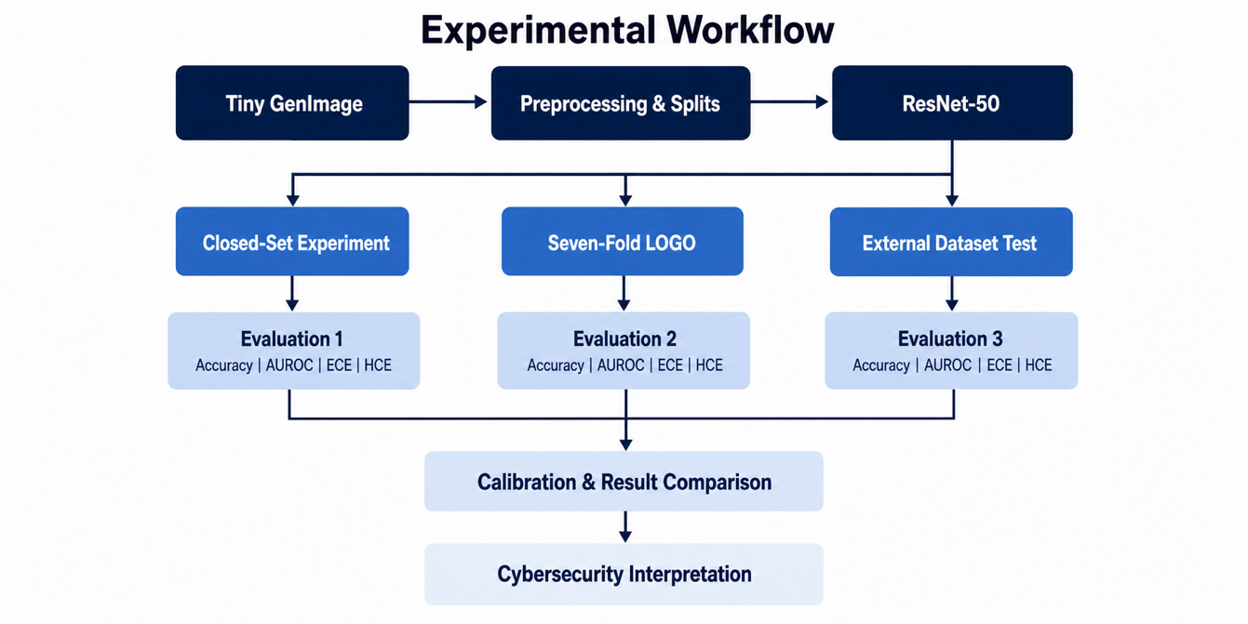
Figure 1: End to end Workflow.

1.2 Cybersecurity Context
Four cybersecurity scenarios motivate the evaluation.
First, identity and Know Your Customer workflows may receive portrait photographs or supporting documents that are generated, altered, or composited. A detector can contribute evidence, but a false positive may block a legitimate applicant and a false negative may help a fraudulent identity proceed.
Second, trust and safety systems screen uploaded images for impersonation, coordinated influence, or deceptive advertising. Here the cost of a false alarm includes reviewer workload and inconsistent moderation, while the cost of a missed synthetic image may include public harm.
Third, fraud teams evaluate visual evidence submitted for marketplaces, insurance, expense claims, and customer disputes. A model score can prioritize cases but cannot establish intent on its own.
Fourth, digital-forensics and incident-response teams may use a detector during triage, where calibrated uncertainty is important because downstream conclusions require validation.
In all four scenarios, the model is best understood as a fallible sensor. The score should be logged with the model version, calibration version, input transformations, and policy decision. It should be combined with provenance information where available. The Coalition for Content Provenance and Authenticity specification describes cryptographically verifiable content credentials that can record origin and editing history [4]. Such credentials and a learned detector solve different problems: provenance can provide positive evidence about a content history, while a detector estimates patterns associated with synthesis when provenance is absent or untrusted. A secure deployment benefits from both and should not treat either as universally conclusive.
The cybersecurity framing also changes how errors are interpreted. Accuracy weights all test images equally, while operational losses are asymmetric and context dependent. A false positive on a legitimate identity image may deny service; a false negative on generated fraud evidence may permit loss; a high-confidence mistake is especially concerning because it is more likely to bypass review or dominate a multi-signal decision. This study therefore reports confusion-matrix components, confidence on wrong predictions, and high-confidence errors in addition to accuracy and AUROC. The purpose is to show what evidence a deployment owner would need before selecting an operating policy.

1.3 Problem Statement
In cybersecurity systems, model outputs are not merely binary classifications but often serve as risk indicators guiding automated decisions and human review processes. Miscalibrated confidence estimates can result in incorrect automated actions, such as blocking legitimate users or approving fraudulent submissions. Ensuring reliability under open-set conditions is therefore critical for risk-based decision-making.

1.4 Research Questions
Main Research Question:
How does open-set generator shift affect the reliability of AI-generated image detectors in cybersecurity deployment scenarios?
Sub-Question:
Can post-hoc temperature scaling improve confidence calibration and reduce high-confidence errors under such distribution shift without affecting classification accuracy?

1.5 Research Objectives
The first objective is to establish a closed-set reference for an ImageNet-initialized ResNet-50 before and after fine-tuning on real and AI-generated images. This reference separates the contribution of task-specific learning from the initial feature representation. It also provides a final saved model and validation-derived temperature for external evaluation.
The second objective is to implement a true leave-one-generator-out (LOGO) protocol. In each of seven folds, one AI generator is absent from both training and validation. A fresh ResNet-50 is trained on real images and the remaining six generators and then tested on a balanced set containing real images and images from the held-out generator. This design makes the held-out family genuinely unseen by that fold. Seven folds therefore require seven independently trained models, they are not repeated evaluations of one model.
The third objective is to quantify probability reliability. The analysis includes Expected Calibration Error (ECE), negative log-likelihood where stored artifacts permit it, Brier score for the external test, mean confidence on wrong predictions, and the number and rate of wrong predictions above a confidence threshold of 0.90. Temperature scaling is fitted only on validation logits and is then applied without refitting to the corresponding test logits.
The fourth objective is to evaluate the saved detector on a recent cross-dataset stress-test sample containing newer generator families. This test is intentionally different from the primary dataset: it changes both generator provenance and real-image provenance. It therefore probes a broader deployment shift than LOGO and helps distinguish strong within-benchmark performance from transferable reliability.
The fifth objective is to translate the empirical findings into a defensible cybersecurity deployment pattern. This includes the role of human review, threshold governance, logging, calibration monitoring, provenance, and fallback behavior. The thesis does not claim to validate a production system. It identifies controls that follow from the observed failure modes.

1.6 Scope and Delimitations
The empirical scope is binary still-image classification: label 0 represents a real image and label 1 represents an AI-generated image. Audio, video, face-swap localization, source attribution, watermark detection, and text-image consistency are outside the experiments. The study uses ResNet-50 as a single controlled backbone so that differences across evaluation conditions are attributable to data shift and calibration rather than architecture changes.
Open set is used only in this generator-level sense. In every LOGO fold, one generator is left out, a fresh detector is trained on the other six, and the excluded generator is used only for testing. The output remains real or AI-generated; there is no third unknown class. The thesis therefore evaluates reliability on an unseen generator rather than proposing a new open-set recognition algorithm.
The primary dataset is Unbiased Tiny GenImage, a curated subset with seven AI-generator folders and a Nature folder. The closed-set reference uses a stratified 80, 10, 10 split. The LOGO experiment creates a different split per held-out generator and uses a balanced real versus held-out test set. The external experiment uses a reproducible 3,000 image stratified sample from MS COCOAI/Defactify: 500 real images and 500 images from each of five recent generator sources. It is a stress test, not a full-benchmark claim.
The calibration scope is post-hoc scalar temperature scaling. This choice supports the sub-question because it cannot change the binary decision boundary when the temperature is positive. More flexible calibrators, ensembles, Bayesian methods, conformal prediction, selective classification, and class-conditional calibration are discussed but not evaluated. Policy thresholds other than the analytical 0.50 label threshold and 0.90 high-confidence threshold are not optimized.

1.7 Contributions
This thesis makes five practical contributions. It supplies an experimental structure that separates the closed-set reference, genuine LOGO training, and recent external testing. It reports complete seven-fold LOGO evidence rather than calling generator-wise slicing of one trained model an open-set experiment. It harmonises the interpretation of saved metrics and recalculates the external probabilities with the final validation temperature. It adds confidence and error-oriented views that are more informative for cybersecurity. Finally, it provides an evidence-based answer to both registered research questions and a deployment design that treats the detector as one control in a layered security process.
These contributions are empirical and methodological rather than architectural. No novel detector architecture is proposed. The value lies in asking whether a familiar high-performing detector remains dependable when the generator changes, and in reporting enough detail to prevent accuracy from being mistaken for operational trustworthiness.

1.8 Thesis Structure
Chapter 1 introduces the motivation, cybersecurity problem, research objectives and research questions of the thesis. Chapter 2 presents the theoretical foundations of AI-generated image detection, ResNet-50, confidence calibration, distribution shift and open-set reliability. It also reviews the relevant literature and state of the art and identifies the research gap addressed by this study. Chapter 3 describes the methodological approach, including the datasets, preprocessing, model construction, closed-set experiment, seven-fold leave-one-generator-out protocol, temperature scaling, external evaluation, evaluation metrics and result-harmonisation procedure. Chapter 4 constitutes the main empirical part of the thesis and presents the closed-set, LOGO and recent external-dataset results using tables and complementary visual representations. Chapter 5 synthesises the results, answers the research questions and presents the main conclusions. Chapter 6 discusses the limitations, cybersecurity deployment implications and recommendations and identifies directions for future research.
The appendices contain selected implementation details, result-integrity checks and the reproducibility record.

2 Theoretical Basics

2.1 AI-Generated Images and Detection Signals
AI-generated images are produced by models that learn a distribution over visual data and sample from that learned representation. Earlier large-scale image generators were dominated by generative adversarial networks (GANs). A GAN trains a generator to synthesize images and a discriminator to distinguish generated from training images. Improvements in architecture and training stability enabled systems such as BigGAN to create high-quality class-conditional images. Variational and vector-quantized models introduced different latent representations, while diffusion models learned to reverse a gradual noising process. Modern text-to-image systems combine large visual encoders, text encoders, latent diffusion, and sophisticated decoders. These families do not leave one universal artifact [6].
Detection methods exploit several types of evidence. Pixel-level or frequency-domain artifacts can arise from up-sampling, convolution, denoising, and image decoding operations. Local texture statistics may differ from camera captured images. Semantic inconsistencies can appear in geometry, lighting, text, or object relationships. Learned detectors can also exploit dataset shortcuts such as resolution, compression, watermarks, content category, or preprocessing differences. A detector may score well because it has learned stable synthesis evidence, because it recognizes generator specific fingerprints, or because it recognizes accidental dataset construction cues. Cross-generator and cross-dataset tests are therefore essential for understanding what has generalized.
Wang et al. showed that a convolutional detector trained on images from one generator could generalize to several other CNN-based generators, while also observing that post-processing and future generators challenge this apparent universality [5]. GenImage later provided a million-scale benchmark with real and generated images from multiple GAN and diffusion families [6]. A recent MS COCOAI/Defactify dataset provides an additional source of newer generated images and MS COCO real images [7]. The current study uses a curated, class-labelled GenImage subset as its primary dataset [8]. Together, the primary and external data support two distinct tests: generator exclusion within a controlled benchmark and broader cross-dataset stress.
The binary detector estimates the probability that an input belongs to the AI generated class. Let x denote an image and y in {0,1} the ground-truth label, where 0 is real and 1 is AI generated. The network produces a scalar logit z(x). The uncalibrated probability is
p = σ(z) = 1 / (1 + exp(−z)) | (1)
Binary probability from a scalar logit.
A prediction is AI generated when p >= 0.5 and real otherwise. This threshold defines the analytical decision rule used throughout the experiments. A deployed security system could choose a different threshold after cost analysis, but such optimization is outside the study.

2.2 Residual Networks and ResNet-50
Deep convolutional networks learn increasingly abstract visual representations through stacked filters and nonlinear transformations. Very deep networks, however, can become difficult to optimize because gradients must travel through many layers. Residual networks address this problem by learning a residual mapping F(x) and adding the input through an identity shortcut. A residual block can be written as
y = F(x, W) + x | (2)
Residual learning with an identity shortcut.
The shortcut provides a direct information and gradient path. K He demonstrated that residual learning supports substantially deeper image-recognition networks and introduced the family that includes ResNet-50 [9]. ResNet-50 uses bottleneck residual blocks and was evaluated on ImageNet in the original study [9], [10]. In this thesis, the TensorFlow ImageNet-pretrained weights initialise the backbone before adaptation to the smaller task-specific dataset [39].
The model in this thesis removes the original ImageNet classification head and retains the convolutional backbone. Global average pooling converts the final spatial feature map into a 2,048-dimensional feature vector. Dropout with rate 0.20 provides regularization, and a single linear output produces the binary logit. A sigmoid is applied for probabilities. This explicit logit construction is important: temperature scaling must operate on logits, not on probabilities that have already passed through a sigmoid.
Transfer learning is performed in two conceptual stages. The initial head-only state evaluates how useful fixed ImageNet features are for the target distinction. Fine-tuning then makes the backbone trainable with a lower learning rate so that representations can adapt to synthetic-image evidence. Binary cross entropy is minimized with Adam. Class weights compensate for the primary dataset containing more AI generated than real images. Early stopping based on validation loss and restoration of the best checkpoint reduce unnecessary training after validation performance stops improving.
ResNet-50 is a defensible baseline for three reasons. It is widely understood and reproducible, prior synthetic-image work has used related convolutional architectures and its scalar output makes calibration analysis transparent. It is not presented as the newest possible detector. Restricting the thesis to one backbone also prevents architecture differences from becoming a confounder when the central question concerns generator shifts and confidence reliability.

2.3 Discrimination, Probability, and Calibration
Discrimination and calibration describe different properties. A model discriminates well when positive examples tend to receive higher scores than negative examples. AUROC summarizes this ranking behavior over all possible thresholds. Accuracy evaluates one threshold. Calibration asks whether the numerical confidence attached to a prediction corresponds to its empirical correctness. A model can rank almost perfectly and remain overconfident; conversely, a weak model can be calibrated if its reported confidence is consistent with its low success rate.
For a binary classifier, top-label confidence is c_i = max(p_i , 1 - p_i). The predicted label is correct when the thresholded prediction equals y_i. Informally, among predictions issued with confidence near 0.80, a calibrated model should be correct about 80% of the time. Modern neural networks frequently violate this relationship. Guo et al. documented substantial miscalibration in contemporary architectures and showed that a single temperature parameter can be a strong post-hoc correction [11]. Ovadia et al. further demonstrated that uncertainty quality can degrade under dataset shift even when methods look satisfactory in distribution [12].
Reliability diagrams visualise calibration by grouping predictions into confidence bins and comparing mean confidence with observed accuracy. Points on the diagonal represent agreement. Points below the diagonal indicate overconfidence because confidence exceeds accuracy. A reliability diagram is more informative than one scalar because two models can have similar ECE values while failing in different confidence regions. Bin occupancy should also be considered: an extreme gap in a bin containing very few predictions has less aggregate effect but may still matter for rare, high-cost events.
Expected Calibration Error approximates the average absolute gap between confidence and empirical accuracy. If B_m is a bin, acc(B_m) its observed accuracy, conf(B_m) its mean confidence, and n the sample size, then
ECE = ∑ₘ₌₁ᴹ (|Bₘ| / n) × |acc(Bₘ) − conf(Bₘ)| | (3)
Expected Calibration Error for M confidence bins.
ECE depends on the definition of confidence, the number of bins, and bin boundaries. Positive-class ECE groups the predicted probability of the positive class and compares it with the positive-class frequency. Top-label ECE groups predicted-class confidence and compares it with correctness. They answer related but non-identical questions. A thesis should not pool their absolute values as though they were the same estimator. This study retains the estimators available in the final saved artifacts, reports them transparently, and limits cross-protocol synthesis accordingly.
Negative log-likelihood (NLL), equivalent to binary cross-entropy on probabilities, is a proper scoring rule that strongly penalises confident mistakes:
NLL = −(1/n) ∑ᵢ₌₁ⁿ [yᵢ ln(pᵢ) + (1 − yᵢ) ln(1 − pᵢ)] | (4)
Binary negative log-likelihood.
The Brier score is the mean squared probability error:
Brier = (1/n) ∑ᵢ₌₁ⁿ (pᵢ − yᵢ)² | (5)
Binary Brier score.
Both incorporate probability quality without binning, although they combine discrimination and calibration effects. The external experiment reports NLL and Brier score because per-image probabilities are available. The closed-set JSON artifacts do not contain those fields, so the thesis does not invent them retrospectively.

2.4 Temperature Scaling
Temperature scaling divides each logit by a positive scalar T before applying the sigmoid [11]:
pₜ = σ(z/T) | (6)
Temperature-scaled probability.
When T > 1, logits move toward zero and confidence generally decreases. When 0 < T < 1, their magnitude increases and predictions become sharper. The temperature is learned on a held-out validation set, commonly by minimising NLL. Test labels must not influence the selected temperature. This validation-only separation is critical because fitting T on a test set would leak outcome information and overstate calibration performance.
For binary classification with threshold 0.5, positive temperature scaling preserves predicted labels. The sigmoid is monotonically increasing and z/T has the same sign as z for T > 0. Thus, a sample on the AI side of the decision boundary remains on that side. The ranking of scores is also preserved, so AUROC remains unchanged aside from negligible floating-point effects. Temperature scaling can improve probability quality and move predictions below a high-confidence threshold, but it cannot correct a false positive or false negative at the 0.5 decision boundary.
This limitation is central to interpretation. If external real images are incorrectly classified as AI-generated, temperature scaling may make some errors less confident, but the confusion matrix remains unchanged. A cybersecurity policy can use better-calibrated scores to choose review levels more rationally; calibration does not make a structurally shifted classifier accurate. More flexible calibration and rejection methods are reviewed in Section 2.8.5. The simplicity and decision-preserving property of scalar temperature scaling nevertheless make it well matched to the registered sub-question.

2.5 Dataset Shift and Generator-Level Open Set
Dataset shift occurs when the joint distribution encountered during deployment differs from the distribution used for training. Covariate shift changes p(x), label shift changes p(y), and concept shift changes p(y|x) [12]. Real evaluations often mix these categories. A new generator changes low-level artifacts, content, and image processing, while a new real-image source can change camera characteristics, subject matter, compression, and curation. A cross-dataset test therefore represents a broader shift than holding out one generator inside a common benchmark.
Open-set recognition traditionally assumes that test data may contain classes not represented during training and asks a model to identify or reject unknown classes. Scheirer et al. formalised open-space risk and established a foundation for open-set recognition [13]. Surveys by Geng et al. describe recognition, detection, and adaptation strategies [14], while Vaze et al. show that a strong closed-set classifier remains an important component of open-set performance [15]. Out-of-distribution detection similarly asks whether a test input belongs to the training distribution; the maximum softmax-probability baseline of Hendrycks and Gimpel is a widely cited reference [16].
The experimental problem here is narrower and easier to state. The detector always predicts real or AI-generated. Open-set generator shift means that the AI generator used for testing was not included in training or validation. The LOGO design measures whether evidence learned from six generators transfers to the seventh. It does not add an unknown output class or claim a complete open-set recognition method.
True LOGO training must remove the held-out generator from both training and validation. Evaluating a generator after it contributed training samples is not LOGO, even if results are later grouped by generator. Each fold has a different training distribution and therefore requires a fresh model. In this thesis the seven held-out families are Midjourney, Stable Diffusion v1.5, GLIDE, Wukong, BigGAN, VQDM, and ADM. Together, the seven folds answer whether the same ResNet-50 workflow remains reliable when each generator is unseen in turn.

2.6 Reliability as Cybersecurity Risk Evidence
A probability emitted by a model is not automatically a risk. Risk depends on the probability of an undesirable event, the severity of the consequence, the context, and the available controls. A calibrated synthetic-image probability can be one input to a risk model, but a security decision should also consider source reputation, user behavior, transaction value, provenance, metadata, and analyst evidence. Risk management is an organisational process spanning identification, analysis, evaluation, treatment, monitoring, and communication [1], [2], [38]. This lifecycle view is appropriate because generator and data distributions evolve after deployment.
Three reliability indicators are especially relevant. First, false-positive and false-negative rates reveal class-conditional burden. Overall accuracy can conceal a detector that performs well on the majority class and poorly on the minority class. Balanced accuracy gives equal weight to real-image recall and AI-image recall. Second, confidence on wrong predictions reveals whether errors are likely to appear authoritative. Third, high-confidence errors count mistakes beyond a chosen confidence threshold. The count, the fraction of all samples, and the fraction of high-confidence predictions have different denominators and must be named explicitly.
An operational threshold should be derived from costs and capacity, not copied from a research plot. For example, a high threshold may limit human-review volume but allow more false negatives, while a lower threshold may detect more generated images at the cost of blocking legitimate submissions. Calibration helps a policy owner reason about these trade-offs, yet calibration must itself be monitored under shift. The detector should therefore support abstention or escalation when evidence is ambiguous or when the input resembles a known failure region.

2.6.1 Cybersecurity Threat Model
The protected asset is not merely a correct image label. It is the integrity of a security decision, the availability of review, and the evidential value of submitted media. Synthetic images can support impersonation, fraudulent claims, fabricated evidence, social engineering, or influence activity. Real images from shifted cameras, compression pipelines, or content domains can also trigger false alarms. Europol identifies deepfakes as a challenge for evidential trust [3], while the NIST generative-AI profile emphasises measurement, monitoring, and risk-appropriate controls [2].
The detector is therefore one reliability service inside a larger workflow. Its probability is evidence about model confidence, not proof of origin. Temperature scaling may improve score interpretation within an evaluated protocol, but it cannot establish provenance, infer intent, or repair a shifted decision boundary. Image intake, model assessment, policy interpretation, and response are separated in Figure 2 in accordance with risk-governance principles [1], [38].
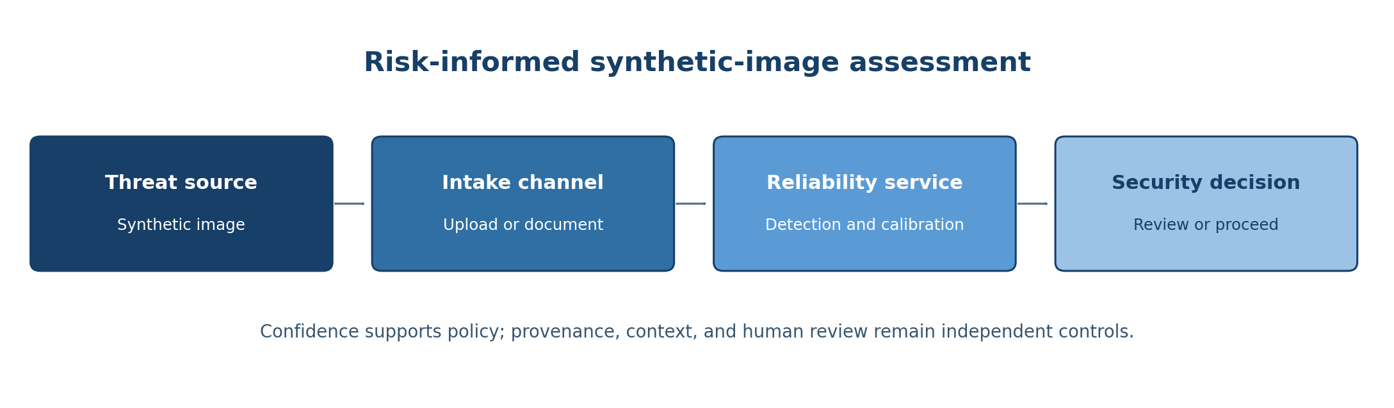
Figure 2: Cybersecurity threat model.

2.6.2 Assets, Attack Paths, and Controls
Four failure routes are relevant. Evasion occurs when a generated image is accepted as real. False accusation occurs when legitimate content is flagged as synthetic. Confidence misuse occurs when a downstream system treats an uncalibrated score as a dependable probability. Evidence loss occurs when the organisation retains a detector decision but discards the original file, metadata, model version, or review record. These routes affect integrity, availability, accountability, and procedural fairness differently and should not be collapsed into one accuracy value.
Threat event | Security consequence | Required control
Generated image accepted | Fraudulent evidence enters a workflow | Human review, provenance checks, corroboration
Real image rejected | Legitimate user or evidence is blocked | Appeal, reversible action, false-positive monitoring
Overconfident score | Automation exceeds validated evidence | Calibration monitoring and bounded thresholds
Dataset shift | Performance degrades silently | Challenge sets, drift detection, re-evaluation
Incomplete record | Decision cannot be reconstructed | Input hash, model version, score, action, outcome
Table 1: Threats and controls.
The controls form defence in depth. C2PA credentials can provide provenance evidence when present, but absence of a credential does not prove that an image is synthetic [4]. A detector score may justify triage but should not independently authorise an irreversible adverse action. Policy thresholds and organisational controls remain deployment choices outside the experiments.

2.7 Summary
Synthetic-image detection combines representation learning, generator-specific evidence, and potentially fragile dataset cues. ResNet-50 provides an established backbone, while calibration metrics test whether its probabilities are meaningful beyond binary correctness. Temperature scaling can reshape confidence without changing decisions. LOGO supplies a controlled generator-exclusion test, and recent cross-dataset evaluation supplies a stronger deployment stress test. These foundations lead to the integrated literature survey in Section 2.8 and the concrete experimental design in Chapter 3. The threat model additionally defines assets, attack paths, decision boundaries, and defence-in-depth controls.

2.8 Literature Survey and State of the Art

2.8.1 Review Scope and Organising Questions
The literature survey connects four bodies of work: AI-generated image detection, cross-generator generalisation, confidence calibration under shift, and cybersecurity-oriented governance. The purpose is not to catalogue every deepfake detector. It is to identify what prior work establishes, what it measures, and what remains unanswered for a binary detector whose confidence may influence a security decision.
The review is organised around four questions. First, which visual signals have been used to detect generated images, and how transferable are they? Second, how do recent methods evaluate unseen generators and cross-dataset conditions? Third, what is known about neural-network calibration under distribution shift? Fourth, what additional controls are required when detector scores enter a cybersecurity workflow? These questions produce a narrower and more defensible research gap than a broad claim that synthetic-image detection is unexplored.
The selected method papers include foundational work and recent conference publications through 2025. The 2026 Roy et al. paper is included specifically because it documents the external dataset used in this thesis, alongside current risk-management and provenance specifications. The review prioritises primary papers and official standards. Dataset webpages are included only where they document the exact experimental artifact. The opening literature matrix gives broad coverage of the relevant research areas, while Section 2.8.8 provides a focused synthesis of the current state of the art and the limitation most relevant to this thesis.
Reference | Focus | Relevant contribution | Boundary for this thesis
Wang et al. [5] | CNN detector | Cross-generator detection | Calibration and recent diffusion shift not central
Zhu et al. [6] | GenImage benchmark | Million-scale multi-generator evaluation | Benchmark scores do not establish confidence reliability
Roy et al. [7] | MS COCOAI / Defactify dataset | Newer generators and COCO real images | Calibration under generator and dataset shift is not the paper's primary focus
Guo et al. [11] | Temperature scaling | Simple post-hoc calibration | Primarily in-distribution classification
Ovadia et al. [12] | Uncertainty under shift | Shows degradation as shift increases | Not specific to synthetic-image detection
Scheirer et al. [13] | Open-set recognition | Formalises open-space risk | Different from generator-level binary shift
Geng et al. [14] | Open-set survey | Taxonomy of unknown handling | Broad recognition scope
Vaze et al. [15] | Open-set baseline | Strong closed-set models remain important | Does not test detector calibration
Yu et al. [17] | GAN fingerprints | Supports detection and attribution | Fingerprints can be generator dependent
Frank et al. [18] | Frequency analysis | Exposes spectral synthesis traces | Sensitive to processing and generator changes
Ojha et al. [20] | Universal detector | Large pretrained features improve transfer | Probability reliability is secondary
Wang et al. [21] | DIRE | Diffusion reconstruction-error detection | Computational and reconstruction-model dependence
Tan et al. [22] | LGrad | Gradient representations for transfer | Cross-dataset calibration not central
Ricker et al. [24] | AEROBLADE | Training-free autoencoder reconstruction | Diffusion-oriented detection
Luo et al. [25] | LaRE^2 | Learned reconstruction-error transfer | Calibration not primary outcome
Cozzolino et al. [26] | CLIP detector | Strong pretrained representation baseline | Different architecture and probability behaviour
Minderer et al. [34] | Modern calibration | Architecture and pretraining affect calibration | Not generator-shift specific
Kull et al. [36] | Dirichlet calibration | Flexible multiclass post-hoc method | More parameters than scalar scaling
Table 2: Comparative literature survey and relationship to the present study.

2.8.2 Convolutional Detection and Generator Fingerprints
Early work established that generated images can contain learnable traces even when they appear realistic. Wang et al. trained a binary classifier on images from a single generator and found notable transfer to other convolutional generators [5]. The result was influential because it suggested that detectors could learn shared synthesis artifacts rather than memorising one source. The qualification in the title, "for now," is equally important: changes in generator architecture and image processing can erode those cues.
Source attribution research provides a related perspective. Yu, Davis, and Fritz showed that GANs can leave model-specific fingerprints that support attribution as well as real-versus-fake discrimination [17]. Fingerprints are valuable when they persist, but dependence on them creates a shift risk. If a detector uses a generator signature that is absent from a new system, confidence can remain high even though the learned evidence no longer applies. The LOGO protocol in this thesis directly tests this concern by removing one generator family from each training fold.
Frank et al. demonstrated that frequency analysis can expose systematic differences between real and generated images [18]. Frequency-domain methods are attractive because many synthesis pipelines introduce characteristic spectra through convolution, up-sampling, or decoding. However, resizing, compression, and a change from GAN to diffusion generation can modify these traces. Frequency evidence is therefore a useful feature family, not a guarantee of universality.
Hendrycks and Dietterich's corruption benchmark is not specific to generated images, but it provides an important methodological lesson: in-distribution accuracy is an incomplete robustness claim [19]. Common corruptions and perturbations can reveal brittleness that ordinary test splits conceal. In synthetic-image detection, a new generator, new real-image source, or changed compression pipeline plays a similar role. This supports using more than one evaluation condition and reporting the type of shift explicitly.

2.8.3 Large Benchmarks and General-Purpose Detectors
GenImage expanded evaluation from individual generators to a million-scale benchmark covering multiple families [6]. Its scale and source labels enable cross-generator testing and have made it a central reference for AI-generated image detection. The Unbiased Tiny GenImage subset used here reduces the computational burden while preserving seven generator folders and real images from the Nature folder [8]. A smaller curated dataset cannot reproduce every GenImage benchmark result, but it supports a complete seven-fold experiment within the available resources.
Ojha, Li, and Lee proposed a universal detector that uses a large pretrained vision-language representation and nearest-neighbour classification or linear probing to improve transfer to unseen generative models [20]. Their work is significant because it shifts attention from generator-specific training toward representations that may capture broader semantics and artifacts. It also illustrates that detector generalisation depends on the pretraining domain and selected features, not solely on the size of a synthetic training set.
Wang et al. introduced DIRE, which detects diffusion-generated images using reconstruction error from a pretrained diffusion model [21]. The method connects the detector to the generative process: images generated by a related diffusion distribution may reconstruct differently from natural images. This can improve transfer among diffusion models, but it increases computation and can still depend on the chosen reconstruction model. The current thesis instead uses a conventional discriminative backbone so that the calibration experiment remains simple and reproducible.
Tan et al. proposed learning on gradients (LGrad), using gradients from a pretrained network as a representation for universal generated-image detection [22]. Lorenz, Durall, and Keuper explored local intrinsic dimensionality as a signal for detecting generated images [23]. These approaches are valuable because they search beyond raw RGB artifacts. They also reinforce the need for cross-dataset analysis: a representation may separate sources in one benchmark yet respond to unrelated properties in another.
Recent methods have increasingly targeted diffusion and reconstruction signals. Ricker, Lukovnikov, and Fischer's AEROBLADE uses autoencoder reconstruction error for training-free generated-image detection [24]. Luo et al.'s LaRE^2 learns from reconstruction error to support transfer across diffusion models [25]. Cozzolino et al. raised the performance bar by leveraging CLIP features for AI-generated image detection [26]. These methods report strong transfer and illustrate the value of large pretrained representations. Their principal focus remains detector performance; probability calibration and high-confidence mistakes under a controlled LOGO design are less commonly the central outcome.
Tan et al. examined up-sampling operations as a source of generalisable traces [27]. This line of work is especially relevant to unseen-generator claims because many generators share decoder operations even when their training data and architectures differ. Yet operations can change between model versions, and post-processing may weaken them. The evidence supports cautious generalisation rather than the assumption of a permanent synthetic signature.
The pace of recent research is reflected by FIRE, B-Free, and CatAID. FIRE uses frequency-guided reconstruction error to detect diffusion-generated images [28]. Guillaro et al.'s B-Free paradigm reduces content and format bias through semantically aligned real and generated training pairs and strong augmentation [29]. Cai et al.'s CatAID uses category-contextualised prompts and vision-language model adaptation to reduce dependence on semantic content [30]. These publications show that the field is moving beyond one benchmark and one artifact family. They also make the external experiment important: a detector trained on older generator families should be challenged with newer diffusion systems rather than discussed as if the training list represented deployment indefinitely.

2.8.4 Cross-Generator and Cross-Dataset Evaluation
Cross-generator evaluation appears under several names, including unseen-generator testing, cross-model generalisation, universal detection, and open-world detection. These terms are not interchangeable. A result can be called cross-generator when the test generator differs from the training generator, but a true LOGO result requires a documented exclusion for each fold. A cross-dataset result changes additional factors and may be a more severe but less controlled test.
The key threat in weak protocols is leakage. If all generators are pooled before a random train/test split, every family contributes examples to training and test. Per-generator test metrics then describe within-family performance, not unseen-generator generalisation. If one generator is removed only at evaluation time after a model has already trained on it in a previous shared run, the model is still contaminated for that fold. The correct unit of repetition is the entire model-training pipeline. Seven held-out generators imply seven fresh initialisations and seven model fits.
Balanced testing helps interpret a fold because the majority-class baseline and expected accuracy of uniform random guessing are both 0.50. False-positive and false-negative counts also have comparable denominators. It does not make the training set balanced, and it changes the prevalence relative to many deployments. For this reason, AUROC is reported alongside accuracy, while confusion components reveal how errors are distributed. Calibration values are prevalence-sensitive in practice, so they should be interpreted in the context of the sampled test distribution.
The MS COCOAI/Defactify dataset supplies a recent external condition with five generator sources: Stable Diffusion 2.1, SDXL, Stable Diffusion 3, DALL-E 3, and Midjourney v6, paired with MS COCO real images [7]. MS COCO is a widely used dataset of complex everyday scenes [31]. In contrast, the primary benchmark uses Nature real images. The external comparison therefore changes both positive and negative data sources. A reduction in balanced accuracy can reflect generator novelty, real-domain shift, dataset construction, or their interaction. The experiment is best described as a cross-dataset stress test rather than a clean estimate of generator novelty alone.

2.8.5 Calibration Research
Guo et al. showed that modern neural networks can be poorly calibrated despite improved accuracy and identified temperature scaling as a strong, simple baseline [11]. This result established a practical separation between representation training and probability correction. The method's single parameter limits overfitting and preserves class ordering, qualities that are attractive when calibration must be documented and deployed separately from the model.
Subsequent work has refined how calibration is measured. Nixon et al. compared calibration metrics and demonstrated that conclusions can depend on the estimator [32]. Widmann, Lindsten, and Zachariah developed calibration tests for multiclass classification and highlighted the statistical complexity hidden by a single binned score [33]. These findings motivate the metric-harmonization boundary in this thesis: ECE values generated with different confidence definitions and bin counts are not pooled as a common absolute scale.
Minderer et al. revisited calibration with modern architectures and large-scale pretraining [34]. Their results show that architecture, pretraining, augmentation, and shift all influence calibration. High-performing models are not automatically calibrated, and calibration rankings can change under distribution shift. This is relevant even though the current study uses only ResNet-50: it prevents the findings from being overgeneralized to all architectures.
Kumar, Liang, and Ma proposed verified uncertainty calibration and examined how empirical estimates can provide misleading assurances when sample coverage is limited [35]. Kull et al. introduced Dirichlet calibration as a multiclass extension beyond scalar temperature scaling [36]. Ni et al. examined calibration with rejection, connecting probability quality with the decision to abstain [37]. Together, these papers show that scalar temperature scaling is not the final word. It is selected here because the registered sub-question asks whether a lightweight post-hoc method reduces high-confidence errors while preserving accuracy.
Ovadia et al. evaluated predictive uncertainty under dataset shift and found that uncertainty methods often degrade as shift severity increases [12]. This result is crucial for the external stress test. A temperature fitted on the primary validation distribution may still improve a shifted sample, but there is no guarantee that the calibration map transfers. The external evaluation must therefore report the observed effect rather than assuming calibration portability.

2.8.6 Open-Set Recognition and Rejection
Scheirer et al. introduced the concept of open-space risk and argued that a recognition system should control positive decisions far from known training support [13]. Geng et al. survey methods that recognise, detect, or adapt to unknown categories [14]. Vaze et al. demonstrate that strong closed-set classifiers form a surprisingly competitive basis for open-set recognition when paired with suitable scoring [15]. Hendrycks and Gimpel provide a simple baseline based on maximum softmax probability for detecting misclassified and out-of-distribution examples [16].
These works provide terminology and caution for the present thesis. The ResNet-50 detector does not implement an unknown category or train an explicit open-set loss. Confidence is analysed as a reliability signal, not asserted to be a validated unknownness score. A high confidence value cannot prove that an image lies within the training distribution. The LOGO experiment answers a narrower question: how much reliability is retained when the positive-class production mechanism changes?
This distinction improves the cybersecurity interpretation. A production policy should not equate low synthetic probability with proof that an image is authentic, nor high probability with proof of malicious intent. It may use uncertainty or distribution-shift indicators to route cases to review. A future extension could add abstention, conformal sets, density-based out-of-distribution scores, or open-set recognition methods. Such methods would require their own validation against realistic unknown sources and attack strategies.

2.8.7 Cybersecurity, Provenance, and Governance
Official risk frameworks focus less on a specific detector architecture and more on the control environment. NIST AI RMF organizes risk work into Govern, Map, Measure, and Manage functions [1]. The Generative AI Profile adapts that logic to generative system risks and emphasizes pre-deployment testing, incident disclosure, monitoring, and content provenance [2]. ISO/IEC 23894 similarly treats AI risk as a lifecycle responsibility [38]. These sources support the thesis's view that a calibration result is evidence for a control, not a complete control system.
C2PA content credentials provide a technical provenance mechanism that can record claims about content origin and transformations [4]. Provenance can reduce reliance on probabilistic detection when valid credentials are present, but absence of a credential is not proof of synthesis. Credentials may be stripped, unsupported, or unavailable for legacy content. Learned detection remains useful as a complementary signal, particularly during triage, while cryptographic provenance can provide stronger positive evidence when the trust chain is intact.
Europol's analysis of synthetic media describes risks involving social engineering, fraud, non-consensual content, and evidentiary manipulation [3]. These applications involve adversarial behavior. Attackers can select generator versions, compress images, submit screenshots, or probe a public detector. This differs from an independent and identically distributed benchmark. A defensible deployment must monitor for drift, rate-limit probing where appropriate, protect model details, retain review and appeal paths, and periodically re-evaluate calibration.

2.8.8 State of the Art Synthesis
As of 2025, no single detector can be treated as universally dominant across generator families, datasets, post-processing conditions, and evaluation protocols. The state of the art is better understood as several competing method families. Large pretrained-representation approaches use semantically rich features, particularly CLIP-derived representations, to reduce dependence on the fingerprints of one training generator [20], [26]. Reconstruction-based approaches instead test how naturally an image can be reproduced by a diffusion model or autoencoder; DIRE, AEROBLADE, LaRE^2, and FIRE are representative examples [21], [24], [25], [28]. A third family develops specialised transferable evidence or bias-control strategies, including gradients, up-sampling traces, category-aware features, and semantically aligned training data [22], [27], [29], [30].
These directions improve transfer by reducing reliance on one visible artifact. Pretrained representations can exploit broad visual knowledge, reconstruction methods connect the decision to properties of modern diffusion pipelines, and operation-aware methods target traces shared by multiple synthesis architectures. However, each family retains dependencies. A representation inherits the coverage and biases of its pretraining; a reconstruction score depends on the selected generative or autoencoding model; and low-level traces can be weakened by resizing, compression, screenshots, or changes in generator design. Consequently, strong results on one benchmark do not establish permanent robustness against future generators.
Evaluation practice has therefore moved toward cross-generator, cross-dataset, and training-free tests. This is an important improvement over random pooled splits, but direct ranking remains difficult because papers use different real-image sources, synthetic generators, image resolutions, post-processing pipelines, and metrics. High AUROC or accuracy in one setting cannot be assumed to transfer to another. The state-of-the-art comparison in Table 3 should therefore be read as a methodological synthesis rather than a numerical leaderboard.
Method | Year | Core signal | State-of-the-art contribution | Gap relevant here
Ojha et al. [20] | 2023 | Large pretrained / CLIP representation | Cross-generator transfer | Calibration is not central
Wang et al. (DIRE) [21] | 2023 | Diffusion reconstruction error | Diffusion-image detection | Depends on reconstruction model
Tan et al. (LGrad) [22] | 2023 | Gradient representation | Transferable generator evidence | LOGO calibration is not evaluated
Ricker et al. (AEROBLADE) [24] | 2024 | Autoencoder reconstruction error | Training-free diffusion detection | Diffusion-oriented scope
Luo et al. (LaRE²) [25] | 2024 | Learned latent reconstruction error | Cross-diffusion transfer | Probability reliability is secondary
Cozzolino et al. [26] | 2024 | CLIP features | Strong transferable representation | Architecture and performance focus
Tan et al. [27] | 2024 | Up-sampling traces | Generalisable synthesis evidence | Traces can change with processing
Chu et al. (FIRE) [28] | 2025 | Frequency-guided reconstruction error | Robust diffusion-image detection | Calibration under security-relevant shift is not central
Guillaro et al. (B-Free) [29] | 2025 | Bias-controlled training pairs | Improved generalisation and calibration | Different training paradigm; not LOGO
Cai et al. (CatAID) [30] | 2025 | Category-guided VLM adaptation | Reduced semantic-content bias | Does not answer LOGO reliability
Table 3: State of the art.
Across this frontier, discrimination remains the principal objective. Confidence calibration, validation-only fitting of a post-hoc calibrator, and high-confidence errors under a documented LOGO protocol are still not normally the central evaluation target [20]-[30]. Security consequences are also usually outside the detector benchmark: a model may be accurate on average while still producing confidently wrong scores that trigger an unsafe automated action. The present thesis does not claim to outperform all recent architectures. Its state-of-the-art contribution is instead an evaluation perspective that combines true generator exclusion, confidence reliability, a recent external stress test, and cybersecurity decision controls around one reproducible detector.

2.8.9 Research Gap
The literature establishes that generated images can often be detected, that stronger pretrained representations and reconstruction signals improve transfer, and that neural confidence can be miscalibrated under shift. What remains less frequently integrated is a compact, reproducible experiment that connects a genuine per-generator exclusion protocol, post-hoc calibration, recent cross-dataset testing, and cybersecurity decision consequences.
Detection papers generally prioritise accuracy and AUROC. Calibration papers generally evaluate broad classification tasks rather than synthetic-image detection across generator folds. Open-set work often studies unknown semantic classes or rejection, which is related to but distinct from an unseen generator producing a known positive label. Governance documents explain what trustworthy deployment requires but do not supply detector-specific evidence. The gap is therefore at the intersection of these literatures.
This thesis addresses that intersection with one controlled backbone. The claim is intentionally bounded: it evaluates generator-level open-set reliability for ResNet-50 on the available data and tests whether scalar temperature scaling improves saved confidence measures without moving the decision boundary. The external stress test examines whether conclusions survive a newer and broader shift. The final contribution is not a universal detector; it is a traceable evidence chain from experimental design to operational recommendation.

2.8.10 Literature Survey Summary
Prior work supplies strong detector families, but generalisation depends on the source of evidence and the severity of shift. Calibration literature shows why probability quality must be measured separately from discrimination. Open-set literature supplies useful concepts but also demonstrates why the term should be scoped. Governance and provenance work show that a detector belongs inside a layered process. Chapter 3 operationalises these lessons in the dataset splits, LOGO folds, calibration procedure, metrics, and reproducibility controls used in this study.

3 Method and Approach

3.1 Research Design
The study uses a quantitative experimental design with three linked evaluation conditions. The closed-set reference measures the effect of task-specific fine-tuning and supplies the final saved ResNet-50 model. The seven-fold LOGO experiment measures unseen-generator generalization under controlled exclusion. The recent external experiment applies the final saved model to a newer cross-dataset sample. Temperature scaling is evaluated in each condition using validation-derived temperatures and unchanged class decisions.
The conditions answer different parts of the evidence chain and are not treated as interchangeable repetitions. Closed-set results establish capability on a familiar stratified split. LOGO results isolate generator-family exclusion while keeping the primary dataset construction largely stable. External results test transfer when generated and real data provenance both changes. This layered design makes it possible to state where reliability degrades without claiming that one number represents all deployment conditions.
The independent factors are training condition, held-out generator, and calibration state. The principal dependent variables are accuracy, balanced accuracy where available, AUROC, ECE, confidence on wrong predictions, and high-confidence errors. The operational high-confidence threshold is fixed at 0.90 for analysis. No threshold is tuned on test results.
Condition | Model runs | Test context | Purpose
Closed-set reference | One saved ResNet-50 | All seven generators represented | Fine-tuning effect and final calibration
True LOGO | Seven fresh ResNet-50 folds | One generator excluded per fold | Controlled generator-level open-set shift
Recent external | Final saved ResNet-50 | Five newer generators + MS COCO real | Cross-dataset deployment stress
Table 4: Experimental conditions and their role in the research design.

3.1.1 Operational Open-Set Taxonomy
Open-set recognition concerns test inputs outside the known support represented during training [13], [14]. This thesis uses a narrower operational meaning: the binary classes remain real and AI-generated, while the generator responsible for an AI test image is excluded from model development. LOGO therefore measures generator-level open-set shift, not discovery of an additional semantic class. The external experiment broadens the shift because generator families and real-image provenance both change.
Condition | Training visibility | Supported interpretation | Excluded claim
Closed set | All seven AI sources represented | Capability on familiar source families | Unknown-generator reliability
Seven-fold LOGO | One generator absent from train and validation | Bounded generator-level open-set reliability | Universal open-set detection
External stress test | New AI sources and MS COCO real images | Cross-dataset deployment stress | Generator novelty as the sole cause
Table 5: Open-set evaluation boundaries.
LOGO isolates generator exclusion under one primary dataset. The external condition is more deployment-like, but its shift factors are confounded. Results are therefore synthesised directionally rather than pooled. This preserves the registered research question without claiming universal unknown-class recognition and is consistent with evidence that uncertainty can deteriorate under distribution shift [12], [16].

3.2 Data Sources

3.2.1 Unbiased Tiny GenImage
The primary dataset is Unbiased Tiny GenImage, obtained from Kaggle through the ‘kagglehub’ interface [8]. It contains one real-image directory named Nature and seven AI-generator directories: Midjourney, Stable Diffusion v1.5, GLIDE, Wukong, BigGAN, VQDM, and ADM. The final inventory contains 23,328 images: 5,828 real images and 2,500 images from each AI generator. The AI class therefore contains 17,500 images.
The dataset is derived from the broader GenImage benchmark [6]. It is suitable for the present study because generator identity is explicit at directory level and the total size permits seven complete fine-tuning runs. The reduced scale is also a limitation: it cannot represent the full content and processing diversity of the original benchmark. Results are reported for this artifact, not extrapolated to all GenImage images.
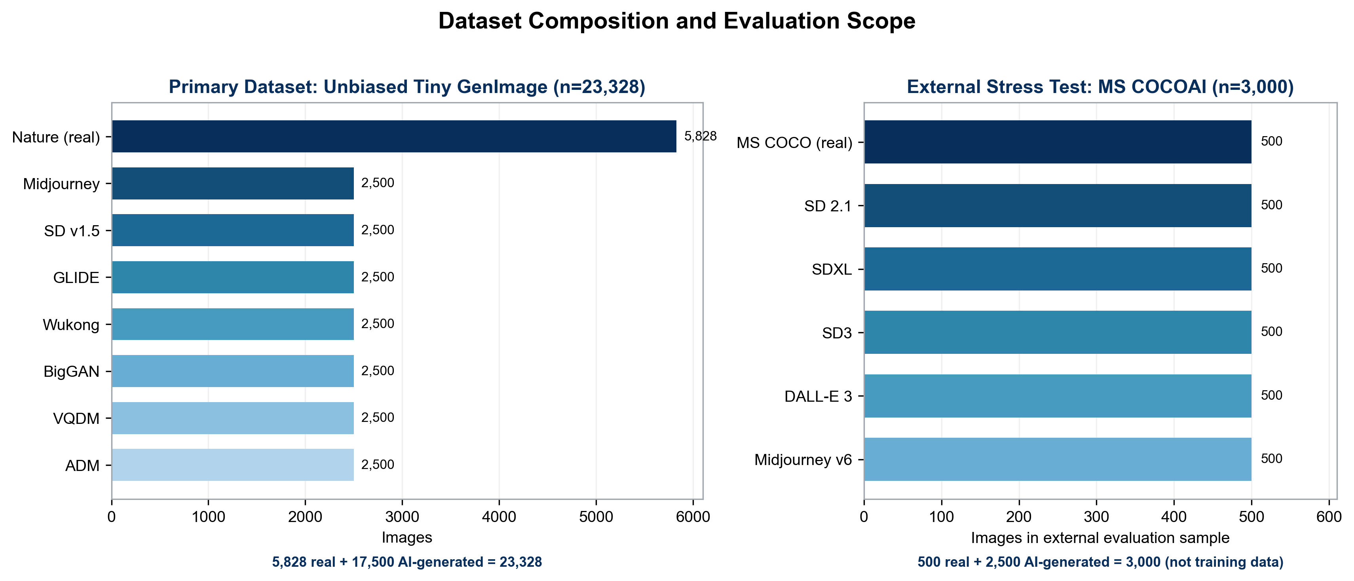
Figure 3: Dataset composition.
Source folder | Binary class | Images
Nature | Real | 5,828
Midjourney | AI-generated | 2,500
Stable Diffusion v1.5 | AI-generated | 2,500
GLIDE | AI-generated | 2,500
Wukong | AI-generated | 2,500
BigGAN | AI-generated | 2,500
VQDM | AI-generated | 2,500
ADM | AI-generated | 2,500
Total | Real + AI | 23,328
Table 6: Primary Unbiased Tiny GenImage inventory.

3.2.2 Closed-Set Split
The closed-set reference uses a stratified 80/10/10 split with random seed 42. Training contains 18,662 images: 4,662 real and 14,000 AI-generated. Validation contains 2,333 images: 583 real and 1,750 AI-generated. Test contains 2,333 images with the same validation class counts. Stratification preserves the class ratio but does not make the test set balanced.
The validation split serves three purposes: early-stopping selection, learning-rate scheduling, and post-hoc temperature fitting. The test split is used only for final metric computation. Because the same generator families appear in all three splits, this condition is closed set with respect to generator identity.
Split | Total | Real | AI-generated
Training | 18,662 | 4,662 | 14,000
Validation | 2,333 | 583 | 1,750
Test | 2,333 | 583 | 1,750
Table 7: Closed-set train, validation, and test split.

3.2.3 LOGO Splits
For a held-out generator g, all images from g are excluded from the training and validation arrays. Real images are divided into fixed train, validation, and test partitions. The six seen AI-generator pools are split for training and validation. The test set contains 583 real images and a deterministic sample of 583 images from g, producing 1,166 balanced test images per fold.
This exclusion is the operational definition of open-set generator shift used in the thesis. Put simply, the held-out generator is unseen by the model until testing. The detector still predicts real or AI-generated and does not predict a separate unknown class.
Each fold has 18,162 training images, 2,083 validation images, and 1,166 test images. The exact training and validation counts reflect the exclusion of one 2,500-image generator from the primary inventory and the fold-specific sampling procedure. The held-out generator contributes no images to training or validation. The seven folds together test every generator exactly once as the unseen test generator.
The use of fresh ImageNet-initialised weights for every fold is essential. Reusing a model trained on Midjourney when later calling Midjourney held out would invalidate the exclusion. Checkpoints and outputs are stored in fold-specific directories. The resulting seven models are the expected cost of true LOGO and are analysed as one experiment.
Held-out generator | Train | Validation | Test | Test real / AI
Midjourney | 18,162 | 2,083 | 1,166 | 583 / 583
Stable Diffusion v1.5 | 18,162 | 2,083 | 1,166 | 583 / 583
GLIDE | 18,162 | 2,083 | 1,166 | 583 / 583
Wukong | 18,162 | 2,083 | 1,166 | 583 / 583
BigGAN | 18,162 | 2,083 | 1,166 | 583 / 583
VQDM | 18,162 | 2,083 | 1,166 | 583 / 583
ADM | 18,162 | 2,083 | 1,166 | 583 / 583
Table 8: True LOGO fold construction and held-out generator exclusion.

3.2.4 Recent External Stress-Test Sample
The external source is the MS COCOAI/Defactify image dataset [7]. It includes MS COCO real images and generated images from newer systems. The full dataset is substantially larger than the available local evaluation artifact, so a fixed stratified sample is used: 500 real MS COCO images and 500 images from each of Stable Diffusion 2.1, SDXL, Stable Diffusion 3, DALL-E 3, and Midjourney v6. This sampling choice is explicitly reported. It makes the experiment tractable and equally represents all six sources, but it is not a full benchmark estimate. The sample changes the base rate to 500 real and 2,500 AI images. Overall accuracy is therefore influenced by the 5:1 class ratio; balanced accuracy and the confusion matrix are necessary for interpretation. The external condition consequently combines generator shift, real-domain shift, content shift, and possible preprocessing shift. It is a deployment-oriented stress test, not an isolated causal estimate of generator novelty.
Source | Class | Sample size
MS COCO | Real | 500
Stable Diffusion 2.1 | AI-generated | 500
SDXL | AI-generated | 500
Stable Diffusion 3 | AI-generated | 500
DALL-E 3 | AI-generated | 500
Midjourney v6 | AI-generated | 500
Total | Real + AI | 3,000
Table 9: Recent external stress-test sample.

3.3 Preprocessing and Data Pipeline
All images are decoded to three RGB channels and resized to 224 by 224 pixels. ResNet-50 preprocessing converts pixel values according to the ImageNet convention expected by the backbone. Training data use modest horizontal flipping and brightness augmentation. The LOGO pipeline additionally applies random contrast with factors between 0.90 and 1.10. Validation and test images are not randomly augmented. Batches contain 32 images, and TensorFlow data pipelines use parallel mapping and prefetching where available [39].
Paths and labels are materialized before dataset construction so that fold membership can be audited. Real images receive label 0 and AI-generated images label 1. Generator names are retained separately from the binary label. This separation permits a binary training objective and generator-wise evaluation without treating seven generators as seven target classes.
Class weighting is computed from the training labels. For class k, the weight is proportional to n/(2 n_k), where n is the training-set size and n_k is the number of samples in class k. This gives greater loss weight to real images in the imbalanced primary split. The balanced LOGO test sets remain unweighted during metric computation.
Data leakage controls include a fixed seed, split-before-pipeline construction, absence of held-out-generator paths from each LOGO train and validation set, and validation-only temperature fitting. The code prints fold counts and seen-generator lists before training. These checks are included because a syntactically correct notebook can still implement an invalid open-set generator protocol if source exclusion is not verified.

3.4 Model Architecture and Training
The backbone is Keras ResNet-50 with ImageNet weights and no original top layer [9], [10]. The final convolutional output is followed by global average pooling, dropout 0.20, and one linear logit. The closed-set notebook originally used a sigmoid output for training and then reconstructed a true-logit model from the trained dense weights for calibration. The corrected LOGO implementation creates the linear logit directly and trains with binary cross-entropy configured for logits.
The fine-tuning run uses Adam and a low learning rate, with up to ten epochs, validation-loss early stopping, best-weight restoration, and reduction of the learning rate on a plateau. The closed-set training log records a final scheduled learning rate of 2.5 × 10⁻⁵. Because the final JSON files, rather than stale notebook cell outputs, define the authoritative result, the thesis does not infer an unsupported final epoch from conflicting intermediate records. It reports the protocol and saved checkpoint selection.
Component | Configuration
Backbone | ResNet-50, ImageNet initialisation, include_top=False
Input | 224 × 224 RGB; ResNet-50 preprocessing
Head | Global average pooling; dropout 0.20; one linear logit
Loss | Binary cross-entropy; logits used in corrected LOGO implementation
Optimizer | Adam; closed-set 1 × 10⁻⁴ with plateau reduction; LOGO warm-up 1 × 10⁻³ and fine-tuning 1 × 10⁻⁵
Training | Closed-set: up to 10 epochs; LOGO: 2 warm-up and up to 8 fine-tuning epochs; validation-loss early stopping; best weights restored
Batch | 32
High confidence | Top-label confidence ≥ 0.90
Random seed | 42
Table 10: ResNet-50 model and training configuration.
The closed-set Phase 1 baseline uses the ImageNet-initialized feature extractor and randomly initialized task head without target fine-tuning. Phase 2 makes the backbone trainable and optimizes on the primary training split. Phase 3 fits temperature using validation logits and applies it to test logits. The saved ‘.keras’ model and three downloaded JSON files belong to the same final result set and are used together.
Each LOGO fold starts from a new ImageNet initialization. A short head warm-up is followed by fine-tuning, with early stopping and fold-specific checkpoints. The fold temperature is fitted to that fold's validation logits by minimizing NLL. Test logits are transformed only after the temperature is fixed.

3.5 Temperature-Fitting Procedure
For each LOGO fold, the temperature T is selected by bounded scalar optimisation of binary NLL using only that fold's validation logits and labels. The closed-set notebook instead selects T by bounded minimisation of validation ECE. Both searches are constrained to positive values. Given the selected T, raw and scaled test probabilities are computed without using test labels in either optimisation objective.
The final closed-set temperature is T=1.2408854103. All seven LOGO temperatures are greater than one and range from approximately 1.130 to 1.290, indicating that each fold benefits from softened confidence. The external experiment does not fit a new temperature on external labels. Instead, its stored raw binary logits are recalibrated with the final primary validation temperature T=1.2408854103. This evaluates transfer of the calibration map and avoids leakage from external test labels.
Temperature scaling leaves the sign and ordering of logits unchanged. The 0.5 label predictions, accuracy, confusion matrix, and AUROC are therefore unchanged. Differences in these metrics between raw and scaled probabilities would indicate an implementation error or rounding anomaly. Improvements should appear in ECE, NLL, Brier score, confidence on errors, and counts crossing the 0.90 high-confidence threshold.

3.6 Evaluation Metrics
Accuracy is the fraction of correct thresholded predictions. Balanced accuracy is the average of real-image recall and AI-image recall. AUROC measures the probability that a randomly selected AI image receives a higher score than a randomly selected real image. Log loss and Brier score assess probability quality. ECE summarizes a binned confidence-accuracy gap. Average confidence on wrong predictions focuses directly on the severity of mistakes.
The confusion matrix uses true real, predicted real (TN); true real, predicted AI (FP); true AI, predicted real (FN); and true AI, predicted AI (TP). From these values, real-image specificity is TN/(TN+FP), the real false-positive rate is FP/(TN+FP), and AI recall is TP/(TP+FN). These class-conditional rates are particularly important in the imbalanced external sample.
High-confidence errors use top-label confidence c = max(p, 1 - p). The closed-set and LOGO notebooks use c > 0.90, whereas the external recalculation uses c ≥ 0.90; this endpoint convention is stated when results are compared. Three quantities are distinguished. The HCE count is the number of wrong predictions meeting the relevant threshold. HCE/all divides the count by all test images. HCE/high-confidence divides by all high-confidence predictions. The final closed-set JSON stores the latter. The LOGO summary stores the latter under ‘high_conf_error_rate’. The external recalculation reports both denominators.
Metric | Definition | Operational meaning
Accuracy | Correct / all | Thresholded overall correctness
Balanced accuracy | Mean of real and AI recall | Controls class imbalance
AUROC | Ranking across thresholds | Discrimination independent of one policy threshold
ECE | Binned confidence-accuracy gap | Probability calibration: estimator must be stated
Log loss | Mean negative log probability | Strong penalty for confident mistakes
Brier | Mean squared probability error | Proper probability score
Confidence on wrong | Mean max(p,1-p) for errors | Severity of mistaken certainty
HCE count | Wrong prediction exceeding the protocol-specific 0.90 threshold | Potentially dangerous automation errors
Table 11: Evaluation metrics and cybersecurity interpretation.

3.7 Metric Harmonisation
The final artifacts were produced across multiple notebooks, so metric harmonisation is required before synthesis. "Harmonised" in this thesis does not mean that unavailable per-image closed-set predictions were reconstructed. It means that the authoritative artifact for each protocol was selected, definitions were traced, the external logits were recalculated with the final temperature, and cross-protocol comparisons were restricted to mathematically compatible quantities.
The closed-set JSON uses positive-class ECE with ten bins. The LOGO summaries use top-label confidence-versus-correctness ECE with ten bins. The external analysis uses top-label ECE with fifteen bins. Absolute ECE values across these protocols are therefore not treated as one scale. Within each protocol, before/after values use the same estimator and validly show the effect of temperature scaling. Accuracy and AUROC are directly comparable where sampling contexts are stated. HCE values are compared only after naming their denominator.
The initial draft and executed notebook contain older metrics from earlier runs. They are not averaged or selectively combined with the final files. The authoritative closed-set values are the three JSON files downloaded together with the final model on 3 August 2026. The authoritative LOGO values are the combined seven-fold summary. The authoritative external values are recalculated from the saved per-image prediction CSV using T=1.2408854103.
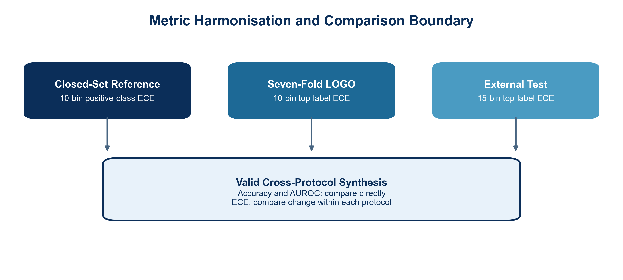
Figure 4: Metric harmonisation.
Protocol | Authoritative artifact | Harmonisation decision
Closed set | Three final JSON files + final .keras model | Use downloaded values; exclude stale notebook outputs
LOGO | Combined seven-fold CSV | Use all folds; verify counts and unchanged decisions
External | 3,000-row prediction CSV | Recompute from raw logits using T=1.2408854103
ECE comparison | 10-bin positive class / 10-bin top label / 15-bin top label | Compare before/after within protocol; do not pool absolute ECE
Table 12: Authoritative result artifacts and harmonisation decisions.

3.8 Reproducibility and Integrity Controls
The experimental code uses fixed random seeds for Python, NumPy, TensorFlow, and deterministic path sampling where supported. Output directories are fold specific. Each summary row stores held-out and seen generator names, temperature, validation NLL, sample counts, discrimination metrics, probability metrics, and confusion components. The external prediction file stores dataset and source identifiers, binary logits, probabilities, predicted labels, confidence, and correctness.
Result validation includes arithmetic consistency checks. For each LOGO fold, TN+FP equals 583 real images and FN+TP equals 583 held-out AI images. Accuracy recomputed from the confusion matrix matches the saved value. After temperature scaling, confusion components, accuracy, balanced accuracy, and AUROC remain equal to their before-calibration values. For the external sample, TN+FP=500 and FN+TP=2,500. These checks guard against accidental row loss and probability-column mismatch.
The saved artifacts also expose two earlier implementation risks. First, a return statement inside the ECE loop would terminate after the first bin; the corrected function returns only after all bins. Second, prediction-record creation must occur inside the batch loop; otherwise the prediction array and metadata frame have different lengths. The corrected external notebook resolves both issues. Important excerpts are included in Appendix A.

3.8.1 Leakage Controls and Fold Provenance
A generator is genuinely held out only when none of its images influence training, early stopping, learning-rate adjustment, temperature fitting, or model selection. For every fold, path arrays are reconstructed after the held-out source is selected. Validation contains real images and the six seen AI generators; the excluded source enters only the balanced test set.
Control point | Implemented rule | Evidence retained
Inventory | Seven source identities remain explicit | Folder names and counts
Training | Zero held-out paths | Fold construction
Validation | Zero held-out paths | Seen-source list and labels
Model lifecycle | Fresh ResNet-50 per fold | Model and training log
Calibration | Validation logits only | Temperature and validation NLL
Runtime recovery | Only completed folds consolidated | Metrics and predictions
Table 13: Leakage controls.
Midjourney was completed in the earlier run and the other six folds in the continuation notebook. Midjourney remained in the inventory as seen training data whenever another generator was held out. The final seven-row summary was assembled from completed fold records that use the same exclusion, training, calibration, and metric definitions. No interrupted model was counted as a completed fold.

3.9 Ethical and Legal Considerations
The experiments evaluate datasets rather than human subjects and do not infer protected traits. Nevertheless, a detector applied to identity or user-generated content can affect people. False positives may create unequal friction if image quality, device type, compression, geography, or accessibility tools differ across groups. The current datasets do not support a demographic fairness analysis, so the thesis does not claim demographic neutrality.
Licensing and dataset terms must be respected in reproduction. The primary Kaggle artifact documents a CC BY-NC-SA 4.0 licence [8]. The external dataset and its MS COCO sources have their own terms [7]. Model and dataset redistribution is outside this document. The thesis reports aggregate and source-level metrics and does not reproduce individual images.
AI tools were used for language refinement, document structuring, code troubleshooting and review, visualisation design, and consistency checking. The author remains responsible for dataset selection, experiment execution, validation of numerical results, interpretation, and final submission. This use is disclosed in the declaration on the thesis.

3.10 Chapter Summary
The methodology separates familiar-distribution capability, true unseen-generator evaluation, and recent cross-dataset stress. It uses one reproducible ResNet-50 backbone, validation-only scalar temperature scaling, and security-relevant error measures. The harmonisation procedure prevents stale or definitionally incompatible values from being combined. Chapter 4 reports the resulting evidence. The open-set taxonomy and leakage controls make the scope and provenance of each evaluation explicit.

4 Main Part

4.1 Result-Selection Rule
LOGO values come from the combined seven-fold summary. External values are recomputed from the 3,000 saved prediction rows using the final temperature T=1.2408854103. Older numbers embedded in notebook display cells or the initial draft are excluded where they conflict with these artifacts.
Results are reported to four decimals in detailed tables and narrative text, and to three decimals in figures. Percent reductions are calculated from unrounded values. Calibration results are compared before and after within the same protocol. ECE is not pooled across protocols because the stored estimators differ as explained in Section 3.7.

4.2 Closed-Set Reference

4.2.1 Phase 1: ImageNet Initialised Baseline
Before target fine-tuning, the model reaches accuracy 0.5722 and AUROC 0.4994 on the 2,333-image closed-set test split. AUROC is effectively at chance, indicating that the initial binary head does not rank real and AI images meaningfully. Accuracy is higher than 0.50 because the split is class imbalanced and the random task head is not constrained to balanced predictions. It should not be interpreted as useful detection.
The baseline ECE is 0.1946 under the saved positive-class ten-bin estimator. Mean confidence is 0.6843 and mean confidence on wrong predictions is 0.6659. There are 126 predictions above the 0.90 confidence threshold, of which 30 are wrong. Thus 23.81% of high-confidence baseline predictions are errors. The baseline exhibits both weak discrimination and unreliable certainty.

4.2.2 Phase 2: Fine-Tuned Detector
Fine-tuning changes the detector substantially. Accuracy rises to 0.9571 and AUROC to 0.9921. ECE decreases to 0.0344. The model's average confidence is 0.9821, and confidence on correct predictions is 0.9874. These figures show that most closed-set cases are both correctly ranked and assigned extreme probabilities.
The remaining mistakes are still issued with substantial certainty. Mean confidence on wrong predictions is 0.8625. Of 2,205 high-confidence predictions, 52 are wrong, an error fraction of 2.36% among high-confidence predictions. The absolute HCE count is higher than the baseline count because fine-tuning moves far more predictions into the high-confidence region. This is why HCE count must be read with the total number of high-confidence predictions rather than treated as a standalone before/after measure.

4.2.3 Phase 3: Temperature-Scaled Detector
The validation-fitted temperature is 1.2408854103. Because it is greater than one, the transformation softens the fine-tuned logits. Accuracy remains 0.9571 and AUROC remains 0.9921, as expected from a positive scalar transformation. ECE decreases from 0.03436 to 0.03162, a relative reduction of 7.98% under the saved estimator.
Mean confidence on wrong predictions decreases from 0.8625 to 0.8347, a relative reduction of 3.23%. High-confidence errors decrease from 52 to 41, a reduction of 21.15%. The error fraction among high-confidence predictions decreases from 0.02358 to 0.01894, or 19.70%, while the high-confidence population decreases from 2,205 to 2,165. Temperature scaling improves confidence quality but cannot turn the remaining wrong labels into correct labels.
Metric | Phase 1 baseline | Phase 2 fine-tuned | Phase 3 calibrated
Accuracy | 0.5722 | 0.9571 | 0.9571
AUROC | 0.4994 | 0.9921 | 0.9921
ECE | 0.1946 | 0.0344 | 0.0316
Average confidence | 0.6843 | 0.9821 | 0.9764
Confidence on correct | 0.6981 | 0.9874 | 0.9828
Confidence on wrong | 0.6659 | 0.8625 | 0.8347
High-confidence total | 126 | 2,205 | 2,165
High-confidence errors | 30 | 52 | 41
Error rate among high-confidence | 0.2381 | 0.0236 | 0.0189
Temperature | - | Not applied | 1.2409
Table 14: Closed-set results before, after fine-tuning and after temperature scaling.
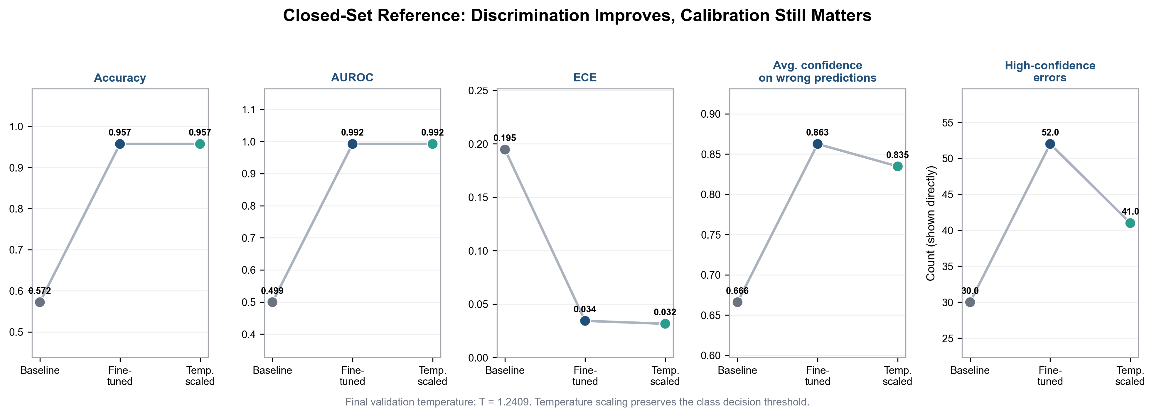
Figure 5: Closed-set performance.
The closed-set condition establishes two points. First, task-specific fine-tuning is indispensable. ImageNet features and a random binary head do not solve the task. Second, strong accuracy and AUROC do not remove the need to inspect confidence on errors. The final temperature produces a modest ECE improvement and a larger reduction in the number of highly confident mistakes.

4.3 True Seven-Fold LOGO Results

4.3.1 Discrimination Under Held-Out Generators
This section contains the thesis's primary open-set evidence. In every row, the named generator was left out of training and validation and used only for testing.
Mean LOGO accuracy is 0.9075 with a standard deviation of approximately 0.0159 across the seven held-out generators. Mean AUROC is 0.9741 with a standard deviation of approximately 0.0197. These results are lower than the closed-set reference of 0.9571 accuracy and 0.9921 AUROC, indicating a measurable generalisation penalty when the generator family is unseen during training.
Performance is not uniform. BigGAN is the easiest held-out family by accuracy (0.9305) and AUROC (0.9991). Midjourney is the most difficult by both accuracy (0.8825) and AUROC (0.9408). VQDM accuracy is 0.8962, while Wukong, GLIDE, ADM, and Stable Diffusion v1.5 fall between 0.9031 and 0.9220. The range of approximately 4.8 percentage points in accuracy demonstrates generator-dependent reliability even though every fold uses the same backbone and sample count.
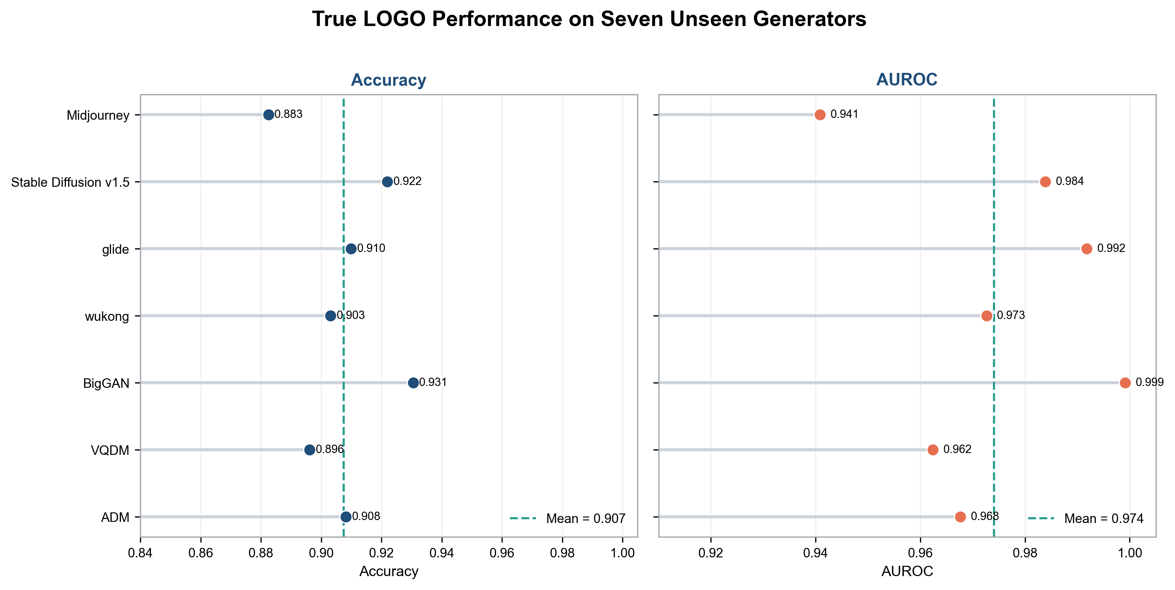
Figure 6: LOGO discrimination.
The confusion components reveal different error structures. In the GLIDE fold the model produces 103 false positives on the common 583-image real test partition but only 2 false negatives among 583 GLIDE images.
BigGAN produces no false negatives but 81 false positives. Midjourney is more symmetric, with 68 false positives and 69 false negatives. These patterns matter operationally: a high AUROC can coexist with a fixed threshold that burdens legitimate real images.
Held-out | Accuracy | AUROC | TN | FP | FN | TP
Midjourney | 0.8825 | 0.9408 | 515 | 68 | 69 | 514
SD v1.5 | 0.9220 | 0.9839 | 500 | 83 | 8 | 575
GLIDE | 0.9099 | 0.9918 | 480 | 103 | 2 | 581
Wukong | 0.9031 | 0.9727 | 489 | 94 | 19 | 564
BigGAN | 0.9305 | 0.9991 | 502 | 81 | 0 | 583
VQDM | 0.8962 | 0.9624 | 490 | 93 | 28 | 555
ADM | 0.9082 | 0.9677 | 507 | 76 | 31 | 552
Mean | 0.9075 | 0.9741 | - | - | - | -
Table 15: Per-generator true LOGO discrimination and confusion-matrix results.

4.3.2 Calibration Across Folds
Every fold fits a temperature greater than one. The values range from 1.1298 for Midjourney to 1.2899 for GLIDE. Mean top-label ECE decreases from 0.0394 before scaling to 0.0267 after scaling, a relative reduction of 32.09%. All seven folds improve, although the amount varies. Wukong shows the largest absolute reduction, from 0.0351 to 0.0141. BigGAN shows the smallest, from 0.0381 to 0.0328.
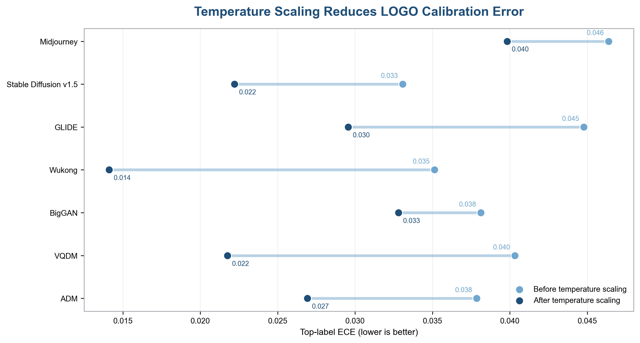
Figure 7: LOGO calibration error.
The mean confidence on wrong predictions decreases from approximately 0.8063 to 0.7786, a relative reduction of 3.43%. The absolute change appears smaller than the ECE change because many incorrect predictions remain decisively on the wrong side of the 0.5 boundary. Temperature scaling reduces their reported certainty but does not alter their class.
High-confidence errors decrease in every fold. The average count falls from 39.57 to 31.43, a 20.58% reduction. Midjourney decreases from 52 to 44; Stable Diffusion v1.5 from 36 to 25; GLIDE from 40 to 29; Wukong from 33 to 28; BigGAN from 35 to 28; VQDM from 42 to 34; and ADM from 39 to 32. The consistent direction across folds provides stronger descriptive evidence than an aggregate result alone.
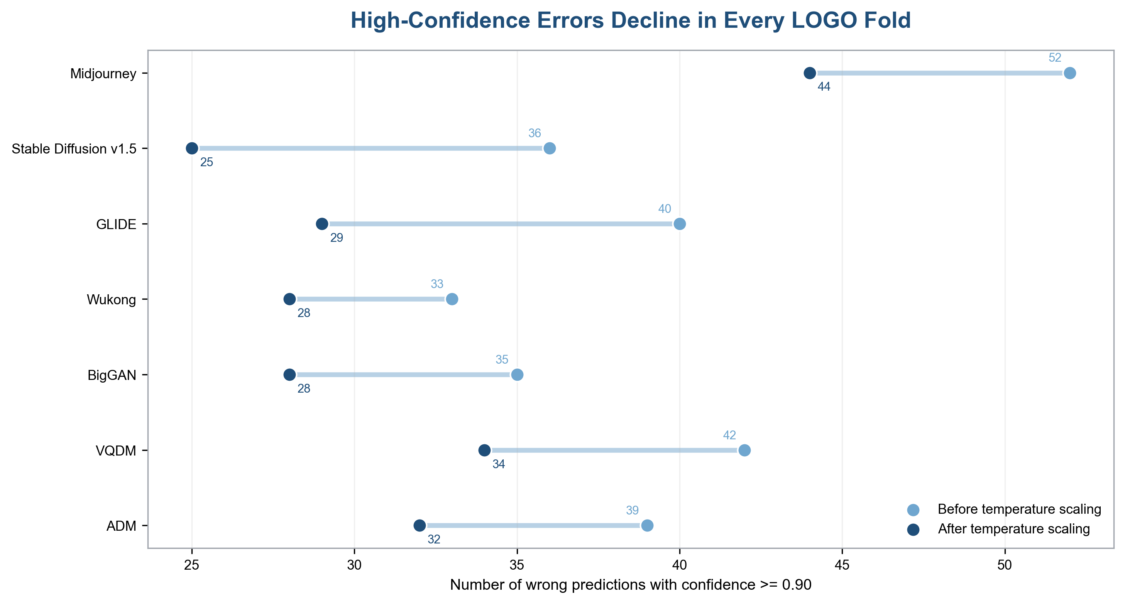
Figure 8: High-confidence errors.
Held-out | T | ECE raw | ECE scaled | Wrong conf. raw | Wrong conf. scaled | HCE raw → scaled
Midjourney | 1.1298 | 0.0464 | 0.0398 | 0.8143 | 0.7987 | 52 → 44
SD v1.5 | 1.2344 | 0.0331 | 0.0222 | 0.8054 | 0.7762 | 36 → 25
GLIDE | 1.2899 | 0.0448 | 0.0296 | 0.8022 | 0.7669 | 40 → 29
Wukong | 1.2493 | 0.0351 | 0.0141 | 0.7775 | 0.7467 | 33 → 28
BigGAN | 1.2196 | 0.0381 | 0.0328 | 0.8396 | 0.8096 | 35 → 28
VQDM | 1.2525 | 0.0403 | 0.0218 | 0.7965 | 0.7649 | 42 → 34
ADM | 1.1545 | 0.0379 | 0.0269 | 0.8087 | 0.7875 | 39 → 32
Mean | - | 0.0394 | 0.0267 | 0.8063 | 0.7786 | 39.57 → 31.43
Table 16: Per-generator LOGO calibration and high-confidence-error results.

4.3.3 Generator-Specific Reliability Profile
The risk-profile heatmap combines discrimination, calibrated ECE, confidence on errors, and class-conditional rates. Darker colour indicates a less favourable relative value within a column; it does not imply that one metric is numerically equivalent to another. Midjourney is least favourable on accuracy, AUROC, calibrated ECE, and false-negative rate. GLIDE has excellent AUROC and very low false-negative rate, but the highest false-positive rate. BigGAN has the best discrimination and zero false negatives, yet the highest calibrated confidence on its remaining wrong predictions.
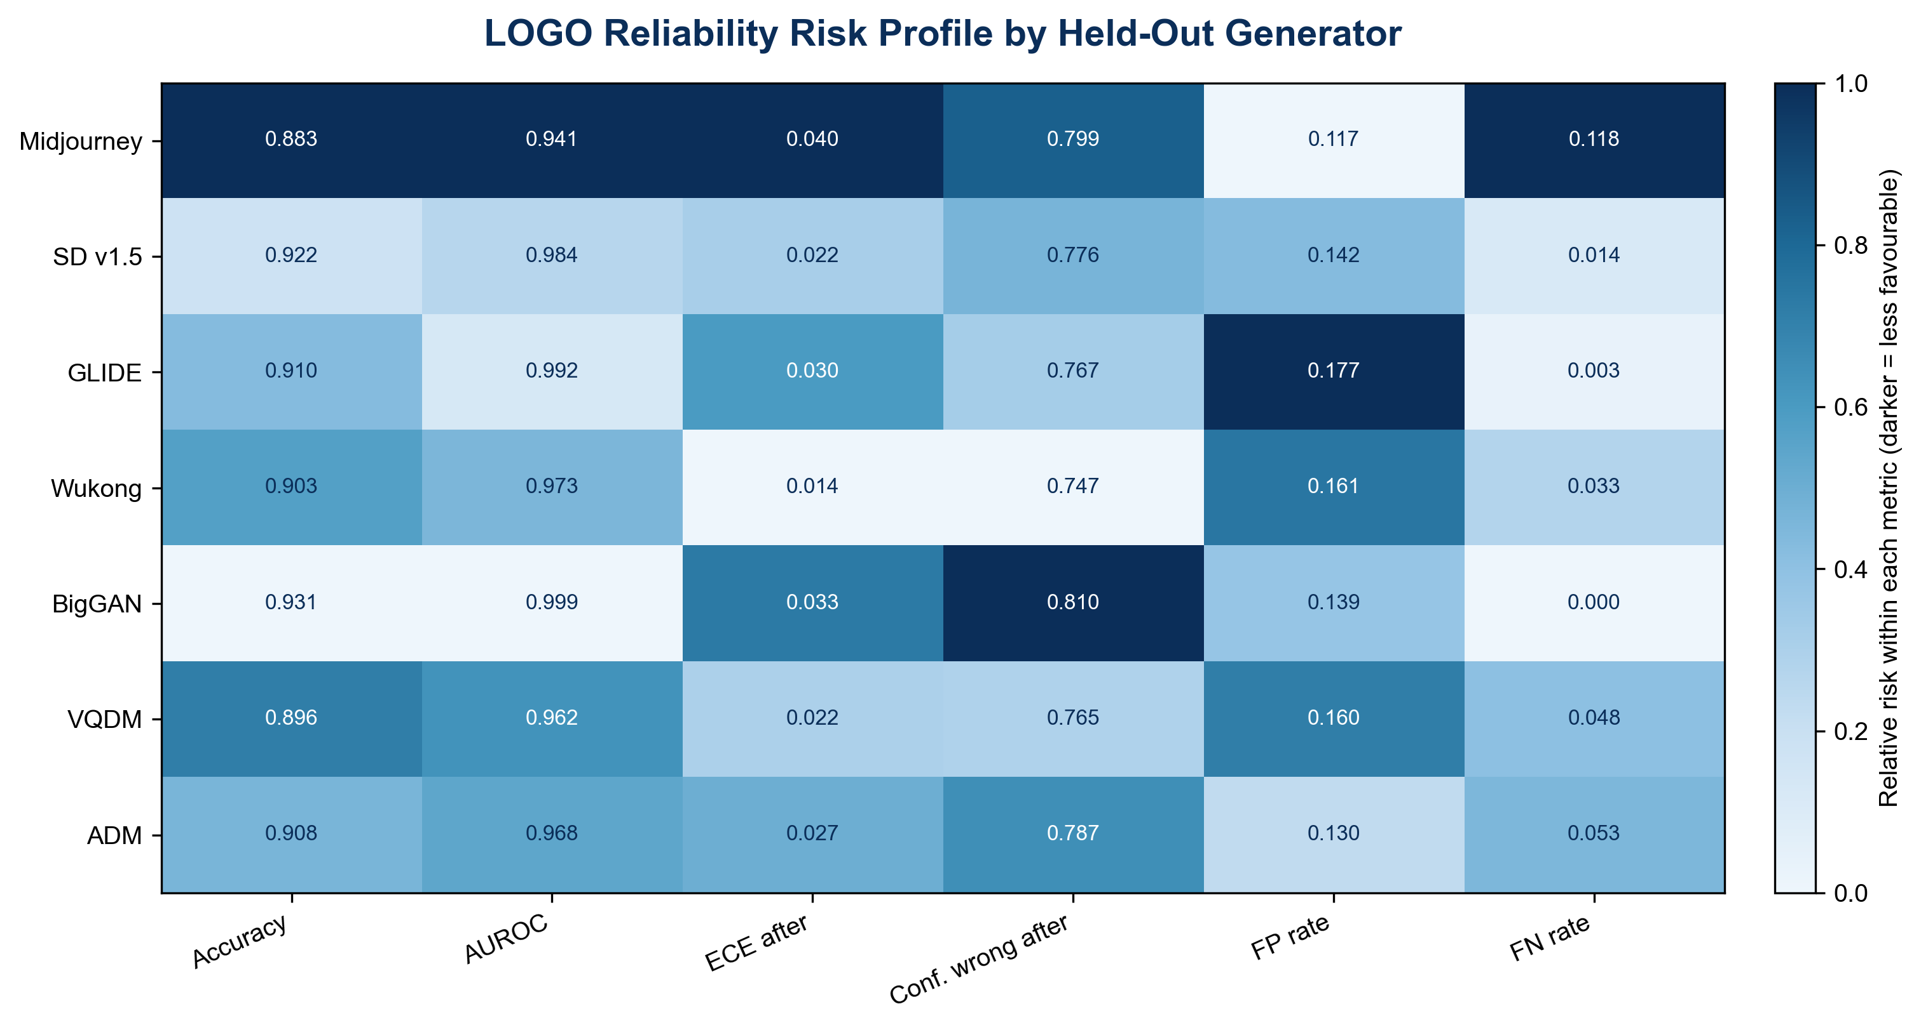
Figure 9: LOGO reliability risk profile.
This view prevents a one-dimensional ranking. For a content-moderation system concerned mainly with missing generated images, BigGAN and GLIDE appear favourable at the 0.5 threshold. For a Know Your Customer (KYC) system concerned with blocking legitimate images, GLIDE's false-positive burden is problematic. Midjourney combines lower ranking performance with balanced but substantial error counts. A deployment policy therefore needs class-specific costs and cannot select a model from AUROC alone.

4.4 Recent Cross-Dataset Stress Test

4.4.1 Overall Discrimination
On the 3,000-image recent sample, overall accuracy is 0.8117. Because AI images outnumber real images five to one, this value overstates class-balanced performance. Balanced accuracy is 0.6734 and AUROC is 0.7924. The decline from both closed-set and LOGO conditions is substantial.
The confusion matrix contains 233 true negatives, 267 false positives, 298 false negatives, and 2,202 true positives. Real-image specificity is only 0.4660, meaning 53.4% of the 500 legitimate MS COCO images are classified as AI-generated. AI recall is 0.8808. The detector is more successful at finding generated images than at accepting external real images, but the real-image false-positive burden would be unacceptable for an automated deny decision.
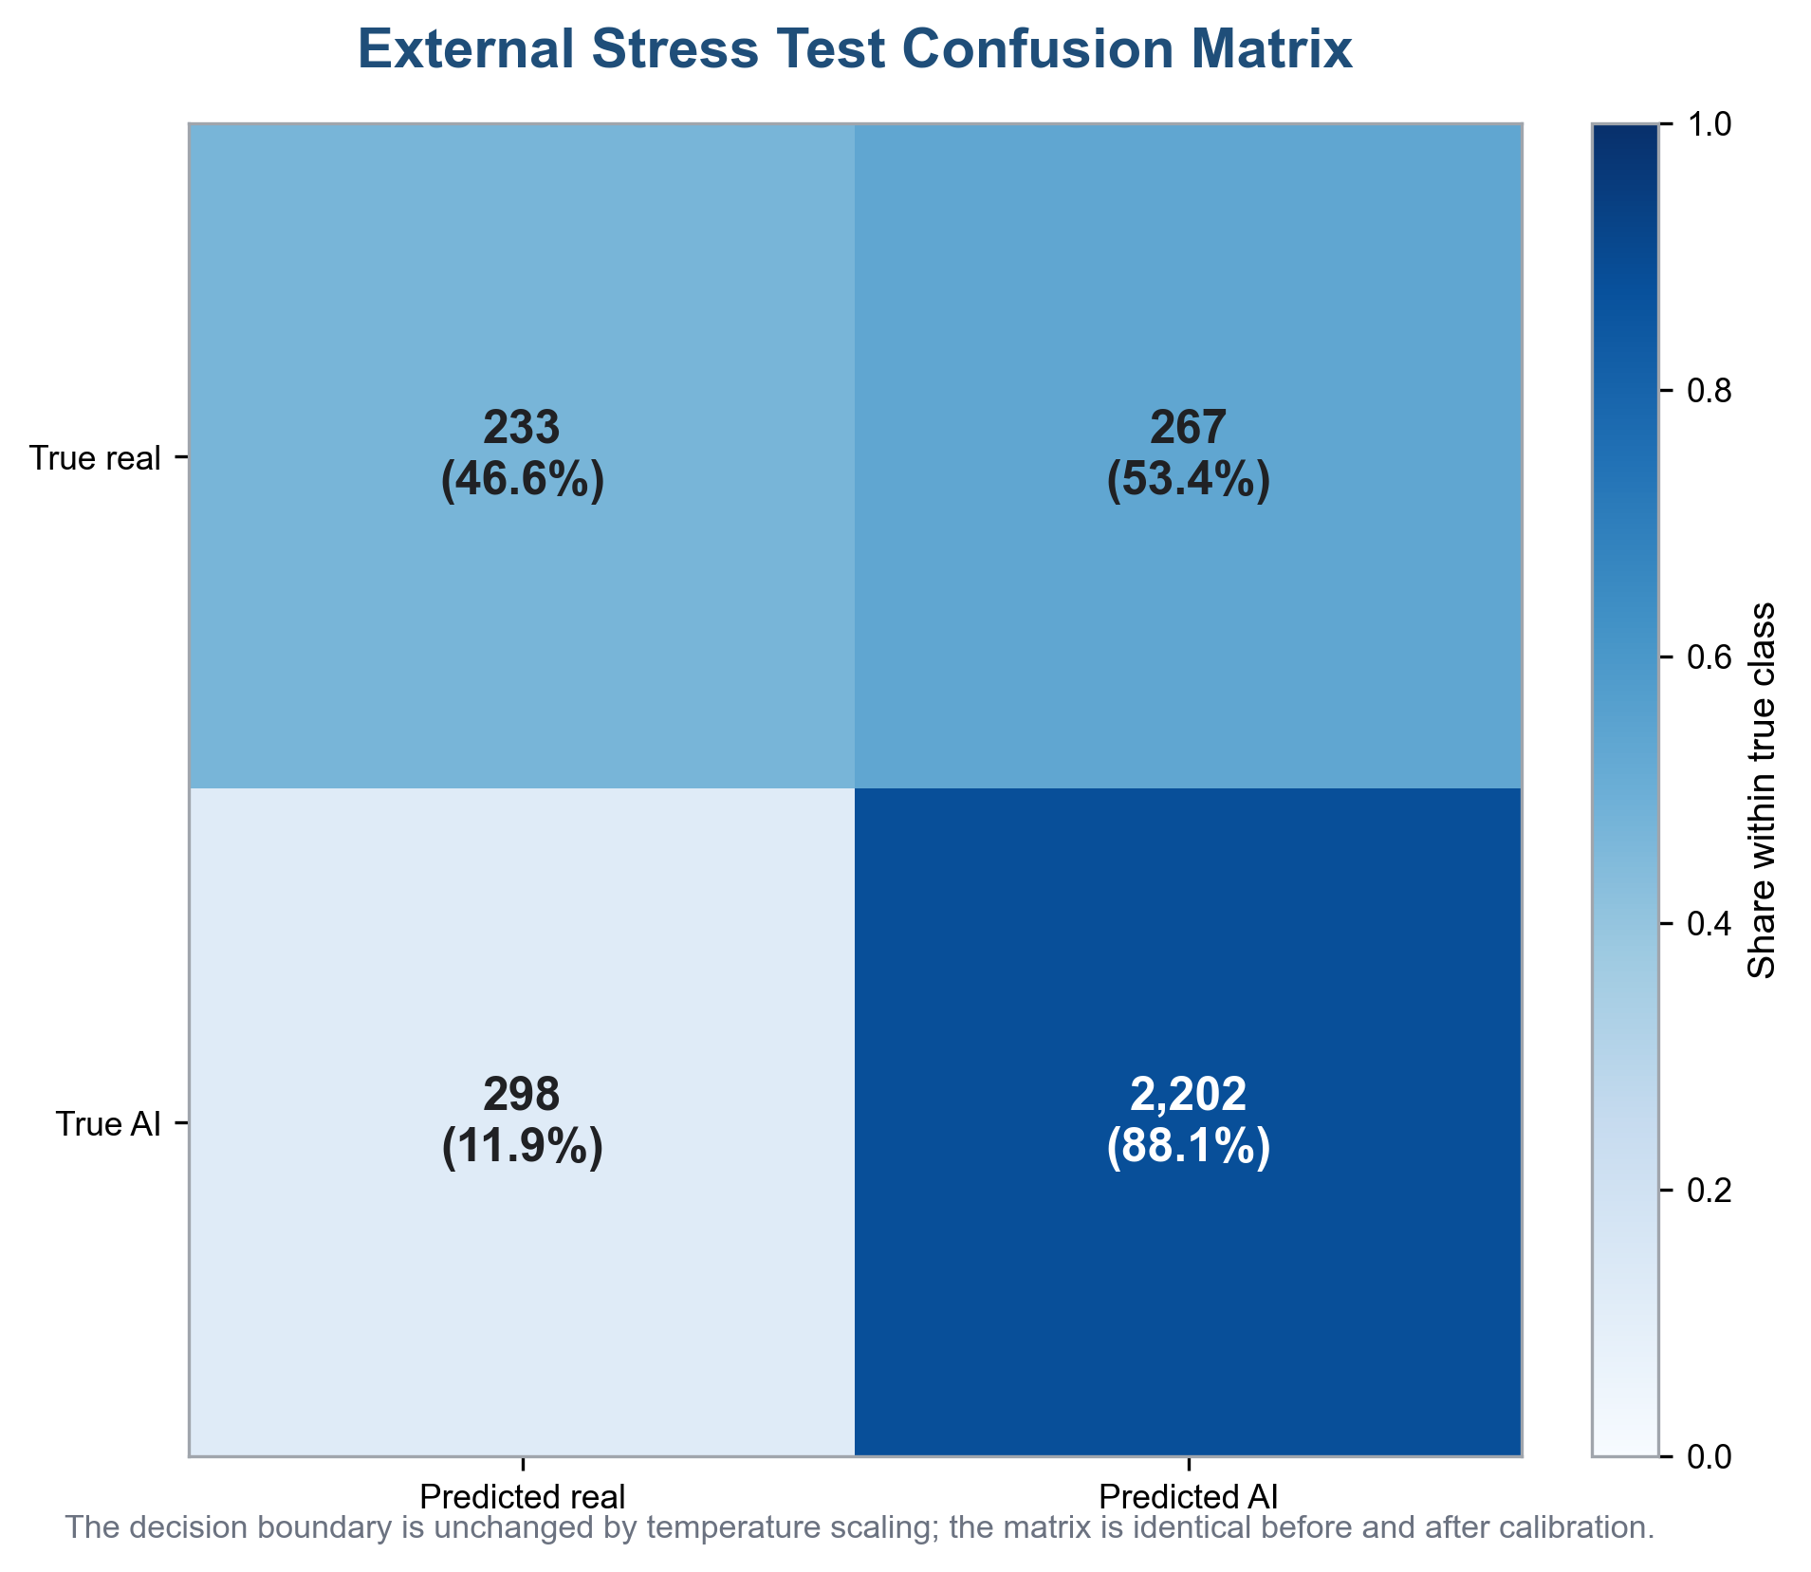
Figure 10: External confusion matrix.
Metric | Raw | T = 1.2408854103
Accuracy | 0.8117 | 0.8117
Balanced accuracy | 0.6734 | 0.6734
AUROC | 0.7924 | 0.7924
Log loss | 0.7333 | 0.6207
Brier score | 0.1577 | 0.1520
Top-label ECE (15 bins) | 0.1357 | 0.1201
Confidence on wrong | 0.8782 | 0.8525
HCE count | 330 | 283
HCE / all | 0.1100 | 0.0943
HCE / high-confidence | 0.1347 | 0.1222
High-confidence total | 2,449 | 2,316
TN / FP / FN / TP | 233 / 267 / 298 / 2,202 | unchanged
Table 17: External stress-test metrics before and after final-temperature recalibration.
The result does not isolate a single cause. The model encounters newer generators, MS COCO rather than Nature real images, different content, and potentially different file processing. The evidence supports the claim that reliability degrades under broader deployment shift. It does not support attributing all degradation to one new generator.

4.4.2 External Calibration Transfer
Before recalibration, the external top-label ECE with fifteen bins is 0.1357. Applying the final primary validation temperature reduces it to 0.1201, an 11.46% relative reduction. Log loss decreases from 0.7333 to 0.6207, a 15.35% reduction, and Brier score decreases from 0.1577 to 0.1520, a 3.64% reduction. Mean confidence on wrong predictions decreases from 0.8782 to 0.8525, a 2.92% reduction.
The number of high-confidence errors decreases from 330 to 283, a 14.24% reduction. The HCE fraction over all 3,000 images decreases from 0.1100 to 0.0943. Among high-confidence predictions, the error fraction decreases from 0.1348 to 0.1222, a 9.32% relative reduction. The total number of high-confidence predictions decreases from 2,449 to 2,316.
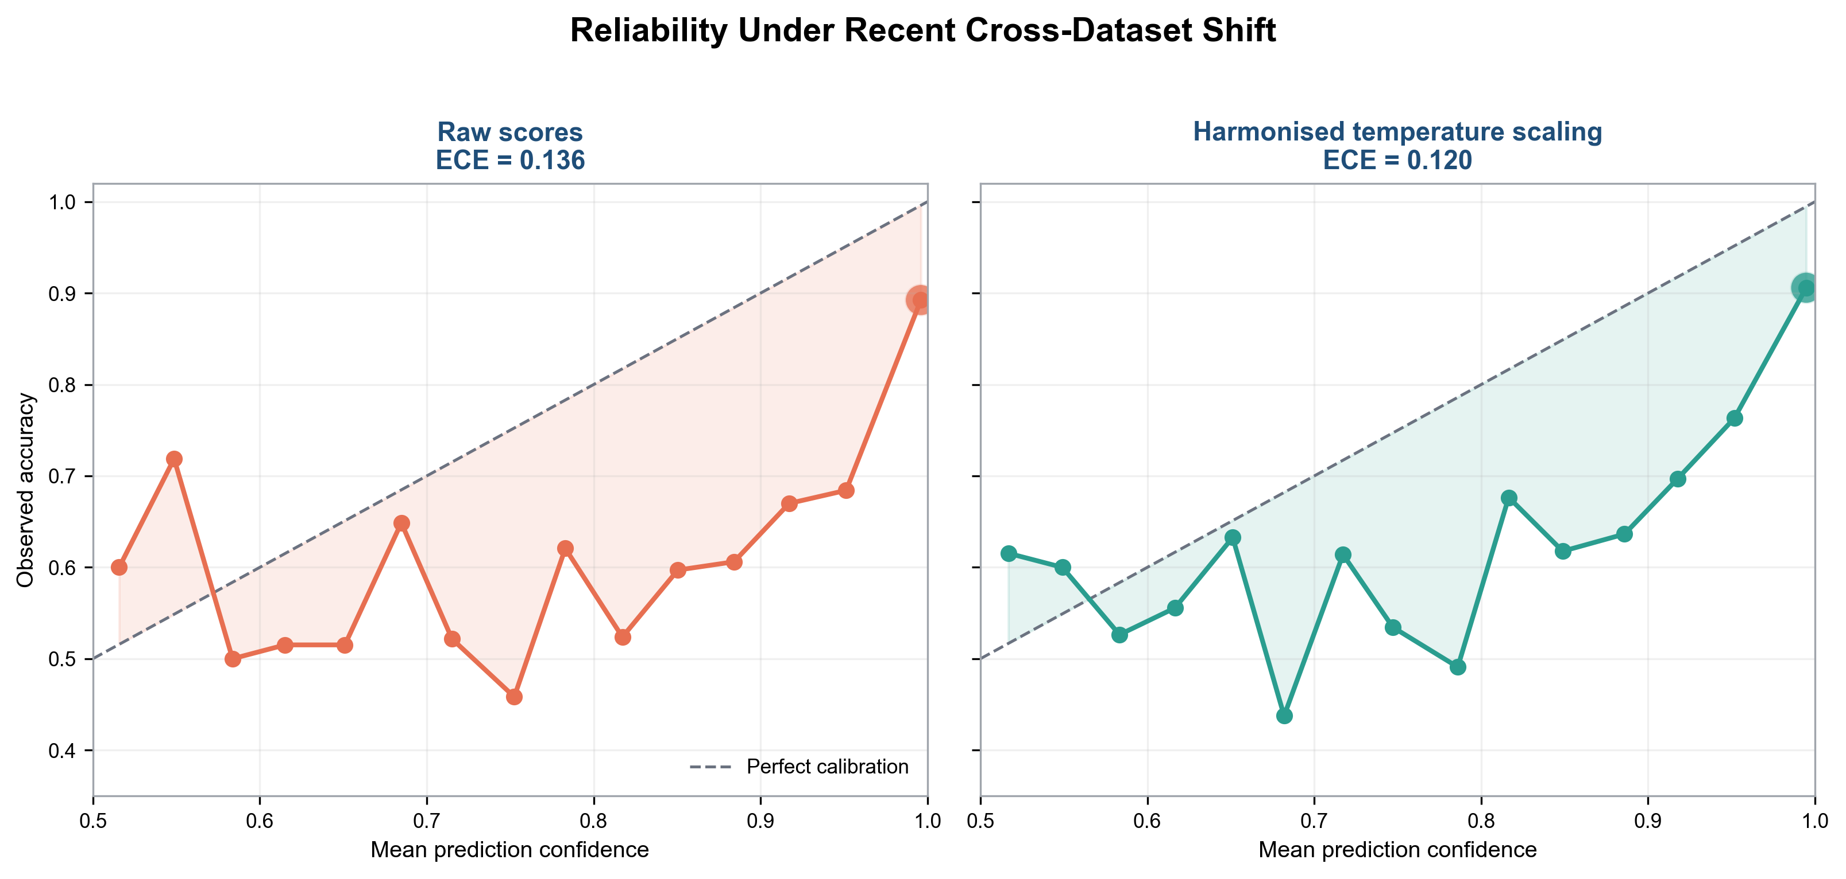
Figure 11: External reliability.
The reliability curves remain below the ideal line over much of the high-confidence range, indicating residual overconfidence. Temperature transfer improves all reported probability-quality measures but does not make the external scores fully calibrated. As expected, accuracy, balanced accuracy, AUROC, and the confusion matrix are unchanged.

4.4.3 Source-Level External Results
Each source-level pair contains the same 500 MS COCO real images and 500 generated images from one system. DALL-E 3 has the highest paired accuracy (0.7110) and AUROC (0.8885). Stable Diffusion 2.1 follows with AUROC 0.8163. Stable Diffusion 3 reaches accuracy 0.6780 and AUROC 0.7771. Midjourney v6 and SDXL have paired accuracies of 0.6480 and 0.6450 and AUROCs of 0.7541 and 0.7259 respectively.
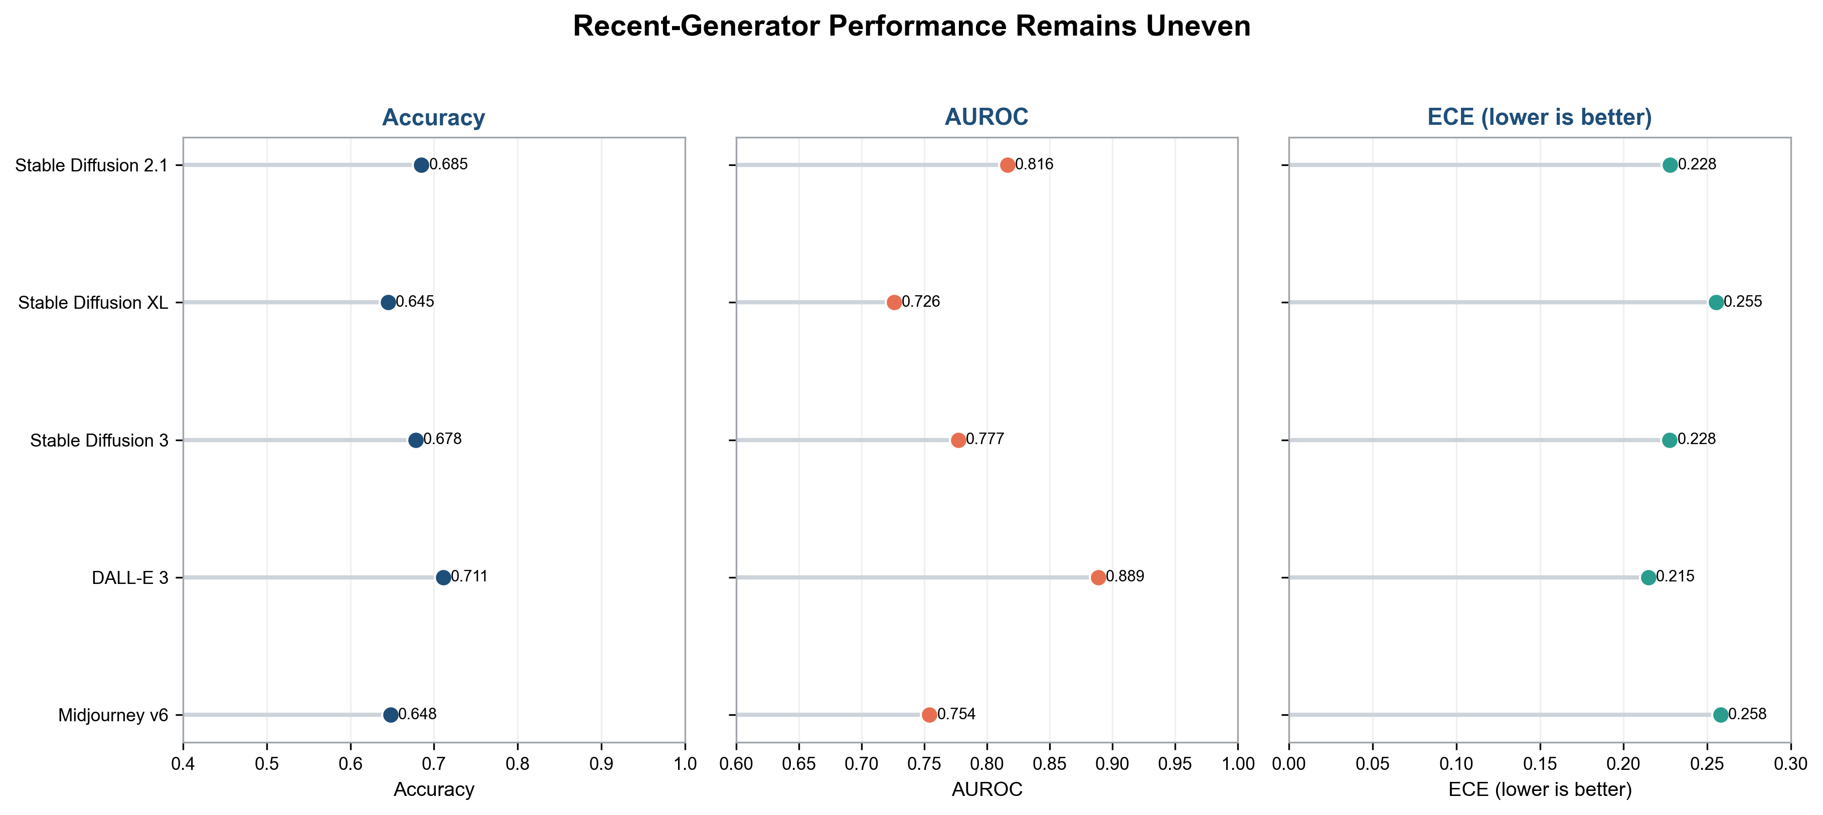
Figure 12: External source performance.
AI source paired with 500 real images | Accuracy | AUROC | ECE | Confidence on wrong | HCE | TN / FP / FN / TP
Stable Diffusion 2.1 | 0.6850 | 0.8163 | 0.2279 | 0.8709 | 178 | 233 / 267 / 48 / 452
Stable Diffusion XL | 0.6450 | 0.7259 | 0.2553 | 0.8675 | 198 | 233 / 267 / 88 / 412
Stable Diffusion 3 | 0.6780 | 0.7771 | 0.2276 | 0.8676 | 182 | 233 / 267 / 55 / 445
DALL-E 3 | 0.7110 | 0.8885 | 0.2149 | 0.8728 | 170 | 233 / 267 / 22 / 478
Midjourney v6 | 0.6480 | 0.7541 | 0.2581 | 0.8697 | 199 | 233 / 267 / 85 / 415
Table 18: External paired source-level metrics after final-temperature recalibration.
Paired accuracy should be interpreted carefully because the same 267 false positives on real images are included in every pair. Differences are driven by generator false negatives and score ranking. DALL-E 3 has only 22 false negatives, while SDXL has 88 and Midjourney v6 has 85. The common real-image problem means that even the strongest generator pair is not suitable for automatic action without additional controls.

4.4.4 Class-Conditional Failure Attribution
Overall external accuracy hides a security-relevant asymmetry. Of 500 MS COCO real images, 267 were classified as AI-generated, giving a false-positive rate of 0.534. Of 2,500 generated images, 298 were classified as real, giving an aggregate false-negative rate of 0.1192. Positive temperature scaling leaves the 0.5-threshold labels unchanged, so the counts apply before and after calibration.
Source | Error | Errors / n | Rate | Wilson 95% interval
MS COCO real | FP | 267 / 500 | 0.534 | 0.490-0.577
Stable Diffusion 2.1 | FN | 48 / 500 | 0.096 | 0.073-0.125
Stable Diffusion XL | FN | 88 / 500 | 0.176 | 0.145-0.212
Stable Diffusion 3 | FN | 55 / 500 | 0.110 | 0.085-0.140
DALL-E 3 | FN | 22 / 500 | 0.044 | 0.029-0.066
Midjourney v6 | FN | 85 / 500 | 0.170 | 0.140-0.205
Table 19: External error attribution.
The dominant external failure is rejection of legitimate real content. Automatic blocking would create a substantial denial burden in this sample. DALL-E 3 has the lowest observed false-negative rate, whereas Stable Diffusion XL and Midjourney v6 are more difficult at the fixed threshold. These are conditional sample results, not population-wide generator rankings.

4.4.5 Statistical Uncertainty and Interpretation
The Wilson intervals in Table 19 quantify binomial sampling uncertainty for each observed error count. They do not include uncertainty from retraining, dataset construction, prompt selection, or dependence among related images. They are descriptive intervals for the saved 500-image source samples rather than complete deployment-performance bounds.
Evidence | Direct support | Remaining uncertainty
Closed set | Strong familiar-split discrimination | Single saved training trajectory
Seven-fold LOGO | Each generator unseen in one fresh fold | No repeated seeds per fold
External sample | Combined generator and real-source shift | Shift factors not causally separable
Temperature scaling | Improved confidence within protocol | No repair of decision boundary
Wilson intervals | Sampling uncertainty of error proportions | No model-selection uncertainty
Table 20: Statistical interpretation.
The evidence is strongest when claims remain at the tested level. LOGO describes seven named exclusions within Unbiased Tiny GenImage. The external result describes one reproducible stratified Defactify sample. Neither guarantees performance on all future generators. Open-set recognition remains an evolving problem, and strong closed-set discrimination does not remove the need to test unknown inputs explicitly [13]-[16].
For an IEEE paper, the central result should be framed as reliability under two complementary shifts: controlled generator exclusion and broader cross-dataset stress. Exact sample composition, confidence definitions, ECE binning, and class-conditional errors make the claim auditable and prevent one aggregate score from obscuring operational risk.

4.5 Cross-Experiment Synthesis
The three evaluation conditions form a severity progression. Closed-set fine-tuning produces accuracy 0.9571 and AUROC 0.9921. Controlled generator exclusion reduces mean accuracy to 0.9075 and mean AUROC to 0.9741. The broader external test reduces accuracy to 0.8117, balanced accuracy to 0.6734, and AUROC to 0.7924. Because class balance and data provenance differ, these are not three points on a single formal shift scale. They nevertheless show that favourable familiar-data results do not guarantee external reliability.
Figure 13 presents the comparison as a reliability evidence board rather than as another performance graph. Each column combines discrimination, the before-and-after calibration transition, high-confidence errors, the principal observed failure mode, and the strongest operational claim supported by the evidence. The format prevents one favourable metric from visually dominating the deployment interpretation. In particular, the external column places the unchanged 53.4% real-image false-positive rate beside the improvement in ECE and HCE, making clear that better confidence quality does not repair the shifted classification boundary.
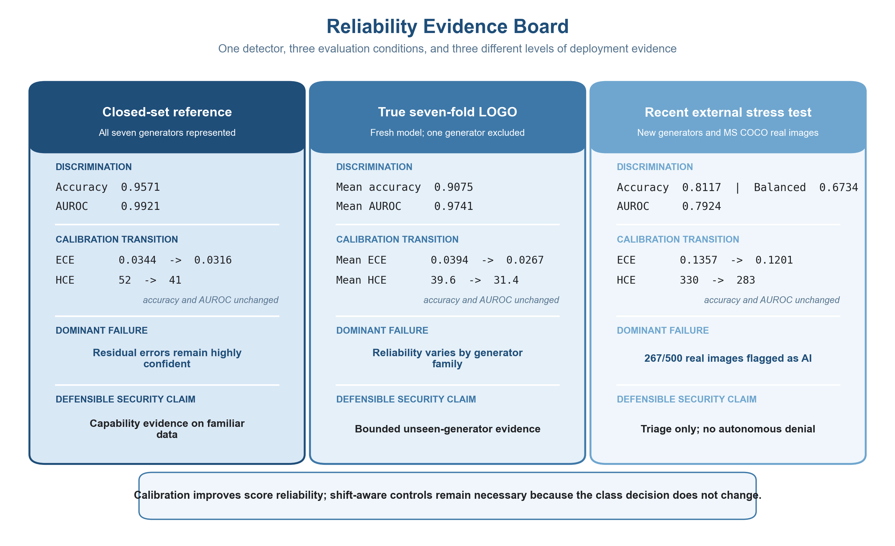
Figure 13: Reliability evidence board.

4.5.1 Cybersecurity Interpretation of Existing Results
The results have direct consequences for cybersecurity use. The LOGO reduction shows that a detector may become less dependable when attackers adopt a generator that was not represented during development. The external false-positive rate shows a different danger: a shifted detector can incorrectly treat legitimate images as suspicious and create denial-of-service or wrongful-review risk. At the same time, the 298 missed external AI images show that the detector cannot independently prevent synthetic evidence from entering a workflow.
Existing evidence | Security risk | Application consequence | Required control
Closed-set accuracy 0.9571 | Residual errors remain even on familiar data | Do not treat a binary output as proof | Use the score only with corroborating evidence
LOGO mean accuracy 0.9075 | New generators reduce and vary reliability | A newly released generator may evade familiar rules | Test new sources and route novel cases to review
External real FPR 0.5340 | Legitimate external images are frequently flagged | Automatic blocking could deny service to genuine users | Require human review and an appeal path
External AI recall 0.8808 | 298 of 2,500 generated images were missed | Synthetic fraud evidence may be accepted | Combine provenance, behaviour, metadata, and liveness
External HCE 330 → 283 | Calibration reduces exaggerated confidence but not errors | Some wrong decisions become less likely to bypass review | Version calibration and monitor high-confidence incidents
Table 21: Cybersecurity interpretation of the existing experimental results.
These findings support one application rule: the model should prioritise or support an investigation, not make a final authenticity or fraud decision. A calibrated probability can help determine which cases need attention, but intent and origin require additional evidence.

4.5.2 Calibration Benefit and Boundary
Temperature scaling provides a consistent but bounded benefit. Closed-set ECE decreases 7.98%, mean LOGO ECE decreases 32.09%, and external ECE decreases 11.46% using each protocol's own estimator. High-confidence errors decrease 21.15% in the closed-set result, 20.58% on average across LOGO folds, and 14.24% externally. Accuracy and AUROC are unchanged throughout.
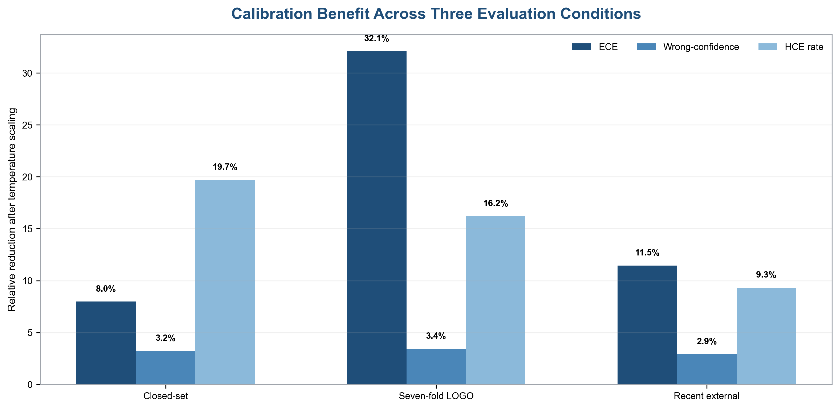
Figure 14: Calibration effects.
Condition | Accuracy | AUROC | Calibration reduction | HCE reduction | Boundary
Closed-set fine-tuned | 0.9571 | 0.9921 | 7.98% ECE | 21.15% HCE count | Familiar stratified split
Seven-fold LOGO mean | 0.9075 | 0.9741 | 32.09% ECE | 20.58% mean HCE | One unseen generator per fold
Recent external | 0.8117 | 0.7924 | 11.46% ECE | 14.24% HCE count | Balanced accuracy 0.6734
Table 22: Cross-experiment evidence summary with comparison boundaries.
These results establish the central distinction of the thesis. Calibration improves the interpretation of model scores, especially by reducing the most confident mistakes, but it does not restore discrimination or class-conditional accuracy under shift. The external false-positive rate remains 53.4%. A security team that uses calibration as a substitute for retraining, shift detection, or human review would therefore misapply the result.

4.6 Chapter Summary
Fine-tuning transforms the ResNet-50 from a chance-ranking baseline into a strong closed-set detector. True LOGO evaluation reveals a moderate and generator-dependent generalisation penalty. The recent external test reveals a much larger degradation and a serious false-positive problem on changed real-image provenance. Temperature scaling improves ECE and high-confidence-error measures in all three conditions without changing discrimination. Class-conditional attribution and Wilson intervals expose the external false-positive burden while preserving sample limits.

5 Conclusion and Results

5.1 Interpreting the Closed-Set Improvement
The difference between the baseline and the fine-tuned model confirms that general ImageNet representation is not sufficient for the target decision. The baseline AUROC of 0.4994 indicates no useful ordering of real and AI images. The fine-tuned AUROC of 0.9921 shows that the dataset contains highly learnable evidence once the representation adapts. This evidence may include transferable synthesis features, generator fingerprints, content correlations, or preprocessing cues. The experiment demonstrates capability but does not identify which cues dominate.
The baseline accuracy of 0.5722 should not be described as better-than-random task knowledge. The test split contains 75% AI images, so an always-AI classifier would achieve approximately 0.75 accuracy. AUROC is the more informative baseline statistic because it is insensitive to this fixed class prevalence. This illustrates why the thesis reports multiple metrics and why older narrative claims based on accuracy alone were removed.
Fine-tuning also moves almost all predictions toward extreme confidence. The number of predictions above 0.90 increases from 126 to 2,205. The fraction of errors among those predictions falls sharply, but the absolute count rises from 30 to 52. This is not a contradiction. A much stronger model can place more correct and incorrect samples into a high-confidence region. Temperature scaling then reduces the highly confident error count to 41 while preserving labels.

5.2 Effect of Generator-Level Open-Set Shift
The LOGO experiment provides the cleanest answer to the generator-shift part of the main research question. Mean accuracy falls by approximately 4.96 percentage points relative to the closed-set fine-tuned result, from 0.9571 to 0.9075. Mean AUROC falls from 0.9921 to 0.9741. The held-out family therefore affects both thresholded decisions and ranking, even though the detector remains useful on average.
The variation across folds indicates that "unseen generator" is not one homogeneous condition. BigGAN is detected with near-perfect ranking, while Midjourney is noticeably harder. This may reflect architectural similarity with seen generators, the persistence of fingerprints, content composition, or image-processing differences. The current artifacts cannot distinguish these mechanisms. What they do establish is that reporting only the fold mean would conceal operationally relevant variability.
False-positive behavior is also fold dependent even though the LOGO real test partition is common. This occurs because every fold produces a different trained decision boundary. The GLIDE fold labels 103 of 583 real images as AI, whereas the Midjourney fold labels 68. Holding out a generator changes what the model learns from the remaining AI families and therefore changes its treatment of real images. Open-generator generalisation is not solely about recall on the unseen positive source; it can alter legitimate-user burden.
These observations are consistent with prior work on generator fingerprints and generalisation [17], [20], [22], [26]-[30]. Shared synthesis operations permit transfer, but no fixed feature family is guaranteed to survive changes in architecture, data, or decoding. The LOGO result is stronger than generator-wise evaluation of one pooled model because it measures the cost of exclusion. It remains narrower than a real open-world deployment because all seven families come from one curated dataset and the held-out identities are known to the experimenter.

5.3 Effect of Broader Cross-Dataset Shift
The external result is more severe than LOGO. Balanced accuracy falls to 0.6734 and AUROC to 0.7924. The most significant operational result is the 0.5340 false-positive rate on MS COCO real images. More than half of legitimate external real images would be flagged at the analytical 0.5 threshold. In a KYC or evidence-ingestion workflow, automatic rejection at this threshold would create unacceptable harm and review volume.
The external result combines several shifts, so it should be interpreted as a stress test. Newer generators are present, but the negative class also changes from Nature images to MS COCO scenes. The model may have learned aspects of the primary real-image collection as well as synthesis evidence. Differences in JPEG encoding, resolution, subject distribution, and preprocessing can contribute. This class-conditional failure is precisely why one should test a new real source rather than evaluating only newer generated images.
Overall accuracy of 0.8117 is potentially misleading because 2,500 of 3,000 images are AI-generated and AI recall remains 0.8808. A system can achieve an apparently respectable overall accuracy while treating real images poorly. Balanced accuracy, specificity, and confusion counts expose this. Any publication or deployment report should foreground class-conditional reliability rather than only overall accuracy.
The source-level external pairs show that newer generators differ. DALL-E 3 is ranked more effectively than SDXL and Midjourney v6. Yet all pairs inherit the same 267 false positives. The central deployment weakness is therefore not confined to one generator; it includes the model's concept of what a real image looks like. Future training data should diversify real-image sources as deliberately as synthetic sources.

5.4 Does Temperature Scaling Solve Overconfidence?
Temperature scaling consistently improves the measured probability quality, but "solve" would be too strong. In the closed-set result it reduces ECE by 7.98%, mean confidence on errors by 3.23%, and HCE count by 21.15%. Across LOGO folds it reduces mean ECE by 32.09% and mean HCE count by 20.58%. On the external sample, transferred scaling reduces ECE by 11.46%, log loss by 15.35%, Brier score by 3.64%, and HCE count by 14.24%.
The consistency of HCE reduction is important. Every LOGO fold has fewer wrong predictions above 0.90 after scaling, and the external result also improves without fitting on external labels. This supports the practical value of a separate calibration layer. A security policy can receive less exaggerated probabilities and send more borderline cases to review instead of treating them as certain.
Residual overconfidence remains. External mean confidence on wrong predictions is 0.8525 after scaling, and 283 wrong predictions remain above 0.90. The reliability diagram remains below the ideal diagonal over much of the high-confidence region. A single scalar cannot correct class-specific, source-specific, or non-monotonic calibration errors. The external temperature is also transferred from a different validation distribution, so its improvement should not be assumed permanent as deployment data change.
Most importantly, temperature scaling does not change the confusion matrix. The 267 external false positives and 298 false negatives remain. Calibration improves the meaning of the score but not the decision boundary. This is mathematically expected and empirically confirmed. The method should be described as confidence-risk mitigation, not detector repair.

5.5 Answer to the Main Research Question
The main research question asks: How does open-set generator shift affect the reliability of AI-generated image detectors in cybersecurity deployment scenarios?
In this thesis, open-set generator shift is operationalised as testing on a generator excluded from training and validation, as specified in Section 3.3. The evidence shows that this shift reduces reliability and makes performance generator dependent. Under true LOGO, mean accuracy decreases from the closed-set 0.9571 to 0.9075 and mean AUROC decreases from 0.9921 to 0.9741. Accuracy ranges from 0.8825 to 0.9305 across held-out generators, and false-positive and false-negative patterns vary substantially. Thus, a strong closed-set result does not transfer uniformly to unseen generation mechanisms.
The broader external condition shows that deployment shift can be more damaging than controlled generator exclusion. Balanced accuracy decreases to 0.6734, AUROC to 0.7924, and the real-image false-positive rate reaches 0.5340. In cybersecurity terms, this means a detector trained and validated on one benchmark can create both false assurance and denial-of-service risk when data provenance changes. Reliability must therefore be evaluated on unseen generators and representative real-image sources before scores are allowed to trigger automated action.
The answer is bounded to ResNet-50, the named datasets, and the sampled conditions. It does not establish the behaviour of all detectors or introduce an unknown output class. It establishes that unseen generators and broader dataset shift are material reliability risks for this detector, and that mean performance alone hides source- and class-specific failure.

5.6 Answer to the Calibration Sub-Question
The sub-question asks: Can post-hoc temperature scaling improve confidence calibration and reduce high-confidence errors under such distribution shift without affecting classification accuracy?
Yes, within the evaluated protocols. Temperature scaling reduces ECE and high-confidence errors in the final closed-set result, in every LOGO fold, and in the external stress-test recalculation. It leaves accuracy and AUROC unchanged because positive scalar scaling preserves logit sign and ordering. The result directly satisfies the "without affecting classification accuracy" condition.
The answer requires two qualifications. First, ECE uses different saved estimators across protocols, so the valid evidence is the before/after improvement within each protocol rather than an absolute ranking of ECE values. Second, calibration does not correct classification errors. On the external sample, scores improve while balanced accuracy remains 0.6734 and the confusion matrix remains poor. Temperature scaling is therefore an effective lightweight confidence correction, but it is not sufficient for deployment by itself.
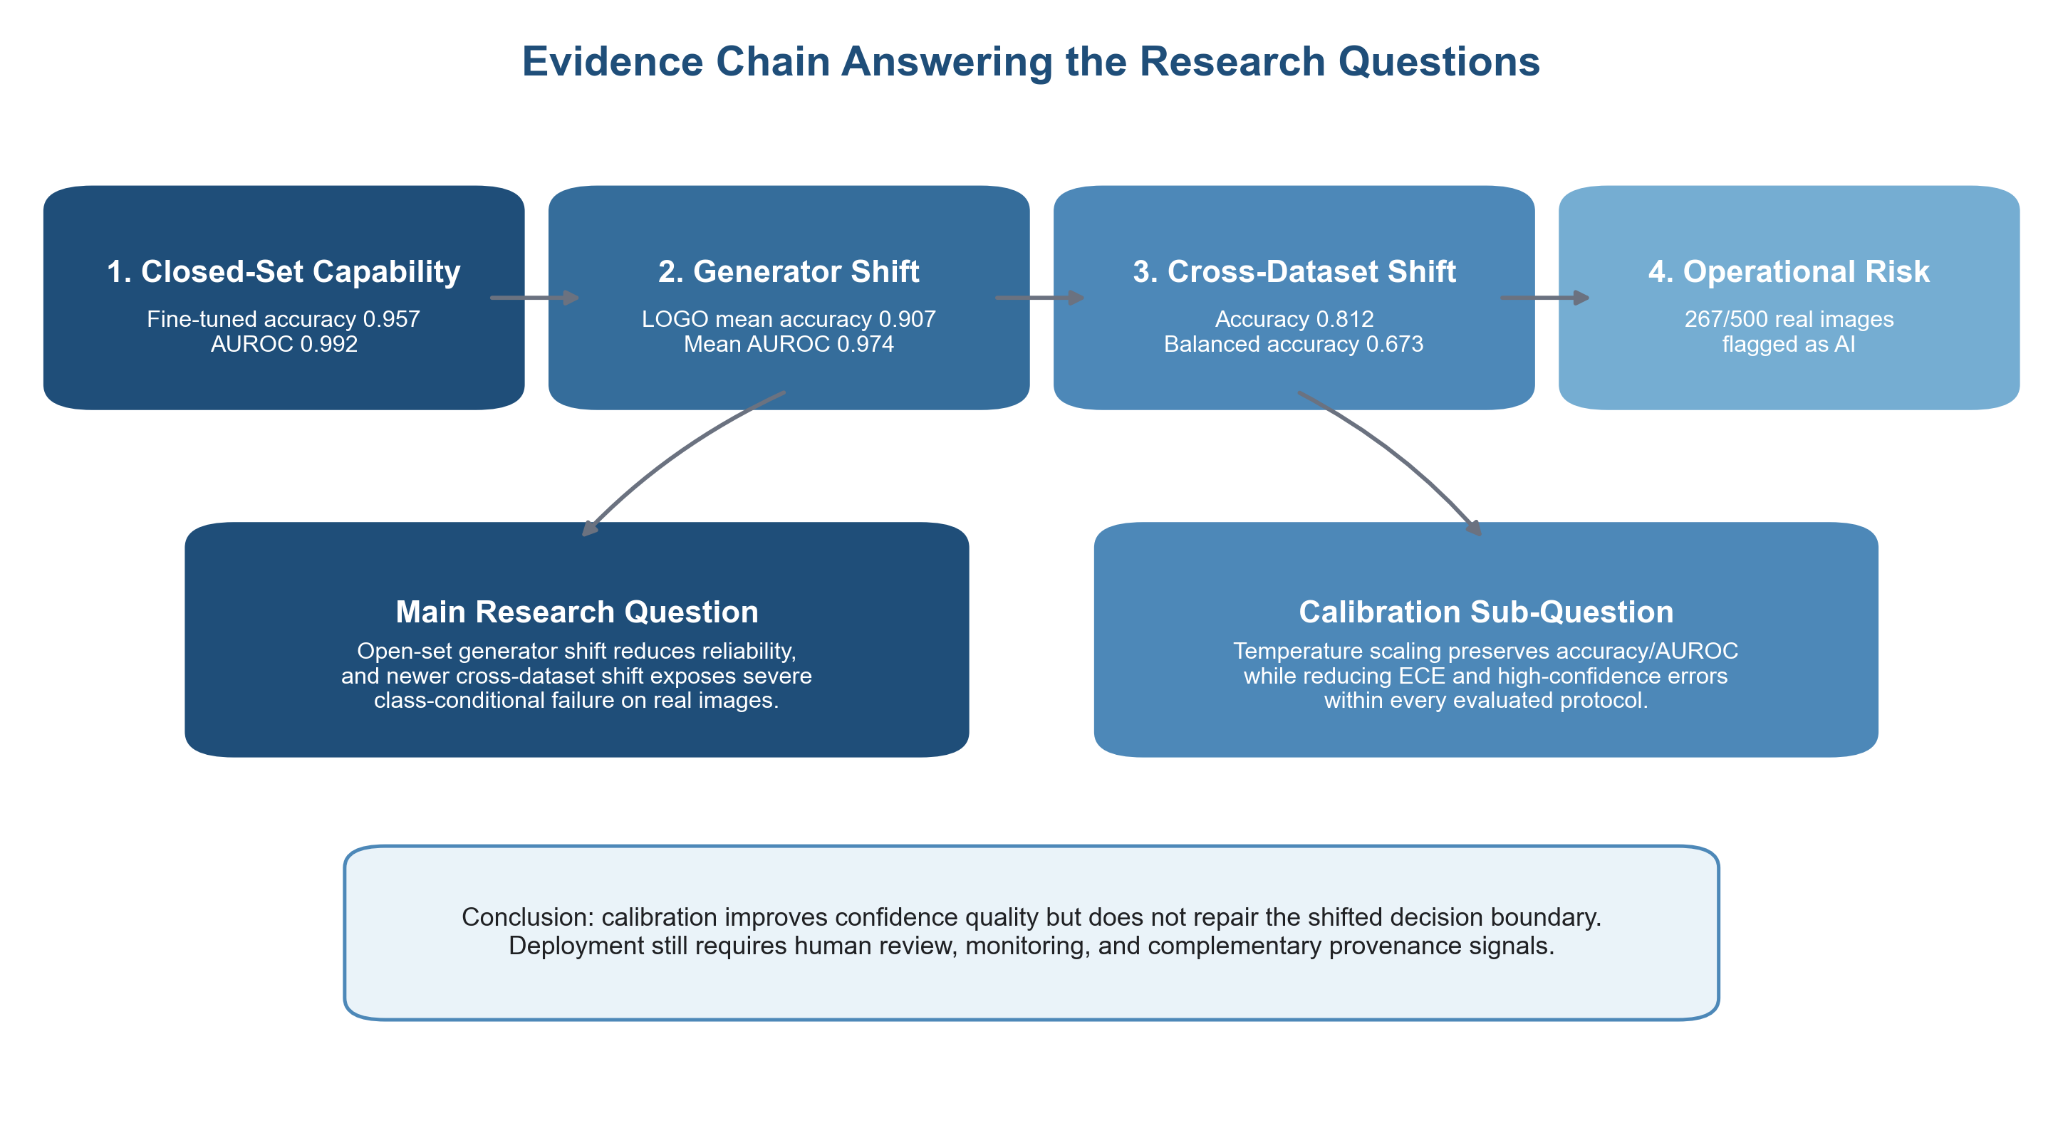
Figure 15: Research evidence chain.

5.7 Cybersecurity Meaning of High-Confidence Errors
A high-confidence error can be more harmful than an uncertain error because automation is likely to trust it. In an identity workflow, a high-confidence false positive can block or delay a legitimate user. A high-confidence false negative can allow synthetic evidence to proceed without review. In moderation, the same errors can cause wrongful removal or missed harmful content. In incident triage, they can misdirect scarce analyst attention.
The 0.90 threshold used here is analytical rather than universally optimal. Its value is that it identifies a region defines the high-confidence region used in this analysis. The closed-set and LOGO reductions show that calibration can move some wrong predictions out of that region. The external result shows that many remain. A policy should therefore avoid a single symmetric rule such as "accept real below 0.10 and block synthetic above 0.90" until threshold-specific false-positive and false-negative costs have been tested on deployment data.
High confidence should also be separated from high evidentiary weight. A calibrated 0.95 probability is a statement about model behaviour under an evaluated distribution, not proof of image origin and not proof of malicious intent. Security decisions require corroboration. Provenance credentials, metadata integrity, account history, reverse-image search, liveness checks, and analyst review can provide independent evidence [1], [2], [4].

5.8 Threats to Validity

5.8.1 Internal Validity
The final results were assembled from saved artifacts produced across several notebook runs. This creates a risk of mixing stale values. The audit mitigates it by selecting the downloaded JSON files co-located with the final model, the completed combined LOGO summary, and the external per-image predictions. Arithmetic invariants and unchanged decision metrics after scaling were checked. Training histories for the authoritative final run were not available as a separate artifact, so claims about exact best epoch or wall-clock time are avoided.
Randomness can affect fine-tuning. The experiments use fixed seeds, but GPU kernels and data-pipeline operations may not be perfectly deterministic. LOGO reports one run per held-out generator rather than repeated seeds. Variation across folds therefore includes generator difficulty and optimisation noise. Repeated-seed confidence intervals would strengthen a publication.

5.8.2 Construct Validity
The term open set is restricted to unseen generator family with a known binary label. The model does not reject unknowns. This limitation is stated to prevent construct inflation. ECE is estimator dependent, and the three protocols do not share one exact definition. Harmonisation preserves valid within-protocol comparisons but cannot make the absolute values identical.
The high-confidence threshold is a proxy for operational risk, not a measured business loss. Average confidence on wrong predictions similarly weights all errors equally. A real deployment should connect errors to case severity, user impact, and review outcomes.

5.8.3 External Validity
The primary dataset is a curated subset, one backbone is evaluated, and the external experiment uses 3,000 rather than all available images. The findings should not be generalised to every generator, image domain, post-processing operation, or detector architecture. The external sample is useful because it is recent and stratified, but a paper-quality extension should evaluate the full dataset and several seeds.
No adversarial attack is executed. An attacker could deliberately remove artifacts, optimise against the detector, exploit compression, or probe score responses. Reliability under natural dataset shift is a necessary baseline, not an adversarial robustness guarantee.

5.8.4 Conclusion Validity
The result tables report descriptive statistics and fold means. Seven LOGO folds are generator conditions, not independent random draws from a known population of all possible generators. Standard deviations describe variability among these seven folders but should not be read as population uncertainty. Claims therefore remain empirical: all evaluated folds improved after calibration, and the observed generator shift reduced average performance.

5.9 Comparison with Prior Work
The strong closed-set accuracy aligns with literature showing that generated images are often easy to detect under matched conditions [5], [6]. The reduction under LOGO and external shift aligns with work that questions universal artifacts and develops transfer-oriented features [20]-[30]. The class-conditional external failure provides a concrete example of why cross-dataset evaluation matters.
The calibration findings align with Guo et al. [11], who showed that temperature scaling can improve neural confidence without changing accuracy. The incomplete transfer aligns with Ovadia et al. [12], who showed that uncertainty degrades under shift. This thesis adds a focused connection: validation-only temperature scaling reduces high-confidence errors across seven true LOGO folds and a recent external sample, but the shifted classification boundary remains the dominant deployment limitation.

5.9.1 Research-Question Evidence Matrix
Each conclusion is linked to the protocol capable of supporting it. Closed-set, LOGO, and external values are not treated as interchangeable estimates. Accuracy and AUROC describe decisions and ranking; ECE, confidence on errors, and HCE describe reliability of the associated scores.
Question | Verified evidence | Supported answer | Boundary
Open-generator shift | LOGO accuracy 0.9075; AUROC 0.9741 | Reliability varies by held-out generator | Seven named primary sources
Broader shift | Accuracy 0.8117; balanced accuracy 0.6734; AUROC 0.7924 | Larger decline and asymmetric real-image failure | Generator and real-source shifts combined
Temperature scaling | Closed-set ECE 0.0344 to 0.0316; LOGO 0.0394 to 0.0267 | Calibration improves | Compare ECE only within protocol
Discrimination | Accuracy, AUROC, confusion unchanged | Scaling does not change classifications | Positive scalar binary-logit scaling
Cybersecurity | 267/500 real images flagged AI | Use for triage, not autonomous denial | Thresholds not operationally optimised
Table 23: Research-question evidence.
The main question is answered affirmatively but conditionally: generator-level open-set shift changes reliability, and broader cross-dataset shift exposes a more consequential failure mode. The sub-question is also answered affirmatively within scope: temperature scaling reduces calibration error and high-confidence mistakes without changing accuracy. It improves score quality but does not make the classifier shift-invariant.

5.10 Chapter Summary
The experimental evidence supports both registered questions while placing strict limits on the claims. Generator-level open-set shift reduces reliability and produces generator-dependent variation; broader cross-dataset shift can expose severe real-image false positives. Temperature scaling consistently improves confidence-related measures without changing accuracy, but cannot repair discrimination. The evidence matrix connects each registered question to verified results and an interpretation boundary.

6 Discussion and Forecast

6.1 Deployment Principle
The detector should be deployed as one probabilistic sensor in a layered decision process [1], [2], [38]. The experiments do not justify automatic blocking based solely on the 0.5 prediction threshold. In particular, the external 53.4% real-image false-positive rate demonstrates that an apparently strong model can cause substantial harm to legitimate users when real data provenance changes. The calibrated score can prioritise investigation, but the action must be governed by context and corroborating evidence.
The recommended pattern separates four responsibilities: image processing and model inference, probability calibration, policy evaluation, and outcome monitoring. Keeping the calibration component explicit allows a new temperature to be validated and versioned without retraining the detector. Keeping policy outside the model prevents a research threshold from becoming an undocumented business rule.
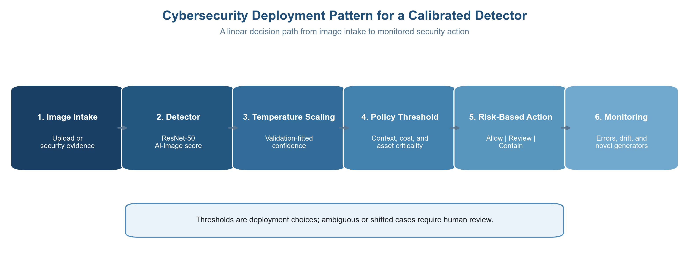
Figure 16: Cybersecurity deployment.

6.2 Cybersecurity Application Profiles
The detector has a different supporting role in each cybersecurity application. In identity verification, it can flag image evidence for additional checks but should not independently reject an applicant. In claims and marketplace fraud, it can prioritise suspicious submissions while transaction history and metadata establish context. In trust and safety, it can rank content for moderation while preserving appeal and restoration mechanisms. In incident response, it can help analysts triage large image collections but cannot establish authorship, intent, or evidentiary authenticity by itself.
Application | Detector role | Primary error impact | Companion controls
KYC and identity | Flag suspicious image evidence for review | Wrongful delay or approval | Liveness, document checks, provenance, appeal
Claims and marketplace fraud | Prioritise submitted visual evidence | Legitimate claim rejected or synthetic evidence accepted | Transaction context, metadata, account history
Trust and safety | Rank potentially synthetic uploads | Wrongful removal or missed deceptive content | Moderator review, user reporting, restoration process
Incident response | Triage images during investigation | Analyst attention misdirected | Evidence preservation, source validation, forensic corroboration
Table 24: Application-specific role and limitations of the detector in cybersecurity workflows.
Across these applications, the external false-positive result is the strongest warning against automatic action. The detector incorrectly flags 267 of 500 external real images. A cybersecurity workflow must therefore treat a high score as a reason to seek corroboration, not as proof that a legitimate user or submitted image is malicious.

6.2.1 Operational Deployment Scenarios
A defensible deployment begins with the protected decision and cost of error rather than a universal probability threshold. The same calibrated score can support different actions in different workflows.
Scenario | Detector role | Primary failure | Safeguard
Upload moderation | Prioritise review | Legitimate content removed | Reversible action and appeal
Identity screening | Add a fraud-risk signal | Real evidence rejected | Independent identity checks
Forensic triage | Rank evidence for examination | Confident false alarms prioritised | Preserve originals and analyst notes
Incident intelligence | Flag possible impersonation media | Alert fatigue or shifted escape | Corroboration and drift monitoring
Table 25: Deployment scenarios.
The external result makes autonomous rejection difficult to justify: 267 of 500 saved real images were classified as AI-generated. Moderation and identity workflows should route cases to review rather than treat the model as dispositive evidence. Forensic ranking may still help because an analyst can inspect provenance and context before acting.
Deployment records should identify model version, calibration temperature, threshold, intended population, review capacity, and escalation route. This aligns with NIST AI RMF governance [1], the generative-AI profile [2], and ISO/IEC 23894 risk-management guidance [38].

6.2.2 Decision Responsibilities and Escalation
Calibration supports a policy engine but does not define policy. Responsibility remains distributed among the model owner, security operations, application owner, human reviewer, and governance function. This prevents a technically correct probability transformation from being mistaken for authority to block a user, reject evidence, or initiate an investigation.
Role | Responsibility | Required record
Model owner | Validate performance and drift | Model, data scope, metrics, limitations
Security operations | Define alert routing | Alert, corroboration, disposition
Application owner | Set thresholds and reversible actions | Impact, rationale, fallback
Human reviewer | Assess context and provenance | Reasoned decision and uncertainty
Governance | Approve use and manage harm | Risk acceptance, incidents, correction
Table 26: Decision responsibilities.
A practical policy can proceed with logging when assessed risk is low, route ambiguous or shifted cases to review, and contain high-risk cases while collecting independent evidence. These are workflow states, not universal score bands, because operational thresholds and prevalence were not optimised in this thesis. Numeric bands require validation on local traffic and review capacity.
Monitoring closes the loop. Reviewer outcomes should be joined to scores to measure false-positive burden, false-negative escapes, calibration drift, generator novelty, and changes in real-image provenance. A sustained change should trigger threshold review or re-evaluation rather than automatic trust in the original temperature.

6.3 Intake and Evidence Preservation
The system should preserve the original submitted file before resizing or decoding. Cryptographic hashes, file metadata, transport source, timestamp, and case identifier should be logged. Preprocessing performed for the model should be recorded so that an analyst can distinguish the original evidence from the 224 × 224 model input. Re-encoding an image before preservation may destroy useful metadata or alter forensic evidence.
The intake layer should validate format and resource limits, isolate malformed files, and use secure image-decoding libraries. It should extract provenance credentials when present and validate their trust chain according to the supported C2PA specification [4]. A valid credential can supply origin information; a missing or invalid credential should be treated as unknown rather than automatically malicious.
Privacy and retention requirements depend on the application. Identity images and incident evidence may be sensitive. Logs should therefore minimise unnecessary image copies, apply access controls, use encryption, and follow defined deletion schedules. Model-monitoring datasets should be sampled and de-identified where possible [1], [38].

6.4 Detector and Calibration Services
The inference service should return the raw logit, raw probability, calibrated probability, model version, calibration version, preprocessing version, and basic quality indicators. Returning only a binary label discards information needed for audit and threshold analysis. The raw logit is particularly useful because a new approved temperature can be evaluated retrospectively without rerunning image inference.
Calibration parameters should be treated as model artefacts. They require validation data that represent the intended environment, an approval record, an effective date, and rollback support. The final temperature in this study improves the external sample, but production teams should not assume one scalar remains correct after generator or camera distributions change. Calibration drift can occur even when accuracy appears stable.
The inference endpoint should be protected against abuse. Authentication, request limits, anomaly detection, and careful score disclosure can reduce automated probing. Publicly exposing full probability precision may help an attacker optimise inputs against the detector. A user-facing system can communicate a decision or review status while retaining detailed scores for authorised analysts [2].

6.5 Policy and Human Review
A three-zone policy is preferable to one hard automation threshold [1], [2], [38]. A low-assessed-risk zone may allow the workflow to continue with routine logging. An ambiguous zone should request human review, provenance verification, or additional evidence. A high-assessed-risk zone may delay action, contain the submission, or require stronger identity and transaction checks. The boundaries must be selected from deployment validation data and a documented cost model.
Policy should be asymmetric. For account access or KYC, a false positive can deny a legitimate service, so high synthetic probability should normally trigger review rather than irreversible rejection. For low-cost content triage, a lower threshold may be acceptable if appeal and restoration are easy. For high-value fraud evidence, a false negative may be costly, so multiple independent signals and liveness or source verification are appropriate.
Human reviewers need more than the model score. The interface should show original image context, provenance results, relevant metadata, and related account or transaction signals. It should avoid presenting a probability as a forensic fact. Reviewer decisions and reasons should be captured for quality control and future evaluation. Disagreement between reviewers and the model is valuable monitoring data, not merely noise.
Zone | Illustrative action | Evidence expectation | Safeguard
Low assessed risk | Continue with logging | Provenance and metadata available; no conflicting signals | Periodic sampling
Ambiguous or shifted | Human review / request evidence | Uncertain score, novel source, weak provenance, model disagreement | Reviewer rationale and appeal
High assessed risk | Contain or delay; do not infer intent | High score plus corroborating behavioral or provenance evidence | Two-person review for consequential action
Table 27: Illustrative decision zones and required cybersecurity controls.

6.6 Monitoring and Drift Detection
Monitoring should cover input, prediction, calibration, and outcome layers. Input monitoring tracks image size, format, compression, source channel, content embeddings, and provenance availability. Prediction monitoring tracks score distributions, rates in each policy zone, and sudden changes by channel or customer segment. Outcome monitoring tracks confirmed false positives, false negatives, reviewer overrides, appeal outcomes, and time to resolution.
Calibration monitoring requires labelled feedback. Reliability diagrams, ECE, log loss, Brier score, and confidence on errors should be recomputed on recent adjudicated samples. Because labels may arrive slowly and selectively, teams should document sampling bias. A review queue enriched for uncertain cases does not directly estimate population calibration without adjustment.
Trigger conditions should be defined before deployment. Examples include a material increase in real-image false-positive rate, a sustained change in score distribution, emergence of a new generator, degradation of ECE beyond a tolerance, or a high-confidence incident. A trigger can initiate deeper sampling, temporary threshold changes, calibration refitting, or full retraining. Emergency controls should allow the detector to move from automated action to advisory-only mode.

6.7 Defence in Depth
Model scores should be combined with signals that fail differently. Provenance credentials can provide cryptographic history [4]. Metadata analysis can identify editing tools or inconsistencies, although metadata can be removed or forged. Reverse-image and web search can reveal reuse. Account and device reputation can link a suspicious image to broader behaviour. Liveness checks, challenge-response capture, and trusted camera workflows can reduce reliance on passive image analysis in identity scenarios.
Ensembles can add diversity, but adding models without independent validation can create correlated confidence. A frequency detector, a reconstruction-based method, a large pretrained representation, and a provenance system may be more complementary than several closely related CNNs [4], [18], [20], [21], [24]-[26], [28], [30]. Fusion rules should themselves be calibrated and audited.
Security teams should also plan for adversarial adaptation. Attackers may use post-processing, screenshots, noise, or optimisation to lower the score. They may submit repeated variants and observe outcomes. Monitoring for near-duplicate attempts, restricting feedback, and rotating or retraining controls can raise attack cost. No detector should be described as proof against an adaptive adversary unless it has been tested accordingly [2].

6.8 Governance and Documentation
The deployment owner should maintain a model card or equivalent record covering intended use, prohibited use, training and validation data, known limitations, threshold rationale, calibration method, and monitoring responsibilities. This documentation supports the Govern and Map functions of NIST AI RMF [1] and the lifecycle process of ISO/IEC 23894 [38].
Every production decision should be reproducible from logged versions. A minimum record includes input hash, model version, raw logit, calibration version, calibrated probability, policy version, additional signals, action, reviewer identity where relevant, and final outcome. Versioning is necessary because a later calibration update changes probability interpretation even when the underlying model is unchanged.
Incident procedures should define who investigates high-confidence mistakes, how affected users are notified or remediated, and when regulators or stakeholders must be informed. Appeals should be possible for consequential actions. Governance should also prevent function creep: a detector validated for triage should not silently become the sole basis for punitive decisions.

6.9 Deployment Readiness Checklist
Control | Status | Reason / next action
Representative validation data | Partial | External sample reveals major real-domain shift
True unseen-generator test | Completed | Seven independently trained LOGO folds
Full recent external benchmark | Pending | Current result is a 3,000-image stress sample
Calibration versioning | Required | Store T, validation set, dates, and rollback
Class-conditional thresholds | Pending | Must be derived from deployment costs
Human review and appeal | Required | Do not auto-deny from detector alone
Provenance integration | Recommended | Use C2PA and metadata as complementary evidence
Drift and outcome monitoring | Required | Track FP, FN, ECE, HCE, overrides, and appeals
Adversarial robustness | Pending | No adaptive attack evaluation in this thesis
Privacy and retention | Required | Preserve evidence with access control and minimisation
Table 28: Deployment-readiness checklist derived from the experimental findings.
The checklist distinguishes experimental completeness from deployment readiness. This thesis completes a useful research evaluation but does not satisfy every production criterion. In particular, full external-dataset testing, repeated seeds, demographic and device analysis, adversarial testing, application-specific cost modelling, and live monitoring remain necessary before high-impact automation.

6.10 Paper-Oriented Reporting Recommendations
An IEEE paper derived from this work should centre on one coherent contribution: confidence reliability of a ResNet-50 detector under true generator exclusion and recent cross-dataset shift. The three evaluation conditions form a coherent narrative: closed-set reference, seven-fold LOGO, and external stress test, each before and after calibration.
The main table should report all seven LOGO folds with accuracy, AUROC, ECE before and after, and high-confidence errors before and after. A second table should report closed-set and external summary results with explicit sampling. Figures 5, 6, 7, 9, and 10 provide a compact visual set. The abstract should mention the external false-positive rate because it is the clearest cybersecurity finding, together with the consistent reduction in high-confidence errors.
Claims should remain bounded. The paper can state that temperature scaling reduced high-confidence errors in all evaluated LOGO folds and in the external sample without affecting accuracy. It should not claim universal open-set detection, architectural superiority, or production safety. Full external evaluation and repeated seeds would be the most valuable additions before submission.

6.11 Discussion Summary
The empirical results support a layered cybersecurity design in which the calibrated detector informs, but does not dictate, policy. Original evidence must be preserved, scores and versions logged, thresholds derived from costs, and ambiguous or consequential cases reviewed. Monitoring must cover class-conditional error and calibration drift. Complementary provenance and behavioural signals are necessary because calibration improves confidence quality but cannot repair a shifted decision boundary. Deployment scenarios and responsibility assignments translate evidence into review, logging, escalation, and monitoring duties.

6.12 Conclusion and Future Work

6.12.1 Conclusion
This thesis investigated the registered questions on open-set reliability and confidence calibration in AI-generated image detection for cybersecurity applications. Open-set generator shift was tested by leaving one generator out of training and validation and using it only for testing. A ResNet-50 detector was evaluated in a closed-set reference, seven true leave-one-generator-out folds, and a recent cross-dataset stress-test sample. Post-hoc scalar temperature scaling was applied using validation-only temperatures. The analysis combined discrimination, calibration, confidence on errors, high-confidence errors, and class-conditional confusion measures.
Fine-tuning was necessary and effective. The closed-set AUROC increased from 0.4994 to 0.9921 and accuracy reached 0.9571. Yet the LOGO experiment showed a material generalisation penalty: mean LOGO accuracy was 0.9075 and mean AUROC was 0.9741, with clear variation among generator families. The recent external sample exposed a stronger weakness. Overall accuracy was 0.8117, but balanced accuracy was only 0.6734 and 267 of 500 real MS COCO images were incorrectly flagged as AI-generated.
The main research question is answered as follows: generator-level open-set shift reduces reliability and produces generator-dependent variation, while broader cross-dataset shift can expose severe class-conditional failure that familiar-data accuracy conceals. In cybersecurity deployment, this creates both missed-threat and legitimate-user risks. A detector score should therefore support triage and review rather than serve as independent proof.
The calibration sub-question is also answered affirmatively, with limits. Temperature scaling preserved accuracy and AUROC while reducing ECE and high-confidence errors in the closed-set result, every LOGO fold, and the external recalculation. Mean LOGO ECE decreased by 32.09%, and mean LOGO high-confidence-error count decreased by 20.58%. External ECE decreased by 11.46% and high-confidence errors decreased from 330 to 283. Calibration improved score reliability but did not change the external confusion matrix.
The practical conclusion is therefore two-part. Temperature scaling is a worthwhile lightweight control because it reduces exaggerated confidence and can improve risk routing. It is not a substitute for representative data, retraining, threshold validation, drift monitoring, provenance, or human oversight. The evidence supports calibrated assistance, not autonomous authenticity judgement.

6.12.2 Contributions Revisited
The completed work corrects the earlier workflow by distinguishing pooled fine-tuning from true LOGO. It provides all seven separately trained LOGO folds with explicit exclusions and keeps the thesis focused on one controlled backbone. It evaluates a recent dataset containing newer generator families and a changed real-image source. It harmonises saved results without combining incompatible ECE estimators. Finally, it translates detector errors into concrete cybersecurity controls and answers both registered research questions directly.

6.12.3 Future Work
The first priority is to run the saved model over the full external dataset rather than the 3,000-image sample. This would narrow sampling uncertainty and enable content- and source-level error analysis. The second priority is to repeat closed-set and LOGO training with multiple seeds, reporting confidence intervals or robust dispersion measures. Repeated runs would separate generator difficulty from optimisation variability.
The third priority is to diversify the real class. Training and validation should include multiple camera datasets, screenshots, social-media compression, documents, and domain-specific legitimate images. The external false-positive result indicates that real-domain coverage may be as important as adding newer generators. Data splits should control duplicates and near-duplicates across sources.
The fourth priority is to compare calibration and selective-prediction methods. Class-conditional temperature scaling, vector or Dirichlet calibration, isotonic regression, conformal prediction, and abstention could be tested using one harmonised metric implementation. Any added flexibility should be evaluated for overfitting and external transfer [32]-[37].
The fifth priority is to evaluate complementary detector families and adversarial robustness. A transformer or CLIP-based detector, reconstruction-based detector, and frequency-based detector could be compared under the same LOGO and external protocol. Post-processing, screenshots, resizing, compression, and adaptive attacks should be included [18], [20], [21], [24]-[30]. This extension should remain a separate, adequately powered study rather than an incomplete appendix to the present thesis.

6.12.4 Final Statement
AI-generated image detection is valuable to cybersecurity only when its uncertainty and failure conditions are visible. The experiments show that strong benchmark discrimination can coexist with generator-dependent errors and major external false positives. Calibration makes the scores less misleading, but trustworthy use depends on a layered process that can question the model. That combination of measurable confidence, representative evaluation, and controlled human decision-making is the central result of this thesis.

References
[1] E. Tabassi, Artificial Intelligence Risk Management Framework (AI RMF 1.0), NIST AI 100-1. Gaithersburg, MD, USA: National Institute of Standards and Technology, Jan. 2023, doi: 10.6028/NIST.AI.100-1.
[2] C. Autio et al., Artificial Intelligence Risk Management Framework: Generative Artificial Intelligence Profile, NIST AI 600-1. Gaithersburg, MD, USA: National Institute of Standards and Technology, Jul. 2024, doi: 10.6028/NIST.AI.600-1.
[3] Europol, Facing Reality? Law Enforcement and the Challenge of Deepfakes. Luxembourg: Publications Office of the European Union, 2022, doi: 10.2813/08370.
[4] Coalition for Content Provenance and Authenticity, 'Content Credentials: C2PA Technical Specification, Version 2.4,' Apr. 2026. [Online]. Available: https://spec.c2pa.org/specifications/specifications/2.4/specs/C2PA_Specification.html. Accessed: Aug. 3, 2026.
[5] S.-Y. Wang, O. Wang, R. Zhang, A. Owens, and A. A. Efros, 'CNN-generated images are surprisingly easy to spot... for now,' in Proc. IEEE/CVF Conf. Comput. Vis. Pattern Recognit. (CVPR), 2020, pp. 8695-8704.
[6] M. Zhu et al., 'GenImage: A million-scale benchmark for detecting AI-generated image,' in Advances in Neural Information Processing Systems, vol. 36, 2023.
[7] R. Roy et al., 'A comprehensive dataset for human vs. AI generated image detection,' arXiv:2601.00553, 2026. [Online]. Available: https://arxiv.org/abs/2601.00553. Dataset: https://huggingface.co/datasets/Rajarshi-Roy-research/Defactify_Image_Dataset. Accessed: Aug. 3, 2026.
[8] cartografia, 'Unbiased Tiny GenImage,' Kaggle, n.d. [Online]. Available: https://www.kaggle.com/datasets/cartografia/unbiased-tiny-genimage. Accessed: Aug. 3, 2026.
[9] K. He, X. Zhang, S. Ren, and J. Sun, 'Deep residual learning for image recognition,' in Proc. IEEE Conf. Comput. Vis. Pattern Recognit. (CVPR), 2016, pp. 770-778.
[10] J. Deng, W. Dong, R. Socher, L.-J. Li, K. Li, and L. Fei-Fei, 'ImageNet: A large-scale hierarchical image database,' in Proc. IEEE Conf. Comput. Vis. Pattern Recognit. (CVPR), 2009, pp. 248-255.
[11] C. Guo, G. Pleiss, Y. Sun, and K. Q. Weinberger, 'On calibration of modern neural networks,' in Proc. 34th Int. Conf. Mach. Learn. (ICML), vol. 70, 2017, pp. 1321-1330.
[12] Y. Ovadia et al., 'Can you trust your model's uncertainty? Evaluating predictive uncertainty under dataset shift,' in Advances in Neural Information Processing Systems, vol. 32, 2019.
[13] W. J. Scheirer, A. de Rezende Rocha, A. Sapkota, and T. E. Boult, 'Toward open set recognition,' IEEE Trans. Pattern Anal. Mach. Intell., vol. 35, no. 7, pp. 1757-1772, Jul. 2013, doi: 10.1109/TPAMI.2012.256.
[14] C. Geng, S.-J. Huang, and S. Chen, 'Recent advances in open set recognition: A survey,' IEEE Trans. Pattern Anal. Mach. Intell., vol. 43, no. 10, pp. 3614-3631, Oct. 2021.
[15] S. Vaze, K. Han, A. Vedaldi, and A. Zisserman, 'Open-set recognition: A good closed-set classifier is all you need?,' in Proc. Int. Conf. Learn. Representations (ICLR), 2022.
[16] D. Hendrycks and K. Gimpel, 'A baseline for detecting misclassified and out-of-distribution examples in neural networks,' in Proc. Int. Conf. Learn. Representations (ICLR), 2017.
[17] N. Yu, L. S. Davis, and M. Fritz, 'Attributing fake images to GANs: Learning and analyzing GAN fingerprints,' in Proc. IEEE/CVF Int. Conf. Comput. Vis. (ICCV), 2019, pp. 7556-7566.
[18] J. Frank, T. Eisenhofer, L. Schoenherr, A. Fischer, D. Kolossa, and T. Holz, 'Leveraging frequency analysis for deep fake image recognition,' in Proc. 37th Int. Conf. Mach. Learn. (ICML), vol. 119, 2020, pp. 3247-3258.
[19] D. Hendrycks and T. Dietterich, 'Benchmarking neural network robustness to common corruptions and perturbations,' in Proc. Int. Conf. Learn. Representations (ICLR), 2019.
[20] U. Ojha, Y. Li, and Y. J. Lee, 'Towards universal fake image detectors that generalize across generative models,' in Proc. IEEE/CVF Conf. Comput. Vis. Pattern Recognit. (CVPR), 2023, pp. 24480-24489.
[21] Z. Wang et al., 'DIRE for diffusion-generated image detection,' in Proc. IEEE/CVF Int. Conf. Comput. Vis. (ICCV), 2023, pp. 22445-22455.
[22] C. Tan et al., 'Learning on gradients: Generalized artifacts representation for GAN-generated images detection,' in Proc. IEEE/CVF Conf. Comput. Vis. Pattern Recognit. (CVPR), 2023, pp. 12105-12114.
[23] P. Lorenz, R. Durall, and J. Keuper, 'Detecting images generated by deep diffusion models using their local intrinsic dimensionality,' in Proc. IEEE/CVF Int. Conf. Comput. Vis. Workshops (ICCVW), 2023, pp. 448-459.
[24] J. Ricker, D. Lukovnikov, and A. Fischer, 'AEROBLADE: Training-free detection of latent diffusion images using autoencoder reconstruction error,' in Proc. IEEE/CVF Conf. Comput. Vis. Pattern Recognit. (CVPR), 2024, pp. 9130-9140.
[25] Y. Luo et al., 'LaRE^2: Latent reconstruction error based method for diffusion-generated image detection,' in Proc. IEEE/CVF Conf. Comput. Vis. Pattern Recognit. (CVPR), 2024, pp. 17006-17015.
[26] D. Cozzolino et al., 'Raising the bar of AI-generated image detection with CLIP,' in Proc. IEEE/CVF Conf. Comput. Vis. Pattern Recognit. Workshops (CVPRW), 2024, pp. 4356-4366.
[27] C. Tan et al., 'Rethinking the up-sampling operations in CNN-based generative network for generalizable deepfake detection,' in Proc. IEEE/CVF Conf. Comput. Vis. Pattern Recognit. (CVPR), 2024, pp. 28130-28139.
[28] B. Chu, X. Xu, X. Wang, Y. Zhang, W. You, and L. Zhou, 'FIRE: Robust detection of diffusion-generated images via frequency-guided reconstruction error,' in Proc. IEEE/CVF Conf. Comput. Vis. Pattern Recognit. (CVPR), 2025, pp. 12830-12839, doi: 10.1109/CVPR52734.2025.01197.
[29] F. Guillaro, G. Zingarini, B. Usman, A. Sud, D. Cozzolino, and L. Verdoliva, 'A bias-free training paradigm for more general AI-generated image detection,' in Proc. IEEE/CVF Conf. Comput. Vis. Pattern Recognit. (CVPR), 2025, pp. 18685-18694, doi: 10.1109/CVPR52734.2025.01741.
[30] Y. Cai, S. Jia, J. Tian, J. Dai, J. Han, and S. Lyu, 'CatAID: Category-guided AI-generated image detection via vision-language model adaptation,' in Proc. IEEE/CVF Int. Conf. Comput. Vis. Workshops (ICCVW), 2025, pp. 1564-1574.
[31] T.-Y. Lin et al., 'Microsoft COCO: Common objects in context,' in Proc. Eur. Conf. Comput. Vis. (ECCV), 2014, pp. 740-755.
[32] J. Nixon, M. W. Dusenberry, L. Zhang, G. Jerfel, and D. Tran, 'Measuring calibration in deep learning,' in Proc. IEEE/CVF Conf. Comput. Vis. Pattern Recognit. Workshops (CVPRW), 2019, pp. 38-41.
[33] D. Widmann, F. Lindsten, and D. Zachariah, 'Calibration tests in multi-class classification: A unifying framework,' in Advances in Neural Information Processing Systems, vol. 32, 2019.
[34] M. Minderer et al., 'Revisiting the calibration of modern neural networks,' in Advances in Neural Information Processing Systems, vol. 34, 2021.
[35] A. Kumar, P. Liang, and T. Ma, 'Verified uncertainty calibration,' in Advances in Neural Information Processing Systems, vol. 32, 2019.
[36] M. Kull et al., 'Beyond temperature scaling: Obtaining well-calibrated multiclass probabilities with Dirichlet calibration,' in Advances in Neural Information Processing Systems, vol. 32, 2019.
[37] C. Ni, N. C. Charoenphakdee, J. Honda, and M. Sugiyama, 'On the calibration of multiclass classification with rejection,' in Advances in Neural Information Processing Systems, vol. 32, 2019.
[38] International Organization for Standardization, ISO/IEC 23894:2023, Information Technology - Artificial Intelligence - Guidance on Risk Management, 2023.
[39] TensorFlow, 'TensorFlow API documentation,' n.d. [Online]. Available: https://www.tensorflow.org/api_docs. Accessed: Aug. 3, 2026.

Appendix A: Important Code Excerpts
This appendix documents the implementation details that determine whether the experimental claims are reproducible. It focuses on generator exclusion, data identity, logits, optimisation, calibration, metric correctness, prediction alignment, result JSON structure, and artefact integrity. Environment installation and repetitive plotting code are omitted because they do not change the reported protocol.

A.1 Generator inventory and binary labels
The inventory is the first reproducibility boundary. Real images are assigned label 0 and every listed generator is assigned label 1, while the source name is retained separately. Keeping the binary target and source identity in different arrays allows the detector to learn a binary task without losing the generator information required for LOGO partitioning and source-level error analysis.
The generator list is explicit rather than inferred from every directory under the dataset root. This prevents temporary folders, notebook outputs, or an accidentally renamed directory from silently entering training. Before fitting, the implementation verifies that each expected source exists and that the observed counts match the documented inventory. A discrepancy is treated as a data-integrity failure rather than ignored.
AI_GENERATORS = [
"Midjourney", "stable_diffusion_v_1_5", "glide",
"wukong", "BigGAN", "VQDM", "ADM",
]
REAL_FOLDER = "Nature"

all_paths, all_labels, all_sources = [], [], []
for path in list_images(DATA_ROOT / REAL_FOLDER):
all_paths.append(str(path))
all_labels.append(0)
all_sources.append(REAL_FOLDER)

for generator in AI_GENERATORS:
for path in list_images(DATA_ROOT / generator):
all_paths.append(str(path))
all_labels.append(1)
all_sources.append(generator)

A.2 True held-out-generator fold construction
A true LOGO fold is defined by exclusion, not merely by selecting one generator for a final report. The held-out generator must be absent from both training and validation because validation influences checkpoint selection, early stopping, and temperature fitting. The fold therefore rebuilds all path arrays after the held-out name is selected and trains a fresh model from its initial ImageNet state.
The test partition pairs 583 held-out AI images with the same number of real images. This gives an interpretable 0.50 chance accuracy within every fold and makes false-positive and false-negative counts directly comparable. The balanced test composition is an evaluation design choice; it does not represent deployment prevalence and is not used to claim calibrated real-world posterior probabilities.
def make_fold_arrays(heldout_generator):
# The held-out source is absent from both train and validation.
seen = [g for g in AI_GENERATORS if g != heldout_generator]
real_train, real_val, real_test = split_real_paths(real_paths)
ai_train, ai_val = split_seen_ai_paths(
inventory, heldout_generator=heldout_generator
)
heldout_test = sample_heldout_ai_for_test(
inventory[heldout_generator], n_real_test=len(real_test)
)

train_paths = np.concatenate([real_train, ai_train])
train_labels = np.concatenate([
np.zeros(len(real_train)), np.ones(len(ai_train))
]).astype("int32")

val_paths = np.concatenate([real_val, ai_val])
val_labels = np.concatenate([
np.zeros(len(real_val)), np.ones(len(ai_val))
]).astype("int32")

test_paths = np.concatenate([real_test, heldout_test])
test_labels = np.concatenate([
np.zeros(len(real_test)), np.ones(len(heldout_test))
]).astype("int32")

assert heldout_generator not in seen
assert all(
heldout_generator not in Path(path).parts
for path in np.concatenate([train_paths, val_paths])
)
return (
train_paths, train_labels, val_paths, val_labels,
test_paths, test_labels,
)

A.3 ResNet-50 with an explicit binary logit
The final layer produces one unrestricted logit rather than a sigmoid probability. Binary cross-entropy is therefore configured with `from_logits=True`, and binary accuracy uses a logit threshold of zero, which is equivalent to a probability threshold of 0.5. This representation avoids repeatedly converting clipped probabilities back into logits during temperature fitting.
During the warm-up stage the ImageNet backbone is called in inference mode while the new pooling, dropout, and logit head learn the binary task. Fine-tuning is performed only after the head has stabilised and requires recompilation after changing trainable variables. The explicit separation reduces the risk that high initial gradients immediately disrupt the pretrained representation.
def build_resnet50_logits_model():
inputs = tf.keras.Input(shape=(224, 224, 3), name="image")
backbone = tf.keras.applications.ResNet50(
include_top=False,
weights="imagenet",
input_shape=(224, 224, 3),
)
features = backbone(inputs, training=False)
features = tf.keras.layers.GlobalAveragePooling2D()(features)
features = tf.keras.layers.Dropout(0.20)(features)
logits = tf.keras.layers.Dense(1, activation=None, name="logit")(features)
return tf.keras.Model(inputs, logits), backbone

def compile_logits_model(model, learning_rate):
model.compile(
optimizer=tf.keras.optimizers.Adam(learning_rate),
loss=tf.keras.losses.BinaryCrossentropy(from_logits=True),
metrics=[tf.keras.metrics.BinaryAccuracy(threshold=0.0)],
)

A.4 Validation-only temperature fitting
Temperature is fitted only on validation logits and labels. The test fold remains untouched until the temperature has been selected, preserving the distinction between model selection and final evaluation. The executed LOGO notebook uses bounded scalar minimisation over T in [0.05, 10.0], with a convergence tolerance of 1e-4.
The objective is validation negative log-likelihood. Dividing logits by a positive scalar preserves their sign and ordering, so the predicted class, accuracy, confusion matrix, and AUROC remain unchanged at the fixed threshold. The fitted value changes confidence magnitude only. This mathematical property is verified again after scaling rather than assumed from the implementation.
def fit_temperature_nll(val_logits, val_labels):
val_logits = np.asarray(val_logits, dtype="float64").reshape(-1)
val_labels = np.asarray(val_labels, dtype="float64").reshape(-1)

def objective(temperature):
probabilities = expit(val_logits / float(temperature))
return log_loss(val_labels, probabilities, labels=[0, 1])

result = minimize_scalar(
objective,
method="bounded",
bounds=(0.05, 10.0),
options={"xatol": 1e-4},
)
return float(result.x), float(result.fun)

A.5 Correct top-label ECE implementation
Top-label ECE compares the confidence assigned to the predicted class with empirical correctness. For binary detection this confidence is `max(p, 1-p)`, not always the probability of the AI class. Each occupied bin contributes its sample proportion multiplied by the absolute gap between mean confidence and mean correctness.
The return statement appears after the complete bin loop. Returning from inside the loop would report only the first occupied interval and can make an apparently plausible calibration value methodologically invalid. The implementation uses non-overlapping bin boundaries. It is called with 10 bins for LOGO and 15 bins for the recent external test; ECE values from these unlike estimators are therefore not pooled.
def expected_calibration_error(y_true, prob_ai, n_bins=15):
y_true = np.asarray(y_true, dtype=int)
prob_ai = np.asarray(prob_ai, dtype=float)
prediction = (prob_ai >= 0.5).astype(int)
confidence = np.maximum(prob_ai, 1.0 - prob_ai)
correct = (prediction == y_true).astype(float)
boundaries = np.linspace(0.0, 1.0, n_bins + 1)
ece = 0.0
for index in range(n_bins):
lower, upper = boundaries[index], boundaries[index + 1]
if index == 0:
mask = (confidence >= lower) & (confidence <= upper)
else:
mask = (confidence > lower) & (confidence <= upper)
if np.any(mask):
gap = abs(correct[mask].mean() - confidence[mask].mean())
ece += mask.mean() * gap
return float(ece) # Return only after all bins are processed.

A.6 Correct external batch prediction and record alignment
Prediction arrays are only useful when every score remains aligned with the image label and source metadata that produced it. Records are appended inside the batch loop using the same `batch_indices` and `rows` that created the model input. Appending metadata outside the loop would retain only the final batch variables while the output array contained predictions from every batch.
After concatenation, an explicit length assertion checks one-to-one correspondence between records and model outputs. The output-normalisation function separately handles one-logit, one-probability, two-logit, and two-probability model signatures. The detected output kind is reported so that an incorrect sigmoid or softmax assumption cannot silently alter the external probabilities.
records, raw_outputs = [], []
for start in range(0, len(selected_indices), BATCH_SIZE):
batch_indices = selected_indices[start:start + BATCH_SIZE]
rows = [dataset[index] for index in batch_indices]
images = [image_to_pil(row[IMAGE_COL]) for row in rows]
batch_x = preprocess_batch(images)
raw_outputs.append(model.predict(batch_x, verbose=0))

# Metadata is appended inside the batch loop.
for original_index, row in zip(batch_indices, rows):
records.append({
"original_index": int(original_index),
"label_binary": int(row[LABEL_COL]),
"source_id": int(row[SOURCE_COL]),
})

raw_outputs = np.concatenate(raw_outputs, axis=0)
prob_ai, binary_logit, output_kind = normalize_model_output(raw_outputs)
predictions = pd.DataFrame(records)
assert len(predictions) == len(prob_ai)

A.7 External recalibration with the final saved temperature
The external evaluation reuses the final temperature stored in the authoritative Phase 3 JSON artifact. It does not fit a new value on external test labels. This tests whether the validation-derived calibration transformation transfers under broader dataset shift while maintaining a clean external evaluation boundary.
Both raw and harmonised probabilities are retained. The equality assertion confirms that scaling with a positive temperature leaves every 0.5-threshold label unchanged. Consequently, any reported change in accuracy or confusion counts would indicate a processing error. Calibration, log-loss, Brier score, confidence on errors, and HCE may change because they depend on probability magnitude.
FINAL_TEMPERATURE = 1.2408854103475755
predictions["prob_ai_harmonized"] = expit(
predictions["binary_logit"].to_numpy(float) / FINAL_TEMPERATURE
)

raw_metrics = compute_metrics(predictions, prob_col="prob_ai")
scaled_metrics = compute_metrics(
predictions, prob_col="prob_ai_harmonized"
)

# Positive temperature preserves signs and therefore the 0.5 labels.
raw_label = (predictions["prob_ai"] >= 0.5).astype(int)
scaled_label = (predictions["prob_ai_harmonized"] >= 0.5).astype(int)
assert np.array_equal(raw_label, scaled_label)

A.8 Deterministic input pipeline and seed control
The executed LOGO notebook supplies the same seed to Python, NumPy, and TensorFlow. Training-data shuffling uses this seed and a buffer capped at 4,096 samples. Image decoding, augmentation, and preprocessing use parallel mapping, followed by automatic prefetching.
These controls reduce avoidable variation but do not guarantee bitwise reproduction across TensorFlow, accelerator, driver, and kernel versions. The executed pipeline did not request deterministic TensorFlow operations explicitly. Stronger deterministic execution and saved fold manifests are therefore recommended for a future replication rather than claimed for the reported runs.
SEED = 42
random.seed(SEED)
np.random.seed(SEED)
tf.random.set_seed(SEED)

def make_dataset(paths, labels, training=False):
ds = tf.data.Dataset.from_tensor_slices((paths, labels))
if training:
ds = ds.shuffle(
buffer_size=min(len(paths), 4096), seed=SEED
)
ds = ds.map(decode_and_resize, num_parallel_calls=tf.data.AUTOTUNE)
if training:
ds = ds.map(augment_image, num_parallel_calls=tf.data.AUTOTUNE)
ds = ds.map(resnet_preprocess, num_parallel_calls=tf.data.AUTOTUNE)
ds = ds.batch(BATCH_SIZE)
return ds.prefetch(tf.data.AUTOTUNE)

A.9 Two-stage optimisation and weight selection
Training is divided into a head warm-up and a lower-learning-rate full-network stage. The first stage freezes the backbone and uses a learning rate of 1e-3 for two epochs. The second stage unfreezes the backbone, recompiles the model, and uses 1e-5 for up to eight epochs. Validation loss, rather than test performance, controls early stopping and learning-rate reduction.
Early stopping restores the best validation-loss weights within each training stage. After fine-tuning, that model is saved as `resnet50_logo_logits.keras` in the held-out generator's fold directory and is then used for validation-logit extraction and test evaluation. The executed notebook did not create or reload a separate best-model checkpoint.
def make_callbacks(fold_dir):
return [
tf.keras.callbacks.EarlyStopping(
monitor="val_loss", patience=3,
restore_best_weights=True, verbose=1,
),
tf.keras.callbacks.ReduceLROnPlateau(
monitor="val_loss", factor=0.5,
patience=2, verbose=1,
),
tf.keras.callbacks.CSVLogger(
str(fold_dir / "training_log.csv")
),
]

base_model.trainable = False
compile_logits_model(model, learning_rate=1e-3)
model.fit(train_ds, validation_data=val_ds, epochs=2,
callbacks=make_callbacks(fold_dir))

base_model.trainable = True
compile_logits_model(model, learning_rate=1e-5)
model.fit(train_ds, validation_data=val_ds, epochs=8,
callbacks=make_callbacks(fold_dir))

model.save(fold_dir / "resnet50_logo_logits.keras")

A.10 Structured JSON result record
The result JSON is a compact audit record, not merely a convenient printout. It preserves the exact temperature and unrounded metrics used to create thesis tables. The example contains the verified Phase 3 values: accuracy 0.9571367338, AUROC 0.9921470228, ECE 0.0316203436, mean confidence on wrong predictions 0.8346730064, and 41 high-confidence errors.
A required-key assertion prevents downstream table generation from silently accepting an incomplete artifact. In a full reproduction, the record should also include the seed, data manifest identifier, code version, framework versions, checkpoint path, metric definition, bin count, and HCE threshold. Human-readable JSON complements the saved model and row-level predictions by making the reported run independently inspectable.
phase3_record = {
"artifact": "phase3_results (1).json",
"model": "ResNet50",
"optimal_temperature": 1.2408854103475755,
"accuracy": 0.957136733819117,
"auroc": 0.9921470227885322,
"ece": 0.03162034362964304,
"avg_conf_wrong": 0.834673006382895,
"high_conf_total": 2165,
"high_conf_errors": 41,
"high_conf_error_rate": 0.018937644341801386,
}

required = {
"optimal_temperature", "accuracy", "auroc", "ece",
"avg_conf_wrong", "high_conf_errors",
}
assert required.issubset(phase3_record)
with open(OUTPUT_DIR / "phase3_results.json", "w") as handle:
json.dump(phase3_record, handle, indent=2)

A.11 Reloaded-artifact integrity checks
Final reporting reloads artifacts from disk instead of trusting notebook variables that may belong to an earlier run. The checks confirm that Phase 2 and Phase 3 discrimination are identical, that all seven LOGO rows exist, and that each fold contains 583 real and 583 held-out AI test images. These assertions directly test the protocol claims used in the thesis narrative.
The external checks verify 3,000 prediction rows, the documented 500-to-2,500 class composition, the confusion total, and the final saved temperature. Arithmetic checks do not prove that the model is correct, but they prevent inconsistent tables, copied display values, or partial-batch outputs from being presented as one coherent experiment. Failed assertions must stop document generation until the source artifact is reconciled.
phase2 = json.loads(PHASE2_JSON.read_text())
phase3 = json.loads(PHASE3_JSON.read_text())
logo = pd.read_csv(LOGO_SUMMARY_CSV)
external = pd.read_csv(EXTERNAL_PREDICTIONS_CSV)

assert np.isclose(phase2["accuracy"], phase3["accuracy"])
assert np.isclose(phase2["auroc"], phase3["auroc"])
assert len(logo) == 7
assert (logo["test_n"] == 1166).all()
assert (logo["test_real_n"] == 583).all()
assert (logo["test_ai_n"] == 583).all()

assert len(external) == 3000
assert int((external["label_binary"] == 0).sum()) == 500
assert int((external["label_binary"] == 1).sum()) == 2500
assert 233 + 267 + 298 + 2202 == len(external)

temperature = float(phase3["optimal_temperature"])
assert np.isclose(temperature, 1.2408854103475755)

A.12 Complete per-fold LOGO orchestration
The orchestration loop makes the unit of repetition explicit: one held-out generator requires one complete model lifecycle. `run_logo_fold` reconstructs the fold data, builds and trains a new ResNet-50, saves the resulting model, and fits temperature from that fold's validation logits. A model trained for one held-out generator is not reused as the starting point for another fold.
Midjourney was completed in the earlier run. The continuation notebook therefore retained Midjourney in `AI_GENERATORS` as seen training data but placed only the remaining six sources in `RUN_FOLDS`. Each completed fold saved `metrics.json`, `predictions.csv`, the training log, and `resnet50_logo_logits.keras` in its own directory. The saved Midjourney record and six continuation records were consolidated later into the verified seven-fold summary.
# Midjourney was completed in the earlier run.
RUN_FOLDS = [
"stable_diffusion_v_1_5", "glide", "wukong",
"BigGAN", "VQDM", "ADM",
]

all_results = []
for heldout in RUN_FOLDS:
result, _ = run_logo_fold(heldout)
all_results.append(result)

summary_df = pd.DataFrame(all_results)
summary_path = OUTPUT_DIR / "logo_summary.csv"
summary_df.to_csv(summary_path, index=False)

A.13 Metric bundle and source-level result writing
One metric function produces discrimination, probability-quality, high-confidence-error, and confusion values from the same rows and selected probability column. Probabilities are clipped to [1e-6, 1 - 1e-6] before calculation so logarithmic metrics remain finite; this only changes exact endpoint values. The 0.5 decision threshold, 0.90 HCE threshold, and 15-bin top-label ECE remain explicit.
The source-level external loop pairs each generated source with the same 500 real rows. This design supports generator comparison while holding the negative sample constant, but it also means that the 267 real-image false positives are repeated in every paired record. The source CSV therefore supports conditional diagnosis rather than five independent estimates of real-image performance. The thesis states this dependency when interpreting source-level accuracy.
def compute_metrics(frame, prob_col):
y_true = frame["label_binary"].astype(int).to_numpy()
probability = np.clip(
frame[prob_col].astype(float).to_numpy(), 1e-6, 1 - 1e-6
)
pred = (probability >= 0.5).astype(int)
confidence = np.maximum(probability, 1 - probability)
wrong = pred != y_true
high = confidence >= HIGH_CONF_THRESHOLD
tn, fp, fn, tp = confusion_matrix(
y_true, pred, labels=[0, 1]
).ravel()
return {
"n": int(len(frame)),
"accuracy": float(accuracy_score(y_true, pred)),
"balanced_accuracy": float(balanced_accuracy_score(y_true, pred)),
"auroc": float(roc_auc_score(y_true, probability)),
"log_loss": float(log_loss(y_true, probability, labels=[0, 1])),
"brier": float(brier_score_loss(y_true, probability)),
"top_label_ece_15": top_label_ece(y_true, probability, 15),
"avg_conf_wrong": float(confidence[wrong].mean()),
"high_confidence_errors": int(np.sum(wrong & high)),
"hce_rate_all": float(np.mean(wrong & high)),
"hce_rate_high": float(np.sum(wrong & high) / np.sum(high)),
"specificity_real": float(tn / (tn + fp)),
"ai_recall": float(tp / (tp + fn)),
"tn": int(tn), "fp": int(fp), "fn": int(fn), "tp": int(tp),
}

real_rows = predictions[predictions["source_id"] == 0]
generator_pair_rows = []
for source_id in sorted(
i for i in predictions["source_id"].unique() if int(i) != 0
):
paired = pd.concat([
real_rows, predictions[predictions["source_id"] == int(source_id)]
], ignore_index=True)
for state, prob_col in [
("Raw", "prob_ai"),
("Temperature-scaled", "prob_ai_temp"),
]:
metrics = compute_metrics(paired, prob_col)
metrics.update({
"source_id": int(source_id),
"source_name": SOURCE_MAP[int(source_id)],
"state": state,
})
generator_pair_rows.append(metrics)

pd.DataFrame(generator_pair_rows).to_csv(
RUN_DIR / "generator_pair_metrics.csv", index=False
)

Appendix B Detailed Result Records
This appendix documents arithmetic and provenance checks for the authoritative results reported in Chapter 4. Repeated result tables have been removed.

B.1 Result Integrity Checks
Check | Evidence | Status
Closed-set Phase 2 and Phase 3 accuracy | 0.9571367338 = 0.9571367338 | Pass
Closed-set Phase 2 and Phase 3 AUROC | 0.9921470228 = 0.9921470228 | Pass
Every LOGO test size | 583 real + 583 held-out AI = 1,166 | Pass
Every LOGO confusion total | TN + FP + FN + TP = 1,166 | Pass
External class totals | 233 + 267 = 500; 298 + 2,202 = 2,500 | Pass
External decision invariance | Raw and scaled labels identical at threshold 0.5 | Pass
Final external temperature | 1.2408854103 from final Phase 3 JSON | Pass
Table 29: Result integrity checks.

Appendix C Reproducibility Record
A reproduction should use the same data identities, source exclusions, class labels, preprocessing, and metric definitions. Hardware differences may change training time and nondeterministic kernels may cause small numerical variation.
Item | Required value
Primary dataset | cartografia/unbiased-tiny-genimage via KaggleHub
Primary inventory | 23,328 images; 5,828 real; seven AI folders with 2,500 each
External artifact | MS COCOAI/Defactify 3,000-row saved stratified sample
Framework | TensorFlow/Keras 2.x; scikit-learn; SciPy; pandas; NumPy
Input | 224 x 224 RGB; ResNet-50 preprocessing
Backbone | ImageNet-initialised ResNet-50
Seed | 42
Batch size | 32
LOGO rule | Held-out generator absent from training and validation; fresh model per fold
Calibration | Validation logits only; NLL optimisation; test set untouched
External temperature | T=1.2408854103475755 applied to stored binary logits
HCE threshold | Top-label confidence >= 0.90
Table 30: Reproducibility record.

