**Comp 2322 Computer Networking**

**Homework Five**

**Due time: 11:59pm, April 16, 2024, Tuesday**

**Total marks: 10 points**

**Submission Requirements:**

You need to submit the homework to the blackboard via Learn@PolyU on or before the due time. Late submission will cause the marks to be deducted 25% per day.

**Questions:**

1. (2 points) Consider the network shown below. Suppose AS3 and AS2 are running OSPF for their intra-AS routing protocol. Suppose AS1 and AS4 are running RIP for their intra-AS routing protocol. Suppose eBGP and iBGP are used for the inter-AS routing protocol. Initially suppose there is no physical link between AS2 and AS4.

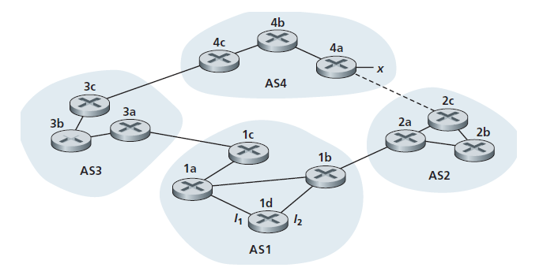

From which routing protocol: OSPF, RIP, eBGP, or iBGP, do the following routers learn about prefix x? Justify your answer.

1. Router 3c (1 point)

eBGP

1. Router 1d (1 point)

iBGP

1. (4 points) Referring to the previous problem, once router 1d learns about x it will put an entry (x, I) in its forwarding table.
2. Will I be set to I1 or I2 for this entry? Why? (1 point)

I1， Because the only gateway router is 1c that can reach to x(AS4), I1 interface start the least cost path from 1d towards 1c.

1. Now suppose that there is a physical link between AS2 and AS4, shown by the dotted line. Suppose router 1d learns that x is accessible via AS2 as well as via AS3. Will I be set to I1 or I2? Why? (1 point)

I2, because 1b is the closest NEXT-HOP router and I2 interface have the least cost path from 1d towards 1b.

1. Now suppose there is another AS, called AS5, which lies on the path between AS2 and AS4 (not shown in diagram). Suppose router 1d learns that x is accessible via AS2 AS5 AS4 as well as via AS3 AS4. If the shortest AS path first policy is applied, will I be set to I1 or I2? If the hot potato protocol is applied, will I be set to I1 or I2? Justify your answers. (2 points)

If the shortest AS path first policy is enforced, my configuration will be set to interface I1. This is due to the fact that the path through AS3 and AS4 is shorter, with 1c serving as the gateway router for this route. Subsequently, the I1 interface will establish the most cost-effective route from 1d to 1c.

On the other hand, if the hot potato routing protocol is implemented, my configuration will be set to interface I2. This is because both 1b and 1c can act as gateways to reach target x, but 1b is the nearest next-hop router from 1d. Therefore, the I2 interface will start the most cost-effective route from 1d to 1b.

1. (4 points) We consider the use of small packets for Voice-over-IP applications. Suppose that the packet consists of *L* bytes of data and 5 bytes of header.
2. A small packet size causes a fraction of link bandwidth to be consumed by overhead. The transmission overhead can be defined as the percentage of the amount of transmitted overhead bits relative to the total amount of transmitted bits. Determine the transmission overhead for *L* = 1,000 bytes and for *L* = 100 bytes. (2 points)

Transmission overhead =（5 / L + 5）* 100%

When L = 1,000, transmission overhead = (5 / 1000 + 5) * 100% $≈$ 0.4975 %

When L = 100, transmission overhead = (5 / 100 + 5) * 100% $≈$ 4.76 %

1. Consider sending a digitally encoded voice source directly. Suppose the source is encoded at a constant rate of 128 kbps. Assume each packet is entirely filled before the source sends the packet into the network. The time required to fill a packet is the packetization delay. Packetization delays larger than 20 msec can cause a noticeable and unpleasant echo. In terms of *L* bytes, determine the packetization delay in milliseconds. Also, determine the packetization delay for *L* = 1,000 bytes and for *L* = 100 bytes. (2 points)

When L = 1,000, the packetization delay is 8 * 1000/(128×10^3 ) sec = 62.5 msec

When L = 100, the packetization delay is 8 * 100/(128×10^3 ) sec = 6.25 msec