# Comp 2322 Computer Networking

**Lab 6: TCP**

**Due time: 11:59pm, April 15, 2024, Monday**

**Total marks: 10 points**

**HE YIYANG**

**22100143D**

Q2.

The IP address of gaia.cs.umass.edu is 128.119.245.12 and TCP port number is 80.

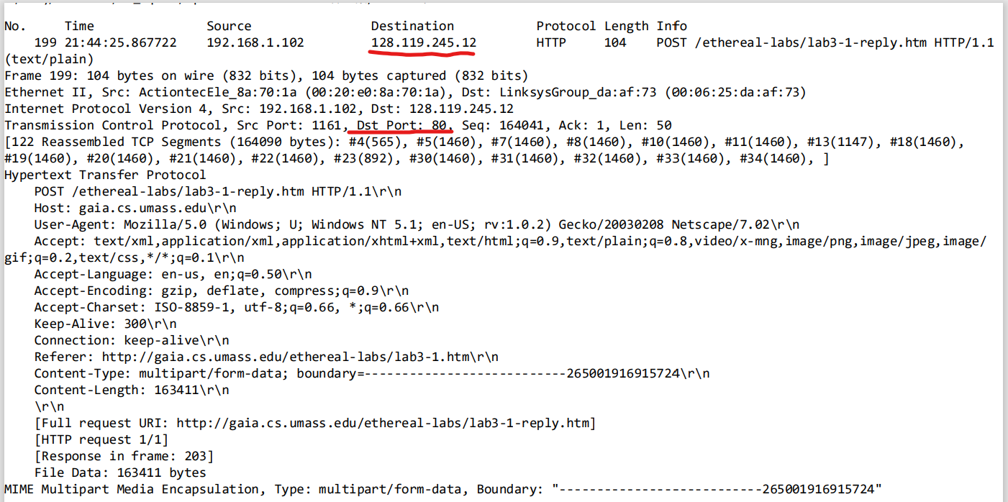

Q4.

The TCP SYN segment's sequence number is set to 0 in this particular trace, which initiates the TCP connection between the client computer and gaia.cs.umass.edu.

When the SYN flag is set to 1 it means this segment is a SYN segment.

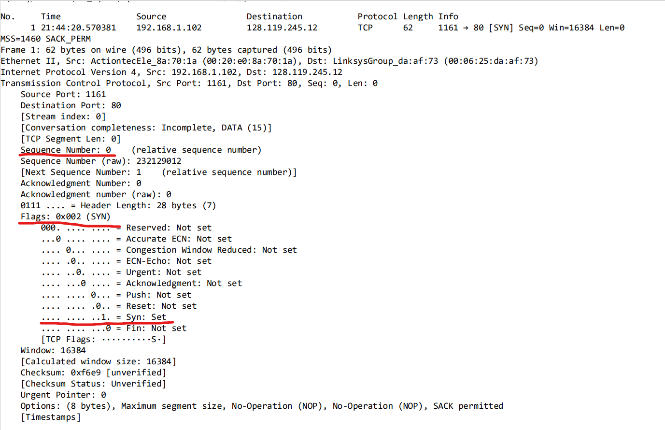

Q8.

TCP Segment Number: 1 2 3 4 5 6

TCP Segment Length: 565 1460 1460 1460 1460 1460

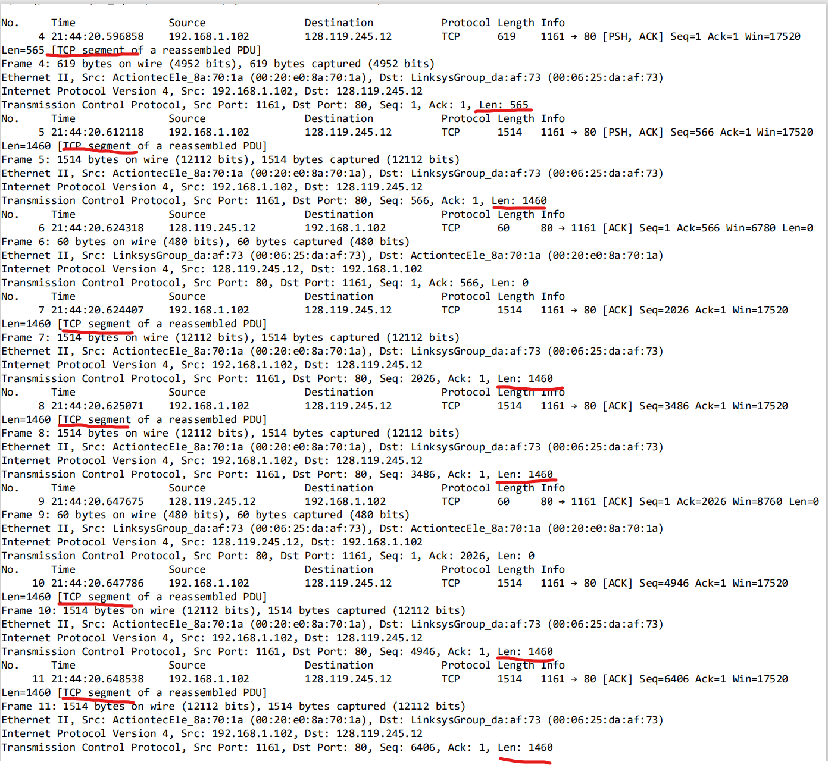

Q10.

The trace file contains no retransmitted segments, as confirmed by examining the sequence numbers of the TCP segments within it. The Time-Sequence Graph (Stevens) for this trace shows that sequence numbers from the source (192.168.1.102) to the destination (128.119.245.12) consistently increase over time. Should there be a retransmitted segment, its sequence number would be lower than those of adjacent segments.

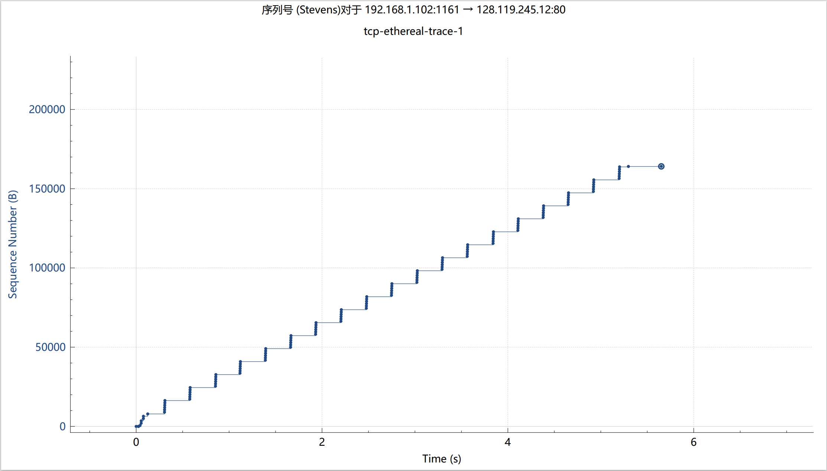

Q12.

Throughput

= total data transferred / total time cost

= (164091 – 1) bytes / (26.026211 - 20.596858) sec

= 30.222 kBps

