QA (1)

ER_diagram

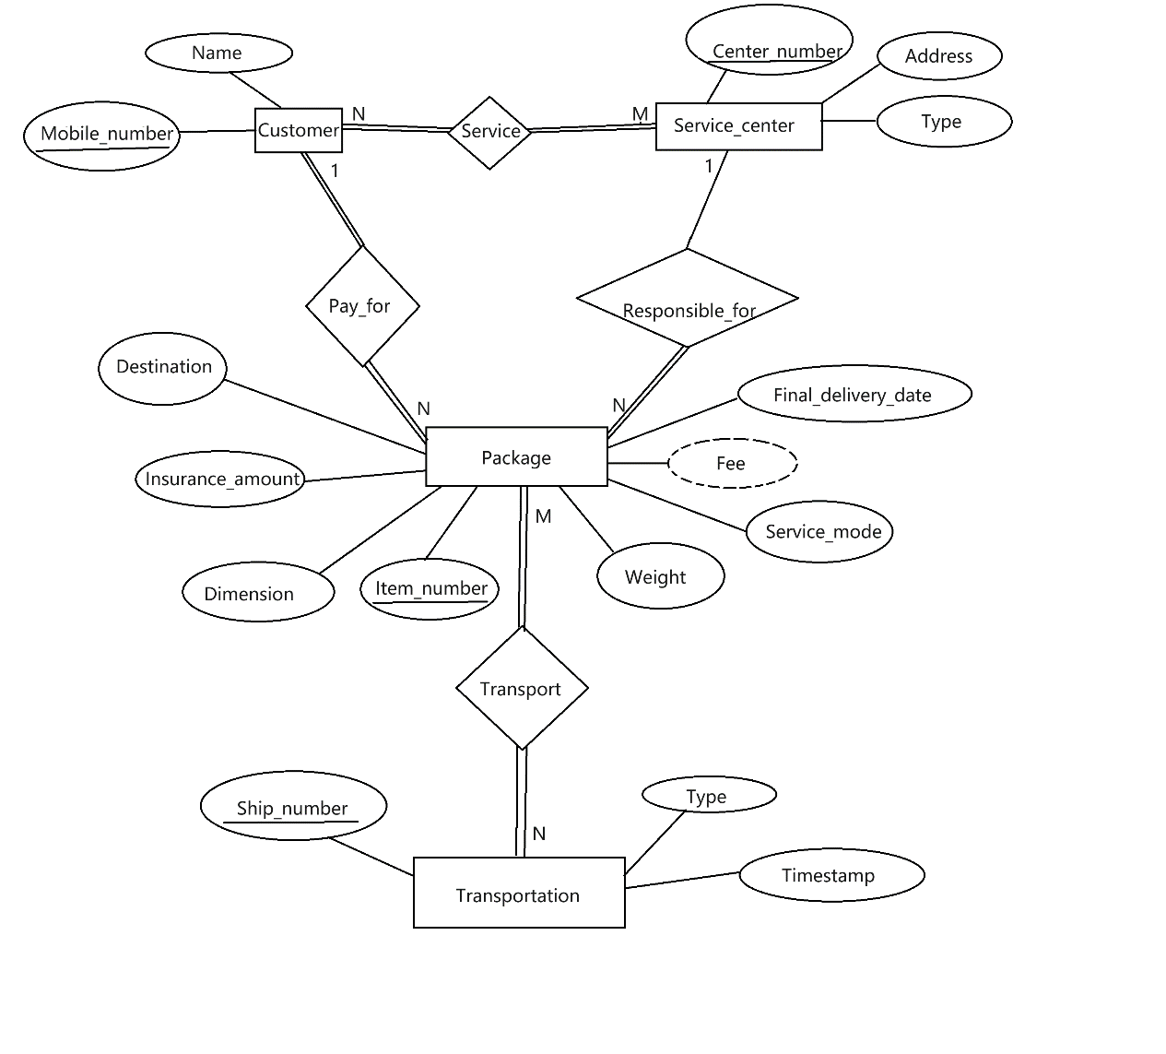

Assumptions:

1. Each customer can only go to one type of service center for one delivery, but customer can choice different service center to deliver different packages at the same time even their previse packages are not arrived yet.
2. Customer can deliver as many packages as they want but they must go to only one service center.
3. Service center can provide service for many customers, one customer or no customer.
4. Each package is belonged to one customer.
5. Service center can associate with many packages, one package or no package.
6. Mobile number is used to distinguish customers.
7. Each package has to be associate with one transportation and it can associate with more than one transportation.
8. Attribute “Type” for service center and transportation are not the same.

QA (2)

CUSTOMER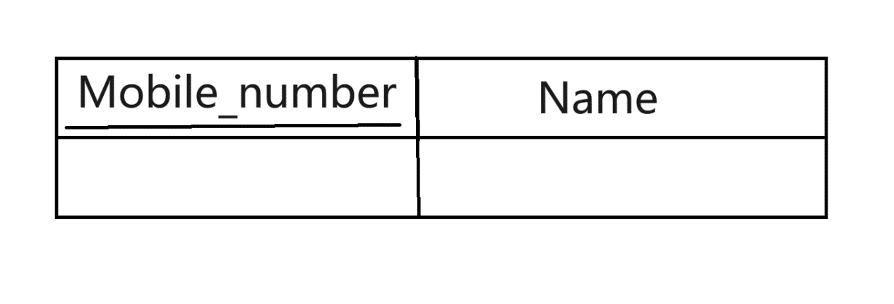

SERVICE_CENTER

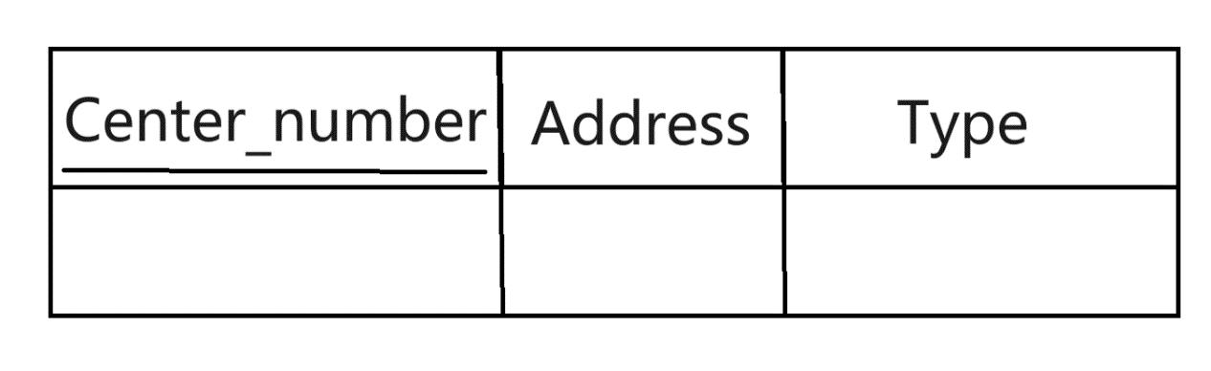

SERVICE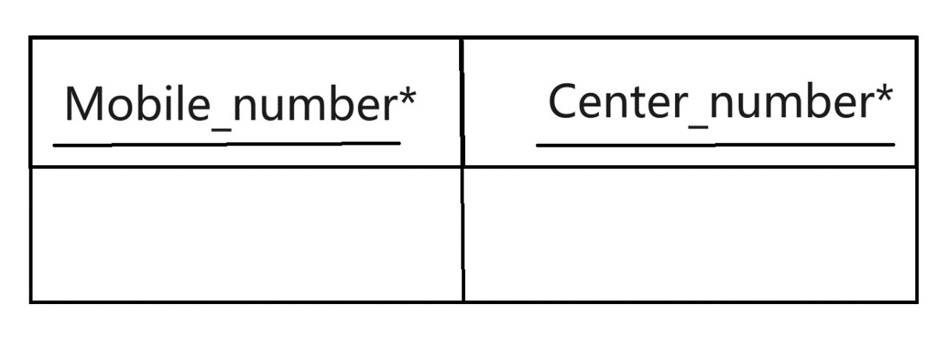

PACKAGE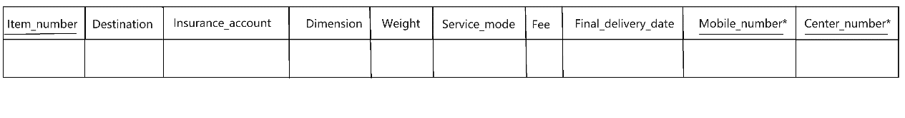

TRANSPORT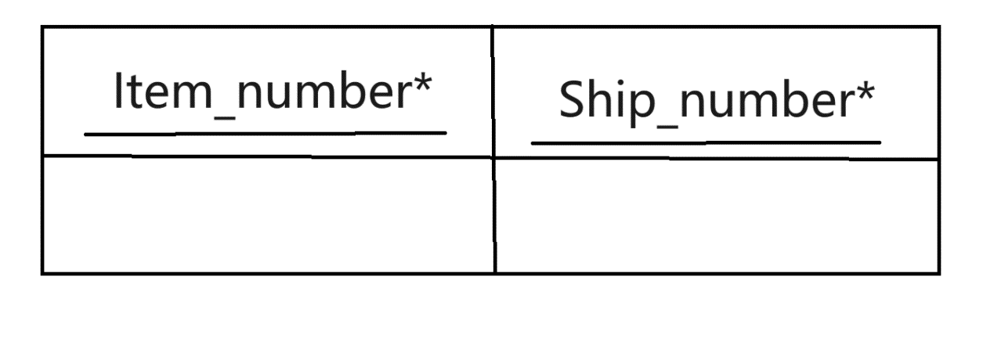

TRANSPROTATION