Please open run command and run below mentioned command **inetcpl.cpl**.

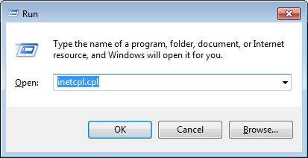

Click on the connections Tab and click LAN settings button.

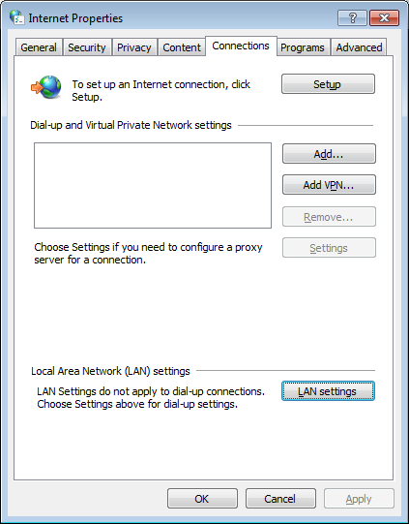

Please enable the check box of “Use a proxy server for your LAN …”

Proxy Server:

Address: proxy.cognizant.com

Port: 6050

Click OK button.

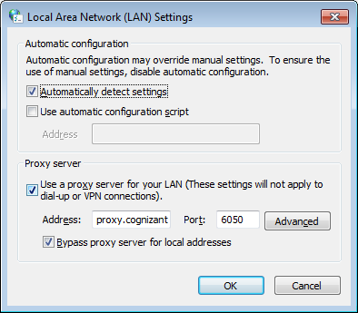

Open System Properties Dialog box and click Environment Variables button.

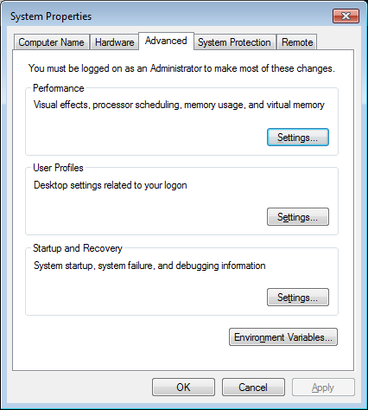

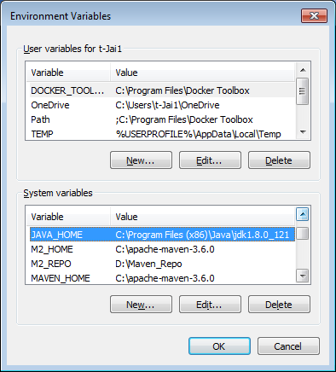

Set above environment variables.

Maven_Home Location **%MAVEN_HOME%\conf\settings.xml take backup existing xml file and replace the contents in file.**

<?xml version="1.0" encoding="UTF-8"?>

<settings xmlns="http://maven.apache.org/SETTINGS/1.0.0"

xmlns:xsi="http://www.w3.org/2001/XMLSchema-instance"

xsi:schemaLocation="http://maven.apache.org/SETTINGS/1.0.0 http://maven.apache.org/xsd/settings-1.0.0.xsd">

<profiles>

<profile>

<id>local</id>

<repositories>

<repository>

<id>central</id>

<url>http://10.223.70.118/mvn-repo</url>

<releases>

<enabled>true</enabled>

</releases>

</repository>

</repositories>

<pluginRepositories>

<pluginRepository>

<id>central</id>

<url>http://10.223.70.118/mvn-repo</url>

<releases>

<enabled>true</enabled>

</releases>

</pluginRepository>

</pluginRepositories>

</profile>

</profiles>

<activeProfiles>

<activeProfile>local</activeProfile>

</activeProfiles>

</settings>

Once all above setup done you can run **mvn clean install** in your project root folder to ensure the download happening or not.

**Below configuration for Eclipse Maven Configuration.**

Please follow steps to complete eclipse configuration.

Window -> Preferences -> Java -> Installed JREs -> Edit (Default Jre) -> Default VM arguments: (Paste below content)

-Dmaven.multiModuleProjectDirectory=$M2_REPO

