

**Department of Artificial Intelligence & Machine Learning**

**EVENT REPORT**

**Event Name :** Cyber Psycho

**Event Description :**

The technical club of the AIML department, Brainiacs conducted the event, Cyber Psycho, which was an Inter-Department level event consisting of multiple technical rounds. One of the rounds in this event were inspired by the algorithms used in machine learning and how neural network systems work. The motive of this event was to familiarise people even out of the AI department with how neural networks work.

**Event details:**

Event was conducted on 17th November 2022 from 10:00am to 4:00pm.

**ROUND 1**

**Quietplace**

Participants assembled in two classrooms in the AIML block and took turns to participate in the event, with 3 groups of 4 members each at a time. Two roles of data nodes, one role of name node and failover controller were assigned to every 4 people. The role of data nodes was to pick two questions from given options that they were supposed to recite to the name node. The name node was blindfolded and the data nodes were asked to clap as the name node was given a choice to go to either one of the two data nodes based on their hearing ability. In case a name node failed to answer the question, they were to be replaced with the failover node. The participants were ranked on the basis of how many questions they were able o answer correctly.

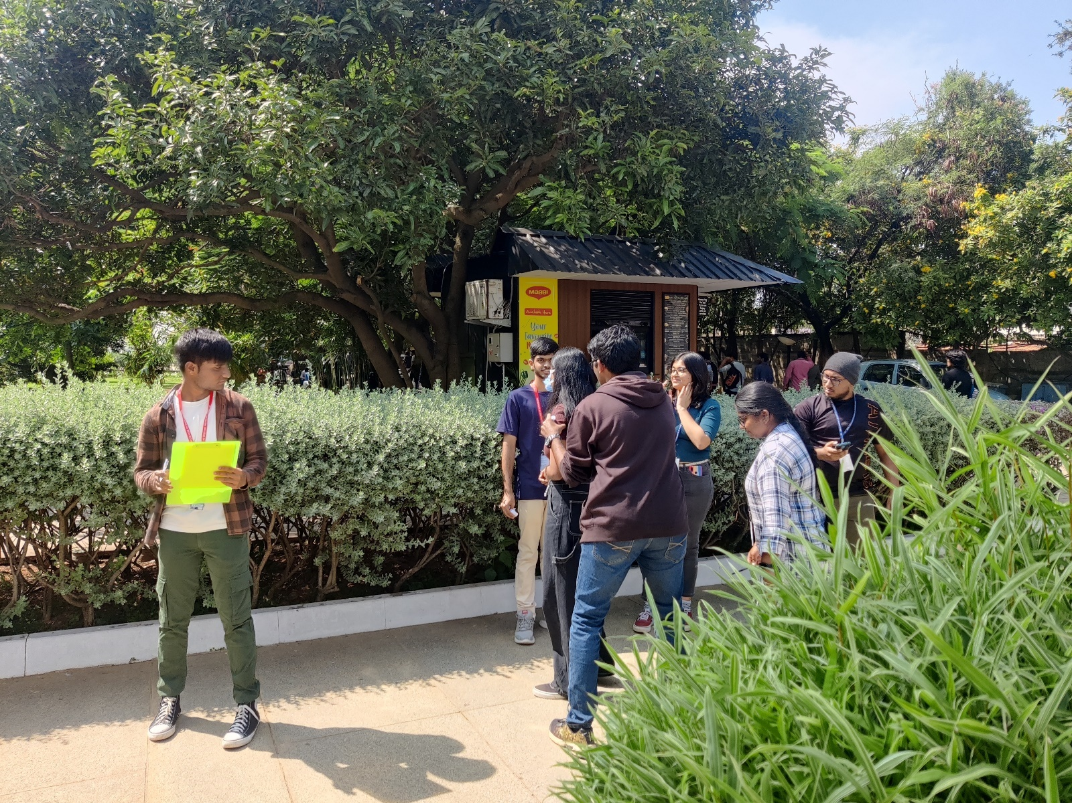

An event coordinator spinning the name node around while the volunteer keeps a note of the teams score

**ROUND 2**

**Geoguesser**

This round was based on the team’s geographical and cognitive skills. With access to data from google streetview, the participants were required to guess a place based off the geographical features present in an image. The features varied from landmarks to sign boards to plain terrestrial features. The team was scored off how close their guess was from the actual place.

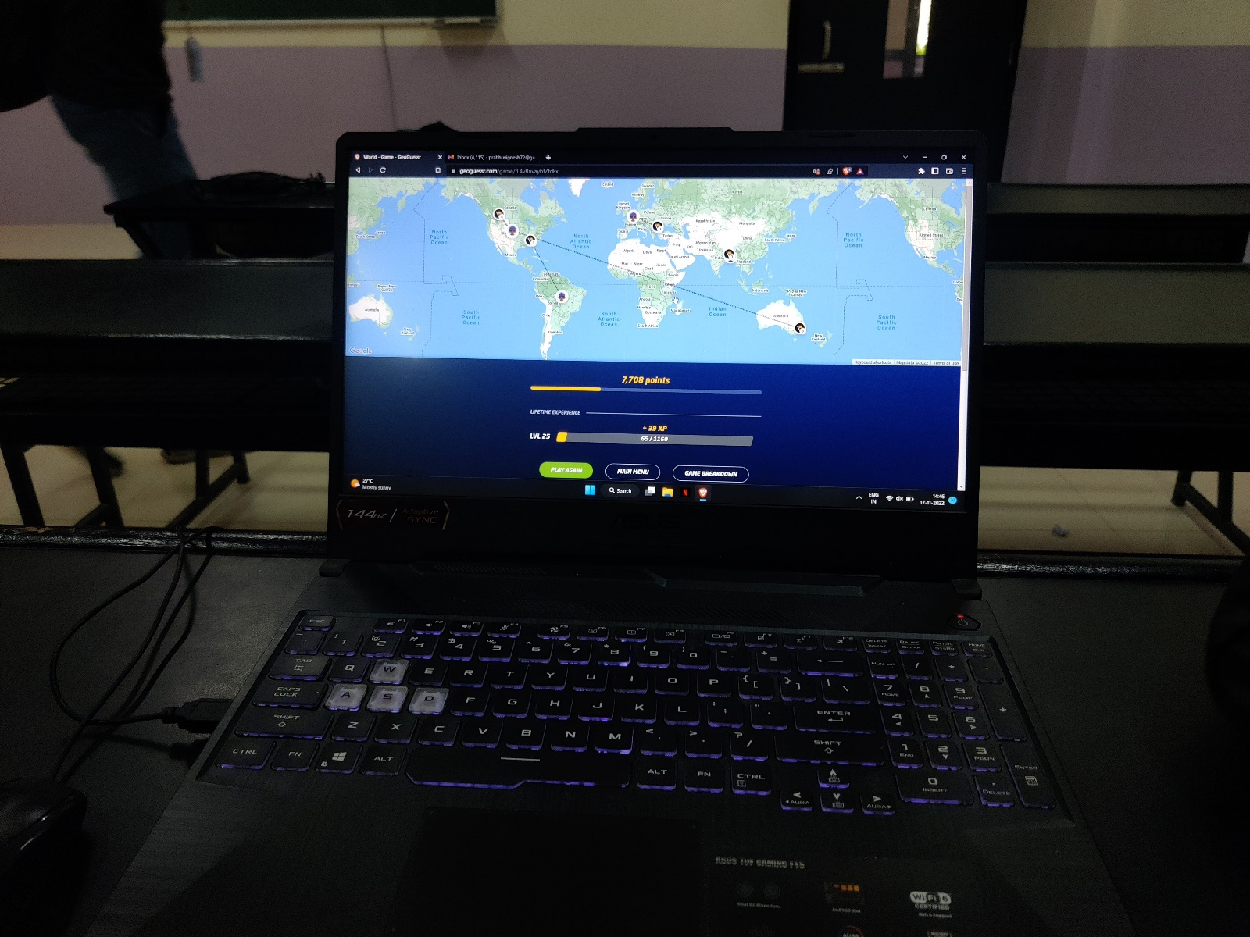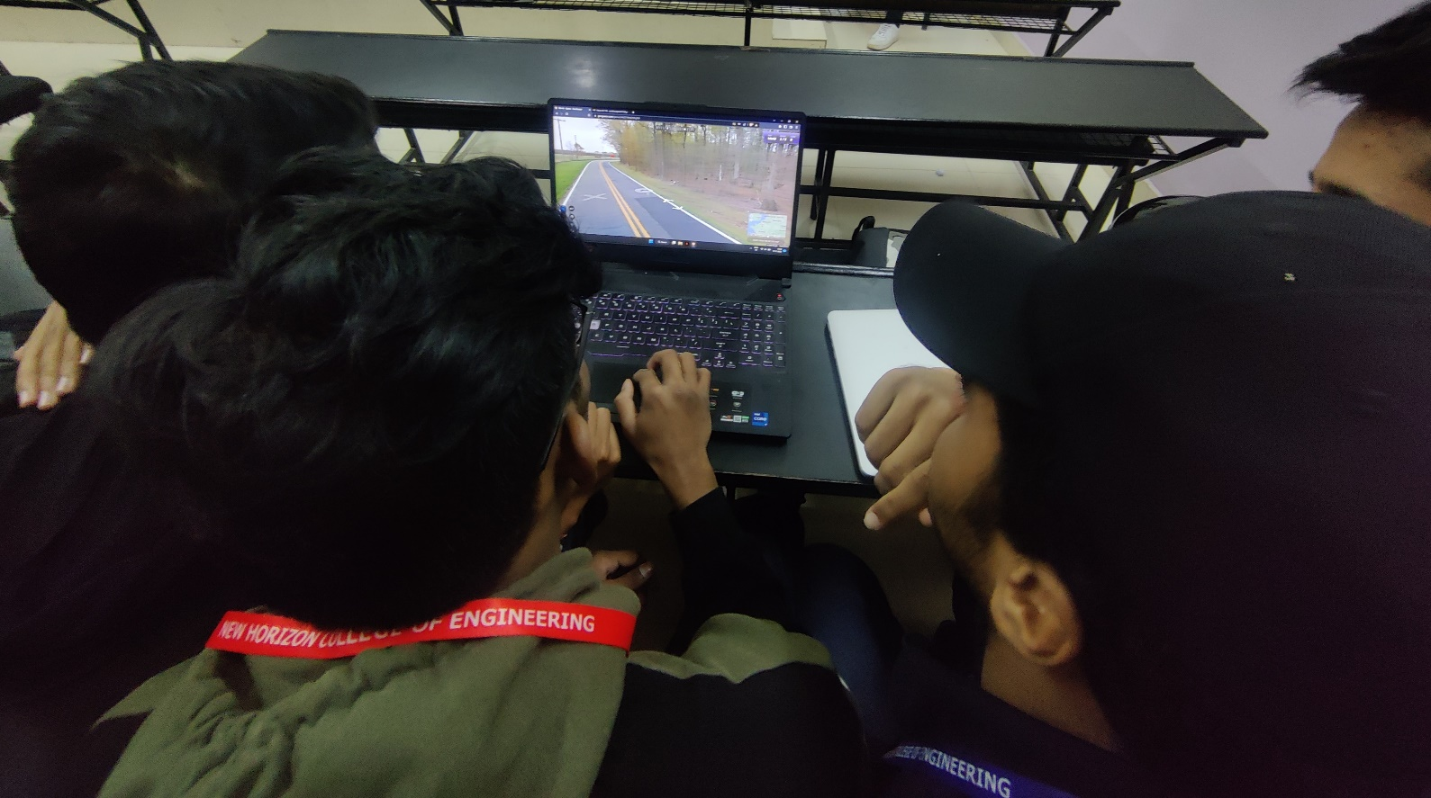

**A team’s score summary**

**Round 3**

**Hangman**

This was a team round of 2. Every team who qualified round 2 were split into two and made to participate in this round. This round starts with a rope hung on a grip. It included the team guess a 5-letter word, one letter at a time given from a list of all alphabets. After every one wrong guess, one feature (e.g. Arms, legs, body, head) is added to the rope. As the game progresses, every wrong letter adds a feature to the rope. In the end, when the stickman is completed after 6 wrong guesses the team fails that word and starts a new one. In case the team guesses it right, the team wins that word. The team with the highest win rate (wins/words) won the competition.

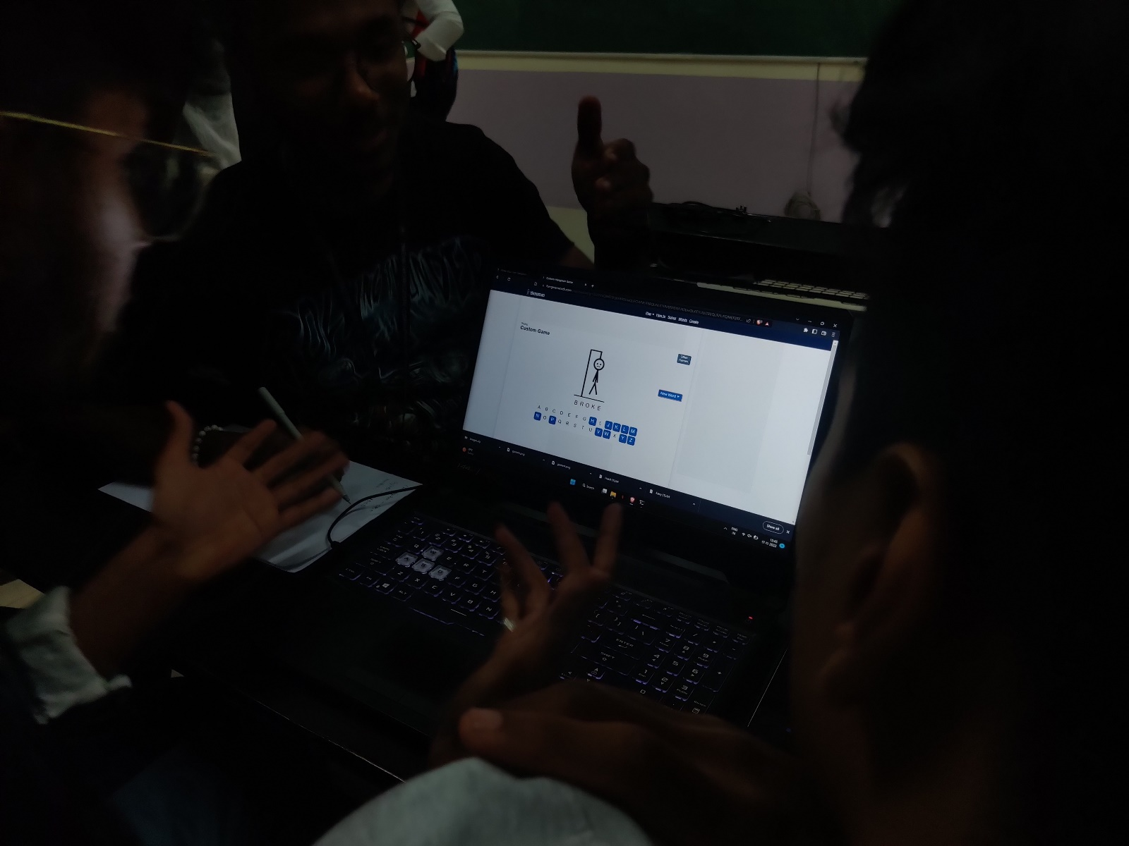

A player gets frustrated as he is not able to guess the word

**The event with 2 winners and 2 runnerups.**

**Winners: Sharath Ram & Divyesh Jaiswal**

**Runner ups: Sarim farooque and harshita**