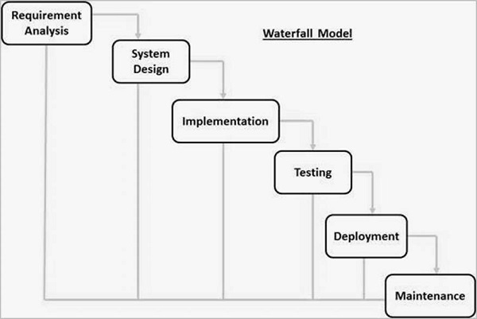

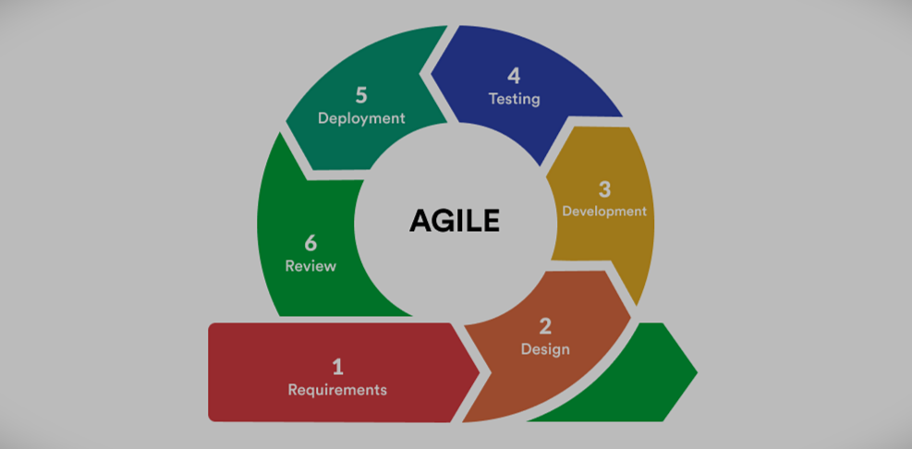

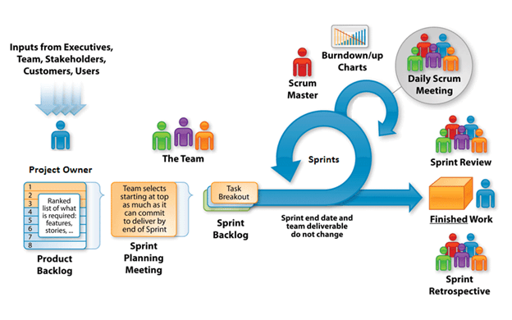

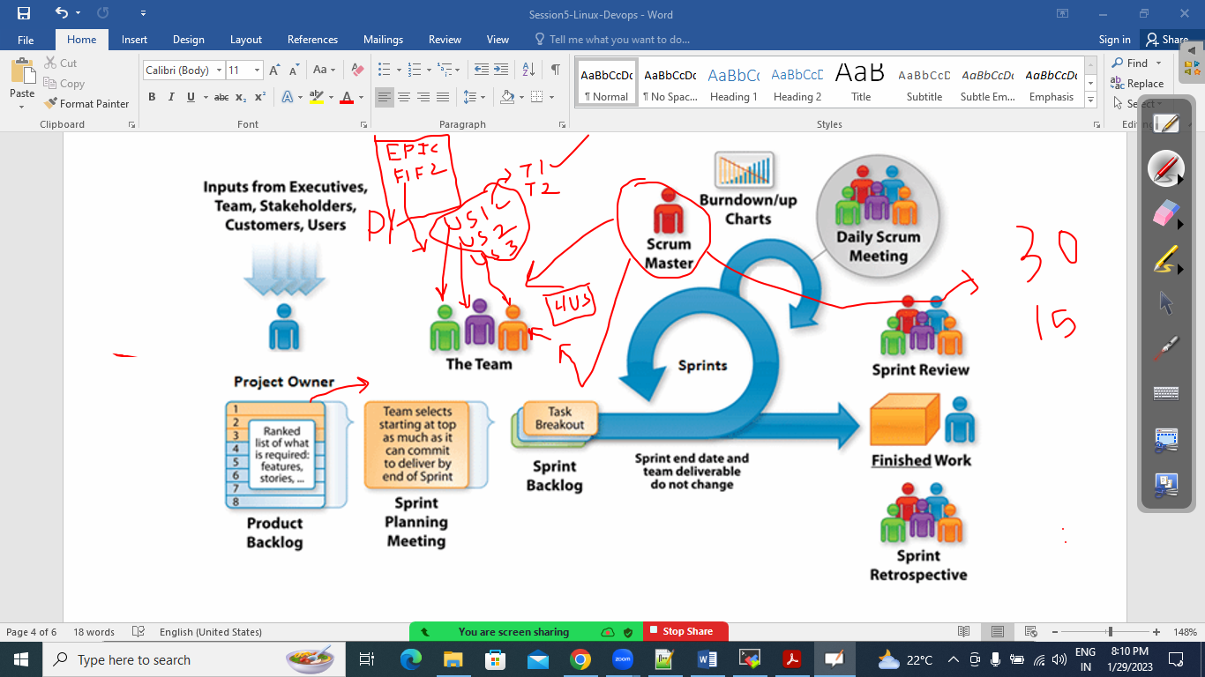



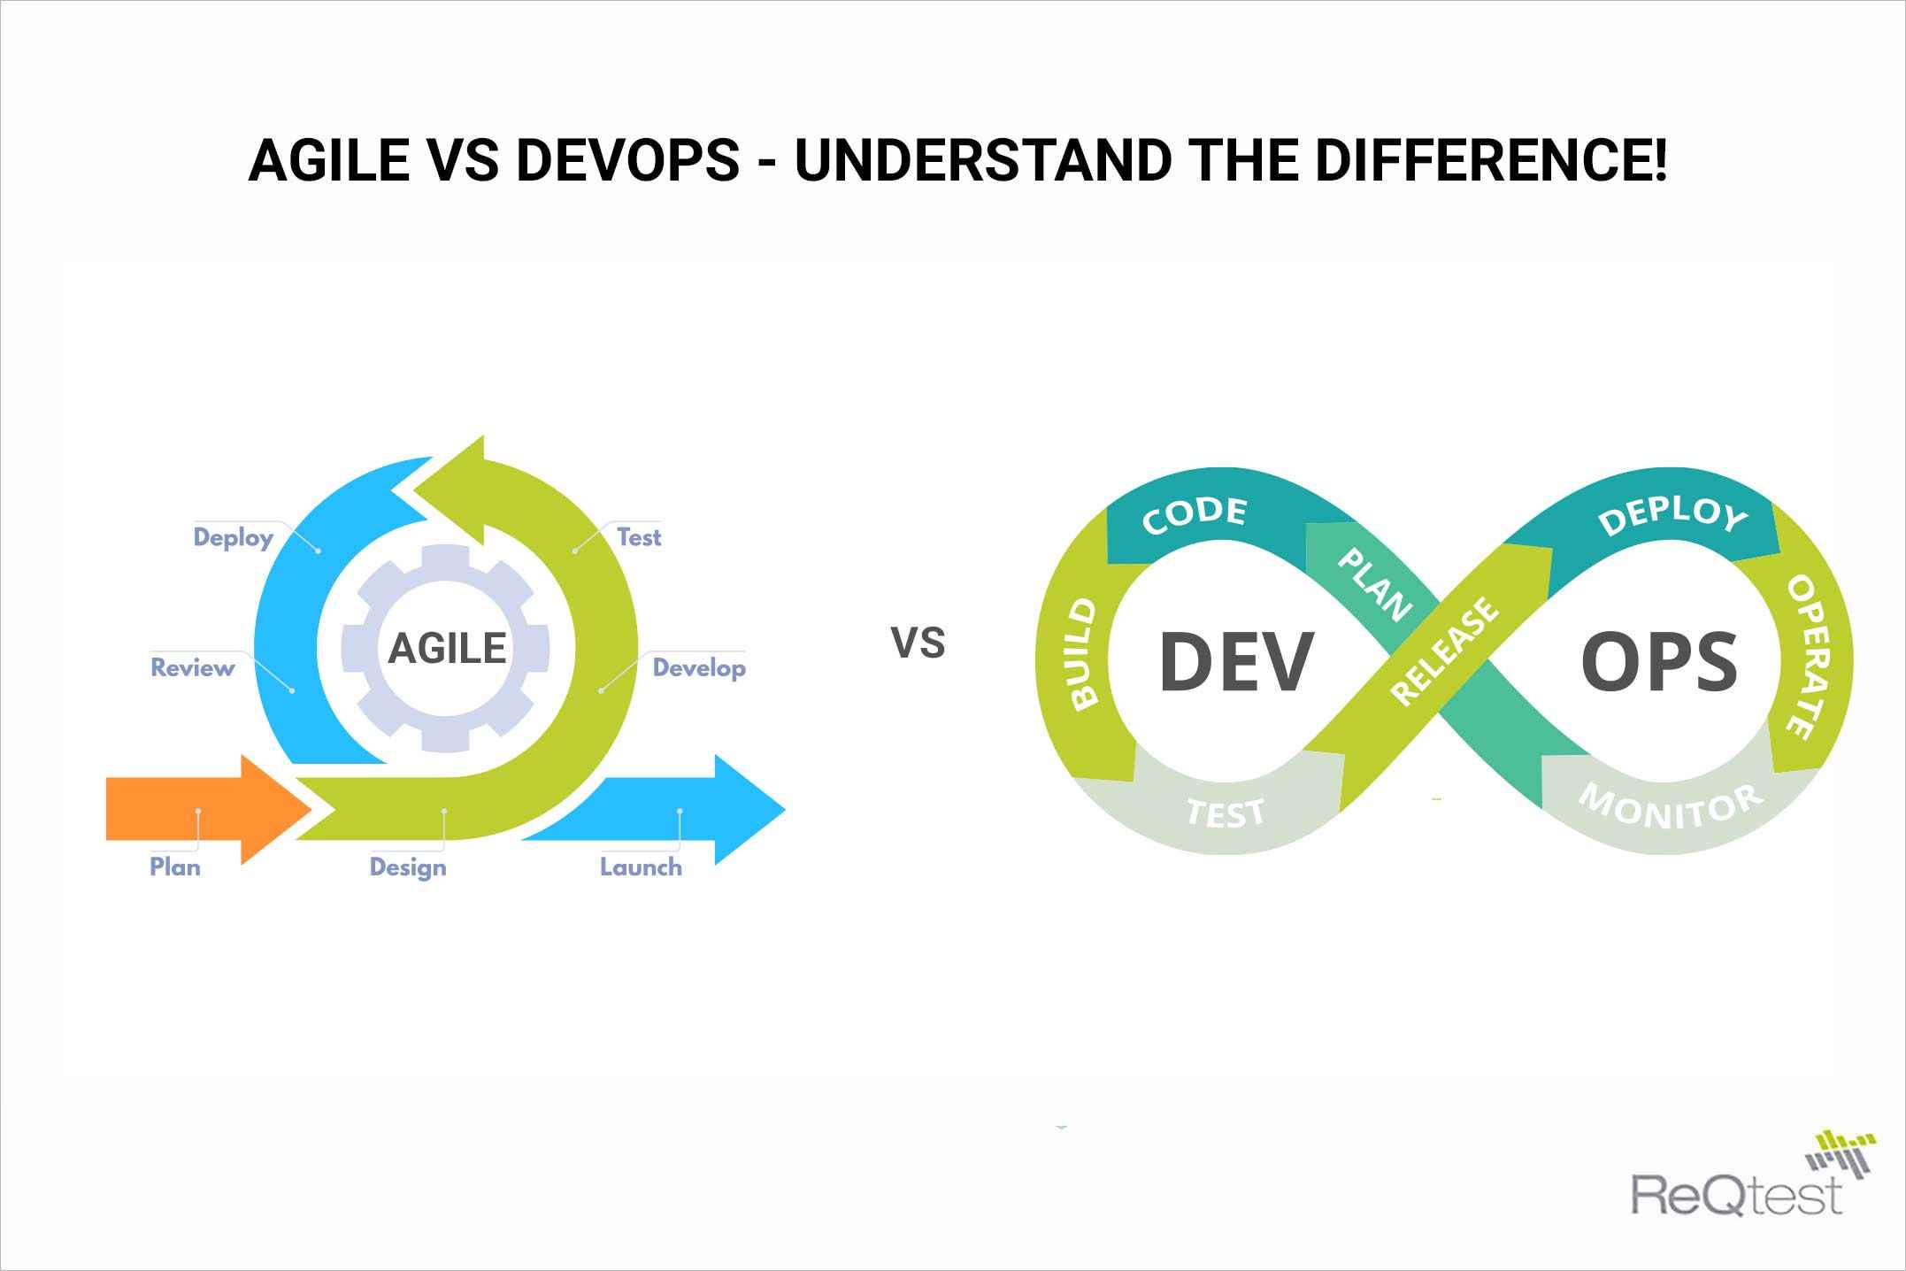

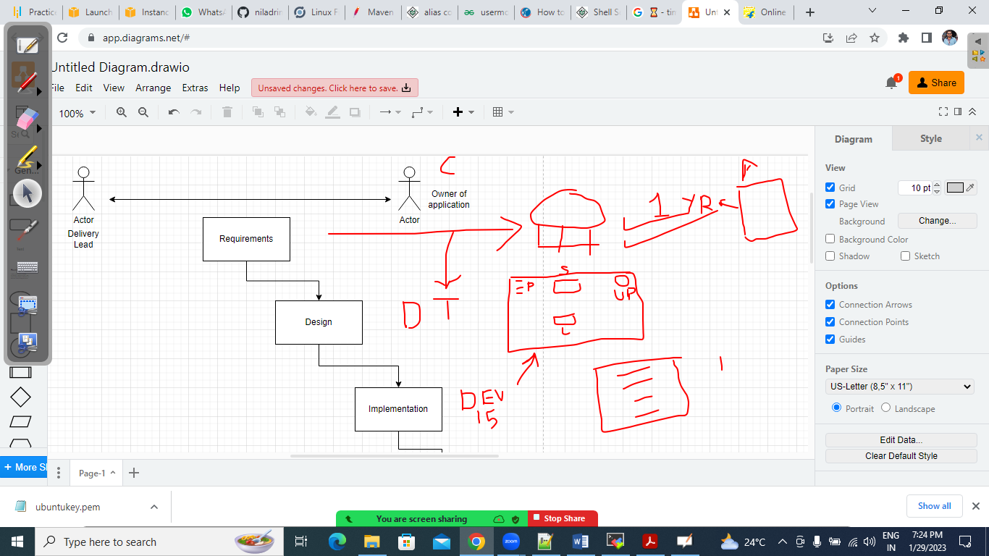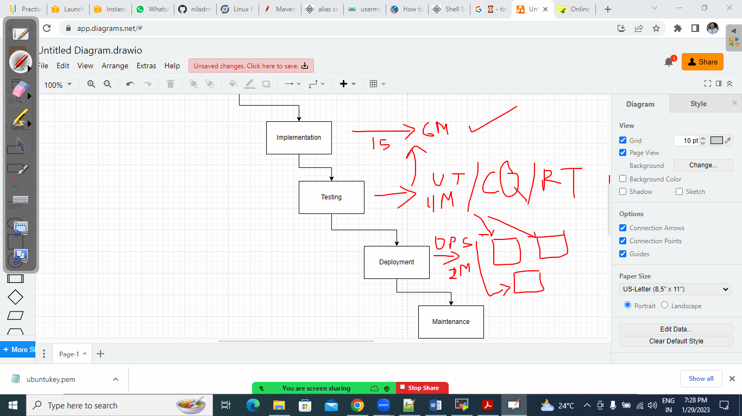



Drawback of waterfall model

1. Time consuming
2. Code size huge
3. Difficult to Achieve Goal
4. Investment

Benefits of the devops:

1. Reliability
2. Scalability
3. Security
4. Rapid Delivery
5. Improved Collaboration
6. Speed
7. Maintenance/Monitoring

Best Practices to adopt devops

1. Continuous integration
2. Continuous Deployment
3. Monitoring and logging
4. Infrastructure as a code
5. Micro services
6. Communication and collaboration

Devops tools:

Checkout the code : Source code Management (git, bitbucket, gitlab)

Build: Maven (mvn clean install) , gradel,ant

Unit Testing: mvn test , mvn pmd, junit

Quality assurance: Sonarqube, Coverity

Deploy the same to env: Jenkins m Bamboo

Integration Testing(Testing Framework) : Selenium

Packaging and archiving tools: Nexus , artifact repo,

Configuration management tools and deployments tools: chef, puppet , ansible

Environment : Aws , Azure , Openstack

Monitoring tools : Nagios, Dynatrace, Azure Monitor, cloud watch

Containerization : docker, eks ,aks, k8s