1. Download Apache Ant
2. Configure the same in ENV
3. Integrate sane in Jenkis

<https://ant.apache.org/bindownload.cgi>

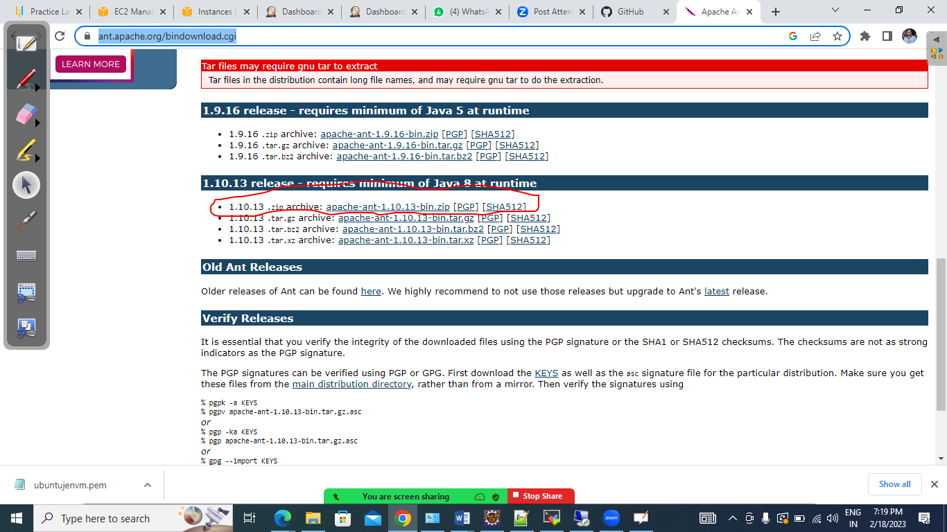

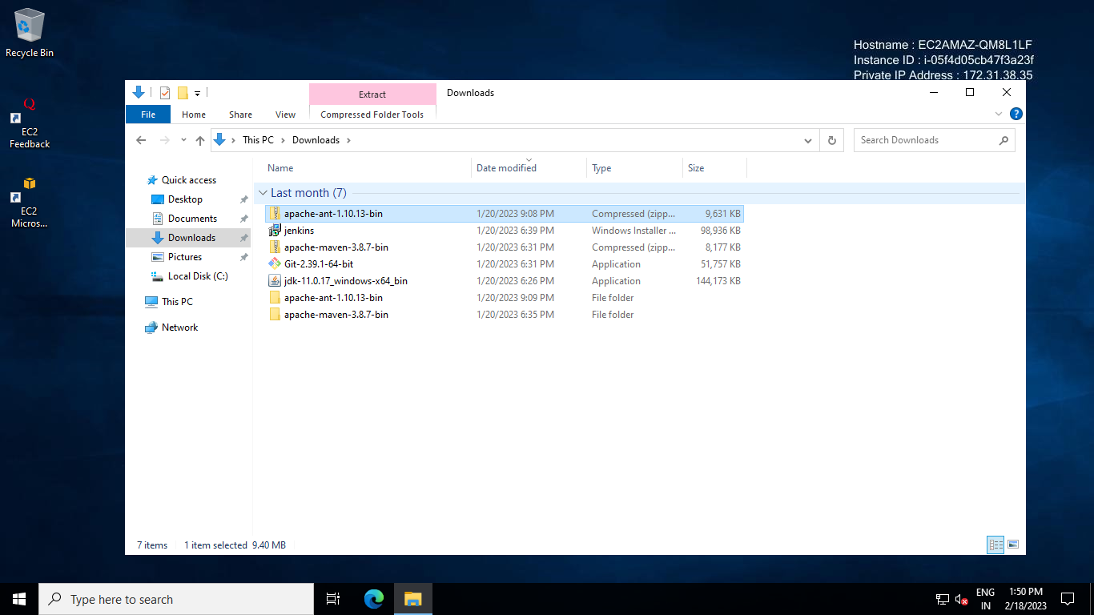

Now extract the zip file and copy the folder in somewhere and enable the env from there

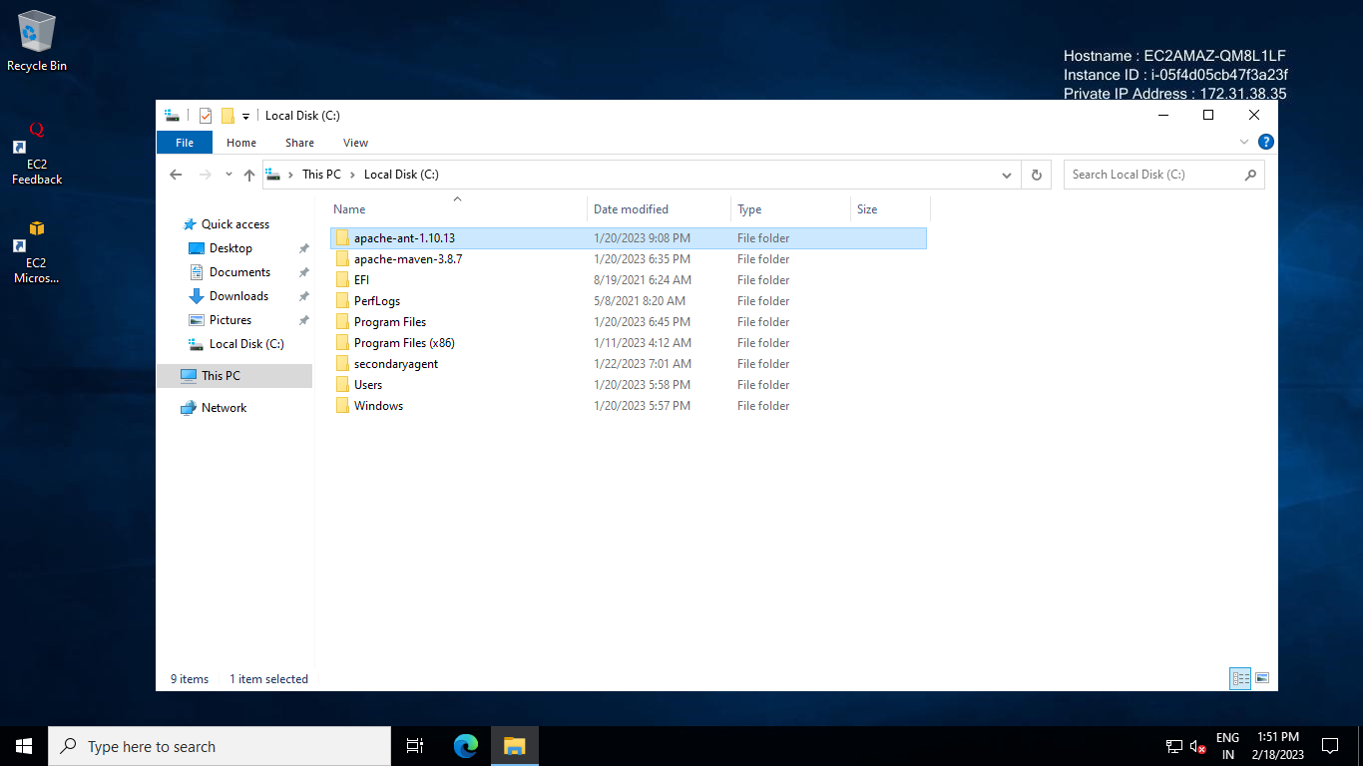

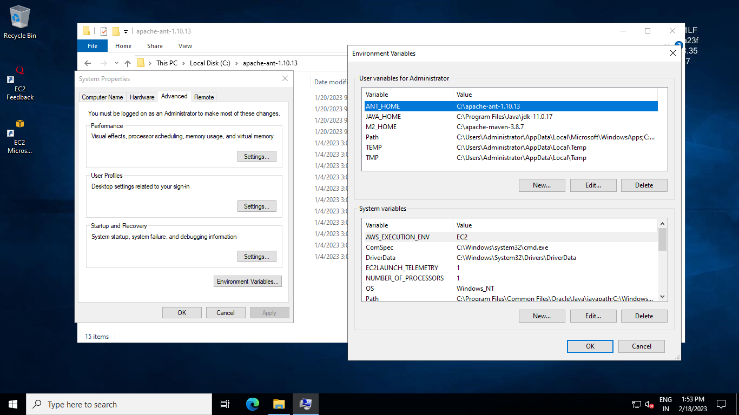

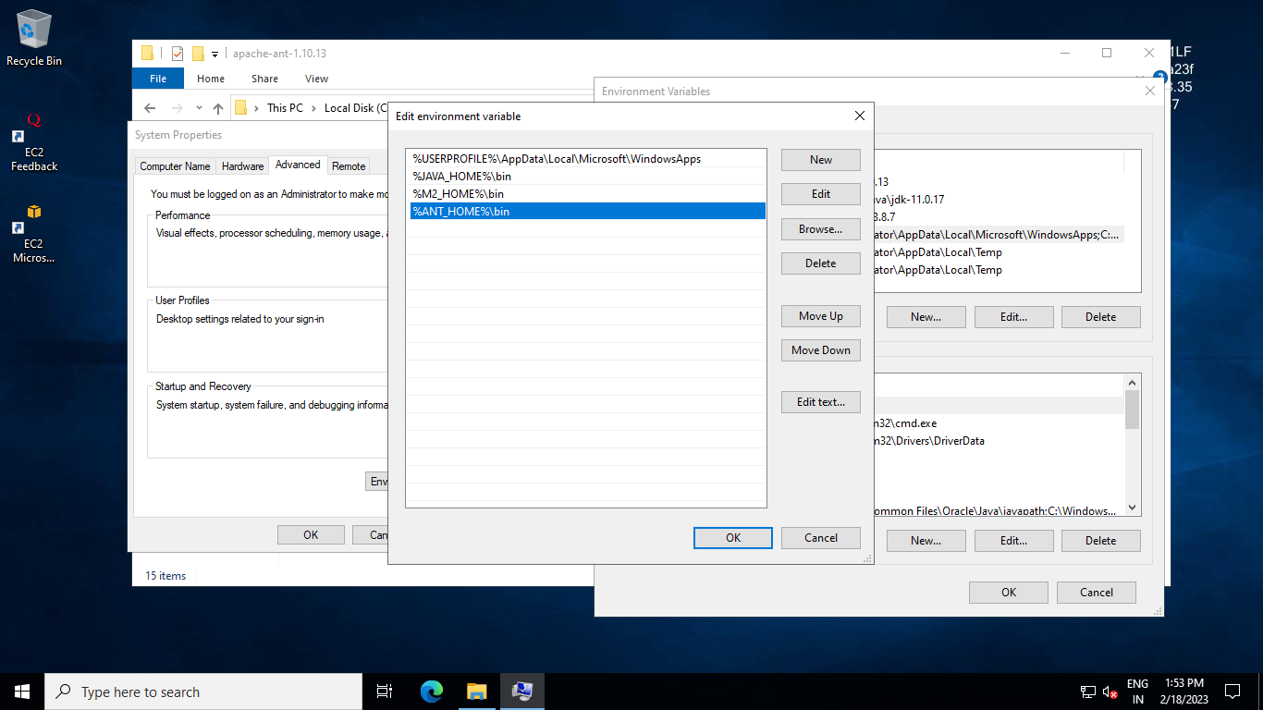

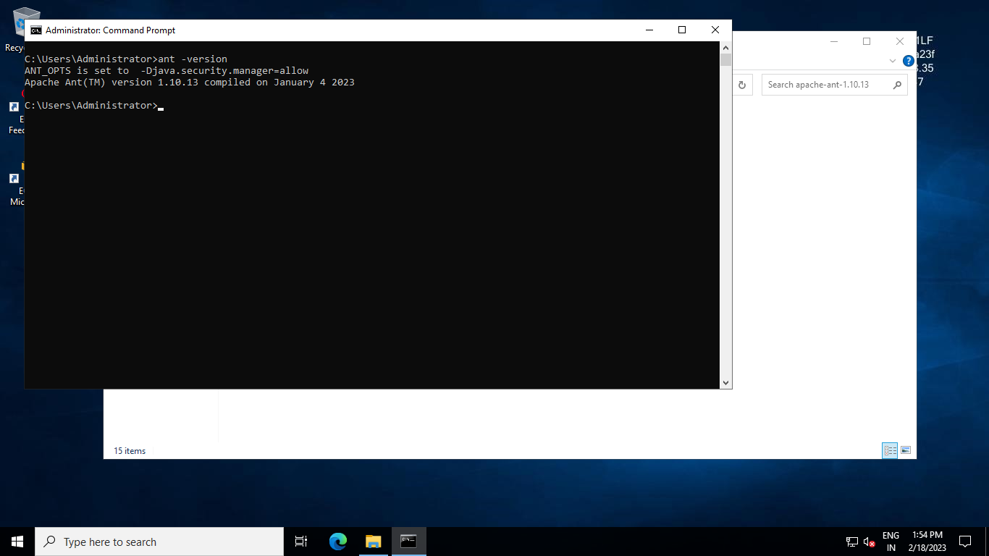

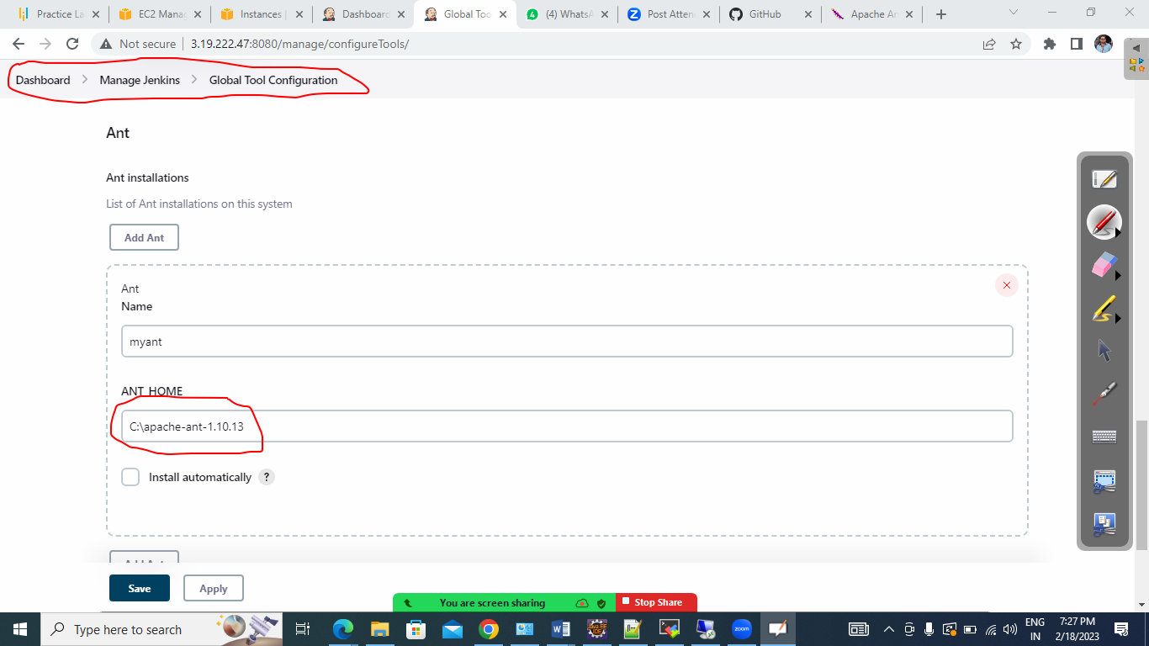

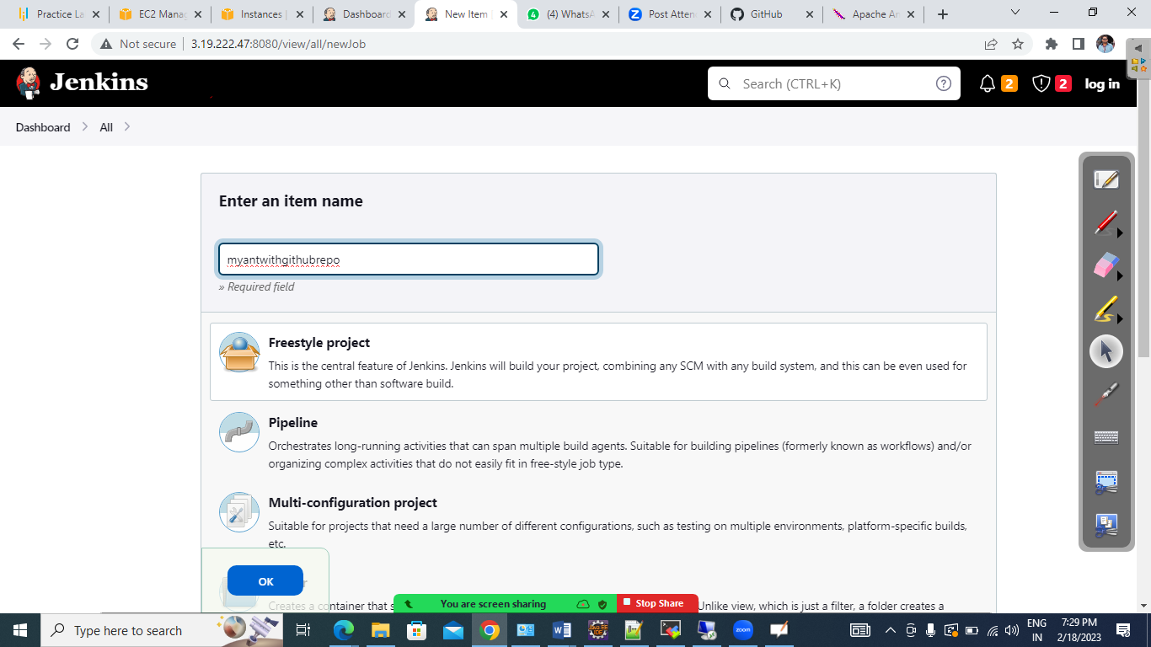

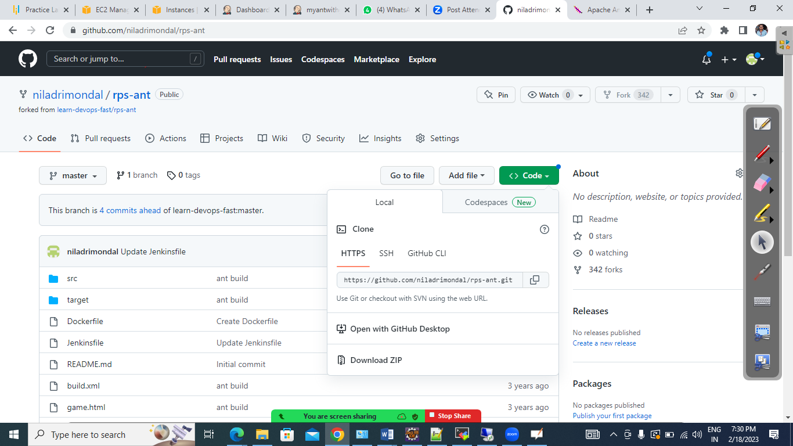

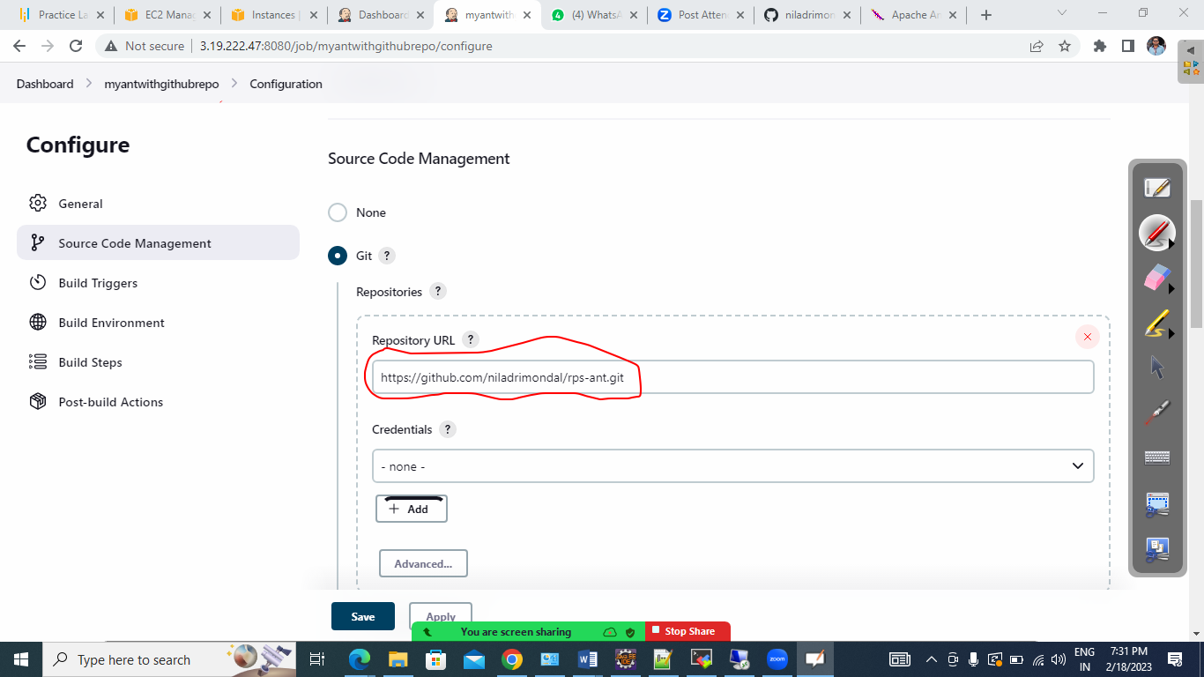

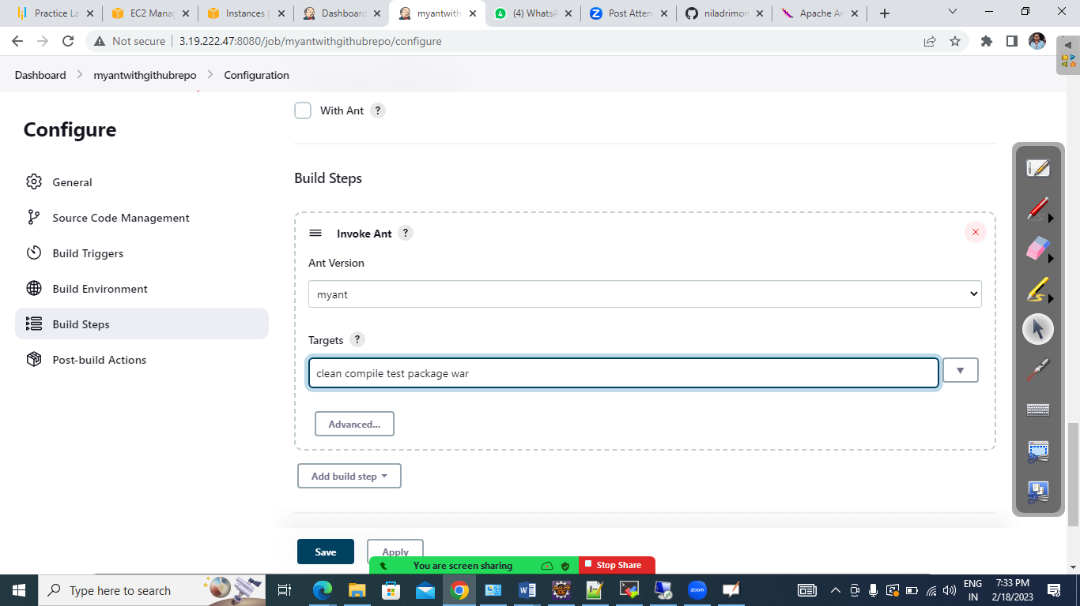

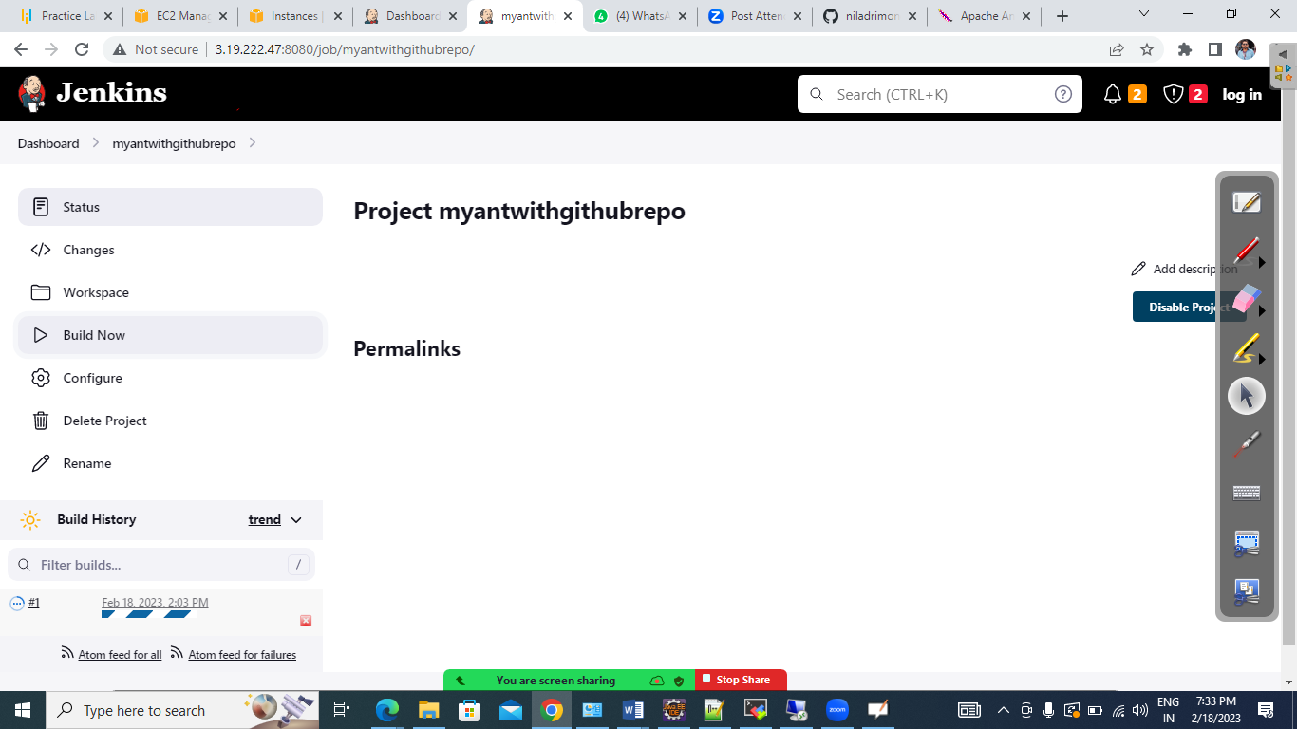

+++++++++++++++++++++++++++++++++++++++++++++++++++++++++++++++++++++++++++

Setup your FirstPipeline using some groovy script

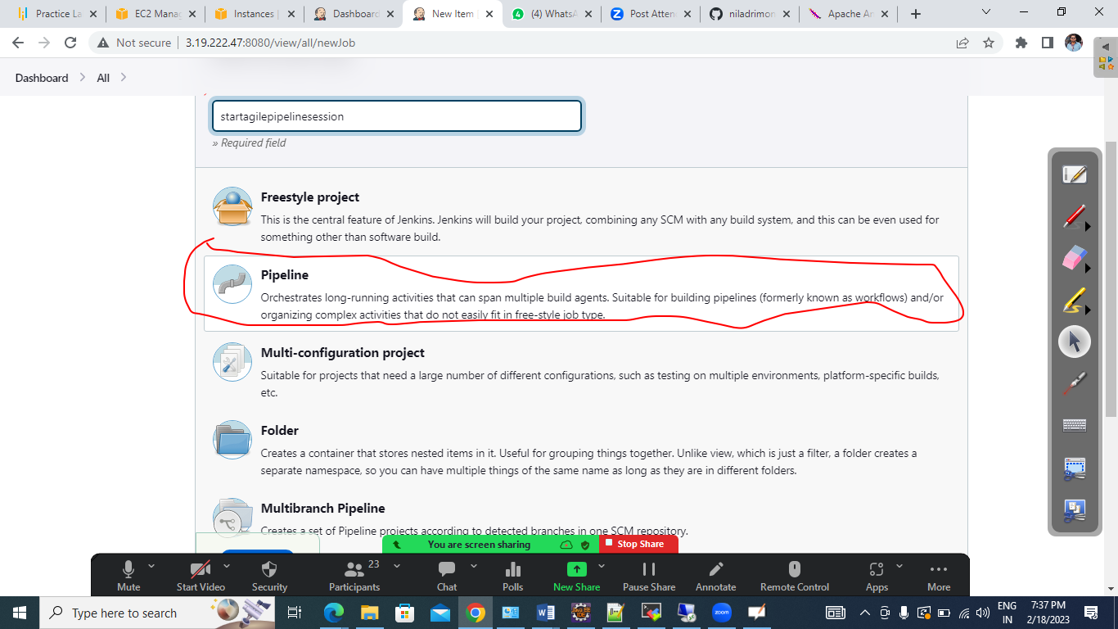

# Now we are going to use a Maven Github repo and build the same with Groovy script

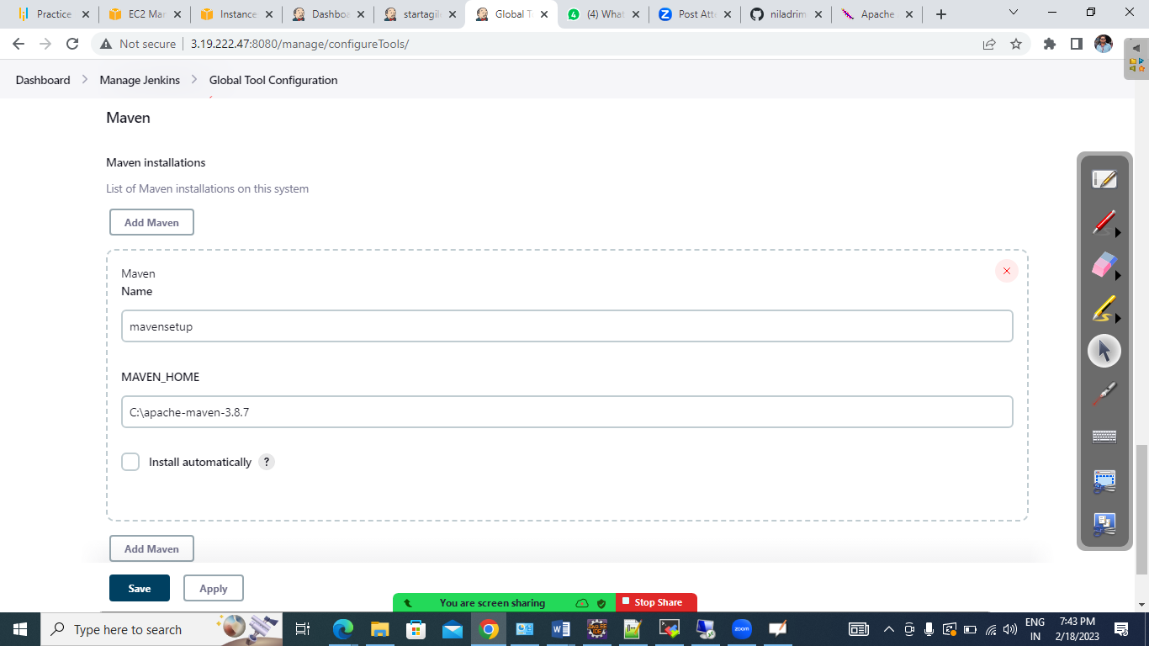

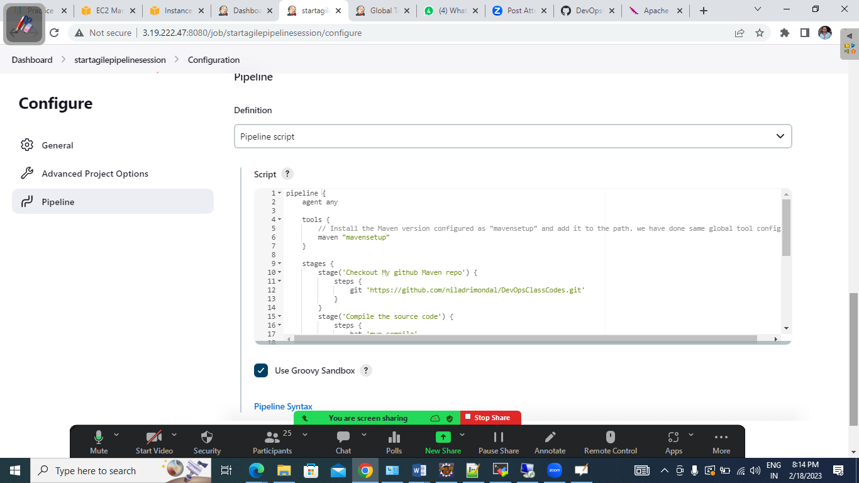

++++

pipeline {

agent any

tools {

// Install the Maven version configured as "mavensetup" and add it to the path. we have done same global tool configuration

maven "mavensetup"

}

stages {

stage('Checkout My github Maven repo') {

steps {

git 'https://github.com/niladrimondal/DevOpsClassCodes.git'

}

}

stage('Compile the source code') {

steps {

bat 'mvn compile'

}

}

stage('Run unit test case') {

steps {

bat 'mvn test'

}

}

stage('Run the Code quality check') {

steps {

bat 'mvn pmd:pmd'

}

}

stage('Package the code as a war file') {

steps {

bat 'mvn package'

}

}

}

}

++++

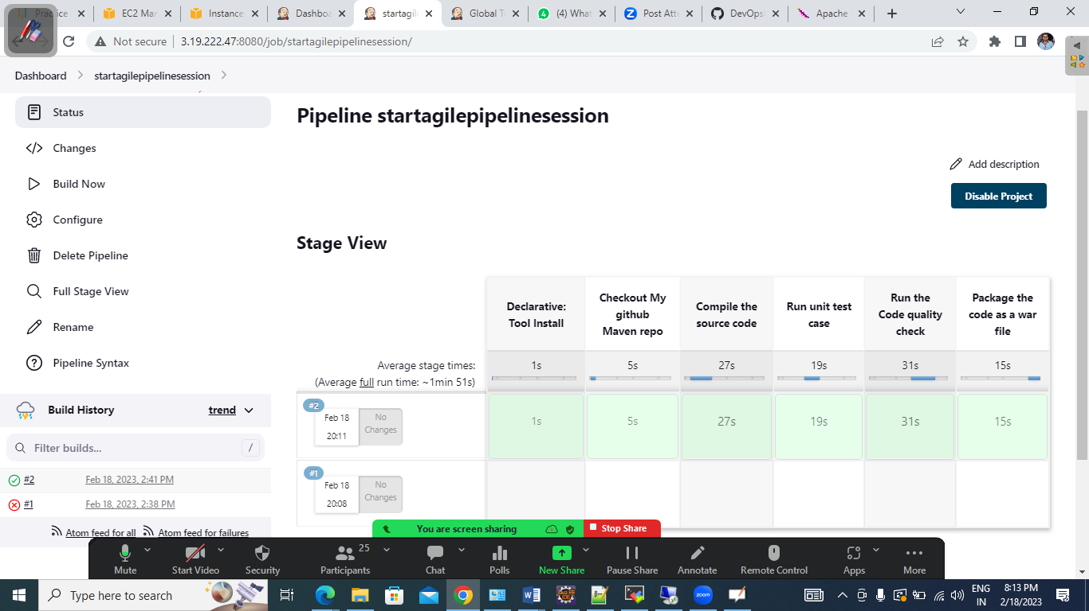

++++++++++++++++++++++++++++++++++++++++++++++++++++++++++++

We have install Jenkins in Ubuntu VM and also created another VM for secondary slave node

Created a directory inside the slave node and used the same for remote root directory

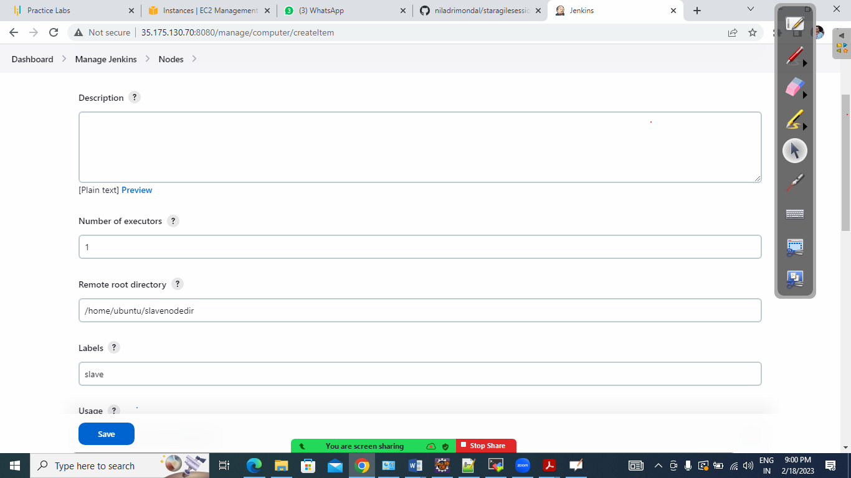

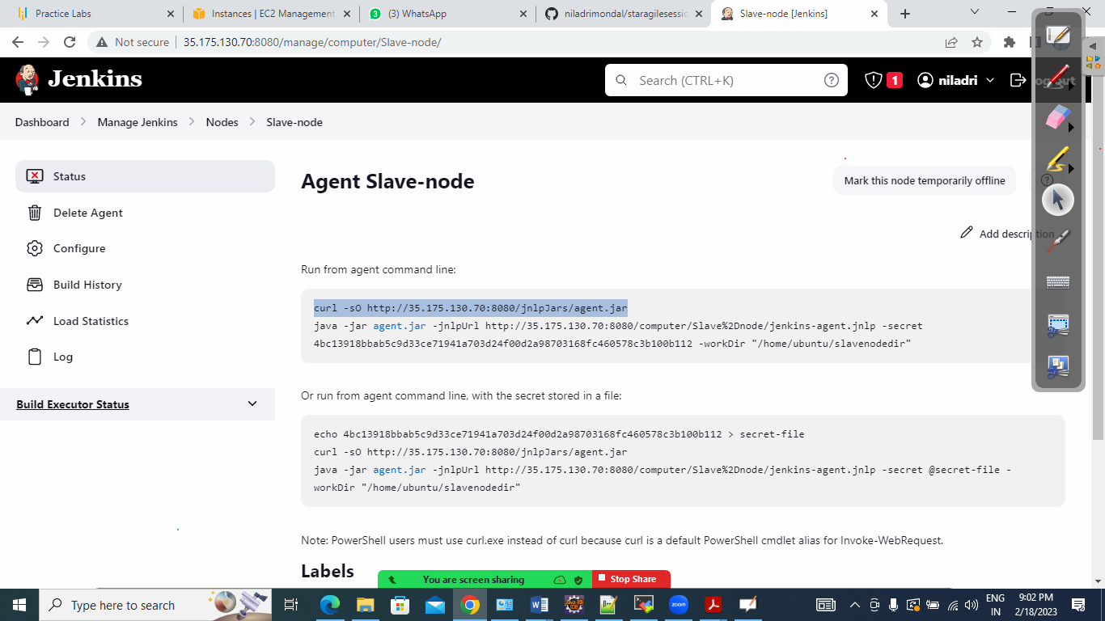

Run the commands in slave node

