**How to annotate – a Guide.**

**Annotation and Validation Guideline.**

This annotation and validation guideline was created as part of the DFG Project ‘Transfer Learning for Human Activity Recognition in Logistics (Fi799/10-2 & HO2403/14-2)’. The document is for guiding the annotators through the LARa dataset annotation process. The document is purposed to support annotators, irrespective of their knowledge in Logistics. Annotation guideline for both activity classes and attribute representation is available. Prior to annotation, please make yourself aware of the special cases and exceptions that may occur during the annotation.

For queries on classes and attributes, please contact Christopher Reining ([christopher.reining@tu-dortmund.de](mailto:christopher.reining@tu-dortmund.de)) and Friedrich Niemann ([friedrich.niemann@tu-dortmund.de](mailto:friedrich.niemann@tu-dortmund.de)). For queries on the tool and this document, please refer to Fernando Moya (fernando.moya@tu-dortmund.de), Erik Altermann (erik.altermann@tu-dortmund.de), and Nilah Nair ([nilah.nair@tu-dortmund.de](mailto:nilah.nair@tu-dortmund.de)).

Table of Contents

Contents

General Information 3

Activities and Attributes 4

Activity-wise Annotation 4

Attribute-Wise Annotation 6

Documentation of Annotation 9

# General Information

* Each file has 6 identifiers
  + **L Logistic Warehouse Scenario**: There are 3 in total. The first scenario is a simple one, the second and third are based on a real warehouse processes and are more complex. (For more information on Scenarios, please refer LARa[1])
  + **S Subjec**t: There are 16 subjects.
  + **R Recording**: There are 30 recordings of 2min each, per subject. Few subjects may have lesser number of recordings, as these recordings were deleted due to noise.
  + **A Annotator**: ID of the person who annotated manually. Assigned prior to annotation process.
  + **N Number of annotation**: How many times did the annotator already annotate this file (relevant for repetition tests regarding the consistency).
* For the recording from 2018-11, there are 30x2min=60min of recording per participant, 6 participants in total resulting in 6h of recordings to be annotated. All recordings are taking place in Logistic Scenario I.
* For the recording from 2019-08, there are 60min recordings per participant. ( hours of recording was performed with 8 participants. Logistics Scenarios II and III were of priority.
* For the recording from 2020-07, there are 60min recordings per participant. Two participants were recorded for a total of 2 hours each.
* The recording number for each participant begins from 1. If any recording was deleted, the numbers have not been shifted.
* Recordings are annotated in two ways at the same time: activity-wise and attribute-wise.
* We only annotate the MoCap data. The IMU data will be synchronized posteriorly for (semi-) automated annotation.
* Once the initial, manual annotation is done, revision and validation of all annotations will take place.
* Annotation effort will be documented; the ease and correctness of annotation are more important than the speed!

# Activities and Attributes

## Activity-wise Annotation

* **c1 Standing:** Standing while not doing any specific action. Smaller steps while standing are still considered standing. One can hold boxes, a cart or other items meanwhile.
* **c2 Walking:** Gait cycle (Figure: 1) while moving to a new position. No difference is made in regards to whether something is carried or not. **For the class walking, the attribute “gait cycle” is mandatory.**
* **c3 Cart:** Pushing or pulling the cart to a new position (walking with it) with one or both hands. **Does not include** the handling of items and boxes on the cart (this is considered handling). **Does not include** handling the cart before putting boxes on it or before pushing/pulling - this is considered a handling activity.

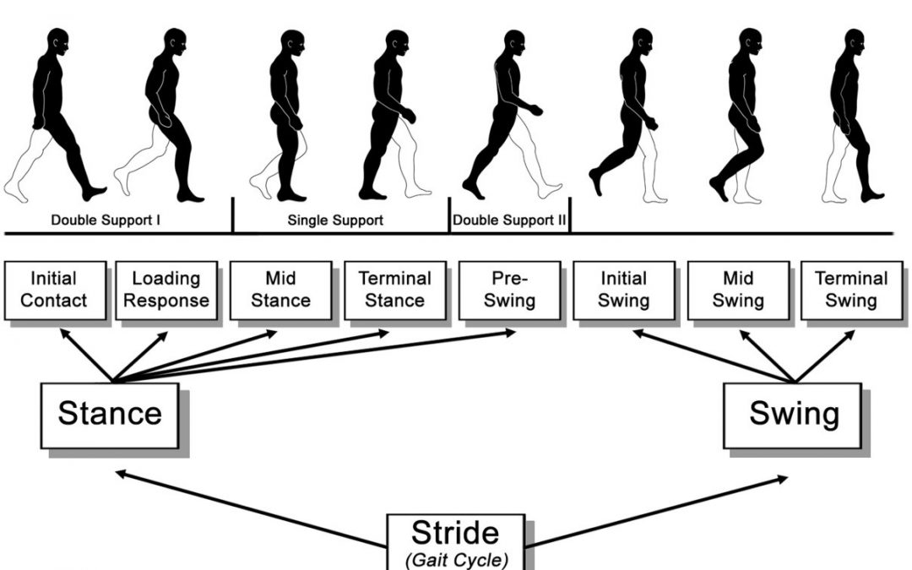

Figure 1. Functional divisions pf the gait cycle[2].

The **handling activities** refer to a motion of the upper body. The motion isn’t of holding onto something, e.g. when pushing a cart or holding a box while walking, but it refers to motion of the upper body prior to holding the cart or removing the hand after moving the cart to a new position.

Figure 2. Human motion areas[3]

* **c4 Handling (upwards):** At least one of the used hand(s) is/are on the same height as the shoulder joint or higher (Area E and Area F within the motion range of the hands) as seen in Figure: 2.
* **c5 Handling (centered):** Handling is possible without bending over, kneeling, or lifting arms to shoulder joint height (Area B, Area C, and Area D within the range of the hands) - as it is not possible to lift an item without tilting your spine at all. Take the direction of the participant's sight for reference: does he/she look forward or downwards?
* **c6 Handling (downwards):** Legs or back need to be adjusted for handling, e.g. kneeling, bending over, etc. The back is tilted to a horizontal line or further.
* **c7 Synchronization:** Waving Motion at the beginning of each recording; stops as soon as the participant’s arms are at the lowest point, attention: this activity has a fixed attribute representation (standing still, upwards, right, left, no item).
* **c8 None:** Frames that shall not be taken into account, because the activity is not recognizable. Reasons can be unspecified activities, errors/gaps in the recording, or when an activity is not recognizable because it is cut by the end of each recording. Also, the subject may be moving outside the camera range or the mocap data is corrupt.

## Attribute-Wise Annotation

At least one of the attributes per group I-IV has to be picked! Otherwise, the annotation is invalid!

Common mistakes:

* **Gait Cycle + Torso Rotation is invalid!**
* **Class Cart + Centered Handling is invalid!** Class Cart requires no intentional motion. If the centered attribute is picked, the class is handling centered.
* ‘No Intentional motion’ cannot be combined with downwards/centered/upwards.
* If the person was walking (gait cycle) and then starts picking before having stopped entirely, one has to pick the gait cycle in the next window as well.

1. **Legs:** Exclusive choice since a person can only perform either one of these motions;
   1. Gait Cycle: see Figure 1.
   2. Step: A single step without a foot swing. This can also refer to a step forward, followed by a step backward using the same foot. A step requires the foot to leave the ground.
   3. Standing Still: Both feet stay on the ground.
2. **Upper Body:** Exclusive choice between A, B, C, D - Torso Rotation (E) is independent. These attributes refer to a motion of the upper body, not holding onto something, e.g. when pushing a cart or holding a box while walking.
   1. Upwards: At least one of the user hand(s) is/are on the same height as the shoulder joint or higher (see Figure: 2)
   2. Centered: Handling is possible without bending over, kneeling, or lifting arms to shoulder joint height - as it is not possible to lift an item without tilting your spine at all, take the direction of the participant's sight for reference: does he/she look forward or downwards?
   3. Downwards: Legs or back need to be adjusted for handling, e.g. kneeling, bending over, etc. The back is tilted to a horizontal line or further.
   4. No intentional motion: Default value when no intentional motion is performed, e. g. when standing or walking around without doing anything specific. Also applied when carrying a box or walking with a cart. This is because there is no intentional motion when performing these activities, only a steady stance.
   5. Torso Rotation: Rotation in the transverse plane, see Figure: 3. Either a rotating motion, e.g. when taking something from the cart and turning towards the shelf, or a fixed position when handling something while the torso is rotated. Torso rotation cannot be used with “gait cycle” at the same time.
3. **Handedness:** Non-exclusive choice between right, left or both - otherwise pick *no arms.* Handedness is activated while handling items and also while pushing/pulling the cart, holding an item, and so forth.
   1. Right
   2. Left
   3. No Arms
4. **Item Pose**: Exclusive Choice. In case several items are handled at the same time; **utility/aux** > **handy unit** > **bulky unit** > **computer** > **cart**
   1. **Bulky Unit**: Large items that one cannot put his/her hands around, e.g. boxes.
   2. **Handy Unit**: Small item that can be carried with a single hand or that one can put his/her arms around, e. g. the weight sacks as well as the shipping list during packaging.
   3. **Utility-Aux.**: Use or preparation of equipment such as scissors, knifes, cushions, labels, straps, scanners, stamps, plastic bags, a scanned item but not computer since this is a separate attribute. Does not refer to taking them from somewhere or putting them somewhere but refers to their use or preparation (e.g., the opening of a plastic bag). Taking or putting them somewhere is regarded as a bulky/handy unit, because the motion patterns is like handling a box or package.
   4. **Cart**:
      1. Moving the cart to a proper position before taking it to a different location or before putting boxes on it (considered as upper body motion as well and therefore class handling)
      2. Pushing/Pulling the cart to a new location (considered no intentional motion combined with gait cycle and class cart).
      3. Standing while placing the hands on the cart (standing class).
   5. **Computer**: using Mouse / Keyboard, reading from the screen.
   6. **No Item**: Default value - For activities that do not include any item like plain walking or standing. For example, handling (downwards) with no item is looking into a box positioned on a low level but not taking anything from it.
5. **None:** Frames that shall not be taken into account, because the activity is not recognizable. Reasons can be unspecified activities, errors/gaps in the recording, or when an activity is not recognizable because it is cut by the end of each recording.

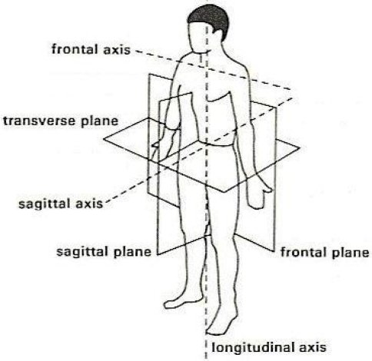

Figure 3. Body planes and axis. Frontal axis is defined along medio-lateral direction; sagittal axis is defined along antero-posterior direction and longitudinal axis is defined along superior-inferior direction.[4]

1. Niemann F, Reining C, Moya Rueda F, Nair NR, Steffens JA, Fink GA, ten Hompel M. LARa: Creating a Dataset for Human Activity Recognition in Logistics Using Semantic Attributes. Sensors. 2020; 20(15):4083. <https://doi.org/10.3390/s20154083>
2. <https://www.researchgate.net/publication/278963725_The_mental_representation_of_the_human_gait_in_young_and_older_adults>
3. Bokranz, Rainer, and Kurt Landau. "Handbuch industrial engineering." *Produktivitätsmanagement mit MTM* 1 (2012).
4. Sato, Tatiana de Oliveira, Gert-Åke Hansson, and Helenice Jane Cote Gil Coury. "Goniometer crosstalk compensation for knee joint applications." *Sensors* 10.11 (2010): 9994-10005.