TECHNICAL DOCUMENTATION
RAG Document Q&A Bot
System Architecture, Design and Operations Guide
Product name: Paperlight | Retrieval-Augmented Generation over PDF documents
Document information
Document ID | RAG-QA-TD-001
Version | 1.0
Status | Final
Date | 7 October 2026
Project | Basic Document Q&A Bot using RAG (AI Internship Assignment)
Prepared by | AI Engineering Intern
Classification | Internal

Document Control
Revision history
Version | Date | Description | Author
0.1 | 6 Oct 2026 | Initial indexing pipeline: loader, chunker, ChromaDB store, ingestion script. | AI Engineering Intern
0.5 | 7 Oct 2026 | Diversity-aware retrieval, grounded prompt, CLI chat, automated test suite. | AI Engineering Intern
1.0 | 7 Oct 2026 | Streamlit interface (Paperlight), interface defect fixes, documentation release. | AI Engineering Intern

Review and approval
Role | Name | Signature | Date
Author | AI Engineering Intern |  | 7 Oct 2026
Technical reviewer
Approver

Distribution
Engineering mentors and reviewers; project team members. This document is for internal use.

Table of Contents
1. Introduction 4
1.1 Purpose 4
1.2 Scope 4
1.3 Intended Audience 4
1.4 Definitions and Abbreviations 4
1.5 References 5
2. Project Overview 6
2.1 Background and Business Context 6
2.2 Objectives 6
2.3 Requirements Traceability 6
2.4 Assumptions and Constraints 7
3. Knowledge Base 8
3.1 Document Inventory 8
3.2 Content Coverage 8
3.3 Compliance with Document Criteria 8
4. System Architecture 9
4.1 Architectural Overview 9
4.2 Logical Architecture 9
4.3 Technology Stack 10
4.4 Indexing Pipeline 10
4.5 Query Pipeline 11
4.6 Architecture Decisions 12
5. Detailed Design 13
5.1 Project Structure 13
5.2 Document Loader (loader.py) 13
5.3 Chunker (chunker.py) 14
5.4 Vector Store and Retrieval (vectorstore.py) 14
5.5 Answer Generator (generator.py) 15
5.6 Command-Line Interface (chat.py) 16
5.7 Web Application (app.py) 16
5.8 Data Model 17
6. Grounding and Quality Controls 18
7. Configuration Reference 19
8. Installation and Operation 20
8.1 Prerequisites 20
8.2 Installation 20
8.3 Building the Index 20
8.4 Running the Application 20
8.5 Updating the Knowledge Base 21
8.6 Troubleshooting 21
9. Testing and Validation 22
9.1 Strategy 22
9.2 Test Suite Design 22
9.3 Results 23
9.4 Failure Analysis 23
9.5 Defects Found During Integration 24
10. Security and Privacy 25
11. Known Limitations and Risks 26
12. Future Enhancements 27
Appendix A: Dependencies 28
Appendix B: Sample Answers 29

1. Introduction

1.1 Purpose
This document is the technical reference for the RAG Document Q&A Bot (product name in the user interface: Paperlight). It describes what the system does, how it is structured, why the main design decisions were taken, how to install and operate it, and how its quality was verified. It is written so that a new engineer can understand, run, and extend the system without reading the source code first.

1.2 Scope
The document covers the complete Retrieval-Augmented Generation (RAG) pipeline implemented in the project: document ingestion, text chunking, embedding, vector storage, retrieval, grounded answer generation, and the two user interfaces (command line and Streamlit web application).
Table 1: Scope of this document
Area | Coverage
In scope | Architecture, component design, data model, configuration, installation and operation, test strategy and results, security and privacy considerations, known limitations, future roadmap.
Out of scope | Model training or fine-tuning, production hosting (containers, CI/CD, monitoring), user authentication, and support for non-PDF file types (identified as future work in Section 12).

1.3 Intended Audience
Table 2: Audience and recommended reading
Reader | Most relevant sections
Engineering mentors / reviewers | Sections 2 (requirements traceability), 4 (architecture), 9 (testing), 11 (limitations)
Developers extending the system | Sections 4, 5 (detailed design), 7 (configuration), 12 (roadmap)
Operators / end users | Sections 8 (installation and operation) and Appendix B (sample answers)
Security and compliance reviewers | Sections 6 (grounding controls) and 10 (security and privacy)

1.4 Definitions and Abbreviations
Table 3: Glossary
Term | Definition
RAG | Retrieval-Augmented Generation: a technique in which relevant passages are retrieved from a document collection and supplied to a language model so that its answer is grounded in those passages.
LLM | Large Language Model. In this project: openai/gpt-oss-120b served through the Groq API.
Chunk | A short passage of text (here at most 700 characters) cut from a source page; the unit that is embedded, stored and retrieved.
Embedding | A fixed-length numeric vector that represents the meaning of a text. Texts with similar meaning have vectors that are close together.
Vector database | A database that stores embeddings and finds the nearest ones to a query vector. Here: ChromaDB.
Top-k | The number of most similar chunks returned for a query.
Cosine distance | A similarity measure between two vectors (0 = identical direction, larger = less similar). Used by the vector index in this project.
HNSW | Hierarchical Navigable Small World: the approximate nearest-neighbour index structure used by ChromaDB.
ONNX | Open Neural Network Exchange: a portable model format. ChromaDB runs its default embedding model through ONNX Runtime on the CPU.
Grounding | Restricting the model to answer only from supplied context, and showing where each statement came from.
Citation badge | The small amber number (for example [2]) in the web UI that corresponds to a numbered source card below the answer.
ADR | Architecture Decision Record: a short note recording a design choice, the alternatives and the rationale.

1.5 References
- AI Internship Assignment: Build a Basic Document Q&A Bot using RAG (assignment brief, RAG_Assignment_DocumentQA_Bot.pdf, 3 pages).
- ChromaDB documentation: persistent client, collections and default embedding function (docs.trychroma.com).
- Groq API documentation: chat completions (console.groq.com/docs).
- Streamlit documentation: session state, caching and chat elements (docs.streamlit.io).
- LangChain text splitters: RecursiveCharacterTextSplitter (python.langchain.com).
- pypdf documentation: PDF text extraction (pypdf.readthedocs.io).
- Sentence-Transformers model card: all-MiniLM-L6-v2 (huggingface.co/sentence-transformers).

2. Project Overview

2.1 Background and Business Context
Organisations keep a large share of their knowledge in long PDF reports. Keyword search over such files is slow and misses paraphrases, while a general-purpose language model on its own can produce fluent but unsupported answers. RAG addresses both problems: it finds the relevant passages first, then asks the model to answer using only those passages and to say which passages it used.
This project delivers a working RAG system built from scratch for an AI Engineering internship assignment. A user asks a natural-language question about a small library of four AI-related papers and receives a short answer with numbered citations that resolve to a file name, a page number and the supporting text.

2.2 Objectives
- Ingest four documents (PDF), clean their text, and split them into overlapping chunks that carry source and page metadata.
- Embed all chunks in batches and persist them in a vector database so that the index is built once and reused.
- Retrieve the most relevant chunks for a question with a configurable top-k, covering every relevant document.
- Generate a concise answer that uses only the retrieved context, cites it, and refuses when the context does not contain the answer.
- Expose the system through an interactive command-line loop and a Streamlit web interface that displays the answer and the source passages.

2.3 Requirements Traceability
Table 4 maps each requirement in the assignment brief (sections 2 to 4) to its implementation. Section references are to the assignment document.
Table 4: Requirements traceability matrix
ID | Requirement (assignment §) | Implementation | Status
R-01 | Ingest 4 to 5 documents of PDF, TXT or DOCX type (§2) | Four PDFs in data/ | Met
R-02 | Each document at least 2 pages, one at least PDF, non-trivial, stored in /data (§3) | Documents of 8, 12, 28 and 44 pages; all PDF; stored in data/ | Met
R-03 | Load from a local folder; PDF support; strip headers, footers and page numbers (§4.1) | loader.load_pdfs() reads data/*.pdf with pypdf; removes lines that repeat across pages and bare page numbers | Met (PDF only; DOCX/TXT bonus not implemented)
R-04 | Chunk before embedding; documented strategy; overlap; store file and page metadata (§4.2) | Recursive character splitter, 700 characters, 150 overlap; metadata source and page (Section 5.3) | Met
R-05 | Embed each chunk with a model of choice; batch the calls (§4.3) | ChromaDB default all-MiniLM-L6-v2; chunks added in batches of 100 | Met
R-06 | Persistent vector database; separate indexing from querying (§4.4) | ChromaDB PersistentClient in chroma_db/; indexing in ingest.py, querying in chat.py and app.py | Met
R-07 | Embed the query, similarity search, configurable top-k, pass chunks to the LLM (§4.5) | search_diverse(query, k=8, ...); chunks passed as numbered context | Met
R-08 | LLM answer with file and page citation; no answers from training data (§4.6) | Groq-hosted open-weight model; grounded system prompt; numeric citations resolved to file and page | Met (hosted open-weight model, not Ollama)
R-09 | CLI loop; Streamlit bonus; display answer and source chunks (§4.7) | src/chat.py and app.py | Met (CLI lists file and page; web UI also shows passage text)

2.4 Assumptions and Constraints
- The PDFs contain a machine-readable text layer. Scanned images are not processed (no OCR).
- The documents are in English; the embedding model is an English-language model.
- The system runs on a single machine for a single user. Concurrency and multi-user access were not design goals.
- Internet access is required for the Groq API and, on first use, to download the embedding model.
- The assignment specifies Python 3.11 or higher. The project was developed and executed with Python 3.12.

3. Knowledge Base

3.1 Document Inventory
The knowledge base consists of four PDF files stored in the data/ folder. The figures below were read directly from the persisted ChromaDB index (366 chunk records).
Table 5: Documents indexed
File | PDF pages | Pages indexed | Chunks | Share of index
2024-wttc-introduction-to-ai.pdf | 44 | 42 | 176 | 48.1 %
Ai Replace human jobs.pdf | 8 | 8 | 48 | 13.1 %
Ai_tech_pros_and_cones.pdf | 12 | 11 | 69 | 18.9 %
future_of_learning.pdf | 28 | 26 | 73 | 19.9 %
Total | 92 | 87 | 366 | 100 %

Why indexed pages are fewer than PDF pages
Pages that contain no extractable text, or whose chunks are all removed by the reference-section filter (Section 5.3), produce no records. The web UI sidebar reports the number of indexed pages per document.

3.2 Content Coverage
The four documents cover complementary angles on artificial intelligence, which makes cross-document questions meaningful.
Table 6: Subject coverage by document
File | Representative content
WTTC: Introduction to AI (2024) | History of AI (chess and quiz-show milestones), healthcare use cases, GPUs and chip manufacturing, ChatGPT, explainable AI, data warehouses versus data lakes, creativity, privacy, the digital divide.
AI and human jobs | Effect of AI on employment, including a challenges table with percentages for job displacement and implementation cost.
AI technology: pros and cons | Advantages and drawbacks of AI: objectivity and bias, privacy and security concerns, job obsolescence.
Future of learning | AI in education: children out of school, teacher shortage to 2030, the "5 % problem", and a learning-science benchmark of language models.

3.3 Compliance with Document Criteria
All documents satisfy the assignment criteria (§3): each is longer than two pages, at least one is a PDF (all four are), the content is substantive rather than placeholder text, and the files are located under data/ in the project tree.

4. System Architecture

4.1 Architectural Overview
The system follows the classic two-phase RAG architecture. An offline indexing phase converts PDFs into searchable vectors once. An online query phase retrieves context for each question and asks the language model to answer from it. The two phases share only the persisted vector store.
Design principles:
- Separation of indexing and querying. Nothing in the query path re-reads PDFs or re-embeds documents; the index is persisted to disk.
- Embedded, serverless storage. ChromaDB runs inside the Python process, so there is no database service to deploy.
- Grounded generation. The prompt, the retrieval strategy and the post-processing all push toward answers that are supported by, and traceable to, retrieved text.
- Thin interfaces over a shared core. The CLI and the web UI import the same search_diverse() and generate_answer() functions, so behaviour is identical.
- Small, single-purpose modules. Each source file in src/ has one responsibility and is under 60 lines.

4.2 Logical Architecture
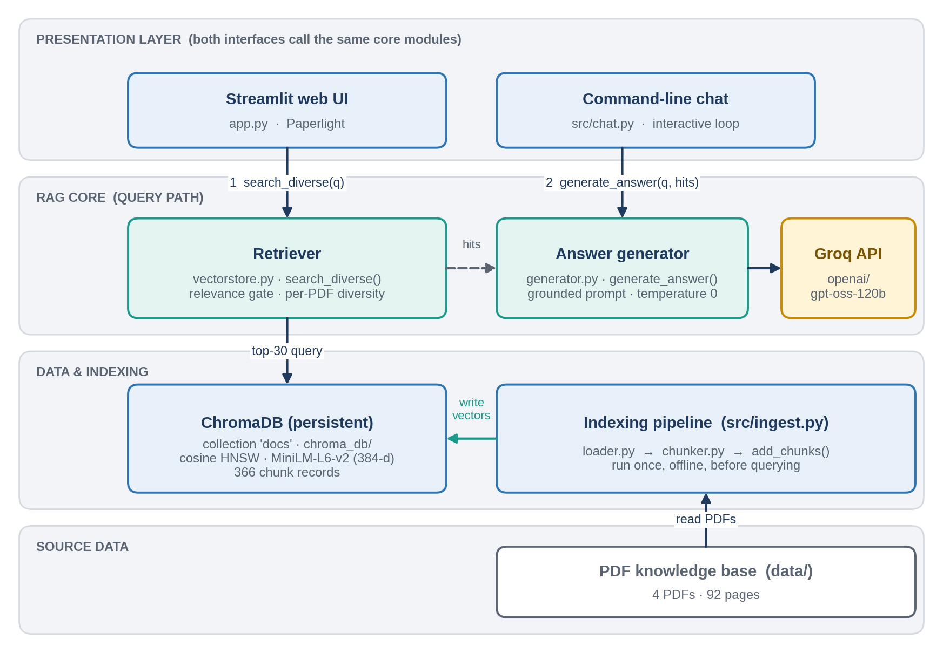
Figure 1: Logical architecture of the RAG Document Q&A Bot
The presentation layer collects the question and renders the answer. The RAG core retrieves passages and generates the answer. The data layer holds the persisted vectors and is populated by the indexing pipeline from the PDF folder. The only external dependency at query time is the Groq API.

4.3 Technology Stack
Table 7: Technology stack
Layer | Technology | Role and notes
Language | Python 3.11+ (3.12 used) | All components.
PDF parsing | pypdf | Extracts text page by page.
Chunking | langchain-text-splitters | RecursiveCharacterTextSplitter.
Embeddings | ChromaDB default: all-MiniLM-L6-v2 (ONNX) | 384-dimensional vectors computed locally on CPU for both chunks and queries.
Vector database | chromadb (PersistentClient) | Collection docs with cosine HNSW index, persisted in chroma_db/.
LLM | openai/gpt-oss-120b via groq SDK | Answer generation, temperature 0, max 800 tokens.
Configuration | python-dotenv | Loads GROQ_API_KEY from a .env file.
Web UI | streamlit | Chat interface named Paperlight, with custom CSS.
Testing | test_rag.py (custom) | 30-question regression suite with automatic checks.

Note on dependencies
sentence-transformers is listed in requirements.txt, but the code does not import it: embeddings are produced by ChromaDB's built-in default embedding function. The package can be removed to reduce install size, or retained if a custom embedding function is introduced later.

4.4 Indexing Pipeline
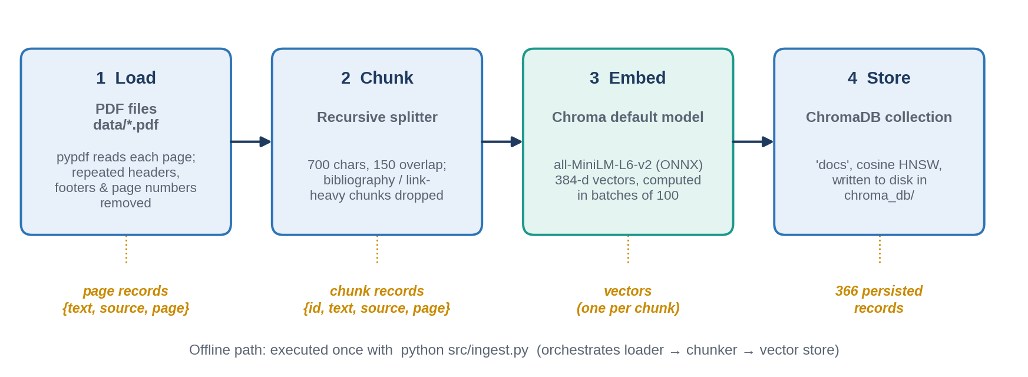
Figure 2: Indexing pipeline (offline)
- Load. load_pdfs() reads every *.pdf in data/ in alphabetical order and extracts the text of each page. Repeated header and footer lines and bare page numbers are removed.
- Chunk. chunk_docs() splits each page into chunks of up to 700 characters with 150 characters of overlap. Chunks that look like bibliographies are discarded. Each chunk receives an id of the form <file>-p<page>-c<index>.
- Embed. add_chunks() passes chunks to ChromaDB in batches of 100. ChromaDB embeds each batch with its default model.
- Store. The vectors, the chunk text and the source and page metadata are written to the persistent collection docs.
The pipeline is started with one command, python src/ingest.py, which prints the number of page records and chunks created.

4.5 Query Pipeline
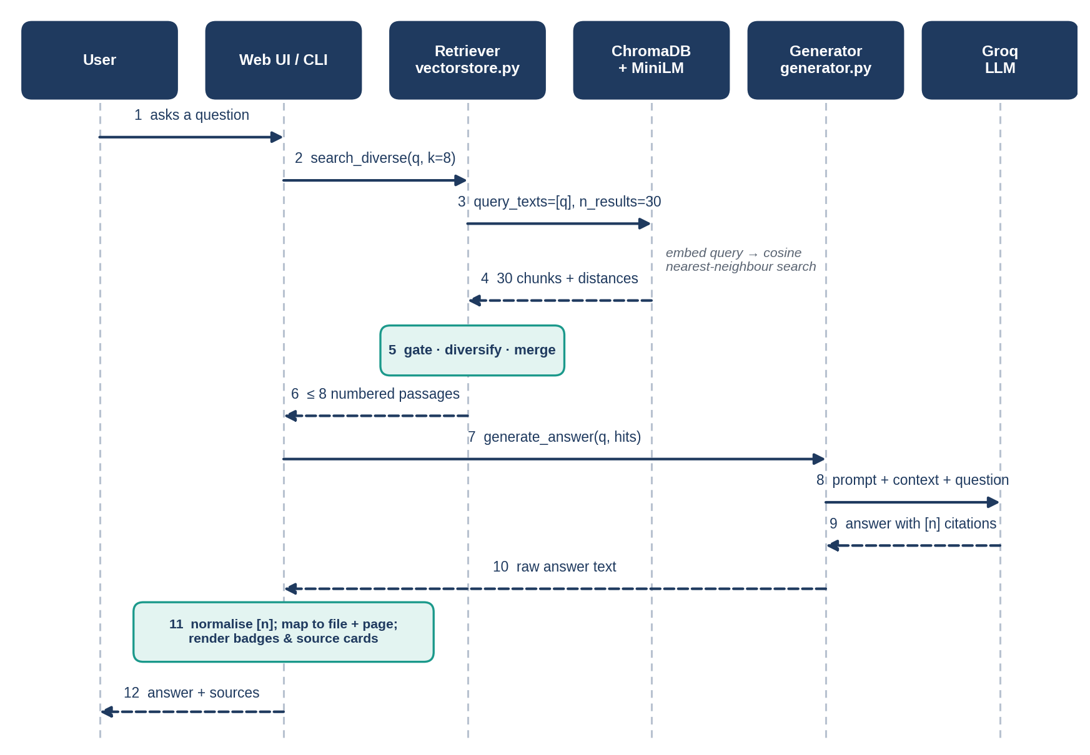
Figure 3: Query pipeline: sequence of interactions for one question
- The user submits a question in the web UI (typed or chosen from the suggestions) or at the CLI prompt.
- The interface calls search_diverse(question, k=8). ChromaDB embeds the question and returns the 30 nearest chunks with cosine distances.
- The retriever applies the relevance gate, guarantees coverage across documents, and merges chunks from the same page (Section 5.4). At most eight numbered passages result.
- The interface calls generate_answer(question, hits). The generator builds a context block in which each passage is labelled [n] (file, page p) and sends it to the Groq-hosted model together with the system prompt.
- The model returns an answer containing [n] markers. The interface normalises unusual citation styles, resolves each [n] to a file, page and text, and renders the answer with citation badges and expandable source cards.

4.6 Architecture Decisions
The assignment asks the engineer to make and justify architecture decisions. Table 8 records the principal ones.
Table 8: Architecture decision records
ID | Decision | Alternatives | Rationale
ADR-1 | Recursive character chunking, 700 characters, 150 overlap | Fixed-size; sentence-based; paragraph-based | The splitter prefers to cut at paragraph, then line, then word boundaries, so chunks stay readable. 700 characters is roughly one short paragraph: specific enough for precise matching, small enough that eight passages fit comfortably in the prompt. The 150-character overlap (about 21 %) preserves context that straddles a boundary.
ADR-2 | ChromaDB default embedding model (all-MiniLM-L6-v2, 384-d) | Hosted embedding APIs; larger local models | Runs offline on CPU, needs no API key and has no per-call cost. Its compact vectors and good general English semantic search suit a 366-chunk corpus.
ADR-3 | ChromaDB persistent collection | FAISS; Qdrant; Weaviate | Embedded and serverless, persists to disk, and stores text and metadata beside the vectors. FAISS would need a separate metadata store; Qdrant and Weaviate add a service to operate.
ADR-4 | Cosine distance on an HNSW index | L2 or inner-product distance | Cosine is the usual measure for sentence embeddings and is independent of vector length.
ADR-5 | Diversity-aware retrieval with a relevance gate | Plain top-k | With four overlapping documents, plain top-k lets one document crowd out the others and breaks cross-document questions. A coverage pass plus a distance gate keeps every relevant document represented without admitting weak matches.
ADR-6 | openai/gpt-oss-120b on Groq | GPT-3.5 or GPT-4; Gemini; Claude; local Ollama model | A strong open-weight model with low-latency hosted inference. No local GPU is required and the SDK is minimal.
ADR-7 | Temperature 0, 800 token limit | Higher temperature | Deterministic, consistent answers suit factual question answering; the limit keeps answers concise.
ADR-8 | Numeric citations [n] mapped to context blocks | Free-text file and page citations | The model cannot invent a file name: it can only refer to a numbered block, and the interface turns the number into the true file and page.
ADR-9 | CLI plus Streamlit UI | CLI only; Gradio | The CLI satisfies the minimum requirement and is useful for testing; Streamlit provides a richer presentation of answers and sources.

5. Detailed Design

5.1 Project Structure
Rag_Doc_Q&A_Bot/
|-- app.py Streamlit web application (Paperlight)
|-- requirements.txt Python dependencies
|-- test_rag.py Automated question-answer regression suite
|-- test_results.txt Full answers from the last test run
|-- data/ Knowledge base: 4 PDF files
|-- chroma_db/ Persisted vector index (generated by ingest.py)
|-- .env GROQ_API_KEY (created by the user; not committed)
`-- src/
|-- ingest.py Indexing entry point
|-- loader.py PDF text extraction and cleaning
|-- chunker.py Chunking and reference filtering
|-- vectorstore.py ChromaDB access, add and search functions
|-- generator.py Prompt construction and LLM call
`-- chat.py Command-line chat loop
Table 9: Source files and responsibilities
File | Lines | Responsibility
src/loader.py | 35 | Reads PDFs page by page, removes repeated headers and footers and bare page numbers, returns page records.
src/chunker.py | 22 | Splits page text into overlapping chunks, discards reference-like chunks, assigns ids and metadata.
src/vectorstore.py | 57 | Creates the persistent collection; batch insert; basic and diversity-aware search.
src/generator.py | 42 | Holds the system prompt, formats the numbered context and calls the Groq chat-completion API.
src/ingest.py | 8 | Orchestrates load, chunk and store; prints counts.
src/chat.py | 27 | Interactive terminal loop: question, retrieval, answer, source list.
app.py | 246 | Web UI: styling, state, suggestions, streaming effect, citation badges, source cards, sidebar library.
test_rag.py | 159 | Thirty test cases with automatic scoring and a saved log.

5.2 Document Loader (loader.py)
load_pdfs(folder="data") returns a list of page records {text, source, page} with 1-based page numbers.
Header and footer removal. The loader needs no per-document configuration. For each PDF it normalises every line (lower-case, digits replaced by #) and counts on how many pages each normalised line occurs. A line is treated as a header or footer, and dropped from every page, when it occurs on at least max(3, 40 % of the pages) pages and is shorter than 120 characters. Normalising digits means a footer such as "Page 4" and "Page 5" is recognised as the same repeating line.
Page numbers. Lines consisting only of a number of up to three digits, optionally preceded by the word "page", are removed. Blank lines are kept so that paragraph breaks survive into chunking. Pages that are empty after cleaning produce no record.

5.3 Chunker (chunker.py)
chunk_docs(docs, size=700, overlap=150) applies LangChain's RecursiveCharacterTextSplitter to each page record. Chunking is done per page, so every chunk belongs to exactly one page and the page number in the metadata is always exact.
Table 10: Chunk produced for each page fragment
Field | Description
id | <source>-p<page>-c<index>, for example future_of_learning.pdf-p7-c2. Unique within the collection.
text | Up to 700 characters of cleaned text.
source | PDF file name.
page | 1-based page number within the PDF.

Reference-chunk filter. Bibliographies and link lists match many questions superficially but contain no answers. is_reference_chunk() discards a chunk when either (a) it contains two or more occurrences of "http", or (b) it contains at least three numeric citation markers such as [12] and at least two four-digit years. These thresholds are heuristic and were chosen for the supplied documents.

5.4 Vector Store and Retrieval (vectorstore.py)
Collection. chromadb.PersistentClient(path="chroma_db") opens (or creates) the on-disk database. The collection docs is created with {"hnsw:space": "cosine"}. The path is relative to the working directory, so all entry points must run from the project root (app.py enforces this by changing directory to its own location).
Insertion. add_chunks() sends chunks to collection.add() in batches of 100 with parallel lists of ids, documents and metadata. ChromaDB computes the embeddings of each batch internally, which satisfies the requirement that embedding calls are batched.
Basic search. search(query, k=4) returns the k nearest chunks with their metadata and distance.
Diversity-aware search. search_diverse() is the retrieval function used by both interfaces. Its steps are shown in Figure 4 and its parameters in Table 11.
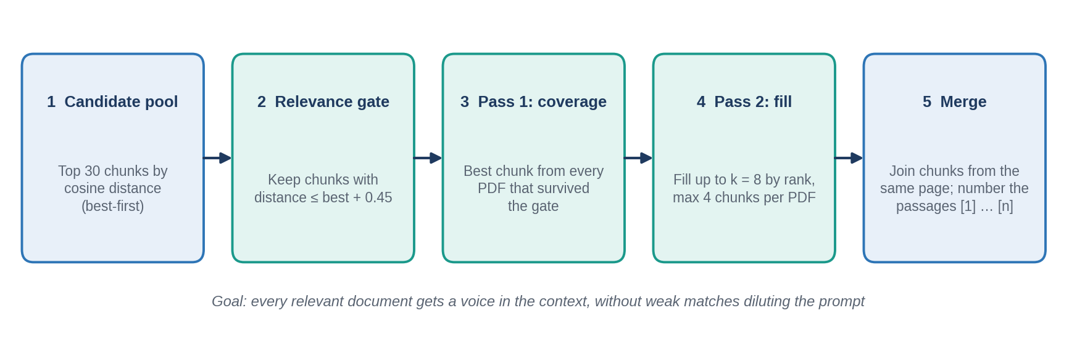
Figure 4: Steps inside search_diverse()
Table 11: search_diverse parameters
Parameter | Default | Purpose
k | 8 | Maximum number of chunks selected before merging. Configurable per call (the interfaces use 8).
pool | 30 | Number of nearest candidates requested from ChromaDB.
max_gap | 0.45 | Relevance gate: a candidate is kept only if its distance is within this margin of the best candidate's distance. Adapts to easy and hard questions because it is relative, not absolute.
per_doc | 4 | Upper bound of chunks taken from any single PDF in the fill pass.

Why a coverage pass? Pass 1 takes the single best chunk from every PDF that survived the gate. This guarantees that a question such as "Do the documents agree on...?" sees evidence from each relevant document. Pass 2 then fills the remaining slots strictly by rank, respecting per_doc. Finally, chunks that came from the same page are concatenated so that the model sees one passage per page and each citation number corresponds to a single (file, page) pair.

5.5 Answer Generator (generator.py)
generate_answer(question, contexts) formats the retrieved passages and calls the chat-completion endpoint.
[1] (2024-wttc-introduction-to-ai.pdf, page 12)
<merged passage text>

[2] (Ai_tech_pros_and_cones.pdf, page 4)
<merged passage text>
The user message contains the context blocks followed by the question, and the system message holds the rules below. The API is called with temperature=0 and max_tokens=800. The API key is read from the GROQ_API_KEY environment variable, loaded from .env by python-dotenv.
Table 12: System prompt rules
Rule | Intent
Use only the provided context | Prevents answers from the model's own training data.
Answer partial coverage and state what is missing | If the context answers only part of a question, answer that part and say plainly what the documents do not cover.
Fixed refusal sentence | The exact sentence "I couldn't find that in the documents." is used only when nothing relevant is in the context, so the interface can detect refusals reliably.
Numeric citations on every claim | Each claim ends with a bracketed context number such as [1]; citing by file name or page alone is forbidden.
Concise answers | Keeps responses short and readable.
Three-part structure for comparison questions | (1) where sources agree, (2) where they differ in emphasis, naming each file with its number, (3) a one-sentence takeaway.
Avoid the words "contradict" and "disagree" | Differences are described as differences in emphasis or focus, which is more faithful when sources address different aspects.
Correct false premises | If the question assumes something that the context contradicts, the answer corrects it using the context.
Report caveats together with claims | If a source states a claim and also lists limitations, both are reported.

5.6 Command-Line Interface (chat.py)
- Loops on the prompt Ask (or 'q'):; empty input is ignored and q exits.
- Calls search_diverse(q, k=8) then generate_answer(), and prints the answer.
- Converts citation styles such as 【3†L1-L3】 into plain [3] with a regular expression.
- Prints a Sources: list of cited numbers with file name and page. If the model omitted citations, all retrieved passages are listed. No sources are printed when the answer is a refusal.

5.7 Web Application (app.py)
The Streamlit application, branded Paperlight, uses a dark theme implemented in custom CSS and keeps its logic in a few functions. The conversation is stored in st.session_state.history.
Table 13: Web UI features
Feature | Behaviour
Hero and suggestions | Title and one-line description. When the conversation is empty, four suggested questions are shown as buttons; clicking one submits it.
Library sidebar | Lists each paper with its indexed page count and the totals (papers and passages). Papers whose passages were used in the latest answer glow, giving visual feedback about provenance.
Progress indicator | An animated scan bar with messages "Searching 366 passages" and "Reading the closest matches" while retrieval and generation run.
Typing effect | The answer is revealed word by word (15 ms per word) before the final render.
Citation badges | Each [n] in the answer is replaced by an amber numbered badge.
Source cards | One expandable card per cited passage showing the badge, the file name, the page and the first 420 characters of the passage. New cards fade in with a short highlight animation.
Clear conversation | Sidebar button that resets the history and the highlighted papers.
Error handling | If retrieval or generation raises an exception, an error message is shown in place of the answer and the run stops.
Accessibility | A prefers-reduced-motion rule disables animations for users who request it.
Performance | Library statistics are computed once and cached with st.cache_data.

5.8 Data Model
Table 14: Data objects exchanged between components
Object | Fields | Produced by / used by
Page record | text, source, page | load_pdfs() → chunk_docs()
Chunk record | id, text, source, page | chunk_docs() → add_chunks()
Stored record | id, embedding (384 floats), document text, metadata {source, page} | ChromaDB collection docs
Hit | text, meta{source,page}, distance | search_diverse() → generate_answer() and the UI
Source card | n, source, page, text | UI, built from the [n] markers found in the answer

6. Grounding and Quality Controls
Preventing unsupported answers is the central quality goal of a RAG system. The project applies controls at every stage rather than relying on the prompt alone.
Table 15: Controls by pipeline stage
Stage | Control | Purpose
Ingestion | Header, footer and page-number removal | Stops boilerplate from matching queries or appearing in answers.
Ingestion | Reference-chunk filter | Prevents bibliography and link lists from being retrieved as evidence.
Retrieval | Relative relevance gate (best distance + 0.45) | Excludes weak matches from the context.
Retrieval | Per-document coverage pass | Ensures each relevant document is represented for comparison questions.
Retrieval | Same-page merging | One citation number maps to one (file, page) pair.
Prompt | Context-only rule and fixed refusal sentence | Blocks outside knowledge; makes refusals detectable.
Prompt | Mandatory numeric citations | Every claim is traceable to a numbered passage.
Model call | Temperature 0 | Consistent, factual output.
Post-processing | Citation normalisation; markers outside the valid range are ignored | Handles odd citation formats and prevents references to non-existent passages.
Post-processing | Sources derived from the markers actually used; fallback to all hits if none | The source list always reflects what the answer cites.
Evaluation | Five out-of-scope questions in the test suite | Verifies that the bot refuses instead of guessing.

Interpretation of citations
A citation shows which passage the model relied on; it is not an independent proof that the sentence is correct. Users can open the corresponding source card to verify the statement against the original text.

7. Configuration Reference
The system has no separate configuration file. Tunable values are constants or default arguments in the modules listed below.
Table 16: Configuration parameters
Parameter | Location | Default | Effect
Data folder | loader.load_pdfs(folder) | data | Where PDFs are read from (relative to the working directory).
Header/footer threshold | loader.py | max(3, 40 % of pages) | Lines repeating on at least this many pages are removed.
Chunk size | chunker.chunk_docs(size) | 700 characters | Maximum chunk length.
Chunk overlap | chunker.chunk_docs(overlap) | 150 characters | Shared text between neighbouring chunks.
Insert batch size | vectorstore.add_chunks | 100 | Chunks embedded and stored per call.
Database path | vectorstore.py | chroma_db | Location of the persisted index.
Collection name / metric | vectorstore.py | docs / cosine | Collection identity and distance measure.
Top-k | search_diverse(k) | 8 | Passages selected for the prompt.
Candidate pool | search_diverse(pool) | 30 | Candidates fetched before filtering.
Relevance margin | search_diverse(max_gap) | 0.45 | Allowed distance above the best match.
Per-document cap | search_diverse(per_doc) | 4 | Maximum chunks from one PDF.
LLM model | generator.MODEL | openai/gpt-oss-120b | Model used for answers.
Temperature / max tokens | generator.py | 0 / 800 | Determinism and answer length.
API key | Environment / .env | none | GROQ_API_KEY, required for answers.
Source snippet length | app.py | 420 characters | Text shown in each source card.
Typing speed | app.py | 0.015 s per word | Delay of the reveal animation.

8. Installation and Operation

8.1 Prerequisites
- Python 3.11 or higher with pip (Python 3.12 was used for development).
- Internet access for the Groq API and the one-time embedding-model download.
- A Groq API key, created in the Groq console.
- Several gigabytes of free disk space for dependencies (the listed sentence-transformers package pulls in PyTorch) and the model cache; the project folder itself (PDFs and index) is about 40 MB.

8.2 Installation
- Open a terminal in the extracted project folder. The folder name contains an ampersand, so quote it: cd "Rag_Doc_Q&A_Bot".
- Create and activate a virtual environment.
python -m venv .venv
# Windows: .venv\Scripts\activate
# macOS / Linux: source .venv/bin/activate
- Install the dependencies.
pip install -r requirements.txt
- Create a file named .env in the project root containing the API key.
GROQ_API_KEY=your_key_here
Keep the key private
Never commit .env to version control. Add .env (and chroma_db/ if desired) to .gitignore.

8.3 Building the Index
Run once from the project root. The supplied chroma_db/ folder already contains an index of the four PDFs (366 chunks), so this step is only needed on a fresh checkout or after the documents change.
python src/ingest.py
# prints: <pages> pages -> <chunks> chunks, then: Done.

8.4 Running the Application
Table 17: Run commands
Interface | Command (from project root) | Notes
Web UI (Paperlight) | streamlit run app.py | Opens at http://localhost:8501. Use the suggested questions or the chat box.
Command line | python src/chat.py | Type a question; enter q to quit.
Regression tests | python test_rag.py | Runs 30 questions; writes test_results.txt. Takes a few minutes because of pauses between calls.

8.5 Updating the Knowledge Base
Ingestion appends records with collection.add() and is not idempotent. To change the documents, copy the PDFs into data/, delete the chroma_db/ folder, and run python src/ingest.py again. Ingestion of the four supplied documents performs the work once; later runs of the chat or web interface only read the index.

8.6 Troubleshooting
Table 18: Common problems
Symptom | Likely cause | Resolution
ModuleNotFoundError for loader or vectorstore | Script started from the wrong place or with a different method. | Run python src/ingest.py and python src/chat.py from the project root; start the web UI with streamlit run app.py.
No results, empty answers or an error on the first question | The index has not been built, or the working directory is not the project root. | Run python src/ingest.py from the project root and check that chroma_db/ exists.
Authentication error from Groq, or "api_key" error | GROQ_API_KEY missing or wrong. | Check .env in the project root; restart the application after editing.
Rate-limit (HTTP 429) errors | Too many requests to the Groq API in a short time. | Wait and retry. The test suite pauses between questions and retries once.
First query is slow | The embedding model is downloaded and cached on first use. | Wait for the one-time download; later runs are fast.
The bot answers "I couldn't find that in the documents" for a document topic | The question uses different wording from the text, or the topic is not covered. | Rephrase with the terms used in the papers; check the library list in the sidebar.
Sidebar cannot be reopened after collapsing (web UI) | Header hidden by custom CSS (fixed in this version). | Use the current app.py and hard-refresh the browser (Ctrl+Shift+R).

9. Testing and Validation

9.1 Strategy
Quality was verified with an automated end-to-end regression suite (test_rag.py) that exercises the real retrieval pipeline and the real language model. Each test sends a question and checks the answer against facts taken from the four PDFs. Because the suite calls the full pipeline, it detects regressions in loading, chunking, retrieval, prompting and citation behaviour alike.
Automatic checks per test case:
- Keyword groups: every group must have at least one of its alternative words in the answer (for example both "20%" and "50%" for the Swedish breast-screening question). Text is normalised for hyphens, spaces and percent signs first.
- Expected file cited: the named PDF must be among the files behind the citations (failures are labelled "retrieval" or "citation" to show which stage failed).
- Minimum number of distinct PDFs cited for cross-document questions.
- Forbidden words: for example, the answer to the agreement question must not use "contradict" or "disagree".
- Refusal: out-of-scope questions must produce a refusal phrase.
- Resilience: an API error is retried once after 10 seconds, with a 3-second pause between questions to respect rate limits.

9.2 Test Suite Design
Table 19: Test categories
Category | Cases | What it verifies | Example
Single fact | 9 | Exact figures and names are retrieved and reported correctly. | "How much did the AI painting Edmond de Belamy sell for?"
Concept | 4 | Definitions and explanations are summarised faithfully. | "What is the 5% problem in AI and education?"
Cross-document | 8 | Evidence from several PDFs is combined and cited. | "What do the documents say about bias in AI?"
Tricky | 4 | Wrong premises, near-miss wording and negative questions are handled. | "Why did the WTTC report say ChatGPT launched in 2019?"
Out of scope | 5 | The bot refuses when the documents do not contain the answer. | "Who is the CEO of Anthropic?"

9.3 Results
The last recorded run (saved in test_results.txt) answered 28 of the 30 questions correctly, an overall pass rate of 93 %.
Table 20: Test results by category
Category | Cases | Passed | Pass rate | Observation
Single fact | 9 | 9 | 100 % | All figures reported with citations.
Concept | 4 | 3 | 75 % | One automatic-check false alarm (F-1).
Cross-document | 8 | 7 | 88 % | One genuine weakness (F-2).
Tricky | 4 | 4 | 100 % | Wrong premise answered with a refusal.
Out of scope | 5 | 5 | 100 % | No answer given from outside knowledge.
Total | 30 | 28 | 93 %

9.4 Failure Analysis
Table 21: Failed test cases
ID | Test | Finding | Classification
F-1 | Q10 "What is explainable AI and why does it matter?" | The answer was correct and cited its source. The checker expected the words "black box" or "glass box", but the model wrote the hyphenated forms "black-box" and "glass-box", which the keyword match did not accept. | Test-oracle false negative. Fix: add the hyphenated variants to the expected keywords.
F-2 | Q21 "Do the documents agree on whether AI will replace jobs?" | The answer followed the required three-part structure but cited only two distinct PDFs (three were required) and did not use the expected ideas of transformation, displacement and uncertainty. | Genuine answer-quality limitation in multi-document synthesis. Mitigation options: Section 12.

Observation on Q23 ("Why did the WTTC report say ChatGPT launched in 2019?"): the bot replied with the refusal sentence. This passes the test, although an even better answer would correct the premise using the report's actual date (Q22 shows the bot reports it as November 2022 when asked directly).

9.5 Defects Found During Integration
Two defects in the web interface were found during use and have been corrected in the delivered app.py.
Table 22: Defect log
ID | Defect | Root cause | Resolution
D-01 | After collapsing the sidebar it could not be reopened, even after restarting. | A CSS rule hid the whole Streamlit header, which contains the control that expands the sidebar. Streamlit also remembers the collapsed state. | Keep the header; hide only the toolbar, menu, deploy button and footer; force the sidebar toggle controls visible and recolour them; set initial_sidebar_state="expanded".
D-02 | The chat input box vanished after a suggested question was clicked. | st.session_state.pop("pending") or st.chat_input(...) short-circuits: when a pending question exists, st.chat_input is never called and so is not drawn. | Always create the input first (typed = st.chat_input(...)), then choose q = pending or typed.

Status
Both defects are closed. The fixes are present in the delivered app.py (sidebar CSS and the two-line input handling).

10. Security and Privacy
Table 23: Security and privacy considerations
Topic | Current state | Recommendation
API key handling | Key is read from the environment or .env and never written to code or logs. | Keep .env out of version control; rotate the key if it is ever exposed.
Data sent to a third party | Each question and the retrieved passages (up to eight) are sent to the Groq API for generation. Whole documents are not uploaded. | Do not use confidential documents without approval of the provider; for sensitive data switch to a locally hosted model.
Local data at rest | PDFs and the ChromaDB index are stored unencrypted in the project folder. | Apply disk or folder encryption and access controls as required.
Output rendering | Source snippets are HTML-escaped before display. The model's answer is rendered with unsafe_allow_html=True so that citation badges can be shown, and is not escaped first. | Escape the answer text before inserting badge markup so that model output cannot inject HTML.
Prompt injection | Retrieved text is placed in the prompt. A document containing malicious instructions could influence the model. The system prompt reduces but does not eliminate this risk. | Only index trusted documents; consider input screening and output checks.
Access control | The application has no login and is designed for one local user. | Add authentication (for example behind a reverse proxy) before sharing.
Dependency management | requirements.txt lists packages without version pins. | Pin versions to make installs reproducible and auditable.

11. Known Limitations and Risks
Table 24: Limitations
ID | Limitation | Impact | Mitigation
L-1 | PDF only; no OCR. | Scanned PDFs, DOCX and TXT files cannot be indexed. | Add loaders for DOCX and TXT; add OCR for scans.
L-2 | Ingestion is not idempotent (uses add). | Re-running without clearing the index does not update existing content. | Switch to upsert, or clear the collection before indexing.
L-3 | Each question is answered independently (no conversation memory). | Follow-up questions that rely on earlier turns, such as "what about the second one?", may fail. | Rewrite follow-up questions into stand-alone queries using the chat history.
L-4 | Dense (semantic) retrieval only. | Rare exact terms or numbers may rank below paraphrases. | Add keyword (BM25) hybrid search and a re-ranker.
L-5 | Text-only extraction. | Tables and charts are flattened to text and may lose structure. | Use table-aware extraction for table-heavy sources.
L-6 | Multi-document synthesis varies (F-2). | Cross-document answers may omit a relevant document. | Raise k or per_doc for comparison questions; decompose into per-document sub-queries.
L-7 | Single hosted LLM provider. | Outages, rate limits and network loss stop answers. | Provider abstraction with a local fallback (for example Ollama).
L-8 | Thresholds (0.45 gap, reference filter) tuned on four documents. | May need re-tuning for other corpora. | Evaluate on a labelled set when the corpus changes.
L-9 | The CLI lists sources as file and page only. | Less transparent than the web UI, which shows passage text. | Print the supporting snippet in the CLI as well.
L-10 | search_diverse() assumes a non-empty index. | Querying an empty index raises an error (shown as a message in the web UI). | Check collection.count() and show a friendly message.

12. Future Enhancements
Table 25: Proposed roadmap
Horizon | Enhancement | Benefit
Short term | DOCX and TXT loaders; idempotent ingestion with upsert; safe HTML escaping of answers; pinned dependencies. | Meets the bonus requirement, removes duplicate-index risk, closes the rendering issue and makes installs reproducible.
Short term | Print passage snippets in the CLI; extend the keyword lists in the test suite; remove the unused sentence-transformers dependency. | Greater transparency and a more accurate test oracle.
Medium term | Conversation memory with query rewriting; hybrid BM25 plus vector search with a re-ranker; per-document sub-queries for comparison questions. | Better follow-ups and more complete cross-document answers.
Medium term | Streaming of model tokens; request logging and latency metrics; evaluation with a labelled set and an automated judge. | Lower perceived latency and measurable quality over time.
Long term | Containerised deployment, authentication, optional local model, document upload from the UI. | Suitable for shared use with controlled data handling.

Appendix A: Dependencies
Contents of requirements.txt (no version pins):
pypdf
langchain-text-splitters
sentence-transformers
chromadb
groq
python-dotenv
streamlit
Table 26: Purpose of each package
Package | Used for
pypdf | PDF text extraction (loader).
langchain-text-splitters | Recursive chunking (chunker).
chromadb | Vector storage, default embedding model, similarity search.
groq | Client for the Groq chat-completion API.
python-dotenv | Reads .env for the API key.
streamlit | Web user interface.
sentence-transformers | Listed but not imported by the current code (see Section 4.3).

Appendix B: Sample Answers
The examples below are taken from the saved test log (test_results.txt). Typographic hyphens have been normalised to plain hyphens for readability.

B.1 Single fact
Question: What did the Swedish study find about AI breast cancer screening?
Answer: The Swedish 2023 study found that AI-supported breast-cancer screening performed as well as two radiologists working together, cut the radiologists' workload by 50 %, and resulted in 20 % more cancers being detected early for treatment [1].
Source: [1] 2024-wttc-introduction-to-ai.pdf (the page number is displayed in the source card).

B.2 Concept
Question: What is the difference between a data warehouse and a data lake?
Answer: A data warehouse stores structured data in a highly organized, optimized way, like "very large, neatly organised filing cabinets" [1]. A data lake holds unstructured or varied data in a more open, disorganized manner, like "a big, open room ... into which all sorts of information can be thrown" [1].

B.3 Cross-document comparison
Question: Do the documents agree on whether AI will replace jobs?
Answer: (1) All three documents agree that AI will significantly affect employment, causing changes to the job market [1][2][3]. (2) They differ in emphasis: Ai Replace human jobs [1] and Ai Replace human jobs [3] stress that AI will mainly augment human work and change the nature of jobs rather than fully replace them, whereas Ai_tech_pros_and_cones [2] highlights that many positions will become obsolete and AI poses a considerable threat to employment. (3) In short, the sources concur AI will impact jobs, but some focus on augmentation while another stresses potential job loss.
This answer is the one that failed the automatic check F-2 (Section 9.4); it is included to illustrate the three-part comparison format.

B.4 Out-of-scope question
Question: Who is the CEO of Anthropic?
Answer: I couldn't find that in the documents.

