Scenario 1:

1. Auto trigger whenever there is a commit to master branch:
   1. Create Azure repo and push the files from local system using git operations to master branch (git stage, commit and push).
   2. Navigate to Pipelines 🡺 Pipelines🡺New Pipeline. Use the classic editor pipeline to create new pipeline.
   3. Select the project, repository and branch name(master) then continue.
   4. Select Asp.net core template and continue
   5. Choose Triggers 🡺Enable Continuous integration 🡺Select master branch. This will enable to continuous build if there any commit happens in master branch
   6. Configure build,

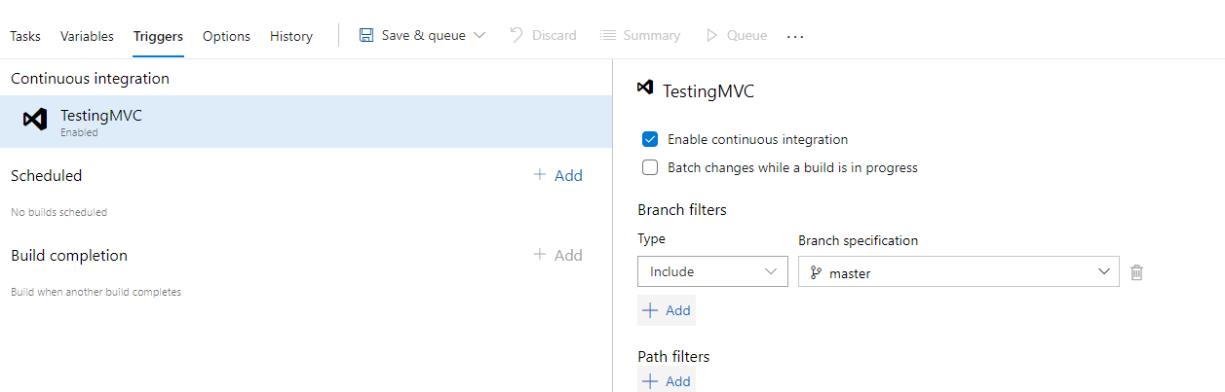

1. Build should fail for any failures: In the “Test” task uncheck “Continue on error” in control options. This will fail the build if test is not success.
2. Deployment of code and artifacts should be automated:
   1. Create release pipeline: navigate to Pipelines 🡺 Releases🡺New 🡺New release pipeline
   2. Add two new tasks(Deploy Azure App Service): Select Deploy Azure App Service 🡺configure Azure subscription 🡺App type as Web app on Windows 🡺 choose apps service name.
   3. Create one for web and another for API.
   4. Select the build artifact:

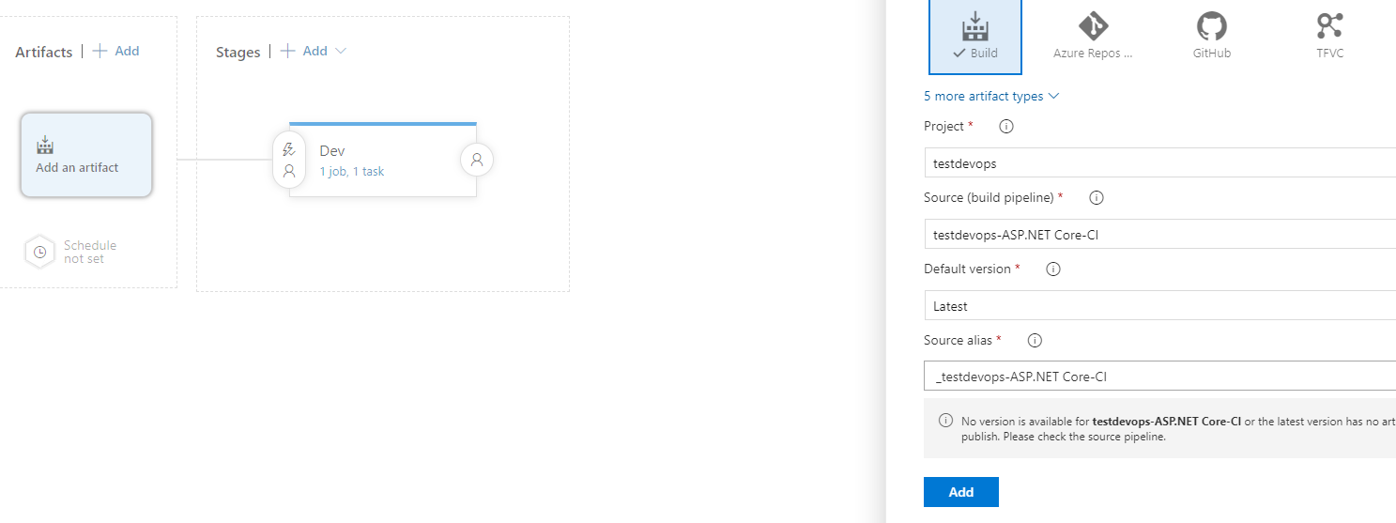

* 1. Add web, api artifacts like above and these will be used to deploy to different Web and API Azure appservices
  2. Select Web application build folder path in the “Package or folder” option in the Azure app service task
  3. Select API application build folder path in the “Package or folder” option in the Azure app service task

1. Promote dev build to QA then Prod:
   1. Add new stages QA and Prod: Add 🡺New stage
   2. QA deployment: Select the event option marked below on the left-hand side of the QA stage. Click on “Triggers🡺After stage 🡺Stages🡺Dev. This will deploy once the dev release is success.
   3. Prod deployment: Select the event option marked below on the left-hand side of the QA stage. Click on “Triggers🡺After stage 🡺Stages🡺QA. This configuration will make sure that QA deployment is success then deploy to production.

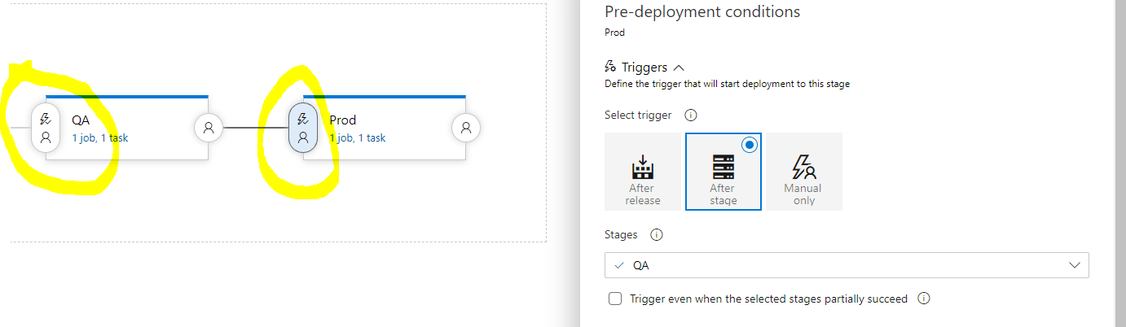

1. Promote builds with approvals:
   1. QA deployment: Select the event option marked below on the left-hand side of the QA stage. Click on “Pre-deployment approvals🡺enabled 🡺Approvers🡺Select team/groups”. Configure Timeout to 1 day or hour to wait the deployment process. Approval policies helpful to avoid same user approval and validate identity of approver.
   2. Prod deployment: Configure similar to QA deployment but we can give different approvers which depends on the requirement.

