Complete Database Maintenance Utility.

import sqlite3

con = sqlite3.connect("sample.db") cur = con.cursor()

cur.execute("""CREATE TABLE IF NOT EXISTS student ( roll_no INTEGER PRIMARY KEY,
name TEXT NOT NULL,
marks REAL
) """)
con.commit()

# 1. Insert Record def insert_record():
roll = int(input("Enter Roll Number: ")) name = input("Enter Name: ")
marks = float(input("Enter Marks: "))

cur.execute(
"INSERT INTO student VALUES (?, ?, ?)",
(roll, name, marks)
)
con.commit()
print("Record inserted successfully!")

# 2. Display Records def display_records():
cur.execute("SELECT * FROM student") records = cur.fetchall()

if records:
print("\nRoll No\tName\tMarks") for row in records:
print(row[0], "\t", row[1], "\t", row[2])
else:
print("No records found.")

# 3. Search Record def search_record():
roll = int(input("Enter Roll Number to search: "))

cur.execute(
"SELECT * FROM student WHERE roll_no = ?",

(roll,)
)
record = cur.fetchone()

if record:
print("Record Found:", record) else:
print("Record not found.")

# 4. Update Record def update_record():
roll = int(input("Enter Roll Number to update: ")) name = input("Enter New Name: ")
marks = float(input("Enter New Marks: "))

cur.execute(
"UPDATE student SET name = ?, marks = ? WHERE roll_no = ?", (name, marks, roll)
)
con.commit()

if cur.rowcount > 0:
print("Record updated successfully!") else:
print("Record not found.")

# 5. Delete Record def delete_record():
roll = int(input("Enter Roll Number to delete: "))

cur.execute(
"DELETE FROM student WHERE roll_no = ?", (roll,)
)
con.commit()

if cur.rowcount > 0:
print("Record deleted successfully!") else:
print("Record not found.")

# Main Menu while True:
print("\n===== DATABASE MAINTENANCE UTILITY =====")
print("1. Insert Record") print("2. Display Records")

print("3. Search Record") print("4. Update Record") print("5. Delete Record") print("6. Exit")
choice = input("Enter your choice: ") if choice == '1':
insert_record()
elif choice == '2': display_records()
elif choice == '3': search_record()
elif choice == '4': update_record()
elif choice == '5': delete_record()
elif choice == '6':
print("Exiting Database Maintenance Utility.") break
else:
print("Invalid choice! Try again.") con.close()

OUTPUT:
===== DATABASE MAINTENANCE UTILITY =====
- Insert Record
- Display Records
- Search Record
- Update Record
- Delete Record
- Exit
Enter your choice: 1 Enter Roll Number: 101 Enter Name: vatsal Enter Marks: 50
Record inserted successfully!

Write a Python program to create a library.db database and dump only the Book table (structure and data) into a SQL file.

import sqlite3

conn = sqlite3.connect("library.db") cursor = conn.cursor()

cursor.execute("""CREATE TABLE IF NOT EXISTS Book (book_id INTEGER PRIMARY KEY,title TEXT,author TEXT,price REAL)""")

cursor.execute("INSERT INTO Book (title, author, price) VALUES (?, ?, ?)",("Python Programming", "John", 500)) cursor.execute("INSERT INTO Book (title, author, price) VALUES (?, ?, ?)",("Database Management", "David", 600))

conn.commit()

with open("book_dump.sql", "w") as file: for line in conn.iterdump():
if "Book" in line: file.write(line + "\n")

print("Book table dumped successfully into book_dump.sql") conn.close()
OUTPUT: Book table dumped successfully into book_dump.sql

Write a Python program to export only the structure of the Employee table without its records.

import sqlite3

conn = sqlite3.connect("company.db") cursor = conn.cursor()

cursor.execute("""CREATE TABLE IF NOT EXISTS Employee (emp_id INTEGER PRIMARY KEY,name TEXT,department TEXT,salary REAL)""")

cursor.execute("""INSERT INTO Employee (name, department, salary) VALUES ('Rahul', 'IT', 30000)""")

conn.commit()

with open("employee_structure.sql", "w") as file:
cursor.execute("""SELECT sql FROM sqlite_master WHERE type = 'table' AND name = 'Employee'""")
result = cursor.fetchone() if result:
file.write(result[0] + ";\n")

print("Employee table structure exported successfully!") conn.close()
OUTPUT: Employee table structure exported successfully!

Write a Python program using iterdump() to create a complete backup of a SQLite database and restore it into a new database.

import sqlite3

conn = sqlite3.connect("company.db") cursor = conn.cursor()

cursor.execute("""CREATE TABLE IF NOT EXISTS Employee (emp_id INTEGER PRIMARY KEY,name TEXT,department TEXT,salary REAL)""")

cursor.execute("SELECT COUNT(*) FROM Employee") if cursor.fetchone()[0] == 0:
cursor.execute("""INSERT INTO Employee (name, department, salary)VALUES ('Rahul', 'IT', 30000)""")

conn.commit()

with open("backup.sql", "w") as file: for line in conn.iterdump():
file.write(line + "\n")

print("Database backup created successfully!") conn.close()
new_conn = sqlite3.connect("company_restore.db")

with open("backup.sql", "r") as file: sql_script = file.read()

new_conn.executescript(sql_script) print("Database restored successfully!")
cursor = new_conn.cursor() cursor.execute("SELECT * FROM Employee")

print("\nRestored Employee Records:") for row in cursor.fetchall():
print(row) new_conn.close()
OUTPUT: Database backup created successfully!
Database restored successfully!
Restored Employee Records:(1, 'Rahul', 'IT', 30000.0)

Write a Python program to export the data of Student, Course, and Faculty tables into a single SQL file containing only INSERT statements.

import sqlite3

conn = sqlite3.connect("college_new.db") cursor = conn.cursor()

cursor.execute("""CREATE TABLE IF NOT EXISTS Student (student_id INTEGER PRIMARY KEY,name TEXT)""")

cursor.execute("""CREATE TABLE IF NOT EXISTS Course (course_id INTEGER PRIMARY KEY,course_name TEXT)""")

cursor.execute("""CREATE TABLE IF NOT EXISTS Faculty (faculty_id INTEGER PRIMARY KEY,name TEXT)""")

cursor.execute("SELECT COUNT(*) FROM Student") if cursor.fetchone()[0] == 0:
cursor.execute("INSERT INTO Student VALUES (1, 'Rahul')")

cursor.execute("SELECT COUNT(*) FROM Course") if cursor.fetchone()[0] == 0:
cursor.execute("INSERT INTO Course VALUES (101, 'Python')")

cursor.execute("SELECT COUNT(*) FROM Faculty") if cursor.fetchone()[0] == 0:
cursor.execute("INSERT INTO Faculty VALUES (1, 'Amit')") conn.commit()
with open("data.sql", "w") as file:
for table in ["Student", "Course", "Faculty"]: cursor.execute(f'SELECT * FROM "{table}"') rows = cursor.fetchall()
columns = [desc[0] for desc in cursor.description] column_names = ", ".join(f'"{col}"' for col in columns)

for row in rows: values = []
for value in row:
if value is None: values.append("NULL")
elif isinstance(value, str):
values.append("'" + value.replace("'", "''") + "'") elif isinstance(value, bytes):
values.append("X'" + value.hex() + "'") else:

values.append(str(value))

file.write(f'INSERT INTO "{table}" ({column_names}) 'f'VALUES ({", ".join(values)});\n')

print("Data exported successfully into data.sql!") conn.close()
OUTPUT: Data exported successfully into data.sql!

Database Initialization and Table Creation : 1.Create a New Database: 2.Create Tables:students table,courses table & enrollments table
import sqlite3

conn = sqlite3.connect("college.db") conn.execute("PRAGMA foreign_keys = ON") cursor = conn.cursor()
cursor.execute("""CREATE TABLE IF NOT EXISTS students (student_id INTEGER PRIMARY KEY AUTOINCREMENT,name TEXT NOT NULL,email TEXT UNIQUE NOT NULL,major TEXT)""")

cursor.execute("""CREATE TABLE IF NOT EXISTS courses (course_id INTEGER PRIMARY KEY AUTOINCREMENT,course_name TEXT NOT NULL,credits INTEGER NOT NULL)""")

cursor.execute("""CREATE TABLE IF NOT EXISTS enrollments (enrollment_id INTEGER PRIMARY KEY AUTOINCREMENT,student_id INTEGER NOT NULL,course_id INTEGER NOT NULL,grade TEXT,
FOREIGN KEY (student_id) REFERENCES students(student_id),

FOREIGN KEY (course_id) REFERENCES courses(course_id))""")

conn.commit()

print("Database and tables created successfully!") conn.close()
OUTPUT: Database and tables created successfully!

Data Insertion (Create Operations) : 1.Insert Sample Data:
import sqlite3

conn = sqlite3.connect("college.db") conn.execute("PRAGMA foreign_keys = ON") cursor = conn.cursor()

students_data = [("Vatsal Nandedkar", "vatsal@gmail.com", "Computer Science"),
("Rahul Patel", "rahul@gmail.com", "Information Technology"), ("Priya Shah", "priya@gmail.com", "Computer Science"), ("Neha Desai", "neha@gmail.com", "Data Science")]

cursor.executemany("""INSERT OR IGNORE INTO students (name, email, major)VALUES (?, ?, ?)""", students_data)

courses_data = [("Python Programming", 4),("Database Management", 3),("Data Structures", 4),("Web Development", 3)]

cursor.executemany("""INSERT OR IGNORE INTO courses (course_name, credits)VALUES (?, ?)""", courses_data)

students = dict(cursor.execute("""SELECT email, student_id FROM students""").fetchall())

courses = dict(cursor.execute("""SELECT course_name, course_id FROM courses""").fetchall())

enrollments_data = [(students["vatsal@gmail.com"],courses["Python Programming"], "A"),

(students["vatsal@gmail.com"], courses["Database Management"], "B+"),

(students["rahul@gmail.com"], courses["Database Management"], "A"),

(students["rahul@gmail.com"], courses["Data Structures"], "B"),

(students["priya@gmail.com"], courses["Python Programming"], "A+"),

(students["priya@gmail.com"], courses["Web Development"], "A"),

(students["neha@gmail.com"], courses["Data Structures"], "B+")]

cursor.executemany("""INSERT INTO enrollments (student_id, course_id, grade)VALUES (?, ?, ?)""", enrollments_data)

conn.commit()
print("Sample data inserted successfully!") cursor.execute("""SELECT s.name, c.course_name, e.grade FROM
enrollments e JOIN students s ON e.student_id = s.student_id JOIN courses c ON e.course_id = c.course_id""")

print("\nEnrollment Records:") for row in cursor.fetchall():
print(row) conn.close()

OUTPUT:
Sample data inserted successfully!

Enrollment Records:
('Vatsal Nandedkar', 'Python Programming', 'A') ('Vatsal Nandedkar', 'Database Management', 'A+') ('Rahul Patel', 'Database Management', 'A') ('Rahul Patel', 'Data Structures', 'B')
('Priya Shah', 'Python Programming', 'A+') ('Priya Shah', 'Web Development', 'A')
('Vatsal Nandedkar', 'Python Programming', 'A') ('Vatsal Nandedkar', 'Database Management', 'B+') ('Rahul Patel', 'Database Management', 'A') ('Rahul Patel', 'Data Structures', 'B')
('Priya Shah', 'Python Programming', 'A+')

Data Retrieval (Read Operations) : 1.Basic Retrieval
2.Filtered Retrieval 3. Complex Queries (using JOINs if needed):
import sqlite3

conn = sqlite3.connect("college.db") cursor = conn.cursor()

print("\n--- ALL STUDENTS ---")

cursor.execute("""SELECT * FROM students""") students = cursor.fetchall()
for student in students: print(student)

print("\n--- COMPUTER SCIENCE STUDENTS ---")

cursor.execute("""SELECT * FROM students WHERE major = 'Computer Science'""")
students = cursor.fetchall() for student in students:
print(student)

print("\n--- STUDENT COURSE DETAILS ---")

cursor.execute("""SELECT students.name,courses.course_name,enrollments.grade FROM enrollments JOIN students ON enrollments.student_id = students.student_id JOIN courses ON enrollments.course_id = courses.course_id""")
results = cursor.fetchall() for row in results:
print(
"Student:", row[0],
"| Course:", row[1],
"| Grade:", row[2]) conn.close()

OUTPUT:

--- ALL STUDENTS ---
(1, 'Vatsal Nandedkar', 'vatsal@gmail.com', 'Cyber Security') (2, 'Rahul Patel', 'rahul@gmail.com', 'Information Technology') (3, 'Priya Shah', 'priya@gmail.com', 'Computer Science')
(5, 'vatsal', 'v@gmail.com', 'html')
(6, 'hevin', 'h@gmail.com', 'it')
(10, 'Neha Desai', 'neha@gmail.com', 'Data Science')

--- COMPUTER SCIENCE STUDENTS ---
(3, 'Priya Shah', 'priya@gmail.com', 'Computer Science')

--- STUDENT COURSE DETAILS ---
Student: Vatsal Nandedkar | Course: Python Programming | Grade: A Student: Vatsal Nandedkar | Course: Database Management | Grade: A+ Student: Rahul Patel | Course: Database Management | Grade: A Student: Rahul Patel | Course: Data Structures | Grade: B
Student: Priya Shah | Course: Python Programming | Grade: A+ Student: Priya Shah | Course: Web Development | Grade: A

Data Update (Update Operations): 1.Update Student Major
2.Update Enrollment Grade:

import sqlite3

conn = sqlite3.connect("college.db") cursor = conn.cursor()

print("\n--- UPDATE STUDENT MAJOR ---")

cursor.execute("""UPDATE students SET major = ?WHERE student_id = ?""", ("Cyber Security", 1))

conn.commit()

print("Student major updated successfully!")
cursor.execute("""SELECT * FROM students WHERE student_id = ?""", (1,)) print("Updated Student Record:")
print(cursor.fetchone())

print("\n--- UPDATE ENROLLMENT GRADE ---")

cursor.execute("""UPDATE enrollments SET grade = ? WHERE enrollment_id
= ?""", ("A+", 2))

conn.commit()

print("Enrollment grade updated successfully!")

cursor.execute("""SELECT * FROM enrollments WHERE enrollment_id = ?""", (2,))

print("Updated Enrollment Record:") print(cursor.fetchone())

conn.close()

OUTPUT:
--- UPDATE STUDENT MAJOR ---
Student major updated successfully! Updated Student Record:
(1, 'Vatsal Nandedkar', 'vatsal@gmail.com', 'Cyber Security')
--- UPDATE ENROLLMENT GRADE ---
Enrollment grade updated successfully! Updated Enrollment Record:
(2, 1, 2, 'A+')

- Data Deletion (Delete Operations): 1.Delete an Enrollment
- Attempt to Delete Enrolled Student (Observe FK Constraint)
- Safe Student Deletion

import sqlite3

conn = sqlite3.connect("college.db") conn.execute("PRAGMA foreign_keys = ON") cursor = conn.cursor()
print("\n--- DELETE AN ENROLLMENT ---")

cursor.execute("""DELETE FROM enrollments WHERE enrollment_id = ?""", (7,))

conn.commit()

print("Enrollment 7 deleted successfully!")

print("\n--- ATTEMPT TO DELETE ENROLLED STUDENT ---")

try:

cursor.execute(""" DELETE FROM students WHERE student_id = ? """, (1,))

conn.commit()

print("Student 1 deleted successfully!") except sqlite3.IntegrityError as e:
conn.rollback()

print("Cannot delete Student 1!") print("Foreign Key Constraint Error:", e) print("Student is still enrolled in a course.")

print("\n--- SAFE STUDENT DELETION ---")

cursor.execute("""DELETE FROM students WHERE student_id = ?""", (4,)) conn.commit()
print("Student 4 deleted safely!")

conn.close()

OUTPUT:
--- DELETE AN ENROLLMENT ---
Enrollment 7 deleted successfully!

--- ATTEMPT TO DELETE ENROLLED STUDENT ---
Cannot delete Student 1!
Foreign Key Constraint Error: FOREIGN KEY constraint failed Student is still enrolled in a course.

--- SAFE STUDENT DELETION ---
Student 4 deleted safely!

Database Dumping: 1.Full Database Dump 2.SchemaOnly Dump 3. Data-Only Dump

import sqlite3

conn = sqlite3.connect("college.db") cursor = conn.cursor()
print("\n--- FULL DATABASE DUMP ---")
with open("full_database_dump.sql", "w", encoding="utf-8") as file: for line in conn.iterdump():
file.write(line + "\n")

print("Full database dump created successfully!") print("File: full_database_dump.sql")

print("\n--- SCHEMA-ONLY DUMP ---")

cursor.execute("""SELECT sql FROM sqlite_master WHERE type = 'table'AND sql IS NOT NULL""")

schema = cursor.fetchall()
with open("schema_only_dump.sql", "w", encoding="utf-8") as file: for row in schema:
file.write(row[0] + ";\n\n")

print("Schema-only dump created successfully!") print("File: schema_only_dump.sql")

print("\n--- DATA-ONLY DUMP ---")

tables = ["students","courses","enrollments"]

with open("data_only_dump.sql", "w", encoding="utf-8") as file: for table in tables:
cursor.execute("SELECT * FROM " + table) rows = cursor.fetchall()
for row in rows: values = []

for value in row:

if value is None: values.append("NULL")

elif isinstance(value, (int, float)): values.append(str(value))

else:
value = str(value).replace("'", "''") values.append("'" + value + "'")

sql = (
"INSERT INTO "
+ table
+ " VALUES ("
+ ", ".join(values)
+ ");\n"
)

file.write(sql)

print("Data-only dump created successfully!") print("File: data_only_dump.sql")

conn.close()

print("\nAll database dumps created successfully!")

OUTPUT:

--- FULL DATABASE DUMP ---
Full database dump created successfully! File: full_database_dump.sql

--- SCHEMA-ONLY DUMP ---
Schema-only dump created successfully! File: schema_only_dump.sql

--- DATA-ONLY DUMP ---
Data-only dump created successfully! File: data_only_dump.sql

All database dumps created successfully!

CSV File Handling: 1.Export Enrollments to CSV 2.Import New Students from CSV

  - Import File:

import sqlite3 import csv

conn = sqlite3.connect("college.db") cursor = conn.cursor()
with open( "new_students.csv", "r",
newline="", encoding="utf-8"
) as file:

reader = csv.DictReader(file) for row in reader:
try:

cursor.execute("""
INSERT INTO students (name, email, major) VALUES (?, ?, ?)
""", (
row["name"],
row["email"],
row["major"]
))

print("Student imported:", row["name"]) except sqlite3.IntegrityError:
print(
"Student already exists:", row["email"]
)

conn.commit()

print("CSV import completed successfully!") conn.close()

OUTPUT:
Student already exists: v@gmail.com Student already exists: h@gmail.com CSV import completed successfully!

Export File:

import sqlite3 import csv
conn = sqlite3.connect("college.db") cursor = conn.cursor() cursor.execute("""SELECT
enrollments.enrollment_id,students.name,courses.course_name,enrollments. grade FROM enrollments JOIN students
ON enrollments.student_id = students.student_id JOIN courses
ON enrollments.course_id = courses.course_id """)

data = cursor.fetchall()

with open("enrollments.csv","w",newline="",encoding="utf-8") as file: writer = csv.writer(file)
writer.writerow(["Enrollment ID","Student Name","Course Name","Grade"]) writer.writerows(data)

print("Enrollments exported successfully!") print("File created: enrollments.csv")

conn.close()

OUTPUT:
Enrollments exported successfully! File created: enrollments.csv

1.Setup Your Database Connection:1. Import Module. 2.
Connect to Database 3. Create a Cursor

import sqlite3

conn = sqlite3.connect("product.db") cursor = conn.cursor()

print("Database connected successfully!") print("Cursor created successfully!")

conn.close()

OUTPUT:
Database connected successfully! Cursor created successfully!

2.Create Your First Table (products):1. Define SQL. 2. Execute SQL. 3. Save Changes 4. Close Connection

import sqlite3

conn = sqlite3.connect("product.db") cursor = conn.cursor()

sql = """CREATE TABLE IF NOT EXISTS products (product_id INTEGER PRIMARY KEY AUTOINCREMENT,product_name TEXT NOT NULL,price REAL NOT NULL,quantity INTEGER NOT NULL)"""

cursor.execute(sql) conn.commit()
print("Products table created successfully!") conn.close()
OUTPUT: Products table created successfully!

Add New Products (Create Operation - INSERT):1. Re-connect and Get Cursor. 2. Insert Single Product. 3. Insert Multiple Products. 4. Confirm Insertions. 5. Commit and Close

import sqlite3

conn = sqlite3.connect("product.db") cursor = conn.cursor()
cursor.execute("""INSERT INTO products (product_name, price, quantity) VALUES (?, ?, ?)""", ("Laptop", 55000, 10))

print("Single product inserted successfully!")

products = [("Mouse", 500, 25),("Keyboard", 1200, 15),("Monitor", 12000,
- ,("Headphones", 2000, 5)]

cursor.executemany("""INSERT INTO products (product_name, price, quantity)VALUES (?, ?, ?)""", products)

print("Multiple products inserted successfully!") cursor.execute("""SELECT * FROM products""") rows = cursor.fetchall()
print("\n--- PRODUCTS ---")

for row in rows: print(row)

conn.commit() conn.close()

OUTPUT:
Single product inserted successfully! Multiple products inserted successfully!

--- PRODUCTS ---
(1, 'Laptop', 58000.0, 20)
(2, 'Mouse', 500.0, 25)
(4, 'Monitor', 12000.0, 8)
(5, 'Headphones', 2000.0, 5)
(6, 'USB Cable', 300.0, 20)
(7, 'USB Cable', 300.0, 20)
(8, 'USB Cable', 300.0, 20)
(9, 'Laptop', 55000.0, 10)

View Your Products (Read Operation - SELECT):1. Print Products.2. Select Specific Product.3. Select Products with Low Quantity

import sqlite3

conn = sqlite3.connect("product.db") cursor = conn.cursor()
print("\n--- ALL PRODUCTS ---")

cursor.execute("""SELECT * FROM products""") products = cursor.fetchall()
for product in products: print(product)

print("\n--- SPECIFIC PRODUCT ---")

cursor.execute("""SELECT * FROM products WHERE product_id = ?""", (1,)) product = cursor.fetchone()
print(product)

print("\n--- LOW QUANTITY PRODUCTS ---")

cursor.execute("""SELECT * FROM products WHERE quantity < ?""", (10,)) products = cursor.fetchall()
for product in products: print(product)

conn.close()

OUTPUT:

--- ALL PRODUCTS ---
(1, 'Laptop', 58000.0, 20)
(2, 'Mouse', 500.0, 25)
(4, 'Monitor', 12000.0, 8)
(5, 'Headphones', 2000.0, 5)
(6, 'USB Cable', 300.0, 20)
(7, 'USB Cable', 300.0, 20)
(8, 'USB Cable', 300.0, 20)
(9, 'Laptop', 55000.0, 10)
(10, 'Mouse', 500.0, 25)
(11, 'Keyboard', 1200.0, 15)
(12, 'Monitor', 12000.0, 8)
(13, 'Headphones', 2000.0, 5)

--- SPECIFIC PRODUCT ---(1, 'Laptop', 58000.0, 20)

--- LOW QUANTITY PRODUCTS ---(4, 'Monitor', 12000.0, 8)
(5, 'Headphones', 2000.0, 5)
(12, 'Monitor', 12000.0, 8)
(13, 'Headphones', 2000.0, 5)

Update Product Information (Update Operation - UPDATE):1. Update Quantity. 2. Update Price. 3. Confirm Updates.

import sqlite3

conn = sqlite3.connect("product.db") cursor = conn.cursor()
cursor.execute("""UPDATE products SET quantity = ?WHERE product_id
= ?""", (20, 1))

print("Product quantity updated successfully!")

cursor.execute("""UPDATE products SET price = ? WHERE product_id = ?""", (58000, 1))

print("Product price updated successfully!") conn.commit()
cursor.execute("""SELECT *FROM products WHERE product_id = ?""", (1,)) product = cursor.fetchone()
print("\n--- UPDATED PRODUCT ---")
print(product) conn.close() OUTPUT:
Product quantity updated successfully!
Product price updated successfully!

--- UPDATED PRODUCT ---(1, 'Laptop', 58000.0, 20)

Remove Products (Delete Operation - DELETE):1. Delete a Product. 2. Confirm Deletion

import sqlite3

conn = sqlite3.connect("product.db") cursor = conn.cursor()
cursor.execute("""DELETE FROM products WHERE product_id = ?""", (3,))

print("Product deleted successfully!") conn.commit()

cursor.execute("""SELECT * FROM products""") products = cursor.fetchall()
print("\n--- PRODUCTS AFTER DELETION ---")

for product in products: print(product)

conn.close()

OUTPUT:

Product deleted successfully!

--- PRODUCTS AFTER DELETION ---(1, 'Laptop', 58000.0, 20)
(2, 'Mouse', 500.0, 25)
(4, 'Monitor', 12000.0, 8)
(5, 'Headphones', 2000.0, 5)
(6, 'USB Cable', 300.0, 20)
(7, 'USB Cable', 300.0, 20)
(8, 'USB Cable', 300.0, 20)
(9, 'Laptop', 55000.0, 10)
(10, 'Mouse', 500.0, 25)
(11, 'Keyboard', 1200.0, 15)
(12, 'Monitor', 12000.0, 8)
(13, 'Headphones', 2000.0, 5)

Understanding commit() and rollback(): 1. Demonstrate Commit. 2. Demonstrate Rollback

  - Commit.
import sqlite3

conn = sqlite3.connect("product.db") cursor = conn.cursor()

cursor.execute("""INSERT INTO products (product_name, price, quantity)VALUES (?, ?, ?)""", ("USB Cable", 300, 20))

# Commit permanently saves the change conn.commit()

print("Product inserted and committed successfully!")

cursor.execute("""SELECT *FROM products WHERE product_name = ?""", ("USB Cable",))

print(cursor.fetchone()) conn.close()

OUTPUT:
Product inserted and committed successfully! (6, 'USB Cable', 300.0, 20)

Rollback.

import sqlite3

conn = sqlite3.connect("product.db") cursor = conn.cursor()
cursor.execute("""INSERT INTO products (product_name, price, quantity)VALUES (?, ?, ?)""", ("Temporary Product", 999, 5))

print("Temporary product inserted.")

# Rollback cancels the insertion conn.rollback()

print("Rollback performed successfully!")

cursor.execute("""SELECT *FROM products WHERE product_name = ?""", ("Temporary Product",))

result = cursor.fetchone() if result is None:
print("Temporary product was removed by rollback.") else:
print(result) conn.close()

OUTPUT:
Temporary product inserted. Rollback performed successfully!
Temporary product was removed by rollback.

Basic Database Backup (Dump):1. Dump Database.2. Save to File

import sqlite3

conn = sqlite3.connect("product.db")
with open("product_database_backup.sql","w",encoding="utf-8") as file: for line in conn.iterdump():
file.write(line + "\n")

print("Database backup created successfully!") print("File: product_database_backup.sql")

conn.close()

OUTPUT:
Database backup created successfully! File: product_database_backup.sql

Export Products to CSV File

import sqlite3 import csv

conn = sqlite3.connect("product.db") cursor = conn.cursor()
cursor.execute("""SELECT * FROM products""") products = cursor.fetchall()
with open("products.csv","w",newline="",encoding="utf-8") as file: writer = csv.writer(file)
writer.writerow(["Product ID","Product Name","Price","Quantity"]) writer.writerows(products)

print("Products exported successfully!") print("File: products.csv")

conn.close()

OUTPUT:
Products exported successfully! File: products.csv

- Setup - Database Connection and Table Creation:
  - Connect to Database 2. Create tasks Table

  - Core To-Do List Functions:
    - add_task(description, due_date) function
    - view_tasks(show_completed=False) function
    - mark_task_completed(task_id) function
    - delete_task(task_id) function

  - Simple User Interface (Main Program Loop):
    - Display Menu: Continuously display the following menu options: To-Do List
Manager:
1. Add New Task 2. View Pending Tasks 3. View All Tasks (including
completed) 4. Mark Task as Completed 5. Delete Task 6. Exit

    - Enter your choice: Get User Input:
    - Process Choice
    - Error Handling for Input

import sqlite3

# 1. SETUP - DATABASE CONNECTION AND TABLE CREATION
conn = sqlite3.connect("todo.db") cursor = conn.cursor()
cursor.execute("""CREATE TABLE IF NOT EXISTS tasks (task_id INTEGER PRIMARY KEY AUTOINCREMENT,description TEXT NOT NULL,due_date TEXT NOT NULL,completed INTEGER DEFAULT 0)""")
conn.commit() conn.close()
print("Database and tasks table created successfully!")

# 2. CORE TO-DO LIST FUNCTIONS
# 2.1 add_task(description, due_date)

def add_task(description, due_date):

conn = sqlite3.connect("todo.db") cursor = conn.cursor()

cursor.execute("""INSERT INTO tasks (description, due_date, completed)VALUES (?, ?, 0)""", (description, due_date))

conn.commit() conn.close()

print("Task added successfully!")

# 2.2 view_tasks(show_completed=False)

def view_tasks(show_completed=False):

conn = sqlite3.connect("todo.db") cursor = conn.cursor()

if show_completed:

cursor.execute("""SELECT task_id, description, due_date, completed FROM tasks ORDER BY task_id""")

else:

cursor.execute("""SELECT task_id, description, due_date, completed FROM tasks WHERE completed = 0 ORDER BY task_id""")

tasks = cursor.fetchall() conn.close()
if not tasks:
print("No tasks found.") return

print("\n TASKS ") for task in tasks:
if task[3] == 1:
status = "Completed" else:
status = "Pending"

print("ID:", task[0],"| Description:", task[1],"| Due Date:", task[2],"| Status:", status)

print(" ")

# 2.3 mark_task_completed(task_id)

def mark_task_completed(task_id):

conn = sqlite3.connect("todo.db") cursor = conn.cursor()

cursor.execute("""UPDATE tasks SET completed = 1 WHERE task_id
= ?""", (task_id,))

if cursor.rowcount == 0: print("Task not found!")
else:
print("Task marked as completed!") conn.commit()
conn.close()

# 2.4 delete_task(task_id)

def delete_task(task_id):

conn = sqlite3.connect("todo.db") cursor = conn.cursor()
cursor.execute("""DELETE FROM tasks WHERE task_id = ?""", (task_id,)) if cursor.rowcount == 0:
print("Task not found!") else:
print("Task deleted successfully!") conn.commit()
conn.close()

# 3. SIMPLE USER INTERFACE - MAIN PROGRAM LOOP

while True:

# 3.1 Display Menu

print("\n====================================") print(" TO-DO LIST MANAGER") print("====================================")
print("1. Add New Task") print("2. View Pending Tasks")
print("3. View All Tasks (including completed)") print("4. Mark Task as Completed")
print("5. Delete Task") print("6. Exit")
print("====================================")

# 3.2 Enter your choice
choice = input("Enter your choice: ")

# 3.3 Process Choice

if choice == "1":

description = input("Enter task description: ") due_date = input("Enter due date (DD-MM-YYYY): ")

if description.strip() == "":
print("Task description cannot be empty!")

elif due_date.strip() == "":
print("Due date cannot be empty!")

else:
add_task(description, due_date) elif choice == "2":
view_tasks(False) elif choice == "3":
view_tasks(True) elif choice == "4":

# 3.4 Error Handling for Input

try:

task_id = int(input("Enter task ID: ")) mark_task_completed(task_id)
except ValueError:

print("Invalid input! Please enter a valid number.") elif choice == "5":
try:

task_id = int(input("Enter task ID: ")) delete_task(task_id)
except ValueError:

print("Invalid input! Please enter a valid number.") elif choice == "6":
print("\nThank you for using To-Do List Manager!") print("Program ended.")
break else:
print("Invalid choice!")
print("Please enter a number between 1 and 6.")

OUTPUT:
Database and tasks table created successfully!

==================================== TO-DO LIST MANAGER
====================================
- Add New Task
- View Pending Tasks
- View All Tasks (including completed)
- Mark Task as Completed
- Delete Task
- Exit
====================================
Enter your choice: 1
Enter task description: python practical Enter due date (DD-MM-YYYY): 10-10-26 Task added successfully!

==================================== TO-DO LIST MANAGER
====================================
- Add New Task
- View Pending Tasks
- View All Tasks (including completed)
- Mark Task as Completed
- Delete Task
- Exit
====================================
Enter your choice: 2

TASKS
ID: 2 | Description: java practical | Due Date: 12-3-2026 | Status: Pending ID: 4 | Description: java programing | Due Date: 10-12-26 | Status: Pending ID: 6 | Description: python practical | Due Date: 10-10-26 | Status: Pending

==================================== TO-DO LIST MANAGER
====================================
- Add New Task
- View Pending Tasks
- View All Tasks (including completed)
- Mark Task as Completed
- Delete Task
- Exit
====================================
Enter your choice: 3

TASKS
ID: 2 | Description: java practical | Due Date: 12-3-2026 | Status: Pending ID: 3 | Description: c++ | Due Date: 08-10-2026 | Status: Completed
ID: 4 | Description: java programing | Due Date: 10-12-26 | Status: Pending ID: 6 | Description: python practical | Due Date: 10-10-26 | Status: Pending

==================================== TO-DO LIST MANAGER
====================================
- Add New Task
- View Pending Tasks
- View All Tasks (including completed)
- Mark Task as Completed
- Delete Task
- Exit
====================================
Enter your choice: 4 Enter task ID: 6
Task marked as completed!

==================================== TO-DO LIST MANAGER
====================================
- Add New Task
- View Pending Tasks
- View All Tasks (including completed)
- Mark Task as Completed
- Delete Task
- Exit
====================================
Enter your choice: 3

TASKS
ID: 2 | Description: java practical | Due Date: 12-3-2026 | Status: Pending ID: 3 | Description: c++ | Due Date: 08-10-2026 | Status: Completed
ID: 4 | Description: java programing | Due Date: 10-12-26 | Status: Pending

ID: 6 | Description: python practical | Due Date: 10-10-26 | Status: Completed

==================================== TO-DO LIST MANAGER
====================================
- Add New Task
- View Pending Tasks
- View All Tasks (including completed)
- Mark Task as Completed
- Delete Task
- Exit
====================================
Enter your choice: 5 Enter task ID: 4
Task deleted successfully!

==================================== TO-DO LIST MANAGER
====================================
- Add New Task
- View Pending Tasks
- View All Tasks (including completed)
- Mark Task as Completed
- Delete Task
- Exit
====================================
Enter your choice:

Tkinter Basic Registration Form.

import tkinter as tk
from tkinter import messagebox import re

root = tk.Tk()
root.title("Basic Registration Form") root.geometry("400x400")

def validate_name(name):
if not re.fullmatch(r"[A-Za-z ]+", name): return False

if len(name.strip()) < 3: return False

return True

def validate_email(email):
pattern = r"^[\w\.-]+@[\w\.-]+\.\w+$"
return re.fullmatch(pattern, email) is not None

def validate_phone(phone):
return phone.isdigit() and len(phone) == 10 def register():
name = name_entry.get().strip() email = email_entry.get().strip() phone = phone_entry.get().strip()

if name == "":
messagebox.showerror("Error", "Name is required!") return

if not validate_name(name): messagebox.showerror(
"Error",
"Name must contain only characters and at least 3 letters!"
)
return

if email == "":
messagebox.showerror("Error", "Email is required!") return

if not validate_email(email): messagebox.showerror(
"Error",
"Please enter a valid email address!"
)
return

if phone == "":
messagebox.showerror("Error", "Phone number is required!") return

if not validate_phone(phone): messagebox.showerror(
"Error",
"Phone number must contain exactly 10 digits!"
)
return

messagebox.showinfo( "Success",
"Registration Successful!"
)

tk.Label(root,text="Basic Registration Form",font=("Arial", 18, "bold")).pack(pady=20)

tk.Label(root, text="Name:").pack()

name_entry = tk.Entry(root, width=30) name_entry.pack(pady=5)

tk.Label(root, text="Email:").pack()

email_entry = tk.Entry(root, width=30) email_entry.pack(pady=5)

tk.Label(root, text="Phone:").pack()

phone_entry = tk.Entry(root, width=30) phone_entry.pack(pady=5)

tk.Button(root,text="Register",command=register).pack(pady=25) root.mainloop()

OUTPUT:
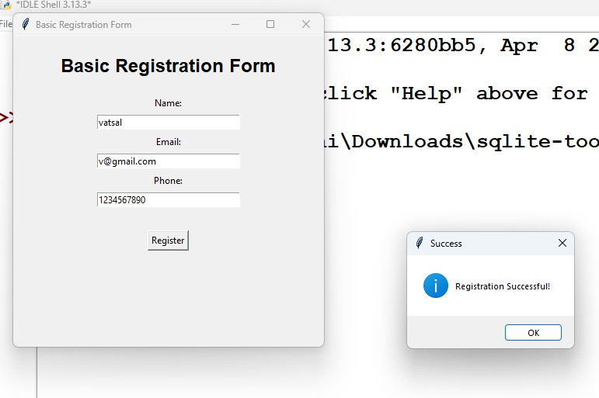

Tkinter Registration Form with Country & Password

import tkinter as tk
from tkinter import messagebox import re

root = tk.Tk() root.title("Registration Form") root.geometry("450x550")
def validate_name(name): if len(name.strip()) < 3:
return False

if not re.fullmatch(r"[A-Za-z ]+", name): return False

return True

def validate_email(email):

pattern = r"^[\w\.-]+@[\w\.-]+\.\w+$"

return re.fullmatch(pattern, email) is not None def register():
name = name_entry.get().strip() email = email_entry.get().strip() country = country_entry.get().strip() password = password_entry.get()
confirm_password = confirm_entry.get()

if name == "":
messagebox.showerror("Error","Name is required!") return

if not validate_name(name):
messagebox.showerror("Error","Name must contain only characters and at least 3 letters!")
return

if email == "":
messagebox.showerror("Error","Email is required!") return

if not validate_email(email): messagebox.showerror("Error","Enter a valid email address!")

return

if country == "": messagebox.showerror("Error","Country is required!") return

if password == "": messagebox.showerror("Error","Password is required!") return

if len(password) < 6:
messagebox.showerror("Error","Password must contain at least 6 characters!")
return

if confirm_password == "": messagebox.showerror(
"Error",
"Please confirm your password!"
)
return

if password != confirm_password: messagebox.showerror("Error","Passwords do not match!") return

messagebox.showinfo("Success","Registration Successful!")

tk.Label(root,text="Registration Form",font=("Arial", 18, "bold")).pack(pady=20) tk.Label(root, text="Name:").pack()
name_entry = tk.Entry(root, width=35) name_entry.pack(pady=5)

tk.Label(root, text="Email:").pack()

email_entry = tk.Entry(root, width=35) email_entry.pack(pady=5)

tk.Label(root, text="Country:").pack()

country_entry = tk.Entry(root, width=35) country_entry.pack(pady=5)

tk.Label(root, text="Password:").pack()

password_entry = tk.Entry(root,width=35,show="*") password_entry.pack(pady=5)

tk.Label(root, text="Confirm Password:").pack()

confirm_entry = tk.Entry(root,width=35,show="*") confirm_entry.pack(pady=5)

tk.Button(root,text="Register",command=register).pack(pady=25) root.mainloop()

OUTPUT:
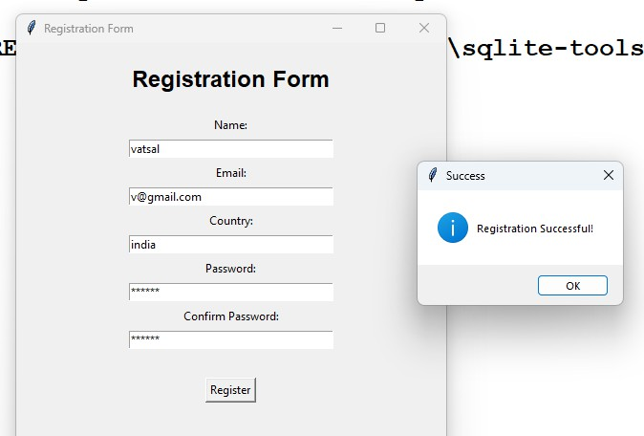

Tkinter Registration Form with Language Selection.

import tkinter as tk
from tkinter import messagebox import re

root = tk.Tk() root.title("Registration Form") root.geometry("500x550")

def validate_name(name): if len(name.strip()) < 3:
return False

if not re.fullmatch(r"[A-Za-z ]+", name): return False

return True

def validate_email(email):
pattern = r"^[A-Za-z0-9._%+-]+@[A-Za-z0-9.-]+\.[A-Za-z]{2,}$" return re.fullmatch(pattern, email) is not None

def register():

name = name_entry.get().strip() email = email_entry.get().strip()

gender_value = gender.get() languages = []
if python_var.get() == 1: languages.append("Python")

if java_var.get() == 1: languages.append("Java")

if cpp_var.get() == 1: languages.append("C++")

if name == "":
messagebox.showerror("Error", "Name is required!") return

if not validate_name(name):
messagebox.showerror("Error","Name must contain only characters and at least 3 letters!")
return

if email == "":
messagebox.showerror("Error", "Email is required!") return

if not validate_email(email):
messagebox.showerror("Error","Please enter a valid email address!") return

if gender_value == 0:
messagebox.showerror("Error","Please select your gender!") return

if len(languages) == 0:
messagebox.showerror("Error","Please select at least one language!") return

if gender_value == 1: selected_gender = "Male"
else:
selected_gender = "Female"

messagebox.showinfo("Registration Successful","Registration Successful!\n\n""Name: " + name +"\nEmail: " + email +"\nGender: " + selected_gender +"\nLanguages: " + ", ".join(languages))

tk.Label(root,text="Registration Form",font=("Arial", 20, "bold")).pack(pady=20) tk.Label(root, text="Name:").pack()
name_entry = tk.Entry(root, width=35) name_entry.pack(pady=5)

tk.Label(root, text="Email:").pack()

email_entry = tk.Entry(root, width=35) email_entry.pack(pady=5)
tk.Label(root,text="Gender:").pack(pady=8) gender = tk.IntVar()
gender.set(0)

tk.Radiobutton(root,text="Male",variable=gender,value=1).pack() tk.Radiobutton(root,text="Female",variable=gender,value=2).pack() tk.Label(root,text="Select Languages:").pack(pady=10)
python_var = tk.IntVar() java_var = tk.IntVar()

cpp_var = tk.IntVar() tk.Checkbutton(root,text="Python",variable=python_var).pack() tk.Checkbutton(root,text="Java",variable=java_var).pack() tk.Checkbutton(root,text="C++",variable=cpp_var).pack() tk.Button(root,text="Register",width=15,command=register).pack(pady=25) root.mainloop()

OUTPUT:
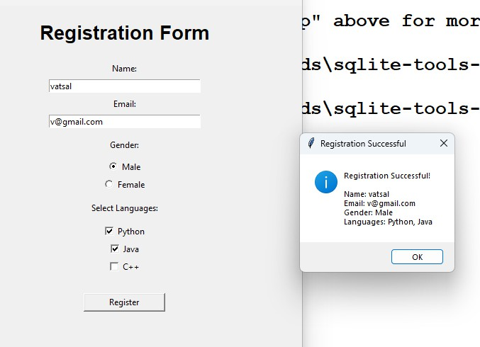

- Environment Setup and Database/Collection Initialization:
  - Connect to MongoDB
  - Select Database and Collection.

mongosh use mean
db.createCollection("exam")

OUTPUT:
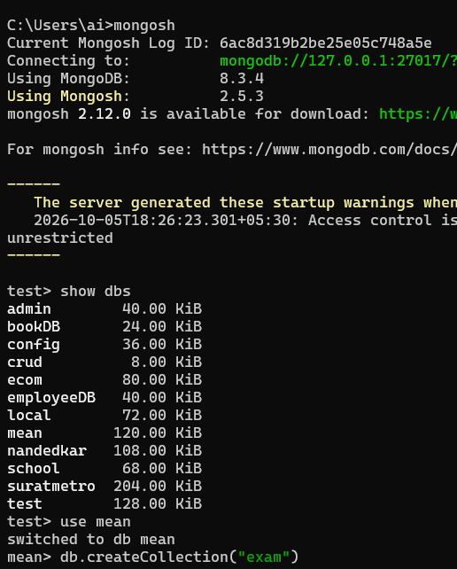

- 2.Data Insertion (Create Operations):
  - Insert Sample Student Documents
  - Vary your data.

db.exam.insertMany([{id:1,name:"vatsal",age:20,major:"computerscience",enr ollments:[{course:"python",marks:85},{course:"dbms",marks:78}]},{id:2,name:" hevin",age:21,major:"IT",enrollments:[{course:"python",marks:92},{course:"jav a",marks:88}]},{id:3,name:"henil",age:19,major:"computerscience",enrollments
:[{course:"dbms",marks:90},{course:"java",marks:75}]},])

OUTPUT:
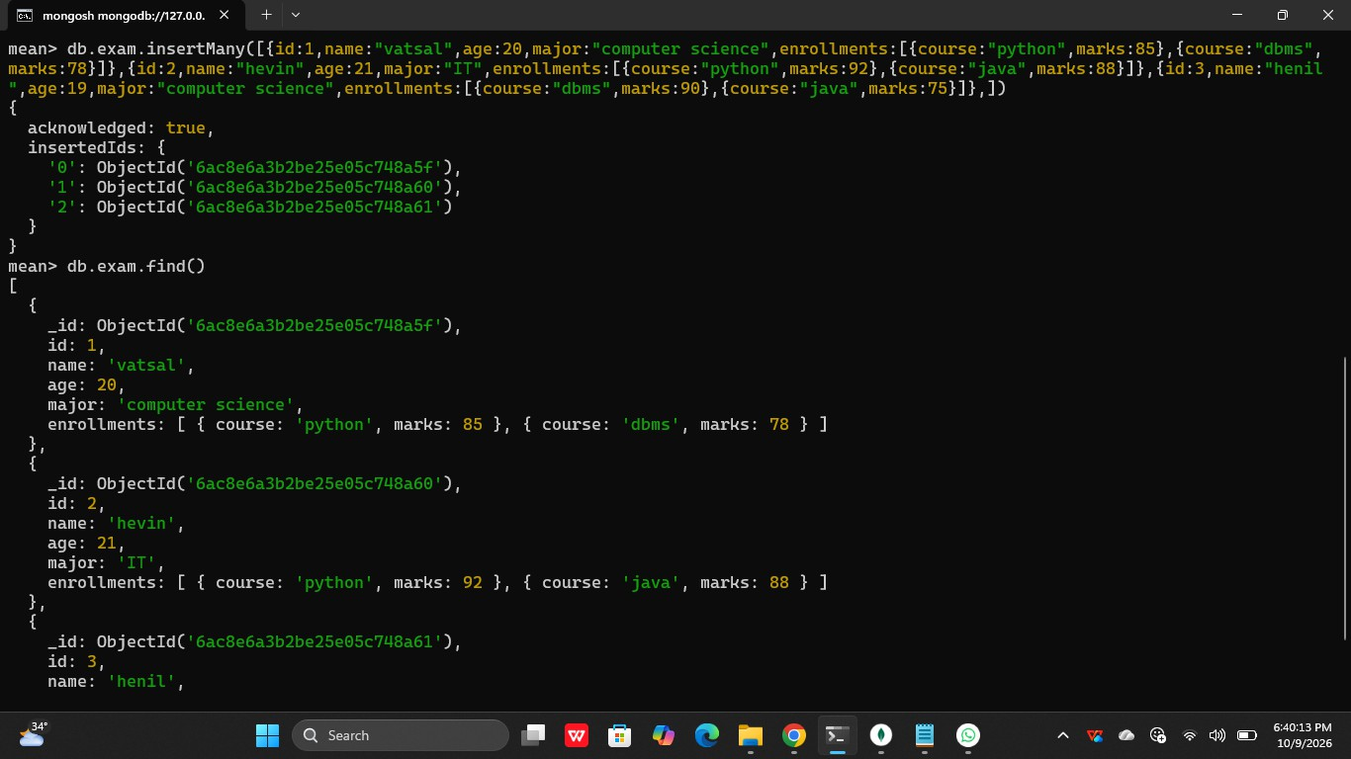

Data Retrieval (Read Operations):

  - Basic Retrieval Query:db.exam.find()

OUTPUT:
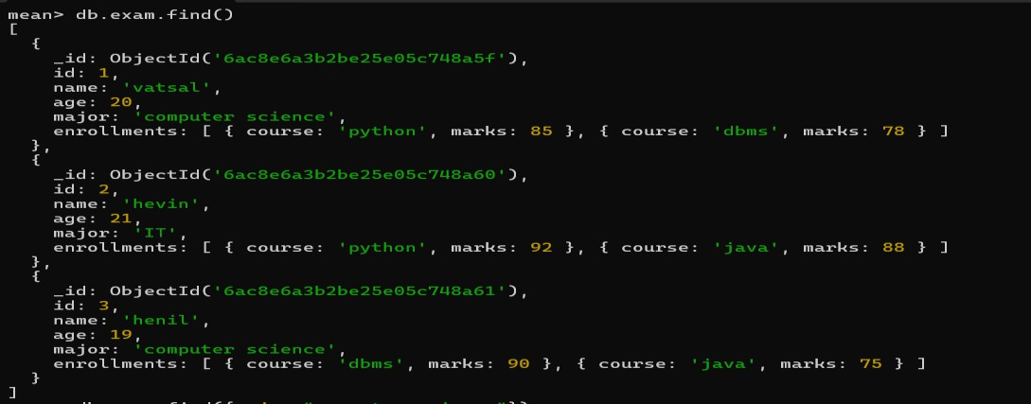

Filtered Retrieval
Query: db.exam.find({major:"computer science"})

OUTPUT:
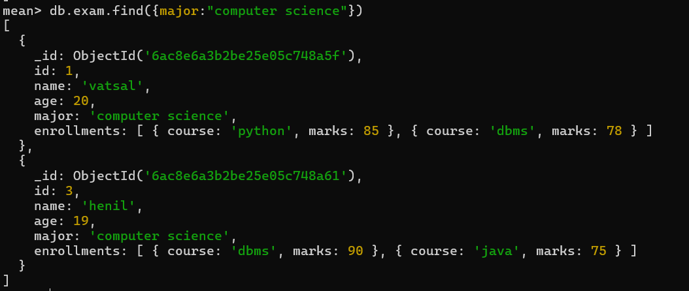

Advanced Retrieval (using sort, limit, skip)
    - Using Sort:db.exam.find().sort({ age: 1 })

OUTPUT:
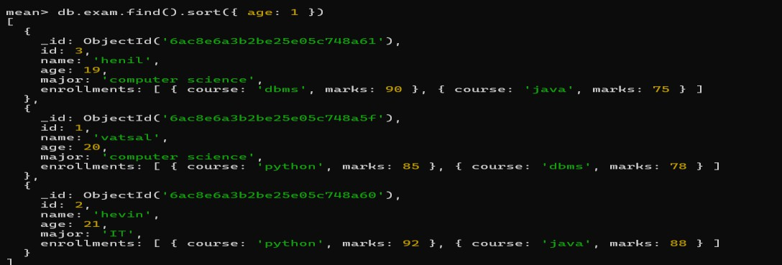

    - using limit: db.exam.find().sort({ age: -1 }).limit(3)

OUTPUT:
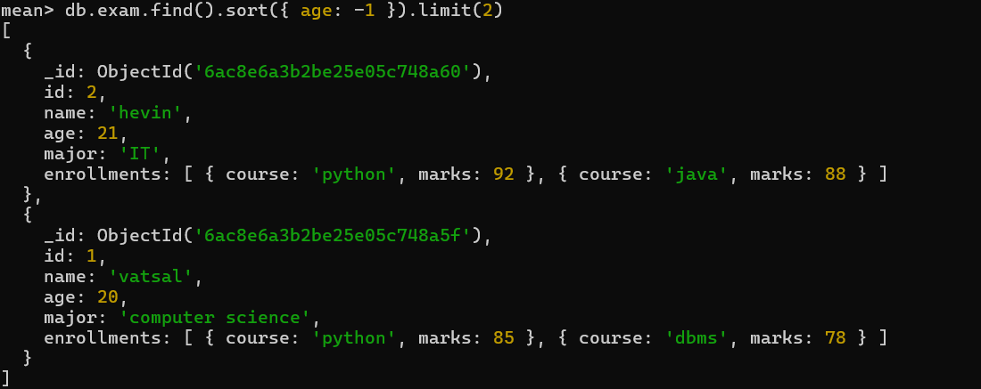

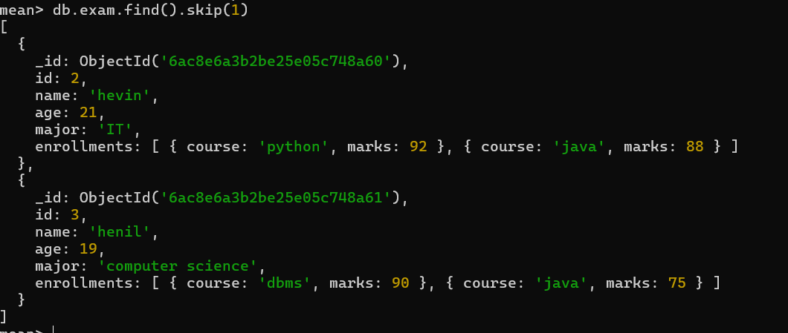
    - Using Skip:db.exam.find().skip(2) OUTPUT:

Aggregation Queries:

    - Count Students per Major:
QUERY: db.exam.aggregate([{$group: {_id: "$major",totalStudents: { $sum: 1 }}}])

OUTPUT:
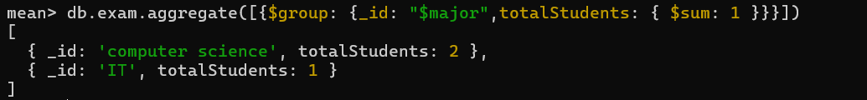

Average Marks per Course:
QUERY: db.exam.aggregate([{ $unwind: "$enrollments" },{$group: {_id: "$enrollments.course",averageMarks: {$avg:
"$enrollments.marks"}}}])

OUTPUT:

Students with High Marks in a Course
QUERY: db.exam.aggregate([{$unwind: "$enrollments"},{$match:
{"enrollments.course": "python","enrollments.marks": { $gt: 85 }}},{$project:
{_id: 0,name: 1,course: "$enrollments.course",marks: "$enrollments.marks"}}])

OUTPUT:

Data Update (Update Operations):

- Update Top-Level Field
QUERY: db.exam.updateOne({ id: 1 },{ $set: { age: 22 } })

OUTPUT:
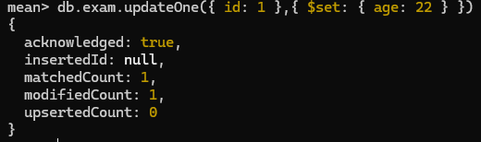

Add a New Enrollment
Query: db.exam.updateOne({ id: 1 },{$push: {enrollments: {course: "mongodb",marks: 90}}})

OUTPUT:
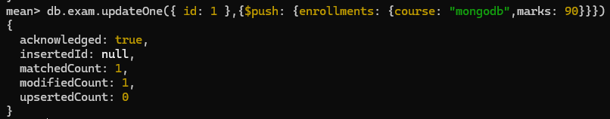

- Update Embedded Field (Specific Array Element) Query: db.exam.updateOne({id: 1,"enrollments.course": "python"},{$set:
{"enrollments.$.marks": 95}})

OUTPUT:
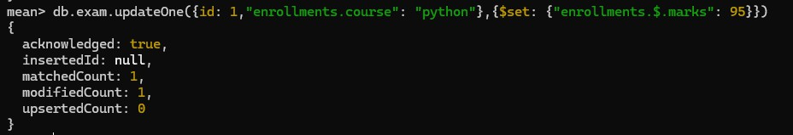

Remove an Enrollment
Query: db.exam.updateOne({ id: 1 },{$pull: {enrollments: { course: "dbms" }}})

OUTPUT:
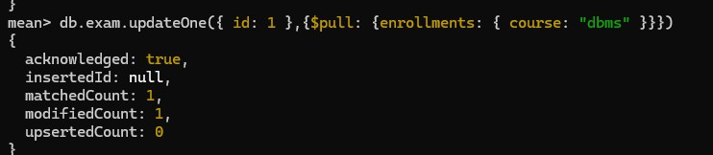

Upsert Operation
Query: db.exam.updateOne({ id: 4 },{$set: {name: "jay",age: 20,major: "cyber security",enrollments: [{ course: "python", marks: 91 }]}},{ upsert: true })

OUTPUT:
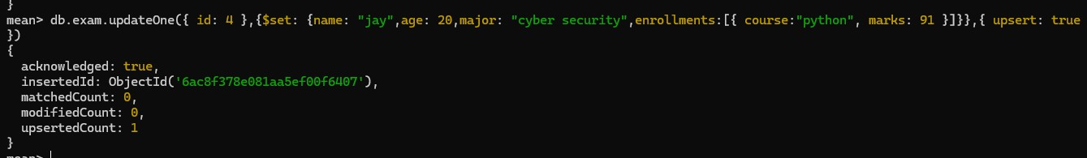

Data Deletion (Delete Operations):

- Delete a Single Student Query: db.exam.deleteOne({ id: 4 })

OUTPUT:
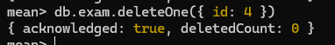

- Delete Multiple Students Query:db.exam.deleteMany({age: { $gt: 20 }})

OUTPUT:

Create a Blank window with Tkinter library.

import tkinter as tk root = tk.Tk()
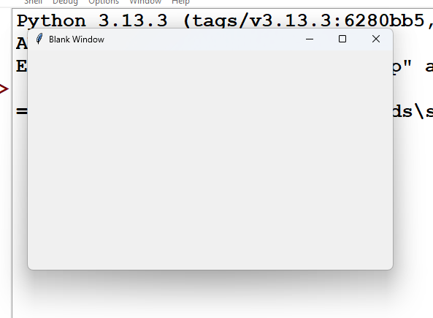
root.title("Blank Window") root.geometry("500x300") root.mainloop() OUTPUT:

Create a window with the help of pack() method (add button widgets inside window).

import tkinter as tk root = tk.Tk()
root.title("Pack Method") root.geometry("400x300")

button1 = tk.Button(root, text="Button 1") button2 = tk.Button(root, text="Button 2") button3 = tk.Button(root, text="Button 3")

button1.pack() button2.pack() button3.pack()

root.mainloop()

OUTPUT:
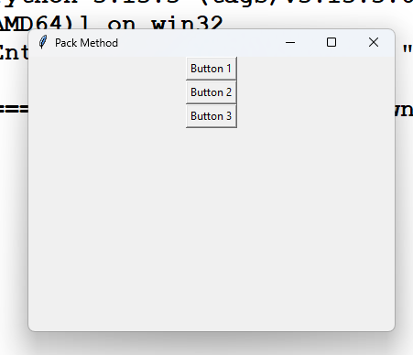

Write a code to create login form using grid() method.

import tkinter as tk root = tk.Tk()
root.title("Login Form") root.geometry("400x250")

username_label = tk.Label(root, text="Username:") username_label.grid(row=0, column=0, padx=10, pady=10)

username_entry = tk.Entry(root) username_entry.grid(row=0, column=1, padx=10, pady=10)

password_label = tk.Label(root, text="Password:") password_label.grid(row=1, column=0, padx=10, pady=10)

password_entry = tk.Entry(root, show="*") password_entry.grid(row=1, column=1, padx=10, pady=10)

login_button = tk.Button(root, text="Login") login_button.grid(row=2, column=1, padx=10, pady=10)

root.mainloop()

OUTPUT:
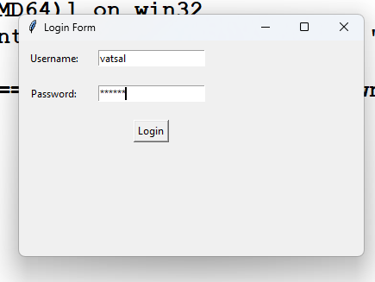

Create a window form with the help of place() method.

import tkinter as tk root = tk.Tk()
root.title("Place Method") root.geometry("500x300")

name_label = tk.Label(root, text="Name:") name_label.place(x=80, y=50)

name_entry = tk.Entry(root) name_entry.place(x=180, y=50)

email_label = tk.Label(root, text="Email:") email_label.place(x=80, y=100)

email_entry = tk.Entry(root) email_entry.place(x=180, y=100)

phone_label = tk.Label(root, text="Phone:") phone_label.place(x=80, y=150)

phone_entry = tk.Entry(root) phone_entry.place(x=180, y=150)

submit_button = tk.Button(root, text="Submit") submit_button.place(x=200, y=210)

root.mainloop()

OUTPUT:
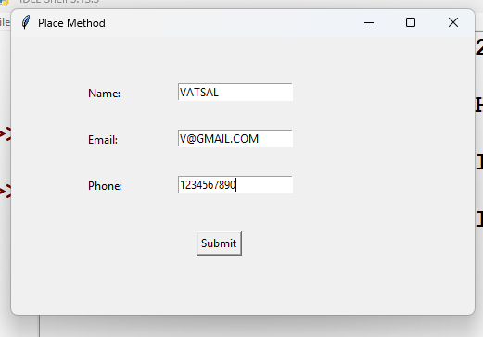

Divide a window form into 2 parts using frame.

import tkinter as tk root = tk.Tk()
root.title("Frame Example") root.geometry("500x300")

frame1 = tk.Frame(root, width=250, height=300, relief="solid", borderwidth=2) frame1.pack(side="left", fill="both", expand=True)

frame2 = tk.Frame(root, width=250, height=300, relief="solid", borderwidth=2) frame2.pack(side="right", fill="both", expand=True)

label1 = tk.Label(frame1, text="Left Part") label1.pack(pady=100)

label2 = tk.Label(frame2, text="Right Part") label2.pack(pady=100)

root.mainloop()

OUTPUT:
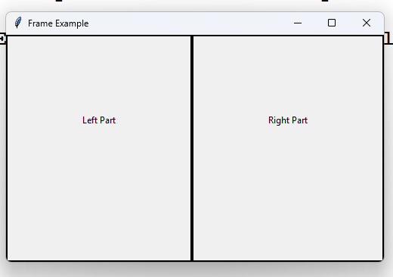

Write python code to gather student information using windows gui form using Tkinter widgets. Form Properties: (Name, Email, Phone, Address, Classname(radiobutton), semester(listbox), hobbies(checkbox), image(canvas) & submit button.).
import tkinter as tk
from tkinter import messagebox

root = tk.Tk()
root.title("Student Information Form") root.geometry("600x650")

heading = tk.Label(root,text="Student Information Form",font=("Arial", 18, "bold"))
heading.pack(pady=10)

frame = tk.Frame(root) frame.pack(pady=10)

tk.Label(frame, text="Name:").grid(row=0, column=0, padx=10, pady=8, sticky="w")

name_entry = tk.Entry(frame, width=30) name_entry.grid(row=0, column=1, padx=10, pady=8)

tk.Label(frame, text="Email:").grid(row=1, column=0, padx=10, pady=8, sticky="w")

email_entry = tk.Entry(frame, width=30) email_entry.grid(row=1, column=1, padx=10, pady=8)

tk.Label(frame, text="Phone:").grid(row=2, column=0, padx=10, pady=8, sticky="w")

phone_entry = tk.Entry(frame, width=30) phone_entry.grid(row=2, column=1, padx=10, pady=8)

tk.Label(frame, text="Address:").grid(row=3, column=0, padx=10, pady=8, sticky="nw")

address_text = tk.Text(frame, width=30, height=4) address_text.grid(row=3, column=1, padx=10, pady=8)

tk.Label(frame, text="Class:").grid(row=4, column=0, padx=10, pady=8, sticky="w")

class_var = tk.StringVar(value="B.Sc CS")

tk.Radiobutton(frame,text="B.Sc CS",variable=class_var,value="B.Sc CS").grid(row=4, column=1, sticky="w")

tk.Radiobutton(frame,text="BCA",variable=class_var,value="BCA").grid(row=5, column=1, sticky="w")

tk.Label(frame, text="Semester:").grid(row=6, column=0, padx=10, pady=8, sticky="nw")

semester_listbox = tk.Listbox(frame, height=4, width=25)

for semester in ["Semester 1", "Semester 2", "Semester 3", "Semester 4","Semester 5", "Semester 6"]:
semester_listbox.insert(tk.END, semester) semester_listbox.grid(row=6, column=1, padx=10, pady=8)
tk.Label(frame, text="Hobbies:").grid(row=7, column=0, padx=10, pady=8, sticky="nw")

reading_var = tk.BooleanVar() coding_var = tk.BooleanVar() sports_var = tk.BooleanVar()

tk.Checkbutton(frame,text="Reading",variable=reading_var).grid(row=7, column=1, sticky="w")

tk.Checkbutton(frame,text="Coding",variable=coding_var).grid(row=8, column=1, sticky="w")

tk.Checkbutton(frame,text="Sports",variable=sports_var).grid(row=9, column=1, sticky="w")

tk.Label(frame, text="Image:").grid(row=10, column=0, padx=10, pady=8)

canvas = tk.Canvas(frame,width=150,height=100,bg="lightgray",highlightthickness=1) canvas.grid(row=10, column=1, padx=10, pady=8)

canvas.create_oval(55, 15, 95, 55, fill="white")
canvas.create_rectangle(40, 55, 110, 90, fill="white")

def submit():
name = name_entry.get() email = email_entry.get() phone = phone_entry.get()
address = address_text.get("1.0", tk.END).strip() class_name = class_var.get()

selected = semester_listbox.curselection()

if selected:
semester = semester_listbox.get(selected[0]) else:
semester = "Not Selected" hobbies = []
if reading_var.get(): hobbies.append("Reading")
if coding_var.get(): hobbies.append("Coding")

if sports_var.get(): hobbies.append("Sports")

messagebox.showinfo( "Student Information", f"Name: {name}\n" f"Email: {email}\n" f"Phone: {phone}\n" f"Address: {address}\n" f"Class: {class_name}\n" f"Semester: {semester}\n"
f"Hobbies: {', '.join(hobbies)}")

submit_button = tk.Button(root,text="Submit",command=submit,width=15) submit_button.pack(pady=15)

root.mainloop()

OUTPUT:
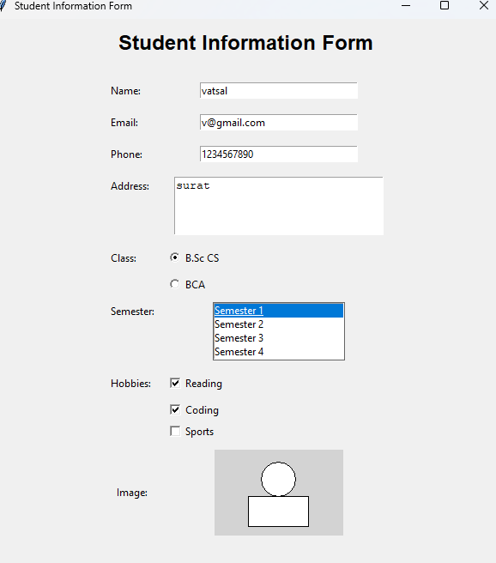

Write a code to demonstrate Button Widget in Tkinter:

import tkinter as tk
from tkinter import messagebox root = tk.Tk()
root.title("Button Widget") root.geometry("400x250")

def show_message():
messagebox.showinfo("Message", "Button Clicked Successfully!")

label = tk.Label(root,text="Button Widget Example",font=("Arial", 16, "bold")) label.pack(pady=30)

button = tk.Button(root,text="Click Me",command=show_message,width=15,height=2) button.pack()

exit_button = tk.Button(root,text="Exit",command=root.destroy,width=15) exit_button.pack(pady=20)

root.mainloop()

OUTPUT:
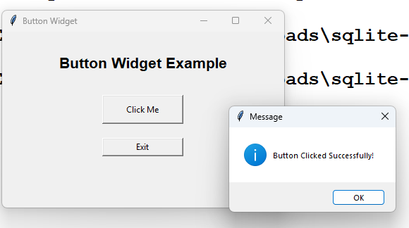

Write a code to demonstrate Checkbutton Widget.

import tkinter as tk
from tkinter import messagebox root = tk.Tk()
root.title("Checkbutton Widget") root.geometry("400x300")

label = tk.Label(root,text="Select Your Hobbies",font=("Arial", 16, "bold")) label.pack(pady=20)

reading = tk.BooleanVar() coding = tk.BooleanVar() sports = tk.BooleanVar()

tk.Checkbutton(root,text="Reading",variable=reading).pack() tk.Checkbutton(root,text="Coding",variable=coding).pack() tk.Checkbutton(root,text="Sports",variable=sports).pack()
def show_selection(): hobbies = []

if reading.get(): hobbies.append("Reading")

if coding.get(): hobbies.append("Coding")

if sports.get(): hobbies.append("Sports")

if hobbies:
messagebox.showinfo("Selected Hobbies","You selected:\n" + "\n".join(hobbies))
else:
messagebox.showwarning("Warning","Please select at least one hobby.")

button = tk.Button(root,text="Submit",command=show_selection) button.pack(pady=20)

root.mainloop()

OUTPUT:
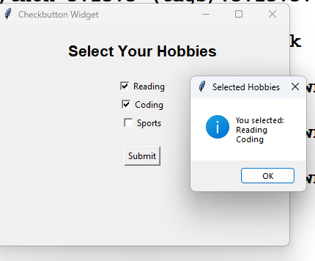

Write a code to demonstrate Entry Widget.

import tkinter as tk root = tk.Tk()
root.title("Entry Widget") root.geometry("400x250")

heading = tk.Label(root,text="Entry Widget Example",font=("Arial", 16, "bold")) heading.pack(pady=20)

name_label = tk.Label(root, text="Enter Your Name:") name_label.pack()

name_entry = tk.Entry(root, width=30) name_entry.pack(pady=10)

def show_name():
name = name_entry.get() result_label.config(text="Hello " + name)

button = tk.Button(root,text="Submit",command=show_name) button.pack(pady=10)

result_label = tk.Label(root, text="") result_label.pack(pady=10)

root.mainloop()

OUTPUT:
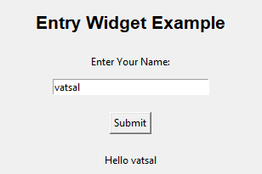

Write a code to demonstrate Frame Widget.

import tkinter as tk root = tk.Tk()
root.title("Frame Widget") root.geometry("500x300")

heading = tk.Label(root,text="Frame Widget Example",font=("Arial", 16, "bold"))
heading.pack(pady=15)

frame1 = tk.Frame(root,width=200,height=150,relief="solid",borderwidth=2) frame1.pack(side="left", padx=30, pady=20)

tk.Label(frame1,text="Frame 1").pack(pady=20) tk.Button(frame1,text="Button 1").pack()
frame2 = tk.Frame(root,width=200,height=150,relief="solid",borderwidth=2) frame2.pack(side="right", padx=30, pady=20)

tk.Label(frame2,text="Frame 2").pack(pady=20) tk.Button(frame2,text="Button 2").pack() root.mainloop()

OUTPUT:
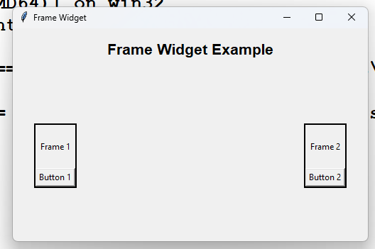

Write a code to demonstrate Label Widget.

import tkinter as tk root = tk.Tk()
root.title("Label Widget") root.geometry("500x300")

label1 = tk.Label(root,text="Hello, Welcome to Tkinter!") label1.pack(pady=20)

label2 = tk.Label(root,text="Label Widget Example",font=("Arial", 18, "bold")) label2.pack(pady=20)

label3 = tk.Label(root,text="This is a Python GUI Application.") label3.pack(pady=20)

root.mainloop()

OUTPUT:
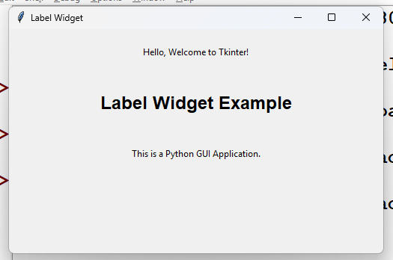

Write a code to demonstrate Listbox Widget

import tkinter as tk
from tkinter import messagebox root = tk.Tk()
root.title("Listbox Widget") root.geometry("400x350")

heading = tk.Label(root,text="Listbox Widget Example",font=("Arial", 16, "bold"))
heading.pack(pady=15)

label = tk.Label(root, text="Select a Semester:") label.pack()

listbox = tk.Listbox(root,height=6,width=25) listbox.pack(pady=10)

semesters = ["Semester 1","Semester 2","Semester 3","Semester 4","Semester 5","Semester 6"]

for semester in semesters: listbox.insert(tk.END, semester)

def show_selection():
selected = listbox.curselection()

if selected:
value = listbox.get(selected[0]) messagebox.showinfo("Selection","Selected: " + value)
else:
messagebox.showwarning("Warning","Please select a semester.")

button = tk.Button(root,text="Submit",command=show_selection) button.pack(pady=15)

root.mainloop()

OUTPUT:
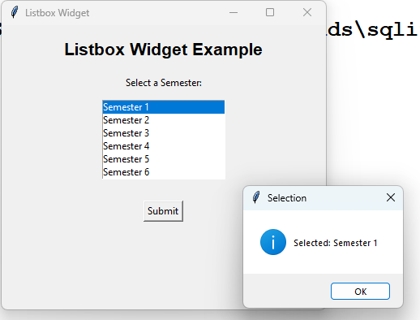

Write a code to demonstrate Radiobutton Widget in Tkinter.

import tkinter as tk
from tkinter import messagebox

root = tk.Tk()

root.title("Radiobutton Widget") root.geometry("400x300")

heading = tk.Label(root,text="Radiobutton Widget Example",font=("Arial", 16, "bold"))
heading.pack(pady=20)

label = tk.Label(root, text="Select Your Gender:") label.pack(pady=10)

gender = tk.StringVar(value="Male")

male_button = tk.Radiobutton(root,text="Male",variable=gender,value="Male") male_button.pack()

female_button = tk.Radiobutton(root,text="Female",variable=gender,value="Female") female_button.pack()

other_button = tk.Radiobutton(root,text="Other",variable=gender,value="Other") other_button.pack()

def show_selection():
messagebox.showinfo("Selected Gender","You selected: " + gender.get())

button = tk.Button(root,text="Submit",command=show_selection) button.pack(pady=20)

root.mainloop()

OUTPUT:
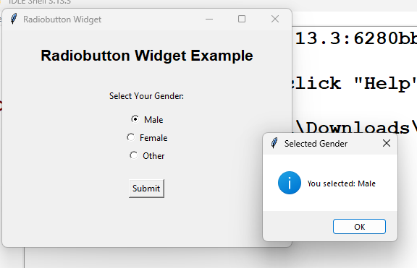

Write a code to demonstrate Text Widget in Tkinter.

import tkinter as tk
from tkinter import messagebox root = tk.Tk()
root.title("Text Widget") root.geometry("500x350")

heading = tk.Label(root,text="Text Widget Example",font=("Arial", 16, "bold")) heading.pack(pady=15)

label = tk.Label(root, text="Enter Your Address:") label.pack()

text_box = tk.Text(root,width=45,height=8) text_box.pack(pady=10)

def show_text():
address = text_box.get("1.0", tk.END).strip() messagebox.showinfo("Entered Address",address)

button = tk.Button(root,text="Submit",command=show_text) button.pack(pady=10)

root.mainloop()

OUTPUT:
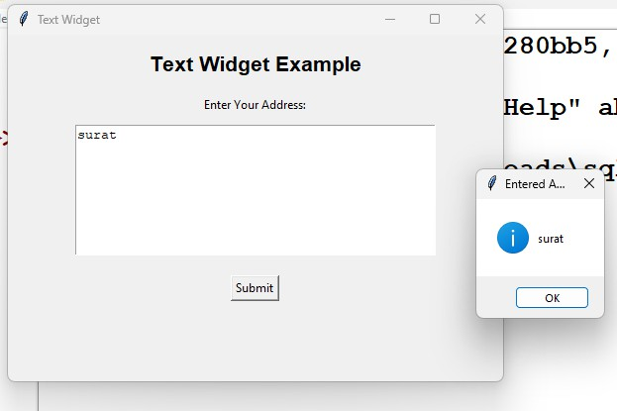

Write a code to demonstrate Scale Widget in Tkinter.

import tkinter as tk root = tk.Tk()
root.title("Scale Widget") root.geometry("400x300")

heading = tk.Label(root,text="Scale Widget Example",font=("Arial", 16, "bold")) heading.pack(pady=20)

def update_value(value):
value_label.config(text="Selected Value: " + str(int(float(value))))

scale = tk.Scale(root,from_=0,to=100,orient=tk.HORIZONTAL,length=250,command= update_value)
scale.pack(pady=20)

value_label = tk.Label(root,text="Selected Value: 0",font=("Arial", 12)) value_label.pack(pady=10)

root.mainloop()

OUTPUT:
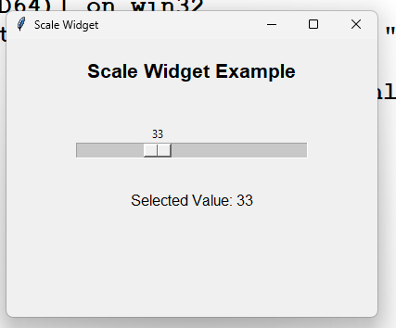

Write a code to demonstrate Toplevel Widget in Tkinter.

import tkinter as tk root = tk.Tk()
root.title("Toplevel Widget") root.geometry("400x250")

def open_window():
new_window = tk.Toplevel(root)

new_window.title("New Window") new_window.geometry("300x200")

label = tk.Label(new_window,text="This is a Toplevel Window",font=("Arial", 12))
label.pack(pady=50)

close_button = tk.Button(new_window,text="Close",command=new_window.destroy)
close_button.pack()

heading = tk.Label(root,text="Toplevel Widget Example",font=("Arial", 16, "bold"))
heading.pack(pady=30)

button = tk.Button(root,text="Open New Window",command=open_window) button.pack(pady=20)

root.mainloop()

OUTPUT:
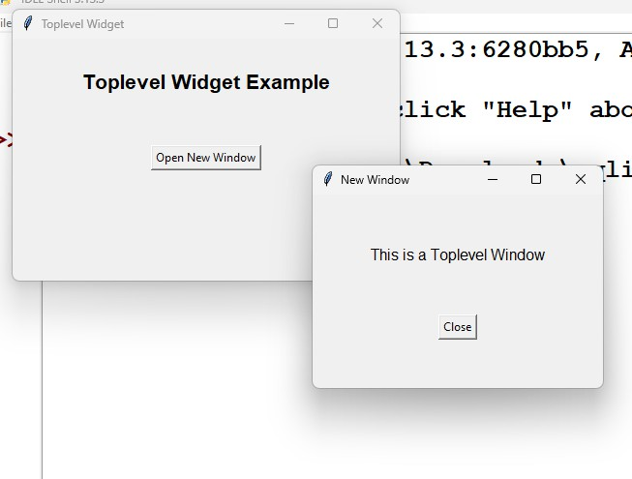

Write a code to demonstrate simple calculations in Tkinter.

import tkinter as tk
from tkinter import messagebox root = tk.Tk()
root.title("Simple Calculator") root.geometry("400x350")

def calculate(operation): try:
num1 = float(entry1.get()) num2 = float(entry2.get())

if operation == "+": result = num1 + num2

elif operation == "-": result = num1 - num2

elif operation == "*": result = num1 * num2

elif operation == "/": if num2 == 0:
messagebox.showerror("Error","Cannot divide by zero.") return

result = num1 / num2 result_label.config(text="Result: " + str(result))
except ValueError:
messagebox.showerror("Error","Please enter valid numbers.")

heading = tk.Label(root,text="Simple Calculator",font=("Arial", 18, "bold")) heading.pack(pady=15)

label1 = tk.Label(root, text="Enter First Number:") label1.pack()

entry1 = tk.Entry(root, width=25) entry1.pack(pady=5)

label2 = tk.Label(root, text="Enter Second Number:") label2.pack()

entry2 = tk.Entry(root, width=25) entry2.pack(pady=5)

button_frame = tk.Frame(root) button_frame.pack(pady=15)

tk.Button(button_frame,text="+",width=5,command=lambda: calculate("+")).grid(row=0, column=0, padx=5)

tk.Button(button_frame,text="-",width=5,command=lambda: calculate("-")).grid(row=0, column=1, padx=5)

tk.Button(button_frame,text="*",width=5,command=lambda: calculate("*")).grid(row=0, column=2, padx=5)

tk.Button(button_frame,text="/",width=5,command=lambda: calculate("/")).grid(row=0, column=3, padx=5)

result_label = tk.Label(root,text="Result: ",font=("Arial", 14, "bold")) result_label.pack(pady=15)

root.mainloop()

OUTPUT:
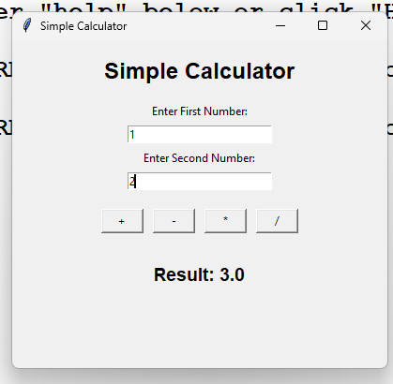

Tkinter form with CREATE,READ, UPDATE, DELETE Operation (Student Details).

import tkinter as tk
from tkinter import ttk, messagebox import sqlite3
import re

conn = sqlite3.connect("student.db") cursor = conn.cursor()

cursor.execute("""CREATE TABLE IF NOT EXISTS students (id INTEGER PRIMARY KEY,name TEXT NOT NULL,email TEXT NOT NULL,phone TEXT NOT NULL,marks INTEGER NOT NULL)""")
conn.commit()

def validate_data():

student_id = entry_id.get().strip() name = entry_name.get().strip() email = entry_email.get().strip() phone = entry_phone.get().strip() marks = entry_marks.get().strip()

"":
if student_id == "" or name == "" or email == "" or phone == "" or marks ==

messagebox.showerror("Validation Error", "All fields are required") return False

if not student_id.isdigit():
messagebox.showerror("Validation Error", "Student ID must contain only numbers")
return False

if not re.fullmatch(r"[A-Za-z ]+", name): messagebox.showerror("Validation Error", "Name must contain only
alphabets")
return False
email_pattern = r"^[A-Za-z0-9._%+-]+@[A-Za-z0-9.-]+\.[A-Za-z]{2,}$" if not re.fullmatch(email_pattern, email):
messagebox.showerror("Validation Error", "Enter a valid email address")
return False

if not phone.isdigit():
messagebox.showerror("Validation Error", "Phone must contain only numbers")
return False

if len(phone) != 10:
messagebox.showerror("Validation Error","Phone number must contain exactly 10 digits")
return False

if not marks.isdigit():
messagebox.showerror("Validation Error", "Marks must be a number") return False

marks_value = int(marks)

if marks_value < 0 or marks_value > 100: messagebox.showerror("Validation Error","Marks must be between 0 and
100")
return False return True

def add_student():

if not validate_data(): return

student_id = int(entry_id.get()) name = entry_name.get().strip() email = entry_email.get().strip() phone = entry_phone.get().strip() marks = int(entry_marks.get())

try:

cursor.execute("""INSERT INTO students VALUES (?, ?, ?, ?, ?)""", (student_id, name, email, phone, marks))

conn.commit()
messagebox.showinfo("Success","Student added successfully") clear_fields()
display_students()

except sqlite3.IntegrityError: messagebox.showerror("Error","Student ID already exists")
def display_students():

for item in table.get_children(): table.delete(item)

cursor.execute("SELECT * FROM students") records = cursor.fetchall()
for record in records:
table.insert("", tk.END, values=record)

def select_student(event): selected = table.focus()
if selected == "": return

data = table.item(selected, "values") clear_fields()
entry_id.insert(0, data[0]) entry_name.insert(0, data[1]) entry_email.insert(0, data[2]) entry_phone.insert(0, data[3]) entry_marks.insert(0, data[4])

def update_student():

if not validate_data(): return

student_id = int(entry_id.get()) name = entry_name.get().strip() email = entry_email.get().strip() phone = entry_phone.get().strip() marks = int(entry_marks.get())

cursor.execute("""UPDATE students SET name = ?,email = ?,phone
= ?,marks = ? WHERE id = ?""", (name, email, phone, marks, student_id)) conn.commit()

if cursor.rowcount == 0: messagebox.showerror("Error","Student ID not found") return
messagebox.showinfo("Success","Student updated successfully")

clear_fields() display_students()

def delete_student():
student_id = entry_id.get().strip() if student_id == "":
messagebox.showerror("Error","Please enter Student ID") return

if not student_id.isdigit():
messagebox.showerror("Error","Student ID must contain only numbers") return

student_id = int(student_id)

cursor.execute("DELETE FROM students WHERE id = ?",(student_id,)) conn.commit()
if cursor.rowcount == 0: messagebox.showerror("Error","Student ID not found") return
messagebox.showinfo("Success","Student deleted successfully")

clear_fields() display_students()

def clear_fields():

entry_id.delete(0, tk.END) entry_name.delete(0, tk.END) entry_email.delete(0, tk.END) entry_phone.delete(0, tk.END) entry_marks.delete(0, tk.END)

root = tk.Tk()

root.title("Student Management System") root.geometry("850x650") root.resizable(False, False)

title = tk.Label(root,text="STUDENT MANAGEMENT SYSTEM",font=("Arial", 22, "bold"))
title.pack(pady=15) main_frame = tk.Frame(root)
main_frame.pack(padx=20, pady=10)

form_frame = tk.LabelFrame(main_frame,text="Student Information",font=("Arial", 12, "bold"),padx=20,pady=15)

form_frame.grid(row=0, column=0, padx=10)

tk.Label(form_frame,text="Student ID",font=("Arial", 11)).grid(row=0, column=0, padx=10, pady=8, sticky="w")

entry_id = tk.Entry(form_frame,width=30) entry_id.grid(row=0, column=1, padx=10, pady=8)
tk.Label(form_frame,text="Student Name",font=("Arial", 11)).grid(row=1, column=0, padx=10, pady=8, sticky="w")

entry_name = tk.Entry(form_frame,width=30) entry_name.grid(row=1, column=1, padx=10, pady=8)
tk.Label(form_frame,text="Email",font=("Arial", 11)).grid(row=2, column=0, padx=10, pady=8, sticky="w")

entry_email = tk.Entry(form_frame,width=30) entry_email.grid(row=2, column=1, padx=10, pady=8)

tk.Label(form_frame,text="Phone",font=("Arial", 11)).grid(row=3, column=0, padx=10, pady=8, sticky="w")

entry_phone = tk.Entry(form_frame,width=30) entry_phone.grid(row=3, column=1, padx=10, pady=8)

tk.Label(form_frame,text="Marks",font=("Arial", 11)).grid(row=4, column=0, padx=10, pady=8, sticky="w")

entry_marks = tk.Entry(form_frame,width=30) entry_marks.grid(row=4, column=1, padx=10, pady=8)

button_frame = tk.Frame(root) button_frame.pack(pady=15)

tk.Button(button_frame,text="CREATE",width=12,command=add_student).gri d(row=0, column=0, padx=5)

tk.Button(button_frame,text="READ",width=12,command=display_students).g rid(row=0, column=1, padx=5)

tk.Button(button_frame,text="UPDATE",width=12,command=update_student). grid(row=0, column=2, padx=5)

tk.Button(button_frame,text="DELETE",width=12,command=delete_student).g rid(row=0, column=3, padx=5)

table_frame = tk.LabelFrame(root,text="Student Records",font=("Arial", 12, "bold"))

table_frame.pack(padx=20,pady=10,fill="both",expand=True) columns = ("ID","Name","Email","Phone","Marks")
table = ttk.Treeview(table_frame,columns=columns,show="headings",height=10)

for column in columns: table.heading(column, text=column)

table.column("ID", width=70) table.column("Name", width=150) table.column("Email", width=220) table.column("Phone", width=130) table.column("Marks", width=80)

table.pack(padx=10,pady=10,fill="both",expand=True) table.bind("<ButtonRelease-1>",select_student)

display_students() root.mainloop()

conn.close()

OUTPUT:
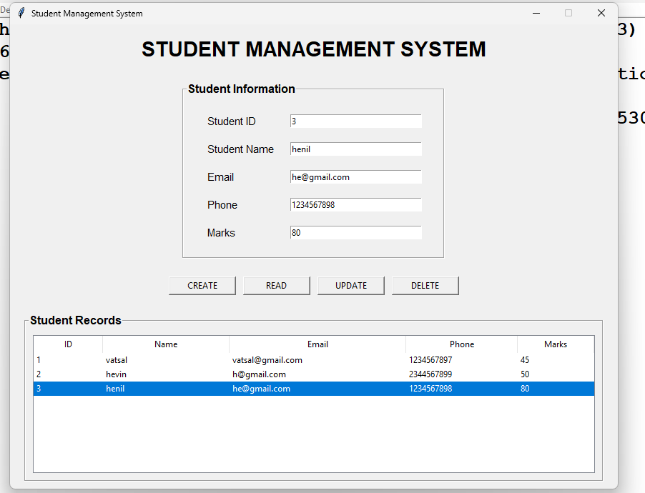

Tkinter form with CREATE,READ, UPDATE, DELETE Operation (Member Details).
import tkinter as tk
from tkinter import ttk, messagebox import sqlite3
import re

conn = sqlite3.connect("member.db") cursor = conn.cursor()

cursor.execute("""CREATE TABLE IF NOT EXISTS members (id INTEGER PRIMARY KEY,name TEXT NOT NULL, email TEXT NOT NULL, phone TEXT NOT NULL,membership TEXT NOT NULL)""")
conn.commit()

def validate_data():

member_id = entry_id.get().strip() name = entry_name.get().strip() email = entry_email.get().strip() phone = entry_phone.get().strip() membership = membership_var.get()

if member_id == "" or name == "" or email == "" or phone == "": messagebox.showerror("Validation Error","All fields are required") return False

if membership == "Select Membership": messagebox.showerror("Validation Error","Please select membership
type")
return False

if not member_id.isdigit():
messagebox.showerror("Validation Error","Member ID must contain only numbers")
return False

if not re.fullmatch(r"[A-Za-z ]+", name): messagebox.showerror("Validation Error","Name must contain only
alphabets")
return False
email_pattern = r"^[A-Za-z0-9._%+-]+@[A-Za-z0-9.-]+\.[A-Za-z]{2,}$" if not re.fullmatch(email_pattern, email):
messagebox.showerror("Validation Error","Enter a valid email address")
return False

if not phone.isdigit():

messagebox.showerror("Validation Error","Phone must contain only numbers")
return False

if len(phone) != 10:
messagebox.showerror("Validation Error","Phone number must contain exactly 10 digits")
return False return True
def add_member():

if not validate_data(): return

member_id = int(entry_id.get()) name = entry_name.get().strip() email = entry_email.get().strip() phone = entry_phone.get().strip() membership = membership_var.get()

try:

cursor.execute("""INSERT INTO members VALUES (?, ?, ?, ?, ?)""", (member_id,name,email,phone,membership))
conn.commit()
messagebox.showinfo("Success","Member added successfully") clear_fields()
display_members()

except sqlite3.IntegrityError: messagebox.showerror("Error","Member ID already exists")
def display_members():

for item in table.get_children(): table.delete(item)

cursor.execute("SELECT * FROM members") records = cursor.fetchall()
for record in records: table.insert("",tk.END,values=record)

def select_member(event):

selected = table.focus() if selected == "":
return

data = table.item(selected,"values") clear_fields()
entry_id.insert(0, data[0]) entry_name.insert(0, data[1]) entry_email.insert(0, data[2]) entry_phone.insert(0, data[3])

membership_var.set(data[4]) def update_member():
if not validate_data(): return

member_id = int(entry_id.get()) name = entry_name.get().strip() email = entry_email.get().strip() phone = entry_phone.get().strip() membership = membership_var.get()

cursor.execute("""UPDATE members SET name = ?,email = ?,phone
= ?,membership = ? WHERE id = ?""", (name,email,phone,membership,member_id))
conn.commit()

if cursor.rowcount == 0: messagebox.showerror("Error","Member ID not found") return
messagebox.showinfo("Success","Member updated successfully")

clear_fields() display_members()

def delete_member():
member_id = entry_id.get().strip() if member_id == "":
messagebox.showerror("Error","Please enter Member ID")

return

if not member_id.isdigit():
messagebox.showerror("Error","Member ID must contain only numbers") return

member_id = int(member_id)

cursor.execute("DELETE FROM members WHERE id = ?",(member_id,)) conn.commit()
if cursor.rowcount == 0: messagebox.showerror("Error","Member ID not found") return
messagebox.showinfo("Success","Member deleted successfully")

clear_fields() display_members()

def clear_fields():

entry_id.delete(0, tk.END) entry_name.delete(0, tk.END) entry_email.delete(0, tk.END) entry_phone.delete(0, tk.END)

membership_var.set("Select Membership") root = tk.Tk()
root.title("Member Management System") root.geometry("900x650")

root.resizable(False, False)

header = tk.Frame(root,padx=20,pady=20) header.pack(fill="x")
tk.Label(header,text="MEMBER MANAGEMENT",font=("Arial", 24, "bold")).pack()
tk.Label(header,text="Create • Read • Update • Delete",font=("Arial", 11)).pack(pady=5)

form_frame = tk.Frame(root)

form_frame.pack(padx=30,pady=10) left_frame = tk.Frame(form_frame) left_frame.grid(row=0,column=0,padx=30)
tk.Label(left_frame,text="Member ID",font=("Arial", 11)).pack(anchor="w") entry_id = tk.Entry(left_frame,width=32)
entry_id.pack(pady=(3, 12))

tk.Label(left_frame,text="Member Name",font=("Arial", 11)).pack(anchor="w") entry_name = tk.Entry(left_frame,width=32)
entry_name.pack(pady=(3, 12)) tk.Label(left_frame,text="Email",font=("Arial", 11)).pack(anchor="w") entry_email = tk.Entry(left_frame,width=32) entry_email.pack(pady=(3, 12))
right_frame = tk.Frame(form_frame) right_frame.grid(row=0,column=1,padx=30) tk.Label(right_frame,text="Phone",font=("Arial", 11)).pack(anchor="w") entry_phone = tk.Entry(right_frame,width=32) entry_phone.pack(pady=(3, 12))
tk.Label(right_frame,text="Membership Type",font=("Arial", 11)).pack(anchor="w")

membership_var = tk.StringVar() membership_var.set("Select Membership")

membership_menu = ttk.Combobox(right_frame,textvariable=membership_var,values=["Basic","Pre mium","Gold","Silver"],state="readonly",width=29)

membership_menu.pack(pady=(3, 12)) button_frame = tk.Frame(root)

button_frame.pack(pady=15)

tk.Button(button_frame,text="CREATE",width=14,command=add_member).gri d(row=0, column=0, padx=5)

tk.Button(button_frame,text="READ",width=14,command=display_members). grid(row=0, column=1, padx=5)

tk.Button(button_frame,text="UPDATE",width=14,command=update_member)
.grid(row=0, column=2, padx=5)

tk.Button(button_frame,text="DELETE",width=14,command=delete_member). grid(row=0, column=3, padx=5)

table_frame = tk.LabelFrame(root,text="Member Records",font=("Arial", 12, "bold"))
table_frame.pack(padx=30,pady=10,fill="both",expand=True) columns = ("ID","Name","Email","Phone","Membership") table =
ttk.Treeview(table_frame,columns=columns,show="headings",height=9)

table.heading("ID", text="Member ID") table.heading("Name", text="Member Name") table.heading("Email", text="Email") table.heading("Phone", text="Phone") table.heading("Membership", text="Membership")

table.column("ID", width=90) table.column("Name", width=160) table.column("Email", width=220) table.column("Phone", width=140) table.column("Membership", width=130)

table.pack(padx=10,pady=10,fill="both",expand=True) table.bind("<ButtonRelease-1>",select_member) display_members()
root.mainloop() conn.close()

OUTPUT:
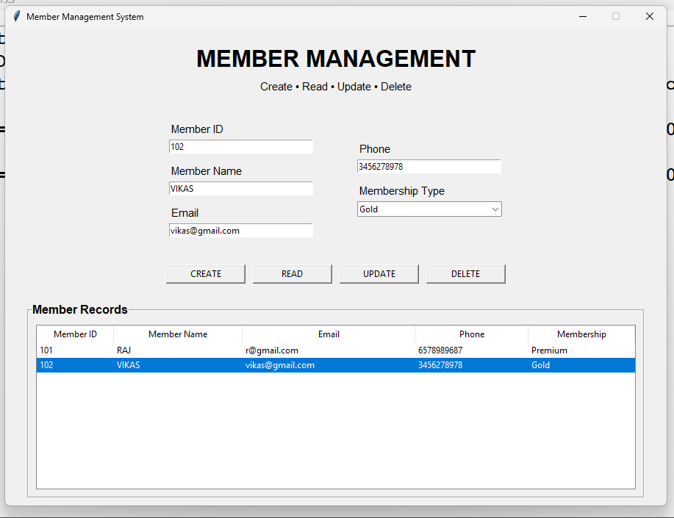

Tkinter form with CREATE,READ, UPDATE, DELETE Operation (Patient Details).

import tkinter as tk
from tkinter import ttk, messagebox import sqlite3
import re

conn = sqlite3.connect("patient.db") cursor = conn.cursor()

cursor.execute("""CREATE TABLE IF NOT EXISTS patients (id INTEGER PRIMARY KEY,name TEXT NOT NULL,age INTEGER NOT NULL,gender TEXT NOT NULL,disease TEXT NOT NULL,phone TEXT NOT NULL)""")

conn.commit()

def validate_data():

patient_id = entry_id.get().strip() name = entry_name.get().strip() age = entry_age.get().strip() gender = gender_var.get()
disease = entry_disease.get().strip() phone = entry_phone.get().strip()

if (patient_id == "" or name == "" or age == "" or disease == "" or phone == ""):

messagebox.showerror("Validation Error","All fields are required") return False

if not patient_id.isdigit():

messagebox.showerror("Validation Error","Patient ID must contain only numbers")
return False
if not re.fullmatch(r"[A-Za-z ]+", name): messagebox.showerror("Validation Error","Patient name must contain
only alphabets")
return False

if not age.isdigit():

messagebox.showerror("Validation Error","Age must be a number") return False

age_value = int(age)

if age_value < 1 or age_value > 120:

messagebox.showerror("Validation Error","Age must be between 1 and 120")
return False

if gender == "Select Gender":

messagebox.showerror("Validation Error","Please select gender") return False
if not re.fullmatch(r"[A-Za-z ]+", disease): messagebox.showerror("Validation Error","Disease must contain only
alphabets")
return False

if not phone.isdigit():

messagebox.showerror("Validation Error","Phone must contain only numbers")
return False

if len(phone) != 10:

messagebox.showerror("Validation Error","Phone number must contain exactly 10 digits")
return False return True
def add_patient():

if not validate_data(): return

patient_id = int(entry_id.get()) name = entry_name.get().strip() age = int(entry_age.get()) gender = gender_var.get()
disease = entry_disease.get().strip() phone = entry_phone.get().strip()

try:

cursor.execute("""INSERT INTO patients VALUES (?, ?, ?, ?, ?, ?)""", (patient_id,name,age,gender,disease,phone))

conn.commit()

messagebox.showinfo("Success","Patient added successfully") clear_fields()
display_patients()

except sqlite3.IntegrityError: messagebox.showerror("Error","Patient ID already exists")
def display_patients():

# Clear old records
for item in table.get_children(): table.delete(item)

cursor.execute("SELECT * FROM patients") records = cursor.fetchall()
for record in records: table.insert("",tk.END,values=record)
def select_patient(event): selected = table.focus()
if selected == "": return

data = table.item(selected,"values") clear_fields()
entry_id.insert(0, data[0]) entry_name.insert(0, data[1]) entry_age.insert(0, data[2])

gender_var.set(data[3])

entry_disease.insert(0, data[4]) entry_phone.insert(0, data[5])

def update_patient():

if not validate_data(): return

patient_id = int(entry_id.get())

name = entry_name.get().strip() age = int(entry_age.get()) gender = gender_var.get()
disease = entry_disease.get().strip() phone = entry_phone.get().strip()

cursor.execute("""UPDATE patients SET name = ?,age = ?,gender
= ?,disease = ?,phone = ? WHERE id = ?""", (name,age,gender,disease,phone,patient_id))

conn.commit()

if cursor.rowcount == 0:

messagebox.showerror("Error","Patient ID not found") return
messagebox.showinfo("Success","Patient updated successfully") clear_fields()
display_patients()

def delete_patient():

patient_id = entry_id.get().strip() if patient_id == "":
messagebox.showerror("Error","Please enter Patient ID") return

if not patient_id.isdigit():

messagebox.showerror("Error","Patient ID must contain only numbers") return

patient_id = int(patient_id)

cursor.execute("DELETE FROM patients WHERE id = ?",(patient_id,)) conn.commit()
if cursor.rowcount == 0:

messagebox.showerror("Error","Patient ID not found") return

messagebox.showinfo("Success","Patient deleted successfully") clear_fields()

display_patients() def clear_fields():
entry_id.delete(0, tk.END) entry_name.delete(0, tk.END) entry_age.delete(0, tk.END) entry_disease.delete(0, tk.END) entry_phone.delete(0, tk.END)

gender_var.set("Select Gender") root = tk.Tk()
root.title("Patient Management System") root.geometry("950x700")

root.resizable(False, False)

tk.Label(root,text="PATIENT MANAGEMENT SYSTEM",font=("Arial", 24, "bold")).pack(pady=15)

tk.Label(root,text="Patient Details",font=("Arial", 12)).pack()

form_frame = tk.LabelFrame(root,text="Patient Information",font=("Arial", 12, "bold"),padx=20,pady=15)

form_frame.pack(padx=30,pady=15,fill="x")

tk.Label(form_frame,text="Patient ID",font=("Arial", 11)).grid(row=0,column=0,padx=15,pady=8,sticky="w")

entry_id = tk.Entry(form_frame,width=28)

entry_id.grid(row=0,column=1,padx=15,pady=8)

tk.Label(form_frame,text="Patient Name",font=("Arial", 11)).grid(row=0,column=2,padx=15,pady=8,sticky="w")

entry_name = tk.Entry(form_frame,width=28)

entry_name.grid(row=0,column=3,padx=15,pady=8)

tk.Label(form_frame,text="Age",font=("Arial", 11)).grid(row=1,column=0,padx=15,pady=8,sticky="w")

entry_age = tk.Entry(form_frame,width=28) entry_age.grid(row=1,column=1,padx=15,pady=8)

tk.Label(form_frame,text="Gender",font=("Arial", 11)).grid(row=1,column=2,padx=15,pady=8,sticky="w")
gender_var = tk.StringVar() gender_var.set("Select Gender") gender_menu =
ttk.Combobox(form_frame,textvariable=gender_var,values=["Male","Female","
Other"],state="readonly",width=26) gender_menu.grid(row=1,column=3,padx=15,pady=8)
tk.Label(form_frame,text="Disease",font=("Arial", 11)).grid(row=2,column=0,padx=15,pady=8,sticky="w")

entry_disease = tk.Entry(form_frame,width=28)

entry_disease.grid(row=2,column=1,padx=15,pady=8)

tk.Label(form_frame,text="Phone",font=("Arial", 11)).grid(row=2,column=2,padx=15,pady=8,sticky="w")

entry_phone = tk.Entry(form_frame,width=28) entry_phone.grid(row=2,column=3,padx=15,pady=8) button_frame = tk.Frame(root) button_frame.pack(pady=10)
tk.Button(button_frame,text="CREATE",width=14,command=add_patient).grid (row=0,column=0,padx=6)

tk.Button(button_frame,text="READ",width=14,command=display_patients).gri d(row=0,column=1,padx=6)

tk.Button(button_frame,text="UPDATE",width=14,command=update_patient). grid(row=0,column=2,padx=6)

tk.Button(button_frame,text="DELETE",width=14,command=delete_patient).gr id(row=0,column=3,padx=6)

table_frame = tk.LabelFrame(root,text="Patient Records",font=("Arial", 12, "bold"))

table_frame.pack(padx=30,pady=10,fill="both",expand=True) columns = ("ID","Name","Age","Gender","Disease","Phone")

table = ttk.Treeview(table_frame,columns=columns,show="headings",height=10)

table.heading("ID", text="Patient ID") table.heading("Name", text="Patient Name") table.heading("Age", text="Age") table.heading("Gender", text="Gender") table.heading("Disease", text="Disease") table.heading("Phone", text="Phone")
table.column("ID", width=90) table.column("Name", width=170) table.column("Age", width=70) table.column("Gender", width=100) table.column("Disease", width=180) table.column("Phone", width=140)

table.pack(padx=10,pady=10,fill="both",expand=True) table.bind("<ButtonRelease-1>",select_patient) display_patients()
root.mainloop() conn.close()

OUTPUT:
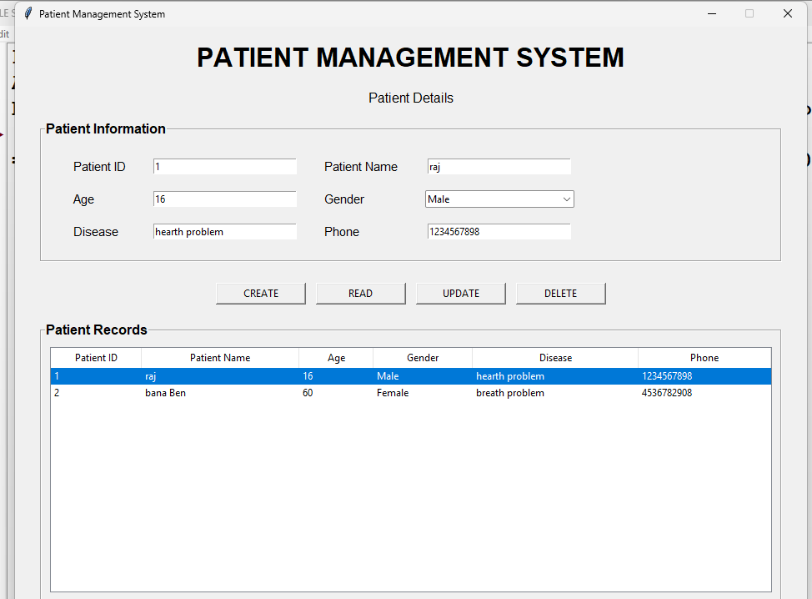

Tkinter form with CREATE,READ, UPDATE, DELETE Operation (emp Details).

import tkinter as tk
from tkinter import ttk, messagebox import sqlite3
import re

conn = sqlite3.connect("employee.db") cursor = conn.cursor()

cursor.execute("""CREATE TABLE IF NOT EXISTS employees (id INTEGER PRIMARY KEY,name TEXT NOT NULL,email TEXT NOT NULL,phone TEXT
NOT NULL,department TEXT NOT NULL,salary REAL NOT NULL)""") conn.commit()
def validate_data():

employee_id = entry_id.get().strip() name = entry_name.get().strip() email = entry_email.get().strip() phone = entry_phone.get().strip() department = department_var.get() salary = entry_salary.get().strip()

if (employee_id == "" or name == "" or email == "" or phone == "" or salary == ""):

messagebox.showerror("Validation Error","All fields are required") return False

if not employee_id.isdigit():

messagebox.showerror("Validation Error","Employee ID must contain only numbers")
return False

if not re.fullmatch(r"[A-Za-z ]+", name):

messagebox.showerror("Validation Error","Employee name must contain only alphabets")
return False

email_pattern = r"^[A-Za-z0-9._%+-]+@[A-Za-z0-9.-]+\.[A-Za-z]{2,}$" if not re.fullmatch(email_pattern, email):
messagebox.showerror("Validation Error","Enter a valid email address") return False

if not phone.isdigit():

messagebox.showerror("Validation Error","Phone must contain only numbers")
return False

if len(phone) != 10:

messagebox.showerror("Validation Error","Phone number must contain exactly 10 digits")

if department == "Select Department":

messagebox.showerror("Validation Error","Please select department") return False

try:
salary_value = float(salary) if salary_value <= 0:
messagebox.showerror("Validation Error","Salary must be greater than 0")
return False except ValueError:
messagebox.showerror("Validation Error","Salary must be a number") return False

return True

def add_employee():

if not validate_data(): return

employee_id = int(entry_id.get()) name = entry_name.get().strip() email = entry_email.get().strip() phone = entry_phone.get().strip() department = department_var.get() salary = float(entry_salary.get())

try:

cursor.execute("""INSERT INTO employees VALUES (?, ?, ?, ?, ?, ?)""", (employee_id,name,email,phone,department,salary))
conn.commit()

messagebox.showinfo("Success","Employee added successfully") clear_fields()
display_employees() except sqlite3.IntegrityError:
messagebox.showerror("Error","Employee ID already exists") def display_employees():
for item in table.get_children(): table.delete(item)
cursor.execute("SELECT * FROM employees") records = cursor.fetchall()
for record in records: table.insert("",tk.END,values=record)
def select_employee(event): selected = table.focus()
if selected == "": return

data = table.item(selected,"values") clear_fields()
entry_id.insert(0, data[0]) entry_name.insert(0, data[1]) entry_email.insert(0, data[2]) entry_phone.insert(0, data[3])

department_var.set(data[4]) entry_salary.insert(0, data[5])
def update_employee():

if not validate_data(): return

employee_id = int(entry_id.get()) name = entry_name.get().strip()

email = entry_email.get().strip() phone = entry_phone.get().strip() department = department_var.get() salary = float(entry_salary.get())

cursor.execute("""UPDATE employees SET name = ?,email = ?,phone
= ?,department = ?,salary = ? WHERE id = ?""", (name,email,phone,department,salary,employee_id))

conn.commit()

if cursor.rowcount == 0: messagebox.showerror("Error","Employee ID not found") return
messagebox.showinfo("Success","Employee updated successfully")

clear_fields() display_employees()

def delete_employee():

employee_id = entry_id.get().strip() if employee_id == "":
messagebox.showerror("Error","Please enter Employee ID") return
if not employee_id.isdigit():

messagebox.showerror("Error","Employee ID must contain only numbers")

return

employee_id = int(employee_id)

cursor.execute("DELETE FROM employees WHERE id = ?",(employee_id,)) conn.commit()
if cursor.rowcount == 0: messagebox.showerror("Error","Employee ID not found") return

messagebox.showinfo("Success","Employee deleted successfully") clear_fields()
display_employees() def clear_fields():
entry_id.delete(0, tk.END) entry_name.delete(0, tk.END) entry_email.delete(0, tk.END) entry_phone.delete(0, tk.END) entry_salary.delete(0, tk.END)

department_var.set("Select Department") root = tk.Tk()
root.title("Employee Management System") root.geometry("1000x720")

root.resizable(False, False) title_frame = tk.Frame(root) title_frame.pack(fill="x",pady=15)
tk.Label(title_frame,text="EMPLOYEE MANAGEMENT SYSTEM",font=("Arial", 24, "bold")).pack()

tk.Label(title_frame,text="Employee CRUD Operations",font=("Arial", 11)).pack(pady=5)

form_frame = tk.LabelFrame(root,text="Employee Information",font=("Arial", 12, "bold"),padx=25,pady=15)

form_frame.pack(padx=30,pady=10)

tk.Label(form_frame,text="Employee ID",font=("Arial", 11)).grid(row=0,column=0,padx=15,pady=8,sticky="w")

entry_id = tk.Entry(form_frame,width=30) entry_id.grid(row=0,column=1,padx=15,pady=8)
tk.Label(form_frame,text="Employee Name",font=("Arial", 11)).grid(row=0,column=2,padx=15,pady=8,sticky="w")

entry_name = tk.Entry(form_frame,width=30)

entry_name.grid(row=0,column=3,padx=15,pady=8)

tk.Label(form_frame,text="Email",font=("Arial", 11)).grid(row=1,column=0,padx=15,pady=8,sticky="w")

entry_email = tk.Entry(form_frame,width=30) entry_email.grid(row=1,column=1,padx=15,pady=8)
tk.Label(form_frame,text="Phone",font=("Arial", 11)).grid(row=1,column=2,padx=15,pady=8,sticky="w")

entry_phone = tk.Entry(form_frame,width=30)

entry_phone.grid(row=1,column=3,padx=15,pady=8)

tk.Label(form_frame,text="Department",font=("Arial", 11)).grid(row=2,column=0,padx=15,pady=8,sticky="w")
department_var = tk.StringVar() department_var.set("Select Department") department_menu =
ttk.Combobox(form_frame,textvariable=department_var,values=["IT","HR","Fi
nance","Marketing","Sales"],state="readonly",width=27) department_menu.grid(row=2,column=1,padx=15,pady=8)
tk.Label(form_frame,text="Salary",font=("Arial", 11)).grid(row=2,column=2,padx=15,pady=8,sticky="w")

entry_salary = tk.Entry(form_frame,width=30) entry_salary.grid(row=2,column=3,padx=15,pady=8) button_frame = tk.Frame(root) button_frame.pack(pady=12)
tk.Button(button_frame,text="CREATE",width=14,command=add_employee). grid(row=0,column=0,padx=6)

tk.Button(button_frame,text="READ",width=14,command=display_employees)
.grid(row=0,column=1,padx=6)

tk.Button(button_frame,text="UPDATE",width=14,command=update_employe e).grid(row=0,column=2,padx=6)

tk.Button(button_frame,text="DELETE",width=14,command=delete_employee
).grid(row=0,column=3,padx=6)

table_frame = tk.LabelFrame(root,text="Employee Records",font=("Arial", 12, "bold"))

table_frame.pack(padx=30,pady=10,fill="both",expand=True)
columns = ("ID","Name","Email","Phone","Department","Salary") table =
ttk.Treeview(table_frame,columns=columns,show="headings",height=10) table.heading("ID",text="Employee ID") table.heading("Name",text="Employee Name") table.heading("Email",text="Email")
table.heading("Phone",text="Phone") table.heading("Department",text="Department") table.heading("Salary",text="Salary") table.column("ID",width=90) table.column("Name",width=170) table.column("Email",width=220) table.column("Phone",width=140) table.column("Department",width=130) table.column("Salary",width=120) table.pack(padx=10,pady=10,fill="both",expand=True) table.bind("<ButtonRelease-1>",select_employee) display_employees()
root.mainloop() conn.close()

OUTPUT:


