• Install Power BI Desktop and share the final screenshot of the report view page which appears when power desktop starts.

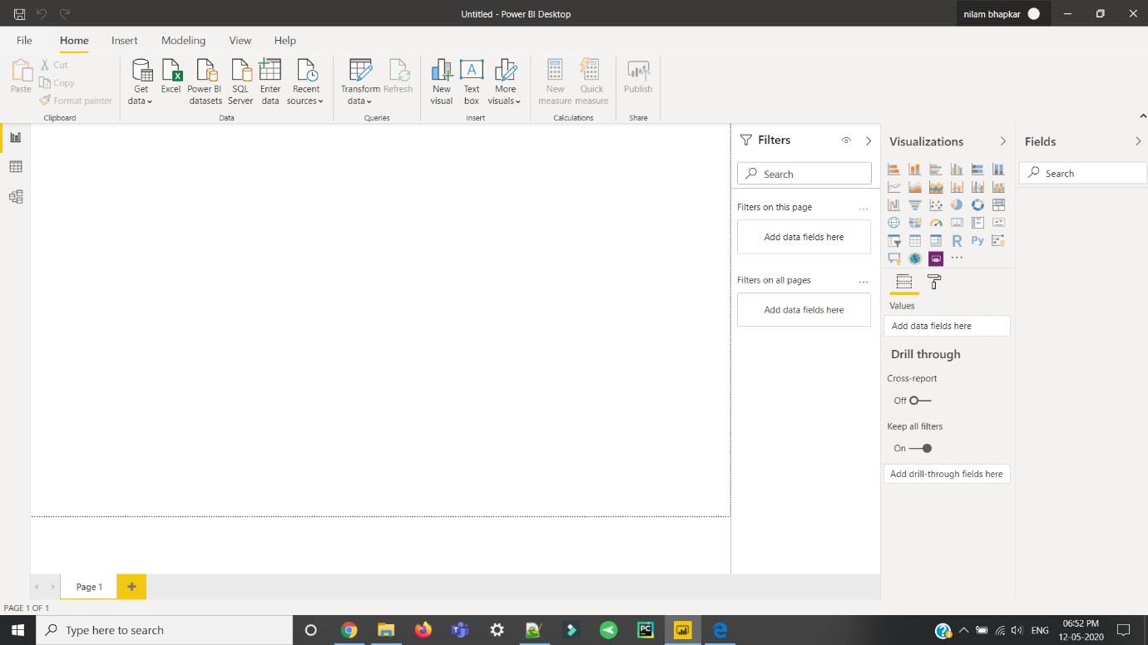

• Prepare a document and with the following screenshot –

Report View

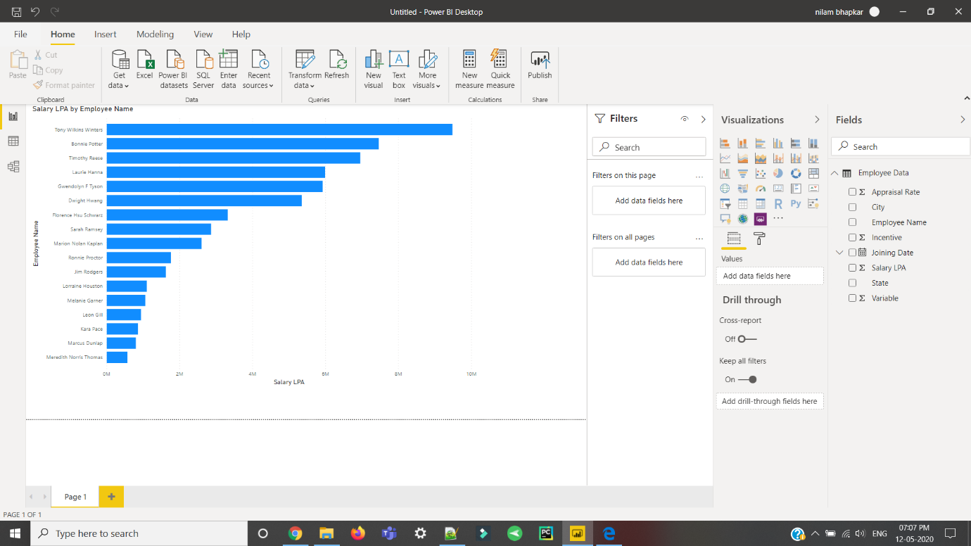

− Data View

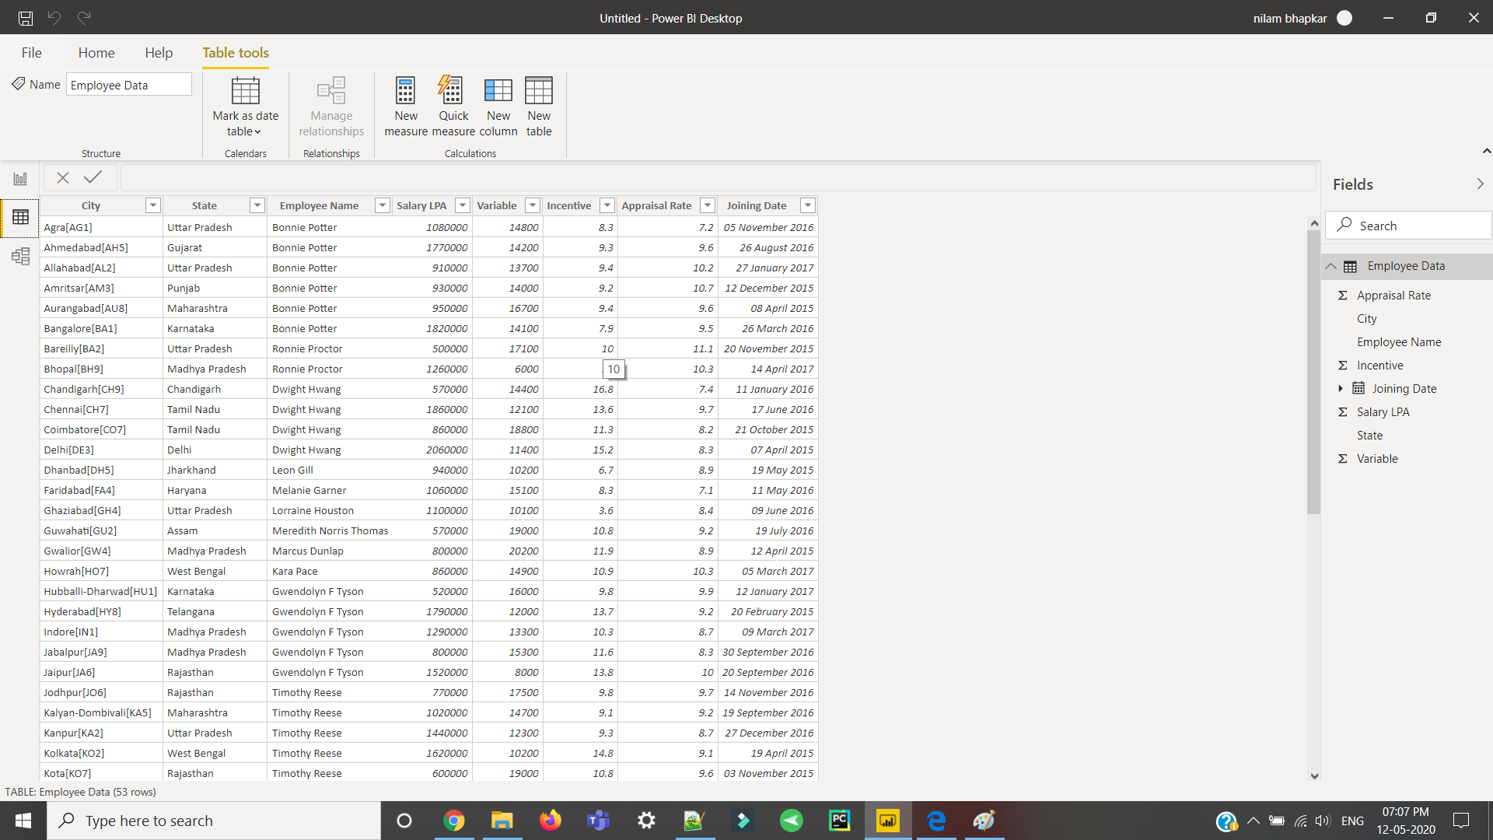

− Model View

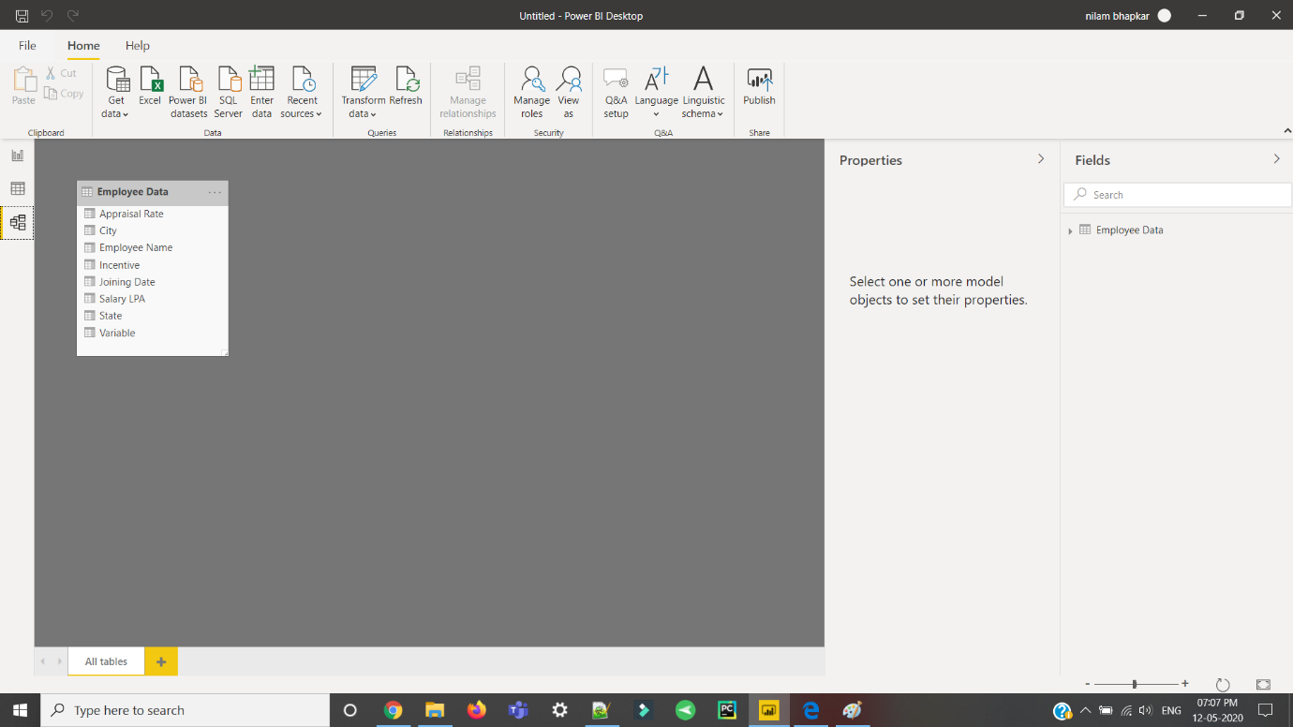

− Power Query Editor

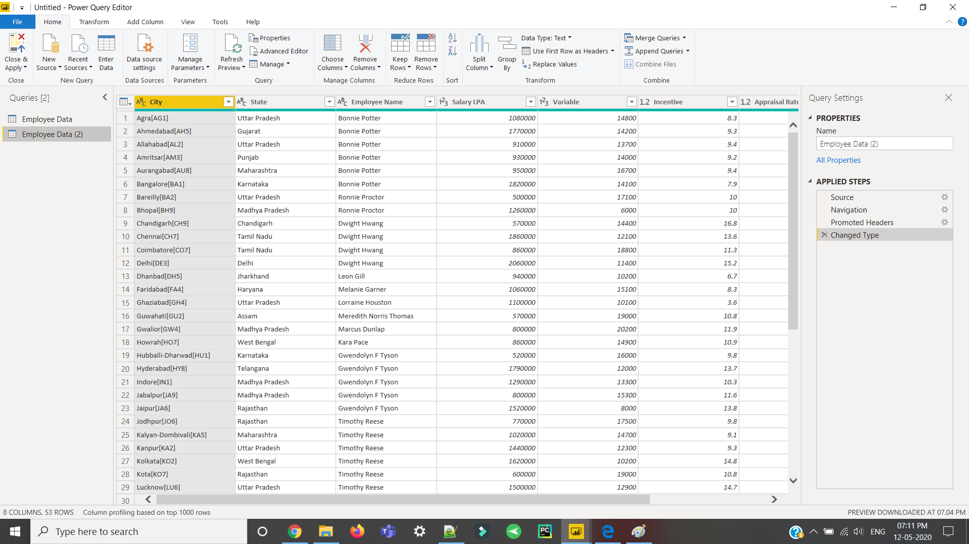

− Advance Editor

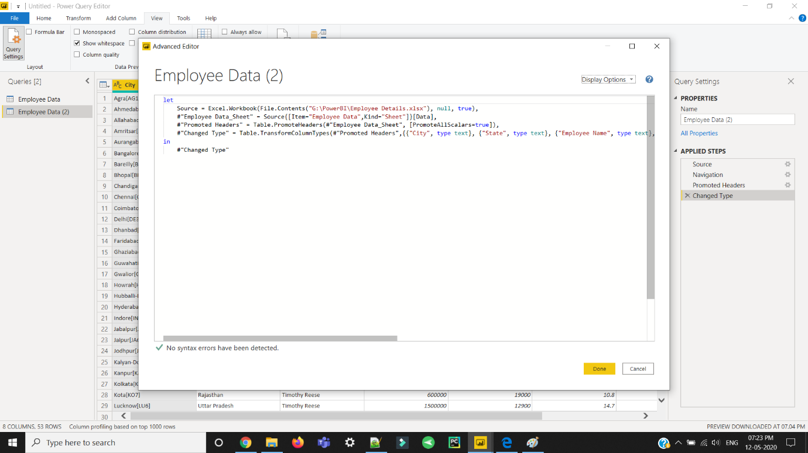

• Prepare a document with details of the following along with their price − Power BI Desktop − Power BI Pro − Power BI Premium

