CMPE 273 – Enterprise Distributed Systems

Lab 3 – Web Service


Student ID: 011457368
GitHub project link with access credentials:
https://github.com/nilamdeka23/Lab3-273
username: nilamdeka23
password: 14Github23
Part 1 – Calculator
Introduction:
Calculator to demonstrate SOAP Web Services
The server includes the following functionalities:
1. Addition
2. Subtraction
3. Multiplication
4. Division
And takes care of exceptions.
Calculator Client uses features of HTML5.

System Design:
Comprises of client -single page application where the most of the input processing takes place and where each calculator input number is made up of input type buttons and 'onclick' event of each number button the parameters are distinguished at client-side itself and relayed to the server for arithmetic processing.
For example if a user clicks a number and then clicks on an operator, the second number input is taken as the second parameter and on subsequent press of operator the parameters are sent to server making http POST calls for processing which on success sends back the result for the calculator to display.
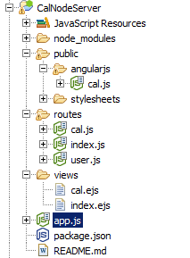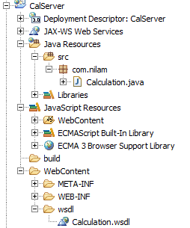

In my design I have used a switch case branching in ascertaining the flow of operation types and a no. of flags to distinguish among numbers, operators and parameters.

Calculator-Client:
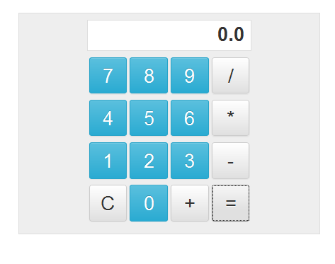

Exception Handling:
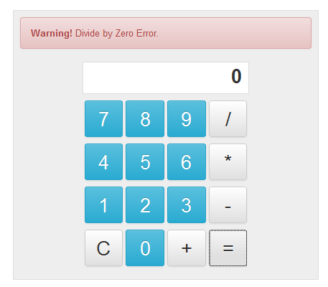

Cal-Node-Server
Running... Screenshot
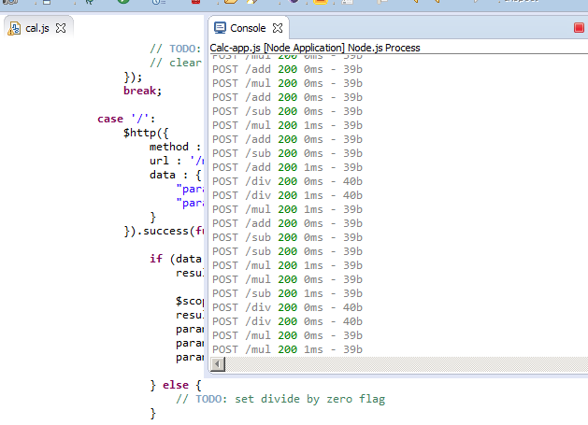
Cal-Web-Server-JAVA
Running... Screenshot
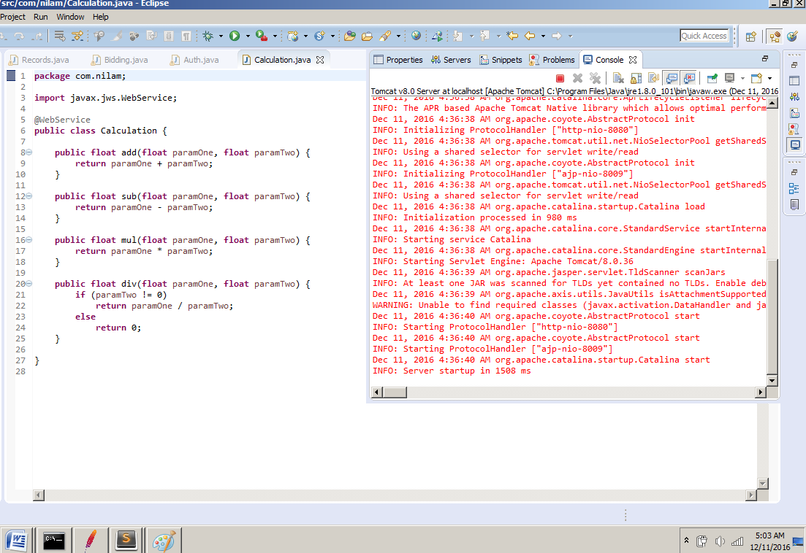

Testing done using JMeter:
Invoke 1000 calls on randomly selected tasks
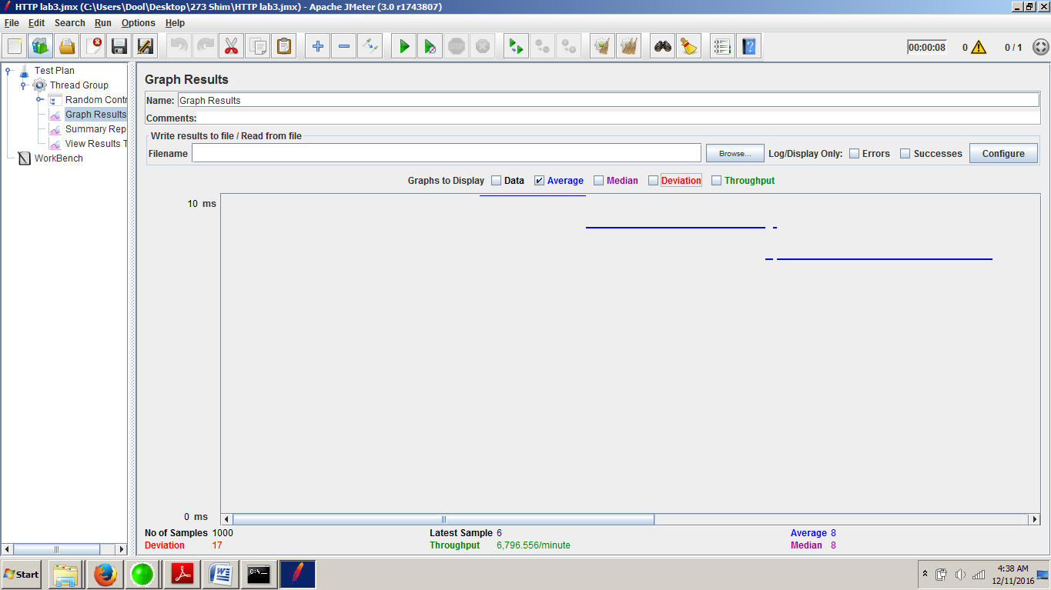

Invoke 5000 calls on randomly selected tasks
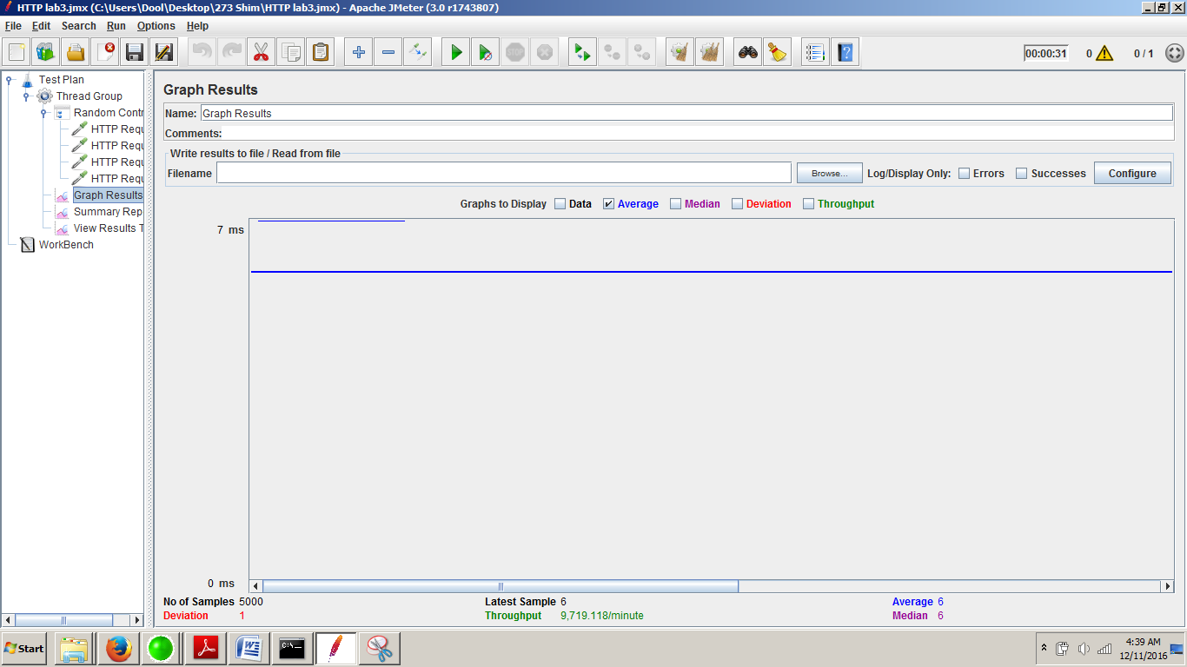

100 concurrent users with 1000 calls on randomly selected tasks
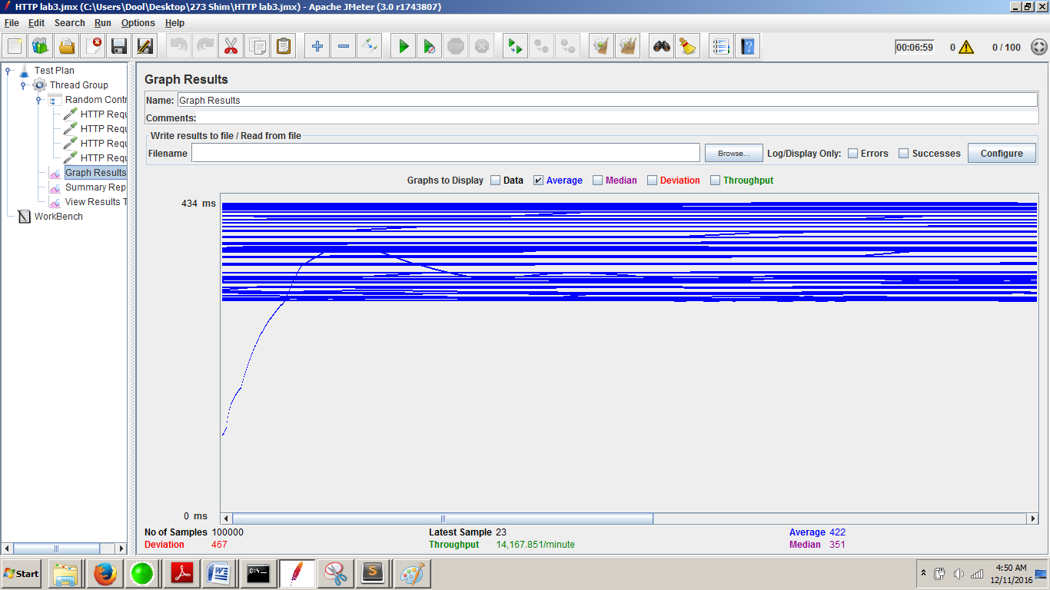

Analyses for the average time among three cases compared with the results from lab1 are:
- For 1000 users it has increased from 0 to 8ms,
- For 5000 users -> 0 to 6ms and
- For 100 concurrent users with 1000 calls -> 355ms to 422ms
There is a latency increase. This is due to a few factors. One that now the same request takes two network roundtrips- first it hits the REST API services exposed by my nope application, which in turn delegates the call to SOAP based Web Server where the business logic and database access takes place and the response is sent back via the same route.
Another reason is RESTful Web Services are faster that SOAP based Web Services, which is a known observation and also supported by these test results.

Part 2- EBay Marketplace Application

Introduction: Goal is to develop “Simple Market Place” like EBay, both client and server side using SOAP Web services. The client-side complements various server functionalities like buy, sell, add to cart, make an order, etc.

System Design:
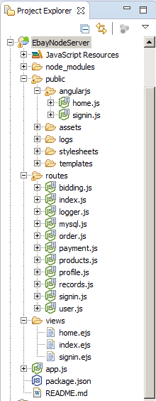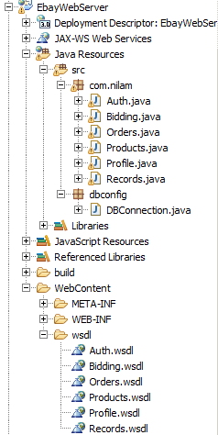
The application is split into multiple parts. One part is the node.js application which acts like a proxy server, delegating all the REST API calls to a remote server, which is another part, which serves the requests via SOAP Web Services and a client-front end comprising of the web pages that call and consume the aforementioned services to suffice business logic.

EBay-Node-Server
Running... Screenshot
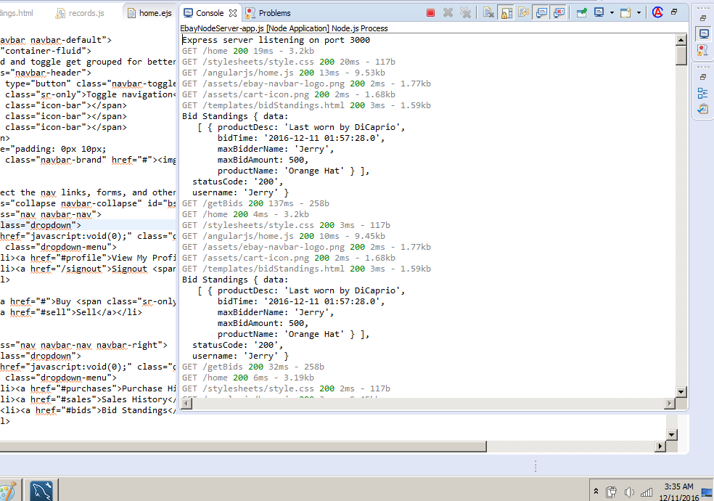
EBay-Web-Server-JAVA
Running... Screenshot
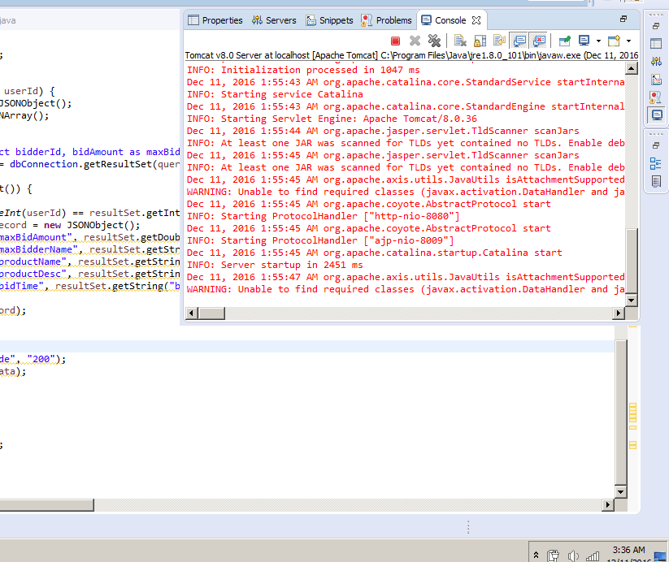
The following are the snapshots of the database design of my EBay implementation using MySQL.
I have reused the same database from lab1.
Tables' info
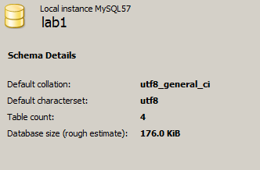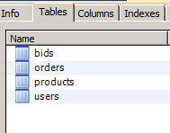
Example: users table, products table
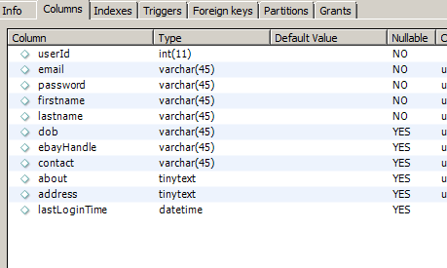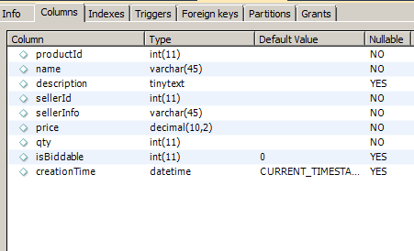

Output screenshots:
a. Sign up the new users (First name, Last name, Email, Password). Passwords is encrypted
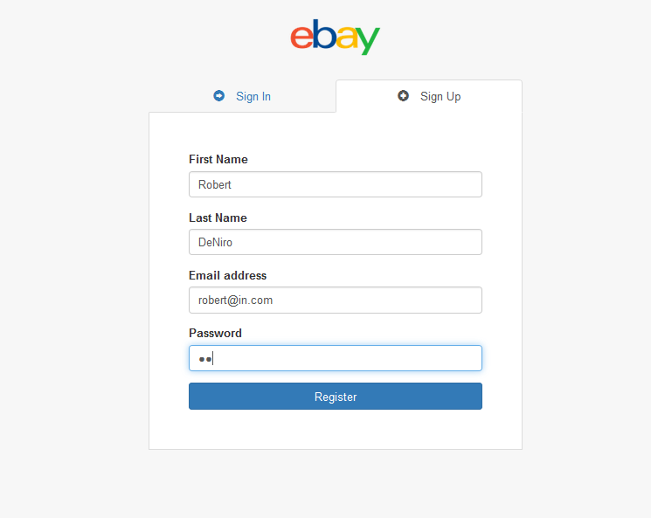

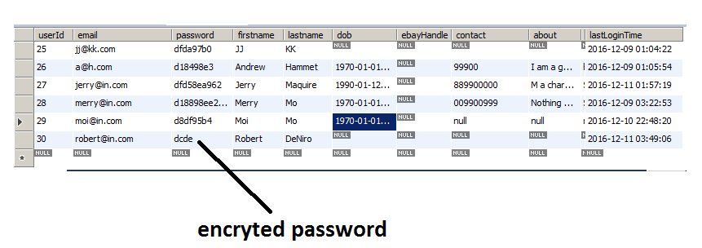

b. Sign in with existing users
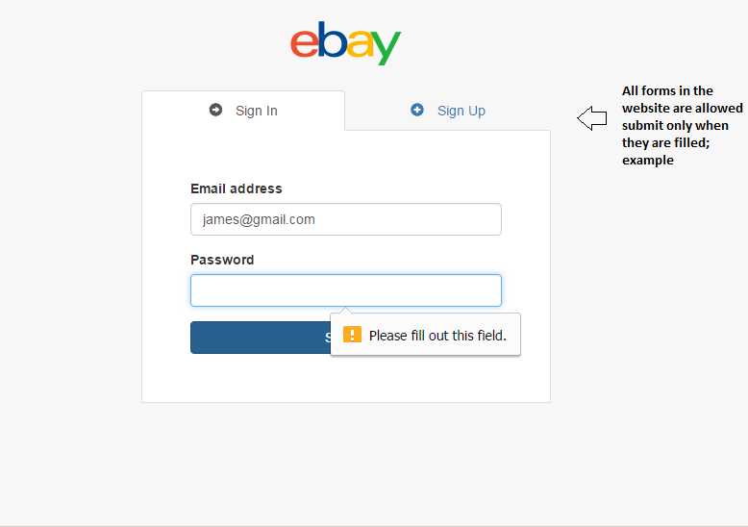

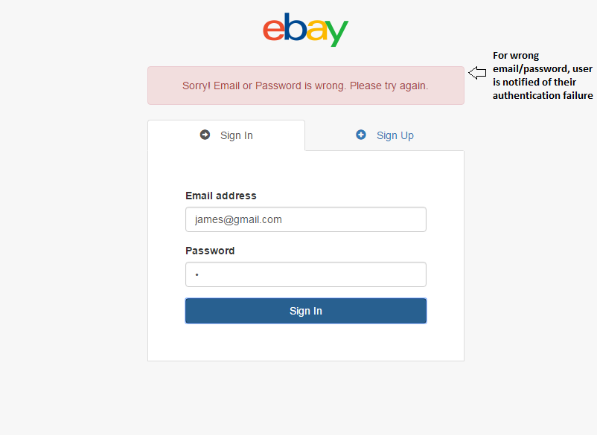

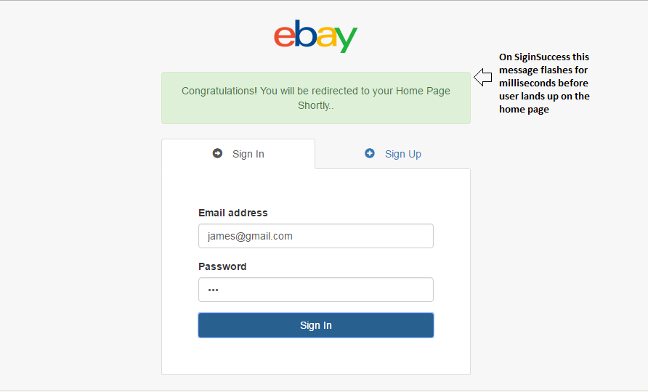

c. Sign out; i. Maintains time last logged in and is returned back when user logs in.
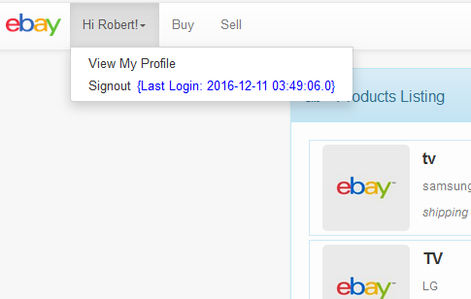

2. Profile:
a. About: Birthday, Ebay handle, contact information and location
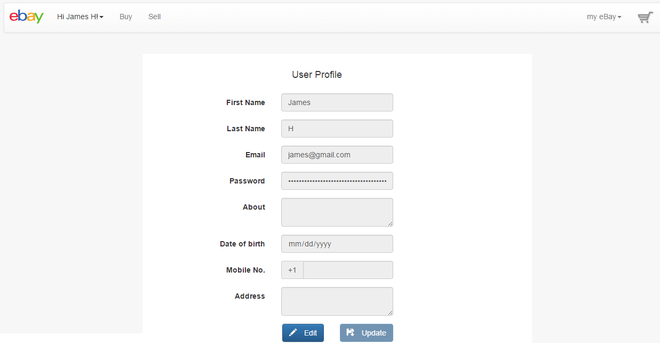

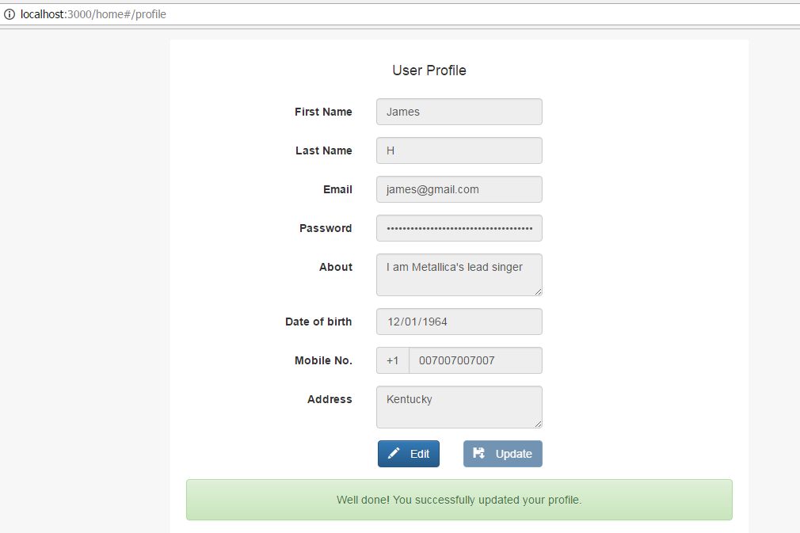

b. Should be able to store user’s advertisements for others to read. This should at-least includes the item name, item description, seller information, item price and quantity.
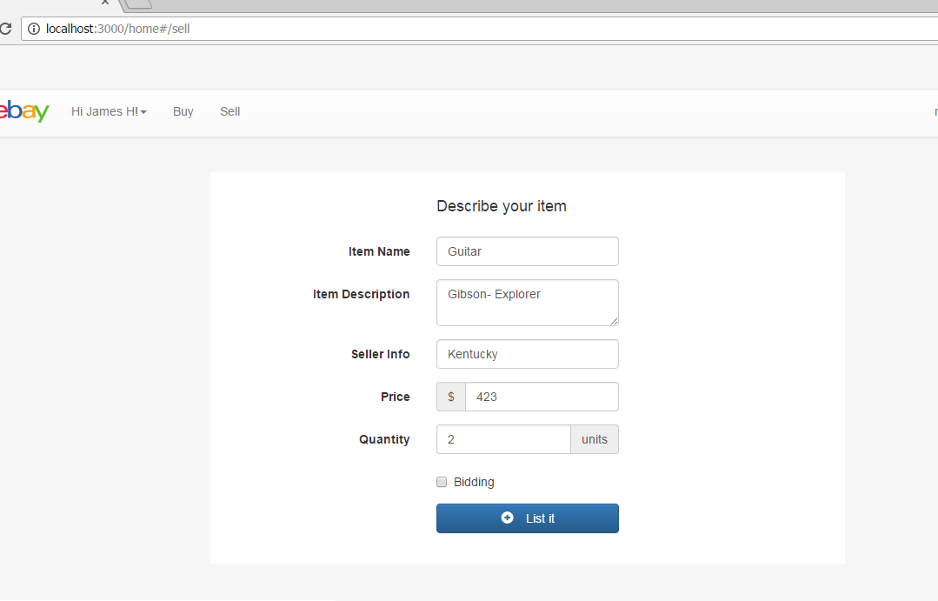

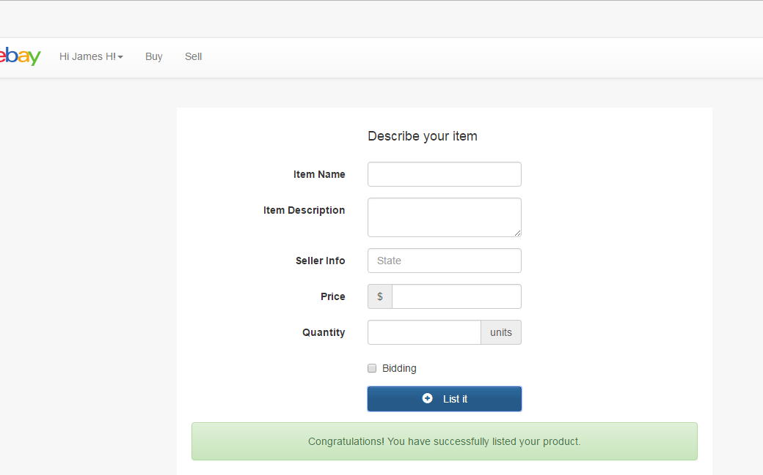

c. Should give all the advertisements details to all the other users.
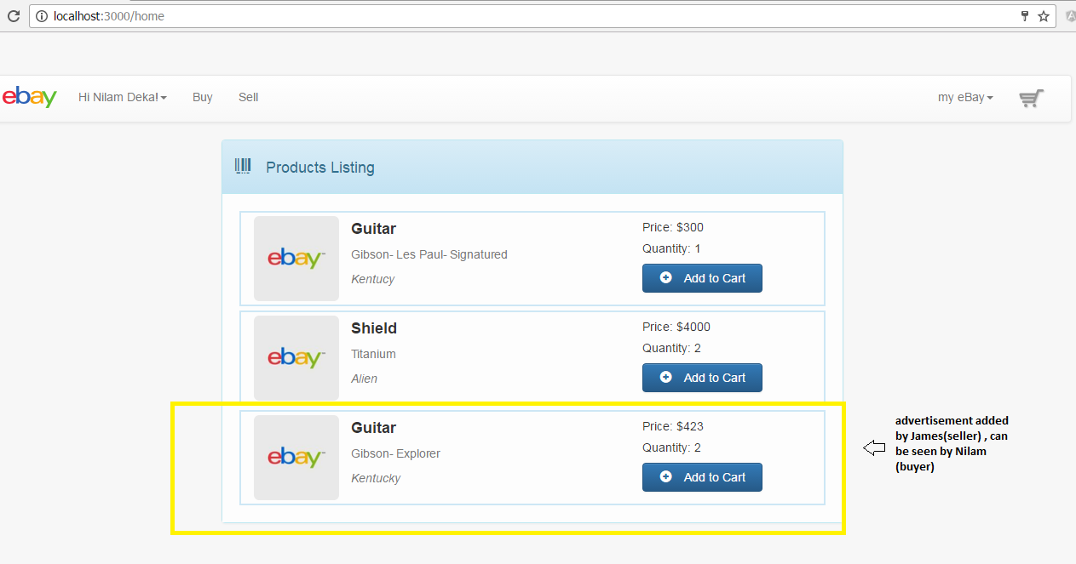

d. Users can bid the product displayed by other users. Bidding takes place over 4 days. For some items, you can purchase without bidding. You should take care of quantities and should respectively reflect user accounts in case of any transaction
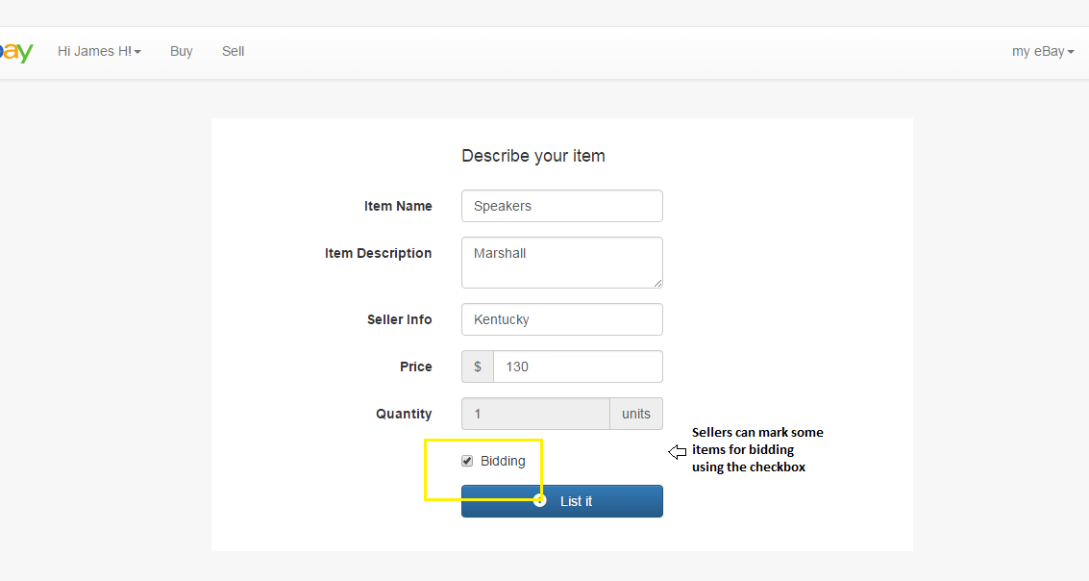

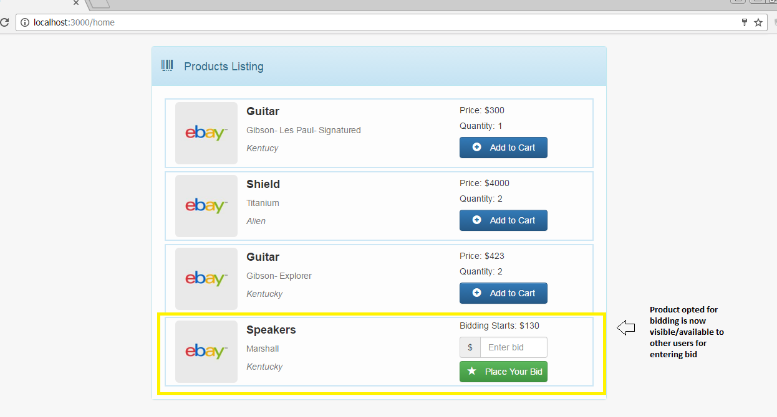

e. Shopping Cart should be maintained which will reflect temporary items. Users should be able to add, remove items from the cart until checkout.
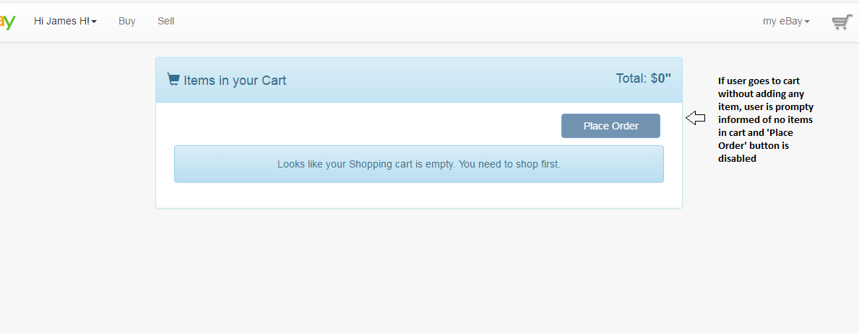
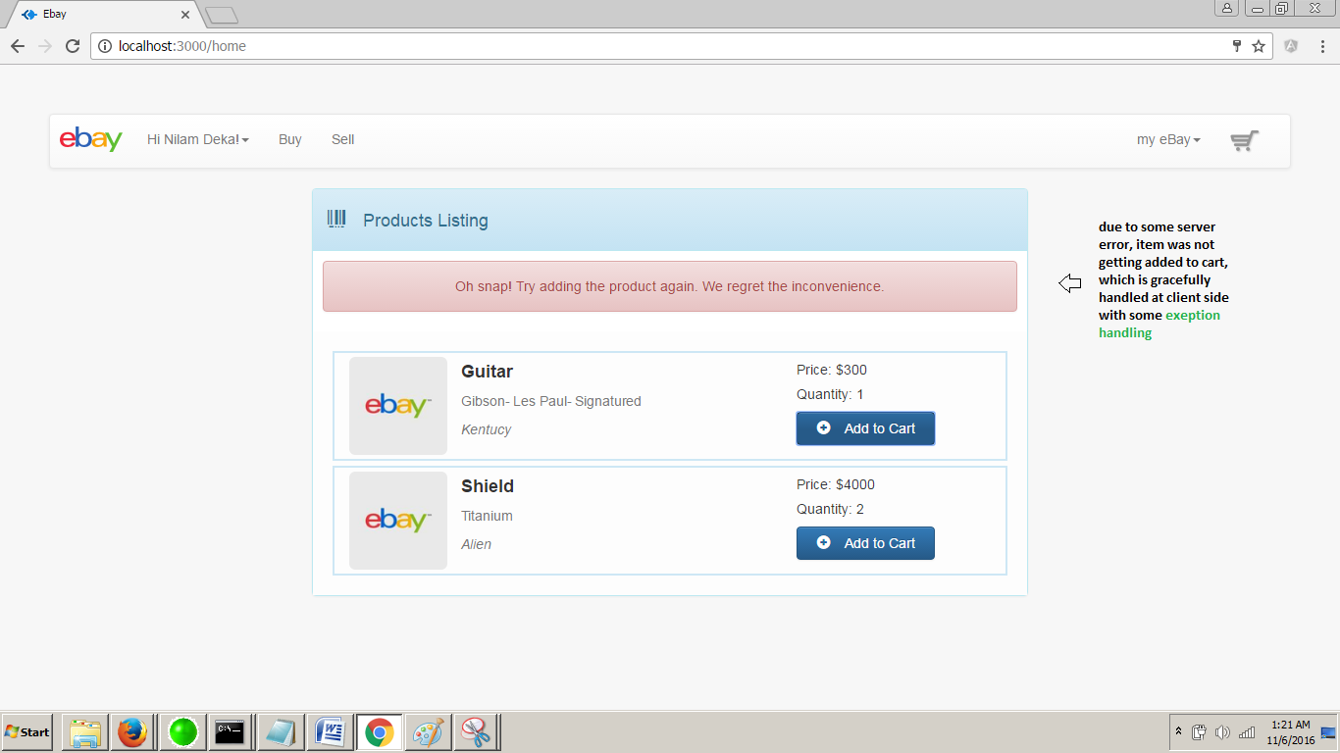

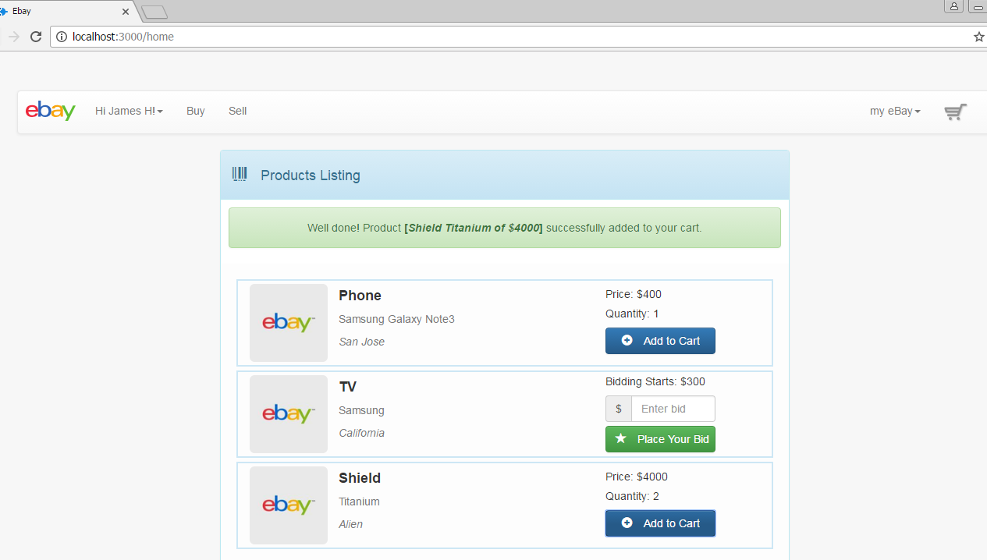

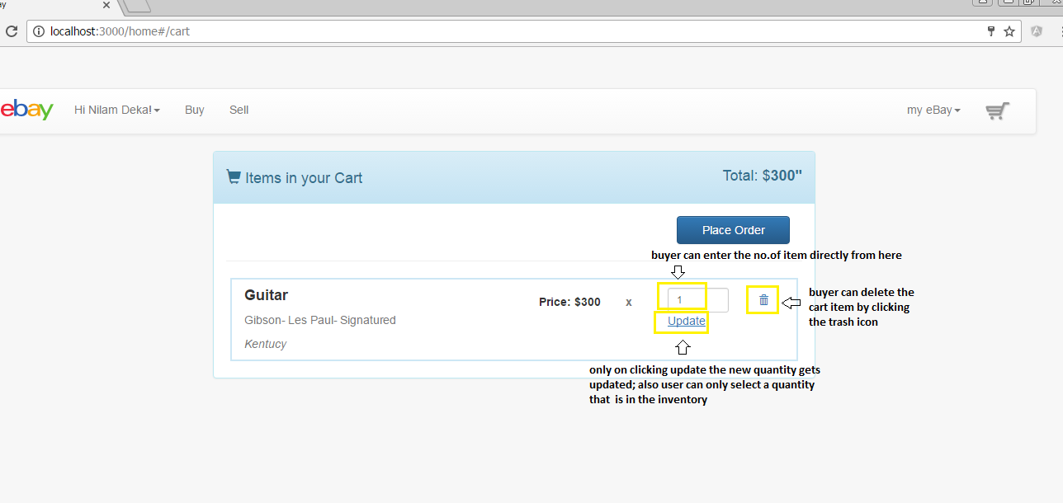

g. Should perform simple credit card validations on payment. 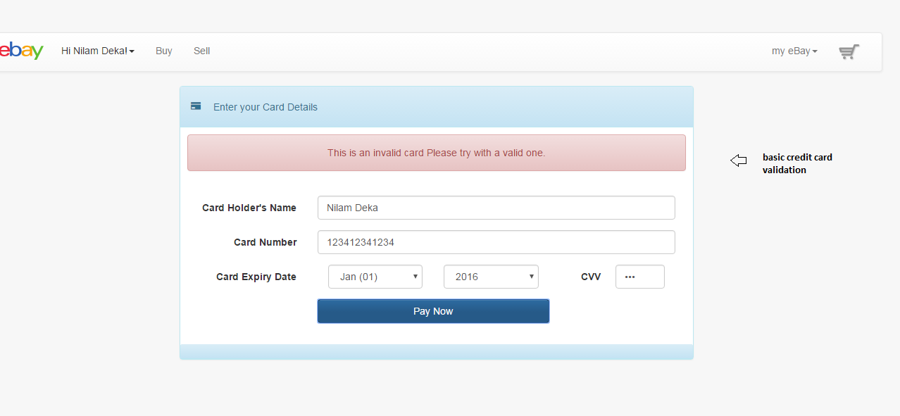

f. Checkout should deduct and add items from seller and buyer respectively.
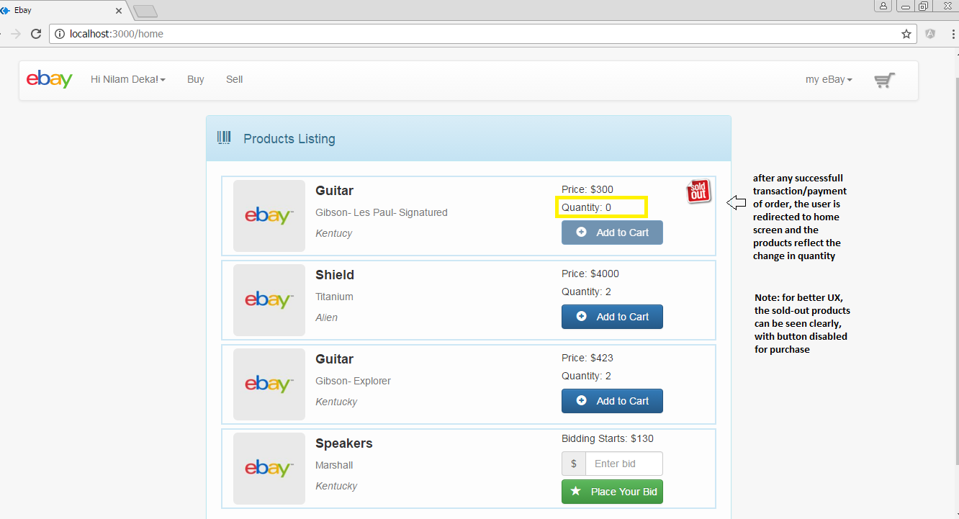

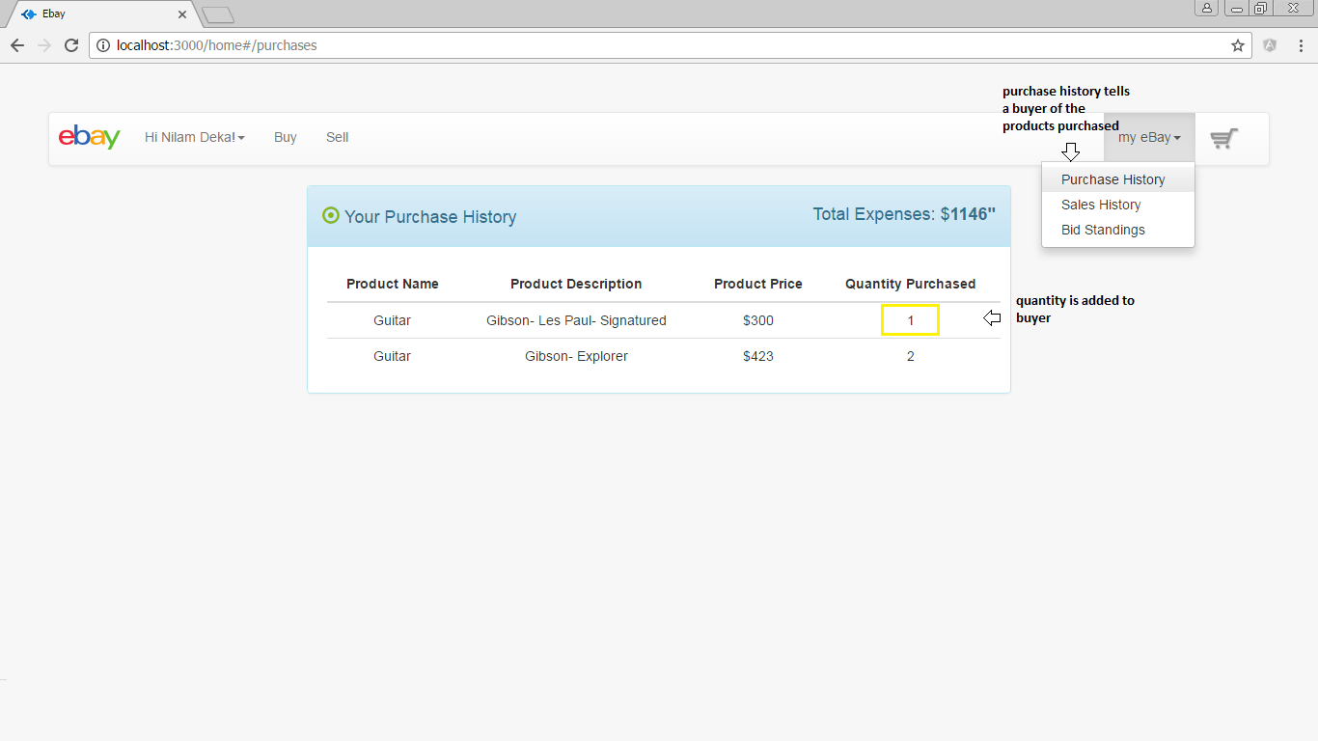

h. Users account should reflect all the bought and sold items.
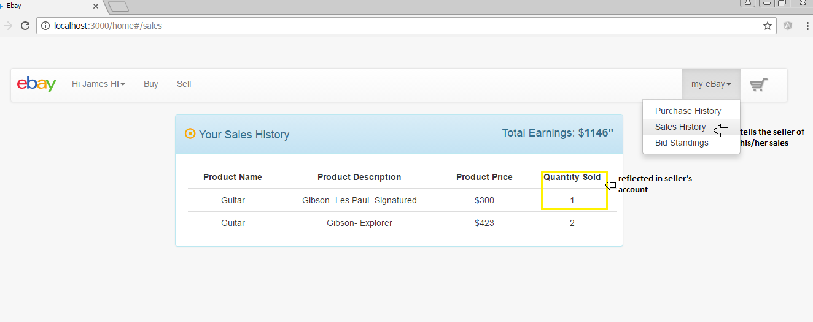

j. User tracking: Generate logs into a file when user clicks any place in the web page. There are generally two major logs. Event Logs: record timestamp, userid, click object id, any descriptions. Bidding Logs (periodic logs of bidding process) timestamp, item id, user id, bid amount.
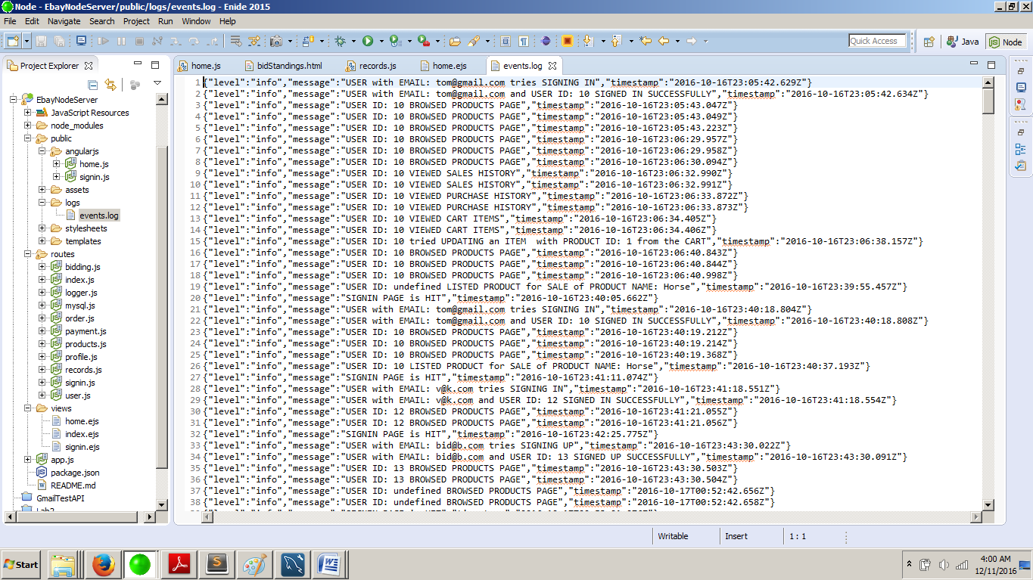

k. Bidding
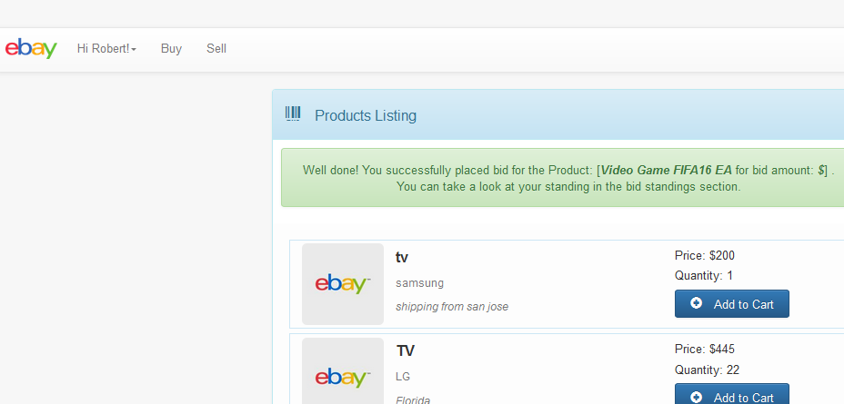

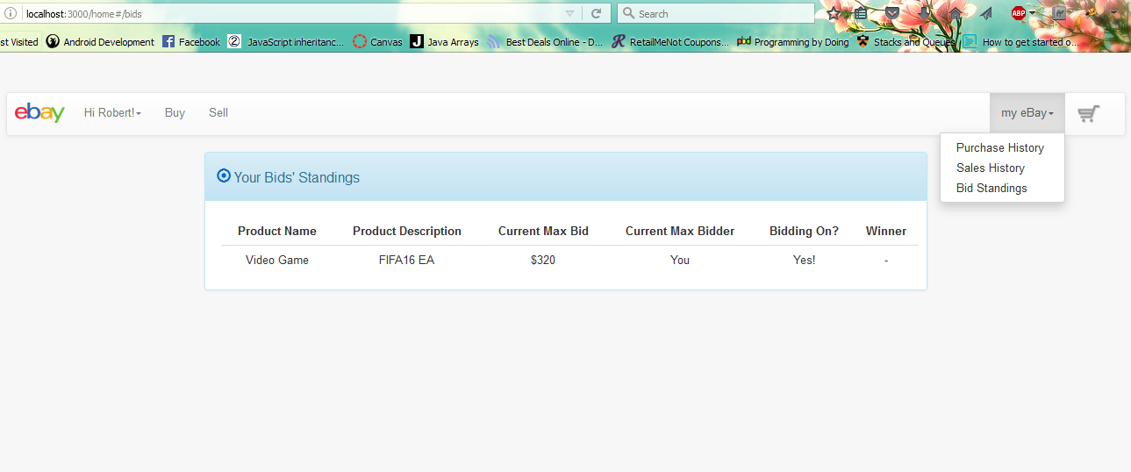

l. Exception handling
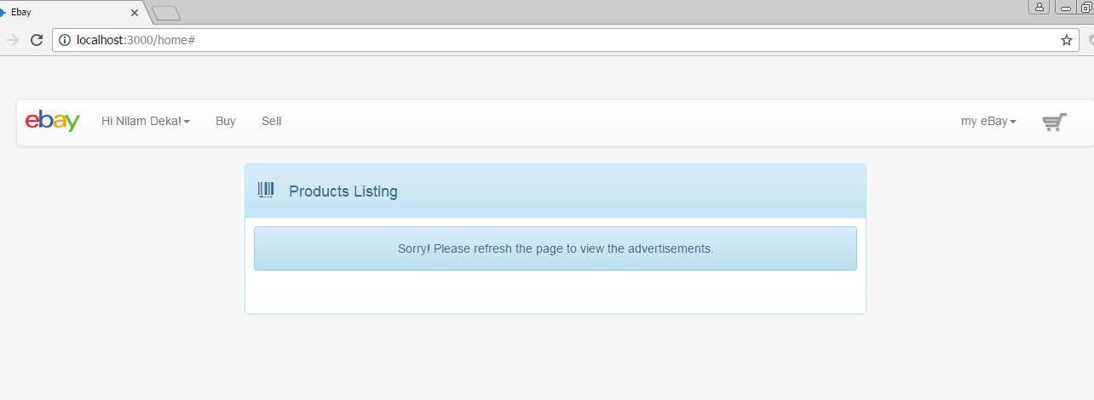

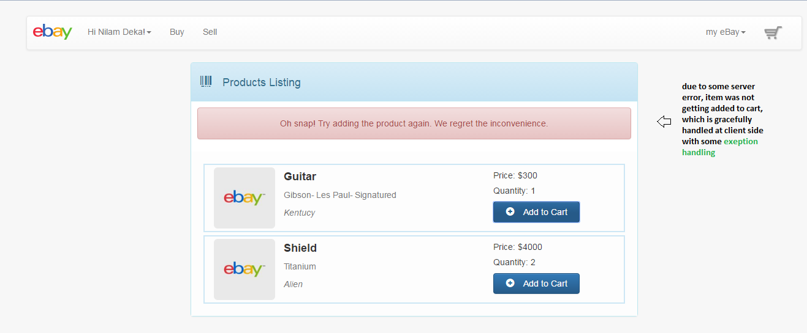

Testing done using JMeter:

1. 100, 200, 300, 400 and 500 concurrent users with connection pooling.
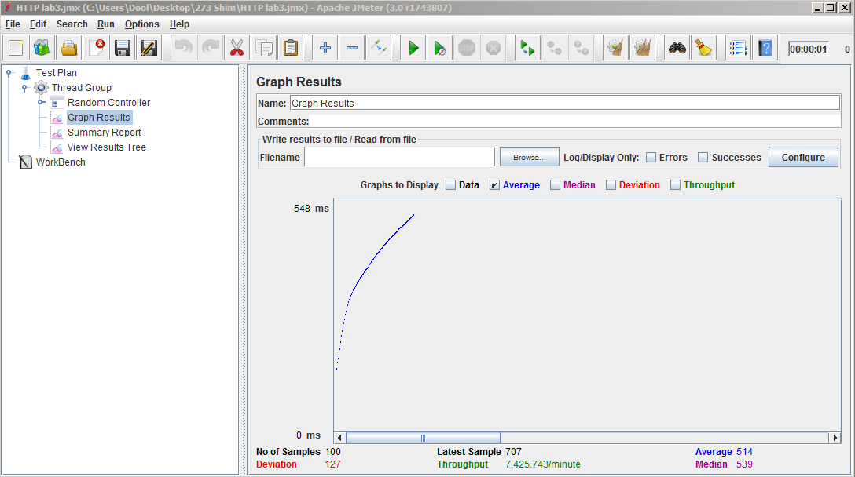
100 concurrent calls

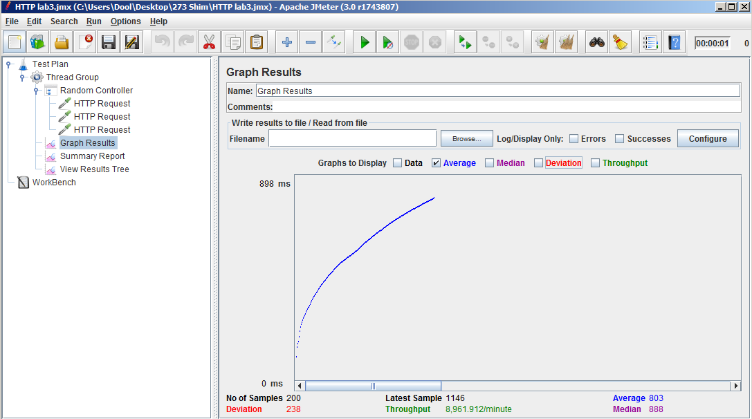
200 concurrent calls
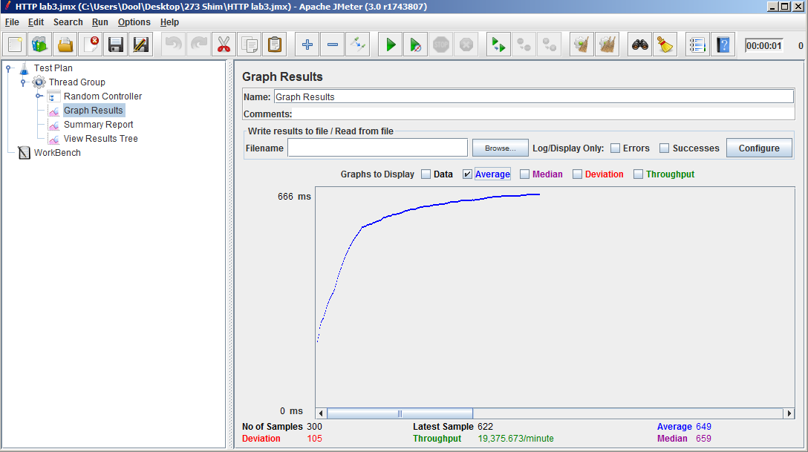
300 concurrent calls
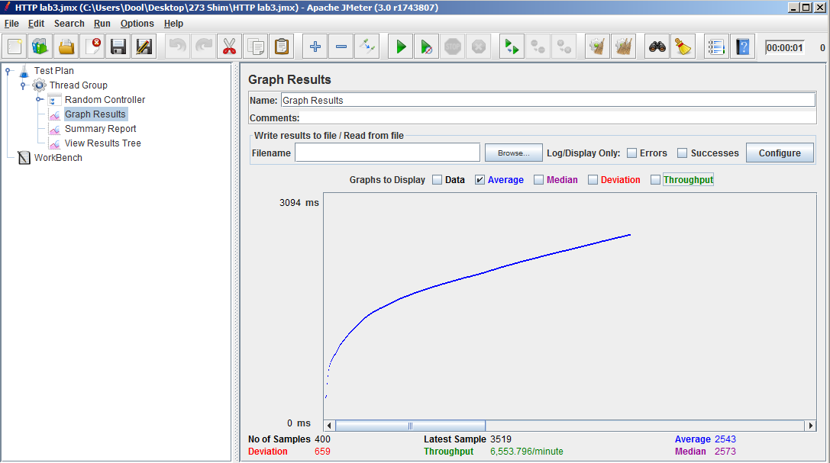
400 concurrent calls
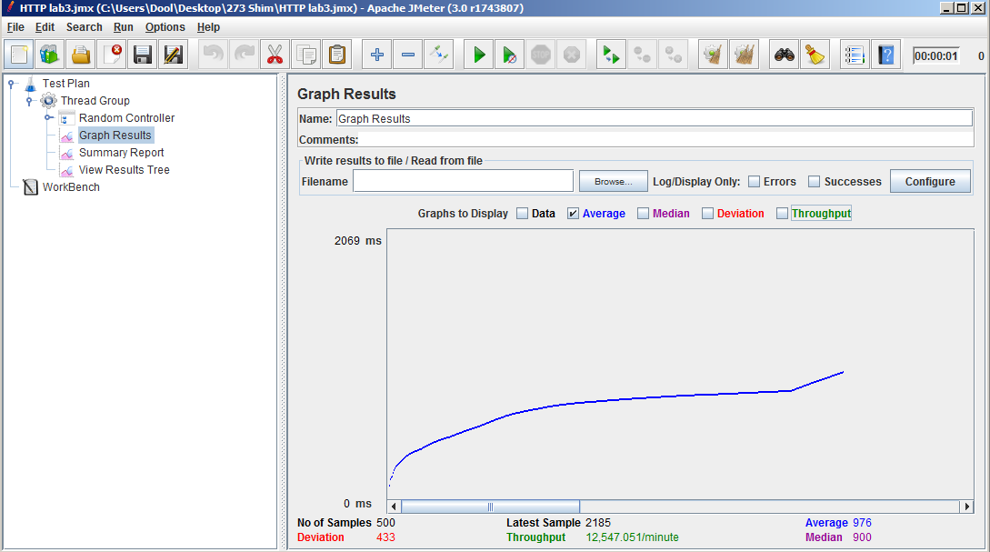
500 concurrent calls

2. 100, 200, 300, 400 and 500 concurrent users without connection pooling.
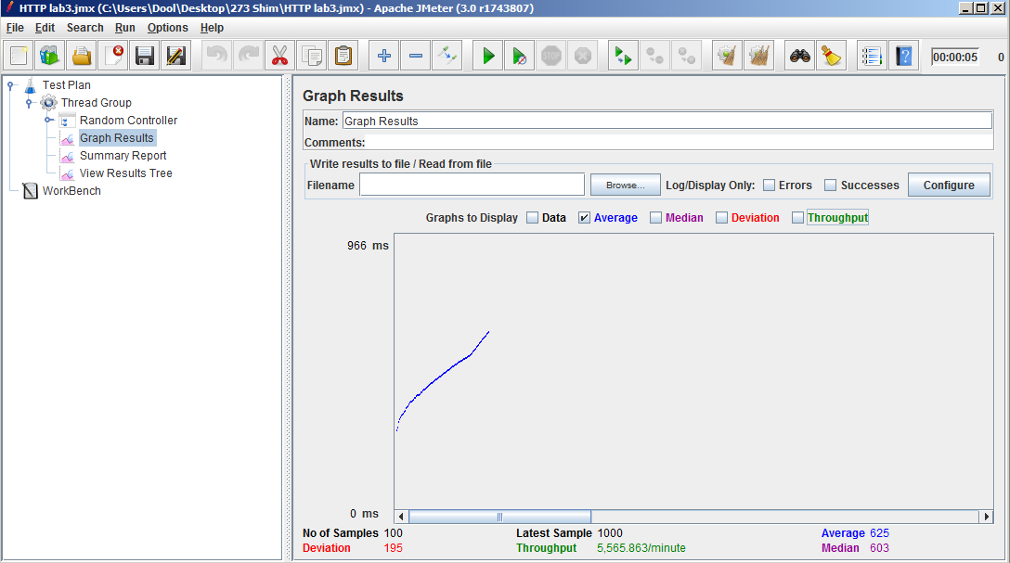
First 100 calls
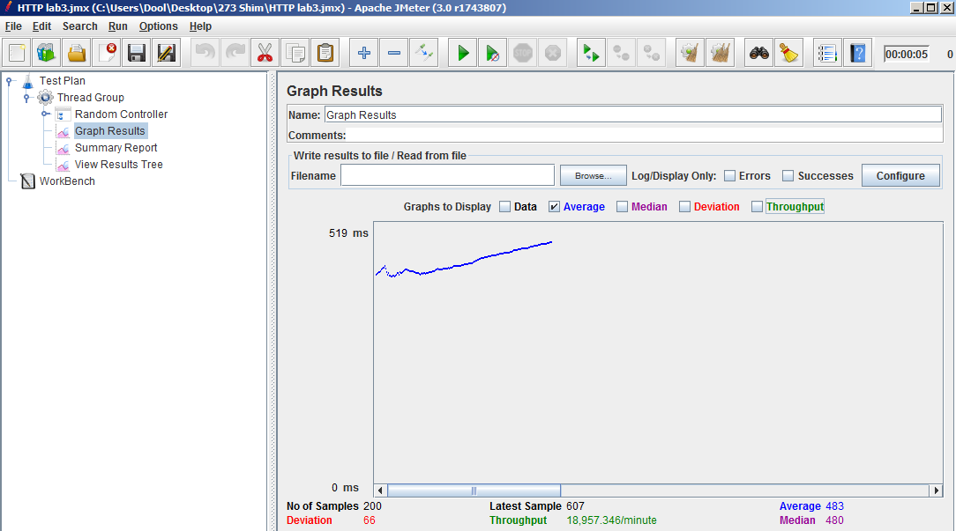
200 calls
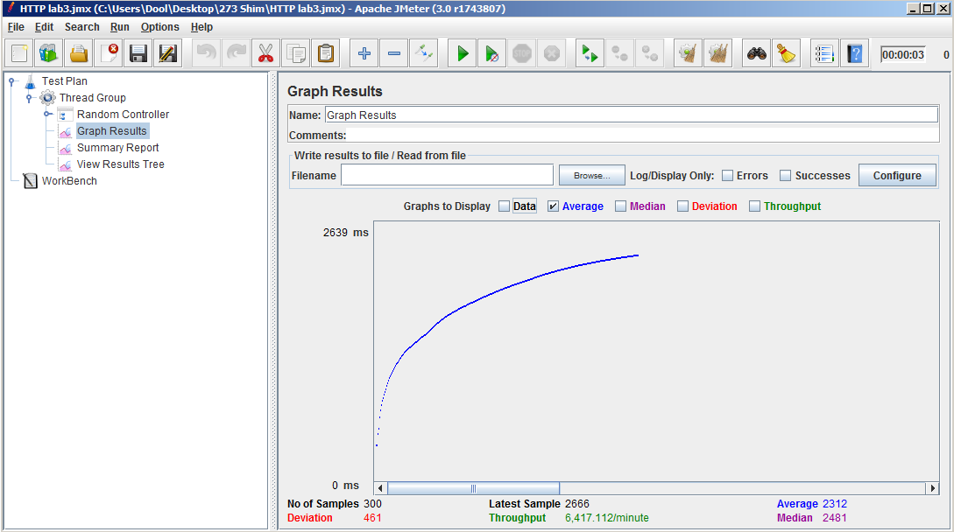
300 calls
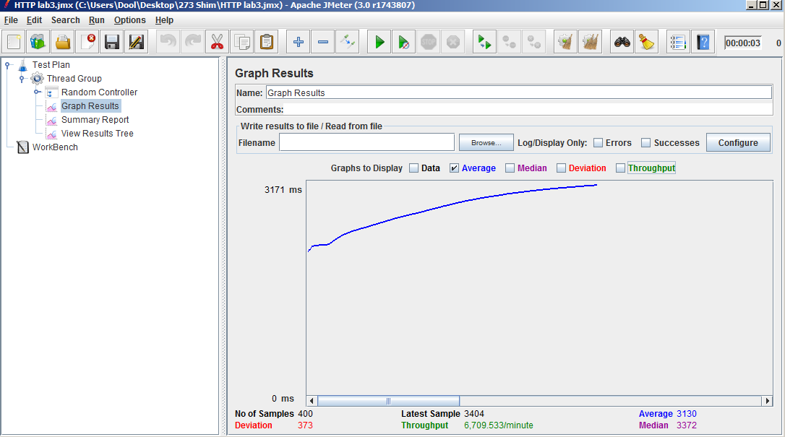
400 calls

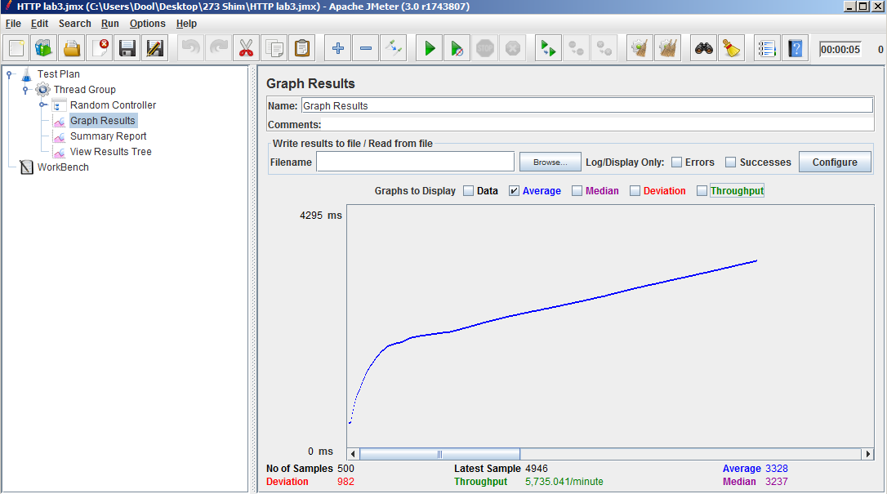
Conclusion:
As can be concluded from the tests, without connection pooling the performance is affected. The average response times have increased 2.41x times.

Testing done using Mocha:
Implemented 5 randomly selected REST web service API calls using Mocha.
Output screenshot.
