Running wordcount program with Local Hadoop

To run wordcount sample program provided by Hadoop,

Hadoop can run program using mapreduce and can be run using below command,

1. Specify jar filename
2. Input folder having input file to run
3. Output folder where output will be created

$hadoop jar jarname –classpath input output

Map reduce can only run jar files.

Step 1: Create input file with some content,

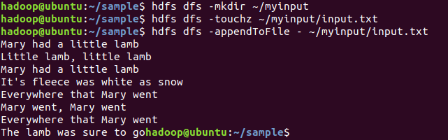

Step 2: Run wordcount jar sample program provided by Hadoop

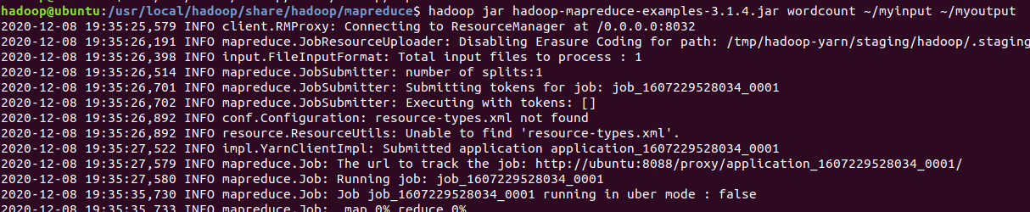

Step 3: Get the output from output folder,

Output is saved in file part-r-00000

