C-CLARKE INTERNATIONAL INSTITUTE OF DIGITAL SCIENCES
Diploma in Advanced AI & Software Engineering | Batch 25/26
SMART HIRE
Software Testing Documentation
Software Testing Design Document
Program | Diploma in Advanced AI & Software Engineering
Batch | 25 / 26
Assessment | Group Software Development Assignment
Deliverable | Testing Documentation
Testing Documentation | Software Testing
Submission Date | 22 July 2026
Prepared by | [Team Member Names – to be completed]
Document Version | 1.0

Table of Contents
Table of Contents 2
1. Introduction 3
1.0 Purpose 3
1.1 Testing Objectives 3
1.2 Testing Scope 3
1.3 Testing Environment 4
1.4 Testing Strategy 4
2. Test Types 5
3. Test Cases 7
3.1 Unit Testing 7
3.2 Integrating Testing 7
3.3 System Testing 8
4. Test Execution Result 9
5. Bug Reporting 10
6. Acceptance Criteria 11
7. Test Summary 11
8. Appendix 11
Appendix - A 12

1. Introduction

1.0 Purpose
The purpose of this document is to define the testing strategy, methodology, and procedures used to verify the functionality, reliability, security, and performance of the Smart Hire application. The testing process ensures that all system components operate according to the Software Requirements Specification (SRS) and satisfy the project requirements before deployment. This document also outlines the testing environment, testing approaches, test cases, and expected outcomes to ensure the quality and reliability of the Smart Hire system.

1.1 Testing Objectives
The primary objectives of testing the Smart Hire application are to,

- Verify that all system functions operate correctly according to the Software Requirements Specification (SRS).
- Validate that the application meets both functional and non-functional requirements.
- Identify, document, and resolve software defects before deployment.
- Ensure AI-powered features, including service recommendations and provider matching, produce accurate and reliable results.
- Verify the security, reliability, and performance of the application under normal operating conditions.
- Confirm that all integrated components, including the Angular frontend, FastAPI backend, PostgreSQL database, and OpenAI API, communicate and function correctly.
- Improve the overall quality, stability, and usability of the Smart Hire system before release.

1.2 Testing Scope

The testing scope defines the modules and functionalities of the Smart Hire application that are included in the testing process. Testing is performed to verify that each module functions correctly both independently and as part of the integrated system. The scope includes functional, integration, security, and AI-related features to ensure that the application meets the requirements specified in the Software Requirements Specification (SRS).

Modules Tested

- Authentication Module
- Customer Module
- Service Provider Module
- Service Management Module
- Booking Module
- Review Management Module
- AI Service Recommendation Module
- AI Provider Matching Module
- Admin Module

1.3 Testing Environment

The testing environment defines the hardware, software, and tools used to test the Smart Hire application. A consistent testing environment ensures that all system components are evaluated under controlled conditions, allowing accurate verification of functionality, performance, security, and AI integration. The following table summarizes the technologies and tools used during the testing process.

Item | Description
Frontend | Angular
Backend | FastAPI
Database | PostgreSQL
AI Service | OpenAI API
Web Browser | Microsoft EDGE
Operating System | Windows 11
API Testing Tool | Postman

1.4 Testing Strategy
The Smart Hire application is tested using a combination of manual testing, API testing, and integration testing techniques to ensure the quality and reliability of the system. Individual modules were first tested independently to verify their functionality before being integrated with other system components. After successful unit testing, integration testing was performed to validate communication between the Angular frontend, FastAPI backend, PostgreSQL database, and OpenAI API. Finally, system testing was conducted to ensure that the complete application met both the functional and non-functional requirements specified in the Software Requirements Specification (SRS).
The testing strategy focused on identifying software defects, verifying expected system behavior, ensuring secure data processing, and validating the performance of AI-powered features under normal operating conditions.
API.

2. Test Types

Unit Testing

Unit testing is performed to verify that individual components or functions of the Smart Hire application operate correctly in isolation before they are integrated with other modules. Each unit is tested independently to ensure that its logic, inputs, outputs, and error handling meet the specified requirements. In the Smart Hire system, unit testing focuses on backend functions developed using FastAPI, including user authentication, service management, booking operations, AI request handling, and database interactions. By identifying defects at an early stage, unit testing improves code quality, simplifies debugging, and increases the reliability of the overall application.

Module | Unit Tested | Expected Result
Authentication | User login function | Valid users are authenticated successfully.
User Management | User registration function | New user account is created successfully.
Service Management | Create service function | New service is stored in the database.
Booking | Create booking function | Booking record is successfully created.
AI Module | AI recommendation function | Returns the correct service category based on the user's request.
Database | Database connection function | Successfully connects to the PostgreSQL database.

Integration Testing

Integration testing verifies that the major components of the Smart Hire system work together correctly after they have been integrated. The objective is to ensure seamless communication and data flow between the Angular frontend, FastAPI backend, PostgreSQL database, and OpenAI API. During testing, requests initiated from the frontend are validated and processed by the backend, stored or retrieved from the PostgreSQL database when required, and forwarded to the OpenAI API for AI-powered functionalities such as service recommendations and provider matching. The responses are then returned through the backend to the frontend, ensuring that all integrated components operate reliably and produce the expected results.

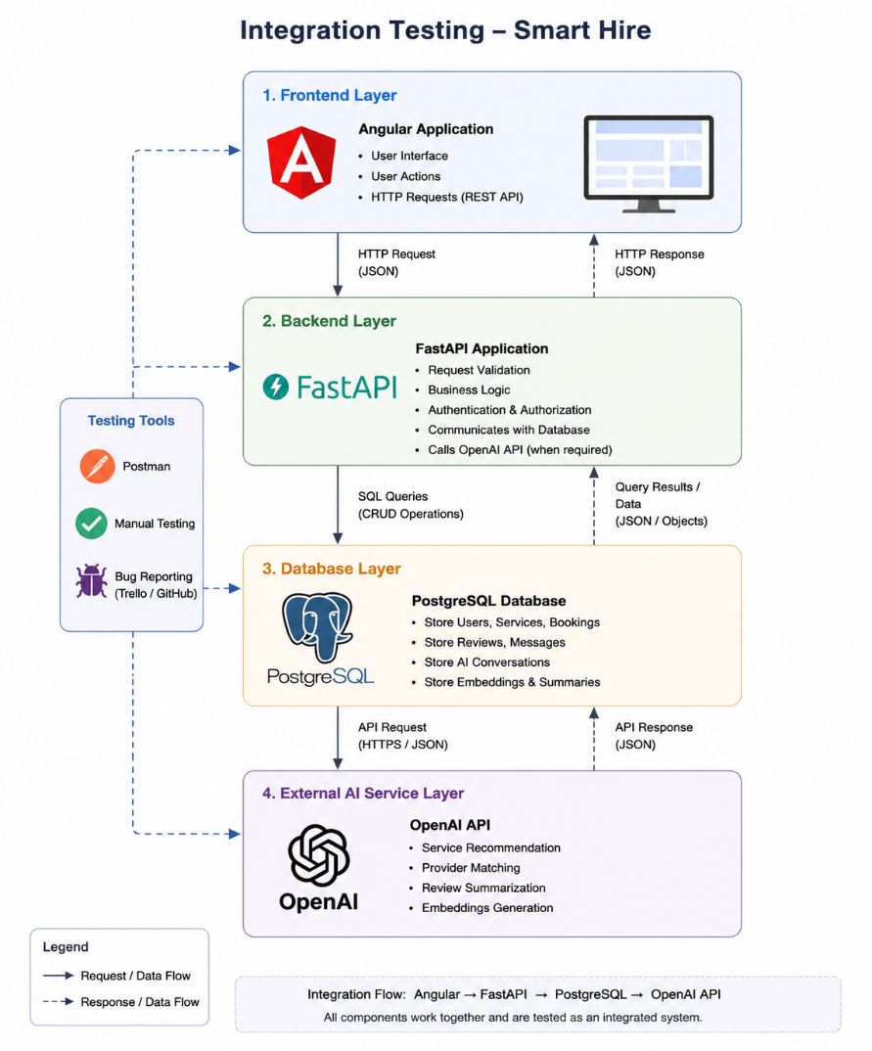

System Testing

System testing is performed to evaluate the Smart Hire application as a complete and fully integrated system. The objective is to verify that all functional and non-functional requirements specified in the Software Requirements Specification (SRS) are satisfied before deployment. During this phase, the entire application—including the Angular frontend, FastAPI backend, PostgreSQL database, and OpenAI API integration—is tested under realistic operating conditions. System testing validates that all modules work together correctly, data flows seamlessly across components, AI-powered features function as expected, and the overall system delivers a reliable, secure, and user-friendly experience.

Module | System Test Scenario | Expected Result
User Authentication | User registers and logs in | User successfully accesses the system
Service Management | Provider creates and updates services | Services are stored and displayed correctly
Booking Module | Customer books a service | Booking is successfully created and confirmed
AI Recommendation | Customer requests a service recommendation | AI returns the appropriate service category
Provider Matching | AI recommends suitable provider | Matching providers are displayed correctly
Review Management | Customer submits a review | Review is stored and displayed successfully
Admin Module | Admin manages users and services | Administrative actions are completed successfully

3. Test Cases

3.1 Unit Testing

Test Case Identifier |  |  | <Test Case No>
Test Case |  |  | <Name of the Test Case>
Test Designed by |  |  | <Name of the person who designed>
Test Designed Date |  |  | <Date of Test case design>
Test Executed by |  |  | <Name of the person who executed>
Test Executed Date |  |  | <Date of Test case Executed>
Description |  |  | <Brief Description of the Test Case>
Pre-Condition |  |  | <If there is a pre-condition affiliated state it>
Dependencies |  |  | <If any Dependencies are available state it>
Test Case # | Sequence # | Test Case Description |  | Test Data / Input Value(s) | Expected Result | Status  (Pass/Fail)
01 | 1.1
Actual Result - <Status>

Screen Shot

3.2 Integrating Testing

Test Case Identifier |  |  | <Test Case No>
Test Case |  |  | <Name of the Test Case>
Test Designed by |  |  | <Name of the person who designed>
Test Designed Date |  |  | <Date of Test case design>
Test Executed by |  |  | <Name of the person who executed>
Test Executed Date |  |  | <Date of Test case Executed>
Description |  |  | <Brief Description of the Test Case>
Pre-Condition |  |  | <If there is a pre-condition affiliated state it>
Dependencies |  |  | <If any Dependencies are available state it>
Test Case # | Sequence # | Test Case Description |  | Test Data / Input Value(s) | Expected Result | Status  (Pass/Fail)
01 | 1.1
Actual Result - <Status>

Screen Shot

3.3 System Testing

Test Case Identifier |  |  | <Test Case No>
Test Case |  |  | <Name of the Test Case>
Test Designed by |  |  | <Name of the person who designed>
Test Designed Date |  |  | <Date of Test case design>
Test Executed by |  |  | <Name of the person who executed>
Test Executed Date |  |  | <Date of Test case Executed>
Description |  |  | <Brief Description of the Test Case>
Pre-Condition |  |  | <If there is a pre-condition affiliated state it>
Dependencies |  |  | <If any Dependencies are available state it>
Test Case # | Sequence # | Test Case Description |  | Test Data / Input Value(s) | Expected Result | Status  (Pass/Fail)
01 | 1.1
Actual Result - <Status>

Screen Shot

4. Test Execution Result

Total Test | Passed | Failed | Pass Rate

5. Bug Reporting

Bug ID | Module | Description | Severity | Status

6. Acceptance Criteria
The Smart Hire application is considered ready for deployment when it satisfies the predefined acceptance criteria. These criteria ensure that the system meets the functional and non-functional requirements specified in the Software Requirements Specification (SRS) and operates reliably under normal conditions.

- The Smart Hire system is considered acceptable when:
- All critical and high-priority test cases have been executed successfully.
- User authentication and authorization functions operate correctly.
- AI-powered features, including service recommendations and provider matching, return accurate and relevant results.
- Database transactions are completed successfully without data loss or inconsistency.
- API requests and responses are processed correctly with acceptable response times.
- All integrated components, including the Angular frontend, FastAPI backend, PostgreSQL database, and OpenAI API, communicate successfully.
- No critical or high-severity defects remain unresolved.
- The system meets the expected performance, security, and usability requirements.

7. Test Summary
Testing confirmed that the Smart Hire platform successfully satisfies the functional and non-functional requirements defined in the Software Requirements Specification (SRS). All major modules, including authentication, customer management, service provider management, booking, review management, and AI-powered features, were tested to verify their functionality, reliability, and performance.
The integration between the Angular frontend, FastAPI backend, PostgreSQL database, and OpenAI API was successfully validated, ensuring seamless communication between all system components. Minor defects identified during the testing process were documented, corrected, and retested before deployment. Based on the testing results, the Smart Hire application is considered stable, secure, and ready for deployment.

8. Appendix
Include
- Test Data
- Postman Screenshots
- API Test Results
- Browser Compatibility Results
- Error Logs
- Test Environment Configuration

Appendix - A

