C-CLARKE INTERNATIONAL INSTITUTE OF DIGITAL SCIENCES
Diploma in Advanced AI & Software Engineering | Batch 25/26

SMART HIRE
Use Case Diagrams Documentation
Software Requirements / System Modelling Deliverable

Program | Diploma in Advanced AI & Software Engineering
Batch | 25 / 26
Assessment | Group Software Development Assignment
Deliverable | Use Case Diagrams
Submission Date | 22 July 2026
Prepared by | [Team Member Names – to be completed]

Table of Contents
1. Introduction
2. System Scope
3. Actors
4. Use Case Diagram Notation
5. Main Use Case Diagram
6. Customer Use Case Diagram
7. Service Provider Use Case Diagram
8. Admin Use Case Diagram
9. AI Assistant Use Case Diagram
10. Use Case Specifications
11. Include / Extend Relationships
12. Use Case Traceability Matrix
13. Assumptions and Constraints
14. Conclusion

1. Introduction

1.1 Purpose
This document specifies the use case model for the Smart Hire platform. It identifies the external actors, their goals, the system functions they interact with, and the relationships between the main use cases. The document is prepared as part of the Smart Hire group software development assignment deliverables.

1.2 Project Background
Smart Hire is a centralized digital marketplace that connects customers with skilled service providers. Customers can discover trustworthy professionals for services such as plumbing, electrical work, home maintenance, tutoring, cleaning, repairs, and technical support. Service providers can publish their skills and reach customers through one unified platform.

1.3 Reference Documents
- Smart Hire Final Group Assignment brief, C-Clarke International Institute of Digital Sciences.
- Smart Hire Database Design Document (PostgreSQL), Document Version 1.0.

2. System Scope

2.1 In Scope
- Customer account registration, login and profile management.
- Service provider registration, verification, profile, service publishing and job management.
- Service searching, filtering, booking, payment, reviews and notifications.
- Admin management of users, categories, provider verification, reports and system monitoring.
- AI features such as service recommendation, support assistant and review summarization.

2.2 Out of Scope
- Physical service delivery after a booking is completed.
- External payment gateway internals.
- Government or third-party provider verification systems.
- Full accounting or payroll features.

3. Actors
Actor | Type | Description
Customer | Primary | A user who searches for services, books providers, pays for bookings and writes reviews.
Service Provider | Primary | A skilled worker or business that publishes services, manages availability and handles customer bookings.
Admin | Primary | A system authority who verifies providers, manages categories, monitors platform activity and handles reports.
AI Assistant | Supporting | A system component that provides recommendations, support responses and review summaries.
Payment Gateway | External Supporting | An external service used to process online payments and provide transaction status.
Email / Notification Service | External Supporting | An external or internal service used to send email and in-app notifications.

4. Use Case Diagram Notation
The diagrams use UML-style use case notation. Actors are shown outside the system boundary. Use cases are shown as ellipses inside the Smart Hire Platform boundary. Associations show which actor communicates with which use case. Include relationships represent mandatory reusable behaviour. Extend relationships represent optional or conditional behaviour.

5. Main Use Case Diagram
The main diagram gives a high-level overview of the Smart Hire system functions and the actors that interact with them.
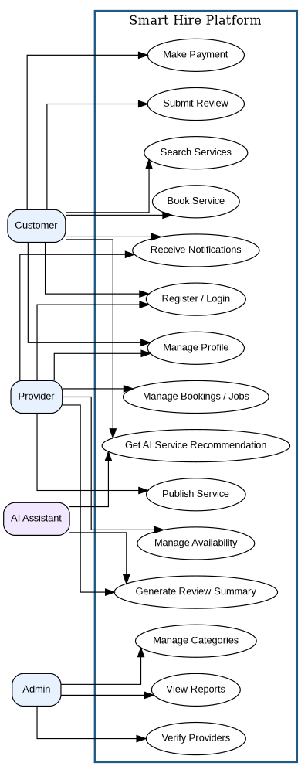
Figure 1: Main Use Case Diagram for Smart Hire

6. Customer Use Case Diagram
Customer functions focus on finding and booking services. Customers register, search for services, request AI recommendations, create bookings, make payments, submit reviews and receive notifications.
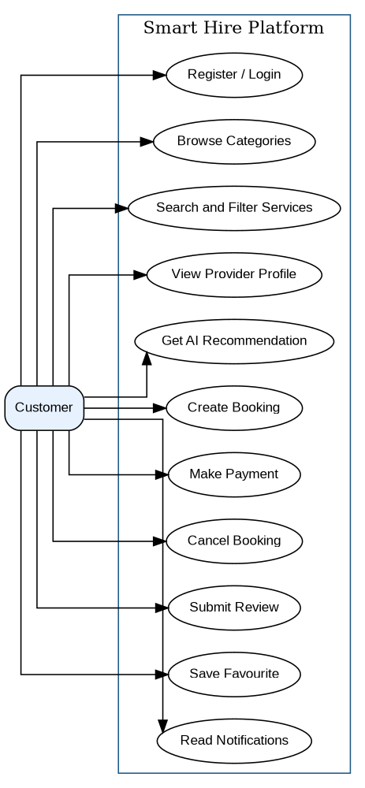
Figure: 6. Customer Use Case Diagram

7. Service Provider Use Case Diagram
Provider functions focus on publishing services and handling jobs. Providers complete their profile, submit verification details, create or update services, set working areas and availability, manage booking requests and view review summaries.
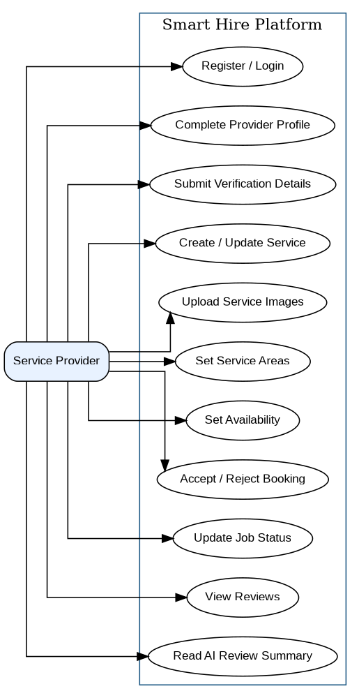
Figure: 7. Service Provider Use Case Diagram

8. Admin Use Case Diagram
Admin functions focus on platform governance. Admin users verify providers, manage users and service categories, monitor bookings, handle reports or complaints and view dashboard reports.
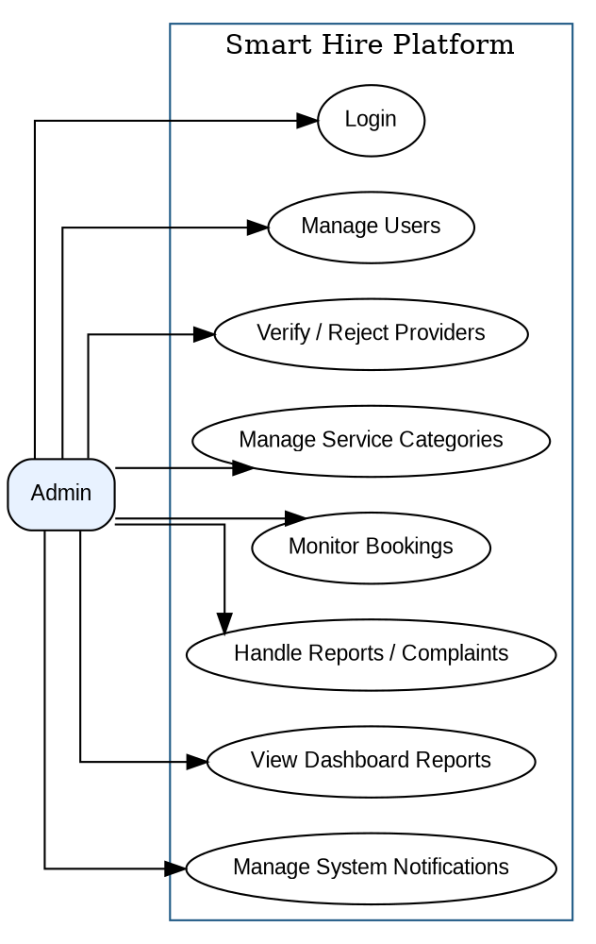
Figure: 8. Admin Use Case Diagram

9. AI Assistant Use Case Diagram
AI Assistant functions support the platform by recommending services, answering support questions, summarizing reviews and storing conversation data for context and auditing.
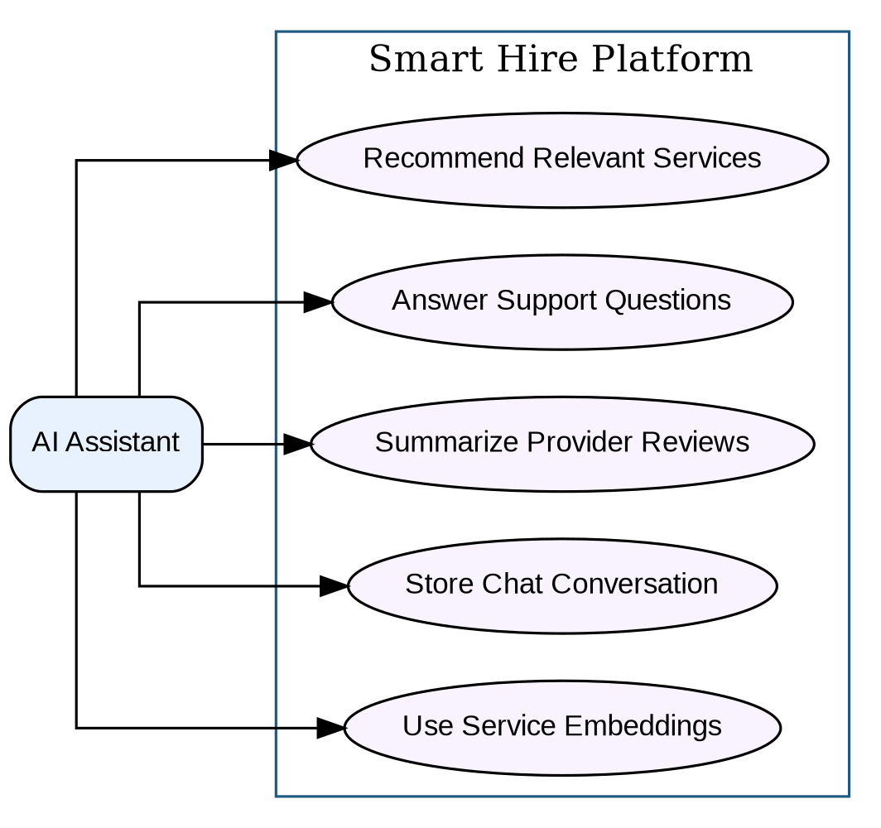
Figure: 9. AI Assistant Use Case Diagram

10. Use Case Specifications

UC-01 – Register Account
Primary Actor | Customer / Provider
Goal | Create a new Smart Hire account.
Precondition | User provides valid name, email, password and role.
Postcondition | Account is created with pending verification status.
Main Success Scenario | 1. Actor starts register account. 2. System validates the request. 3. System saves or retrieves required data. 4. System confirms the result.
Alternative / Exception | Duplicate email or invalid data prevents registration.

UC-02 – Login
Primary Actor | Customer / Provider / Admin
Goal | Authenticate an existing user.
Precondition | User has an existing account.
Postcondition | User is logged into the system dashboard.
Main Success Scenario | 1. Actor starts login. 2. System validates the request. 3. System saves or retrieves required data. 4. System confirms the result.
Alternative / Exception | Invalid credentials show an error message.

UC-03 – Manage Profile
Primary Actor | Customer / Provider
Goal | Update personal and contact information.
Precondition | User is authenticated.
Postcondition | Profile details are saved.
Main Success Scenario | 1. Actor starts manage profile. 2. System validates the request. 3. System saves or retrieves required data. 4. System confirms the result.
Alternative / Exception | Invalid phone or required fields are rejected.

UC-04 – Search Services
Primary Actor | Customer
Goal | Find services by category, keyword, city or filters.
Precondition | Services are available in the catalog.
Postcondition | Matching active services are displayed.
Main Success Scenario | 1. Actor starts search services. 2. System validates the request. 3. System saves or retrieves required data. 4. System confirms the result.
Alternative / Exception | No matching services show an empty result message.

UC-05 – View Service / Provider Details
Primary Actor | Customer
Goal | Review service details, provider profile, rating and availability.
Precondition | Customer selected a service.
Postcondition | Service and provider details are displayed.
Main Success Scenario | 1. Actor starts view service / provider details. 2. System validates the request. 3. System saves or retrieves required data. 4. System confirms the result.
Alternative / Exception | Unavailable service shows inactive status.

UC-06 – Get AI Service Recommendation
Primary Actor | Customer / AI Assistant
Goal | Recommend services based on customer query or need.
Precondition | Customer enters a service requirement.
Postcondition | System returns ranked relevant services.
Main Success Scenario | 1. Actor starts get ai service recommendation. 2. System validates the request. 3. System saves or retrieves required data. 4. System confirms the result.
Alternative / Exception | If AI fails, keyword search fallback is shown.

UC-07 – Create Booking
Primary Actor | Customer
Goal | Book a selected service for a date, time and address.
Precondition | Customer is logged in and service is active.
Postcondition | Booking is saved with pending status.
Main Success Scenario | 1. Actor starts create booking. 2. System validates the request. 3. System saves or retrieves required data. 4. System confirms the result.
Alternative / Exception | Unavailable time or invalid address prevents booking.

UC-08 – Make Payment
Primary Actor | Customer / Payment Gateway
Goal | Pay for a booking by supported method.
Precondition | Booking exists and payment is required.
Postcondition | Payment record is saved and booking payment status updates.
Main Success Scenario | 1. Actor starts make payment. 2. System validates the request. 3. System saves or retrieves required data. 4. System confirms the result.
Alternative / Exception | Failed payment keeps booking unpaid.

UC-09 – Cancel Booking
Primary Actor | Customer / Provider
Goal | Cancel a booking according to rules.
Precondition | Booking is not completed.
Postcondition | Booking status changes to cancelled.
Main Success Scenario | 1. Actor starts cancel booking. 2. System validates the request. 3. System saves or retrieves required data. 4. System confirms the result.
Alternative / Exception | Cancellation is blocked for completed jobs.

UC-10 – Submit Review
Primary Actor | Customer
Goal | Rate and comment on completed service.
Precondition | Booking is completed and not already reviewed.
Postcondition | Review is saved and provider rating updates.
Main Success Scenario | 1. Actor starts submit review. 2. System validates the request. 3. System saves or retrieves required data. 4. System confirms the result.
Alternative / Exception | Duplicate review is rejected.

UC-11 – Publish Service
Primary Actor | Provider
Goal | Create or update a service offering.
Precondition | Provider is logged in and verified or pending according to business rules.
Postcondition | Service is saved as draft or active.
Main Success Scenario | 1. Actor starts publish service. 2. System validates the request. 3. System saves or retrieves required data. 4. System confirms the result.
Alternative / Exception | Missing category, title or price prevents saving.

UC-12 – Manage Availability
Primary Actor | Provider
Goal | Define weekly working slots and service areas.
Precondition | Provider is logged in.
Postcondition | Availability and coverage areas are saved.
Main Success Scenario | 1. Actor starts manage availability. 2. System validates the request. 3. System saves or retrieves required data. 4. System confirms the result.
Alternative / Exception | End time before start time is rejected.

UC-13 – Manage Booking Requests
Primary Actor | Provider
Goal | Accept, reject and update job status.
Precondition | Provider has a booking request.
Postcondition | Booking status is updated and customer is notified.
Main Success Scenario | 1. Actor starts manage booking requests. 2. System validates the request. 3. System saves or retrieves required data. 4. System confirms the result.
Alternative / Exception | Invalid status transition is blocked.

UC-14 – Verify Provider
Primary Actor | Admin
Goal | Approve or reject provider verification.
Precondition | Provider has submitted details.
Postcondition | Provider verification status is updated.
Main Success Scenario | 1. Actor starts verify provider. 2. System validates the request. 3. System saves or retrieves required data. 4. System confirms the result.
Alternative / Exception | Incomplete details keep the provider pending.

UC-15 – Manage Categories
Primary Actor | Admin
Goal | Create and maintain service categories.
Precondition | Admin is authenticated.
Postcondition | Category list is updated.
Main Success Scenario | 1. Actor starts manage categories. 2. System validates the request. 3. System saves or retrieves required data. 4. System confirms the result.
Alternative / Exception | Duplicate category name or slug is rejected.

UC-16 – AI Review Summarization
Primary Actor | AI Assistant / Provider
Goal | Generate a digest of provider reviews.
Precondition | Provider has reviews.
Postcondition | Summary and sentiment are saved for display.
Main Success Scenario | 1. Actor starts ai review summarization. 2. System validates the request. 3. System saves or retrieves required data. 4. System confirms the result.
Alternative / Exception | Insufficient review data returns a simple status message.

UC-17 – Receive Notifications
Primary Actor | Customer / Provider / Admin
Goal | Notify users about booking, payment, review, message or system events.
Precondition | Triggering event occurs.
Postcondition | Notification is created and marked unread.
Main Success Scenario | 1. Actor starts receive notifications. 2. System validates the request. 3. System saves or retrieves required data. 4. System confirms the result.
Alternative / Exception | Notification delivery failure is logged.

11. Include / Extend Relationships
Base Use Case | Relationship | Related Use Case | Reason
Create Booking | <<include>> | Login | A customer must be authenticated before placing a booking.
Make Payment | <<include>> | Create Booking | A payment belongs to an existing booking.
Submit Review | <<extend>> | Create Booking | Review is optional and only available after completion.
Search Services | <<extend>> | Get AI Service Recommendation | AI recommendation is an enhanced search path.
Publish Service | <<include>> | Manage Profile | Provider service details depend on provider profile details.
Manage Booking Requests | <<include>> | Receive Notifications | Customers and providers are notified after booking status changes.
AI Review Summarization | <<include>> | Submit Review | Review data is the input for generated provider summaries.

12. Use Case Traceability Matrix
Requirement Area | Related Use Cases | Primary Actor | Database Support
Identity & Roles | UC-01, UC-02, UC-03 | Customer, Provider, Admin | users, provider_profiles
Service Catalog | UC-04, UC-05, UC-11, UC-15 | Customer, Provider, Admin | services, service_categories, service_images
Booking Management | UC-07, UC-09, UC-13 | Customer, Provider | bookings, provider_availability, service_areas
Payments | UC-08 | Customer, Payment Gateway | payments
Reviews & Ratings | UC-10, UC-16 | Customer, Provider, AI Assistant | reviews, review_summaries
Favourites & Notifications | UC-17 | Customer, Provider, Admin | favorites, notifications
AI Features | UC-06, UC-16 | Customer, Provider, AI Assistant | ai_conversations, ai_messages, service_embeddings, review_summaries

13. Assumptions and Constraints
- Only active services are visible to customers in search and recommendation results.
- A provider must have a user account before a provider profile can be created.
- Each completed booking can have only one review and one payment record.
- The AI assistant supports the user but does not make final business decisions without system validation.
- All important actions should create notifications for relevant users.

14. Conclusion
The use case model defines how customers, service providers, administrators and the AI assistant interact with the Smart Hire platform. These diagrams and specifications provide a clear functional view that can guide SRS writing, API design, database implementation, frontend screens and test case preparation.

