**Fortune Wheel Feasibility Analysis**

**What products needs migration?**

Product Catalog website

Database -> 50 GB Size <1TB

**What is the Requirement?**

Lift and Shift of website/ Database Server

Minimal Code Change/Architecture Change

Scalability/Meet Burst of Demand

Business Continuity Plan(BCP) in case of Catastrophe

Avoid Downtime

Back Up

Leverage Microsoft Tool -> Azure

**What we need?**

1. **Lift and Shift of website**
2. App Service Plan(for Prod P1V2, for Test B1)*2(For Regional Pairing)
3. For Prod need below features on App Service Plan

An App Service Plan with following Feature

**P1V2 Plan**

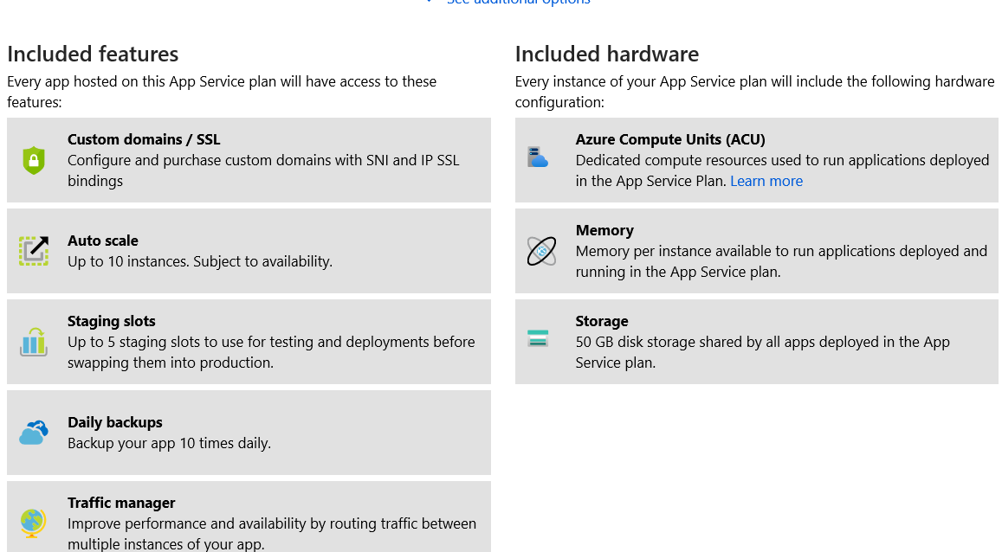

1. **Minimal Code Change/Architecture Change**

If the code is on .NET or PHP we can run a Migration Check using Azure Migration Tool.

If there is no compatibility issues App services can be created in each App Service Plan

For US Regions

1 in East US and another in West US(Regional Pair)

Otherwise in other runtime we need create app services, and while deploying in app service we can Check for any Errors and manually fix it

**Azure Key Vault**

Store the Environment variables to store the Application Keys of the web app and fetch it when the app is running

1. **Scalability/Meet Burst of Demand**

**Scale Out**

We can use a auto scale rule on each app services.

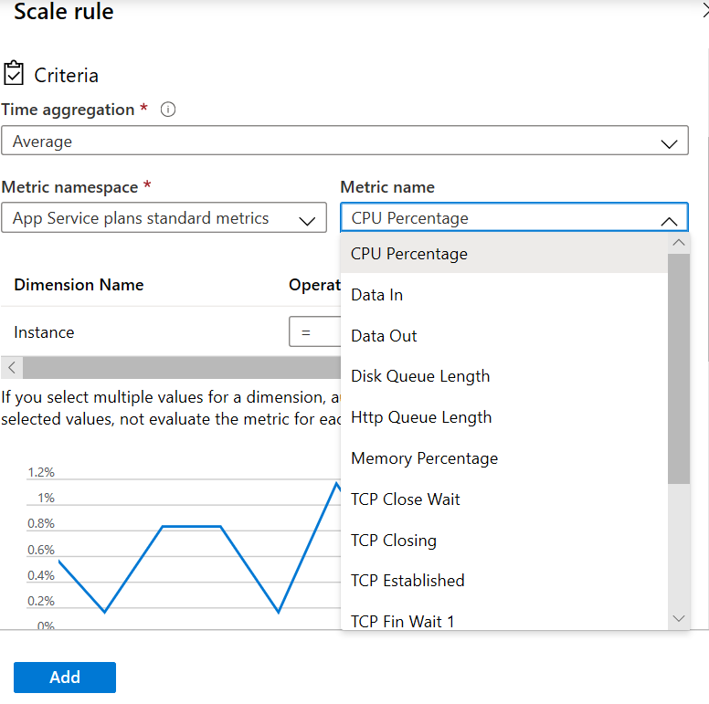

The number of instance depends on the App service plan chosen

1. **Back Up**

We can schedule the back up time after business hours in the app services

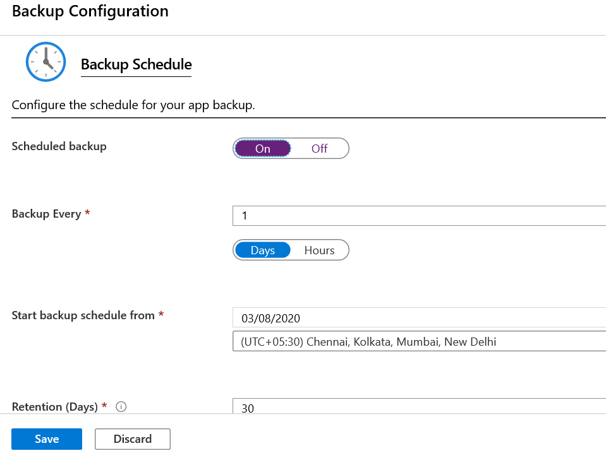

**Scale Up**

We can bump of the configuration of the machines for the App Service Plan

**Business Continuity Plan (BCP) in case of Catastrophe**

We are using Region Pairing so if one region goes does in the same geo another region will work as a primary region

When architecting the resources, we can follow certain cloud architecture e.g.

Health endpoint monitoring Pattern

**Traffic Manager**

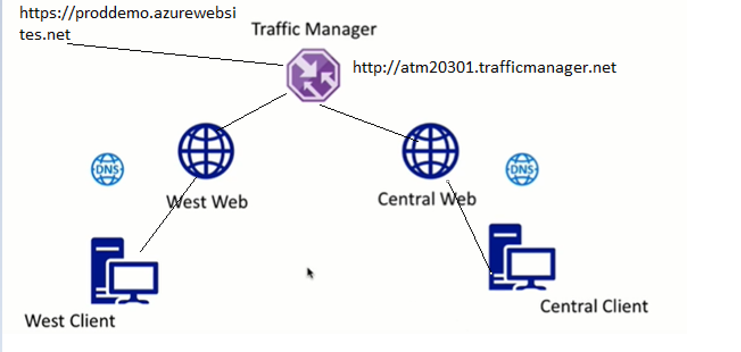

Create Geo based Traffic Manager, and Add endpoints of multiple endpoint deployed in different geographic location.

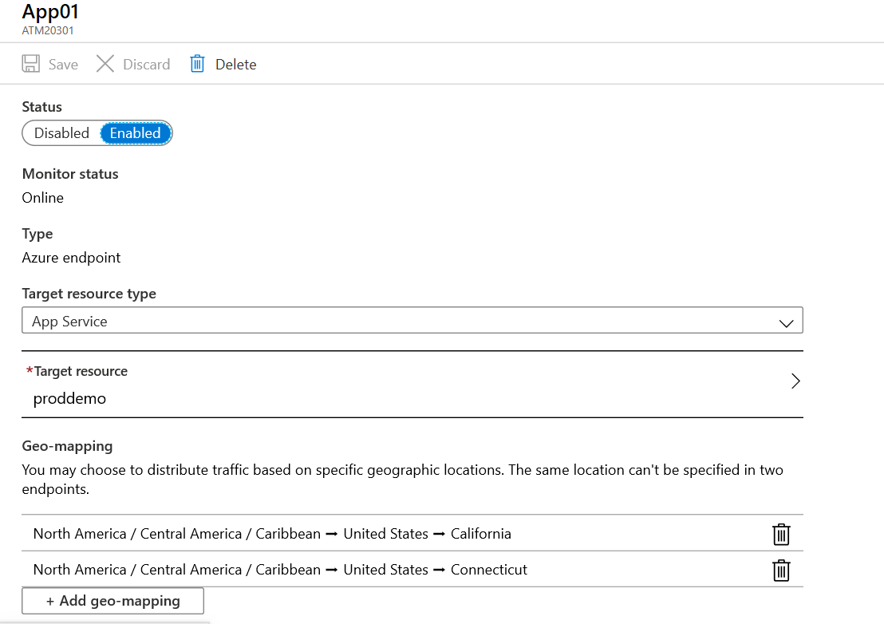

Check the Monitor Status of each endpoint

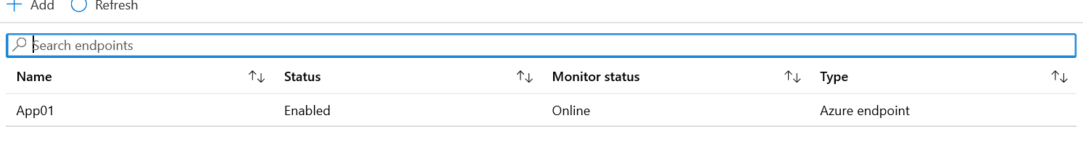

**For product Catalogue Image Storage**

Use Geo Redundant Storage Replication Strategy and Premium storage to have 99.9% SLA

The same storage can be accessed by different app, as the storage is replicated in all the regions

