**IT2030 – Object Oriented Programming Project Individual Project Submission Document 2020**

**Individual Report about my individual contribution**

Campus : SLIIT Malabe

Student ID : IT19105826

Name : M.N.D. Meegoda

GroupID : Batch 06 – G23

Project Name :Online Inventory Management System

Rating of other members :

|  |  |  |
| --- | --- | --- |
| Student ID | Name | Rating (1-5)  1 – Excellent  2 – Very Good  3 – Good  4 - Poor  5 – Not contributed |
| IT19081144 | Jayasundara U.L | 1 |
| IT18160512 | Wellehewa G.C | 1 |
| IT19100180 | Ranaweera K.A.D.S | 1 |

Comments : *(Any comments you want to provide to your evaluators about your work and about your other team members)*

* **Dear Madam/Sir , We all did the project in different PCs, So our User interfaces are somewhat different to each other. I kindly request you to consider about that. As we all have implemented insert, update, delete and select functions to our system individually. Thank You.**

Individual contribution of M.N.D. Meegoda (IT19105826)

UI 1 – Home

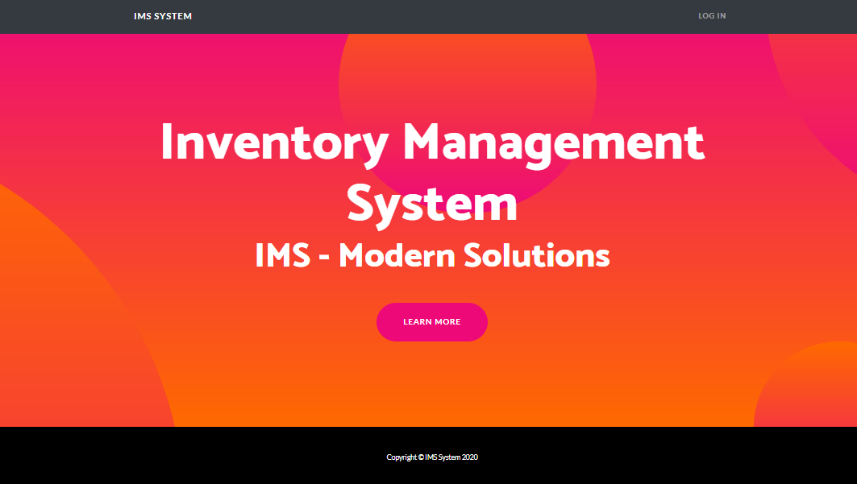

Code for UI – 1

* homepage.jsp - view

UI 2 – Login

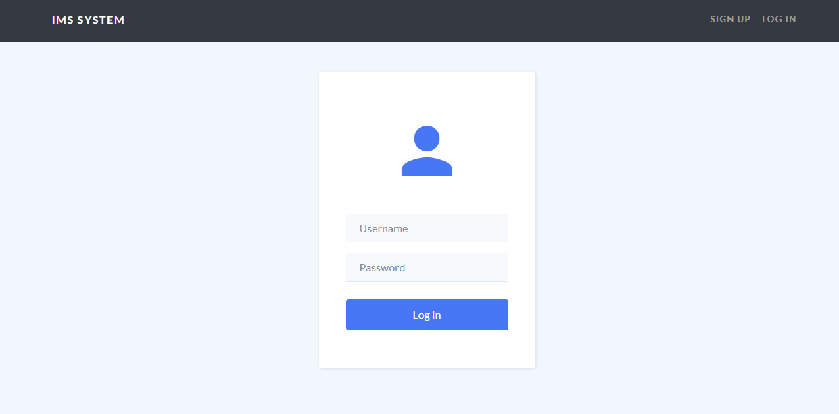

Code for UI – 2

* nlogin.jsp - view
* loginservlet.java – servlet class
* Customer.java – model class
* CustomerDBUtil.java - class

UI 3 – Dashboard

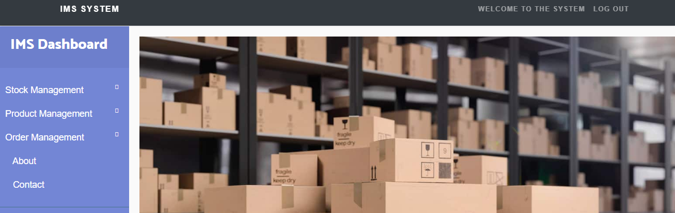

Code for UI – 3

* dasgboard.jsp - view

UI 4 – Add new product

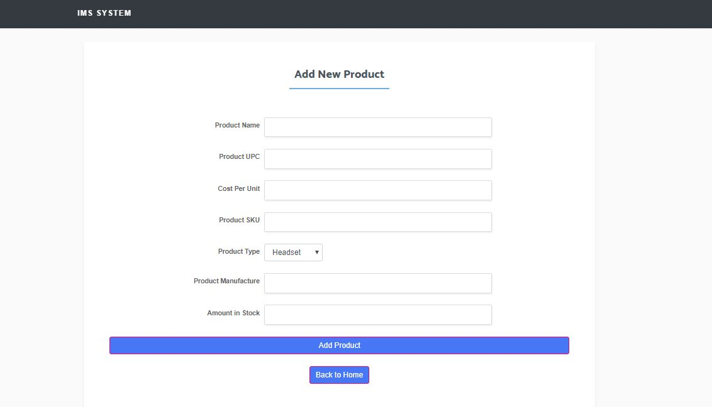

Code for UI – 4

* addproduct.jsp - view
* InsertProduct.java – servlet class
* productDButil.java - class
* product.java – model class

UI 5 – delete product

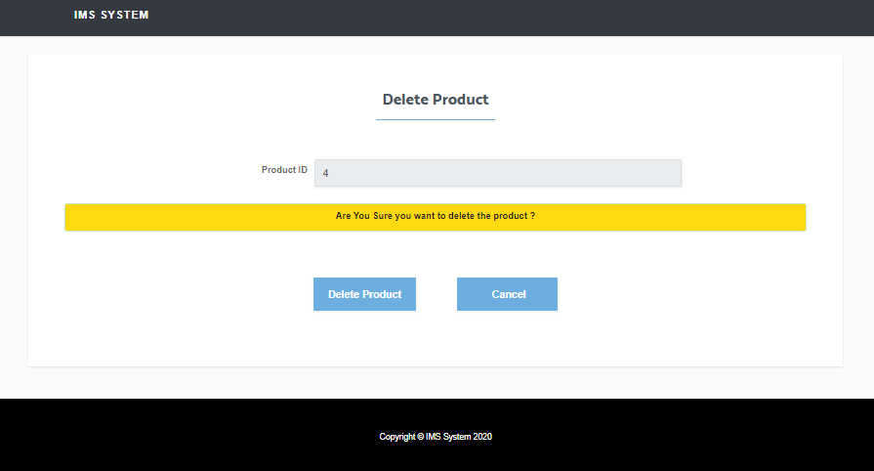

Code for UI – 5

* deleteproduct.jsp - view
* productDButil.java - class
* DeleteProductserv.java – servlet class

UI 6 – Update product

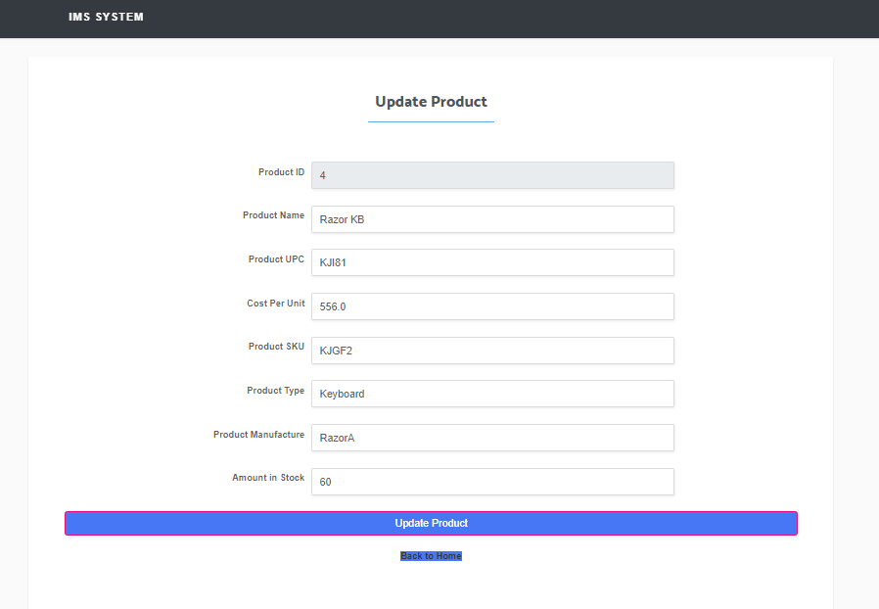

Code for UI – 6

* updateproduct.jsp - view
* UpadteProductserv.java – servlet class
* product.java – model class
* productDButil.java - class

UI 7 – Stock report / Product report

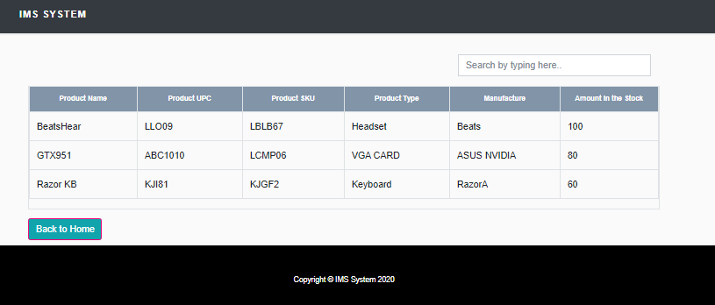

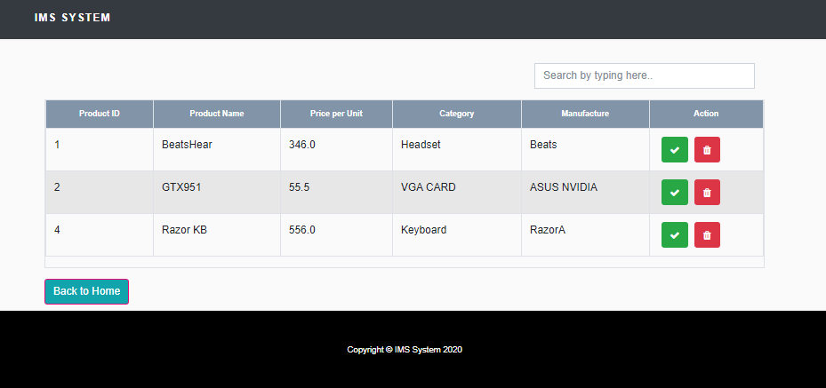

Code for UI – 7

* productreport.jsp - view
* stockreport.jsp - view