**1)**

**//Class Calculator**

**package** com.example;

**public** **class** Calculator {

**public** **int** add(**int** a, **int** b) {

**return** a + b;

}

**public** **int** subtract(**int** a, **int** b) {

**return** a - b;

}

}

**//Class CalculatorTest**

**package** com.example;

**import** org.junit.Test;

**import** **static** org.junit.Assert.*;

**public** **class** CalculatorTest {

@Test

**public** **void** testAdd() {

Calculator calc = **new** Calculator();

*assertEquals*(5, calc.add(2, 3));

}

@Test

**public** **void** testSubtract() {

Calculator calc = **new** Calculator();

*assertEquals*(4, calc.subtract(9, 5));

}

}

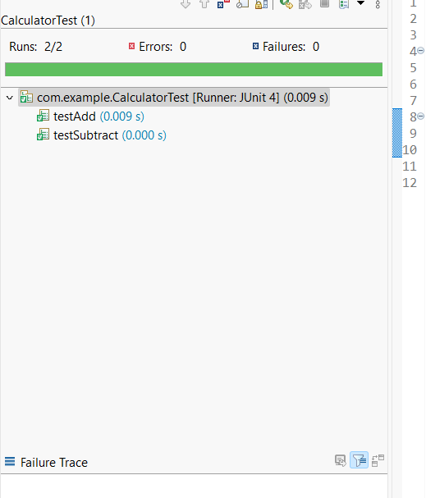

**3)**

**//Class Assertions**

package com.example;

import org.junit.Test;

import static org.junit.Assert.*;

public class AssertionsTest {

@Test

public void testAssertions() {

assertEquals(5, 2 + 3);

assertTrue(5 > 3);

assertFalse(5 < 3);

assertNull(null);

assertNotNull(new Object());

}

}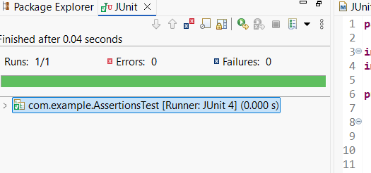

**4)**

**//Class BankAccount.java**

**package** com.example

**public** **class** BankAccount {

**private** **int** balance;

**public** BankAccount(**int** initialBalance) {

**this**.balance = initialBalance;

}

**public** **void** deposit(**int** amount) {

balance += amount;

}

**public** **void** withdraw(**int** amount) {

balance -= amount;

}

**public** **int** getBalance() {

**return** balance;

}

}

**//Class BankAccountTest.java**

**package** com.example;

**import** org.junit.After;

**import** org.junit.Before;

**import** org.junit.Test;

**import** **static** org.junit.Assert.*;

**public** **class** BankAccountTest

**private** BankAccount account;

@Before

**public** **void** setUp() {

account = **new** BankAccount(100);

System.***out***.println("Setting up the test account...");

}

@After

**public** **void** tearDown() {

account = **null**;

System.***out***.println("Cleaning up after test...");

}

@Test

**public** **void** testDeposit() {

account.deposit(50);

*assertEquals*(150, account.getBalance());

@Test

**public** **void** testWithdraw() {

account.withdraw(30);

*assertEquals*(70, account.getBalance());

}

}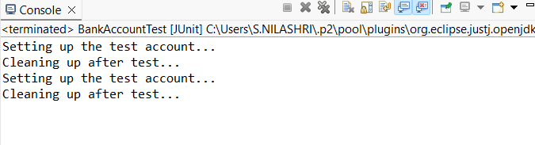

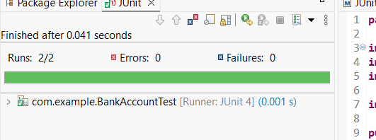

**Mokito**

**1)**

**//Interface ExternalApi**

**package** com.example;

**public** **interface** ExternalApi {

String getData();

}

**//Class MyService.java**

**package** com.example;

**public** **class** MyService {

**private** ExternalApi api;

**public** MyService(ExternalApi api) {

**this**.api = api;

}

**public** String fetchData() {

**return** api.getData();

}

}

**//Class MyServiceTest.java**

**package** com.example;

**import** **static** org.mockito.Mockito.*;

**import** **static** org.junit.jupiter.api.Assertions.*;

**import** org.junit.jupiter.api.Test;

**import** org.mockito.Mockito;

**public** **class** MyServiceTest {

@Test

**public** **void** testExternalApi() {

ExternalApi mockApi = Mockito.*mock*(ExternalApi.**class**);

*when*(mockApi.getData()).thenReturn("Mock Data");

MyService service = **new** MyService(mockApi);

String result = service.fetchData();

*assertEquals*("Mock Data", result);

}

}

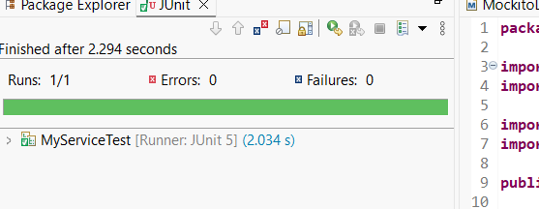

**2)**

**//Interface ExternalApi.java**

**package** com.example;

**public** **interface** ExternalApi {

String getData();

}

**//Class MyService.java**

**package** com.example;

**public** **class** MyService

**private** ExternalApi api;

**public** MyService(ExternalApi api) {

**this**.api = api;

}

**public** String fetchData() {

**return** api.getData();

}

}

**//Class MyServiceTest.java**

**package** com.example;

**import** **static** org.mockito.Mockito.*;

**import** **static** org.junit.jupiter.api.Assertions.*;

**import** org.junit.jupiter.api.Test;

**import** org.mockito.Mockito

**public** **class** MyServiceTest {

@Test

**public** **void** testVerifyInteraction() {

ExternalApi mockApi = Mockito.*mock*(ExternalApi.**class**);

MyService service = **new** MyService(mockApi);

service.fetchData();

*verify*(mockApi).getData();

}

}

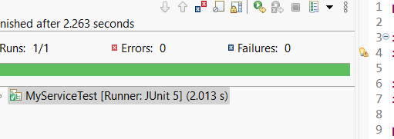

**Logging**

**1)**

**//Class LoggingExample.java**

**package** com.example;

**import** org.slf4j.Logger;

**import** org.slf4j.LoggerFactory;

**public** **class** LoggingExample {

**private** **static** **final** Logger ***logger*** = LoggerFactory.*getLogger*(LoggingExample.**class**);

**public** **static** **void** main(String[] args) {

***logger***.error("This is an error message");

***logger***.warn("This is a warning message");

}

}

