**1)**

**Scenario 1**

DECLARE

    CURSOR cust_cursor IS

        SELECT CustomerID, LoanInterestRate

        FROM Customers

        WHERE Age > 60;

BEGIN

    FOR cust_rec IN cust_cursor LOOP

        UPDATE Customers

        SET LoanInterestRate = LoanInterestRate - 0.01

        WHERE CustomerID = cust_rec.CustomerID;

    END LOOP;

    COMMIT;

END;

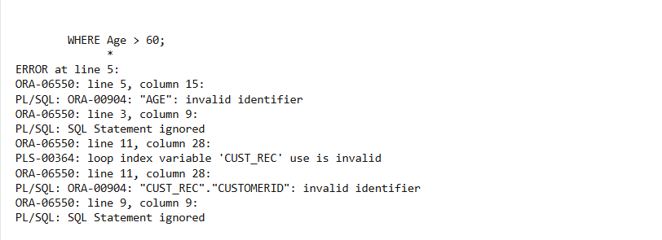

**Scenario 2**

ALTER TABLE Customers ADD (IsVIP VARCHAR2(5));

DECLARE

CURSOR vip_candidates IS

SELECT CustomerID

FROM Customers

WHERE Balance > 10000;

BEGIN

FOR rec IN vip_candidates LOOP

UPDATE Customers

SET IsVIP = 'TRUE'

WHERE CustomerID = rec.CustomerID;

END LOOP;

COMMIT;

END;

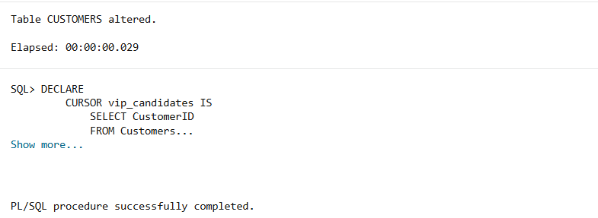

**Scenario 3**

DECLARE

CURSOR due_soon_loans IS

SELECT l.LoanID, c.Name, l.EndDate

FROM Loans l

JOIN Customers c ON l.CustomerID = c.CustomerID

WHERE l.EndDate <= SYSDATE + 30;

BEGIN

FOR rec IN due_soon_loans LOOP

DBMS_OUTPUT.PUT_LINE('Reminder: Loan ID ' || rec.LoanID ||

' for customer ' || rec.Name ||

' is due on ' || TO_CHAR(rec.EndDate, 'DD-MON-YYYY'));

END LOOP;

END;

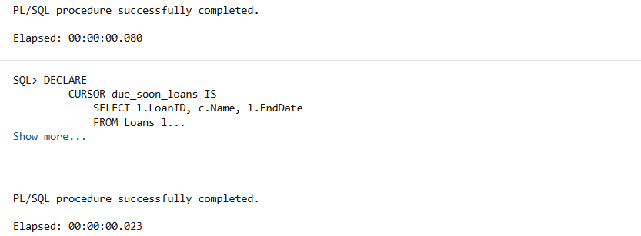

**3)**

**Scenario 1**

CREATE OR REPLACE PROCEDURE ProcessMonthlyInterest AS

BEGIN

UPDATE Accounts

SET Balance = Balance + (Balance * 0.01)

WHERE AccountType = 'Savings';

COMMIT;

END;

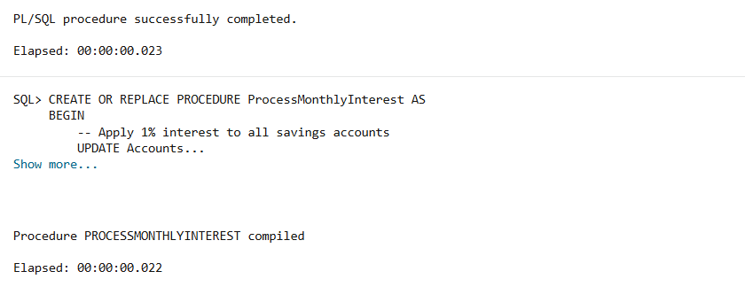

**Scenario 2**

CREATE OR REPLACE PROCEDURE UpdateEmployeeBonus(

p_Department IN VARCHAR2,

p_BonusPercent IN NUMBER

) AS

BEGIN

UPDATE Employees

SET Salary = Salary + (Salary * (p_BonusPercent / 100))

WHERE Department = p_Department;

COMMIT;

END;

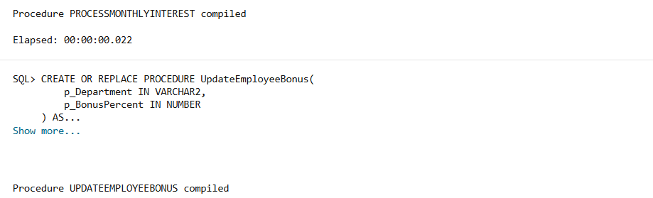

**Scenario 3**

CREATE OR REPLACE PROCEDURE TransferFunds(

    p_FromAccountID IN NUMBER,

    p_ToAccountID IN NUMBER,

    p_Amount IN NUMBER

) AS

    v_FromBalance NUMBER;

BEGIN

    SELECT Balance INTO v_FromBalance

    FROM Accounts

    WHERE AccountID = p_FromAccountID;

    IF v_FromBalance < p_Amount THEN

        RAISE_APPLICATION_ERROR(-20001, 'Insufficient funds in source account.');

    END IF;

    UPDATE Accounts

    SET Balance = Balance - p_Amount

    WHERE AccountID = p_FromAccountID;

    UPDATE Accounts

    SET Balance = Balance + p_Amount

    WHERE AccountID = p_ToAccountID;

    COMMIT;

END;

