1)

//main

**package** com.cognizant.spring_learn;

**import** org.slf4j.Logger;

**import** org.slf4j.LoggerFactory;

**import** org.springframework.boot.SpringApplication;

**import** org.springframework.boot.autoconfigure.SpringBootApplication;

@SpringBootApplication

**public** **class** SpringLearnApplication {

**private** **static** **final** Logger ***LOGGER*** = LoggerFactory.*getLogger*(SpringLearnApplication.**class**);

**public** **static** **void** main(String[] args) {

***LOGGER***.info("START");

SpringApplication.*run*(SpringLearnApplication.**class**, args);

***LOGGER***.info("END");

}

}

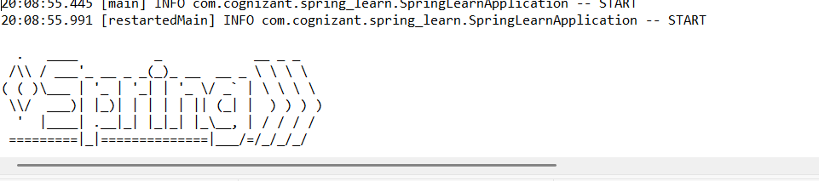

2)

//main

**package** com.cognizant.spring_learn;

**import** java.text.ParseException;

**import** java.text.SimpleDateFormat;

**import** java.util.Date;

**import** org.slf4j.Logger;

**import** org.slf4j.LoggerFactory;

**import** org.springframework.boot.SpringApplication;

**import** org.springframework.boot.autoconfigure.SpringBootApplication;

**import** org.springframework.context.ApplicationContext;

**import** org.springframework.context.support.ClassPathXmlApplicationContext;

@SpringBootApplication

**public** **class** SpringLearnApplication {

**private** **static** **final** Logger ***LOGGER*** = LoggerFactory.*getLogger*(SpringLearnApplication.**class**);

**public** **static** **void** main(String[] args) {

***LOGGER***.info("START");

SpringApplication.*run*(SpringLearnApplication.**class**, args);

*displayDate*();

***LOGGER***.info("END");

}

**public** **static** **void** displayDate() {

ApplicationContext context = **new** ClassPathXmlApplicationContext("date-format.xml");

SimpleDateFormat format = context.getBean("dateFormat", SimpleDateFormat.**class**);

**try** {

Date parsedDate = format.parse("31/12/2018");

System.***out***.println("Parsed Date: " + parsedDate);

} **catch** (ParseException e) {

e.printStackTrace();

}

}

}

//.xml

<?xml version="1.0" encoding="UTF-8"?>

<beans xmlns="http://www.springframework.org/schema/beans"

xmlns:xsi="http://www.w3.org/2001/XMLSchema-instance"

xsi:schemaLocation="http://www.springframework.org/schema/beans

https://www.springframework.org/schema/beans/spring-beans.xsd">

<bean id="dateFormat" class="java.text.SimpleDateFormat">

<constructor-arg value="dd/MM/yyyy" />

</bean>

</beans>

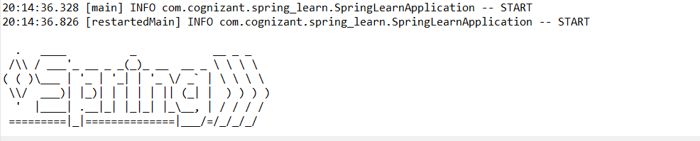

3)

//main

**package** com.cognizant.spring_learn;

**import** org.slf4j.Logger;

**import** org.slf4j.LoggerFactory;

**import** org.springframework.boot.SpringApplication;

**import** org.springframework.boot.autoconfigure.SpringBootApplication;

@SpringBootApplication

**public** **class** SpringLearnApplication {

**private** **static** **final** Logger ***LOGGER*** = LoggerFactory.*getLogger*(SpringLearnApplication.**class**);

**public** **static** **void** main(String[] args) {

***LOGGER***.info("START");

SpringApplication.*run*(SpringLearnApplication.**class**, args);

***LOGGER***.info("END");

}

}

//HelloController

**package** controller;

**import** org.slf4j.Logger;

**import** org.slf4j.LoggerFactory;

**import** org.springframework.web.bind.annotation.GetMapping;

**import** org.springframework.web.bind.annotation.RestController;

@RestController

**public** **class** HelloController {

**private** **static** **final** Logger ***LOGGER*** = LoggerFactory.*getLogger*(HelloController.**class**);

@GetMapping("/hello")

**public** String sayHello() {

***LOGGER***.info("START - sayHello()");

String message = "Hello World!!";

***LOGGER***.info("END - sayHello()");

**return** message;

}

}

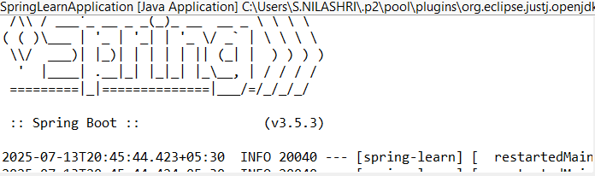

4)

//Model

**package** com.cognizant.spring_learn;

**public** **class** Country {

**private** String code;

**private** String name;

**public** Country() {}

**public** Country(String code, String name) {

**this**.code = code;

**this**.name = name;

}

**public** String getCode() {

**return** code;

}

**public** **void** setCode(String code) {

**this**.code = code;

}

**public** String getName() {

**return** name;

}

**public** **void** setName(String name) {

**this**.name = name;

}

}

//xml

<?xml version="1.0" encoding="UTF-8"?>

<beans xmlns="http://www.springframework.org/schema/beans"

xmlns:xsi="http://www.w3.org/2001/XMLSchema-instance"

xsi:schemaLocation="http://www.springframework.org/schema/beans

https://www.springframework.org/schema/beans/spring-beans.xsd">

<bean id="in" class="com.cognizant.spring_learn.model.Country">

<property name="code" value="IN" />

<property name="name" value="India" />

</bean>

</beans>

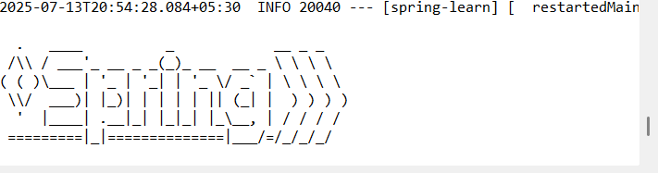

5)

//xml

<?xml version="1.0" encoding="UTF-8"?>

<beans xmlns="http://www.springframework.org/schema/beans"

xmlns:xsi="http://www.w3.org/2001/XMLSchema-instance"

xsi:schemaLocation="http://www.springframework.org/schema/beans

https://www.springframework.org/schema/beans/spring-beans.xsd">

<bean id="countryIN" class="com.cognizant.spring_learn.model.Country">

<property name="code" value="IN" />

<property name="name" value="India" />

</bean>

<bean id="countryUS" class="com.cognizant.spring_learn.model.Country">

<property name="code" value="US" />

<property name="name" value="United States" />

</bean>

<bean id="countryCN" class="com.cognizant.spring_learn.model.Country">

<property name="code" value="CN" />

<property name="name" value="China" />

</bean>

<!-- Define a list of countries -->

<util:list id="countryList" value-type="com.cognizant.spring_learn.model.Country">

<ref bean="countryIN"/>

<ref bean="countryUS"/>

<ref bean="countryCN"/>

</util:list>

</beans>

//CountryService

**package** com.cognizant.spring_learn;

**import** org.springframework.context.ApplicationContext;

**import** org.springframework.context.support.ClassPathXmlApplicationContext;

**import** org.springframework.stereotype.Service;

**import** java.util.List;

**import** java.util.Optional;

@Service

**public** **class** CountryService {

**private** List<Country> countryList;

**public** CountryService() {

ApplicationContext context = **new** ClassPathXmlApplicationContext("country.xml");

countryList = (List<Country>) context.getBean("countryList");

}

**public** Country getCountry(String code) {

Optional<Country> country = countryList.stream()

.filter(c -> c.getCode().equalsIgnoreCase(code))

.findFirst();

**return** country.orElse(**null**); // or throw exception if preferred

}

}

//ountryController

package com.cognizant.spring_learn.controller;

import com.cognizant.spring_learn.model.Country;

import com.cognizant.spring_learn.service.CountryService;

import org.slf4j.Logger;

import org.slf4j.LoggerFactory;

import org.springframework.beans.factory.annotation.Autowired;

import org.springframework.web.bind.annotation.*;

@RestController

public class CountryController {

private static final Logger LOGGER = LoggerFactory.getLogger(CountryController.class);

@Autowired

private CountryService countryService;

@GetMapping("/countries/{code}")

public Country getCountry(@PathVariable String code) {

LOGGER.info("START - getCountry with code: {}", code);

Country country = countryService.getCountry(code);

LOGGER.info("END - getCountry with code: {}", code);

return country;

}

}

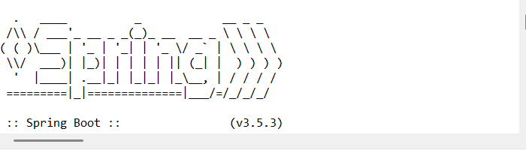

6)

//pom.xml

<dependency>

<groupId>io.jsonwebtoken</groupId>

<artifactId>jjwt</artifactId>

<version>0.9.1</version>

</dependency>

<dependency>

<groupId>org.springframework.boot</groupId>

<artifactId>spring-boot-starter-security</artifactId>

</dependency>

//AuthenticationController

package com.cognizant.spring_learn.controller;

import com.cognizant.spring_learn.util.JwtUtil;

import jakarta.servlet.http.HttpServletRequest;

import org.springframework.http.ResponseEntity;

import org.springframework.web.bind.annotation.*;

import java.util.Base64;

@RestController

public class AuthenticationController {

@GetMapping("/authenticate")

public ResponseEntity<?> authenticate(HttpServletRequest request) {

String authHeader = request.getHeader("Authorization");

if (authHeader == null || !authHeader.startsWith("Basic ")) {

return ResponseEntity.status(401).body("Missing or invalid Authorization header");

}

String base64Credentials = authHeader.substring("Basic ".length());

String credentials = new String(Base64.getDecoder().decode(base64Credentials));

String[] parts = credentials.split(":", 2);

if (parts.length != 2) {

return ResponseEntity.status(400).body("Invalid Basic authentication format");

}

String username = parts[0];

String password = parts[1];

if (!"user".equals(username) || !"pwd".equals(password)) {

return ResponseEntity.status(401).body("Invalid credentials");

}

String token = JwtUtil.generateToken(username);

return ResponseEntity.ok().body("{\"token\":\"" + token + "\"}");

}

}

//SecurityConfig

package com.cognizant.spring_learn.config;

import org.springframework.context.annotation.Bean;

import org.springframework.context.annotation.Configuration;

import org.springframework.security.config.annotation.web.configuration.*;

import org.springframework.security.web.SecurityFilterChain;

import org.springframework.security.config.annotation.web.builders.HttpSecurity;

@Configuration

@EnableWebSecurity

public class SecurityConfig {

@Bean

public SecurityFilterChain filterChain(HttpSecurity http) throws Exception {

http

.csrf(csrf -> csrf.disable())

.authorizeHttpRequests(auth -> auth

.requestMatchers("/authenticate").permitAll()

.anyRequest().authenticated()

)

.httpBasic();

return http.build();

}

}

//JwtUtil

package com.cognizant.spring_learn.util;

import io.jsonwebtoken.Jwts;

import io.jsonwebtoken.SignatureAlgorithm;

import java.util.Date;

public class JwtUtil {

private static final String SECRET_KEY = "secretkey123456";

public static String generateToken(String username) {

return Jwts.builder()

.setSubject(username)

.setIssuedAt(new Date(System.currentTimeMillis()))

.setExpiration(new Date(System.currentTimeMillis() + 10 * 60 * 1000)) // 10 mins

.signWith(SignatureAlgorithm.HS256, SECRET_KEY)

.compact();

}

}

