**2**

**//AccountController.java:**

package com.cognizant.account;

import org.springframework.web.bind.annotation.GetMapping;

import org.springframework.web.bind.annotation.PathVariable;

import org.springframework.web.bind.annotation.RestController;

import java.util.Map;

@RestController

public class AccountController {

@GetMapping("/accounts/{number}")

public Map<String, Object> getAccountDetails(@PathVariable String number) {

return Map.*of*(

"number", number,

"type", "savings",

"balance", 234343

);

}

}

**//AccountApplication.java:**

package com.cognizant.account;

import org.springframework.boot.SpringApplication;

import org.springframework.boot.autoconfigure.SpringBootApplication;

@SpringBootApplication

public class AccountApplication {

public static void main(String[] args) {

SpringApplication.*run*(AccountApplication.class, args);

}

}

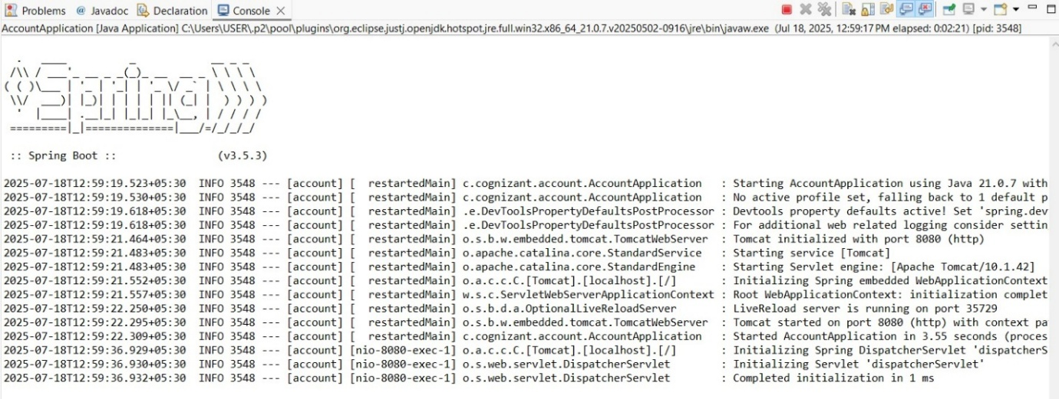

**//LoanController.java:**

package com.cognizant.loan;

import org.springframework.web.bind.annotation.GetMapping;

import org.springframework.web.bind.annotation.PathVariable;

import org.springframework.web.bind.annotation.RestController;

import java.util.Map;

@RestController

public class LoanController {

@GetMapping("/loans/{number}")

public Map<String, Object> getLoanDetails(@PathVariable String number) {

return Map.*of*(

"number", number,

"type", "home loan",

"amount", 500000

);

}

}

**//LoanApplication.java:**

package com.cognizant.loan;

import org.springframework.boot.SpringApplication;

import org.springframework.boot.autoconfigure.SpringBootApplication;

@SpringBootApplication

public class LoanApplication {

public static void main(String[] args) {

SpringApplication.*run*(LoanApplication.class, args);

}

}

**Output:**

