CONTENTS

1) Introduction to the project…………………………………..
2) Introduction to OPEN GL…………………………………….
3) Flow chart………………………………………………………
5) Snapshots……………………………………………………..
6) REFERENCES……………………………………………………

INTRODUCTION TO THE PROJECT
The aim of the project is to give a demo of a moving object with different colored light sources reflecting on it.the is on WTC PLANE CRASH,wtc stands for world trade centre which was attacked by terrorist on the date of 9/11,in this project we tried to show the simulation of the attacked on wtc
The software is developed for user convenience using the concept of GUI. Here the user is interactive with the simulation through menu and keyboard interface concepts containing multiple windows having the information of keyboard controls, object information and Simulation. This software is an excellent tool that can be used as a simulator to explain about the multilights.

INTRODUCTION TO OPEN GL

OpenGL is a low-level graphics library specification. It makes available to the programmer a small set of geomteric primitives - points, lines, polygons, images, and bitmaps. OpenGL provides a set of commands that allow the specification of geometric objects in two or three dimensions, using the provided primatives, together with commands that control how these objects are rendered (drawn).
Since OpenGL drawing commands are limited to those that generate simple geometric primitives (points, lines, and polygons), the OpenGL Utility Toolkit (GLUT) has been created to aid in the development of more complicated three-dimensional objects such as a sphere, a torus, and even a teapot. GLUT may not be satisfactory for full-featured OpenGL applications, but it is a useful starting point for learning OpenGL.
GLUT simplifies the implementation of programs using OpenGL rendering. The GLUT application programming interface (API) requires very few routines to display a graphics scene rendered using OpenGL. The GLUT routines also take relatively few parameters
Libraries :
OpenGL provides a powerful but primitive set of rendering command, and all higher-level drawing must be done in terms of these commands. There are several libraries that allow you to simplify your programming tasks, including the following:
- OpenGL Utility Library (GLU) contains several routines that use lower-level OpenGL commands to perform such tasks as setting up matracies for specific viewing orientations and projections and rendering surfaces.
- OpenGL Utility Toolkit (GLUT) is a window-system-independent toolkit, written by Mark Kilgard, to hide the complexities of differing window APIs
Include Files
For all OpenGL applications, you want to include the stdio.h header file in every file. Almost all OpenGL applications use GLU. So almost every OpenGL source file begins with:
#include <stdio.h>
#include <GL/glut.h>
If you are using the OpenGL Utility Toolkit (GLUT) for managing your window manager tasks, you should include.
Note that glut.h guarantees that gl.h and glu.h are properly included for you so including these three files is redundant. To make your GLUT programs portable, include glut.h and do not include gl.h or glu.h explicitly.

Implementation
We have used some of the inbuilt functions of the graphics package like
Specifying simple geometry:
- Void glBegin(glEnum mode)
Initiates a new primitive of type mode and starts the collection of vertices. Values of mode include GL_POINTS, GL_LINES and GL_POLYGON.
- Void glEnd()
Terminates a list of vertices.

Attributes:
- Void glColor3[b i f d ub us ui](TYPE r ,TYPE g,TYPE b,TYPE a)
Sets the present RGB colors. Valid types are byte (b), int (i), float (f), double (d), unsigned byte (ub), unsigned short (us), and unsigned int (ui).
- Void glClearColor(GLclampf r,GLclampf g,GLclampf b,GLclampf a)
Sets the present RGBA clear color used when clearing the color buffer. Variables of type GLclampf are floating point numbers between 0.0 and 1.0.
- Void glPointSize(GLfloat size)
Sets the point size attribute in pixels.
Working with the window system
- Void glFlush()
Forces any buffered OpenGL commands to execute.
- Void glutInit(int *argc,char **argv)
Initializes GLUT. The arguments from main are passed in and can be used by the application.
- Int glutCreateWindow(char *title)
Creates a window on the display. The string title can be used to label the window. The return value provides a reference to the window that can be used when there are multiple windows.
- Void glutInitDisplayMode(unsigned int mode)
Requests a display with the properties in mode. The value of mode is determined by the logical OR of options including the color model (GLUT_RGB, GLUT_INDEX) and buffering (GLUT_SINGLE, GLUT_DOUBLE).
- Void glutInitWindowSize(int width, int height)
Specifies the initial height and width of the window in pixels.
- Void glutInitWindowPosition(int x,int y)
Specifies the initial position of the top-left corner of the window in pixels.
- Void glViewport(int x,int y,GLsizei width,GLsizei height)
Specifies a width x height viewport in pixels whose lower-left corner is at(x, y) measured from the origin of the window.
- Void glutMainLoop()
Cause the program to enter an event-processing loop. It should be the last statement in main.
- Void glutDisplayFunc(void (*func)(void))
Registers the display function func that is executed when the window needs to be redrawn.
- Void glutPostRedisplay()
Requests that the display callback be executed after the current callback returns.
- Void glutSwapBuffers()
Swaps the front and back buffers.
Interaction
- Void glutReshapeFunc(void *f(int width,int height)
Registers the reshape callback function f.The callback function returns the height and width of the new window. The reshape callback invokes display callback.
- Void glutKeyboardFunc(void *f(char key,int width,int height)
Registers the keyboard callback function f. The callback function returns the ASCII code of the key pressed and the position of the mouse.
- Void glutIdleFunc(void (*f)(void))
Registers the display callback function f that is executed whenever there are no other events to be handled.
- Int glutCreateMenu(void (*f)(int value))
Returns an identifier for a top-level menu and registers the callback function f that returns an integer value corresponding to the menu entry selected.
- Void glutAddMenuEntry(char *name,int value)
Adds an entry with the string name displayed to the current menu. Value is returned to the menu callback when the entry is selected.

Transformations
- Void glMatrixMode(GLenum mode)
Specifies which matrix will be affected by subsequent transactions. Mode can be GL_MODEL_VIEW, GL_PROJECTION, or GL_TEXTURES.
- Void glLoadIdentity()
Sets the current transformation matrix to an identity matrix.
- Void glPushMatrix()
Void glPopMatrix ()
Pushes to and pops from the matrix stack corresponding to the current matrix mode.
- Void glRotate[fd](TYPE angle,TYPE dx,TYPE dy,TYPE dz)
Alters the current matrix by a rotation of angle degrees about the axis (dx, dy, dz).TYPE is either GLfloat or GLdouble.
- Void glTranslate[fd](TYPE x,TYPE y,TYPE z)
Alters the current matrix by a displacement of (x, y, z).TYPE is either GLfloat or GLdouble.
Viewing
- Void gluOrtho2D(GLdouble left, GLdouble right, GLdouble bottom, GLdouble top)
Defines a two dimensional viewing rectangle in the plane z=0.
- Void gluPerspective(GLdouble fov,GLdouble aspect, GLdouble near, GLdouble far)
Defines a perspective viewing volume using the y direction field of view fov measured in degrees, the aspect ratio of the front clipping plane, and the near and far distances.

Function to create objects
- void building();
- void building2();
- void outline();
- void blast();
- void road();
- void build_outline();
- void build_outline2();
- void trees();
- void mountain();
- void frontscreen();

FLOW CHART
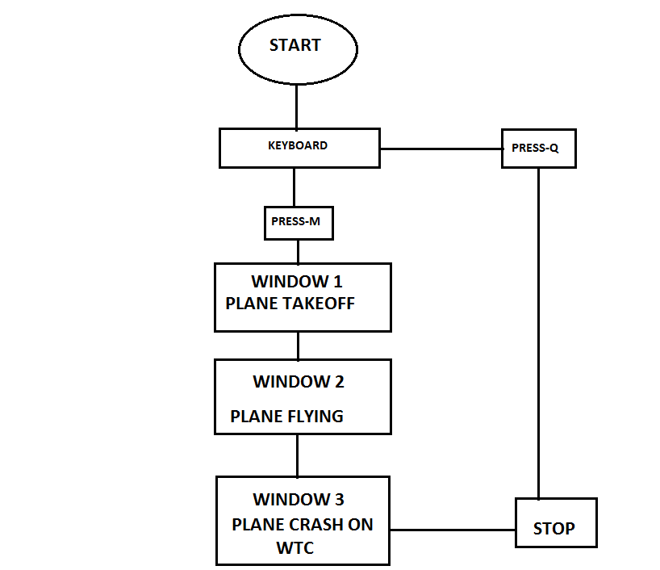

SNAPSHOT
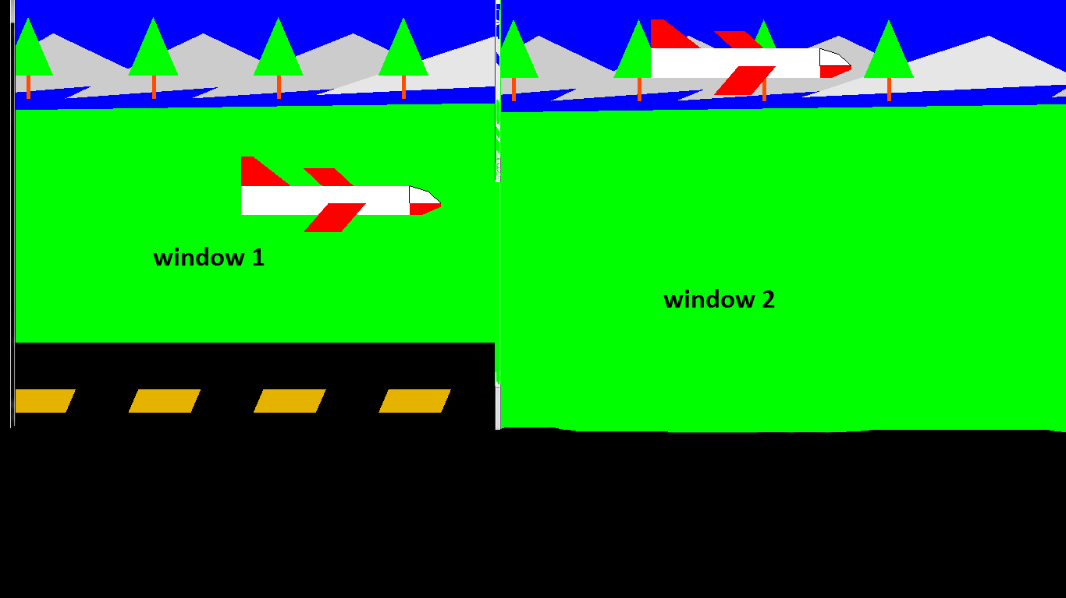
Fig (1): window-1 & window-2

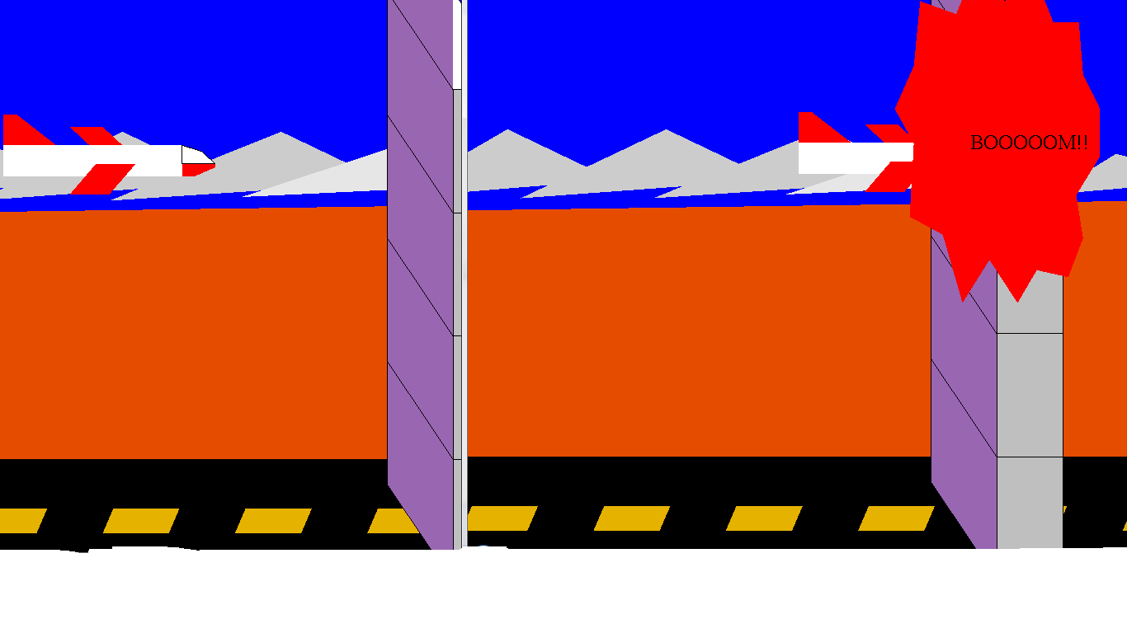
Fig (2):plane crash window-3
REFERENCES
Computer Graphics
Computer Graphics using OPENGL
- F.S.Hill
- James.D Foley, Andries Van Dam ,Steven.K Feiner
- Edward Angel
Computer Graphics
- Donald H and M. Pauline Baker.
C programming
- LET US C By Yeshwanth Kanetkar.
- Peter Norton’s advanced C programming.

