CS-7641-001 MC2-Project2

gatech ID : nghosh9

Contents

1 Part 1 1

1.1 Bollinger Band strategy chart. 1

1.2 Bollinger Band strategy backtest chart. 1

1.3 Summary of Bollinger Band backtest performance metrics. 2

2 Part 2 2

2.1 Written description of your strategy idea. You will be graded on the clarity of your description and also on how compelling an idea it is. 2

2.2 Chart or charts that illustrate your strategy idea. At least one of the charts should be similar to the Bollinger Band strategy chart. 3

2.3 Backtest chart of your strategy 3

2.4 Analysis of the performance of your strategy over the 2008-2009 period. Note that your strategy should outperform the Bollinger band strategy. 4

2.5 Summary of backtest performance metrics. 4

# Part 1

## Bollinger Band strategy chart.

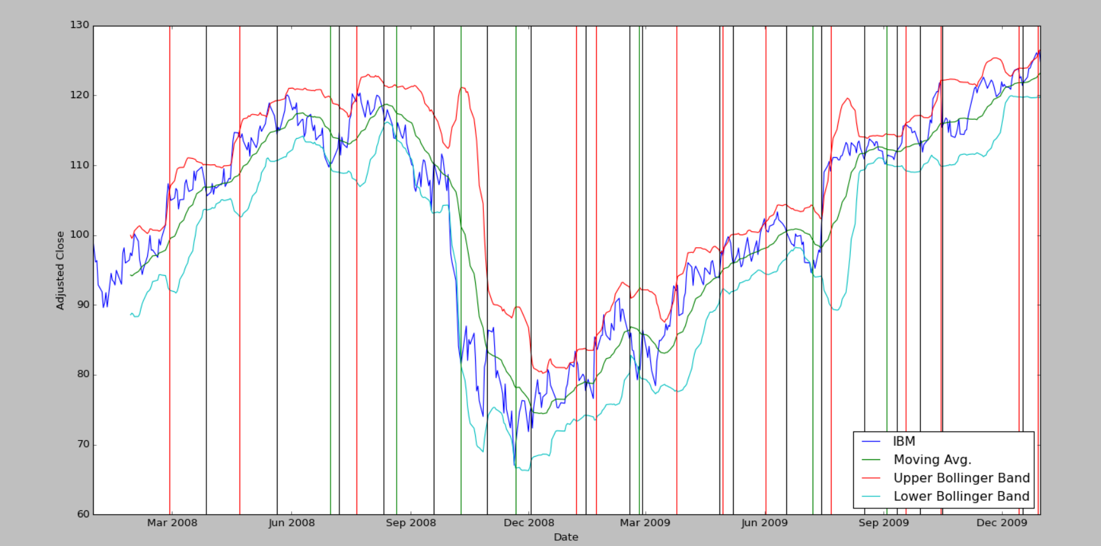

## Bollinger Band strategy backtest chart.

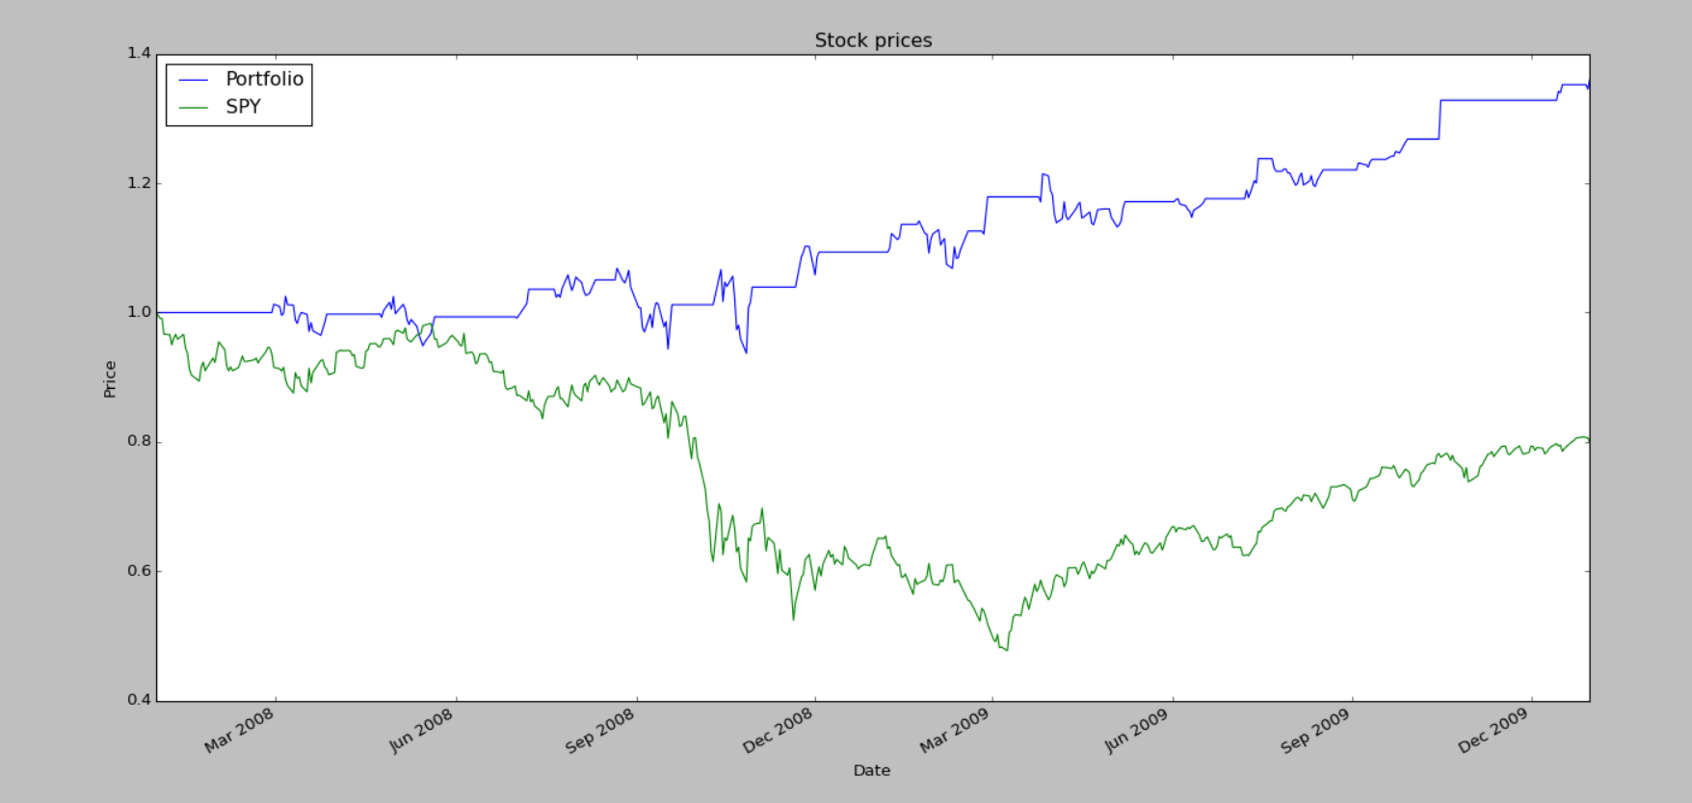

## Summary of Bollinger Band backtest performance metrics.

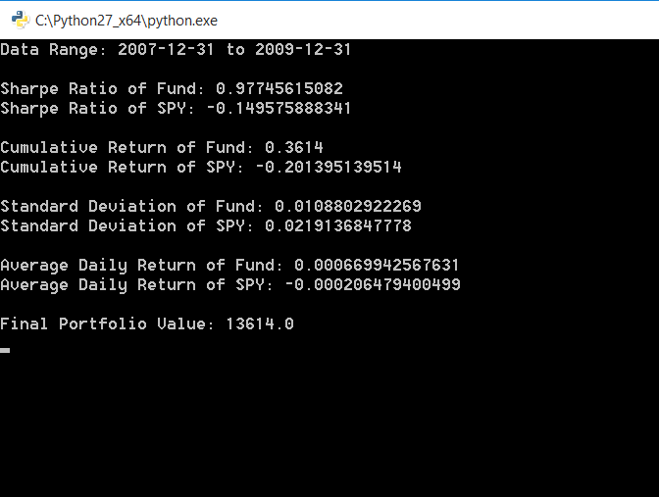

# Part 2

## Written description of your strategy idea. You will be graded on the clarity of your description and also on how compelling an idea it is.

In the Bollinger band strategy applied in Part 1 we were focussing only on the price movements of IBM over the period and not looking to take advantage from the larger market movements.

As part of my own strategy I decide to also factor in the price movements of SPY (which is a pretty good indicator of the market movements). The idea was to go more aggressive when going long and short if the Bollinger indicators for the market were correlated with the indicators for the IBM stock.

Eg.

Consider the following scenario

|  |  |
| --- | --- |
| **SPY** | **IBM** |
|  |  |

On 01-07-2008 IBM has a long signal to buy**. Since SPY is already going through a BUY signal phase (09-06-2008 to 22-07-2008)**, I decided **to go more aggressive** and **use more of my leverage to buy 150 shares instead of the usual 100.**

A similar logic is followed when going short as well. The idea is to go aggressive to take advantage of the information that the market as a whole is also indicating bullish/bearish instincts.

## Chart or charts that illustrate your strategy idea. At least one of the charts should be similar to the Bollinger Band strategy chart.

The chart below shows the various entry (long, aggressive long, short and aggressive short entries)

* red line : short entry
* orange line : aggressive short entry
* green line : long entry
* brown line : aggressive long entry

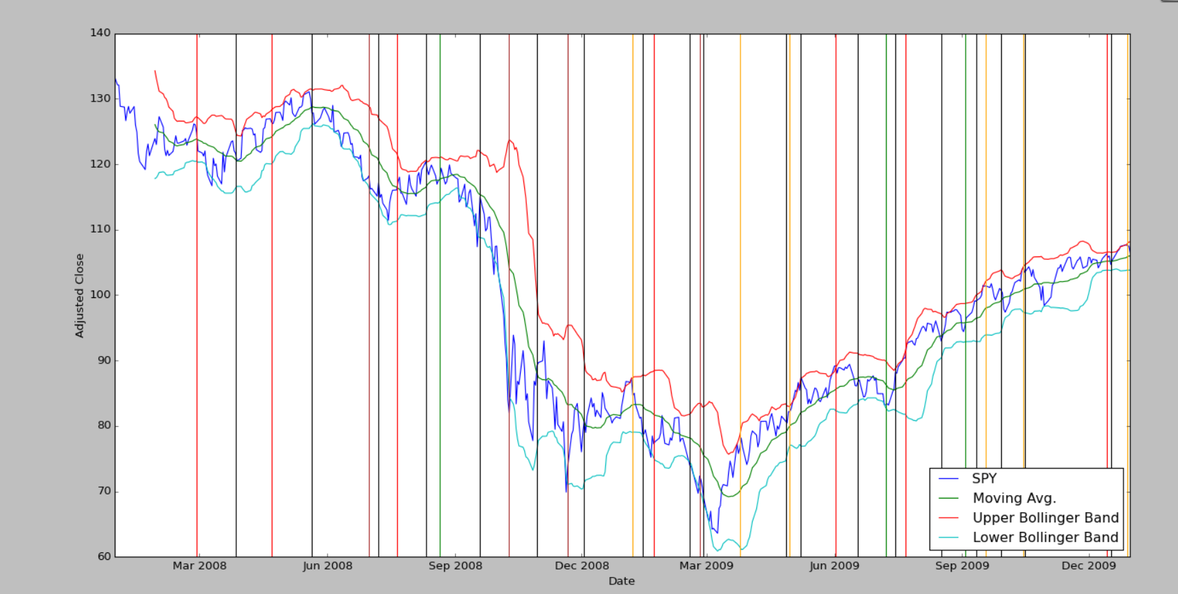

## Backtest chart of your strategy

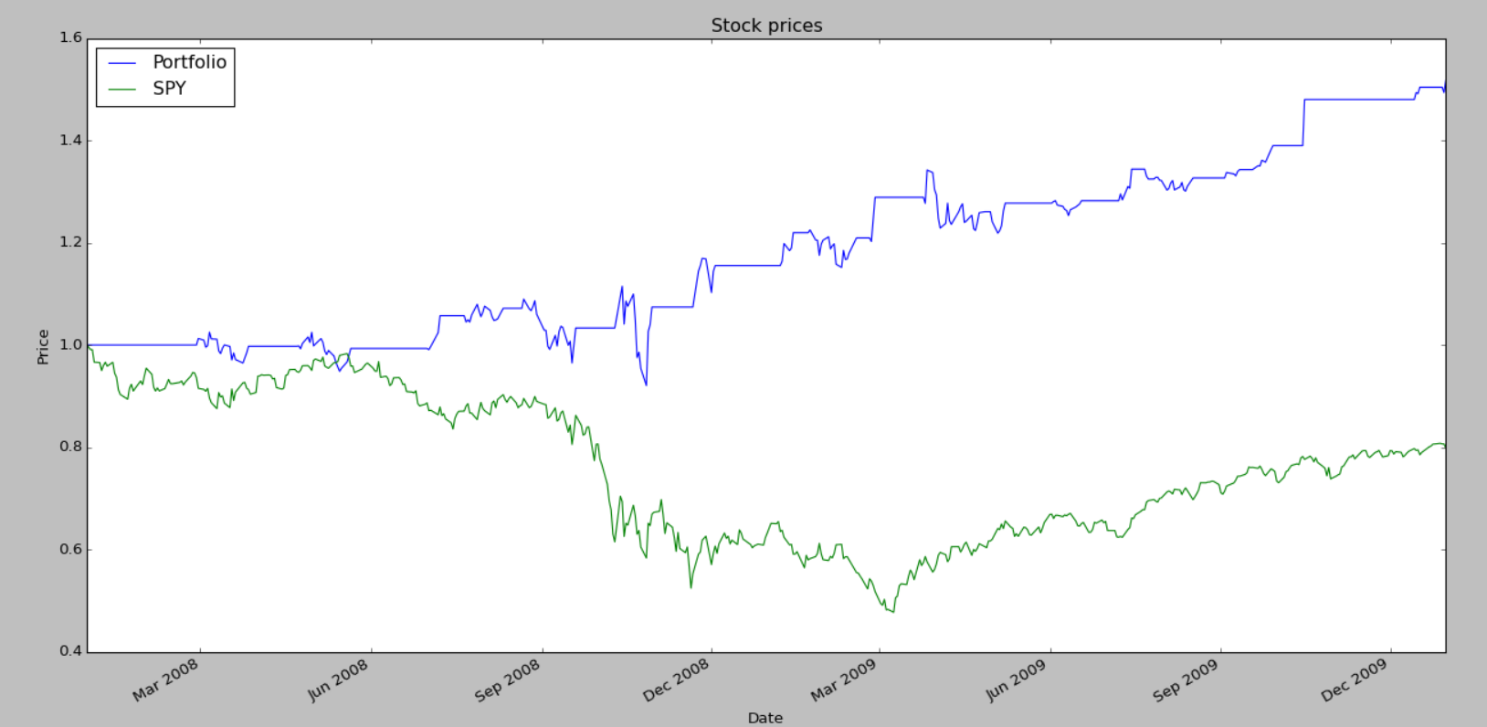

## Analysis of the performance of your strategy over the 2008-2009 period. Note that your strategy should outperform the Bollinger band strategy.

New Orders file:



The strategy outperforms the Bollinger band strategy in Part 1

Final Portfolio Value (Part 1) : $13,164

Final Portfolio Value (Part 2) : $15,178

The aggressive strategy (correlate with market movements) meant that on atleast 10 occasions over the 2 year period we made larger (150 shares instead of 100) long and short entry/exits which led to substantially better returns.

## Summary of backtest performance metrics.

