Home Assignment

Topic : COVID-19

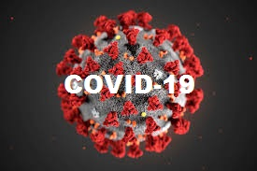

Name : Nilay

Class : Not available

Roll no. Not available

Subject : General Science

Introduction

**What is COVID-19?**

**Coronavirus** disease (**COVID-19**) is an infectious disease caused by a newly discovered **coronavirus**. Most people infected with the **COVID-19** virus will experience mild to moderate respiratory illness and recover without requiring special treatment.

This new virus and disease were unknown before the outbreak began in Wuhan city, China, in December 2019. The most common symtoms of **COVID-19** are fever, tiredness, and dry cough.

Older people and those with underlying medical problems like *cardiovascular disease*, *diabetes*, *chronic respiratory disease* and *cancer* are more likely to develop serious illness.

The **COVID-19** virus spreads primarily through droplets of saliva or discharge from the nose when an infected person coughs or sneezes. so it’s important that we should also practice respiratory etiquette (*for example, by coughing into a flexed elbow*).

Causes

The **coronavirus** disease (**COVID-19**) is caused by a virus, not by bacteria.  
  
The virus that causes **COVID-19** is in a family of viruses called **Coronaviridae**. Antibiotics do not work against viruses. Some people who become ill with COVID-19 can also develop a bacterial infection as a complication. In this case, antibiotics may be recommended by a health care provider. There is currently no licensed medication to cure COVID-19. If you have symptoms, call our health care provider or COVID-19 hotline for assistance.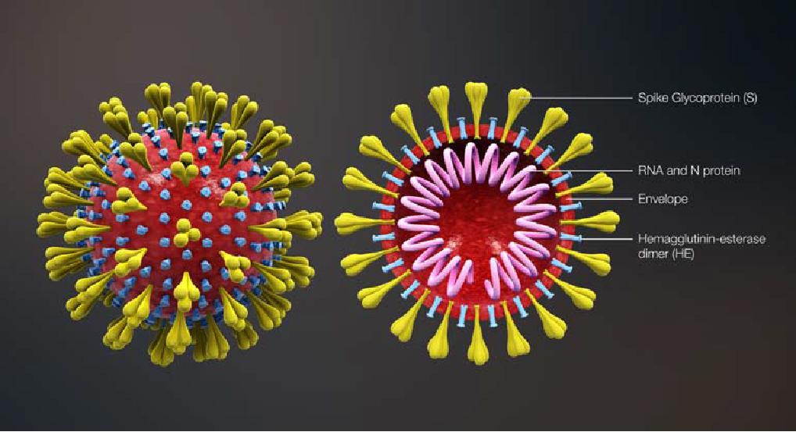

Prevention of COVID-19

To prevent the spread of COVID-19:

* *Clean our hands often. Use soap and water or an alcohol-based hand sanitizer.*
* *Maintain a safe distance from anyone who is coughing or sneezing.*
* *Wear a mask and gloves when physical distancing is not possible.*
* *Don’t touch our eyes, nose or mouth.*
* *Cover our nose and mouth with our bent elbow or a tissue papers when we cough or sneeze.*
* *Stay home if we feel unwell.*
* *If we have a fever, cough and difficulty breathing, seek medical attention.*

*Calling in advance allows our healthcare provider to quickly direct us to the right health facility. This protects us and prevents the spread of viruses and other infections.*

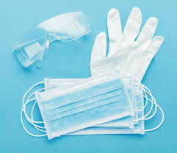 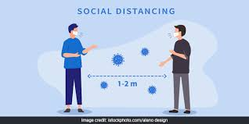

Awareness campaign against COVID-19 in our locality

Understanding the threat and the speed of spread of **coronavirus** in the world, our locality also need to prevent itself and for that awareness and information on person hygiene and social distancing is realized before it’s too late. The main purpose of the campaign is to create awareness to prevent the transmission of the coronavirus and to teach public about the effective ways of hand washing techniques and safety measures. The **WHO** data shows millions of infection and transmission of virus. Developed countries like USA, Italy, China and France are also facing the havoc and are unable to control it. Major cities, countries have set **lockdown** and the world economics is being declining. The only measure to control the situation is to keep social distancing to prevent contamination and transmission of disease form personal contacts. No infrastructure and system, technologies can stop epidemic completely instead human behavior and hygiene can.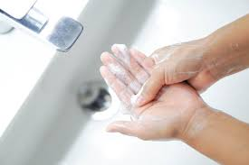

Role of doctors in fighting against COVID-19

The **COVID-19** pandemic has impacted the doctors and healthcare workers physically and psychologically. the doctors are more vulnerable to COVID-19 infection than the general population due to frequent contact with infected individuals. Doctors have been required to work under stressful conditions without proper protective equipment and make difficult decisions involving ethical implications. Health and social systems across the globe are struggling to cope. The situation is especially challenging in humanitarian, fragile and low-income country contexts, where health and social systems are already weak.

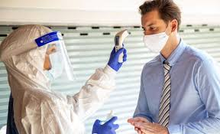

Conclusion

Our science teacher Arunav sir told us to make this assignment. This assignment is about the COVID-19 virus. In this assignment, I have given the causes of COVID-19, measues of prevent the spread of COVID-19, awareness campaign against COVID-19 in our locality and the role of doctors fighting against COVID-19.We will have to follow the prevention measure till the vaccine comes to the market.

Thanks to Arunav sir for giving ideas for this assignment.