**E-COMMERCE SALES**

**1. PROJECT DESCRIPTION**

In this project, I will perform comprehensive data analysis on e-commerce data to gain actionable insights and drive business decisions. Our focus will be on using data visualization tools like Tableau to analyze and present data clearly and effectively. The main aim of this project proposal is to leverage data-driven analysis to increase profitability and stimulate business growth in the e-commerce industry. Our goal is to provide actionable recommendations that enable e-commerce businesses to improve their financial performance and achieve sustainable competitive advantage by leveraging advanced analysis techniques and insights derived from e-commerce data.

**2. PROJECT OBJECTIVES**

The objective of this project is to analyze e-commerce data using big data techniques and tools, and to present the results using effective data visualization methods. The specific goals of this project include:

* Analyzing sales by years and months and whether the sales rate increased or decreased compared to the previous year,
* Analysis of profit by years and months and whether the profit rate increased or decreased compared to the previous year,
* Analysis of the order quantity by years and months and how much it increased or decreased compared to the previous year,
* Market share analysis according to sales,
* Analysis of category-based sales totals during the year and how much category-based sales increased or decreased compared to the previous year,
* Analysis of customer acquisition on a market basis by month.

**3. DATA SOURCE**

The data for this project will be obtained from Kaggle, a popular data science platform. <https://drive.google.com/file/d/1VenmPy5rLs50w0k_9qrH_FS20kJ42toW/view>

The dataset includes the following information: **20 fields and 115746 rows**

**Fields:** AdditionalOrderitems(String), CategoryName(String), CustomerCity(String), CustomerCountry(String), CustomerFname(String), CustomerId(Number), CustomerSegment(String), CustomerState(String), CustomerZipcode(Number), Market(String), OrderCustomerId(Number), OrderDate(Date), OrderId(Number), OrderRegion(String), OrderItemTotal(Number), OrderQuantity(Number), ProductPrice(Number), ProfitMargin(Number), ProfitPerOrder(Number), Sales(Number).

**4. TABLEAU PART (QUESTIONS AND LEARNINGS)**

**4.1 Sales:**

**What is the annual total sales amount and the sales percentage (decrease-increase) compared to the previous year?**

* Total Sales in 2017: $ 14.109.725
* Percentage of sales according to the previous year: 0,05037%

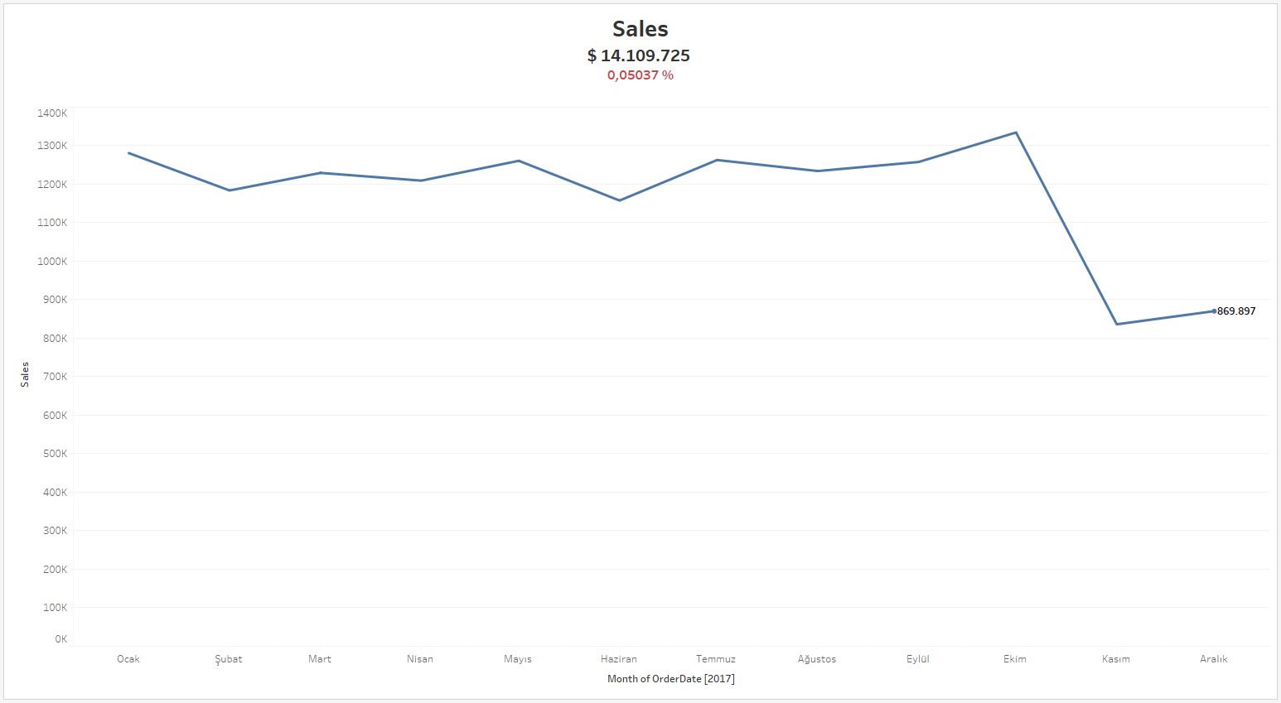

**Formulas used when creating the chart;**

* **YearToDate Sales:** This field calculates the total sales for the current year up to the date represented by the latest data point in the chart. { FIXED : SUM(IF YEAR ([OrderDate]) = {MAX (YEAR ([OrderDate]))} THEN [Sales] END)}
* **Previous YearToDate Sales:**  This field calculates the total sales for the year preceding the current year. { FIXED : SUM(IF YEAR ([OrderDate]) = {MAX (YEAR ([OrderDate]))-1} THEN [Sales] END)}
* **YearOnYear Sales:**  This field compares the sales performance between the current and previous years.This provides a percentage increase or decrease in sales compared to the prior year. ([YearToDate Sales]-[PrevYearToDate Sales])/[PrevYearToDate Sales]

**4.2 Profit:**

**What is the annual total profit amount and the profit percentage (increase-decrease) compared to the previous year?**

* Total Profits in 2017: $ 1.304.085
* Percentage of profits according to the previous year: -0,004606%

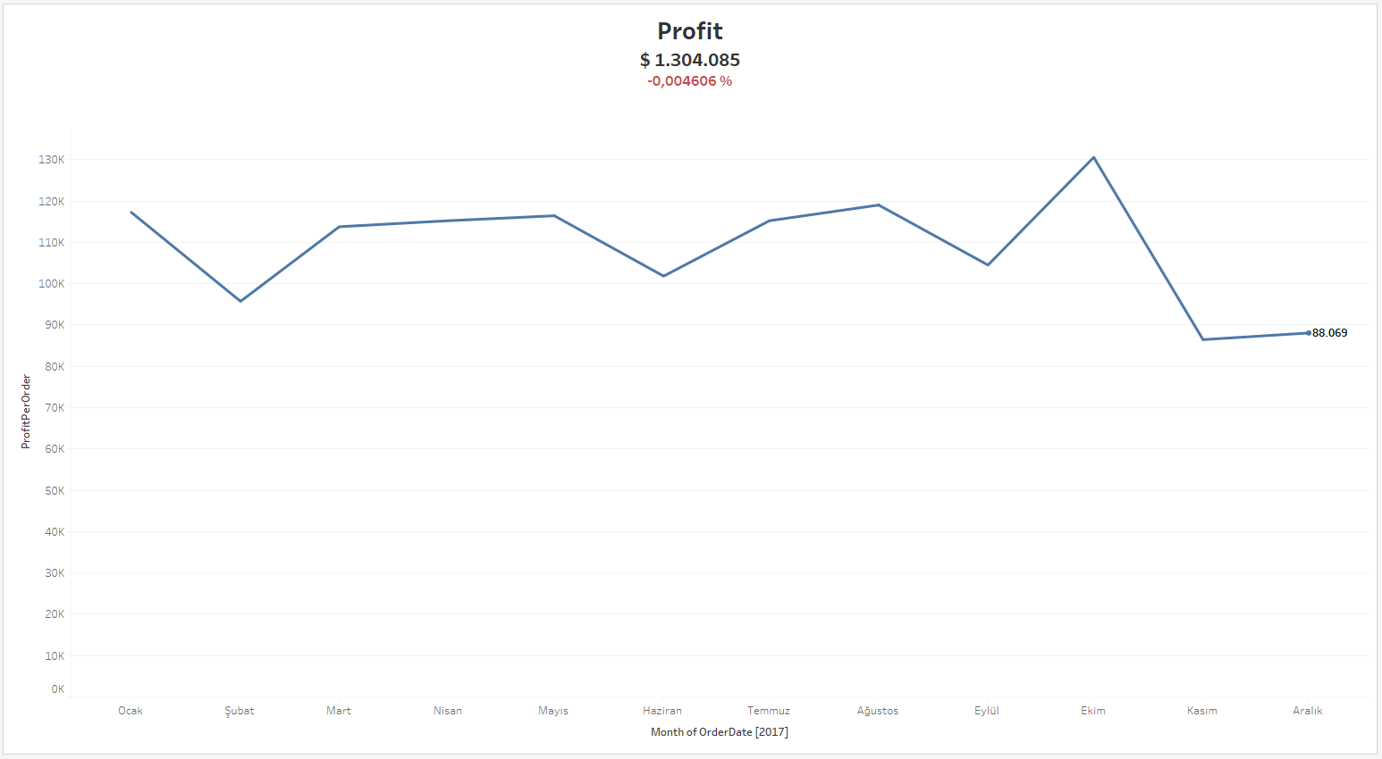

**Formulas used when creating the chart;**

* **YearToDate Profit:** This field calculates the total profits for the current year up to the date represented by the latest data point in the chart. { FIXED : SUM(IF YEAR ([OrderDate]) = {MAX (YEAR ([OrderDate]))} THEN [ProfitPerOrder] END)}
* **Previous YearToDate Profit:** This field calculates the total profits for the year preceding the current year. { FIXED : SUM(IF YEAR ([OrderDate]) = {MAX (YEAR ([OrderDate]))-1} THEN [ProfitPerOrder] END)}
* **YearOnYear Profits:** This field compares the profits performance between the current and previous years.This provides a percentage increase or decrease in profits compared to the prior year. ([YearToDate Profit]-[PrevYearToDate Profit])/[PrevYearToDate Profit]

**4.3 Order Quantity:**

**What is the annual total order quantity and the percentage (increase-decrease) of the order quantity compared to the previous year?**

* Total Order Quantity in 2017: 157.978
* Percentage of order quantity according to the previous year: 0,1502%

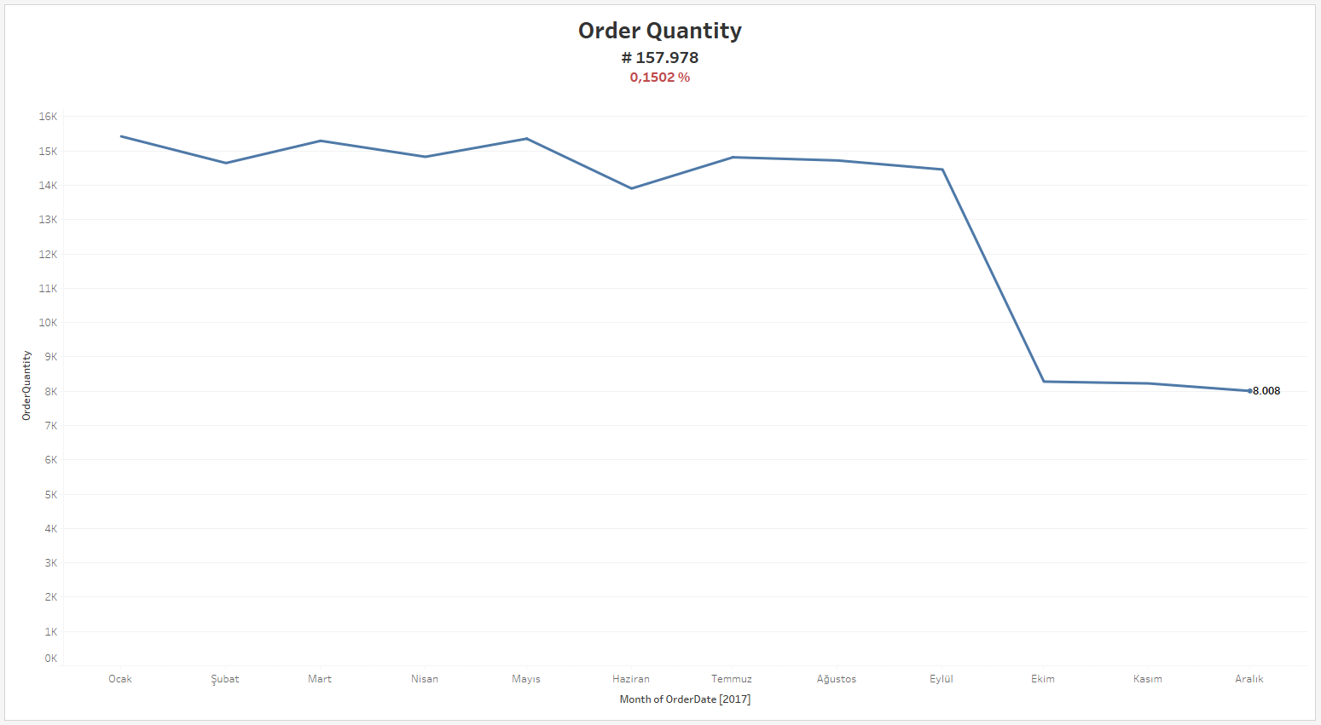

**Formulas used when creating the chart;**

**YearToDate Quantity:** This field calculates the total quantity of order for the current year up to the date represented by the latest data point in the chart. { FIXED : SUM(IF YEAR ([OrderDate]) = {MAX (YEAR ([OrderDate]))} THEN [OrderQuantity] END)}

**Previous YearToDate Quantity:** This field calculates the total quantity of order for the year preceding the current year. { FIXED : SUM(IF YEAR ([OrderDate]) = {MAX (YEAR ([OrderDate]))-1} THEN [OrderQuantity] END)}

**YearOnYear Quantity:** This field compares the total quantity of order performance between the current and previous years. This provides a percentage increase or decrease in total quantity of order compared to the prior year. ([YearToDate Quantity]-[PrevYearToDate Quantity])/[PrevYearToDate Quantity]

**4.4 Market Share By Sales:**

**What is the percentage of the annual total sales amount by country?**

* USCA(0,21%), Africa(2,25%), PacificAsia(8,32%), Europe(43,37%), LATAM(45,86%).

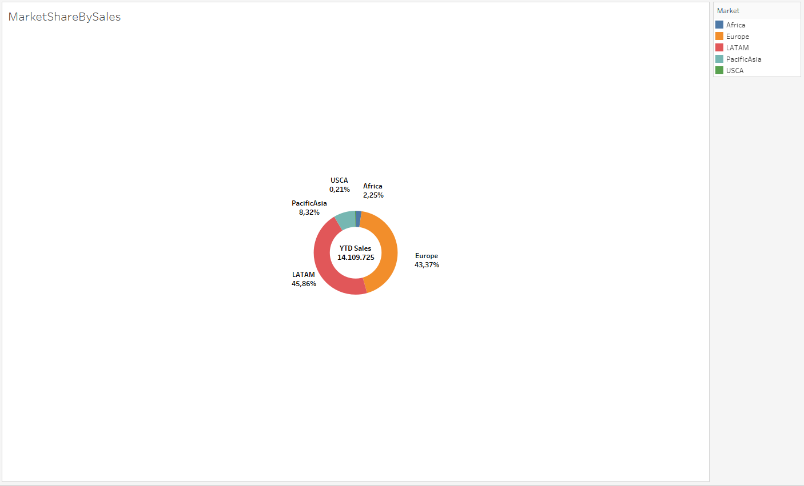

**Formulas used when creating the chart;**

**YearToDate SalesMarketShare:** This field calculates the total sales market share for the current year up to the date represented by the latest data point in the chart. IF YEAR ([OrderDate]) = {MAX (YEAR ([OrderDate]))} THEN [Sales] END

**PrevYearToDate SalesMarketShare:** This field calculates the total sales market share for the year preceding the current year. IF YEAR ([OrderDate]) = {MAX (YEAR ([OrderDate]))} -1 THEN [Sales] END

**4.5 Category wise YearToDate vs PreviousYearToDate Sale**

**Formulas used when creating the chart;**

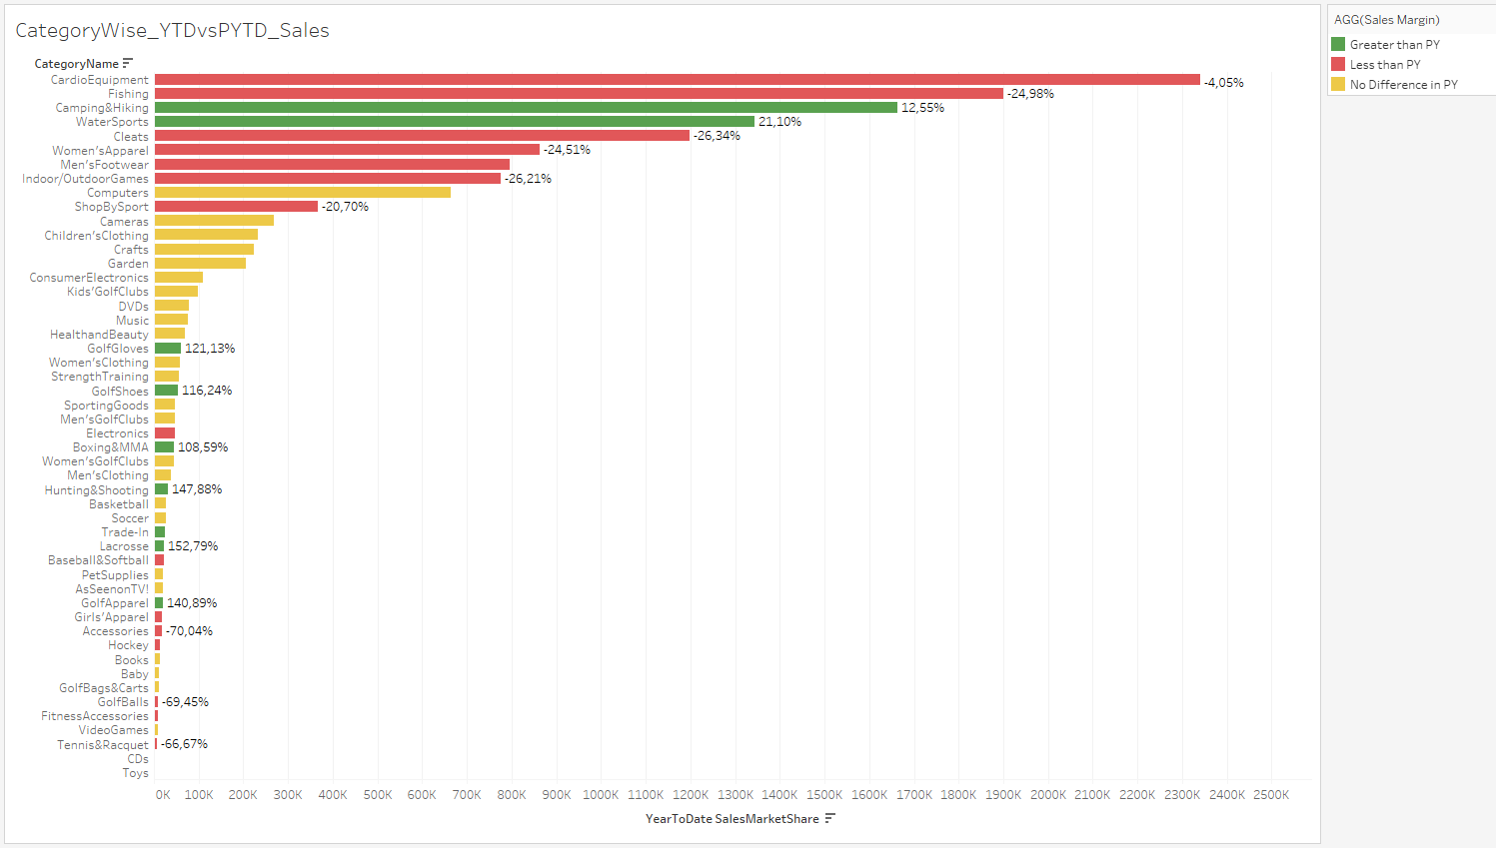**Difference:** (SUM([YearToDate SalesMarketShare])-SUM([PrevYearToDate SalesMarketShare]))/SUM([PrevYearToDate SalesMarketShare])

According to this graph and analysis, we can answer the following questions?

* **Which categories are experiencing the highest growth in sales and Why?**

Looking at the previous year, we see the highest increase in the Lacrosse categories with 152.79%, followed by Hunting&Shooting with 147.88% and GolfApparel with 140.89%.

By investigating the reason for this increase, we can now learn how we can further increase our sales rates. For example; Increased Interest in Sports/Hobbies: Growing professional leagues and health and fitness trends may have increased sales. Successful Marketing Campaigns: Targeted marketing campaigns that effectively reach potential customers interested in these sports/hobbies may have increased sales.

* **Are there any categories experiencing a decrease in sales and Why?**

Looking at the previous year, we see the highest decrease in Girl's Apparel with 72.12%, followed by Electronics with 70.67% and Accessories with 70.04%.

By investigating the reason for this decrease, we can produce new solutions to increase our sales rates. For example; Girls' Clothing: Due to the rapid growth of girls, the need to change clothes frequently may have decreased. Accessories: Perhaps changes in fashion trends have reduced the demand for certain accessories.

**4.6 Category wise YearToDate vs PreviousYearToDate Profit**

**Formulas used when creating the chart;**

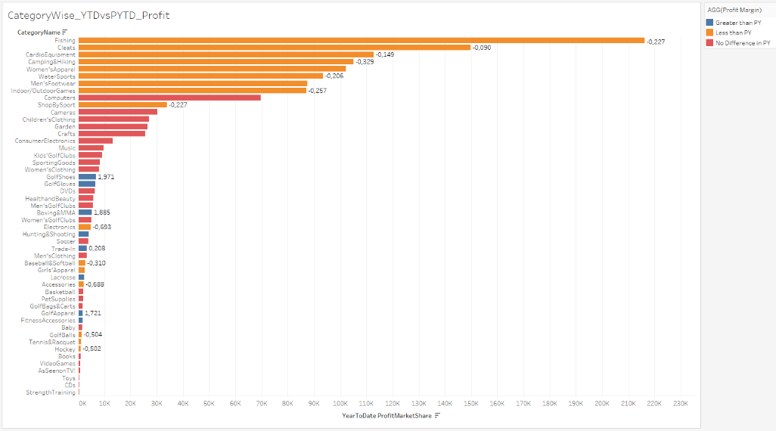**Difference:** (SUM([YearToDate ProfitMarketShare])-SUM([PrevYearToDate ProfitMarketShare]))/SUM([PrevYearToDate ProfitMarketShare]

According to this graph and analysis, we can answer the following questions?

* **Which categories have the highest profit margin and Why?**

When we look at the previous year, we see the highest increase in the Hunting & Shooting categories with 221.41%, followed by Golf Shoes with 197.13% and Boxing categories with 188.45%.

By investigating the reason for this increase, we can now learn how we can further increase our sales rates. For example; Increased Demand: There may be an increase in the popularity of hunting, shooting sports, golf and boxing. Increased interest in outdoor activities and fitness, Positive media portrayals of these sports/hobbies, Impact of social media trends. Strategic Pricing: Perhaps the store has implemented effective pricing strategies for these categories, such as offering competitive prices to attract new customers, adjusting margins based on market trends and competitor prices.

* **Which categories experienced a decrease in annual profits and Why?**

When we look at the previous year, we see the highest decrease in the Electronics categories with 69,29%, followed by Accesories with 68,83%.

By investigating the reason for this decrease, we can produce new solutions to increase our sales rates. For example; Electronics: Perhaps consumers are continuing to use their existing devices rather than purchasing new products. Accessories: Perhaps customers can purchase the accessories they need from physical stores at more affordable prices.

**4.7 Market wise Customer Acquisition Per Month**

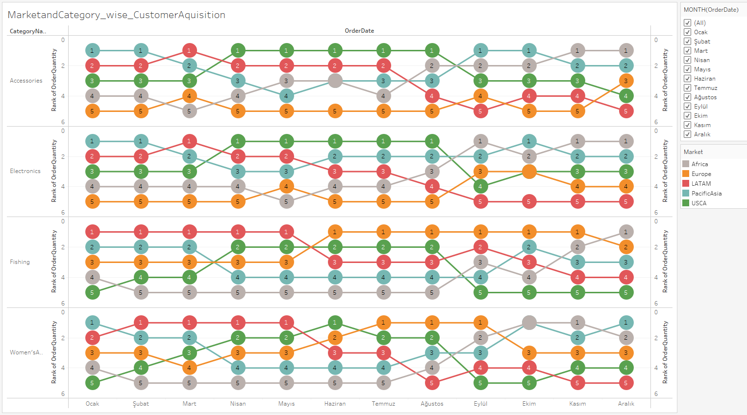

In this chart; The colors represent the countries, the numbers in the circles represent the order in customer acquisition, and the x-axis represents the months.

According to this graph and analysis, we can answer the following questions?

* How does seasonality impact customer acquisition and are there seasonality trends in certain countries?
* Which countries brought in the most or least customers each month?
* In which countries can marketing and sales activities be optimized to gain more customers?

Customer acquisition increases in December and January. This can be attributed to the Christmas shopping season and New Year celebrations.

Customer acquisition declines in July and August. This can be associated with summer holidays and hot weather.

A slight decrease is observed in September. This situation can be associated with the opening of schools.

**5. FORECASTING PART**

Forecasting is a method of predicting future values using historical data.

**Why is Forecasting Necessary?**

Making better business decisions: By predicting values such as future demand, profits and production, businesses can make better business plans and make more informed investments.

Managing risks: Forecasting helps businesses manage their risks by predicting possible risks.

Optimizing resources: Forecasting helps businesses use their resources more efficiently.

**Advantages of Forecasting to Increase Sales and Profit**

* Demand forecasting: Forecasting helps businesses optimize their inventory and reduce inventory costs by predicting future demand.
* Pricing: Forecasting helps businesses price their products accurately.
* Marketing: Forecasting helps businesses plan marketing campaigns more effectively.
* Product development: Forecasting helps businesses make more informed decisions about developing new products and improving existing products.

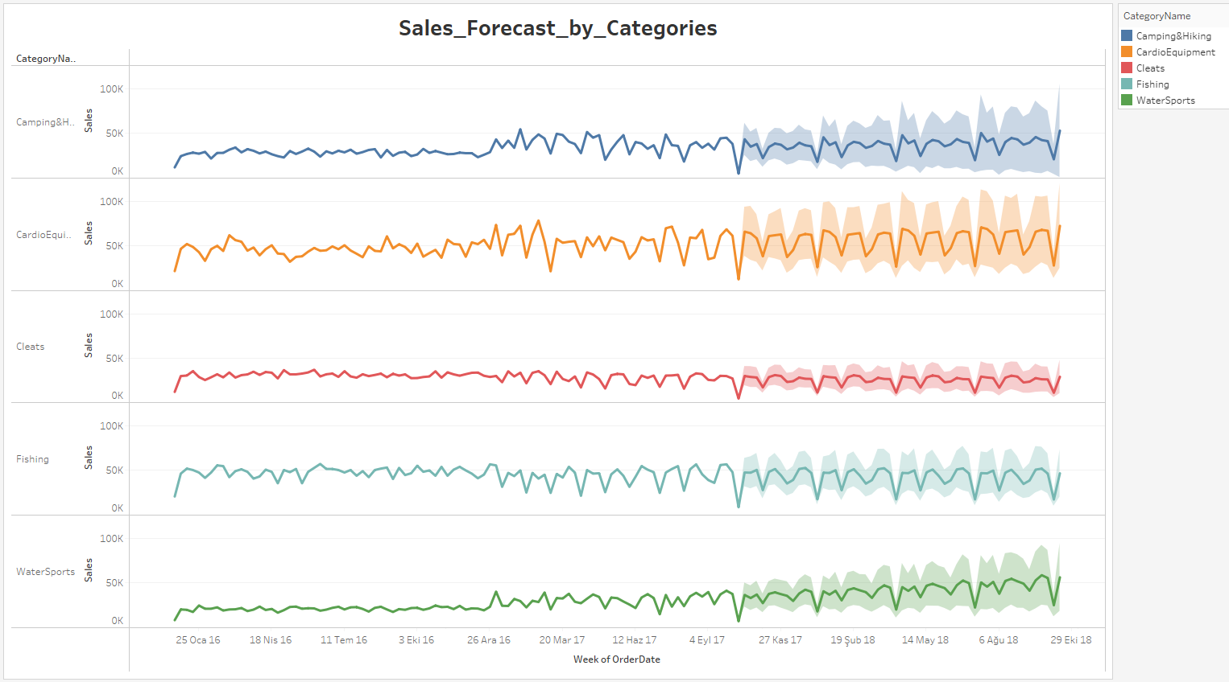**5.1 Sales Forecast by Categories**

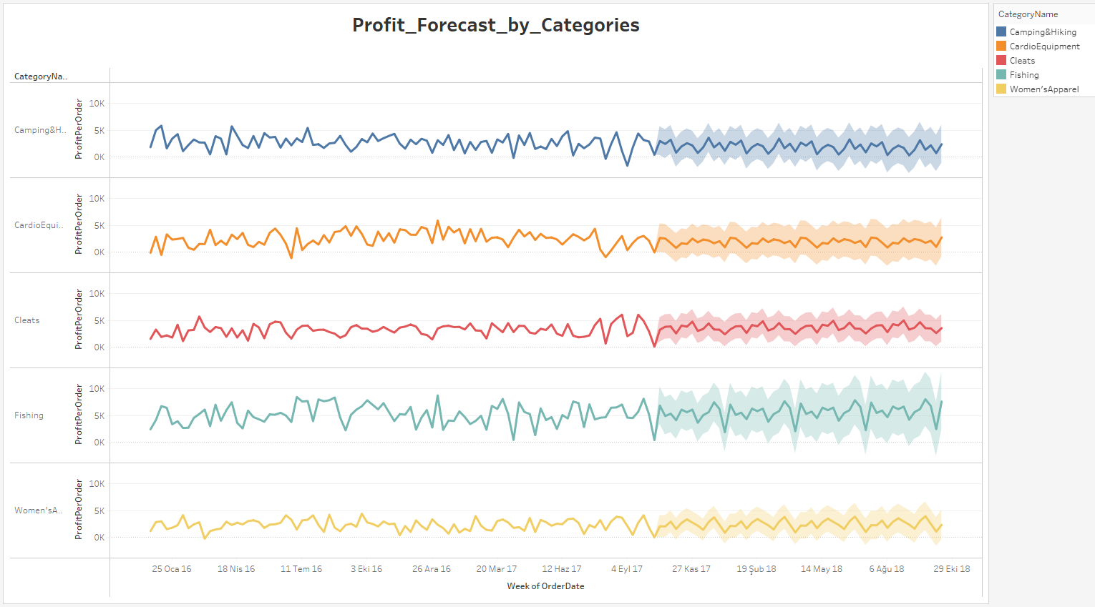**5.2 Profit Forecast by Categories**

**6. CONCLUSION**

To Increase Sales Rates:

* Demand Forecasting: Accurate demand forecasting helps in stock optimization and reducing stock costs.
* Pricing: Correct pricing of products increases sales and profitability.
* Marketing: Effective marketing campaigns help reach more customers and increase sales.
* Customer Experience: Great customer experience increases customer loyalty and repeat purchases.

To Increase Profit Rates:

* Cost Optimization: Optimizing production, marketing and general management costs.
* Productivity Increase: Increasing efficiency by optimizing business processes and using automation.
* Pricing: Reviewing pricing to optimize products' profit margin.
* New Products: Developing and marketing new products with high profitability.
* Reducing Entry Costs: Reducing raw material and other input costs by negotiating with suppliers and finding alternative suppliers.