**Install Jenkins & Setup**

**Introduction to Jenkins**

[Jenkins](https://jenkins.io/) is an open-source automation server that can be used to easily set up continuous integration and continuous delivery (CI/CD) pipelines.

Continuous integration (CI) is a DevOps practice in which team members regularly commit their code changes to the version control repository, after which automated builds and tests are run. Continuous delivery (CD) is a series of practices where code changes are automatically built, tested, and deployed to production.

Jenkins can be installed as a standalone application, as a servlet in a Java servlet container such as [Apache Tomcat](https://linuxize.com/post/how-to-install-tomcat-9-on-ubuntu-20-04/) or can be run as a Docker container.

This article explains how to install Jenkins on Ubuntu 20.04 as a standalone service.

**Installing Jenkins**

Installing Jenkins on Ubuntu is relatively straightforward. We’ll enable the Jenkins APT repository, import the repository GPG key, and install the Jenkins package.

step 1: curl -fsSL <https://pkg.jenkins.io/debian-stable/jenkins.io.key> | sudo tee /usr/share/keyrings/jenkins-keyring.asc > /dev/null

step 2 : echo deb [signed-by=/usr/share/keyrings/jenkins-keyring.asc] <https://pkg.jenkins.io/debian-stable> binary/ | sudo tee /etc/apt/sources.list.d/jenkins.list > /dev/null step

3 : apt update step

4: apt install jenkins step

5: systemctl start jenkins step

6: systemctl status jenkins

* sudo apt udpate
* sudo apt install Jenkins

In case of getting error, during install check port 8080 is avialble by using,

Ss -nlp | grep 8080

**Setting Up Jenkins**

Launch Jenkins by

http://localhost:8080/

A page similar to the following will be displayed, prompting you to enter the Administrator password that is created during the installation:

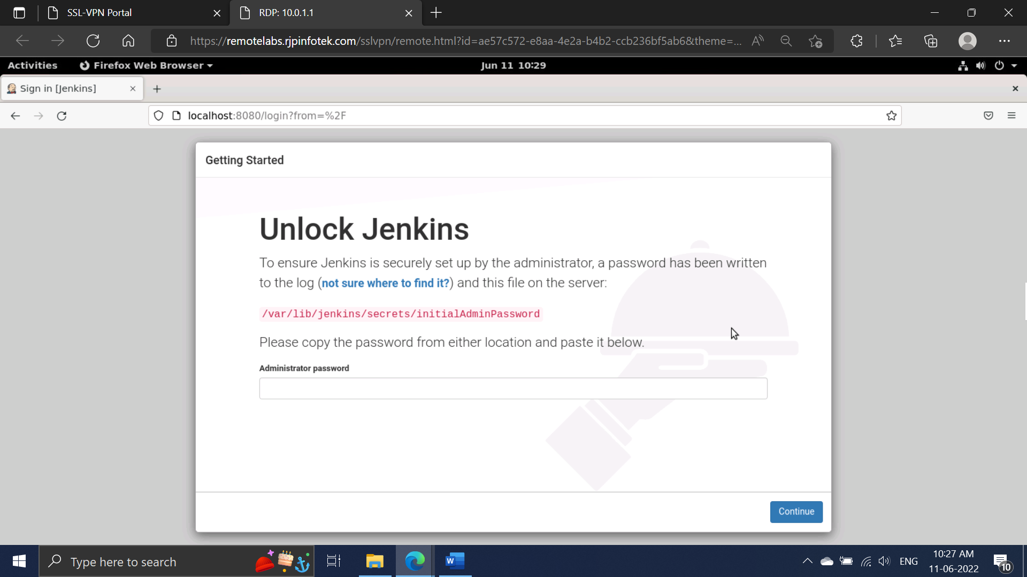

Use [cat](https://linuxize.com/post/linux-cat-command/) to display the password on the terminal:

* sudo cat /var/lib/jenkins/secrets/initialAdminPassword

Copy and paste this Admin Password.

Will navigate to

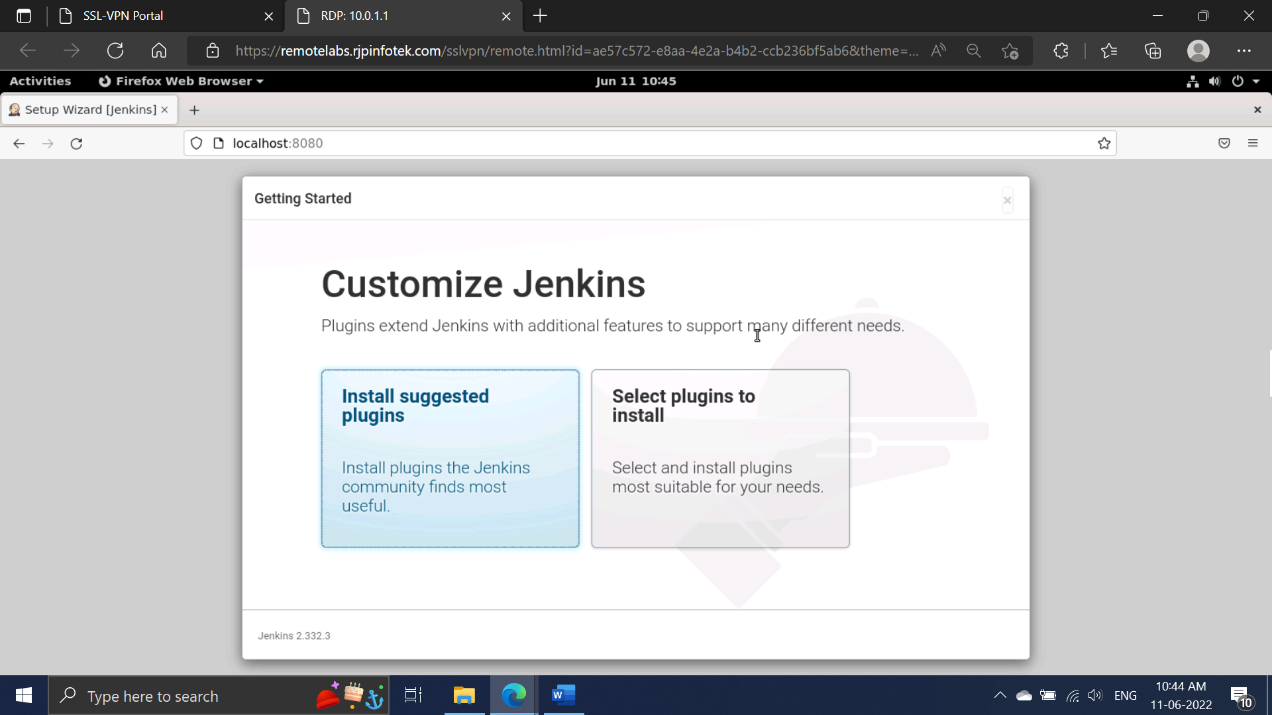

Click on the “Install suggested plugins” box and the installation process will start immediately.

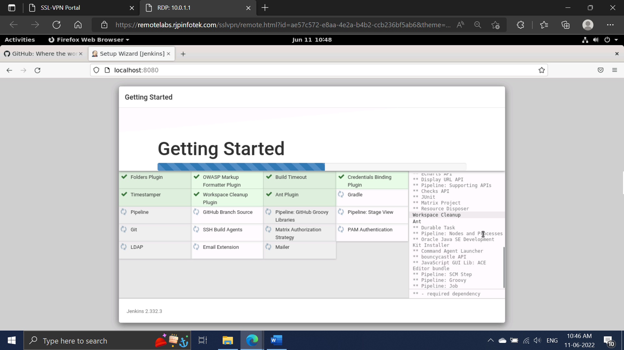

Once the plugins are installed, you will be prompted to set up the first admin user. Fill out all required information and click “Save and Continue”.

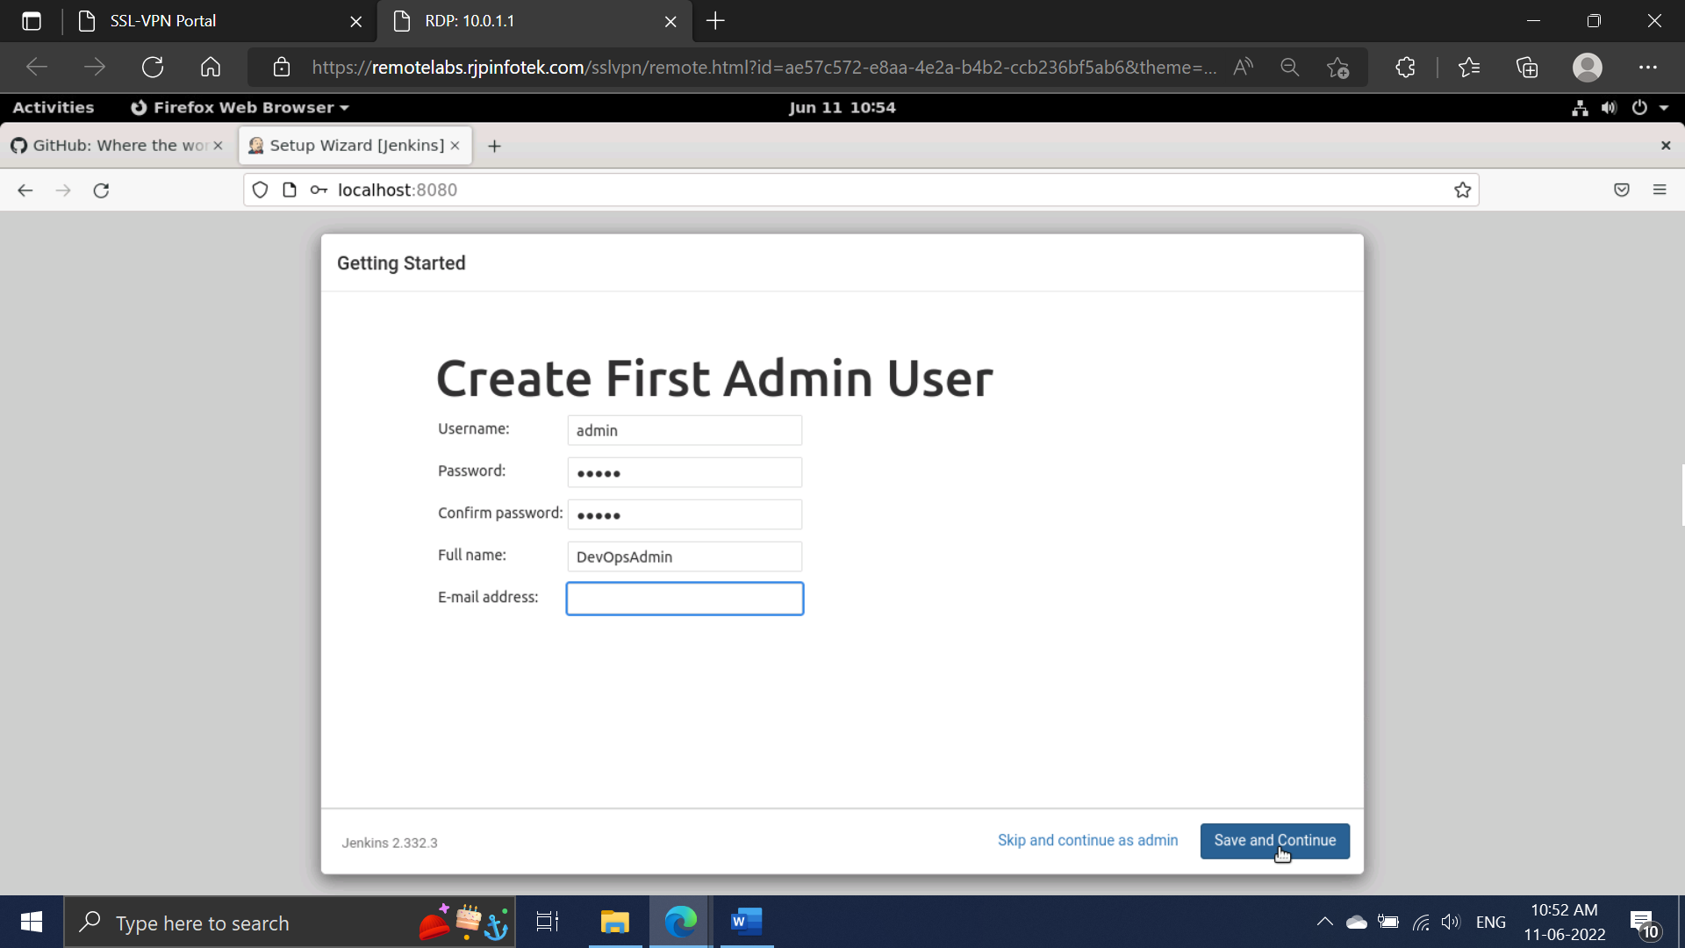

The next page will ask you to set the URL for your Jenkins instance. The field will be populated with an automatically generated URL.

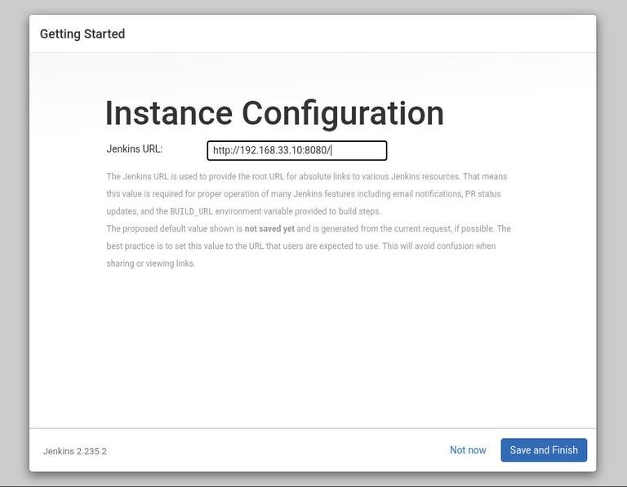

Confirm the URL by clicking on the Save and Finish button, and the setup process will be completed.

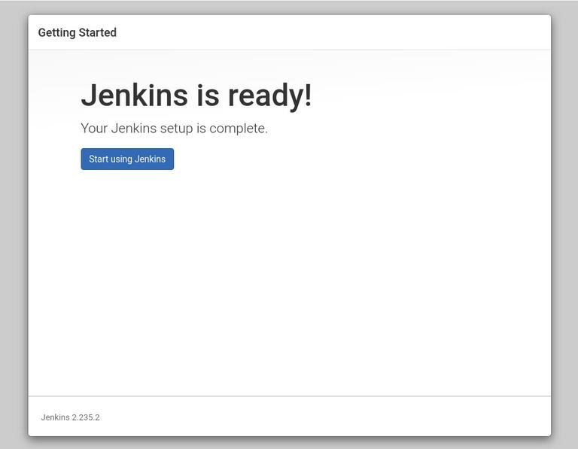

Click on the Start using Jenkins button, and you will be redirected to the Jenkins dashboard logged in as the admin user you have created in one of the previous steps.

