**PYTHON2 AND PYTHON3 SCRIPT EXPLANATIONS**

The second and the third codes belong to my thesis. I firstly would like to remind you the details about my master thesis. The proposed thesis project aims to map the human "*Diseasome* network" onto the mouse genotype and phenotype data. The *Diseasome* databases collected and used OMIM data in terms of diseases genes and disorders for human organism. The purpose is to develop a network based model of human disease genes onto a mouse. For this determination, the Jackson’s Laboratory mouse genome and phenome databases (http://www.informatics.jax.org/) were used. Mouse orthologs of human genes (gathered from "Online Mendelian Inheritance in Man (OMIM) database) from diseasome network were obtained. Subsequently getting the knock out genes, their related affected systems were listed according to the "Mammalian Phenotype Ontology" which enables a quite robust annotation and comparative well designed analysis. By using programming languages such as R Programming and Python with the help of mapping program Gephi, both graphical and systematical visualization has become discernible as in html and pdf format.

**PYTHON2 CODE IS RELATED TO THE GENES NODES VERSION.**

**PYTHON3 CODE IS RELATED TO THE GENES EDGES VERSION.**

* Genes nodes version uses mouse genes as nodes like disease and affected systems.
* Genes edges version uses mouse genes as edges and construct a bridge between disease and

affected systems.

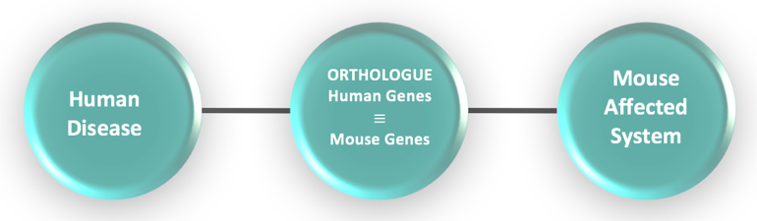

Figure1-1: Gene-Node version design of network

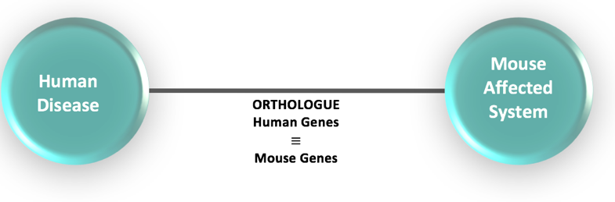

Figure 1‑2: Gene-Edge version design of network