**Designing a Circuit for Maximising Power Output from a Solar Array**

Kartik Agrawal, Nilay Mundra, Sunidhi Sonker under Dr. V.N. Lal, Associate Professor, Department of Electrical Engineering, Indian Institute of Technology (BHU), Varanasi

***Abstract* This paper presents the Simulink simulation of a three-phase solar DC to AC inverter. In this simulation, we have maximized the output from a PV array. The circuit has a three-phase AC output. The inverter uses six IGBT switches with sinusoidal pulse width modulation (SPWM) gating. The filter used in the circuit is a LCL filter. The specific values are designated for the filter to get a smooth sinusoidal output from it. The value of the three-phase load has been precisely calculated using theoretical formulas to obtain maximum power point (MPP) operation. Hence, all these factors put together result in extracting maximum power out of a PV array. The MPP operation of the PV array is verified by the simulation results.**

***Keywords* Three Phase VSI Inverter, SPW7M, MPP, Solar PV System**

**I. INTRODUCTION**

Due to the current state of climate change, a need for change from non-renewable to renewable energy was felt. Renewable energy-based distributed energy sources are becoming increasingly attractive, both economically and technologically. It is hard to address renewable energy without mentioning the most plentiful source, the sun. Given that the sun emits enough solar energy in an hour to cover human energy use for a year, going green with solar PV panels may be the way to go. They have a nonlinear voltage-current characteristic, with a specific maximum power point (MPP) that is affected by environmental conditions including temperature and irradiance. The conversion stage using inverters in these PV systems transforms the PV array's dc current to ac and delivers it to the ac grid/load. However, it is not enough to simply connect the load to panels and draw power. As we will see in upcoming sections, doing so is inefficient. In order to get high efficiency, we make the circuit run on MPP. In this paper, we will be discussing methods for designing a circuit so that it could operate at the MPP. In the section **Mathematical Modelling**, we will discuss the ideas and derivations of concepts that have been utilized. In the **Simulation** section we build upon these ideas and formulas and use them to simulate a real-world scenario using Simulink. The final **Conclusion** section hosts the summary and the results that we observed by simulating the system.

**II. MATHEMATICAL MODELLING**

**1. Photovoltaic Cell**

***1.1 Introduction***

Photovoltaic (PV) cell or solar cells are the basic devices that convert light energy directly into electric energy. It is a semiconductor device that absorbs the photons emitted by the sun and generates a flow of electrons. It is basically a p-n junction diode with the n-side (doped with phosphorus) exposed to sunlight, having one extra electron compared to silicon and an underlying p-side (doped with boron), having one less electron compared to silicon. Also, when the photons strike a semiconductor material, such as silicon, they release electrons from their atoms, leaving behind a vacant space. The released electrons wander around at random in search of another "hole" to fill. Now, an electric field is created at the junction. As a result, these excited electrons are swept to the n-side by an electric field, while the holes drift to the p-side. The electrons and holes are directed to the electrical contacts applied to both sides before flowing in the form of electrical energy to the external circuit. This generates direct current. An anti-reflective coating is added to the top of the cell to minimize [photon](https://www.planete-energies.com/en/content/photon) loss due to surface reflection.

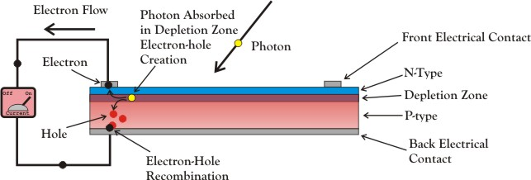

Figure 1: Working of a PV cell

***1.2 Modules, Panels & Arrays***

A photovoltaic cell has a voltage of just around 0.5V. To meet the voltage/current demand according to a given application, several cells are connected in series and/or parallel circuits to produce higher level voltages, currents, and power.

Photovoltaic modules, which are the primary building blocks of PV systems, are made up of PV cell circuits sealed in an environmentally friendly laminate. Photovoltaic panels are made up of one or more PV modules that have been pre-wired and are ready for field-installation. A photovoltaic array is the complete power-generating unit, consisting of any number of PV modules and panels.

*1.2.1 Series Combination*

Series combination is when the voltage of a solar array/ module is increased by wiring the positive of one solar cell to the negative of another solar cell.

*1.2.1 Parallel Combination*

Parallel combination increases the current (amps) output of a solar array/module while keeping the same voltage. Parallel wiring is when the positives of multiple cells are connected together and all the negatives for the same cells are connected together.

***1.3 Cell relations***

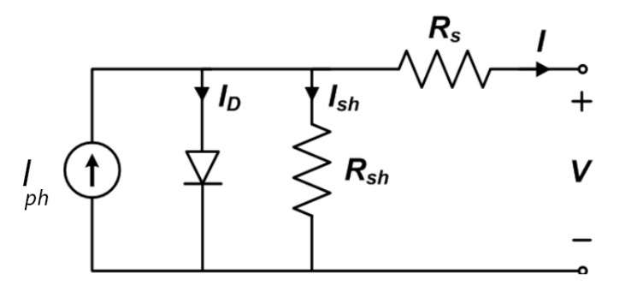

Figure : Equivalent circuit of a PV cell

Let the cell parameters be

= Light generated current source

= Diode current

= Leakage current

= Output current

= Cell saturation of dark current

= Shunt resistance

= Series resistance

= Output voltage

We have,

(1)

where,

= Thermal Voltage =

k = Boltzmann’s constant = J/K

= Cell’s Working Temperature

q = Electron Charge = C

n = Ideality factor

Applying KCL to the node where , diode, and meet,

(2)

Using (1) & (2),

***1.4 Characteristics of PV cell***

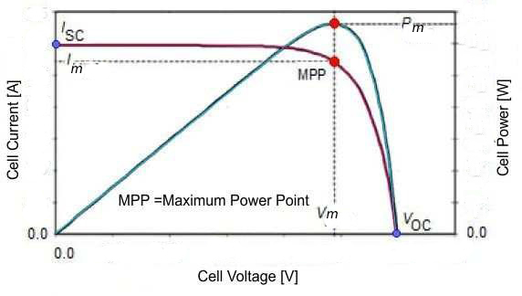

Figure 3: PV Characteristics

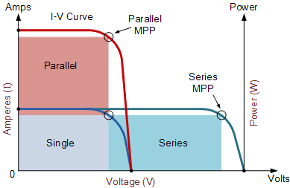

Figure 4: Characteristic curves for series and parallel combination of PV cells

***1.5 Maximum Power Point***

As we can see from Figure 3, in order to get maximum power from a solar cell, it should be operated around maximum power voltage as shown in the figure above. As a result, the maximum power is .

***1.6 Effect of irradiance & temperature***

Irradiance is defined as the power density of sunlight received at a given point on Earth and is measured in watts per metre square. With the rising solar irradiance both the open-circuit voltage and the short circuit current increase and hence the maximum power point varies. Temperature also has a significant impact. With a rise in the temperature at a constant irradiance, the rate of photon generation increases thus rapidly increasing the reverse saturation current, reducing the band gap. Hence this leads to marginal changes in current but major changes in voltage. The cell voltage reduces by 2.2Mv per degree rise of temperature. Temperature acts like a negative factor affecting solar cell performance. As a result, the solar cells give their full performance when the weather is cold and sunny days rather than hot and sunny.

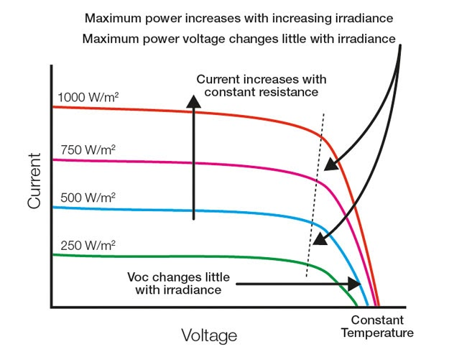

Figure 5: Effect of irradiance

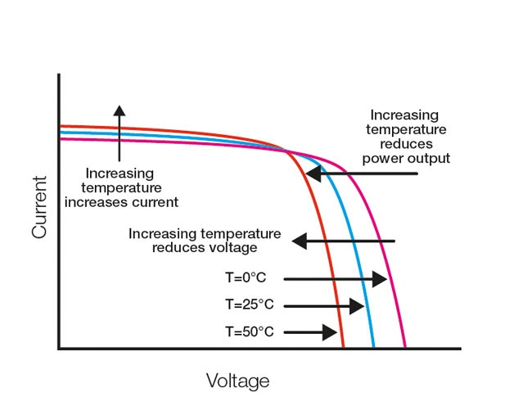

Figure 6: Effect of temperature

**2. Power Inverter**

***2.1 Introduction***

A power inverter is a piece of machinery that converts direct current (DC) electricity to alternating current (AC). Inverters are being used in a variety of industrial applications such as ac motor drives, control systems, power supplies, uninterruptible power supply (UPS) systems, power quality, power systems, and renewable energy usage. The bulk of these applications rely on predefined conditions to provide acceptable levels of power quality.

***2.2 Sinusoidal Pulse-Width Modulation (SPWM)***

Sinusoidal pulse width modulation (SPWM) is a pulse-width modulation method that is generally utilised in inverters. An inverter creates an AC voltage output from a DC input using switching circuits to recreate a sine wave by creating one or more square pulses of voltage each half cycle. When the size of the pulses is changed, the output is said to be pulse width modulated.

The breadth of each pulse in Sinusoidal PWM is proportional to the amplitude of the sine wave evaluated at the pulse's centre. The gating signals are created by comparing a sinusoidal reference wave with a triangular carrier wave of frequency and respectively. The inverter output frequency is determined by and its peak amplitude determines its Modulation Ratio ( /) and hence the rms output voltage . A comparator is used to compare a high frequency carrier wave to a reference signal having the desired frequency. The output voltage is high when the sinusoidal wave has a larger magnitude; otherwise, it is low. In a trigger pulse generator, the comparator output is processed so that the output voltage wave has a pulse width that is in agreement to the comparator pulse width. So, we get

(3)[2]

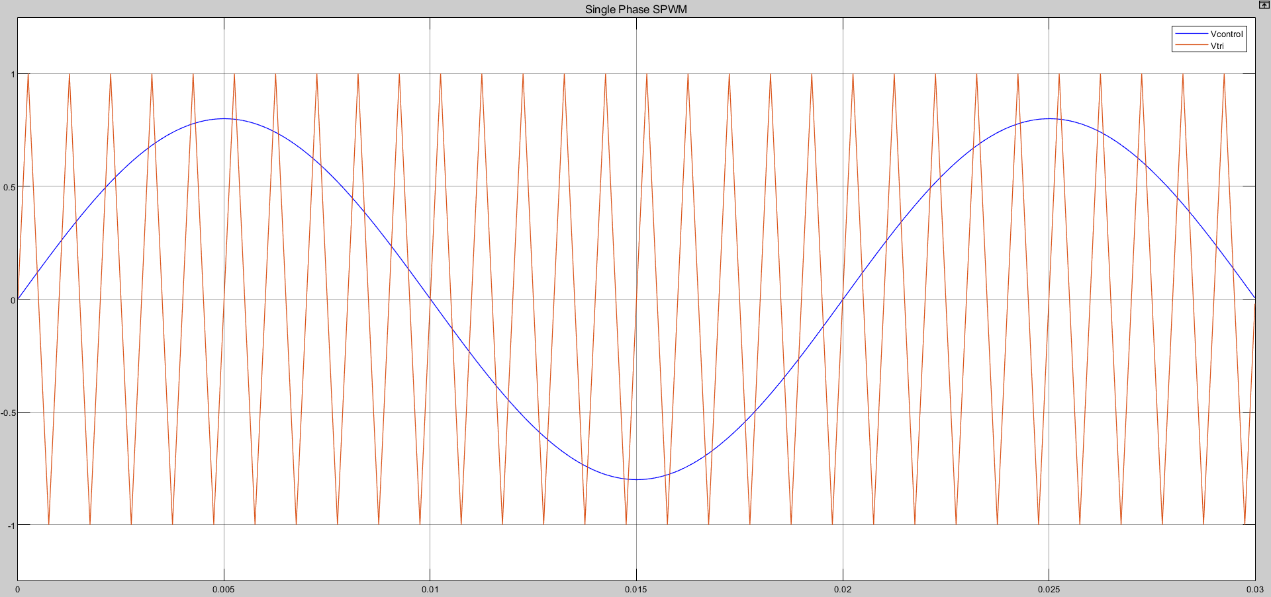

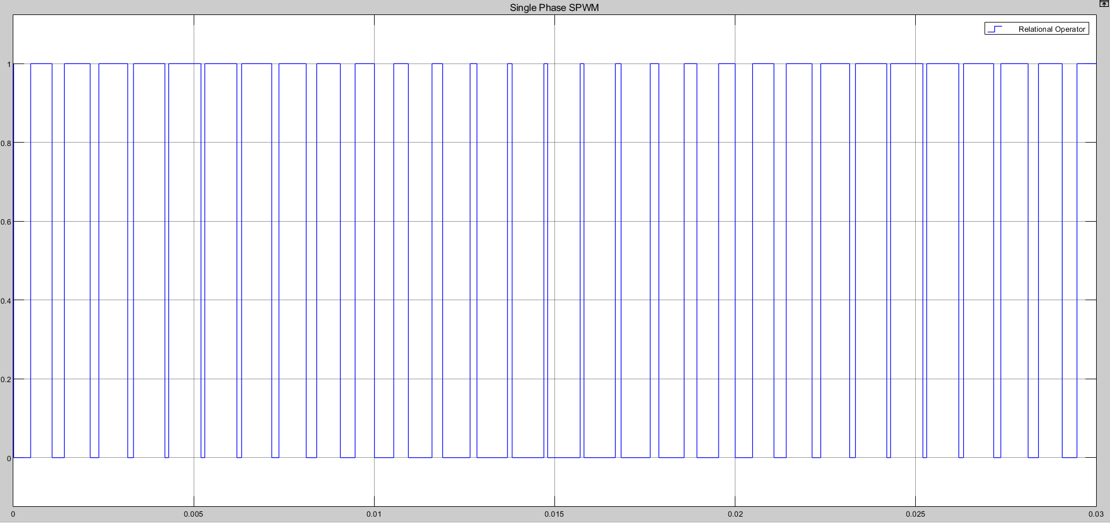

Figure 7: SPWM for a single-phase inverter

In SPWM of three-phase inverter, there are three sinusoidal reference waves (, and ) each shifted by 120°. A carrier wave is compared with the reference signal corresponding to a phase to generate the gating signals for that phase as shown in the below figure.

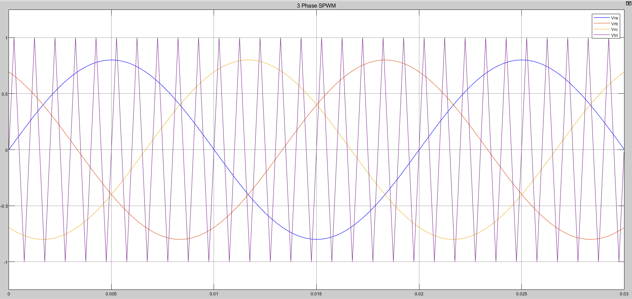

Figure 8: SPWM for a three-phase inverter

***2.3 Working***

The work of an inverter is converting DC electricity to AC electricity and it does not generate power on its own. The DC voltage cannot be directly used for a household appliance as most of them work on AC voltage. As a result, anytime we use a solar power panel, we generally use an inverter to convert DC into AC.

*2.3.1 Single Phase Inverter*

The output of a half-bridge inverter fluctuates from +/2 to -/2, as the name suggests. Two switching devices are connected in one common branch, also known as a leg, as illustrated in the diagram. SCR, MOSFET, or IGBT switching can be used.

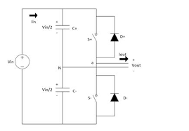

Figure 9: Single Phase Inverter

We have two switching devices, S1 and S2, as illustrated in the diagram. Each gadget is activated once to produce one cycle of alternating voltage. The other being absent at the same time. Similarly, device S2 is switched on while S1 is turned off to generate a negative cycle of alternating supply. The output wave is seen below.

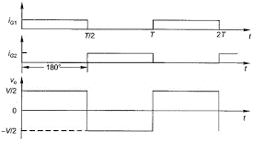

Figure 10: Output wave of a half bridge inverter

When S1 is conducting from 0 to T/2, the output is +/2. Similarly, when S2 conducts from T/2 to T, the output is -/2. As a result, the output alternates between +/2 and -/2, which is known as alternating voltage. T is the total time period of the conduction of two devices.

*2.3.2 Three Phase Inverter*

We need six switching devices in total for the circuit. On the load side, we receive a three-phase alternating voltage from a DC source.

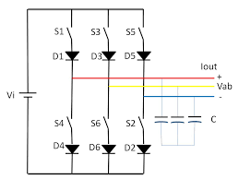

Figure 11: Three-phase inverter

To begin, the device must be numbered for proper operation. The devices are numbered according to the triggering order. This implies that, as indicated in the circuit, the switch S2 is activated after the switch S1, and so on for the other devices. Because the output is three-phase voltage, three-phase sequences separated by 120 degrees are necessary. One pair of switching devices is activated for each phase sequence. This signifies that S1-S2 are switched on to get the R phase. S3-S4 are switched on to acquire the Y phase, and S5-S6 are turned on to produce the B phase.

.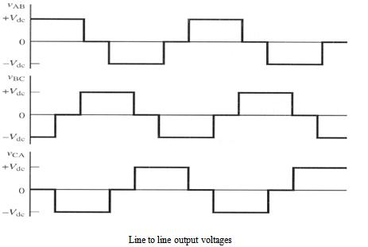

Figure 12: Output voltage for a three-phase Inverter

Also, for a 3 phase Voltage Source Inverter, we get that

(4)

where,

= Maximum output voltage per phase (, and )

= Modulation Ratio

= DC voltage at the input of the inverter (from PV Array)

Now, with SPWM control, the switches (IGBTs) of the inverter are controlled by comparing a sinusoidal signal and a triangular signal in both single as well as three-phase circuits. The sinusoidal wave determines the desired fundamental frequency of the inverter output, while the triangular wave decides the switching frequency of the inverter.

***2.4 LCL Filter Design***

Below is a step-by-step procedure for designing LCL filters for a Voltage Source Inverter (VSI) proposed in [6].

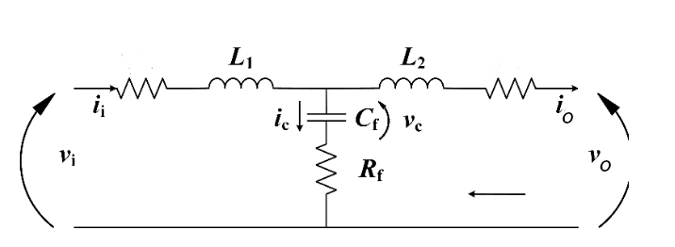

Figure 13: LCL filter per-phase model

Let the circuit parameters be

= Rated power (Maximum power output)

= Output side frequency

= Inverter switching frequency

= Voltage of the DC source (PV Array)

= Output RMS Voltage per phase

First, the base impedance () and capacitance () are calculated with the rated working condition and output side information in (1) and (2),

(5)

(6)

The filter capacitance is then determined by referring to a percentage of the base capacitor . A design factor of 5% is chosen, yielding,

(7)

Next, the inductor design considers the maximum peak-to-peak current ripple of the rated current , which is determined by the rated working conditions of the inverter system defined as follows,

(8)

A 10% ripple of the rated current for design parameters is given by,

(9)

The inverter-side inductor will be determined by,

(10)

The load-side inductor is determined with the required attenuation factor , which is expected to be 20%.

(11)

In the end, the damping resistor is related to the resonant angular frequency of the filter , which is given by,

(12)

(13)

The resonant frequency must satisfy (9). If so, the damping can be determined by,

(14)

***2.5 Design Analysis for MPP***

Resistor selection

The resistor value of the load for MPP operation of the PV Array can be selected in accordance with the maximum power () and the amplitude modulating index ().

(15)

**III. SIMULATION**

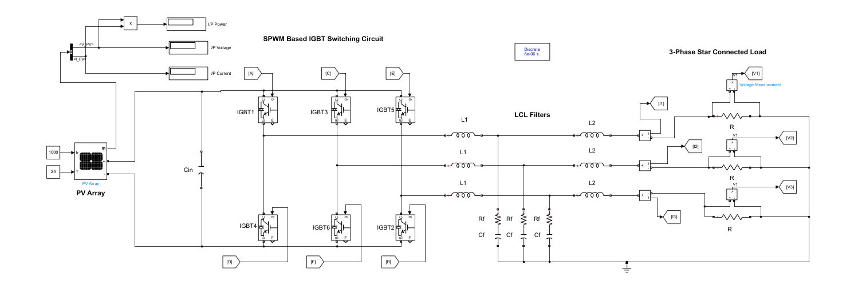

Figure 14: Circuit for MPP operation

The above circuit diagram shows the circuit used for determining the load for MPP operation in a PV system connected to a 3-phase inverter. The gating signals generated using SPWM that are applied to the 3-phase inverter are shown in the figure below.

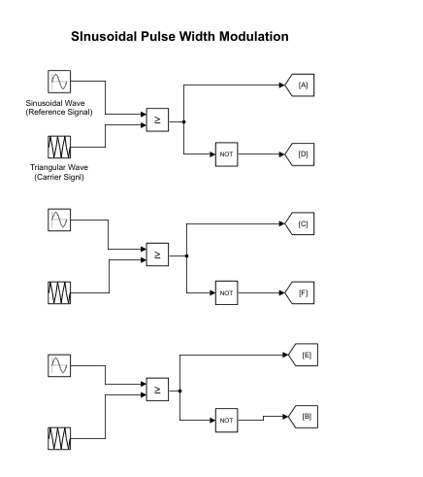

Figure 15: Gating signals for the IGBTs

**1. Circuit Parameters**

Using the formulas derived in section 2.4

Using the formula for output voltage (Equation 4) of the inverter & section 2.5 for MPP operation, we get

R

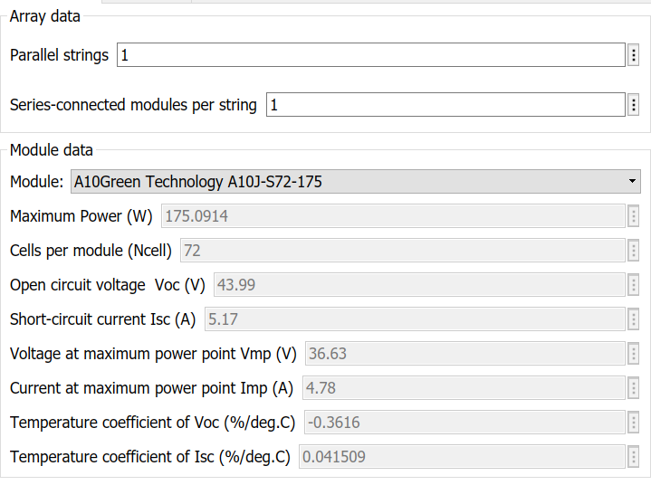

Figure 16: PV array & module parameters

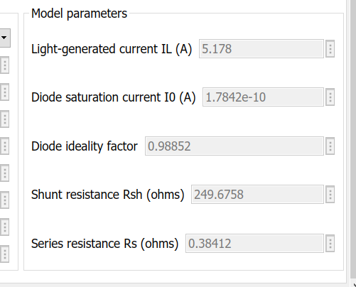

Figure 17: PV cell parameters

**2. Scope Output**

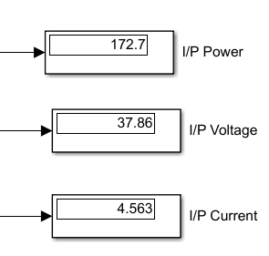

Figure 18: PV array parameters during simulation

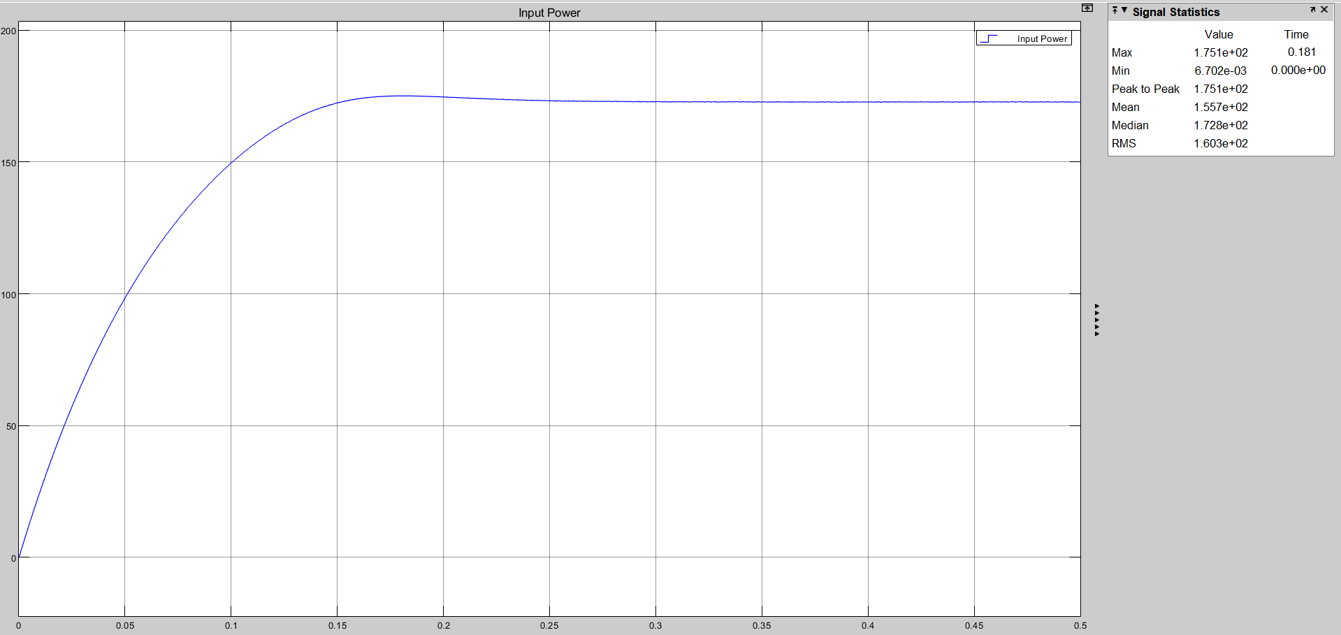

Figure 19: Input power of the PV array

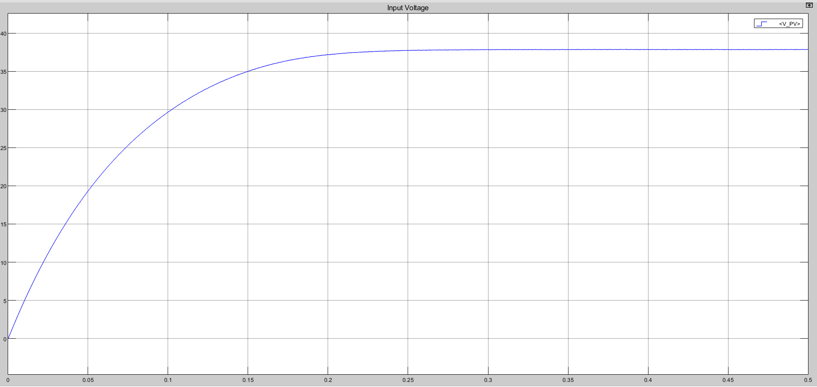

Figure 20: Input voltage of the PV array

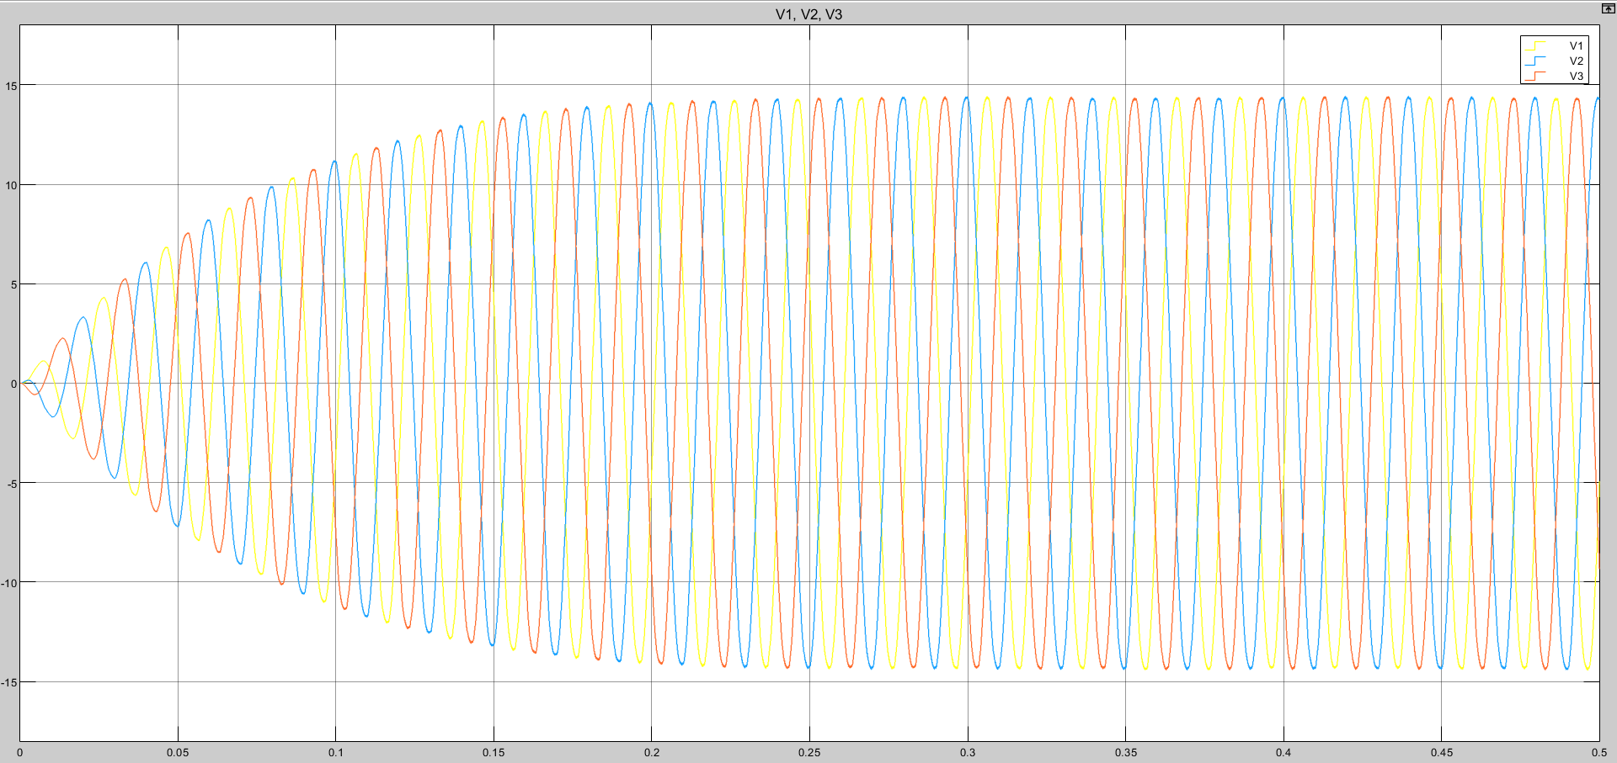

Figure 21: Output voltages across each phase

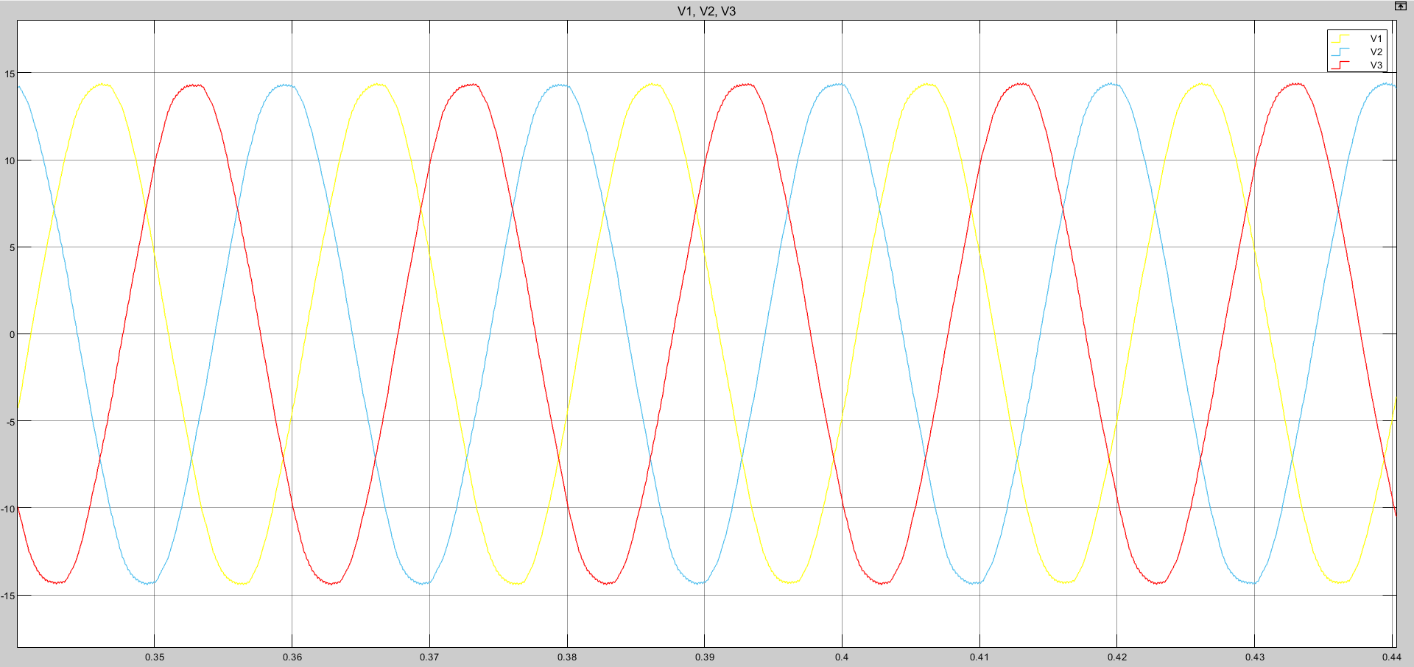

Figure 22: Enlarged plot of output voltages after achieving steady state

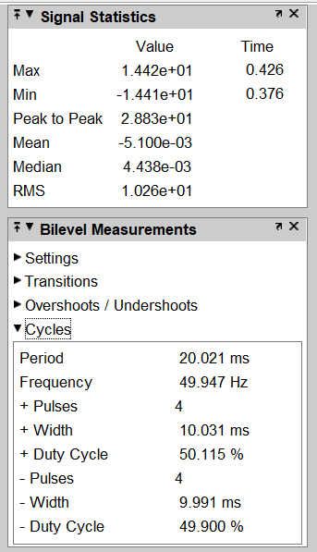

Figure 23: Output voltage data after achieving steady state

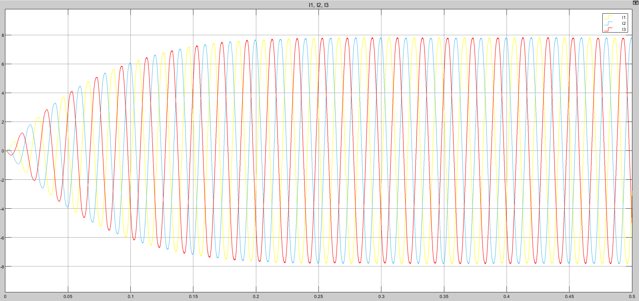

Figure 24: Output current across each load

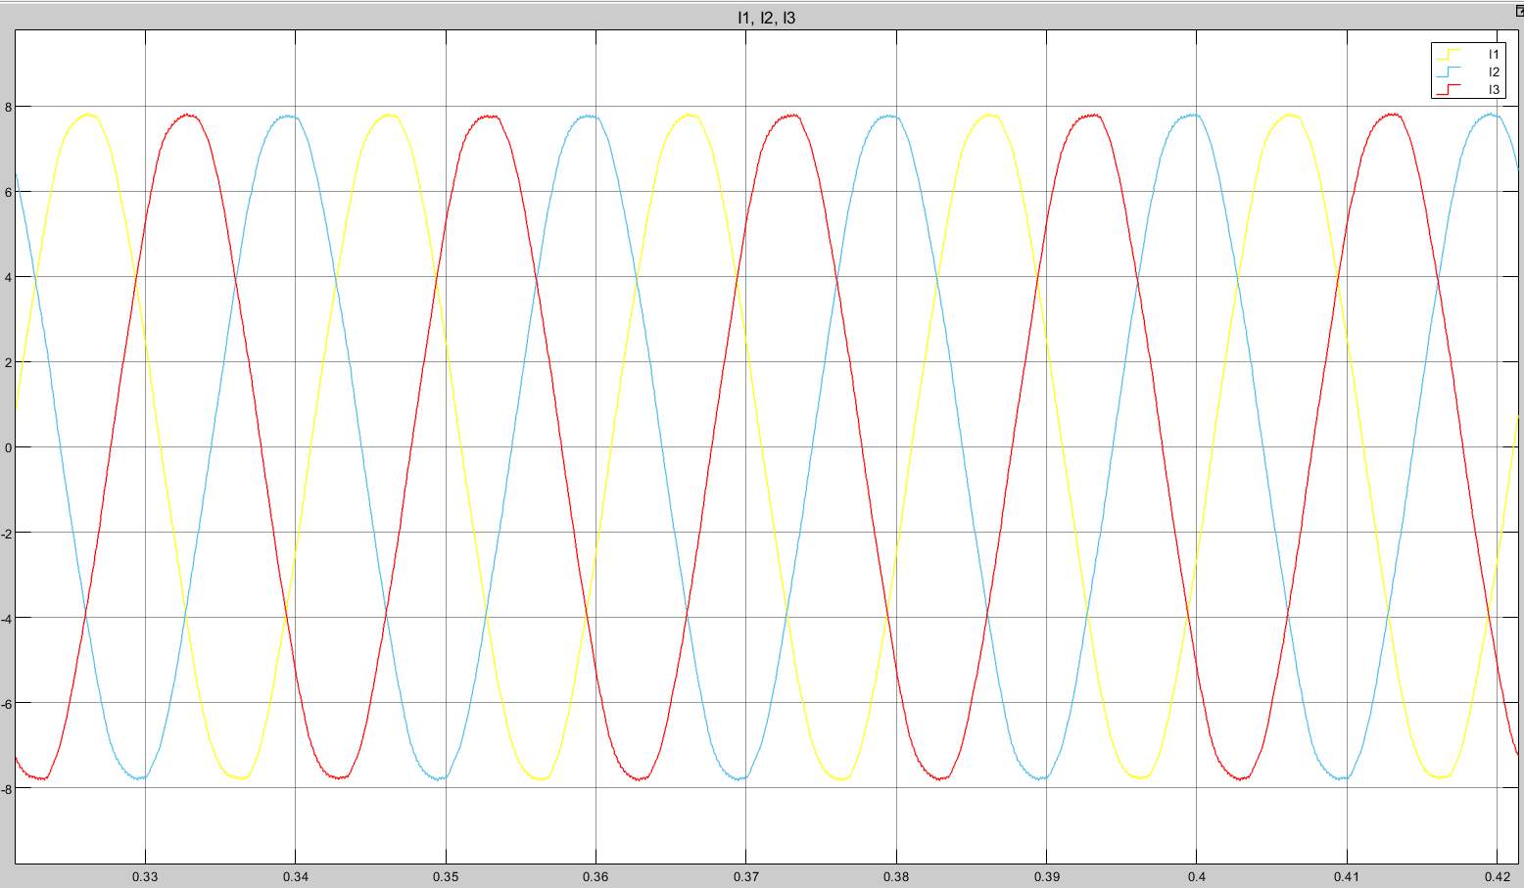

Figure 25: Enlarged output current plot after achieving steady state

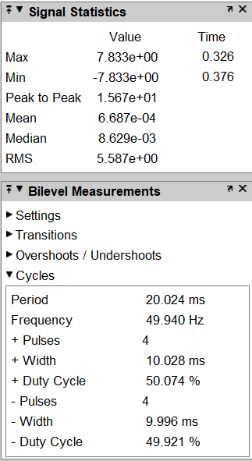

Figure 26: Output current data after achieving steady state

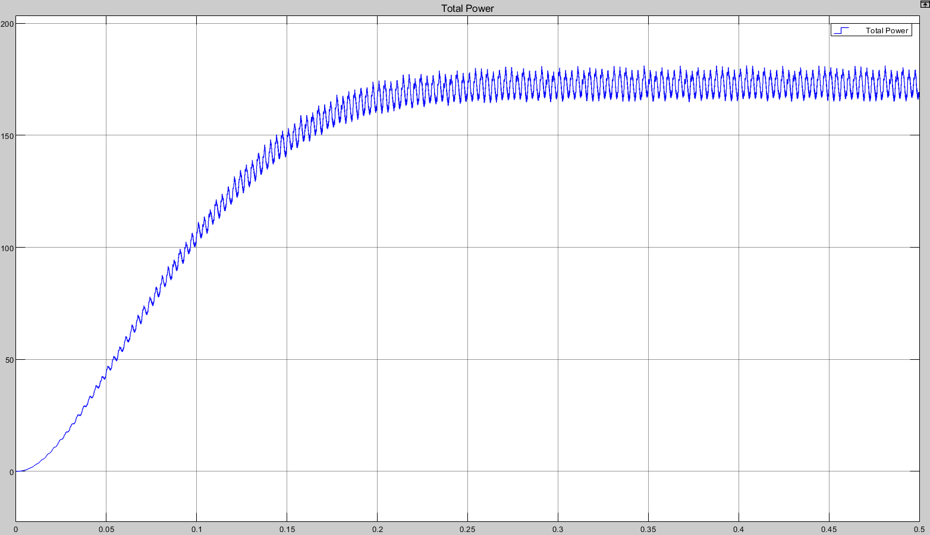

Figure 27: Total output power

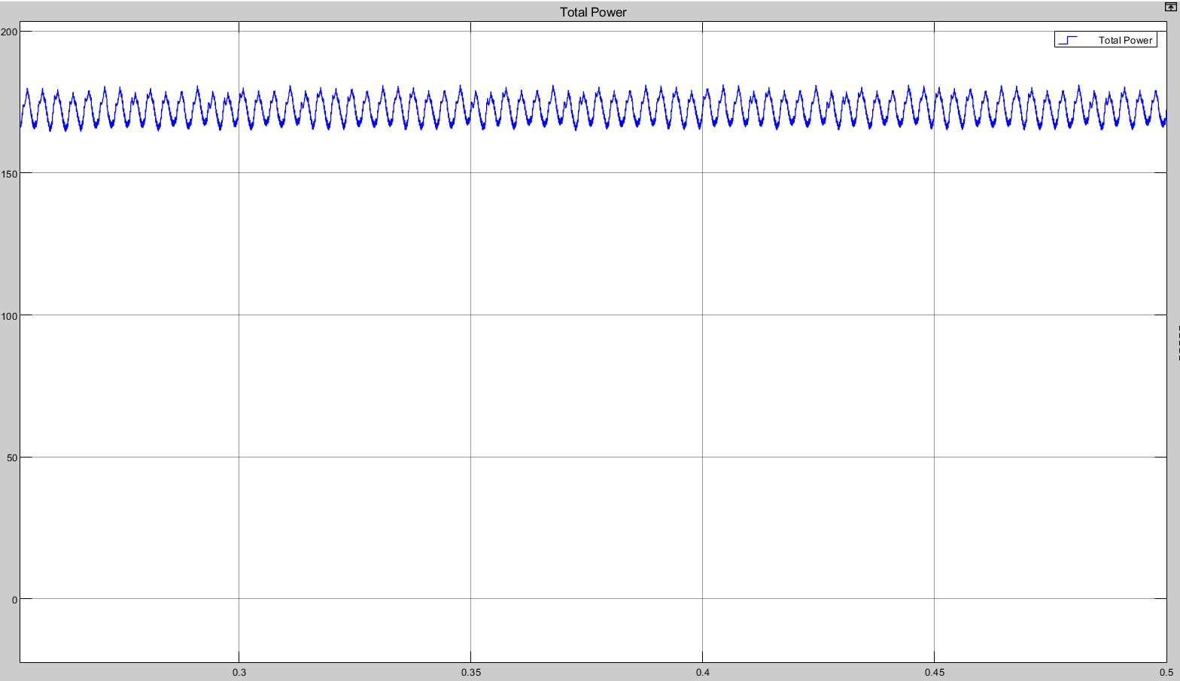

Figure 28: Enlarged total power plot after achieving steady state

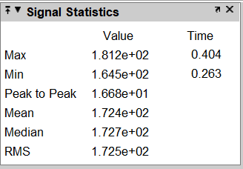

Figure 29: Total power data after achieving steady state

**IV. CONCLUSION**

As a result of the simulation, it is clear that each array has a maximum power point (MPP) from which maximum power may be collected. Each array has I-V characteristics, and the product of current and voltage is maximised at a single point in the characteristics. The array's maximum power is retrieved at this stage. This is premised on a constant amount of solar light and temperature. The load value is also crucial in generating maximum power and may be calculated using a series of formulas. The filters used are also significant, and exact values may be easily determined. Furthermore, Fig. 18, Fig. 27, Fig. 28 and Fig. 29 clearly shows that the circuit is very efficient and the output power is nearly constant, with a loss of just 0.3 watts.

**V. REFERENCES**

1. Ned Mohan, Tore M. Undeland and William P. Robbins, *Power Electronics: Converter, Applications and Design*, 3nd ed. USA: Wiley, 2003
2. M. H. Rashid, *Power Electronics Circuits Devices and Applications,* 4th ed. Boston, MA, USA: Pearson, 2014
3. Wafaa ABD EL-BASIT, Ashraf Mosleh ABD El-MAKSOOD and Fouad Abd El-Moniem Saad SOLIMAN, "Mathematical Model for Photovoltaic Cells", *Leonardo Journal of Sciences*, Issue 23, p. 13 – 28, July-December 2013
4. Abo-Ahmed, Profit-lover & Rahman, M.. (2011). Introduction to Power Inverters. 10.1002/9780470647998.ch1.
5. Alqrimli, Fadhil. (2015). A Study of Harmonics in Pulse Width Modulation Power Inverter as a Motor Drive. Australian Journal of Basic and Applied Sciences. 9. 53-63.
6. X. Yang, M. Alathamneh and R. M. Nelms, "Improved LCL Filter Design Procedure for Grid-Connected Voltage-Source Inverter System," 2021 IEEE Energy Conversion Congress and Exposition (ECCE), 2021, pp. 3587-3591, doi: 10.1109/ECCE47101.2021.9594972.
7. Anubha Gupta, “Three Phase Inverter Simulation using Sinusoidal PWM Technique”, *International Journal of Advanced Research in Electrical, Electronics and Instrumentation Engineering (IJAREEIE)*, Vol. 6, Issue 5, May 2017.