# Documentation

# Technology Used for development:

* .Net Core 5.0 for Web Api
* Swagger (Swashbuckle) for documentation and Testing

# Solution:

Solution contains 2 project.

.NET Core 5.0

Project.Core

StringOperationWeb.API

1. Project.Core
   1. This project contains core business services and business logic.
   2. IStringOperationService is created with method HasAllLettersOfAlphabet to check input string has at least one of each letter of alphabet. Its implementation is inside “Implementation” folder.
   3. “Extention” folder is used to register service for dependency injection and called in start up .
   4. This project is referenced into API project.
2. StringOperationWeb.API
   1. This project contains Web API.
   2. This project is configured to use Swagger and generate api documentation for development environment and testing api.
   3. End point is exposed using “StringOperationController” and API is documented using swagger (Swashbuckle) for API Description, Parameter, Response, Sample request.

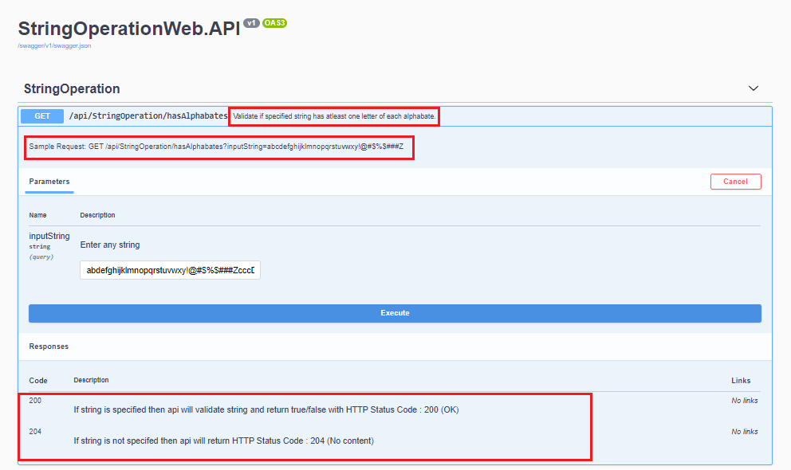

1. We can added one more project to unit test Business Services in Project.Core

# Deployment to Azure:

We can deploy Web API to Azure App Service or Azure Virtual Machine.

## Deploying to Azure App Service:

Recommended way to deploy API is to Azure App Service. It is a platform as service to publish web app without worrying about managing and configuring infrastructure. With Azure virtual machine infrastructure needs to be maintained.

Advantages of App Service:

* Developer can quickly deploy code without worrying about underlying infrastructure including security considerations.
* Easy to scale without re deploying application.
* Streamline CI/CD.

Limitation of App Service:

* It does not provide full control over underlying infrastructure. That means it does not provide granular control over application management and deployment. E.g. Controlling deployed application for monitoring and performance related activity.

## Publishing API to Azure App Service:

There are 2 ways we can deploy

1. Manually publishing from Visual Studio
   1. Right click on web project and click publish.
   2. Select Azure -> Azure App Service
2. Automate build and release by configuring CI/CD pipeline using Azure Dev Ops and deploy API to Azure app service. We can setup trigger (on check in or manual) to generate build and release to respective environment.