EE 610 – Digital Image Processing
Assignment 1

Nihal Rajan Barde
170260010
Python Language

Q 1.
Observation -: Higher number of low intensity pixels
Conclusion -: Log transformation will give better results
Reason -: Log transformation maps lower intensity values to relatively higher values

original Image -:

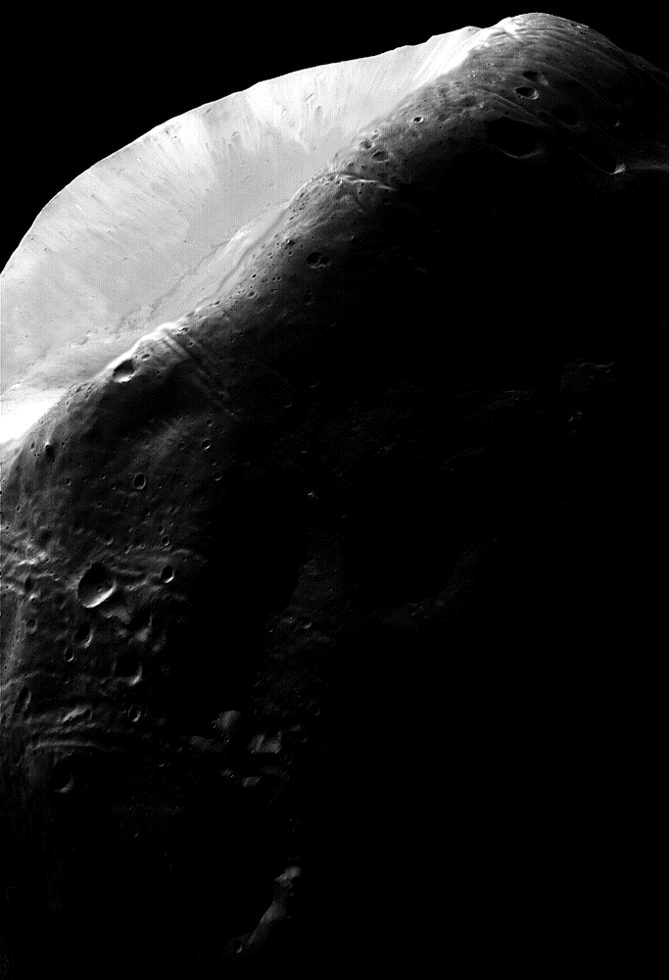

log transformation -:
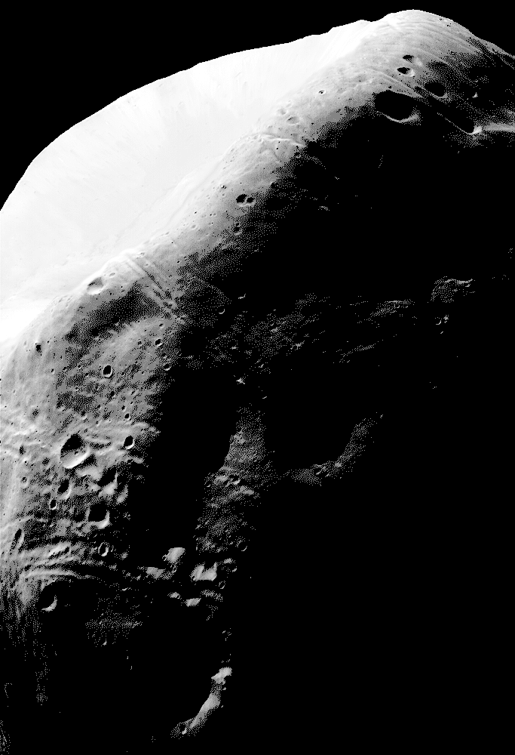
antilog transformation -:
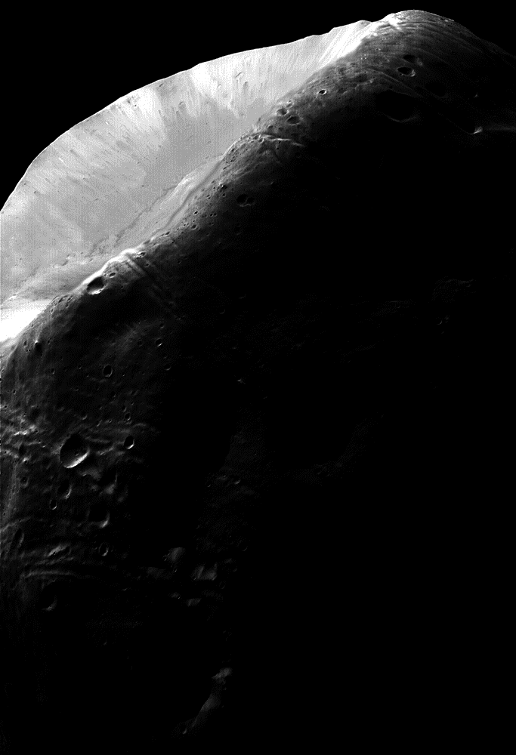
code -:

import cv2
import numpy as np

def logTrans(img):
maxVal = np.amax(img) # max value in image
cTarns = 255.0/np.log(1+maxVal) # scaling factor which sets max value to 255

imgTrans = cTarns*(np.log(img+1.001)) # log transformation
imgTrans = imgTrans.astype("uint8") # converting back to image format

return imgTrans

def antilogTrans(img):
maxVal = np.amax(img) # max value in image
imgTemp = (np.exp(img*1.0/maxVal)-1) # taking antilog (range from 0 to e-1 )

imgTrans = 255*(imgTemp/(np.e-1)) # scaling max value to 255
imgTrans = imgTrans.astype("uint8") # converting back to image format

return imgTrans

if __name__ == "__main__":
imgOriginal = cv2.imread("./Data/q1.png",0) # reading image using openCV

imgLog = logTrans(imgOriginal) # log transformation function
imgAntilog = antilogTrans(imgOriginal) # antilog transformation function

cv2.imwrite("./outputs/q1_log.png",imgLog)
cv2.imwrite("./outputs/q1_antilog.png",imgAntilog)

Q 2.

observation -: Image have different range of intensity values in different parts
conclusion & reason -: local histogram matching will give too much different output if every local patch is normalized pn scale 0 to 255. so we will scale about local min to local max.
Global maximum will give good result as image have good number of high and low intensity values.

Original image -:
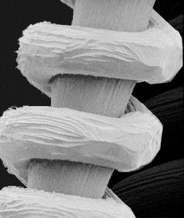

output images -:

global histogram equalization 3x3 local histogram equalization

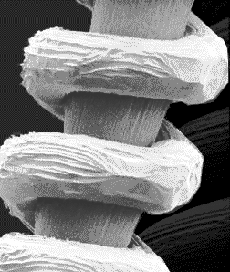
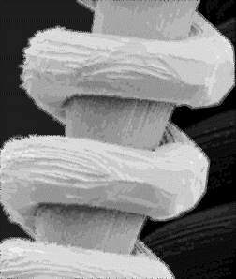

5x5 local histogram equalization 11x11 local histogram equalization

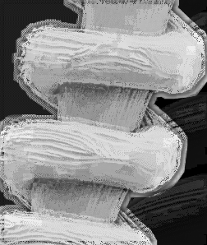
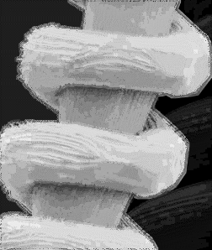

code -:
import cv2
import numpy as np

def globalHistTrans(img):
# making histogram of complete image
hist, bins = np.histogram(img.flatten(),256,[0,256])
cdf = hist.cumsum()

# normalizing histogram
cdfMasked = np.ma.masked_equal(cdf,0)
cdfNorm = (cdfMasked - cdfMasked.min())*255.0/(cdfMasked.max()-cdfMasked.min())

# retaining result
cdfResult = np.ma.filled(cdfNorm,0).astype("uint8")
imgHist = cdfResult[img]

return imgHist

def hist(img):
# finding probability distribution in local domain
probs = np.array([0.0 for i in range(256)])
for x in img.flatten():
probs[x] += 1
# normalizing probability function
probs /= np.sum(probs)

s = img[img.shape[0]//2,img.shape[1]//2]
imgMin, imgMax = img.min(), img.max()

# getting result about min and max value
return imgMin + np.sum(probs[:s+1])*(imgMax-imgMin)

def localHistTrans(img,kernel):
imgResult = img.copy()
# zero padding
imgPad = cv2.copyMakeBorder(img,kernel.shape[0]//2,kernel.shape[0]//2,kernel.shape[1]//2,kernel.shape[1]//2,borderType=0)

imgMin, imgMax = img.min(), img.max()
imgShape = img.shape

# calculating for each pixel differently
for i in range(imgShape[0]):
for j in range(imgShape[1]):
imgResult[i][j] = round((hist(imgPad[i:i+kernel.shape[0],j:j+kernel.shape[1]])))
return imgResult

if __name__ == "__main__":
imgOriginal = cv2.imread("./Data/q2.png",0) # reading image using openCV
x = 11
kernel = np.ones((x,x))/(x*x)
imgGlobalHist = globalHistTrans(imgOriginal)
imgLocalHist = localHistTrans(imgOriginal,kernel)

cv2.imwrite("./outputs/q2_global histogram.png",imgGlobalHist)
cv2.imwrite("./outputs/q2_local histogram_11x11.png",imgLocalHist)

Q 3.

a) observation -: noise does not belong to salt & pepper noise class
conclusion -: using smoothing filter
b) observation -: image have salt & pepper noise
conclusion -: using median filter

3a input
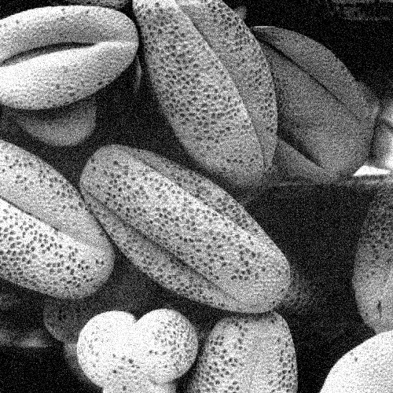

3a after applying smoothing filter
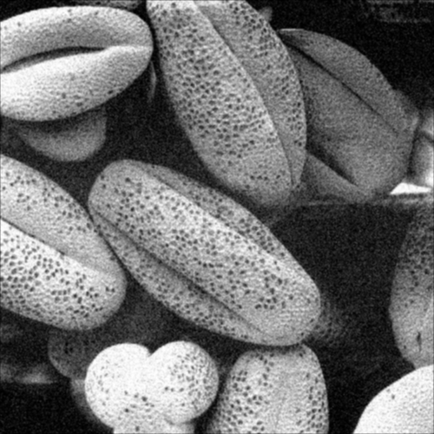

3b input
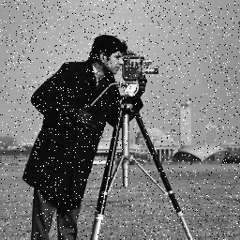

3b after median filter
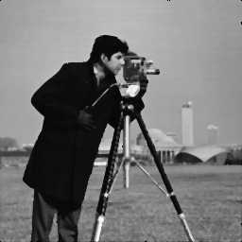

3a code spatial + frequency
import cv2
import numpy as np
import math

def getDFT(img): # DFT function
imgShape = img.shape
imgResult = img.copy()
for i in range(imgShape[0]):
for j in range(imgShape[1]):
imgResult[i,j] = ((-1)**(i+j))*img[i,j]
return np.fft.fft2(imgResult)

def getLogDFT(img): # DFT + log for getting DFT of image
imgFFT = getDFT(img)
imgFFT = np.abs(imgFFT)
imgLogFFT = logTrans(imgFFT)

return imgLogFFT

def IDFT(img): # IDFT function
imgShape = img.shape
imgResult = img.copy()
imgIFFT = np.real(np.fft.ifft2(img))
for i in range(imgShape[0]):
for j in range(imgShape[1]):
imgResult[i,j] = ((-1)**(i+j))*imgIFFT[i,j]
return imgResult.astype("uint8")

def logTrans(img):
maxVal = np.amax(img) # max value in image
cTarns = 255.0/np.log(1+maxVal) # scaling factor which sets max value to 255

imgTrans = cTarns*(np.log(img+1.001)) # log transformation
imgTrans = imgTrans.astype("uint8") # converting back to image format

return imgTrans

def smooth(img,kernel):
imgShape = img.shape
# padding image by zeros
imgPad = cv2.copyMakeBorder(img,kernel.shape[0]//2,kernel.shape[0]//2,kernel.shape[1]//2,kernel.shape[1]//2,borderType=0)
# padding kernel by zeros to make size as same as padded image
kernelPad = cv2.copyMakeBorder(kernel,0,imgShape[0]-1,0,imgShape[1]-1,borderType=0)

# getting DFT of image and kernel
kernelDFT = getDFT(kernelPad)
imgDFT = getDFT(imgPad)

# multiplying by kernel and retrieving result after IDFT
resultFFT = imgPad*kernelPad
result = IDFT(resultFFT)

imgKernel = getLogDFT(kernelPad)
cv2.imwrite('./outputs/q3a_filter.png', imgKernel)

return result #returning the output

if __name__ == "__main__":
kernel = np.ones((5,5))/(5*5)
img = cv2.imread('./Data/q3a.png' , 0)
r_im = getLogDFT(img)

cv2.imwrite('./outputs/q3a_fft.png', r_im)

result = smooth(img,kernel)
cv2.imwrite('./outputs/q3a_out.png', result)

3b code spatial only

import cv2
import numpy as np

def spatialSmoothTrans(img,kernel):
imgResult = img.copy()
# padding by zeros
imgPad = cv2.copyMakeBorder(img,kernel.shape[0]//2,kernel.shape[0]//2,kernel.shape[1]//2,kernel.shape[1]//2,borderType=0)
imgShape = img.shape
# multiplying by kernel
for i in range(imgShape[0]):
for j in range(imgShape[1]):
imgResult[i][j] = np.sum(imgPad[i:i+kernel.shape[0],j:j+kernel.shape[1]]*kernel)
return imgResult

def medianTrans(img,kernel):
imgResult = img.copy()
# zero padding
imgPad = cv2.copyMakeBorder(img,kernel.shape[0]//2,kernel.shape[0]//2,kernel.shape[1]//2,kernel.shape[1]//2,borderType=0)
imgShape = img.shape
# getting median for each image kernel
for i in range(imgShape[0]):
for j in range(imgShape[1]):
imgResult[i][j] = np.median(imgPad[i:i+kernel.shape[0],j:j+kernel.shape[1]])
return imgResult

if __name__ == "__main__":
imgOriginal = cv2.imread("./Data/q3b.png",0) # reading image using openCV
kernel = np.array([[1,2,1],[2,4,2],[1,2,1]]).astype(float)
kernel /= np.sum(kernel)
imgSmooth = spatialSmoothTrans(imgOriginal,kernel)

kernel = np.ones((3,3))/(3*3)
imgMedian = medianTrans(imgOriginal,kernel)

cv2.imwrite("./outputs/q3b_smooth.png",imgSmooth)
cv2.imwrite("./outputs/q3b_median.png",imgMedian)

Q 4.

3x3 sharpening filter not giving good results as background is sharp
Laplacian -: [0,-1,0],[-1,4,-1],[0,-1,0]
4 input image

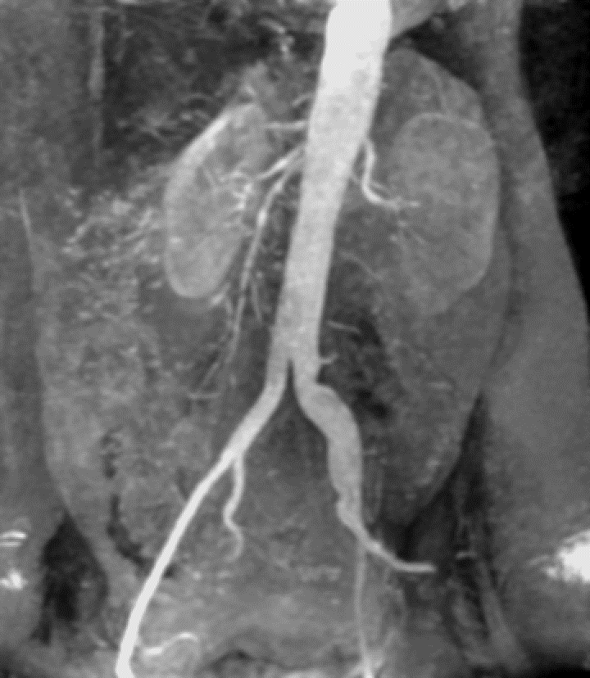

4 output image
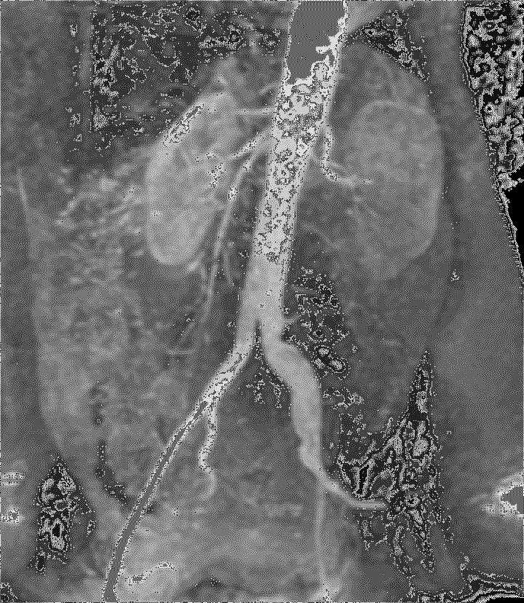
same for spatial and frequency domain

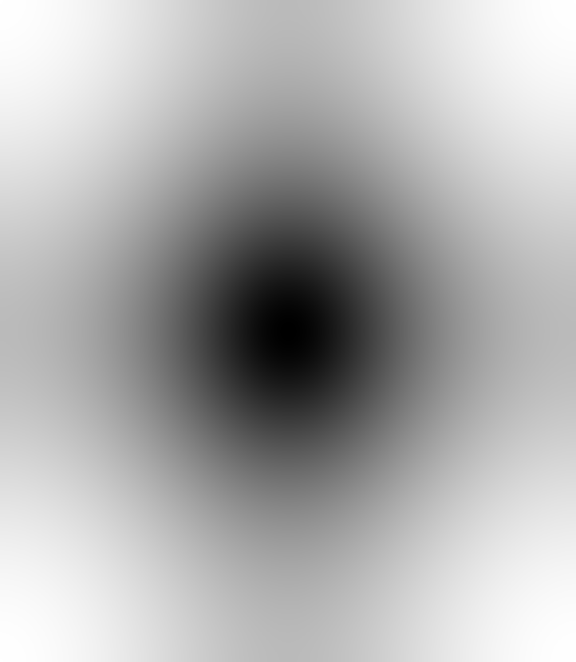

4 filter

q4 code

import cv2
import numpy as np
import math

def getDFT(img): # DFT function
imgShape = img.shape
imgResult = img.copy()
for i in range(imgShape[0]):
for j in range(imgShape[1]):
imgResult[i,j] = ((-1)**(i+j))*img[i,j]
return np.fft.fft2(imgResult)

def getLogDFT(img): # DFT + log for getting DFT of image
imgFFT = getDFT(img)
imgFFT = np.abs(imgFFT)
imgLogFFT = logTrans(imgFFT)

return imgLogFFT

def IDFT(img): # IDFT function
imgShape = img.shape
imgResult = img.copy()
imgIFFT = np.real(np.fft.ifft2(img))
for i in range(imgShape[0]):
for j in range(imgShape[1]):
imgResult[i,j] = ((-1)**(i+j))*imgIFFT[i,j]
return imgResult.astype("uint8")

def logTrans(img):
maxVal = np.amax(img) # max value in image
cTarns = 255.0/np.log(1+maxVal) # scaling factor which sets max value to 255

imgTrans = cTarns*(np.log(img+1.001)) # log transformation
imgTrans = imgTrans.astype("uint8") # converting back to image format

return imgTrans

def laplacianFourierTrans(img,kernel):
imgResult = img.copy()

imgShape = img.shape
# padding image by zeros
imgPad = cv2.copyMakeBorder(img,kernel.shape[0]//2,kernel.shape[0]//2,kernel.shape[1]//2,kernel.shape[1]//2,borderType=0)
# padding kernel by zeros to make size as same as padded image
kernelPad = cv2.copyMakeBorder(kernel,0,imgShape[0]-1,0,imgShape[1]-1,borderType=0)

# getting DFT of image and kernel
kernelDFT = getDFT(kernelPad)
imgDFT = getDFT(imgPad)

# multiplying by kernel and retrieving result after IDFT
resultFFT = imgPad*kernelPad
result = IDFT(resultFFT)

imgKernel = getLogDFT(kernelPad)
cv2.imwrite('./outputs/q4_filter.png', imgKernel)

return result #returning the output

def laplacianTrans(img,kernel):
imgResult = img.copy()
imgPad = cv2.copyMakeBorder(img,1,1,1,1,borderType=0)
imgShape = img.shape
imgResult[:,:] = imgResult[:,:] + 1*((4*imgPad[1:-1,1:-1]) - (1*imgPad[:-2,1:-1]) - (1*imgPad[2:,1:-1]) - (1*imgPad[1:-1,:-2]) - (1*imgPad[1:-1,2:]))
imgResult = np.clip(imgResult,0,255).astype("uint8")
return imgResult

if __name__ == "__main__":
imgOriginal = cv2.imread("./Data/q4.png",0) # reading image using openCV

kernel = np.array([[0,1,0],[1,-4,1],[0,1,0]])
imgLaplacian = laplacianTrans(imgOriginal,kernel)
imgFourierLaplacian = laplacianFourierTrans(imgOriginal,kernel)

cv2.imwrite("./outputs/q4_spatial.png",imgLaplacian)
cv2.imwrite("./outputs/q4_fourier.png",imgFourierLaplacian)

q5

Ideal lowpass filter, Butterworth low pass filter and Gaussian low pass filter perform well. However, Ideal lowpass filter introduces ringing effect
which is absent in the other two.
d = 50 pixels
Butterworth of order 2.

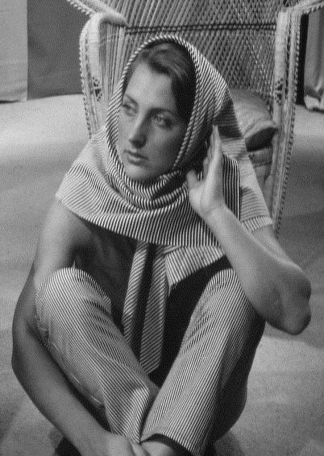
input image

ideal low pass filter
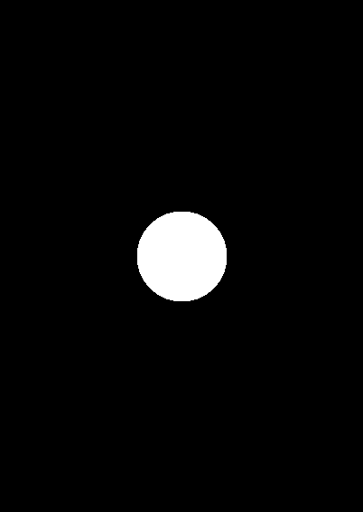
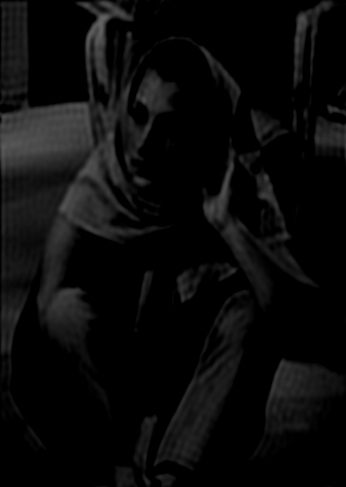

gaussian low pass filter
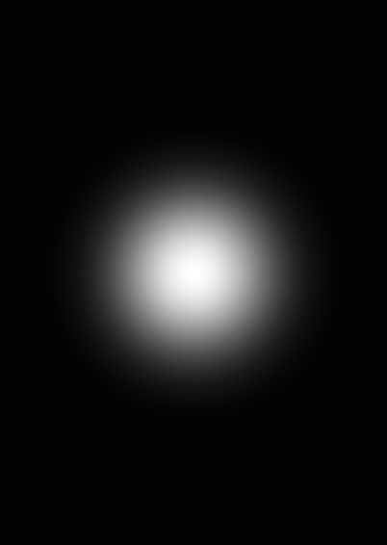
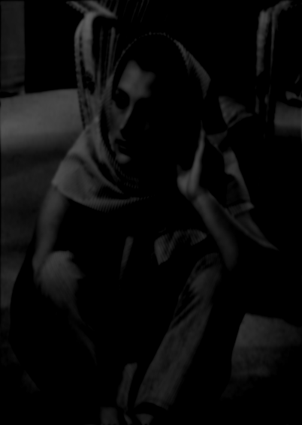

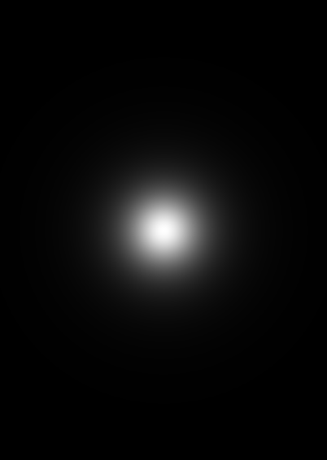
butterworth low pass filter

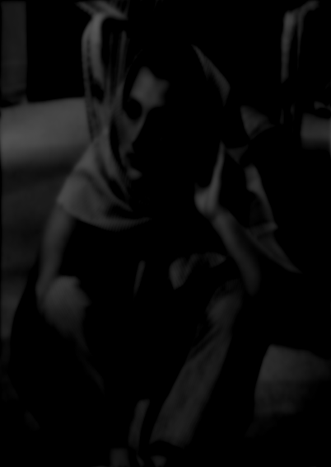

Q 5 code

import cv2
import numpy as np
import math

def getDFT(img): # DFT function
imgShape = img.shape
imgResult = img.copy()
for i in range(imgShape[0]):
for j in range(imgShape[1]):
imgResult[i,j] = ((-1)**(i+j))*img[i,j]
return np.fft.fft2(imgResult)

def getLogDFT(img): # DFT + log for getting DFT of image
imgFFT = getDFT(img)
imgFFT = np.abs(imgFFT)
imgLogFFT = logTrans(imgFFT)

return imgLogFFT

def IDFT(img): # IDFT function
imgShape = img.shape
imgResult = img.copy()
imgIFFT = np.real(np.fft.ifft2(img))
for i in range(imgShape[0]):
for j in range(imgShape[1]):
imgResult[i,j] = ((-1)**(i+j))*imgIFFT[i,j]
return imgResult.astype("uint8")

def logTrans(img):
maxVal = np.amax(img) # max value in image
cTarns = 255.0/np.log(1+maxVal) # scaling factor which sets max value to 255

imgTrans = cTarns*(np.log(img+1.001)) # log transformation
imgTrans = imgTrans.astype("uint8") # converting back to image format

return imgTrans

def BLPF(img,d,n): #butterworth low pass filter
imgShape = img.shape
mask = np.zeros(imgShape)
# calculating mask using BLPF function
for i in range(imgShape[0]):
for j in range(imgShape[1]):
mask[i][j] = 1/((1+(((i-imgShape[0]/2.0)**2+(j-imgShape[1]/2.0)**2)/(d*d)))**n)
cv2.imwrite("./outputs/q5_b.png",logTrans(mask))
# getting DFT of image and multiplying by mask
imgDFT = getDFT(img)
resultDFT = np.multiply(mask,imgDFT)
# getting result by applying IDFT on DFT-result
result = IDFT(resultDFT)

return result

def GLPF(img,d): # gaussian low pass filter
imgShape = img.shape
mask = np.zeros(imgShape)
# calculating mask using GLPF function
for i in range(imgShape[0]):
for j in range(imgShape[1]):
mask[i][j] = math.exp(((i-imgShape[0]/2.0)**2+(j-imgShape[1]/2.0)**2)/(-2.0*d*d))
cv2.imwrite("./outputs/q5_g.png",logTrans(mask))
# getting DFT of image and multiplying by mask
imgDFT = getDFT(img)
resultDFT = np.multiply(mask,imgDFT)
# getting result by applying IDFT on DFT-result
result = IDFT(resultDFT)

return result

def ILPF(img,d): # ideal low pass filter
imgShape = img.shape
mask = np.zeros(imgShape)
# calculating mask using ILPF function
for i in range(imgShape[0]):
for j in range(imgShape[1]):
if((((i-imgShape[0]/2.0)**2+(j-imgShape[1]/2.0)**2)**0.5)<d):
mask[i][j] = 1
cv2.imwrite("./outputs/q5_i.png",logTrans(mask))
# getting DFT of image and multiplying by mask
imgDFT = getDFT(img)
resultDFT = np.multiply(mask,imgDFT)
# getting result by applying IDFT on DFT-result
result = IDFT(resultDFT)

return result

if __name__ == "__main__":
imgOriginal = cv2.imread("./Data/q5.png",0) # reading image using openCV
imgILPF = ILPF(imgOriginal,50)
imgGLPF = GLPF(imgOriginal,50)
imgBLPF = BLPF(imgOriginal,50,2)

cv2.imwrite("./outputs/q5_ILPF.png",imgILPF)
cv2.imwrite("./outputs/q5_GLPF.png",imgGLPF)
cv2.imwrite("./outputs/q5_BLPF.png",imgBLPF)

Q 6.

Ideal lowpass filter, Butterworth low pass filter and Gaussian low pass filter perform well.
Ideal lowpass filter introduces ringing effect
gaussian > butterworth > ideal ( smoothness )
which is absent in the other two.
d = 10 pixels
Butterworth of order 2.

input image

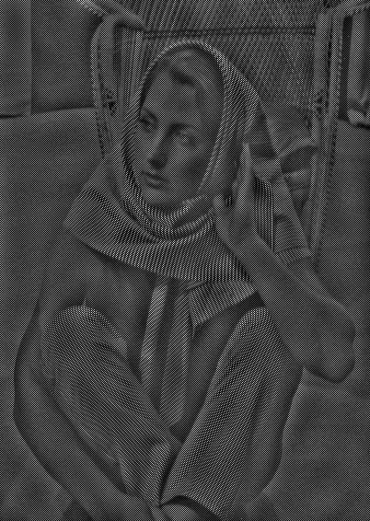
idea high pass filter
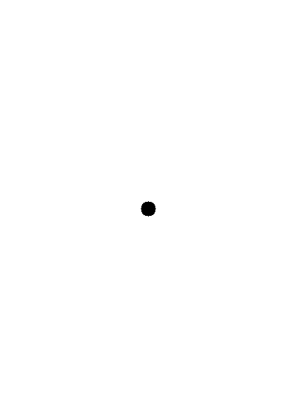

gaussian high pass filter
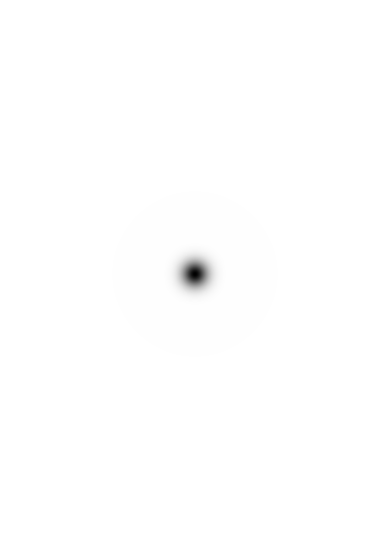
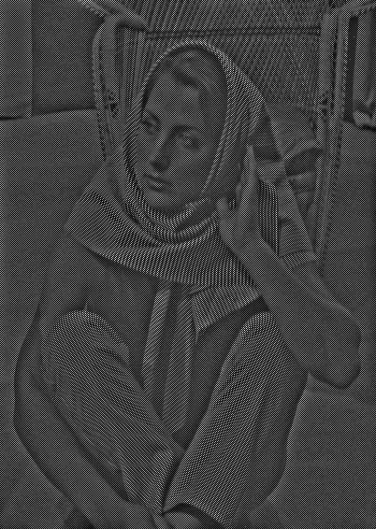

butterworth low pass filter
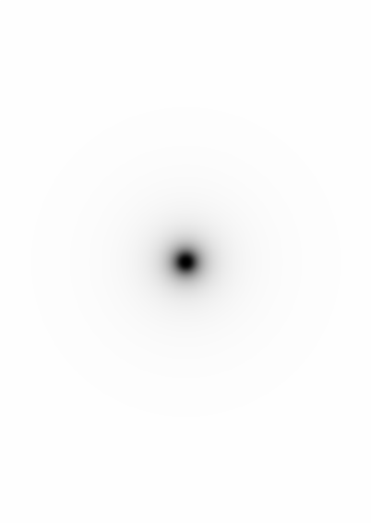
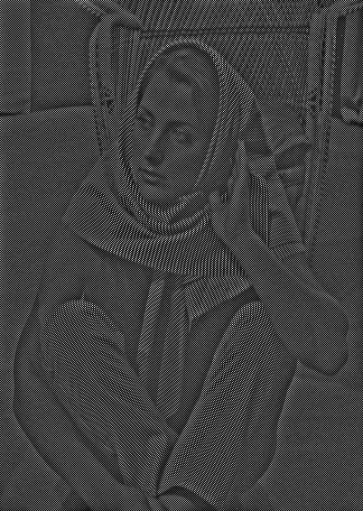

q6 code

import cv2
import numpy as np
import math

def getDFT(img): # DFT function
imgShape = img.shape
imgResult = img.copy()
for i in range(imgShape[0]):
for j in range(imgShape[1]):
imgResult[i,j] = ((-1)**(i+j))*img[i,j]
return np.fft.fft2(imgResult)

def getLogDFT(img): # DFT + log for getting DFT of image
imgFFT = getDFT(img)
imgFFT = np.abs(imgFFT)
imgLogFFT = logTrans(imgFFT)

return imgLogFFT

def IDFT(img): # IDFT function
imgShape = img.shape
imgResult = img.copy()
imgIFFT = np.real(np.fft.ifft2(img))
for i in range(imgShape[0]):
for j in range(imgShape[1]):
imgResult[i,j] = ((-1)**(i+j))*imgIFFT[i,j]
return imgResult.astype("uint8")

def logTrans(img):
maxVal = np.amax(img) # max value in image
cTarns = 255.0/np.log(1+maxVal) # scaling factor which sets max value to 255

imgTrans = cTarns*(np.log(img+1.001)) # log transformation
imgTrans = imgTrans.astype("uint8") # converting back to image format

return imgTrans

def BHPF(img,d,n): # butterworth high pass filter
imgShape = img.shape
mask = np.zeros(imgShape)
# calculating mask using BHPF function
for i in range(imgShape[0]):
for j in range(imgShape[1]):
xxx = ((i-imgShape[0]/2.0)**2+(j-imgShape[1]/2.0)**2)
if xxx:
mask[i][j] = 1/((1+((d*d)/xxx))**n)
cv2.imwrite("./outputs/q6_b.png",logTrans(mask))
# getting DFT of image and multiplying by mask
imgDFT = getDFT(img)
resultDFT = np.multiply(mask,imgDFT)
# getting result by applying IDFT on DFT-result
result = IDFT(resultDFT)

return result

def GHPF(img,d): # gaussian high pass filter
imgShape = img.shape
mask = np.zeros(imgShape)
# calculating mask using GHPF function
for i in range(imgShape[0]):
for j in range(imgShape[1]):
mask[i][j] = 1.0 - math.exp(((i-imgShape[0]/2.0)**2+(j-imgShape[1]/2.0)**2)/(-2.0*d*d))
cv2.imwrite("./outputs/q6_g.png",logTrans(mask))
# getting DFT of image and multiplying by mask
imgDFT = getDFT(img)
resultDFT = np.multiply(mask,imgDFT)
# getting result by applying IDFT on DFT-result
result = IDFT(resultDFT)

return result

def IHPF(img,d): # ideal high pass filter
imgShape = img.shape
mask = np.zeros(imgShape)
# calculating mask using IHPF function
for i in range(imgShape[0]):
for j in range(imgShape[1]):
if((((i-imgShape[0]/2.0)**2+(j-imgShape[1]/2.0)**2)**0.5)>d):
mask[i][j] = 1
cv2.imwrite("./outputs/q6_i.png",logTrans(mask))
# getting DFT of image and multiplying by mask
imgDFT = getDFT(img)
resultDFT = np.multiply(mask,imgDFT)
# getting result by applying IDFT on DFT-result
result = IDFT(resultDFT)

return result

if __name__ == "__main__":
imgOriginal = cv2.imread("./Data/q6.png",0) # reading image using openCV
imgIHPF = IHPF(imgOriginal,10)
imgGHPF = GHPF(imgOriginal,10)
imgBHPF = BHPF(imgOriginal,10,2)

cv2.imwrite("./outputs/q6_IHPF.png",imgIHPF)
cv2.imwrite("./outputs/q6_GHPF.png",imgGHPF)
cv2.imwrite("./outputs/q6_BHPF.png",imgBHPF)

