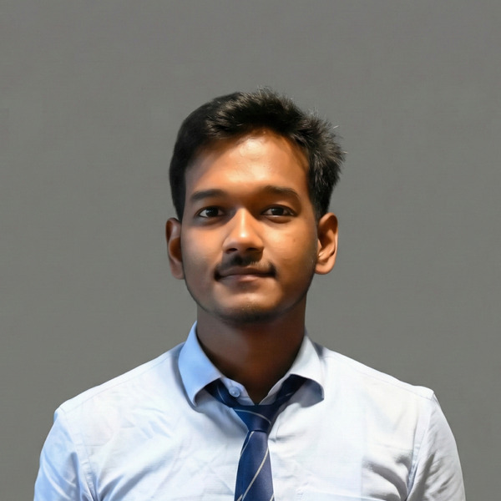 | NILENDU BARMAN  Kolkata, West Bengal 700109 | nilendubarman404@gmail.com | +91-9064418967  linkedin.com/in/nilendu404 | github.com/nilendu404

PROFILE

B.Tech (IT) graduate (2026) with hands-on experience building and shipping full-stack and AI-powered applications, from a live React/Supabase rental platform to a YOLOv8 computer-vision system. Comfortable using modern AI tools — ChatGPT, Claude, and Gemini — to accelerate development, alongside a strong foundation in DSA, DBMS, and Computer Networks. Cisco-certified in networking basics. A quick learner who enjoys turning ideas into working software, looking to contribute to AI, automation, and backend projects in a fast-paced, collaborative team.
EDUCATION

2022 – 2026  Kolkata, WB | Bachelor of Technology (B.Tech) — Information Technology  Narula Institute of Technology  CGPA: 7.7 / 10
2020 – 2022  Jhargram, WB | Higher Secondary Education (Class XII)  Jhargram Kumud Kumari Institution — West Bengal Council of Higher Secondary Education  Percentage: 91%
2018 – 2020  Jhargram, WB | Secondary Education (Class X)  Jhargram Kumud Kumari Institution — West Bengal Board of Secondary Education  Percentage: 76%

CERTIFICATIONS

Sep 2026 | Networking Basics — Cisco Networking Academy Verify credential ↗

SKILLS

Programming Languages  Python, C++, Java, SQL | AI / ML  Machine Learning fundamentals, ChatGPT, Claude, Gemini, prompt engineering | Web Development (MERN)  React, Node.js, Express, MongoDB, Vite, Tailwind CSS, Supabase
Core CS  DSA, DBMS, Operating Systems, Computer Networks | Tools & Platforms  Git, GitHub, VS Code, Vercel, Linux, Windows | Additional  Electronics & IoT (Arduino, sensor interfacing)

PROJECTS

GameRent — Gaming Console & Accessory Rental Platform (live)
- Designed and built a full-stack rental platform solo, end-to-end, where users browse a catalog, select rental dates, get an instant price quote, and submit a booking request.
- Built a private admin dashboard for managing inquiries and inventory, including live “Available” / “Rented Out” status tracking.
- Built with React, Vite, and Tailwind CSS v4 on the frontend, Supabase for the database and admin authentication, and deployed live on Vercel.

Real-Time Coral Health Monitoring System Using YOLOv8 (GitHub)
- Built an AI-powered, deep learning-based system in Python to detect multiple coral health conditions in real time from underwater imagery, using the YOLOv8 object detection model.
- Built and annotated a custom image dataset and implemented data augmentation pipelines to improve model robustness.
- Trained and evaluated multiple model variants, comparing accuracy trade-offs — full-cycle AI application development from raw data to a working, testable system.

VOLUNTEER EXPERIENCE

Cultural Fest Organizer — Narula Institute of Technology
- Led end-to-end planning of the annual cultural fest — logistics, vendor negotiations, sponsorship outreach — coordinating 15 volunteers across 5+ workshops for 200+ participants, working closely with technical and non-technical stakeholders throughout.

