# Grade Checker

**#Explanation:**  
#This program asks the user for a numerical score and prints a letter grade using basic #if-else conditions

score = int(input("Enter the score: "))

if score >= 90:

grade = "A"

elif score >= 80:

grade = "B"

elif score >= 70:

grade = "C"

elif score >= 60:

grade = "D"

else:

grade = "F"

print(f"Grade: {grade}")

**Concepts used:** if-else, user input, comparison operators

**2.Student Grades Dictionary**

**Explanation:**  
This program uses a **dictionary** to store student names and their grades. It allows the user to:

* Add new students
* Update grades
* View all student grades

# Student Grades Manager

student_grades = {}

while True:

print("\nMenu:")

print("1. Add a new student and grade")

print("2. Update an existing student’s grade")

print("3. Print all student grades")

print("4. Exit")

choice = input("Enter your choice (1-4): ")

if choice == '1':

name = input("Enter student name: ")

grade = input("Enter student grade: ")

student_grades[name] = grade

print(f"{name} added with grade {grade}.")

elif choice == '2':

name = input("Enter student name to update: ")

if name in student_grades:

grade = input(f"Enter new grade for {name}: ")

student_grades[name] = grade

print(f"{name}'s grade updated to {grade}.")

else:

print(f"Student {name} not found.")

elif choice == '3':

print("\nStudent Grades:")

for name, grade in student_grades.items():

print(f"{name}: {grade}")

elif choice == '4':

print("Exiting program.")

break

else:

print("Invalid choice. Please enter a number from 1 to 4.")

**Concepts used:** dictionary, input(), if-else, loops

**3. Write to a File**

**Explanation:**  
This program creates a text file and writes sample content into it using open() in write mode.

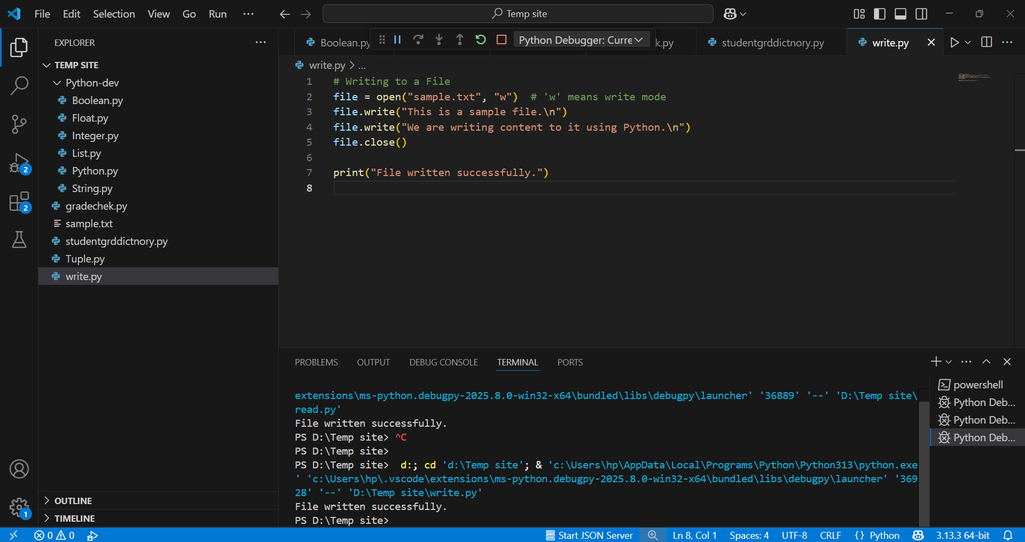

# Writing to a File

file = open("sample.txt", "w") # 'w' means write mode

file.write("This is a sample file.\n")

file.write("We are writing content to it using Python.\n")

file.close()

print("File written successfully.")

**Concepts used:** open(), write(), file handling

**4. Read from a File**

**Explanation:**  
This program opens the text file created above and prints its contents using read().

python

CopyEdit

# Reading from a File

file = open("sample.txt", "r") # 'r' means read mode

content = file.read()

print("File Contents:\n")

print(content)

file.close()

**Concepts used:** open(), read(), file handling