Linux Commands Assignment

# 1. Creating and Renaming Files/Directories

mkdir test_dir  
cd test_dir  
touch example.txt  
mv example.txt renamed_example.txt  
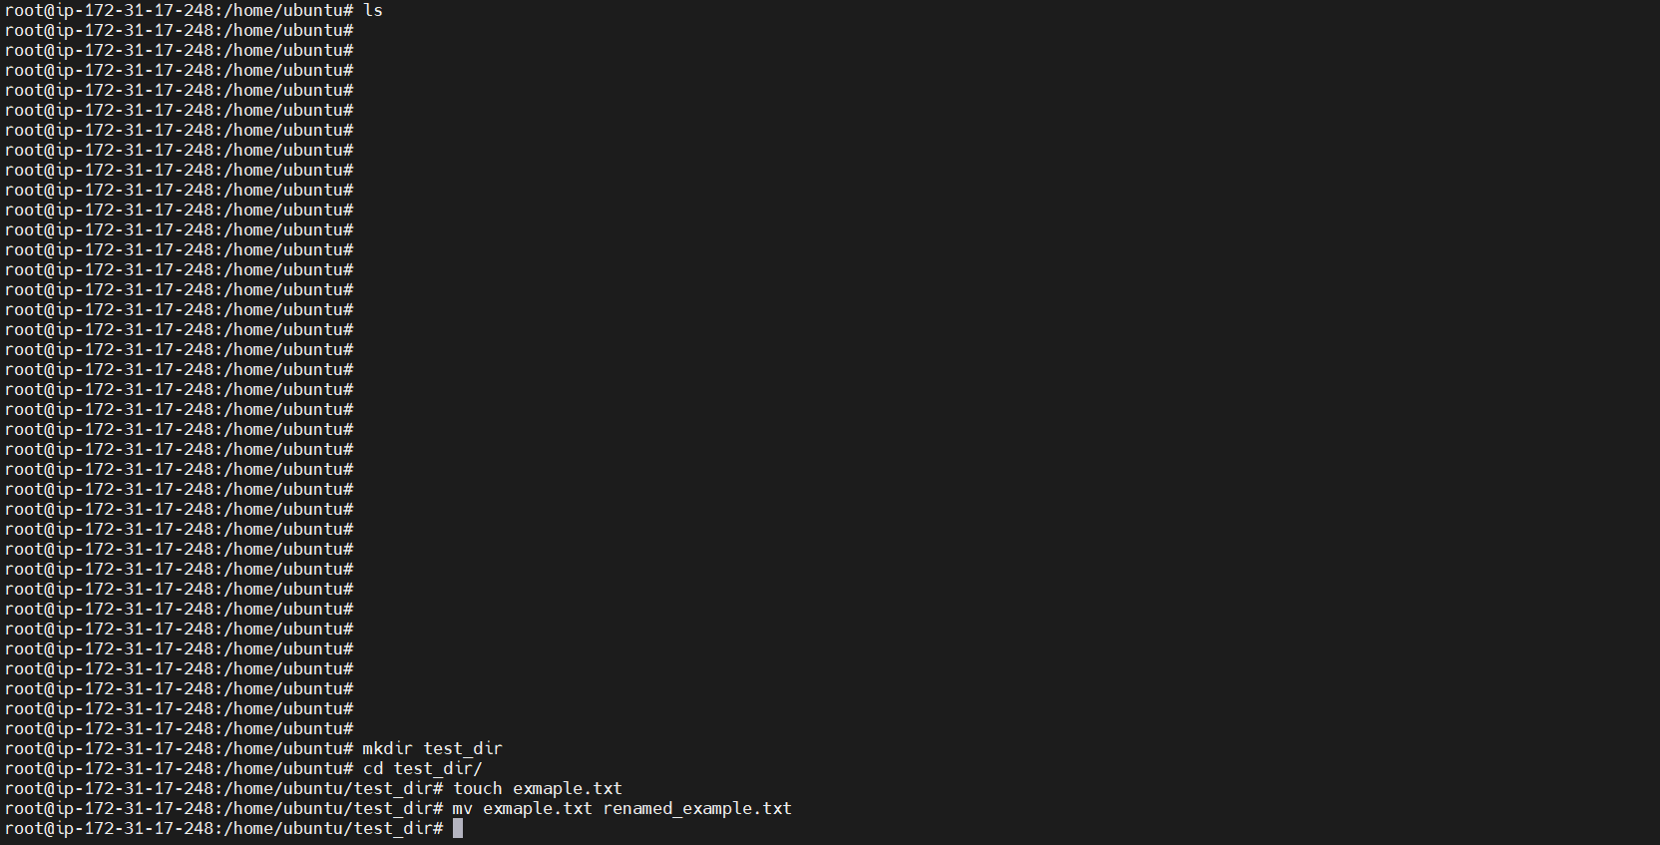

Explanation:  
- mkdir creates a new directory.  
- touch creates an empty file.  
- mv renames a file.

# 2. Viewing File Contents

cat /etc/passwd  
head -n 5 /etc/passwd  
tail -n 5 /etc/passwd

Explanation:  
- cat displays the full contents of a file.  
- head shows the first N lines.  
- tail shows the last N lines.

# 3. Searching for Patterns

grep "root" /etc/passwd

Explanation:  
- grep searches for patterns/strings in a file.

# 4. Zipping and Unzipping

cd ..  
zip -r test_dir.zip test_dir  
mkdir unzipped_dir  
unzip test_dir.zip -d unzipped_dir  
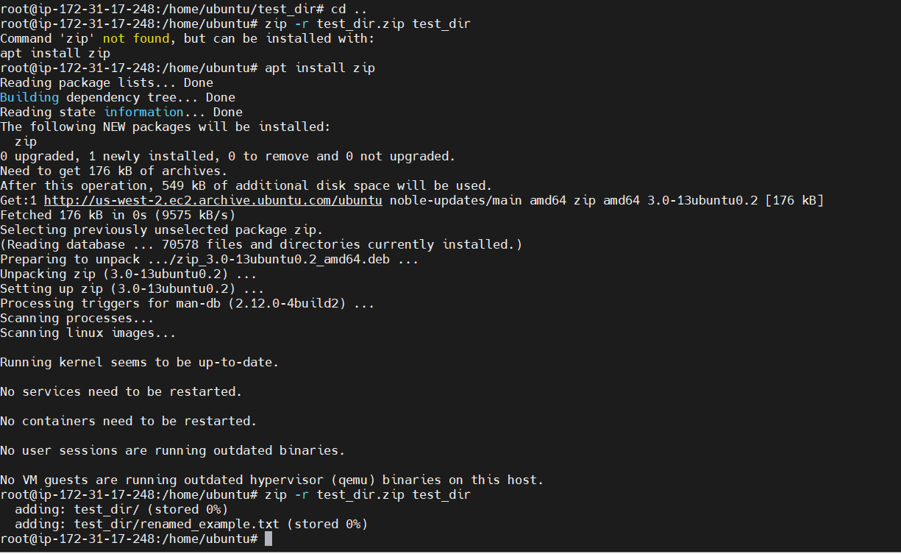

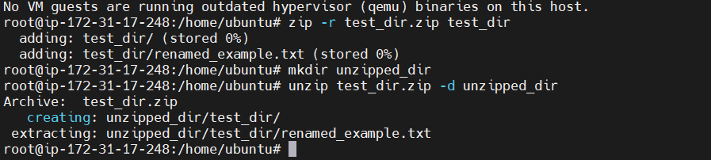

Explanation:  
- zip -r recursively zips a folder.  
- unzip -d extracts to a specific directory.

# 5. Downloading Files

wget <https://example.com/sample.txt>

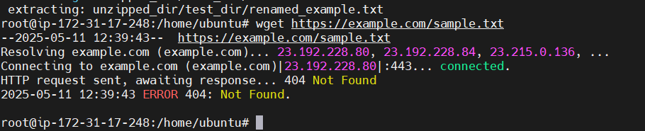

Explanation:  
- wget downloads files from the internet.

# 6. Changing Permissions

touch secure.txt  
chmod 444 secure.txt

Explanation:  
- chmod 444 sets file to read-only for all users.

# 7. Working with Environment Variables

export MY_VAR="Hello, Linux!"  
echo $MY_VAR

Explanation:  
- export sets a temporary environment variable.  
- echo $MY_VAR displays its value.