Classification and Pattern Recognition Using SVM and Neural Networks

PROJECT SYNPOSIS OF B.TECH FINAL YEAR PROJECT

BACHELOR OF TECHNOLOGY

COMPUTER SCIENCE AND ENGINEERING

SUBMITTED BY:
Ayan Dasgupta | Nilesh Chakraborty | Utsav Pandey
CSE/027/2010 | CSE/027/2010 | CSE/027/2010

UNDER THE SUPERVISION OF:
Dr. Minakshi Banerjee

RCC INSTITUTE OF INFORMATION TECHNOLOGY

1. Our Guide

2. The Problem
Background
Millions of programmers use Stack Overflow (stackoverflow.com) to get high quality answers to their programming questions every day. Quality of questions and answers is strictly maintained by a crowd-grown culture of moderation. Any user, by virtue of his/her reputation (collected through moderation activities, peer reviewing and voting on his/her questions and answers) can moderate questions and answers.
Stackoverflow encourages users to post questions that can be answered objectively, that is, short and to-the-point answers with empirical data, facts and links to support their points. Subjective questions that do not have a distinct point or answer are generally frowned upon. Users with sufficient reputation may vote to close a question if they think it doesn't meet the standards or are off-topic, subjective or prone to pointless debate.

Problem Statement
We propose to design a system that will analyze stackoverflow data dumps containing all its questions and answers, and given any new question, predict whether it will be closed or not.
In essence, this is a classification problem; machine learning algorithms and tools like artificial neural networks and support vector machines will be used to classify a question into either of two classes - “may be closed” or “may not be closed”. Each posted question has several attributes like tag strings, votes, post date, closing date (if it is already closed because of being subjective or off-topic) etc. in addition to its text body. These attributes will be used as features, in addition to the features extracted from the question body using natural language processing libraries.

3. Why is the particular topic chosen?
Firstly, this topic requires us to get acquainted with neural network and SVM, along with basic natural language processing concepts. This knowledge would serve us well when we start exploring similar but more involved topics like sports outcome prediction and stock market prediction. Secondly, finding a fairly accurate solution to this classification problem would help semi-automate moderation activities on Q&A sites.

4. Objective and Scope
The specific objectives of the project are:
- Find a method to extract features from the question body. Use these and the question attributes to create a feature vector.
- Train the different classifiers using the training datasets to create the models.
- Use the models to classify the test dataset into two classes - “may be closed” or “may not be closed”.
- Compute the errors and reiterate with different methods if needed.

5. Methodology and Summary
- Preprocessing and Feature extraction: The Python Natural Language Toolkit will be used to extract features from the question bodies. It's useful for automating a lot of things, like extracting named entitites, tokenizing and tagging text etc. We can choose to include some or most of the attributes stored in the dataset for each question in the feature set.
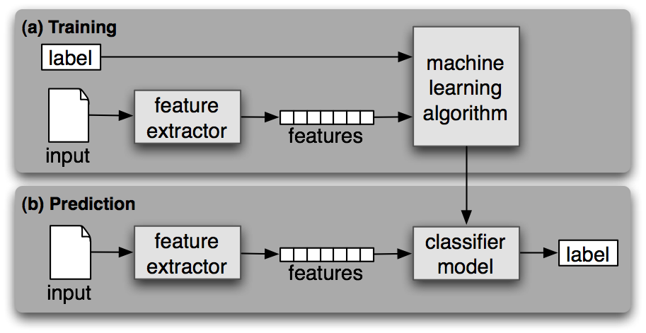
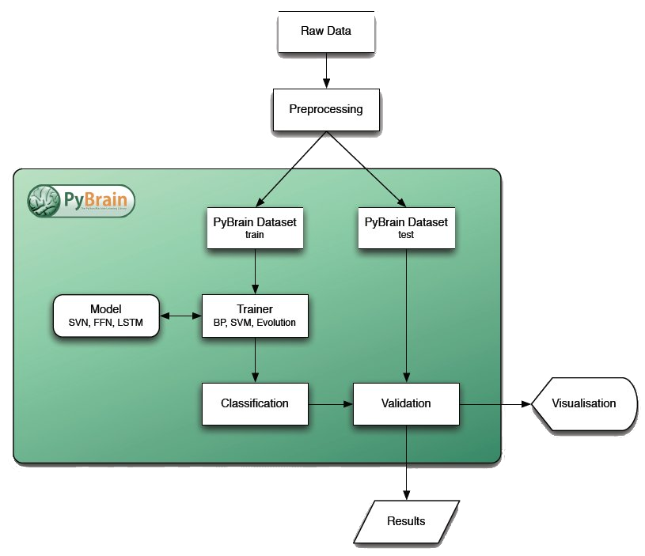
- Supervised Classification: PyBrain is a Python machine learning toolkit that will help us doing the classification with different tools like neural network, SVM, k-NN etc.
- Computing Errors (Validation): After running the classification on the test dataset, we'll be able to find the accuracy of the methods used and compare them. We need to decide which validation method to use.
- Classification methods: We will compare a number of classification methods, to figure out what suits best, including:
- Artificial Neural Network: Neural Network emulates how the human brain works by having a network of neurons that are interconnected and sending stimulating signal to each other.
In the Neural Network model, each neuron is equivalent to a logistic regression unit. Neurons are organized in multiple layers where every neuron at layer i connects out to every neuron at layer i+1
The input moves from the layer 1 to layer i by passing through each subsequent layer. The number of neurons in the final layer generally corresponds to the number of classes in the classification problem.
- Support Vector Machine: A support vector machine constructs a hyperplane (linear or binary classification) or set of hyperplanes in a high- or infinite-dimensional space, which can be used for classification, regression, or other tasks.
- Naive Bayes: A naive Bayes classifier is a simple probabilistic classifier based on applying Bayes' theorem. From a probabilistic viewpoint, the predictive problem can be viewed as a conditional probability estimation; trying to find Y where P(Y | X) is maximized.
- K Nearest Neighbor: In K-Nearest Neighbor, the training process is basically memorizing all the training data. To predict a new data point, we find the closest K (a tunable parameter) neighbors from the training set and let them vote for the final prediction.

6. Hardware & Software to be Used
Hardware:
Main development bed | Test bed
i5-2500K CPU, 4G RAM | i3 CPU, 2G RAM

Software:
Development will be primarily done on Ubuntu.
PyBrain 0.3 for neural network and SVM implementations.
Python NLTK 2.0 for analyzing question body.
MATLAB may be used for rapid prototyping.

7. Testing Technologies to be Used
The stackoverflow data dump is a labeled dataset, where some of the questions will be marked closed. This data dump will be split into two parts – training and testing datasets. The training dataset will be used to train the ANN or SVM classifier, which will be again used with the testing dataset to predict which questions will be closed. PyBrain will be used to do this.

8. What contributions would the project make?
There are several Q&A based websites like stackoverflow, Quora, ServerFault to name a few, that help a huge number of users including students researching on particular topics or wanting to solve a particular problem. A prediction engine like this would help moderating the posts on those websites much easier.
In addition to this, prediction methodologies like the ones used in this project would be useful in developing systems for text-based classification and prediction – for example, predicting the accuracy of articles on Wikipedia.
In addition to this, after successful completion of this project, we wish to explore cricket and football game outcome prediction, and stock market trade outcome prediction through sentiment analysis of public twitter feeds and historical stock market data.

